**Title of the Project**



**BTech/III Year CSE/V Semester**

**15CSE302/Database Management Systems**

**Project Review -1**

|  |  |
| --- | --- |
| Rollno | Name |
| CB.EN.U4CSE18415 | **Dhanush C** |
| CB.EN.U4CSE18439 | **Mithun Rosinth V V** |

**Amrita School of Engineering, Coimbatore**

**Department of Computer Science and Engineering**

**2020 -2021 Odd Semester**

Table of Contents

**Title Page number**

**Chapter 1 Introduction 3**

**Abstract 4**

**Chapter 2 Logical Database Design ER Diagram 5**

**Entities 5**

**Attributes 5**

**Relationships 5**

**Chapter 3 ER to Relational Schema Mapping 6**

**Chapter 4 User Interface Screens 7**

**References 8**

# Chapter 1 Introduction

Food business usually will have high demand and hence online business prospect for food ordering should be profitable. The purpose of this project is to provide an easily accessible interface wherein the customer can view and place the order easily.

Every customer can order anything on the menu for the available quantity. Once the order is placed the desk employee receives it and pushes it to the devices of delivery agents in the vicinity. If any one of the delivery agent picks it up the order is archive as order history or else if nobody accepts the delivery job a new delivery agent is manually allocated by the desk employee.

Technical Specifications of the APP

Backend: MySQL

Frontend: React JS and Material UI guidelines

# Abstract

There is a lot of scope for online food ordering business and we can tap it to the max extent possible as everyone has access to an online ordering facility via the internet. Food business usually will have high demand and hence online business prospect for food ordering should be profitable. The purpose of this project is to provide an easily accessible interface wherein the customer can view and place the order easily.

The customer can register initially with minimum details and will be allowed to check the menu items before ordering them, adding them to cart and submit the order. The system records the details in the database so that it will be easy to retrieve later. The users of the system also include employee/admin who will handle info related to product addition and assigning vehicle for placed orders.

The users of the system include the customers and the employees. The employees of the system are responsible for updating the menu items as well as the delivery of the item to a particular address. The customers will visit the website, check for the items available in the menu, order for one or more items in the menu. All the activities such as ordering items online, delivery of the items by employees, the vehicle used to deliver the items etc. will be recorded in the database for all the events.

# Chapter 2 Logical Database Design ER Diagram

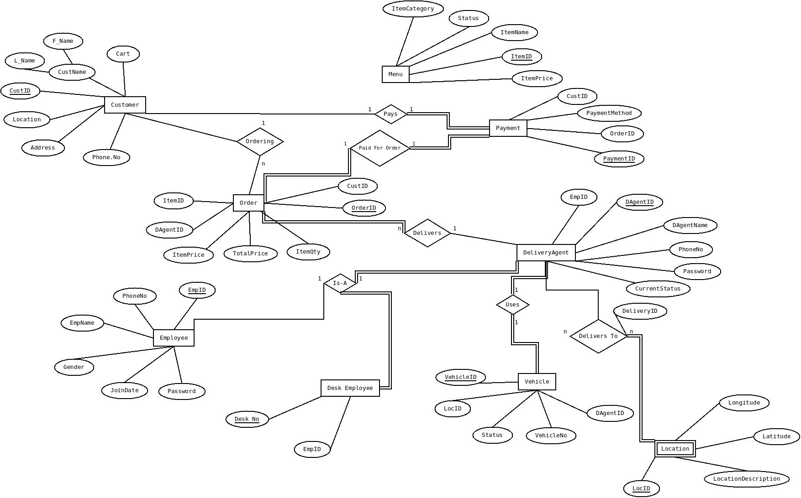

## Entities

* Customer
* Order
* Employee
* Vehicle
* Menu
* Payment
* DeliveryAgent
* DeskEmployee
* Location

## Attributes

* Customer(CustID,F_Name,L_Name,Address,Cart,Location,Phone.no)
* Order(OrderID,DAgentID,ItemPrice,TotalPrice,ItemQty,CustID,ItemID)
* Employee(EmpID,EmpName,PhoneNo,Gender,JoinDate,Password)
* Vehicle(VehicleID,LocID,Status,VehicleNo,DAgentID)
* Menu(ItemID, ItemName,ItemPrice,Status,ItemCategory)
* Payment(CustID,PaymentMethod,OrderID,PaymentID)
* DeliveryAgent(EmpID,DAgentID,AgentName,PhoneNo,Password,CurrentStatus)
* DeskEmployee(EmpID,Desk.no)
* Location(LocID,Longitude,Latitude,LocationDescription)

## Relationships

* Ordering - Customer,Order
* Pays - Customer,Payment
* Paid for Order - Payment,Order
* Delivers - Order,DeliveryAgent
* Is-A - Employee,DeliveryAgent,DeskEmployee
* Uses - Vehicle,DelveryAgent
* DeliversTo - DeliveryAgent,Location

# Chapter 3 ER to Relational Schema Mapping

Since it is a N:N relationship one of the participating entities is involved in a total participation, so the relationship set is converted into an entity set on its own

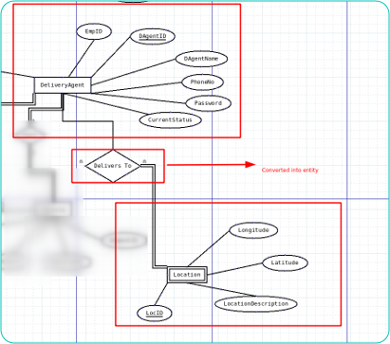

* Delivery Table(DeliveryID,DAgentID,LocID)

# Chapter 4 User Interface Screens

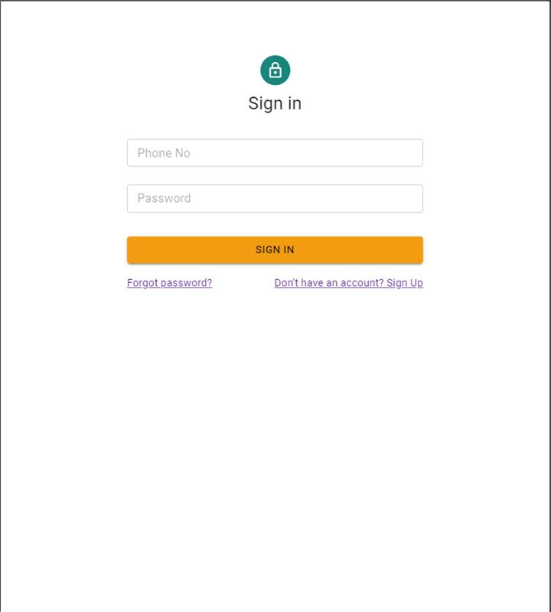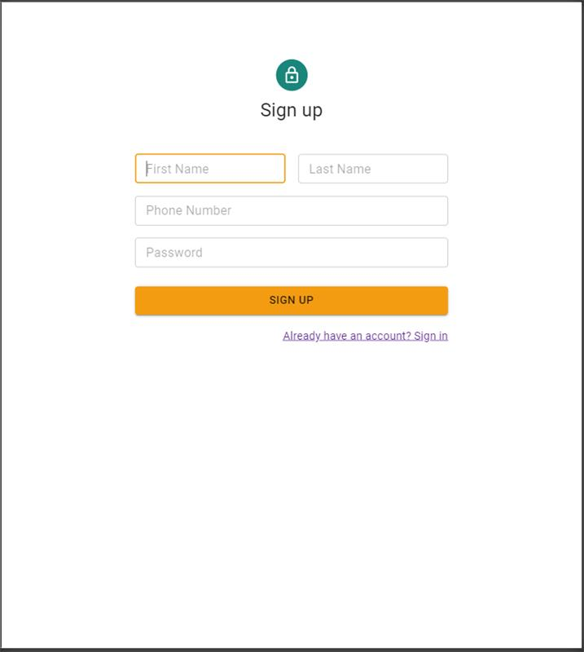

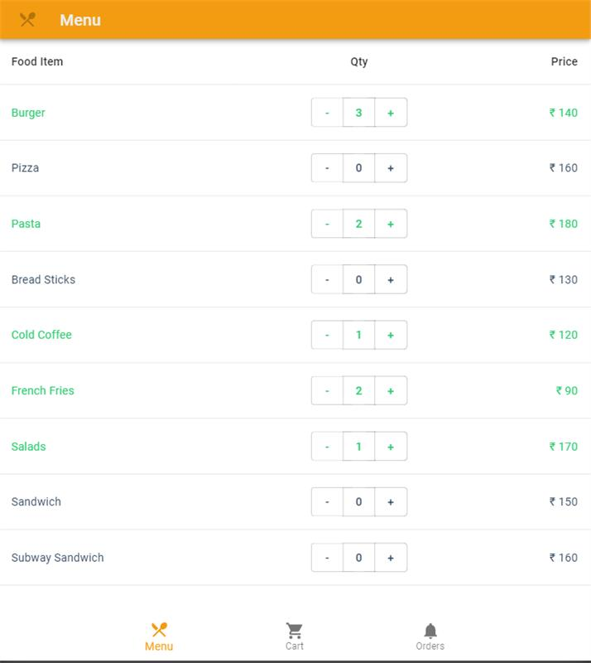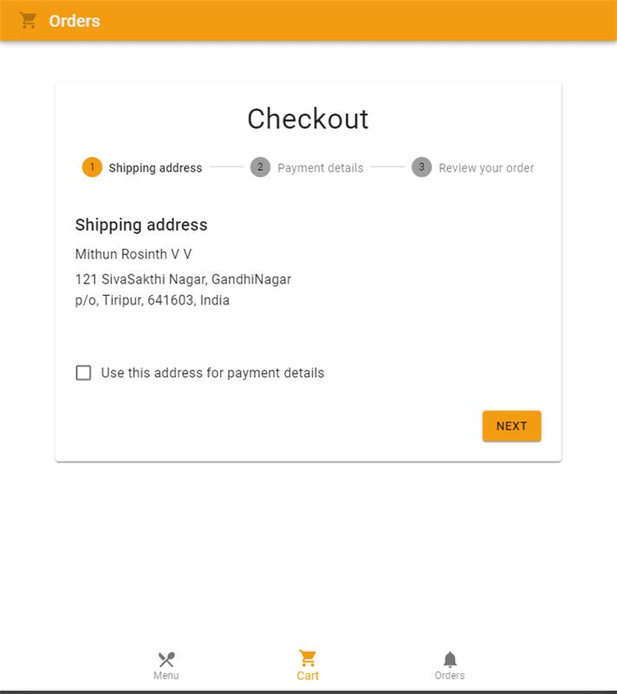

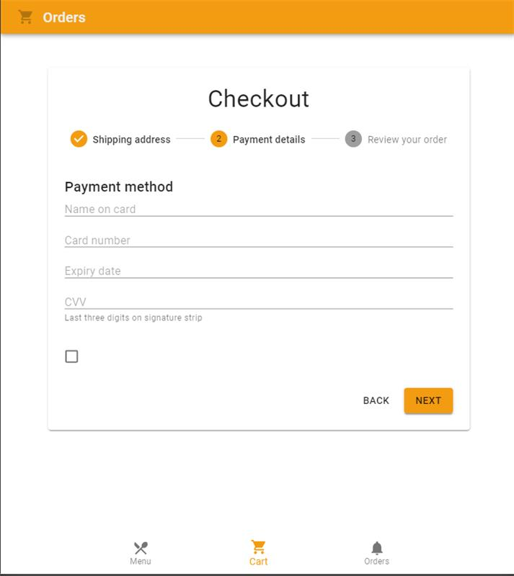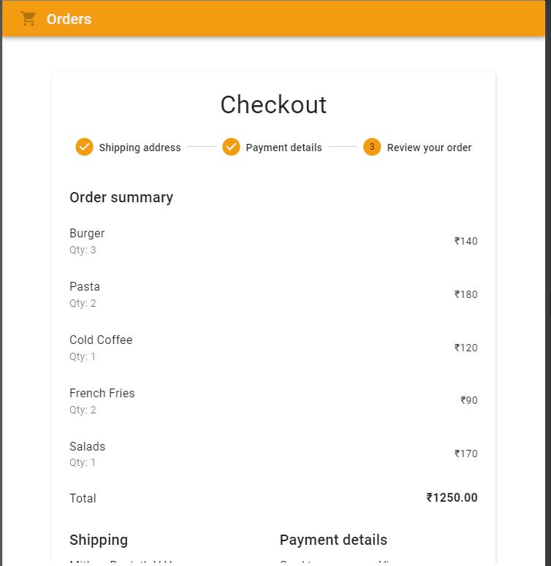

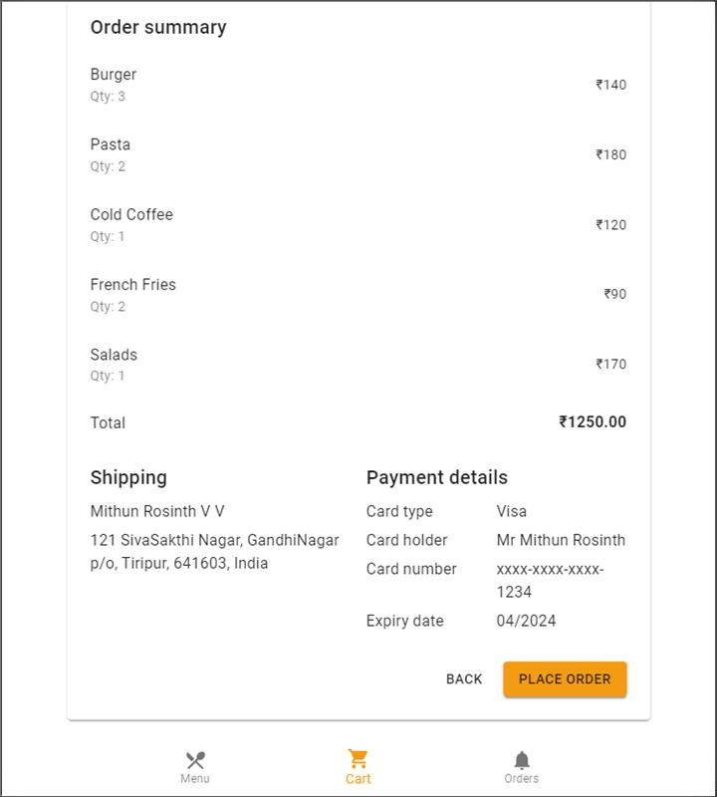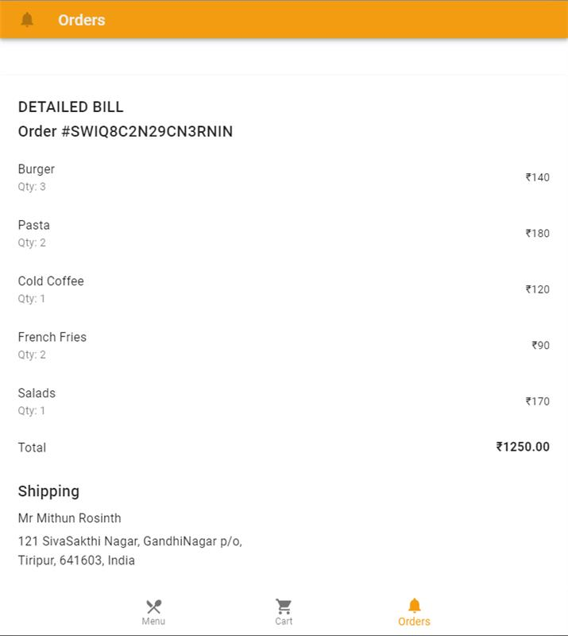

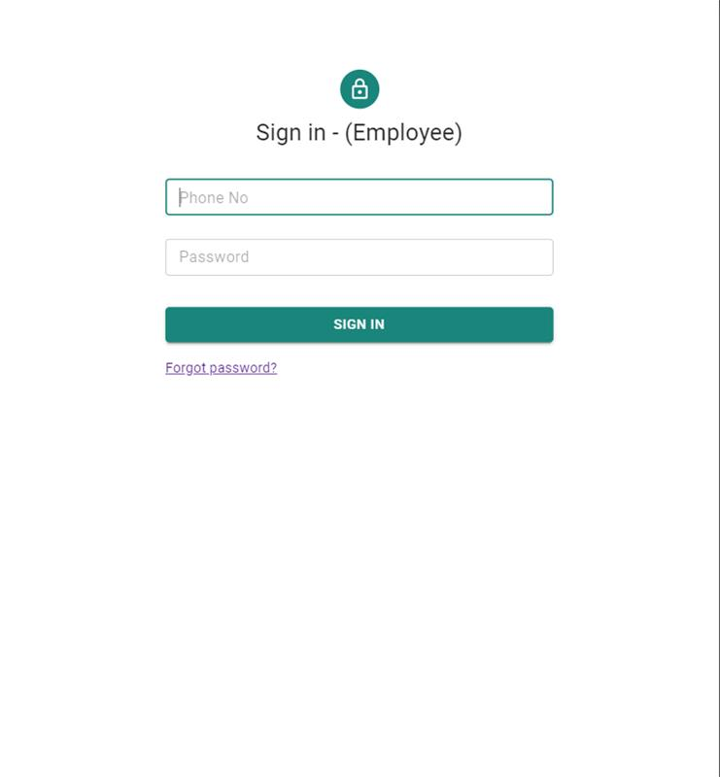

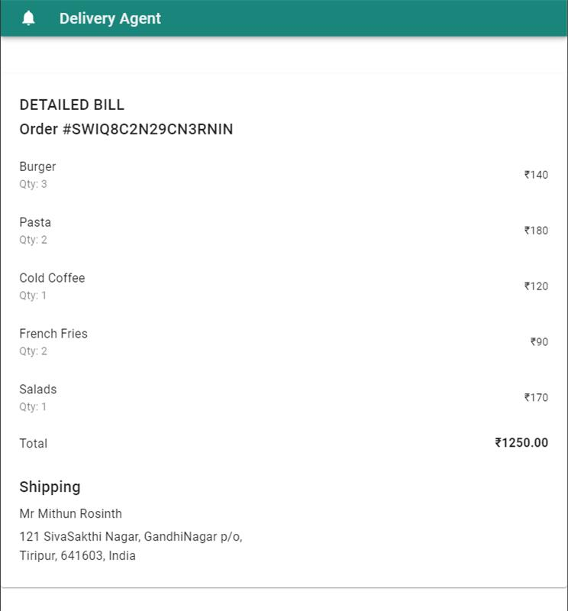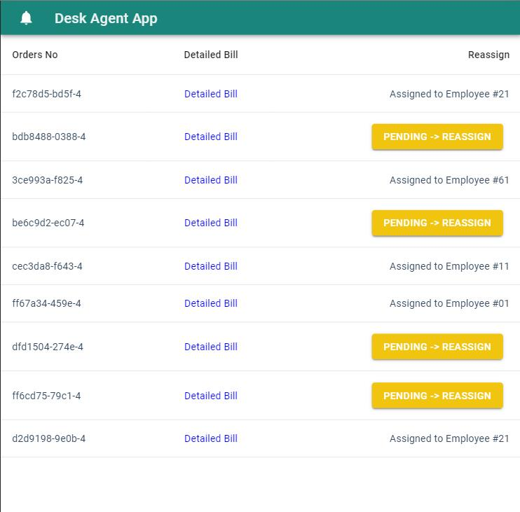

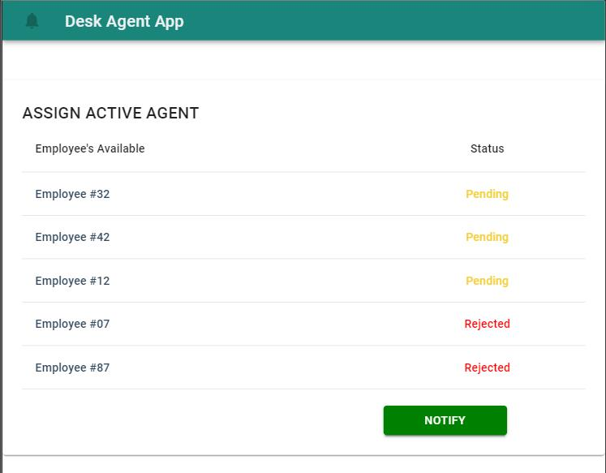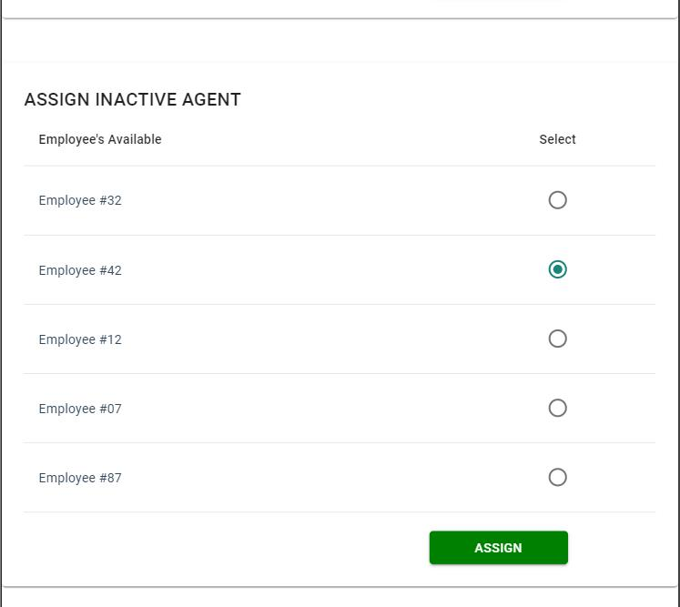

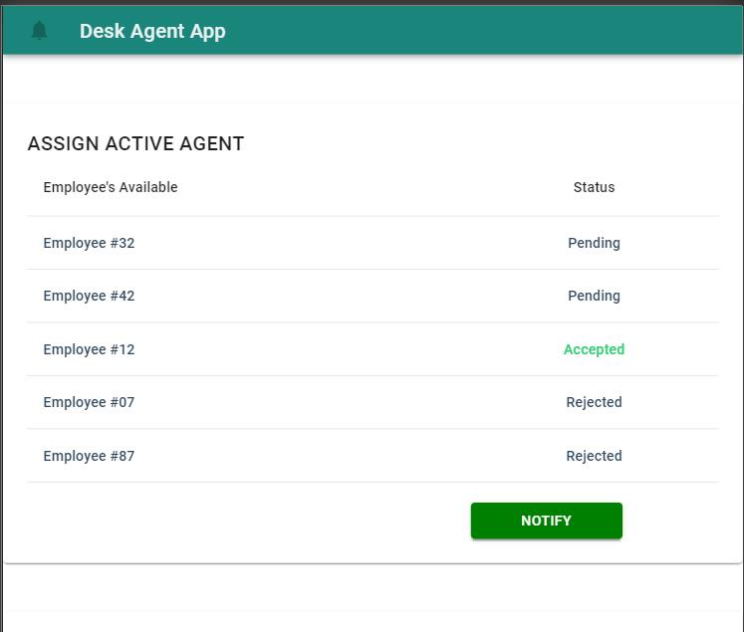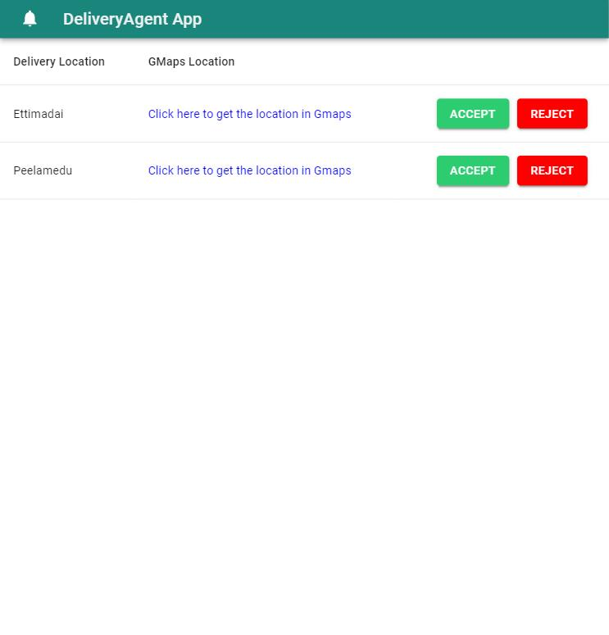

# References

**https://material-ui.com/**