**Online Food ordering System**



**BTech/III Year CSE/V Semester**

**15CSE302/Database Management Systems**

**Project Review -2**

|  |  |
| --- | --- |
| Rollno | Name |
| CB.EN.U4CSE18415 | **C.Dhanush** |
| CB.EN.U4CSE18439 | **V.V.Mithun Rosinth** |

**Amrita School of Engineering, Coimbatore**

**Department of Computer Science and Engineering**

**2020 -2021 Odd Semester**

Table of Contents

**Chapter Title Page number**

Chapter 4 Normalization 4

Chapter 5 Creation of Tables 18

Chapter 6 User Interface Design 19

References 20

**Normalization**

AttribTable(CustID,CustName,LocID,Phone.no,Cart,ItemID,DAgent,ItemPrice,TotalPrice,ItemQty,OrderID,EmpID,Phone.no,EmpName,Gender,JoinDate,Password,Desk.no,EmpID,DAgentID,DAgentName,Phone.no,Password,CurrentStatus,DeliveryID,Address,Landmark,VehicleID,Currentstatus,PaymentID,PaymentMethod,PaymentAmt,ItemName,ItemStatus)

**Fucntional Dependencies:**

CustID -> CustName,LocID,Phone.no,Cart

CustID,OrderID -> ItemID,DAgentID,ItemPrice,TotalPrice,ItemQty

EmpID -> EmpName,Phone,Gender,JoinDate, Password,Deskno,CurrentStatus,DAgentID,DAgentName

LocID -> Landmark,Address

CustID,OrderID -> PaymentID

DAgentID -> DAgentName,Password,EmpID,Phone,CurrentStatus

PaymentID -> PaymentMethod, PaymentAmt

ItemID -> ItemName,ItemPrice,ItemStatus

EmpName -> DAgentName

Phone -> Phone

Password -> Password

OrderID -> DeliveryID

DeliveryID -> DAgentID

VehicleID -> LocID

DAgentID -> LocID

**Removing Multivalued attributes:**

*The cart attribute in the Customer entity is multivalued as it contains the contents of the customer's cart

*We add Cart as a separate entity with CartID and CustID as Primary key

**Specialization:**

*The Employee entity can be specialized by splitting it into two types of employees and having unique attributes to each

*Here we split the Entities into DeskEmployee and DeliveryAgent

**1NF :**

Customer(CustID,LocID,Phone,CustName,CartNo)

Cart(CartID, CustID, ItemID, ItemQty)

Order(OrderID, DAgentID, ItemPrice, TotalPrice, ItemQty, ItemID, CustID)

Employee(Phone,EmpName,Gender,JoinDate,Password,EmpID)

DeskEmployee(Deskno,EmpID)

DeliveryAgent(EmpID,DAgentID,DAgentName,Phone,Password,CurrentStatus)

Location(LocID, Landmark, Address)

Delivery(DeliveryID,DAgentID,OrderID,LocID)

Payment(PaymentID, PaymentAmt,PaymentID, PaymentMethod,OrderID,CustID)

Menu(ItemID,ItemName,ItemPrice,ItemStatus)

Vehicle(VehicleID,LocID,CurrentStatus, DAgentID)

**Partial Dependencies:**

EmpID -> DAgentName,Phone,Password

CustID -> ItemID, ItemQty

**Removing Extraneous Attributes:**

*The attributes DAgentId, DAgentName, Password, Phone are just copies of the EmpID, EmpName, Phone,Password in the Employee table

*The Primary key DAgentID is dependent on EmpID

*So we remove all these attributes out of the table and just have EmpID and CurrentStatus in the table

**Replacing DAgentID with EmpID:**

*As the attribute DAgentID is removed from the schema we have to replace it's occurrences with EmpID

**2NF:**

Customer(CustID,LocID,Phone,CustName,CartNo)

Cart(CustID, ItemID, ItemQty)

Order(OrderID, ItemPrice, TotalPrice, ItemQty, ItemID, CustID)

Employee(Phone,EmpName,Gender,JoinDate,Password,EmpID)

DeskEmployee(Deskno,EmpID)

DeliveryAgent(EmpID,Phone,Password,CurrentStatus)

Location(LocID, Landmark, Address)

Delivery(DeliveryID,EmpID,OrderID,LocID)

Payment(PaymentID, PaymentAmt,PaymentID, PaymentMethod,OrderID,CustID)

Menu(ItemID,ItemName,ItemPrice,ItemStatus)

Vehicle(VehicleID,LocID,CurrentStatus, EmpID)

**Transitive Dependencies:**

ItemID -> ItemQty => This applies in two Entities -> Order and Cart

EmpID -> CurrentStatus => We removed the attributes and added them to new entity

OrderID -> LocID,EmpID => DeliveryID Becomes an Extraneous attribute here (Transitivity Rule)

**Changes:**

*The Primary key of Cart is now both CustID and ItemID

*New Entity named Status is added to satisfy the EmpID -> CurrentStatus dependency

*OrderID is made the Primary Key of the Delivery entity

*To satisfy the ItemID -> ItemQty in the Order entity we add a new entity named OrderItems and Add ItemID,OrderID,ItemQty,ItemPrice to the entity and make ItemID and OrderID the primary key

* Since TotalPrice can be derived from ItemQty and ItemPrice It is also removed

**3NF:**

Customer(CustID,LocID,Phone,CustName,CartNo)

Cart(CustID, ItemID, ItemQty)

Order(OrderID, CustID)

OrderItems(OrderID, ItemPrice, ItemQty, ItemID)

Employee(Phone,EmpName,Gender,JoinDate,Password,EmpID)

DeskEmployee(Deskno,EmpID)

DeliveryAgent(EmpID,Phone,Password,CurrentStatus)

Location(LocID, Landmark, Address)

Delivery(EmpID,OrderID,LocID)

Payment(PaymentID, PaymentAmt,PaymentID, PaymentMethod,OrderID,CustID)

Menu(ItemID,ItemName,ItemPrice,ItemStatus)

Vehicle(VehicleID,LocID)

Status(CurrentStatus, EmpID)

**Dependencies not satisfying BCNF:**

OrderID -> PaymentID => in Payment entity

**Changes:**

*We added PaymentID as an attribute to the Order entity and removed OrderID and CustID from Payment entity

*Since the Dependencies satisfied by the status table is already satisfied by the DeliveryAgent entity, we remove the Status entity

**Dependency Diagram:**

CustID -> CustName,LocID,Phone.no,Cart

CustID,OrderID -> ItemID,ItemPrice,ItemQty

EmpID -> EmpName,Phone,Gender,JoinDate, Password,Deskno,CurrentStatus

LocID -> Landmark,Address

CustID,OrderID -> PaymentID

PaymentID -> PaymentMethod, PaymentAmt

ItemID -> ItemName,ItemPrice,ItemStatus

DeliveryID -> EmpID

VehicleID -> LocID

EmpID -> LocID

OrderID -> PaymentID

ItemID -> ItemQty

EmpID -> CurrentStatus

OrderID -> LocID,EmpID

CustID -> ItemID, ItemQty

**\*All the Dependencies are preserved and even after removing the Extraneous attributes the schema and dependencies are intact**

**Table Records Creation**

create table Menu(ItemID number(3) NOT NULL, ItemPrice number(3,2) NOT NULL, ItemName varchar(60) NOT NULL, Item_Status varchar(5), primary key(ItemID));

create table Location(LocID number(3) NOT NULL, Address varchar(100) NOT NULL, Landmarks varchar(25), primary key(LocID));

create table Employee(EmpID number(3) NOT NULL, EmpName varchar(15) NOT NULL, Phone number(10) NOT NULL, Gender char(1), Joindate date NOT NULL, Password varchar(20) NOT NULL, primary key(EmpID));

create table Customer(CustID number(3) NOT NULL,CustName varchar(15) NOT NULL, LocID number(3) NOT NULL, Phone_no number(10) NOT NULL, primary key (CustID), foreign key(LocID) references Location);

create table Cart(CustID number(3) NOT NULL, ItemID number(3) NOT NULL, Quantity number(2) NOT NULL, primary key(CustID,ItemID), foreign key(ItemID) references Menu, foreign key(CustID) references Customer);

create table Vehicle(VehicleID number(2) NOT NULL, LocID number(3), Status varchar(7), primary key(VehicleID), foreign key(LocID) references Location);

create table Delivery_Agent(EmpID number(3) NOT NULL,CurrentStatus varchar(5) NOT NULL, VehicleID number(2), primary key(EmpID), foreign key (EmpID) references Employee);

create table Desk_Employee(EmpID number(3) NOT NULL, Desk_No number(2) NOT NULL, primary key(EmpID), foreign key (EmpID) references Employee);

create table Payment(PaymentID number(5) NOT NULL, Payment_method varchar(5) NOT NULL, Payment_Amt number(7,2) NOT NULL, primary key(PaymentID));

create table OrderDetails(CustID number(3) NOT NULL,OrderID number(5) NOT NULL, PaymentID number(5) NOT NULL, OrderTimeStamp TIMESTAMP NOT NULL, primary key(OrderID), foreign key(CustID) references Customer, foreign key(PaymentID) references Payment);

create table OrderItems(OrderID number(5) NOT NULL, ItemID number(3) NOT NULL, ItemPrice number(3,2) NOT NULL, Quantity number(2) NOT NULL, primary key(OrderID,ItemID), foreign key(OrderID) references OrderDetails, foreign key(ItemID) references Menu);

create table Delivers(EmpID number(3) NOT NULL, LocID number(3) NOT NULL, OrderID number(5) NOT NULL,foreign key (EmpID) references Employee, foreign key(LocID) references Location, foreign key(OrderID) references OrderDetails, primary key(OrderID));

insert into Menu values(601, 200, 'Reg.Pizza','avl');

insert into Menu values(602, 300, 'Med.Pizza','avl');

insert into Menu values(603, 450, 'Lar.Pizza','avl');

insert into Menu values(604, 175, 'Rice Bowl','avl');

insert into Menu values(605, 350, 'Grill Chicken','avl');

insert into Menu values(606, 460, 'Cheese Grill Chicken','avl');

insert into Menu values(607, 125, 'Chicken Biryani','avl');

insert into Menu values(608, 225, 'Lollypop Chicken','avl');

insert into Menu values(609, 250, '1KG Black Forest','avl');

insert into Menu values(610, 135, '0.5KG Black Forest','avl');

insert into Location values(201, '121 Sivasakthi Nagar' , 'Arun Icecream Parlour');

insert into Location values(202, '11 KPN Nagar' , 'Black and white Saloon');

insert into Location values(203, '140 Kumar Nagar' , 'Dominos Pizza');

insert into Location values(204, '34/9 Gandhi Nagar' , 'Apple service Center');

insert into Location values(205, '1 Park Avenue' , 'Arasan Arisi Mandi');

insert into Location values(206, '13 Prime Appartments' , 'Balaji Electrical Shop');

insert into Location values(207, '121/45 Vivekanadhar Colony' , 'Supreme Mobiles');

insert into Location values(208, '134/18 Golden Nagar' , 'Vasanth And Co');

insert into Location values(209, '48 Brindhavan Nagar' , 'Gandhi Park');

insert into Location values(210, '59 Karupurayan Colony' , 'Stadium Sports Corner');

insert into Employee values(301, 'Kunal', 8907680243, 'M', '19-07-2010', 'Ironmanrocks24');

insert into Employee values(302, 'Sejal', 8956750243, 'F', '1-06-2008', 'Crystalpal13');

insert into Employee values(303, 'Harry', 7307683243, 'M', '13-03-2009', 'Engineer101');

insert into Employee values(304, 'Simran', 7907685243, 'F', '23-05-2010', 'SimplePassword');

insert into Employee values(305, 'Grace', 8907680243, 'F', '29-07-2011', 'Greatday1234');

insert into Employee values(306, 'Karthi', 8907680243, 'M', '9-05-2009', 'MySecurePassword12');

insert into Employee values(307, 'Jai', 8779023243, 'M', '30-08-2009', 'Panther23434');

insert into Employee values(308, 'Sandy', 8457367243, 'M', '21-07-2010', 'Hacker12345');

insert into Employee values(309, 'Siva', 7786890003, 'M', '10-09-2010', 'Uncrackable123');

insert into Employee values(310, 'Sheela', 8212380243, 'F', '11-07-2012', 'Jarvisisgreat1908');

insert into Customer values(101, 'Mithun', 201, 9294029977);

insert into Customer values(102, 'Dhanush', 202, 9924029971);

insert into Customer values(103, 'Vicky', 203, 9993027972);

insert into Customer values(104, 'Rohit' , 204, 9934029673);

insert into Customer values(105, 'Dinesh' , 205, 9944022974);

insert into Customer values(106, 'Gireesh' , 206, 9994042975);

insert into Customer values(107, 'Giri' , 207, 9994029276);

insert into Customer values(108, 'Sai' , 208, 9994629178);

insert into Customer values(109, 'Gokul' , 209, 9994729379);

insert into Customer values(110, 'Marry' , 210, 9994021370);

insert into Cart values(101,NULL,NULL);

insert into Cart values(102,NULL,NULL);

insert into Cart values(103,NULL,NULL);

insert into Cart values(104,NULL,NULL);

insert into Cart values(105,NULL,NULL);

insert into Cart values(106,NULL,NULL);

insert into Cart values(107,NULL,NULL);

insert into Cart values(108,NULL,NULL);

insert into Cart values(109,NULL,NULL);

insert into Cart values(110,NULL,NULL);

insert into Vehicle values(901, 201);

insert into Vehicle values(902, 203);

insert into Vehicle values(903, NULL);

insert into Vehicle values(904, NULL);

insert into Vehicle values(905, NULL);

insert into Vehicle values(906, 206);

insert into Vehicle values(907, 202);

insert into Vehicle values(908, NULL);

insert into Vehicle values(909, NULL);

insert into Vehicle values(910, 208);

insert into Delivery_Agent values(301,'N/A',901);

insert into Delivery_Agent values(302,'avl',0);

insert into Delivery_Agent values(304,'N/A',902);

insert into Delivery_Agent values(305,'N/A',906);

insert into Delivery_Agent values(306,'N/A',907);

insert into Delivery_Agent values(307,'N/A',909);

insert into Desk_Employee values(303,11);

insert into Desk_Employee values(308,12);

insert into Desk_Employee values(309,13);

insert into Desk_Employee values(310,14);

insert into Payment(701,'Card',973.5);

insert into Payment(702,'UPI',708);

insert into Payment(703,'COD',442.5);

insert into Payment(704,'UPI',896.5);

insert into Payment(705,'COD',560.5);

insert into Payment(706,'Card',619.5);

insert into Payment(707,'UPI',236);

insert into Payment(708,'Card',354);

insert into Payment(709,'UPI',531);

insert into Payment(710,'COD',236);

insert into Payment(711,'Card',413);

insert into Payment(712,'COD',572.3);

insert into OrderDetails values(101,401,701,'2010-01-01 00:00:01');

insert into OrderDetails values(101,402,702,'2011-01-01 00:00:01');

insert into OrderDetails values(103,403,703,'2010-01-01 00:00:01');

insert into OrderDetails values(105,404,704,'2012-01-01 00:00:01');

insert into OrderDetails values(106,405,705,'2013-01-01 00:00:01');

insert into OrderDetails values(106,406,706,'2010-01-01 00:00:01');

insert into OrderDetails values(104,407,707,'2012-01-01 00:00:01');

insert into OrderDetails values(107,408,708,'2016-01-01 00:00:01');

insert into OrderDetails values(107,409,709,'2018-01-01 00:00:01');

insert into OrderDetails values(108,410,710,'2011-01-01 00:00:01');

insert into OrderDetails values(108,411,711,'2012-01-01 00:00:01');

insert into OrderDetails values(103,412,712,'2013-01-01 00:00:01');

insert into OrderItems values(401,601,200,1);

insert into OrderItems values(401,603,450,1);

insert into OrderItems values(401,604,175,1);

insert into OrderItems values(402,602,300,2);

insert into OrderItems values(403,607,125,3);

insert into OrderItems values(404,602,300,1);

insert into OrderItems values(404,606,460,1);

insert into OrderItems values(405,608,225,1);

insert into OrderItems values(405,609,250,1);

insert into OrderItems values(406,607,125,1);

insert into OrderItems values(406,608,225,1);

insert into OrderItems values(406,604,175,1);

insert into OrderItems values(407,601,200,1);

insert into OrderItems values(408,602,300,1);

insert into OrderItems values(409,603,450,1);

insert into OrderItems values(410,601,200,1);

insert into OrderItems values(411,605,350,1);

insert into OrderItems values(412,605,350,1);

insert into OrderItems values(412,610,135,1);

insert into Delivers values(301,201,401);

insert into Delivers values(304,203,402);

insert into Delivers values(305,206,403);

insert into Delivers values(306,202,404);

insert into Delivers values(307,208,405);

**Table Screenshots:**

Menu

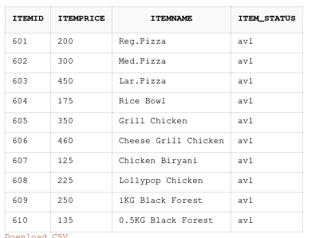

Location

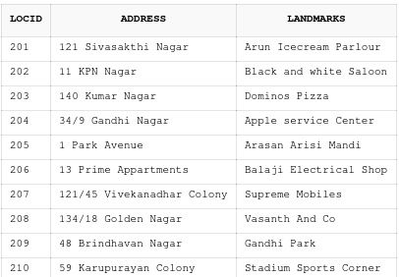

Employee

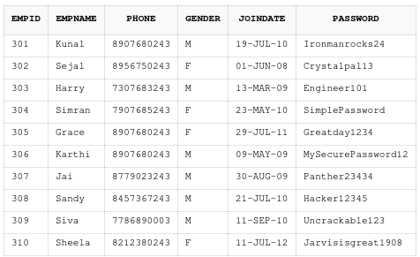

Customer

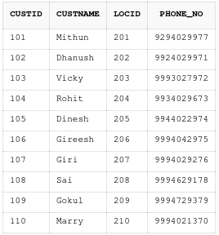

Cart

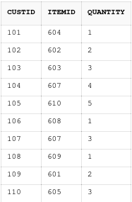

Vehicle

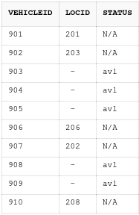

Delivery_Agent

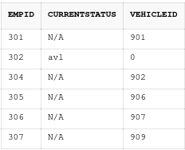

Desk_Employee

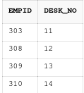

Payment

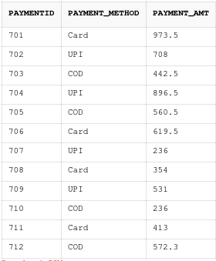

OrderDetails

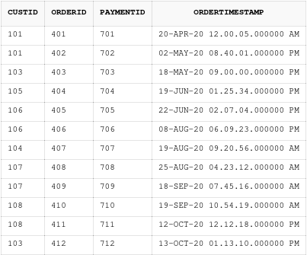

OrderItems

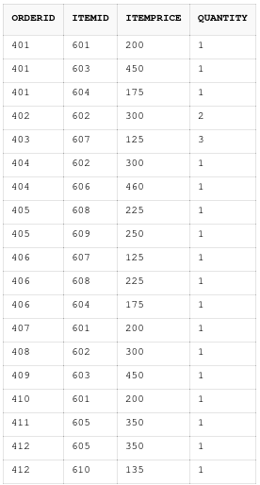

Delivers



**UI Screenshots:**

