1. System Architecture

Overview
The proposed Smart Waste Bin Network is an IoT-enabled waste management system designed to monitor garbage fill levels in real time, notify authorities before overflow, and optimize waste collection routes using data analysis and prediction techniques. The system follows an end-to-end IoT architecture consisting of sensing, processing, communication, cloud computing, and visualization layers.
Hardware Components
Sensor:
An ultrasonic sensor is mounted at the top of each waste bin to measure the distance between the sensor and the garbage surface. This distance is converted into a percentage fill level based on the total depth of the bin.

Microcontroller:
An ESP32 microcontroller is used to interface with the ultrasonic sensor. It performs local processing, data formatting, and wireless transmission. ESP32 is selected due to its low power consumption, integrated communication support, and suitability for IoT applications.
Communication Method:
For city-wide deployment, LoRa (Long Range communication) is proposed due to its:
- Long communication range
- Low power consumption
- Suitability for battery-operated devices
Alternatively, Wi-Fi or NB-IoT can be used for smaller or infrastructure-rich areas.
Cloud & Computing Strategy:
All bin data is transmitted to a cloud platform such as AWS IoT, Firebase, or ThingsBoard. The cloud performs:
- Data storage
- Threshold-based alert generation
- Historical data analysis
- Prediction of future bin fill levels
Edge processing is limited to basic filtering, while analytics and prediction are handled centrally.
Dashboard & Visualization
A web-based dashboard is provided for municipal authorities. It displays:
- Real-time bin fill levels
- Alert notifications
- Zone-wise bin status`
- Map-based visualization for route planning
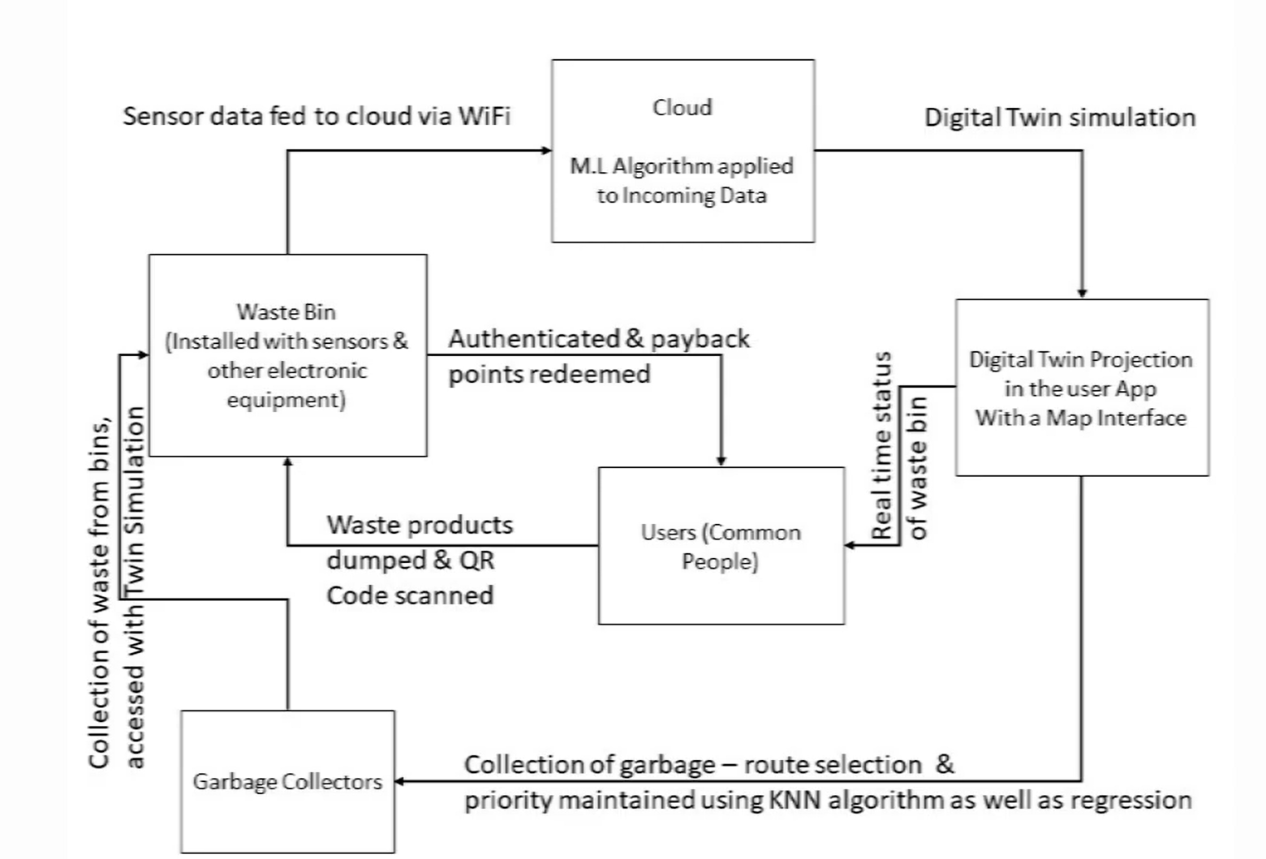
- Data Flow Design
The data flow design ensures continuous monitoring, intelligent prioritization, optimized route planning, and real-time status updates for smart waste management.
The system continuously monitors the fill level of waste bins using ultrasonic sensors installed in each bin.

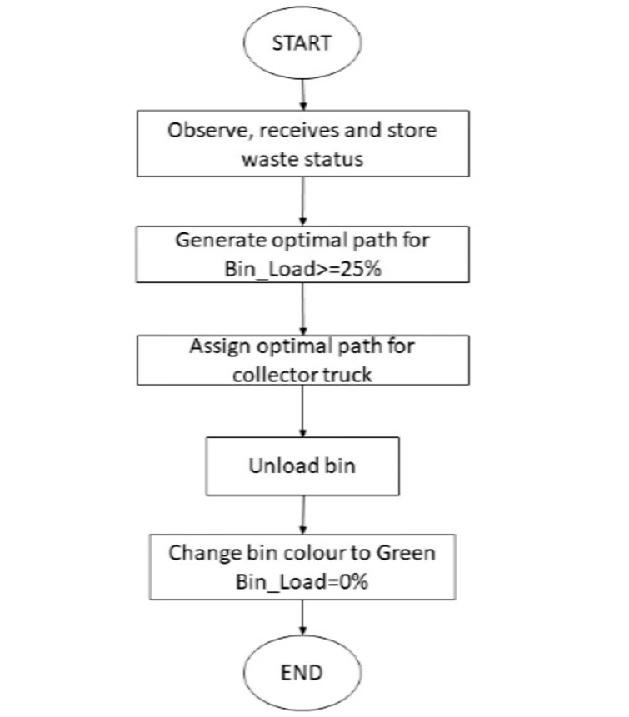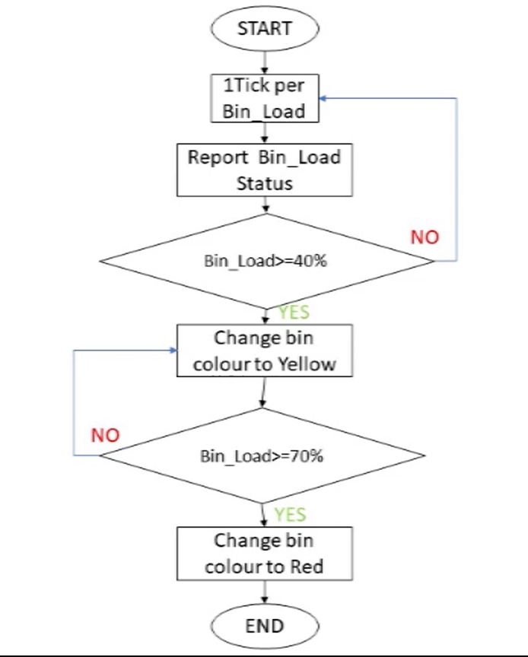
The data flow design ensures continuous monitoring, intelligent prioritization, optimized route planning, and real-time status updates for smart waste management.
The system continuously monitors the fill level of waste bins using ultrasonic sensors installed in each bin.
- Sensor data is processed locally by the ESP32 microcontroller and transmitted periodically to the cloud platform.
- The received data is stored in the cloud as both real-time and historical information for further analysis.
- Based on predefined thresholds, the system classifies bin status using color indicators:
Green for low fill level
Yellow for moderate fill level
Red for high fill level requiring immediate attention
Bins with a minimum fill level (≥25%) are selected for waste collection planning.
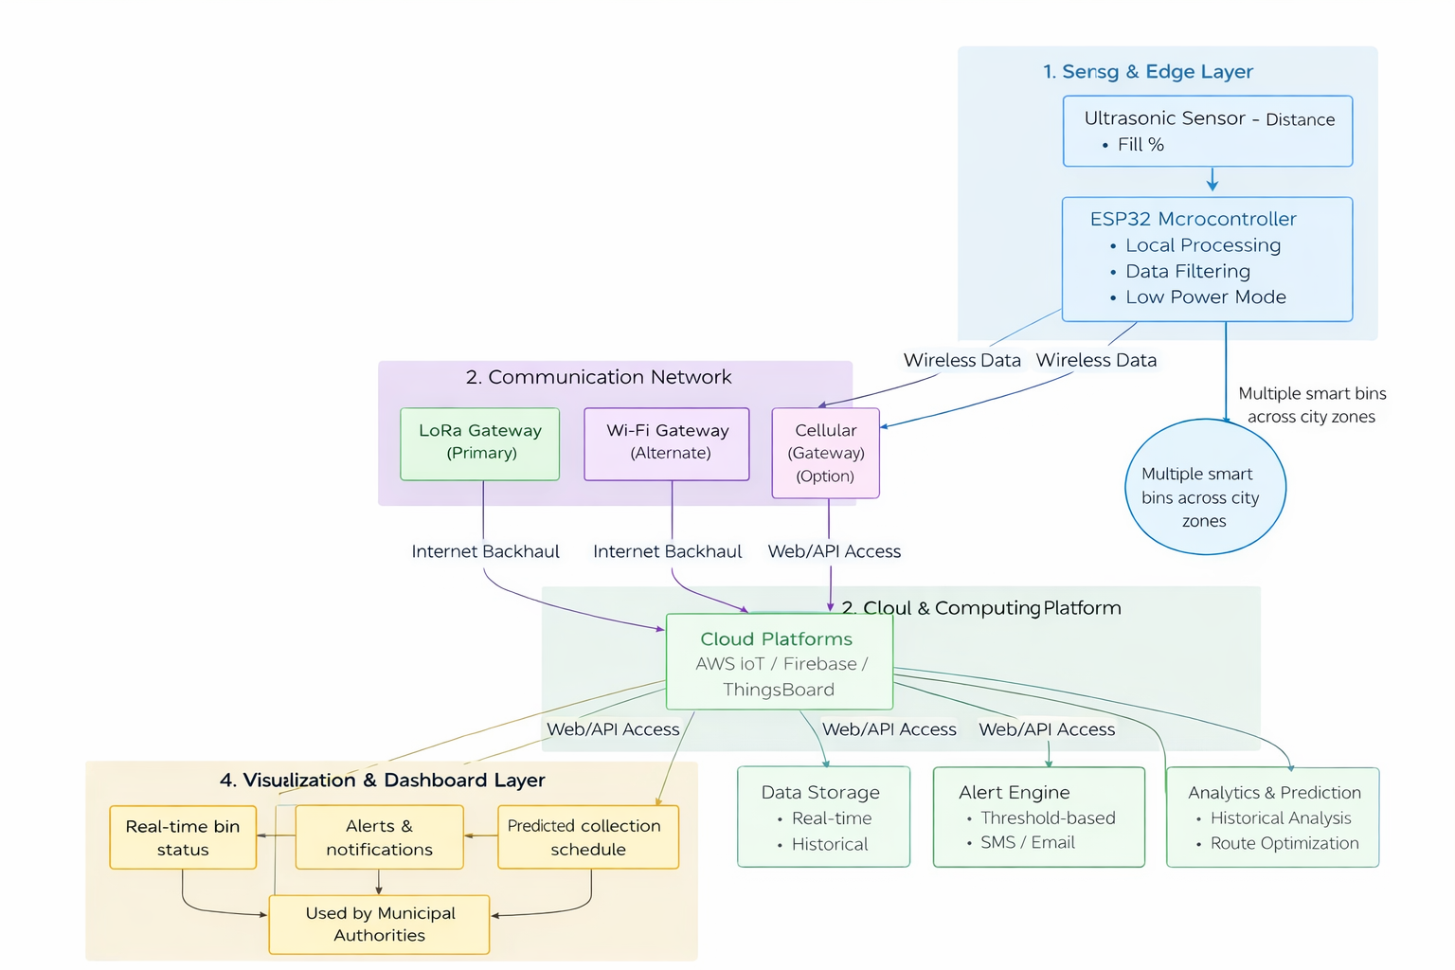The system generates optimized collection routes by grouping nearby bins that require service.The optimized route is assigned to the garbage collection truck to minimize travel distance and fuel consumption.After waste collection, bin fill levels are reset to zero and their status is updated in the system.The updated bin status is reflected on the dashboard for monitoring by municipal authorities.The entire data flow operates continuously to ensure efficient, scalable, and timely waste management.
In the Smart Waste Bin Network, reliable and efficient communication is required between smart bins, cloud servers, and user dashboards. The following protocols are identified and used based on system requirements such as low power consumption, scalability, and real-time updates.
1. MQTT (Message Queuing Telemetry Transport)
Where it is used:
- Between Smart Bins (ESP32) and the Cloud Platform
- For sending bin fill-level data and receiving control messages
Why MQTT is suitable:
- Lightweight protocol, ideal for low-power IoT devices
- Uses publish–subscribe model, enabling easy scalability for thousands of bins
- Requires very low bandwidth, perfect for LoRa, NB-IoT, and unstable networks
- Supports QoS (Quality of Service) ensuring reliable message delivery
- Faster than HTTP for frequent sensor updates
Example use case:
- ESP32 publishes bin fill percentage to the cloud
- Cloud subscribes to the topic and triggers alerts or analytics

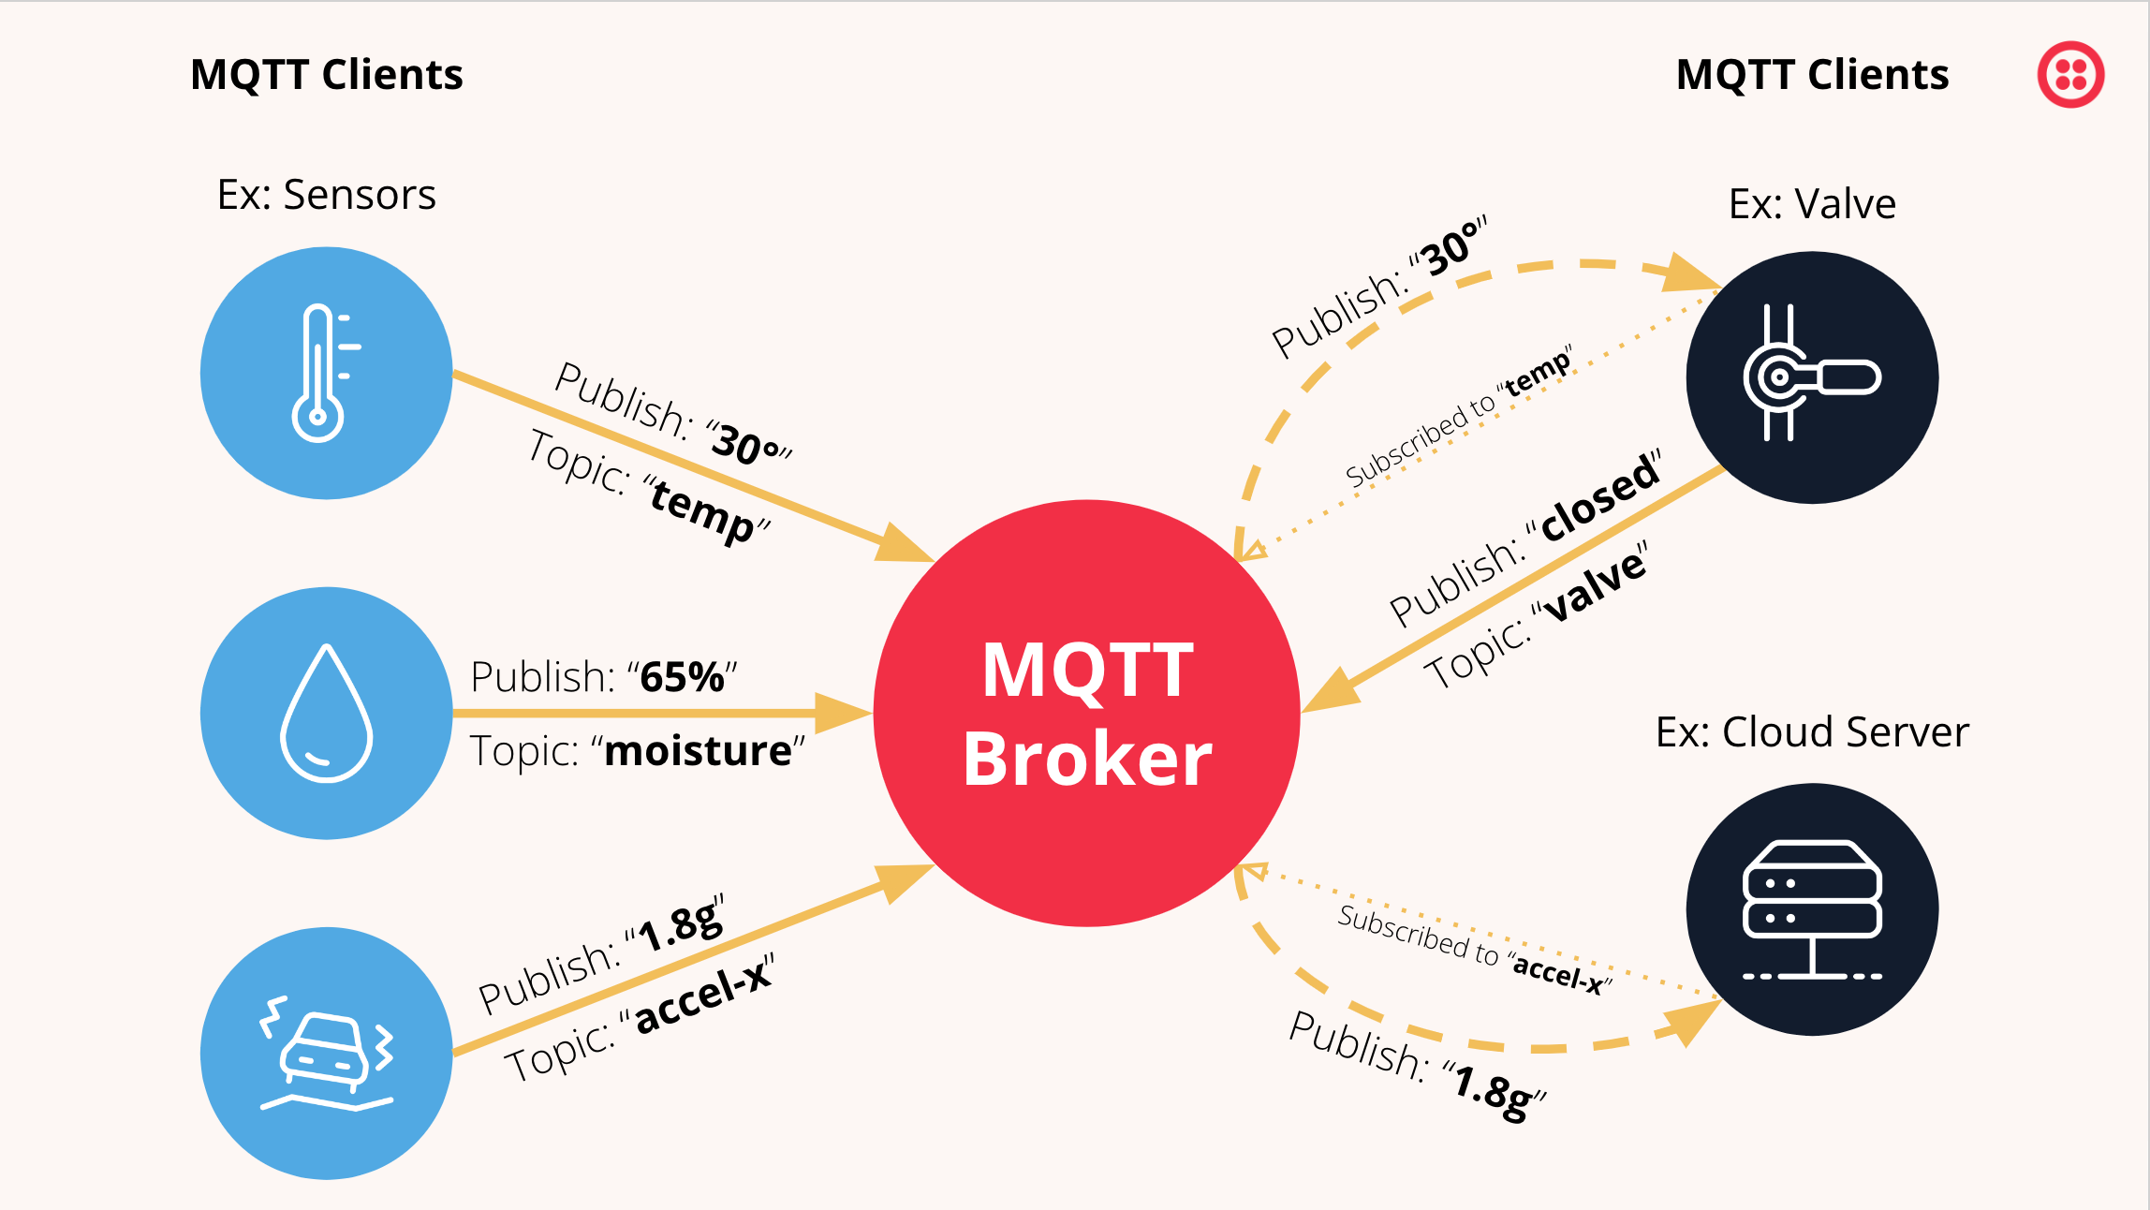
2. HTTP / HTTPS
Where it is used:
- Between Cloud Platform and Web Dashboard / Mobile App
- For fetching reports, visualizations, and system configuration
Why HTTP is suitable:
- Widely supported and easy to implement
- Ideal for request–response communication
- Works well with REST APIs for dashboards and admin panels
- HTTPS ensures secure data transmission
Example use case:
Municipal authority logs in and requests real-time bin status
Dashboard retrieves data via HTTP API
3. Route Optimization Strategy

Rule-Based Collection Logic
Initially, a rule-based strategy is applied:
- If bin fill level exceeds 80%, it is marked as high priority
- Alerts are sent to the dashboard
- These bins are added to the collection schedule
Predictive & Data-Driven Optimization (Scalability Enhancement)
To improve efficiency and scalability, the system incorporates data analysis and prediction. Historical fill-level data is analyzed to learn waste accumulation patterns in different areas.
For example:
- A commercial area bin may reach 80% in 2 days
- A residential area bin may take 4–5 days
Using this information, the system predicts future fill levels and schedules garbage collection before overflow occurs.

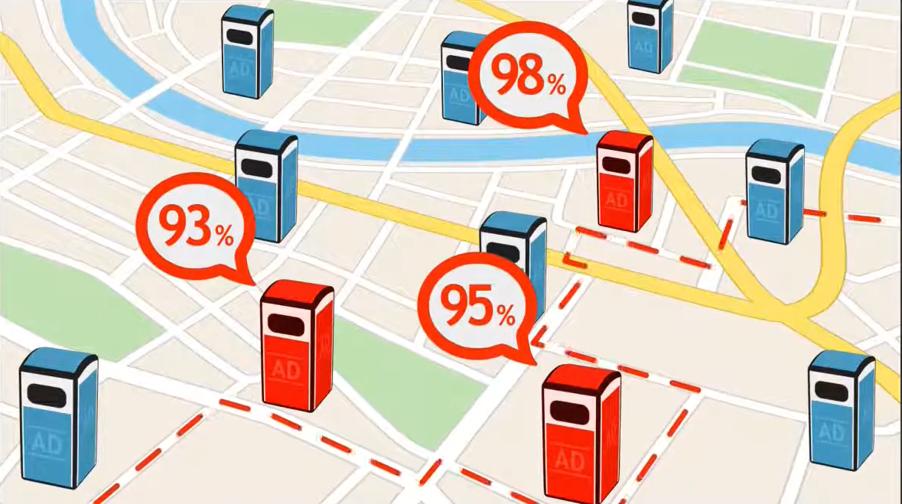

Route Planning Approach
- Bins predicted to reach critical levels soon are grouped.
- Nearby bins are clustered zone-wise.
- Shortest and most efficient route is suggested for garbage trucks.
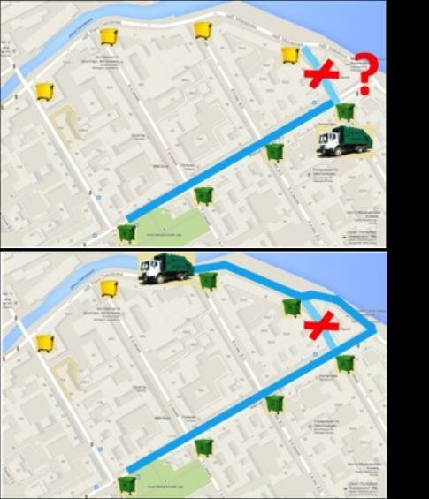
This predictive planning minimizes emergency trips and improves operational efficiency.

4. Power Management Plan
Since waste bins are often battery-powered, power efficiency is a key design consideration.

Power Optimization Techniques:
- Periodic sensing instead of continuous sensing
- ESP32 operates in deep sleep mode
- Low-power communication using LoRa
- Optional solar charging for extended deployment
These measures significantly increase battery life and reduce maintenance requirements.

5. Reliability & Fault Handling

Possible Issues:
- Sensor blockage due to plastic or waste
- False readings caused by uneven garbage surface
- Communication failures
Fault Handling Mechanisms:
- Multiple sensor readings are averaged
- Sudden abnormal readings are flagged
- Periodic calibration during maintenance
- Manual verification alerts for inconsistent data
These techniques improve data reliability and system robustness.
6. Scalability & Network Considerations
The system is designed to support 100+ bins across multiple zones.

Network Topology:
- Star topology is used
- Multiple bins connect to a central LoRa gateway
Scalability Benefits:
- Easy addition of new bins
- Zone-wise expansion
- Centralized monitoring and control
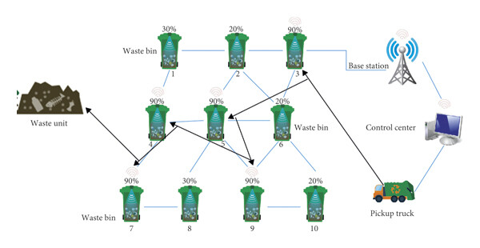

Predictive analytics further enhances scalability by reducing system load and optimizing resource usage.

7. Cost & Feasibility Discussion
Component | Approx. Cost (INR)
Ultrasonic Sensor | 150
ESP32 | 400
LoRa Module | 600
Battery & Enclosure | 350
Total | 1500–2000 INR

Trade-Off Analysis:
- Higher accuracy sensors increase cost
- LoRa has higher initial cost but lower operational expense
- Predictive analytics reduces long-term fuel and manpower costs
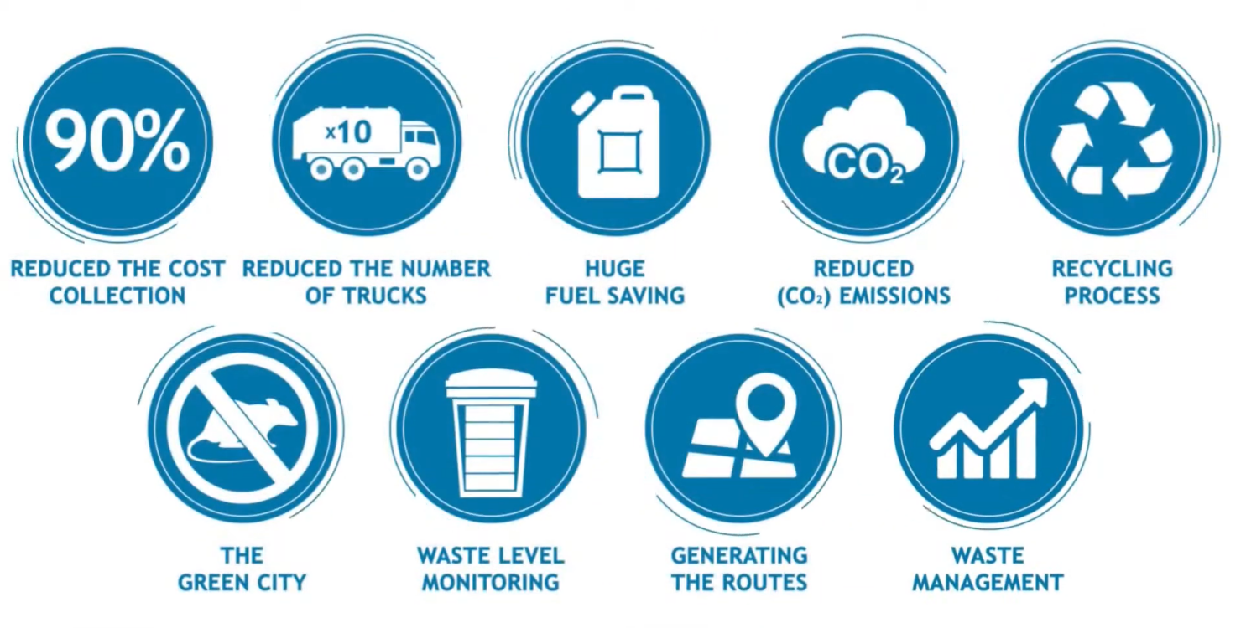Overall, the system is cost-effective, scalable, and feasible for smart city deployment.

