**Exercise 1: Control Structures**

**Scenario 1:**

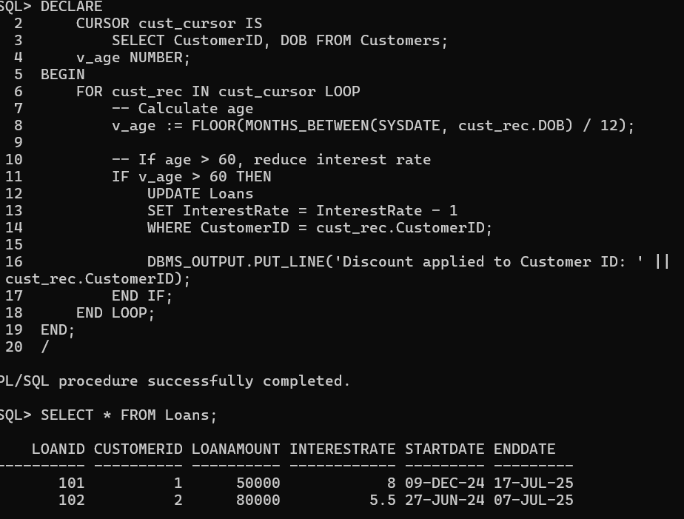

**Scenario 2:**

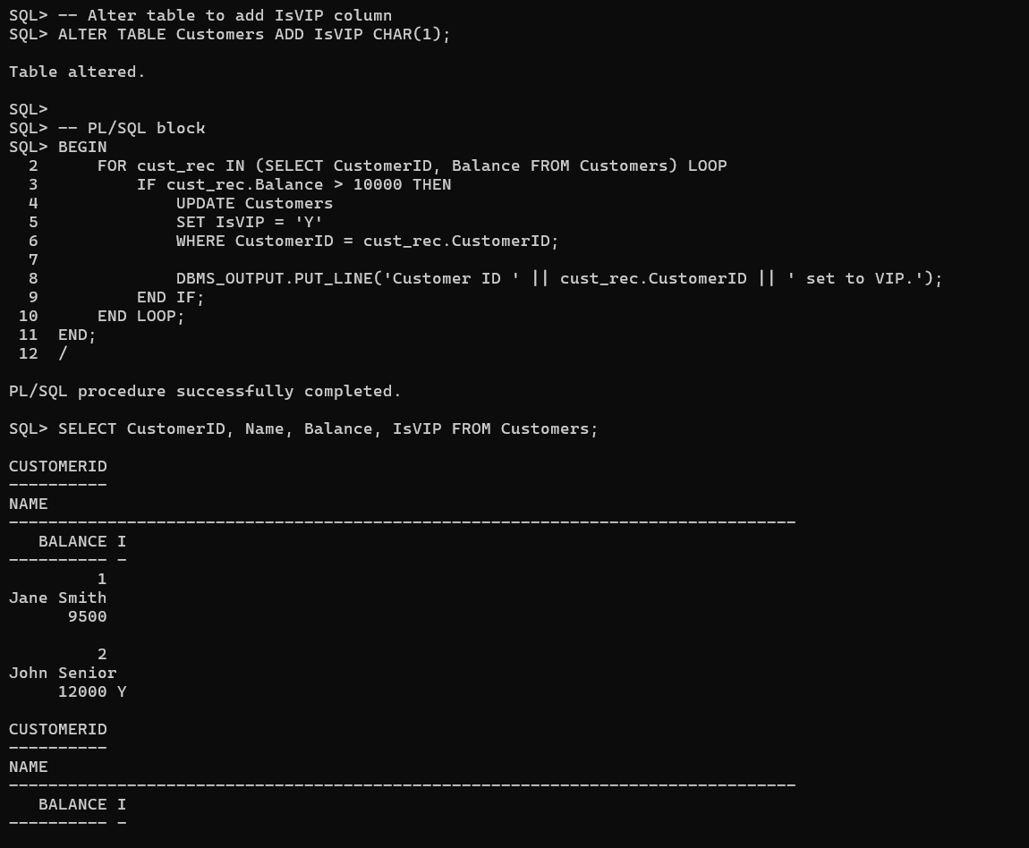

**Scenario 3:**

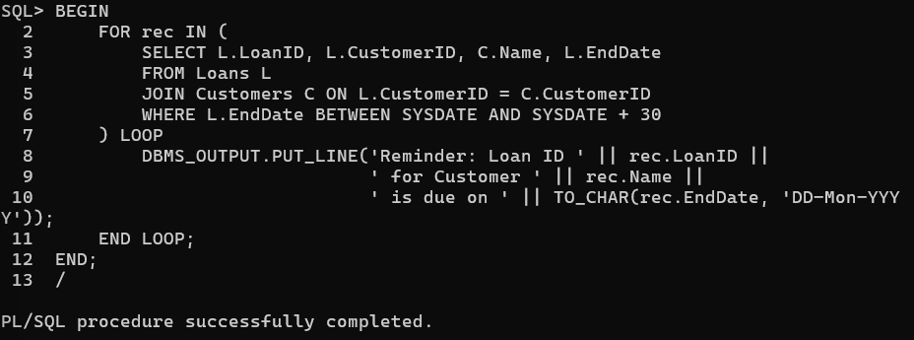

**Exercise 2: Error Handling**

**Scenario 1:**

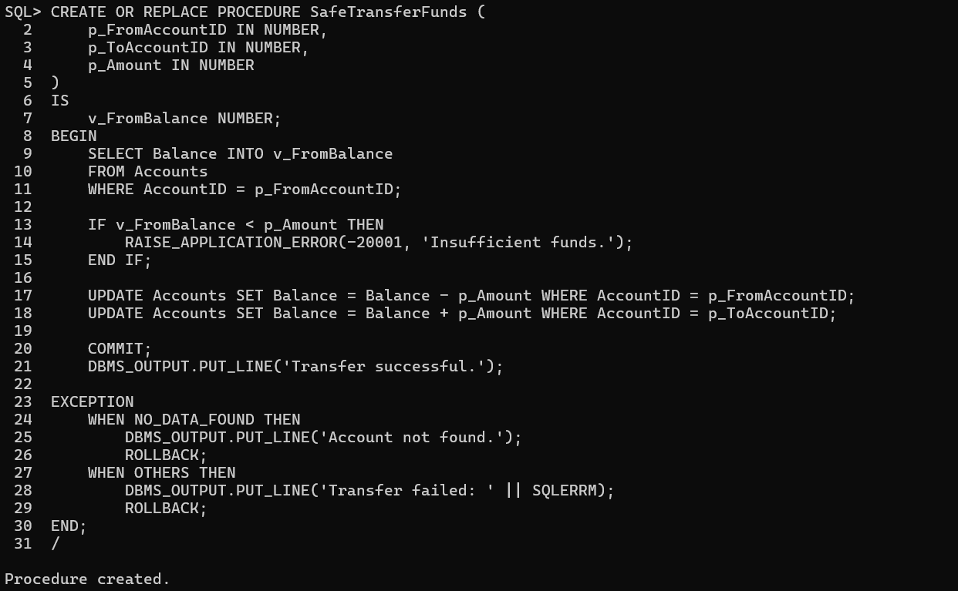

**Scenario 2:**

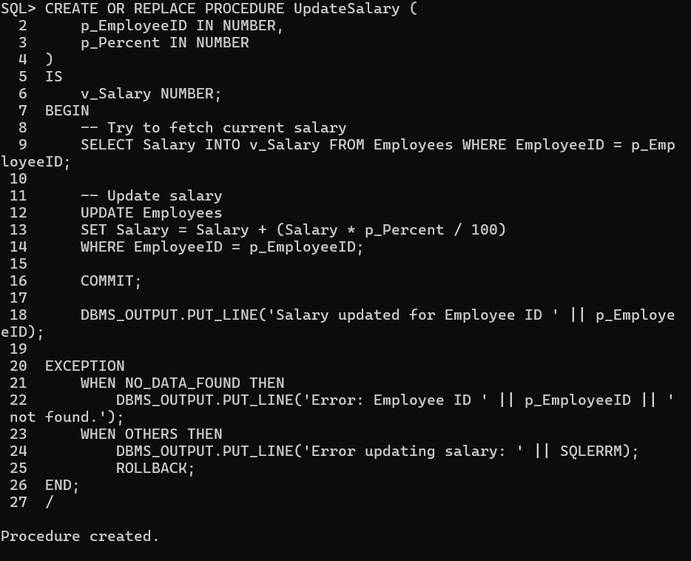

**Scenario 3:**

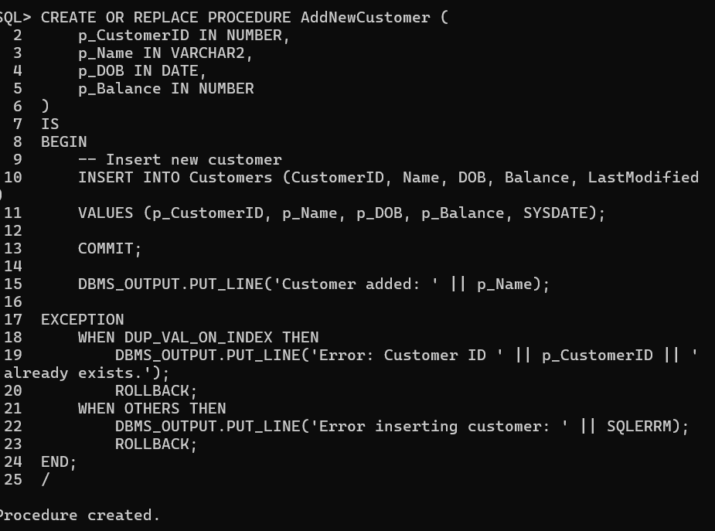

**Exercise 3: Stored Procedures**

**Scenario 1:**

CREATE OR REPLACE PROCEDURE ProcessMonthlyInterest

IS

CURSOR savings_cursor IS

SELECT AccountID, Balance FROM Accounts

WHERE AccountType = 'Savings';

v_new_balance NUMBER;

BEGIN

FOR acc IN savings_cursor LOOP

v_new_balance := acc.Balance + (acc.Balance * 0.01);

UPDATE Accounts

SET Balance = v_new_balance,

LastModified = SYSDATE

WHERE AccountID = acc.AccountID;

DBMS_OUTPUT.PUT_LINE('Interest applied to Account ID ' || acc.AccountID ||

': New Balance = ' || v_new_balance);

END LOOP;

COMMIT;

END;

/

**OUTPUT:**

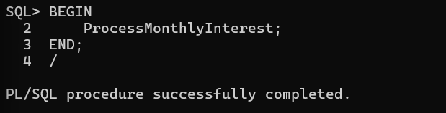

**Scenario 2:**

CREATE OR REPLACE PROCEDURE UpdateEmployeeBonus (

p_Department IN VARCHAR2,

p_BonusPercent IN NUMBER

)

IS

CURSOR emp_cursor IS

SELECT EmployeeID, Salary FROM Employees

WHERE Department = p_Department;

v_bonus_salary NUMBER;

BEGIN

FOR emp IN emp_cursor LOOP

v_bonus_salary := emp.Salary + (emp.Salary * p_BonusPercent / 100);

UPDATE Employees

SET Salary = v_bonus_salary

WHERE EmployeeID = emp.EmployeeID;

DBMS_OUTPUT.PUT_LINE('Bonus applied to Employee ID ' || emp.EmployeeID ||

': New Salary = ' || v_bonus_salary);

END LOOP;

COMMIT;

END;

/

**OUTPUT:**

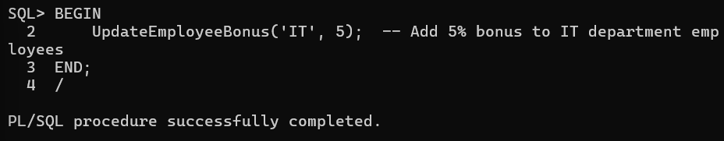

**Scenario 3:**

CREATE OR REPLACE PROCEDURE TransferFunds (

p_FromAccountID IN NUMBER,

p_ToAccountID IN NUMBER,

p_Amount IN NUMBER

)

IS

v_balance NUMBER;

BEGIN

-- Check if source account has enough funds

SELECT Balance INTO v_balance FROM Accounts

WHERE AccountID = p_FromAccountID;

IF v_balance < p_Amount THEN

RAISE_APPLICATION_ERROR(-20001, 'Insufficient balance in source account.');

END IF;

-- Perform transfer

UPDATE Accounts

SET Balance = Balance - p_Amount,

LastModified = SYSDATE

WHERE AccountID = p_FromAccountID;

UPDATE Accounts

SET Balance = Balance + p_Amount,

LastModified = SYSDATE

WHERE AccountID = p_ToAccountID;

COMMIT;

DBMS_OUTPUT.PUT_LINE('Transfer of ' || p_Amount ||

' completed from Account ' || p_FromAccountID ||

' to Account ' || p_ToAccountID);

EXCEPTION

WHEN NO_DATA_FOUND THEN

DBMS_OUTPUT.PUT_LINE('One or both Account IDs not found.');

ROLLBACK;

WHEN OTHERS THEN

DBMS_OUTPUT.PUT_LINE('Transfer failed: ' || SQLERRM);

ROLLBACK;

END;

/

**OUTPUT:**

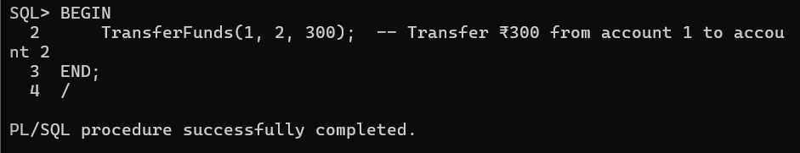

**Exercise 4: Functions**

**Scenario 1:**

CREATE OR REPLACE FUNCTION CalculateAge(p_DOB DATE)

RETURN NUMBER

IS

v_age NUMBER;

BEGIN

v_age := FLOOR(MONTHS_BETWEEN(SYSDATE, p_DOB) / 12);

RETURN v_age;

END;

/

**OUTPUT:**

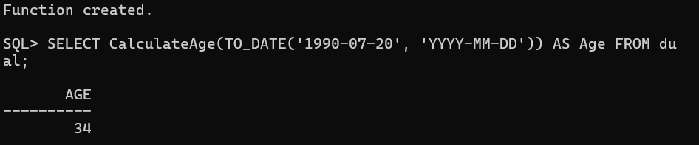

**Scenario 2:** CREATE OR REPLACE FUNCTION CalculateMonthlyInstallment (

p_LoanAmount IN NUMBER,

p_AnnualInterestRate IN NUMBER,

p_Years IN NUMBER

)

RETURN NUMBER

IS

v_monthlyRate NUMBER;

v_months NUMBER;

v_installment NUMBER;

BEGIN

v_monthlyRate := p_AnnualInterestRate / 12 / 100;

v_months := p_Years * 12;

IF v_monthlyRate = 0 THEN

v_installment := p_LoanAmount / v_months;

ELSE

v_installment := p_LoanAmount * v_monthlyRate / (1 - POWER(1 + v_monthlyRate, -v_months));

END IF;

RETURN ROUND(v_installment, 2);

END;

/

**OUTPUT:**

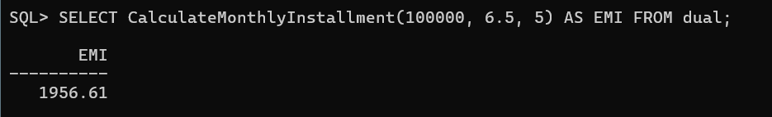

**Scenario 3:**

CREATE OR REPLACE FUNCTION HasSufficientBalance (

p_AccountID IN NUMBER,

p_Amount IN NUMBER

)

RETURN BOOLEAN

IS

v_balance NUMBER;

BEGIN

SELECT Balance INTO v_balance FROM Accounts WHERE AccountID = p_AccountID;

RETURN v_balance >= p_Amount;

EXCEPTION

WHEN NO_DATA_FOUND THEN

RETURN FALSE;

WHEN OTHERS THEN

RETURN FALSE;

END;

/

**OUTPUT:**

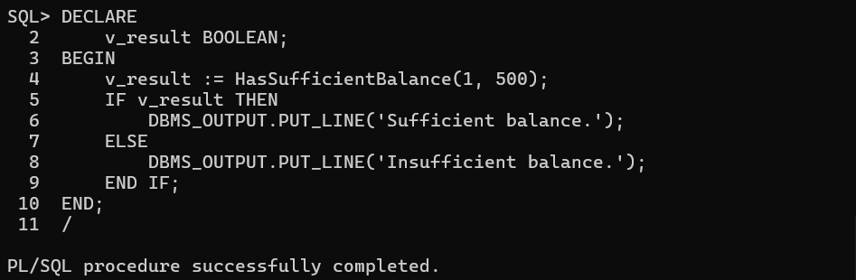

**Exercise 5: Triggers**

**Scenario 1:**

CREATE OR REPLACE TRIGGER UpdateCustomerLastModified

BEFORE UPDATE ON Customers

FOR EACH ROW

BEGIN

:NEW.LastModified := SYSDATE;

END;

/

**OUTPUT:**

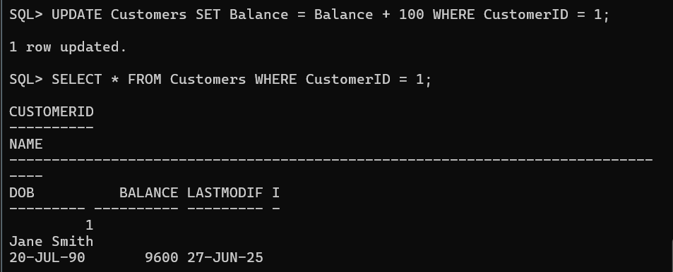

**Scenario 2:**

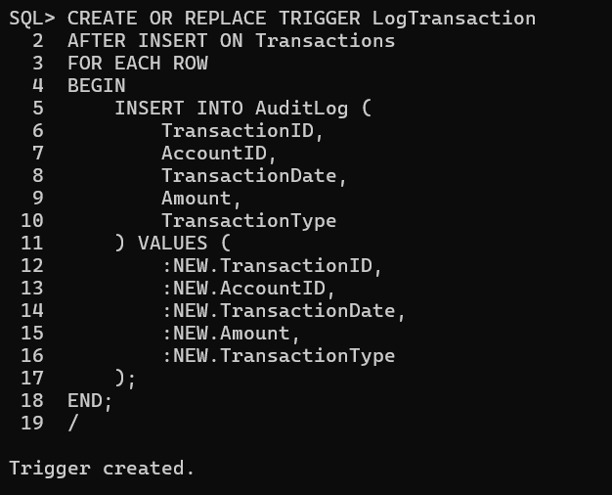

**Scenario 3:**

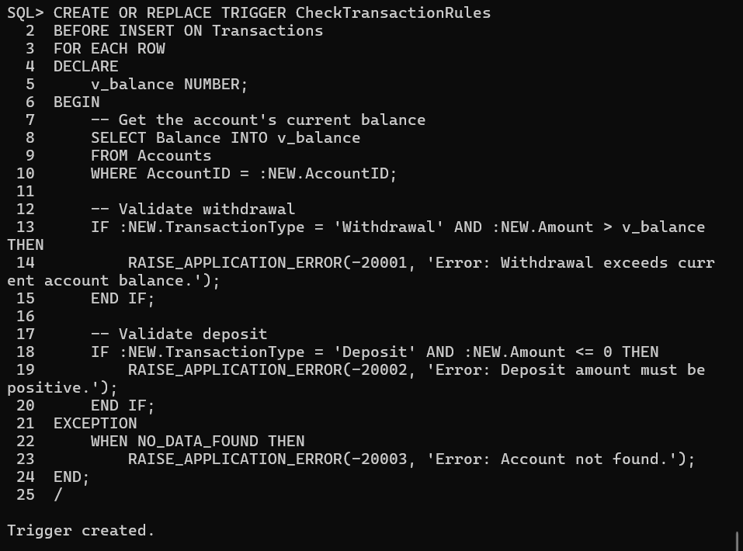

**Exercise 6: Cursors**

**Scenario 1:**

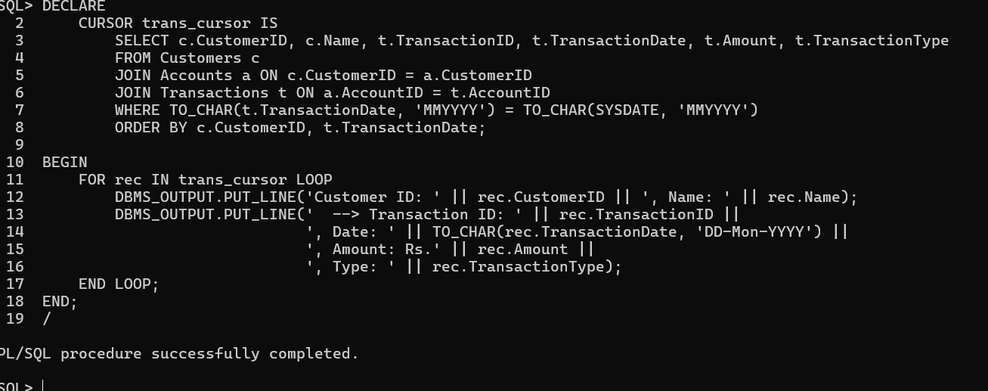

**Scenario 2:**

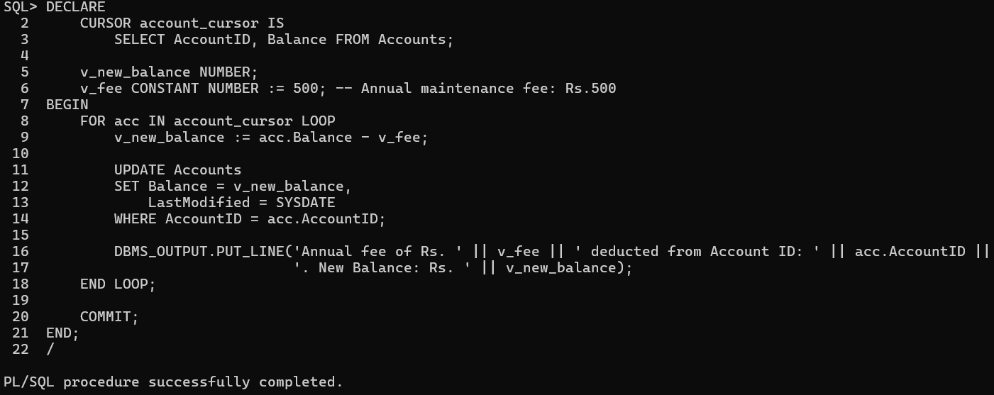

**Scenario 3:**

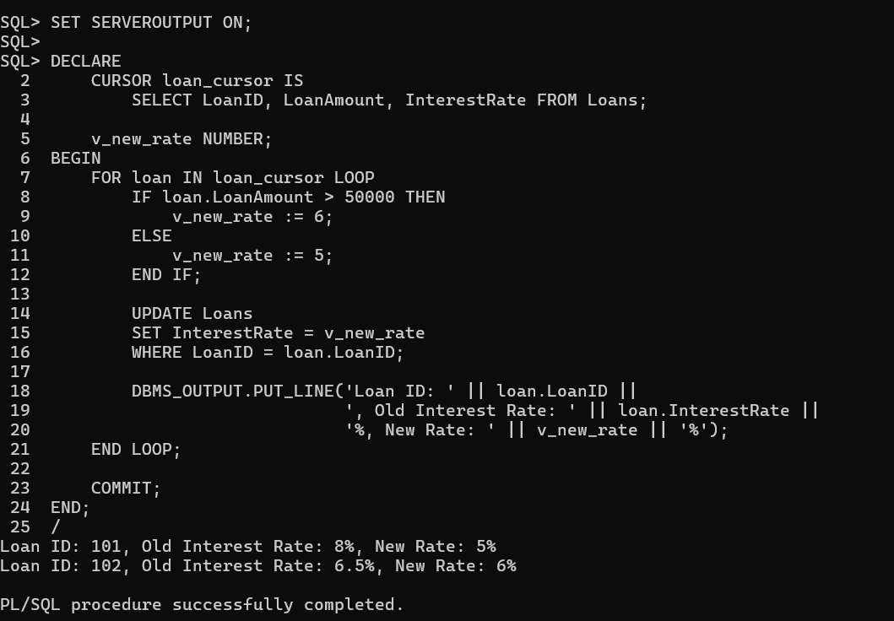

**Exercise 7: Packages**

**Scenario 1:**

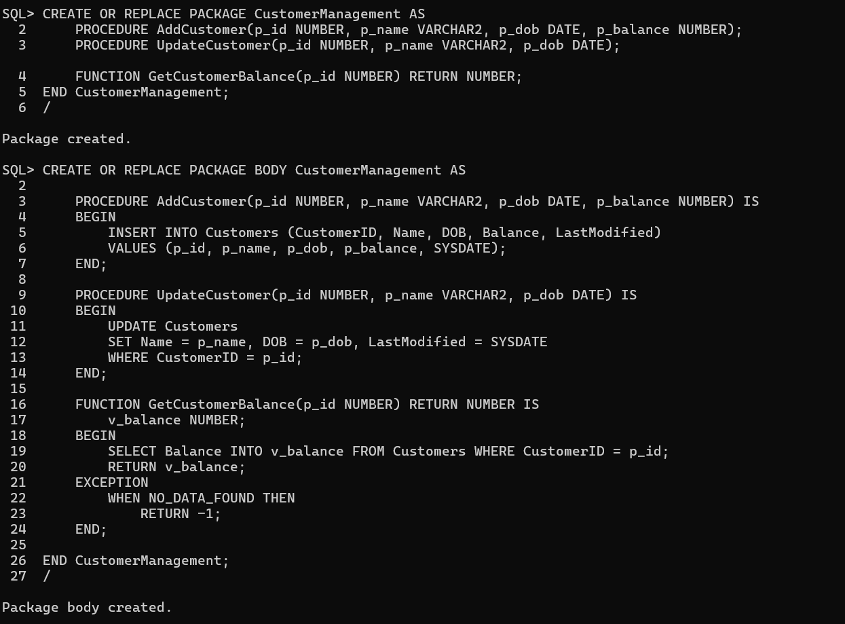

**Scenario 2:**

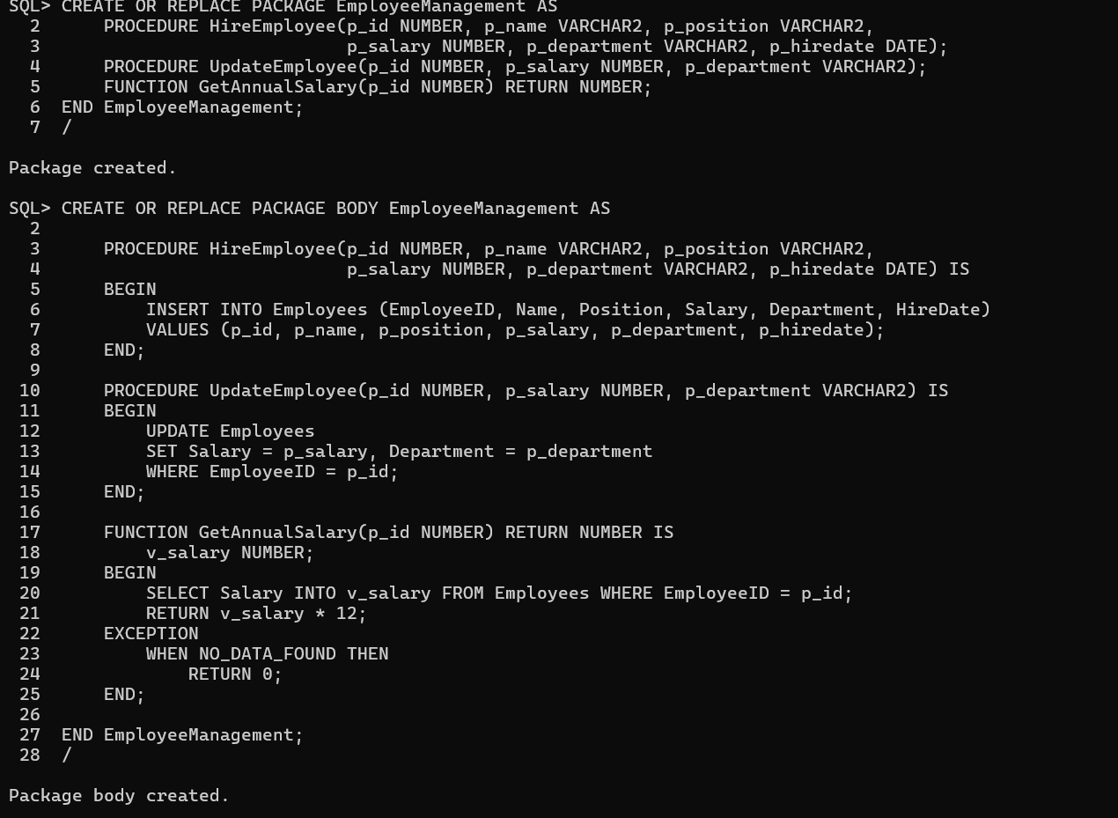

**Scenario 3:**

