**1.Create a new React Application with the name “myfirstreact”, Run the application to print “welcome to the first session of React” as heading of that page.**

**App.js**

import React from 'react';

import './App.css';

function App() {

return (

<div className="header">

<h1>Welcome to the first session of React</h1>

</div>

);

}

export default App;

**App.css**

body {

margin: 0;

padding: 0;

font-family: sans-serif;

}

.header {

text-align: center;

padding: 30px 0;

background-color: white; /* Optional */

}

h1 {

font-size: 2rem;

color: #333;

}

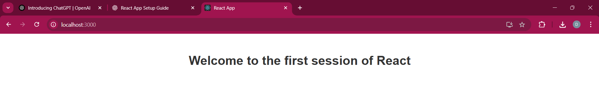

**2.Create a react app for Student Management Portal named StudentApp and create a component named Home which will display the Message “Welcome to the Home page of Student Management Portal”. Create another component named About and display the Message “Welcome to the About page of the Student Management Portal”. Create a third component named Contact and display the Message “Welcome to the Contact page of the Student Management Portal”. Call all the three components.**

**About.js**

import React from 'react';

import './Common.css';

function About() {

return (

<div className="header">

<h1>Welcome to the About page of the Student Management Portal</h1>

</div>

);

}

export default About;

**Contact.js**

import React from 'react';

import './Common.css';

function Contact() {

return (

<div className="header">

<h1>Welcome to the Contact page of the Student Management Portal</h1>

</div>

);

}

export default Contact;

**Home.js**

import React from 'react';

import './Common.css';

function Home() {

return (

<div className="header">

<h1>Welcome to the Home page of Student Management Portal</h1>

</div>

);

}

export default Home;

**App.js**  
import React from 'react';

import Home from './components/Home';

import About from './components/About';

import Contact from './components/Contact';

function App() {

return (

<div >

<Home />

<About />

<Contact />

</div>

);

}

export default App;

**Common.css**

.header {

  text-align: center;

  padding-top: 40px;

  padding-bottom: 20px;

  background-color: white;

}

h1 {

  margin: 0;

  font-size: 24px;

  color: #333;

}

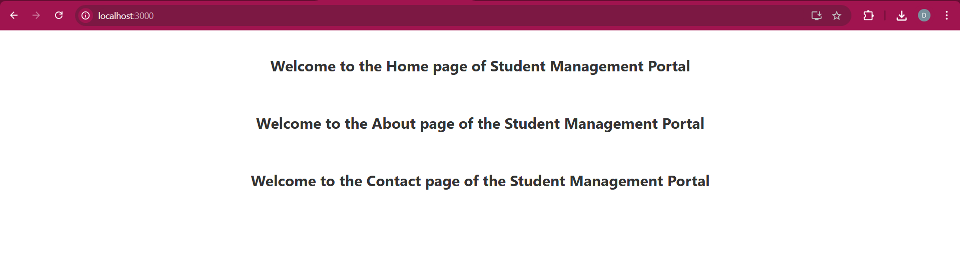

**3.Create a react app for Student Management Portal named scorecalculatorapp and create a function component named “CalculateScore” which will accept Name, School, Total and goal in order to calculate the average score of a student and display the same.**

**CalculateScore.js**

import React from 'react';

import '../Stylesheets/mystyle.css';

function CalculateScore() {

  const name = "Dhanushikha";

  const school = "Green Park School";

  const total = 480;

  const goal = 500;

  const average = (total / goal) * 100;

  return (

    <div className="score-box">

      <h2>Student Score Report</h2>

      <p><strong>Name:</strong> {name}</p>

      <p><strong>School:</strong> {school}</p>

      <p><strong>Total Marks:</strong> {total}</p>

      <p><strong>Goal Marks:</strong> {goal}</p>

      <p><strong>Average Score:</strong> {average.toFixed(2)}%</p>

    </div>

  );

}

export default CalculateScore;

**mystyle.css**

.score-box {

  margin: 50px auto;

  padding: 20px;

  width: 50%;

  border: 2px solid #4CAF50;

  border-radius: 10px;

  background-color: #f9f9f9;

  font-family: Arial, sans-serif;

  text-align: center;

  box-shadow: 0 0 10px rgba(0,0,0,0.1);

}

.score-box h2 {

  color: #4CAF50;

}

**App.js**

import React from 'react';

import './App.css';

import CalculateScore from './Components/CalculateScore';

function App() {

  return (

    <div className="App">

      <CalculateScore />

    </div>

  );

}

export default App;

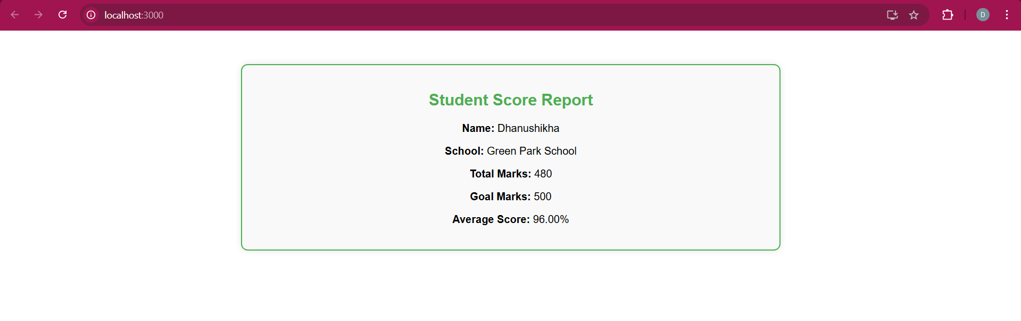

4.

**Post.js**

class Post {

  constructor(id, title, body) {

    this.id = id;

    this.title = title;

    this.body = body;

  }

}

export default Post;

**Posts.js**

import React, { Component } from 'react';

import Post from './Post';

class Posts extends Component {

  constructor(props) {

    super(props);

    this.state = {

      posts: [],

      hasError: false

    };

  }

  loadPosts() {

    fetch('https://jsonplaceholder.typicode.com/posts')

      .then(response => response.json())

      .then(data => {

        const posts = data.map(post => new Post(post.id, post.title, post.body));

        this.setState({ posts });

      })

      .catch(error => {

        console.error('Error fetching posts:', error);

        this.setState({ hasError: true });

      });

  }

  componentDidMount() {

    this.loadPosts();

  }

  componentDidCatch(error, info) {

    alert('An error occurred in Posts component: ' + error.toString());

  }

  render() {

    if (this.state.hasError) {

      return <h2>Something went wrong while loading posts.</h2>;

    }

    return (

      <div>

        <h1>Blog Posts</h1>

        {this.state.posts.map(post => (

          <div key={post.id}>

            <h2>{post.title}</h2>

            <p>{post.body}</p>

            <hr />

          </div>

        ))}

      </div>

    );

  }

}

export default Posts;

**App.js**

import React from 'react';

import './App.css';

import Posts from './Posts';

function App() {

  return (

    <div className="App">

      <Posts />

    </div>

  );

}

export default App;

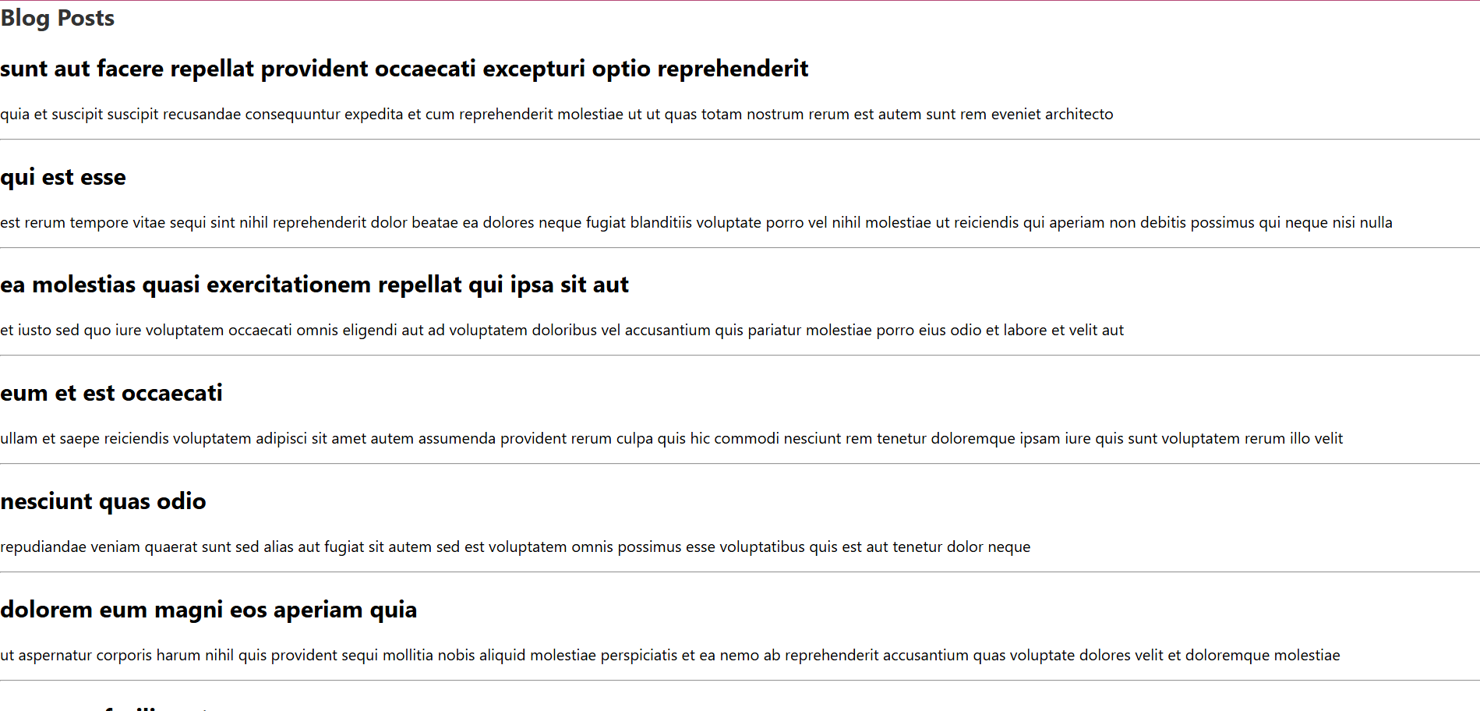

5.**My Academy team at Cognizant want to create a dashboard containing the details of ongoing and completed cohorts. A react application is created which displays the detail of the cohorts using react component. You are assigned the task of styling these react components.**

**App.js**

import React from 'react';

import CohortDetails from './CohortDetails';

function App() {

  return (

    <div className="App">

      <CohortDetails

        name="React Bootcamp"

        status="ongoing"

        startDate="2024-07-01"

      />

      <CohortDetails

        name="Java Backend"

        status="completed"

        startDate="2024-05-10"

      />

    </div>

  );

}

export default App;

**CohortDetails.js**

import React from 'react';

import styles from './CohortDetails.module.css'; // this is the CSS Module

function CohortDetails(props) {

  const { name, status, startDate } = props;

  const headingStyle = {

    color: status === 'ongoing' ? 'green' : 'blue'

  };

  return (

    <div className={styles.box}>

      <h3 style={headingStyle}>{name}</h3>

      <dl>

        <dt>Status:</dt>

        <dd>{status}</dd>

        <dt>Start Date:</dt>

        <dd>{startDate}</dd>

      </dl>

    </div>

  );

}

export default CohortDetails;

**CohortDetails.modules.css**

.box {

  width: 300px;

  display: inline-block;

  margin: 10px;

  padding: 10px 20px;

  border: 1px solid black;

  border-radius: 10px;

}

dt {

  font-weight: 500;

}

