**Exercise :9**

**Create a React Application named “cricketapp” with the following components:**

**ListofPlayers.js**

import React from 'react';

const ListofPlayers = () => {

const players = [

{ name: 'Rohit', score: 80 },

{ name: 'Virat', score: 95 },

{ name: 'Rahul', score: 60 },

{ name: 'Pant', score: 55 },

{ name: 'Jadeja', score: 85 },

{ name: 'Hardik', score: 40 },

{ name: 'Bumrah', score: 90 },

{ name: 'Ashwin', score: 73 },

{ name: 'Shami', score: 68 },

{ name: 'Surya', score: 78 },

{ name: 'Gill', score: 88 }

];

const lowScorers = players.filter(player => player.score < 70);

return (

<div>

<h2>All Players</h2>

<ul>

{players.map((player, index) => (

<li key={index}>{player.name} - {player.score}</li>

))}

</ul>

<h3>Players with score below 70</h3>

<ul>

{lowScorers.map((player, index) => (

<li key={index}>{player.name} - {player.score}</li>

))}

</ul>

</div>

);

};

export default ListofPlayers;

**IndianPlayers.js**

import React from 'react';

const IndianPlayers = () => {

const T20players = ['Rohit', 'Virat', 'Surya', 'Hardik', 'Pant'];

const RanjiTrophy = ['Pujara', 'Rahane', 'Shaw', 'Sarfaraz', 'Abhimanyu'];

const allPlayers = [...T20players, ...RanjiTrophy];

const oddTeam = allPlayers.filter((_, index) => index % 2 === 0);

const evenTeam = allPlayers.filter((_, index) => index % 2 !== 0);

return (

<div>

<h2>All Players (Merged):</h2>

<ul>

{allPlayers.map((player, index) => (

<li key={index}>{player}</li>

))}

</ul>

<h3>Odd Team Players</h3>

<ul>

{oddTeam.map((player, index) => (

<li key={index}>{player}</li>

))}

</ul>

<h3>Even Team Players</h3>

<ul>

{evenTeam.map((player, index) => (

<li key={index}>{player}</li>

))}

</ul>

</div>

);

};

export default IndianPlayers;

**App.js**

import React, { useState } from 'react';

import ListofPlayers from './Components/ListofPlayers';

import IndianPlayers from './Components/IndianPlayers';

function App() {

const [flag, setFlag] = useState(true); // flag is true by default

return (

<div className="App">

<h1>🏏 Cricket Application</h1>

<button onClick={() => setFlag(!flag)}>

Toggle View ({flag ? "Show Indian Players" : "Show List of Players"})

</button>

<hr />

{flag ? <ListofPlayers /> : <IndianPlayers />}

</div>

);

}

export default App;

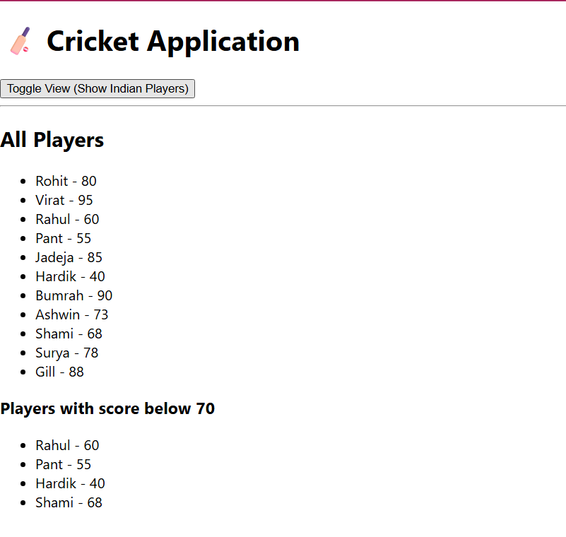

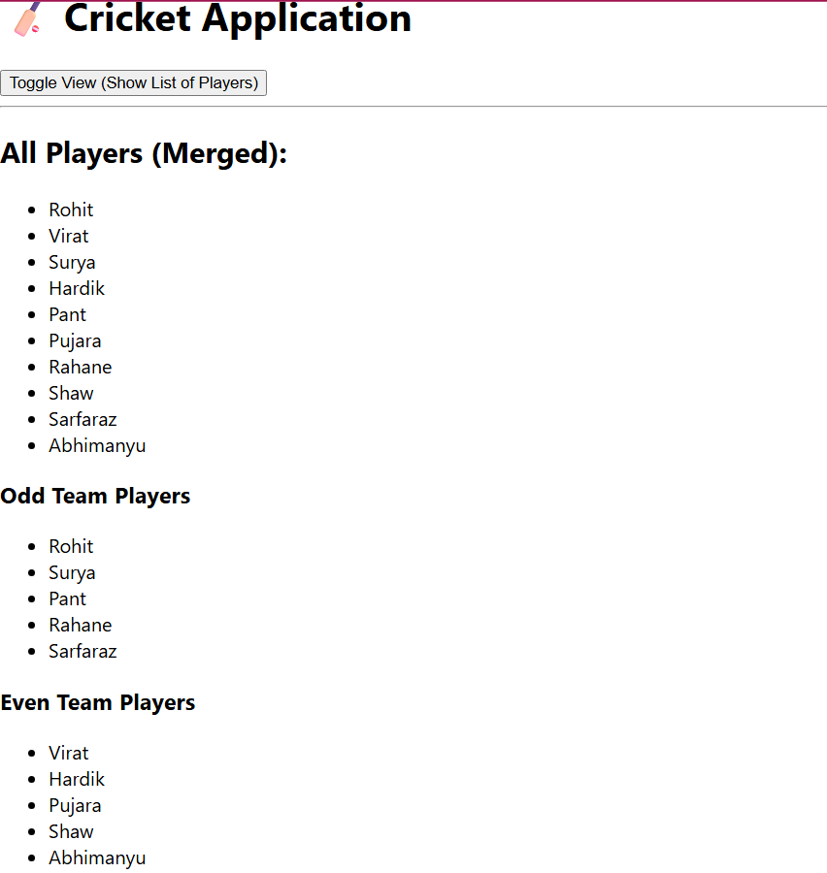

**Exercise :10**

**Create a React Application named “officespacerentalapp” which uses React JSX to create elements, attributes and renders DOM to display the page.**

**OfficeList.js**

import React from 'react';

import img1 from '../images/img1.jpg';

import img2 from '../images/img2.jpg';

import img3 from '../images/img3.jpg';

const OfficeList = () => {

  // List of office space objects

  const offices = [

    {

      name: 'Tech Park Space',

      rent: 45000,

      address: '123 IT Highway, Chennai',

      image: img1

    },

    {

      name: 'Startup Hub',

      rent: 65000,

      address: 'Indira Nagar, Bangalore',

      image:  img2

    },

    {

      name: 'Urban Workspace',

      rent: 58000,

      address: 'T. Nagar, Chennai',

      image:  img3

    }

  ];

  // JSX rendering

  return (

    <div>

      <h1 style={{ textAlign: 'center', color: 'navy' }}>🏢 Office Space Rental Listings</h1>

      {offices.map((office, index) => (

        <div key={index} style={{

          border: '1px solid gray',

          borderRadius: '10px',

          padding: '10px',

          margin: '15px',

          backgroundColor: '#f9f9f9'

        }}>

          <img src={office.image} alt={office.name} style={{ width: '100%', maxWidth: '300px' }} />

          <h2>{office.name}</h2>

          <p><strong>Address:</strong> {office.address}</p>

          <p>

            <strong>Rent:</strong>{' '}

            <span style={{ color: office.rent < 60000 ? 'red' : 'green' }}>

              ₹{office.rent}

            </span>

          </p>

        </div>

      ))}

    </div>

  );

};

export defaultOfficeList;

**App.js**

import React from 'react';

import OfficeList from './Components/OfficeList';

function App() {

  return (

    <div className="App">

      <OfficeList />

    </div>

  );

}

export default App;

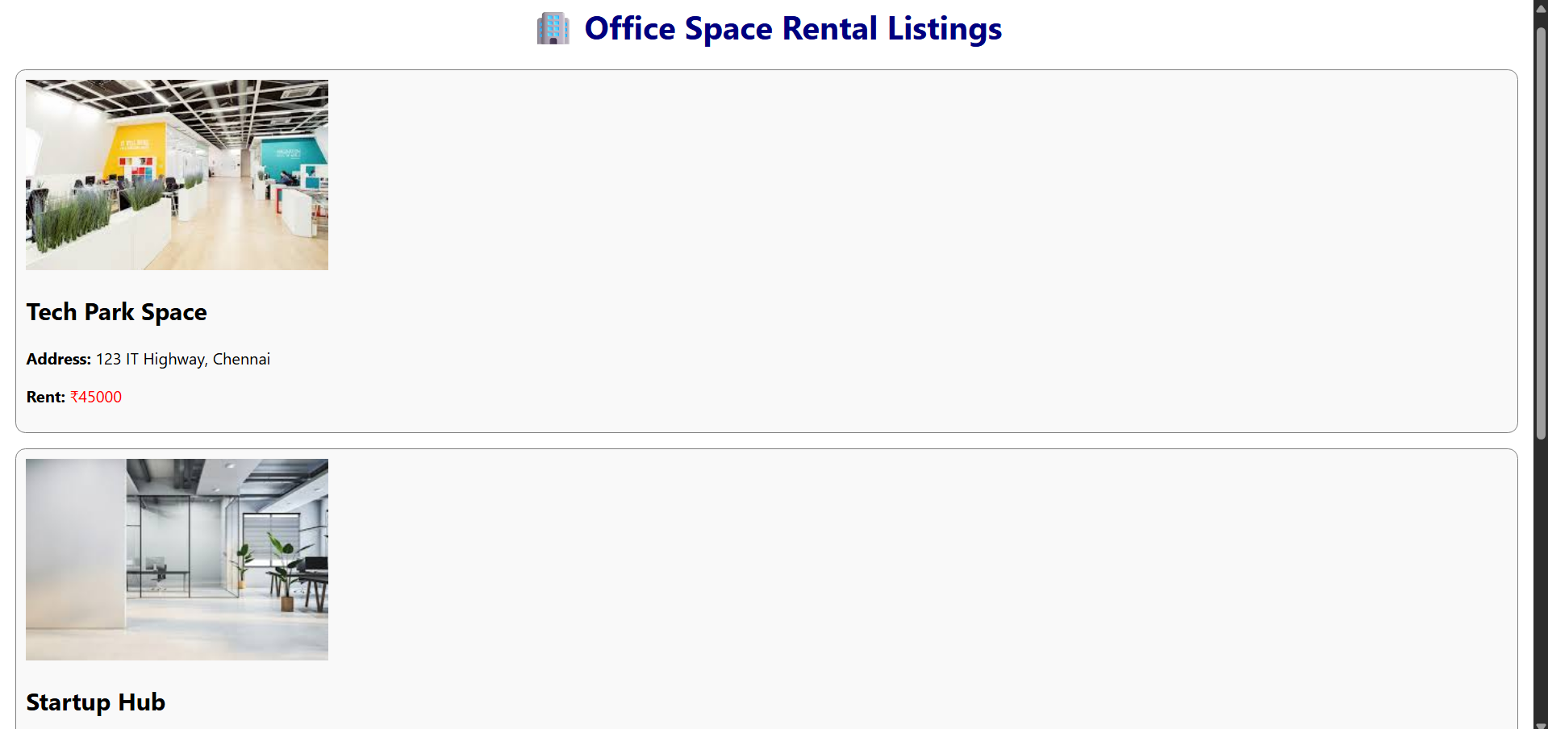

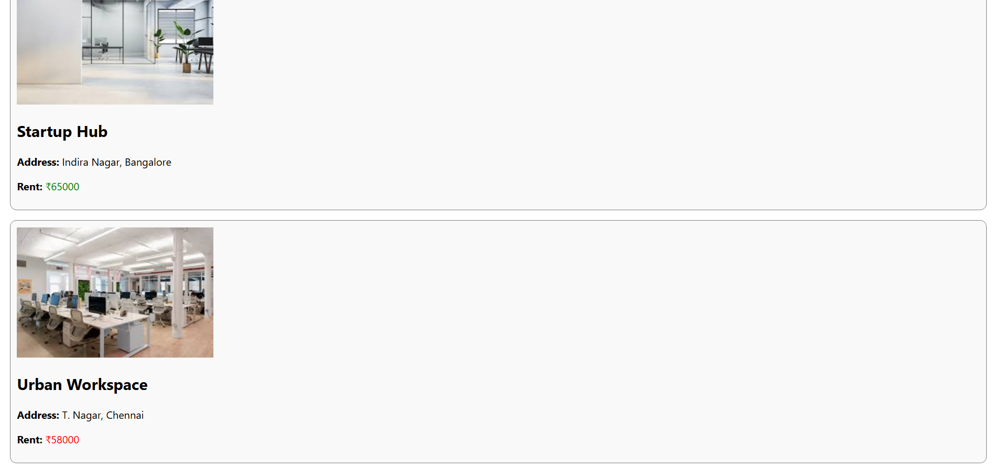

**Exercise :11**

**Create a React Application “eventexamplesapp” to handle various events of the form elements in HTML.**

**CurrencyConvertor.js**

import React, { useState } from 'react';

import CurrencyConvertor from './Components/CurrencyConvertor';

function App() {

const [count, setCount] = useState(0);

const [message, setMessage] = useState('');

// Increments counter and shows hello message

const handleIncrement = () => {

incrementCounter();

sayHello();

};

const incrementCounter = () => {

setCount(count + 1);

};

const sayHello = () => {

setMessage('👋 Hello! Count increased.');

};

const handleDecrement = () => {

setCount(count - 1);

setMessage('');

};

// Function to say welcome using argument

const sayWelcome = (msg) => {

setMessage(`🎉 You said: ${msg}`);

};

// Synthetic event

const handleSyntheticEvent = (e) => {

setMessage('🖱️ I was clicked');

};

return (

<div style={{ padding: '20px' }}>

<h2>React Event Handling Lab</h2>

<div style={{ marginBottom: '15px' }}>

<h3>Counter: {count}</h3>

<button onClick={handleIncrement}>Increment</button>{' '}

<button onClick={handleDecrement}>Decrement</button>

</div>

<div style={{ marginBottom: '15px' }}>

<button onClick={() => sayWelcome('welcome')}>Say Welcome</button>{' '}

<button onClick={handleSyntheticEvent}>OnPress</button>

</div>

<div style={{ marginBottom: '15px', color: 'blue' }}>

{message && <strong>{message}</strong>}

</div>

<hr />

<CurrencyConvertor />

</div>

);

}

export default App;

**App.js**

import React, { useState } from 'react';

import CurrencyConvertor from './Components/CurrencyConvertor';

function App() {

const [count, setCount] = useState(0);

const [message, setMessage] = useState('');

// Increments counter and shows hello message

const handleIncrement = () => {

incrementCounter();

sayHello();

};

const incrementCounter = () => {

setCount(count + 1);

};

const sayHello = () => {

setMessage('👋 Hello! Count increased.');

};

const handleDecrement = () => {

setCount(count - 1);

setMessage('');

};

// Function to say welcome using argument

const sayWelcome = (msg) => {

setMessage(`🎉 You said: ${msg}`);

};

// Synthetic event

const handleSyntheticEvent = (e) => {

setMessage('🖱️ I was clicked');

};

return (

<div style={{ padding: '20px' }}>

<h2>React Event Handling Lab</h2>

<div style={{ marginBottom: '15px' }}>

<h3>Counter: {count}</h3>

<button onClick={handleIncrement}>Increment</button>{' '}

<button onClick={handleDecrement}>Decrement</button>

</div>

<div style={{ marginBottom: '15px' }}>

<button onClick={() => sayWelcome('welcome')}>Say Welcome</button>{' '}

<button onClick={handleSyntheticEvent}>OnPress</button>

</div>

<div style={{ marginBottom: '15px', color: 'blue' }}>

{message && <strong>{message}</strong>}

</div>

<hr />

<CurrencyConvertor />

</div>

);

}

export default App;

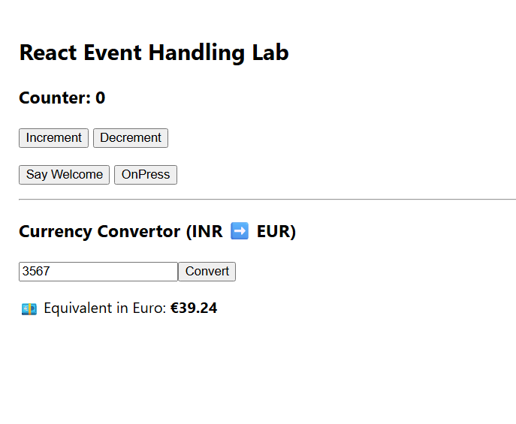

**Exercise :12**

**Create a React Application named “ticketbookingapp” where the guest user can browse the page where the flight details are displayed whereas the logged in user only can book tickets.**

**The Login and Logout buttons should accordingly display different pages. Once the user is logged in the User page should be displayed. When the user clicks on Logout, the Guest page should be displayed.**

**App.js**

import React, { useState } from 'react';

import GuestPage from './Components/GuestPage';

import UserPage from './Components/UserPage';

function App() {

const [isLoggedIn, setIsLoggedIn] = useState(false);

// Toggle login state

const handleLogin = () => setIsLoggedIn(true);

const handleLogout = () => setIsLoggedIn(false);

// Conditional rendering of button and page

let pageContent;

if (isLoggedIn) {

pageContent = <UserPage />;

} else {

pageContent = <GuestPage />;

}

return (

<div className="App" style={{ padding: '20px' }}>

<h1>✈️ Ticket Booking App</h1>

<div style={{ marginBottom: '20px' }}>

{isLoggedIn ? (

<button onClick={handleLogout}>Logout</button>

) : (

<button onClick={handleLogin}>Login</button>

)}

</div>

{pageContent}

</div>

);

}

export default App;

**GuestPage.js**

import React from 'react';

function GuestPage() {

return (

<div>

<h2>🧍 Guest View</h2>

<p>Welcome! Please login to book tickets.</p>

<h3>Available Flights:</h3>

<ul>

<li>Chennai → Mumbai (6:00 AM)</li>

<li>Bangalore → Delhi (9:30 AM)</li>

<li>Hyderabad → Kolkata (5:00 PM)</li>

</ul>

</div>

);

}

export default GuestPage;

**UserPage.js**

import React from 'react';

function UserPage() {

const handleBooking = (flight) => {

alert(`✅ Booking confirmed for: ${flight}`);

};

return (

<div>

<h2>👤 User Dashboard</h2>

<p>You are logged in. Select a flight to book your ticket.</p>

<h3>Available Flights:</h3>

<ul>

<li>

Chennai → Mumbai (6:00 AM)

<button onClick={() => handleBooking('Chennai → Mumbai')} style={{ marginLeft: '10px' }}>Book</button>

</li>

<li>

Bangalore → Delhi (9:30 AM)

<button onClick={() => handleBooking('Bangalore → Delhi')} style={{ marginLeft: '10px' }}>Book</button>

</li>

<li>

Hyderabad → Kolkata (5:00 PM)

<button onClick={() => handleBooking('Hyderabad → Kolkata')} style={{ marginLeft: '10px' }}>Book</button>

</li>

</ul>

</div>

);

}

export default UserPage;

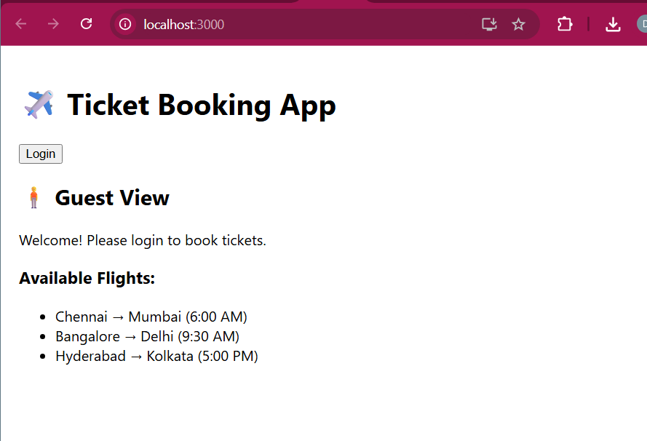

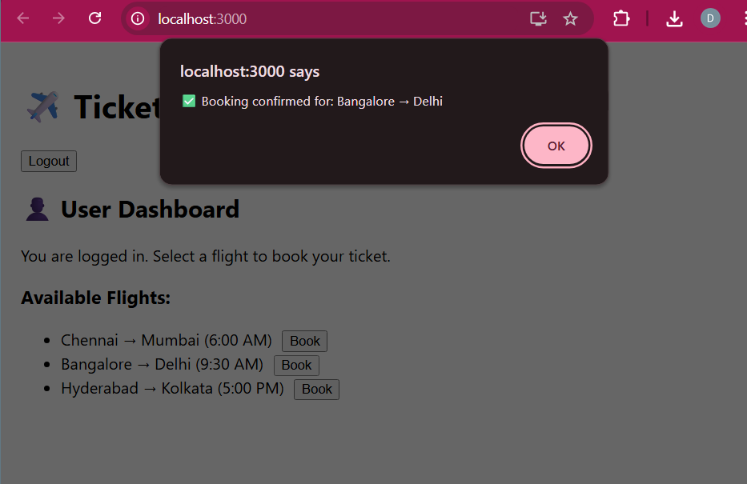

**Exercise :13**

**Create a React App named “bloggerapp” in with 3 components.**

1. **Book Details**
2. **Blog Details**
3. **Course Details**

**Implement this with as many ways possible of Conditional Rendering.**

**CourseDetails.js**

import React from 'react';

const courses = [

{ id: 1, name: 'Angular', date: '4/5/2021' },

{ id: 2, name: 'React', date: '6/3/20201' }

];

function CourseDetails() {

return (

<div className="section">

<h2>Course Details</h2>

{courses.map(course => (

<div key={course.id}>

<h3>{course.name}</h3>

<p>{course.date}</p>

</div>

))}

</div>

);

}

export default CourseDetails;

**BlogDetails.js**

import React from 'react';

const blogs = [

{

id: 1,

title: 'React Learning',

author: 'Stephen Biz',

content: 'Welcome to learning React!'

},

{

id: 2,

title: 'Installation',

author: 'Schewzdenier',

content: 'You can install React from npm.'

}

];

function BlogDetails() {

return (

<div className="section">

<h2>Blog Details</h2>

{blogs.map(blog => (

<div key={blog.id}>

<h3>{blog.title}</h3>

<strong>{blog.author}</strong>

<p>{blog.content}</p>

</div>

))}

</div>

);

}

export default BlogDetails;

**BookDetails.js**

import React from 'react';

function BookDetails(props) {

const books = [

{ id: 1, bname: 'Master React', price: 670 },

{ id: 2, bname: 'Deep Dive into Angular 11', price: 800 },

{ id: 3, bname: 'Mongo Essentials', price: 450 }

];

return (

<div className="section">

<h2>Book Details</h2>

{books.map(book => (

<div key={book.id}>

<h3>{book.bname}</h3>

<h4>{book.price}</h4>

</div>

))}

</div>

);

}

export default BookDetails;

**App.js**

import React from 'react';

import CourseDetails from './components/CourseDetails';

import BookDetails from './components/BookDetails';

import BlogDetails from './components/BlogDetails';

import './App.css';

function App() {

const showCourses = true;

const showBooks = true;

const showBlogs = true;

return (

<div className="container">

{showCourses && <CourseDetails />}

{showBooks ? <BookDetails /> : <p>📚 Book details not available</p>}

{showBlogs && <BlogDetails />}

</div>

);

}

export default App;

**App.css**

.container {

display: flex;

justify-content: space-around;

padding: 30px;

font-family: Arial, sans-serif;

}

.section {

border-left: 5px solid green;

padding-left: 20px;

}

