**WEB BASED CLOTHS ORDERING SYSTEM FOR**

**LITE FASHION STORE**

**REPORT**

**ASSIGNMENT 02**

**Version 1.0**

Prepared by

Dark Devils

KGDME Jayarathna - E2240438

GSS Lakshan - E2240402

PVMC Wickramasinghe - E2240158

**Created: 10.10.2024**

# Table of Contents

Table of Contents i

List of Tables ii

List of Figures iii

Chapter 01: Introduction 1

1.1 Overview 1

1.2 Background & Motivation 1

1.3 Aim and Objectives 2

1.3.1 Aim 2

1.3.2 Objectives 2

1.4 Summary 3

Chapter 02: System Analysis and Design 3

2.1 Introduction 3

2.2 Requirement Analysis 3

2.2.1 Requirement Gathering Techniques 3

2.3 Diagrams 4

2.3.1 Use Case Diagram for Full System 5

2.3.2 Use case Diagram for Customer Registration 6

2.3.3 Use case Diagram for Order Management 7

2.3.4 Activity Diagram for Admin Login 8

2.3.5 Activity Diagram for Order 9

2.3.6 Activity Diagram for Registration 10

2.3.7 Sequence Diagram for Admin Login 11

2.3.8 Sequence Diagram for Order 12

2.3.9 Sequence Diagram for Registration 13

2.3.10 Class Diagram 14

2.3.11 EER Diagram 15

2.4 Database 16

2.4.1 Relational Schema 16

2.5 User Interface 18

2.5.1 Login Interface 18

2.5.2 Products Interface 18

2.5.3 Product Details Interface 19

2.5.4 Search Option 19

2.5.5 Cart Interface 20

References 20

# List of Tables

Table 1 - Use case customer management 6

Table 2 - Use case Order Management 7

# List of Figures

Figure 1 - Full system use case diagram 5

Figure 2 - Use case Diagram for Customer Registration 6

Figure 3 - Use case Diagram for Order Management 7

Figure 4 - Activity Diagram for Admin Login 8

Figure 5 - Activity Diagram for Order 9

Figure 6 - Activity Diagram for Registration 10

Figure 7 - Sequence Diagram for Admin Login 11

Figure 8 - Sequence Diagram for Order 12

Figure 9 - Sequence Diagram for Registration 13

Figure 10 - Class Diagram 14

Figure 11 - EER Diagram 15

Figure 12 - Login Interface 18

Figure 13 - Products Interface 18

Figure 14 - Product Details Interface 19

Figure 15 - Search Option 19

Figure 16 - Cart Interface 20

# Chapter 01: Introduction

## 1.1 Overview

OCSS is an all-in-one solution to give both online customers and store owners the need in abundance of today’s modern fashion retail. It is a complete platform with a good bundle of what it has to offer like user sign up, secure authentication, product browsing, cart management, order processing and real time tracking of the order. Listed as e-commerce and in-store Point of Sale (POS) system, it’s a system that caters for both online and in store customers combined to handle physical transactions and inventory.

It believes that the OCSS provides an opportunity for customers to browse through collections of clothing in categories, to make secure purchases and to follow the progress of their orders from placement until delivery. For a store owner, it has tools for inventory management, sales monitoring and report generation, which helps them learn about their performance in sales on a daily, monthly or yearly basis. The platform also has features that help manage employee data and get customer feedback to constantly improve the platform based on real user input.

The detailed documentation of system functional and non-functional requirements is described in this Report along with the way the platform operates, what the platform will develop and what the platform should be developed to. This document is meant to be a reference for everyone within the stakeholder: developers, project managers, clients, and quality assurance teams to verify that the last system complies with stated requirements.

## 1.2 Background & Motivation

The way people shop has changed drastically with the rapid evolution of e-commerce hence, convenience, accessibility, and efficiency have become keys to the success of any successful online business. In particular, the fashion industry has seen a large increase in online shopping as people choose the convenience of browsing through the collections, buying and following their orders from their houses. As this demand was growing, the Online Clothing Shopping Store (OCSS) was conceptualized as a portal between sellers and customers that effectively blurs the boundaries.

The goal of this project is to deliver an easy-to-use platform for clothing ordering where customers can simply order clothes while also providing store owners with tools for storage control, sales monitoring, and performance analysis. We developed OCSS because the need for a robust, scalable solution to the complexity of online retail business in terms of product discovery, transaction security, order management and tracking, as well as in-store business with a Point of Sale (POS) system.

As an integrated OCSS and by integrating the online and offline capabilities the solution provides the balance between the benefits for customers and benefits for store managers, which leads to operational efficiency, customer satisfaction and result in the business successful.

## 1.3 Aim and Objectives

### 1.3.1 Aim

The aim of the Online Clothing Shopping Store (OCSS) project is to build a complete e-commerce platform which offers a comfortable, simple to use shopping expertise for prospects and powerful administration instruments for store owners. The objective of this project is to allow for world class online clothing transactions that includes secure user registration, user friendly product browsing, streamlined order processing, real time order tracking and effective inventory management. The OCSS objectives will be accomplished through achieving customer satisfaction, increased operational efficiency and a competitive position in the online retail market.

### 1.3.2 Objectives

* User Experience Enhancement: Create a user-friendly interface so customers can easily look through collections, put items in their cart and make safe purchasing.
* Seamless Order Management: Helping order to run a simple and effective order process that allows real time order tracking and notifications so customers know when their order shipped from process purchase to delivery.
* Secure User Registration & Authentication: Also, implement strong user registration and authentication, secure user data and transaction safety.
* Performance Analytics & Reporting: Provide store owners with the ability to generate sales reports, how they’re performing as store employees, and create custom reports aligned with a certain set of criteria.
* Customer Engagement & Feedback: Build a feedback system that will empower customers, to share their experience and thus drive continual improvements to the platform.
* By combining these objectives, we will arrive at a full package of online and offline clothing retail system, which will not only make shopping ease but also bring the business intelligence and operational efficiency to store owners.

## 1.4 Summary

The Online Clothing Shopping Store (OCSS) is a comprehensive platform designed to streamline both online and in-store shopping experiences. It offers features like user registration, secure product browsing, cart management, order tracking, and a review system. Store owners benefit from sales tracking, and detailed reporting tools, along with a Point of Sale (POS) system for in-store transactions. OCSS enhances customer engagement through a user-friendly interface and ensures efficient order fulfillment, providing a scalable and secure solution for the fashion retail industry.

# Chapter 02: System Analysis and Design

## 2.1 Introduction

Any software development process has system analysis and design as its backbone. In order to analyze the system requirements and design architecture of the system to meet the requirements of customer and store owners a complete approach was employed for Online Clothing Shopping Store (OCSS). In this chapter, I explore in detail how requirements were derived, how they were analyzed, and how they influenced the systems design. The collected data is the subject of the outline techniques used to collect it, it compares other systems, and the design approach that guarantees scalability, usability and security.

## 2.2 Requirement Analysis

This phase is critical stage in software development, as it identifies, collects and documents all the functional and non-functional requirements of the application. This process for the OCSS ensured alignment of the platform with user needs and business objectives. This process involved gathering comprehensive insights from these involved key stakeholders such as customers, store owners and staff. The system’s features, designs and architecture were influenced directly by the outcome of the requirement analysis phase.

### 2.2.1 Requirement Gathering Techniques

Different requirement gathering techniques were used so as to train the system about all that the requirements of system are. This allowed them to find out what functionalities, user behaviors and system constraints are needed.

* **Similar Systems**

The features and functionalities implemented in local online clothing platforms were analyzed to understand the fashion e-commerce industry in Sri Lanka. Example of these is: Fashion Bug, House of Fashions, Kandy Selection and Thilakawardhana**.** In terms of making purchase and vendor operations more efficient, these platforms provide features such as categorized product browsing, user registration, secure methods of online payment and order tracking. Each of these systems takes advantage of a combination of traditional and contemporary elements to improve customer satisfaction.

Review of these systems revealed the need for the Online Clothing Shopping Store (OCSS) to have a user-friendly interface, secure payment gateways and robust order tracking mechanisms. These insights from these platforms informed OCSS to compete locally on the market and also help provide a unique and optimized user experience.

* **Manual System Documentation**

Insights from traditional order processing, inventory tracking and customer service methods used on manual systems were gathered through a review of manual systems previously used by small garment stores. Efficiencies and bottlenecks in manual workflows like delayed feed of inventory updates and order handling issues were exposed by this documentation. In the aim to do away with these inefficiencies and automate pertinent processes such as real time stock update, order tracking and so on, OCSS digitized it.

* **Questioners**

A number of questionnaires were distributed among store owners, staff and customers to gather direct feedback from potential users. The questionnaires focused on user preferences for online shopping, preferred payment methods, feedback mechanisms and order tracking needs. The data collected helped us shape the user interface design, so it's intuitive and fits the ways that people use most often. The responses also included insights on the relevance of some elements such as secure payment gateways, personalized recommendations, the possibility to leave reviews.

* **Interviews**

We conducted interviews with key stakeholders: store managers, IT administrators and end users to get a better handle on what they expect and what exactly they are in pain. Through these one-on-one interviews we had the opportunity to delve into these items: system requirements, features and constraints in detail. Real time reporting, inventory management were mentioned as store owners stress, while customers demand a seamless shopping experience, quick order fulfilment and secure payment processing. These interviews helped in identifying the non-functional requirements i.e., system performance, security and scalability.

## 2.3 Diagrams

A graphical representation of a user's potential interactions with a system is called a use case diagram. A use case diagram will frequently be accompanied by other types of diagrams and will display the various use cases and user types the system has. Either circles or ellipses are used to represent the use cases.

### 2.3.1 Use Case Diagram for Full System

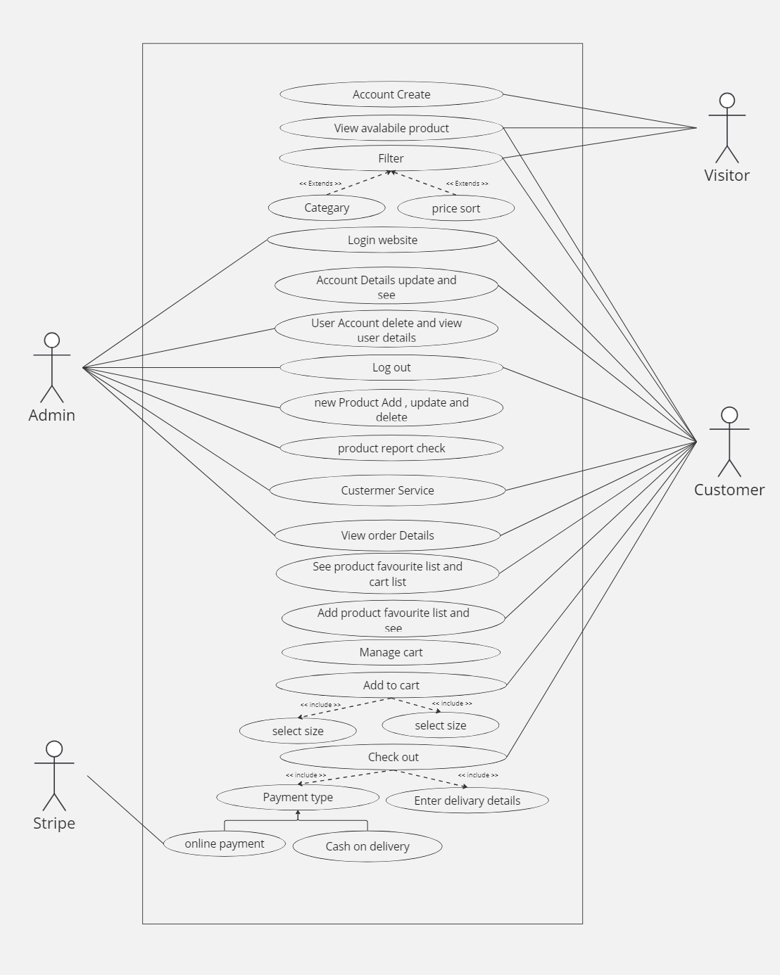

Figure - Full system use case diagram

### 2.3.2 Use case Diagram for Customer Registration

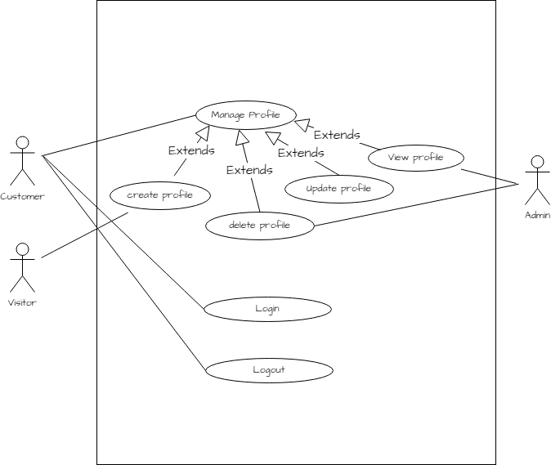

Figure - Use case Diagram for Customer Registration

|  |  |
| --- | --- |
| **Use-Case Name** | **Customer Management** |
| Use-Case Type | Business |
| Use-Case ID | FO-01 |
| Requirements Priority | High Priority |
| Source | Online Form |
| Primary Business Actor | Admin |
| Other Participating Actors | Admin |
| Other Interested Stakeholders | Customer |
| Description | 1. Customer Registration  2. Customer Login  3. Customer Edit Profile  4. Customer Delete Profile  5. Customer Logout |

Table - Use case customer management

### 2.3.3 Use case Diagram for Order Management

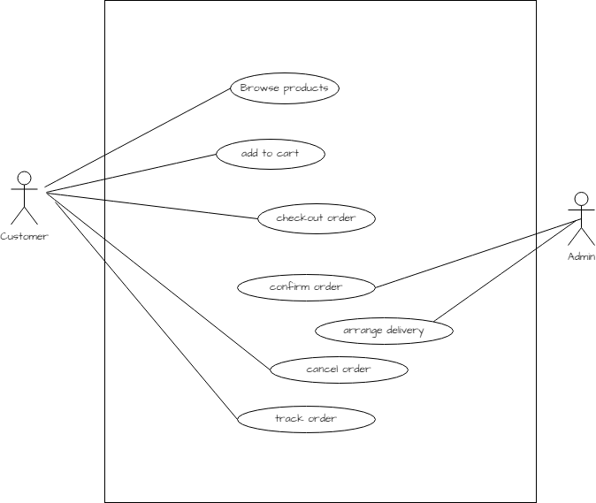

Figure - Use case Diagram for Order Management

|  |  |
| --- | --- |
| **Use-Case Name** | **Order Management** |
| Use-Case Type | Business |
| Use-Case ID | FO-02 |
| Requirements Priority | High Priority |
| Source | Online Form |
| Primary Business Actor | Customer |
| Other Participating Actors |  |
| Other Interested Stakeholders |  |
| Description | 1. View product  2. Add to cart  3. Checkout order  4. Confirm order |

Table - Use case Order Management

### 2.3.4 Activity Diagram for Admin Login

A class diagram in software engineering is a kind of static structure diagram that reveals the classes, attributes, operations, and relationships between objects in a system to describe the system's structure.

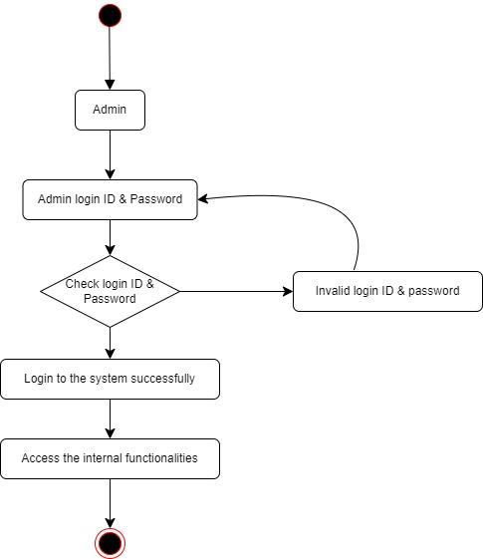

Figure - Activity Diagram for Admin Login

### 2.3.5 Activity Diagram for Order

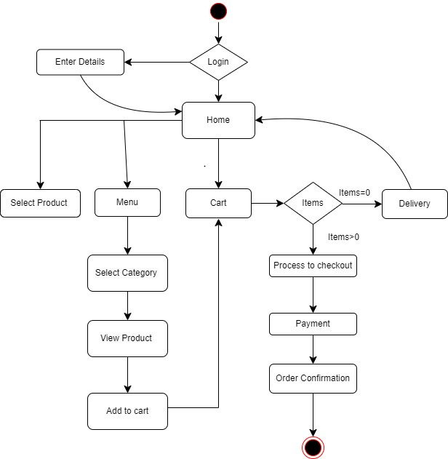

Figure - Activity Diagram for Order

### 2.3.6 Activity Diagram for Registration

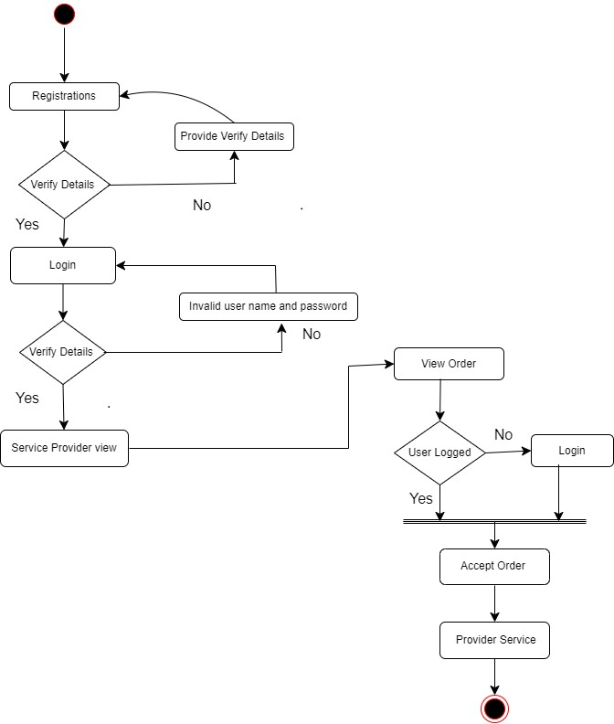

Figure - Activity Diagram for Registration

### 2.3.7 Sequence Diagram for Admin Login

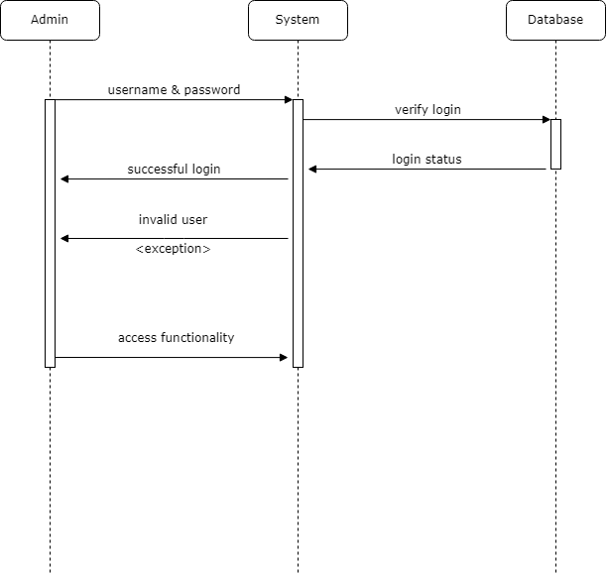

Figure - Sequence Diagram for Admin Login

### 2.3.8 Sequence Diagram for Order

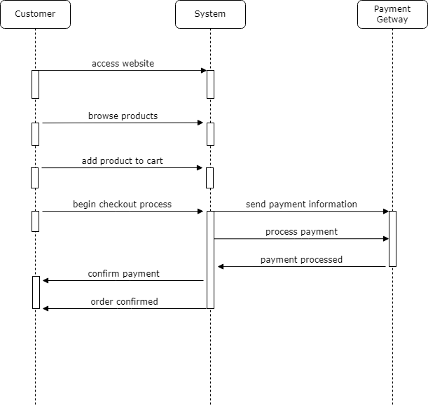

Figure - Sequence Diagram for Order

### 2.3.9 Sequence Diagram for Registration

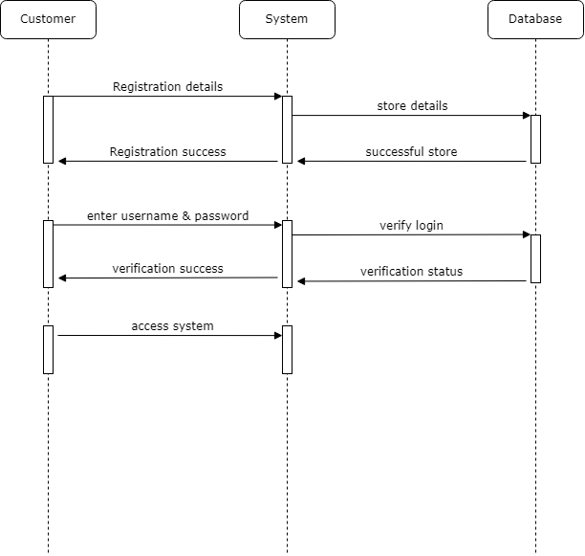

Figure - Sequence Diagram for Registration

### 2.3.10 Class Diagram

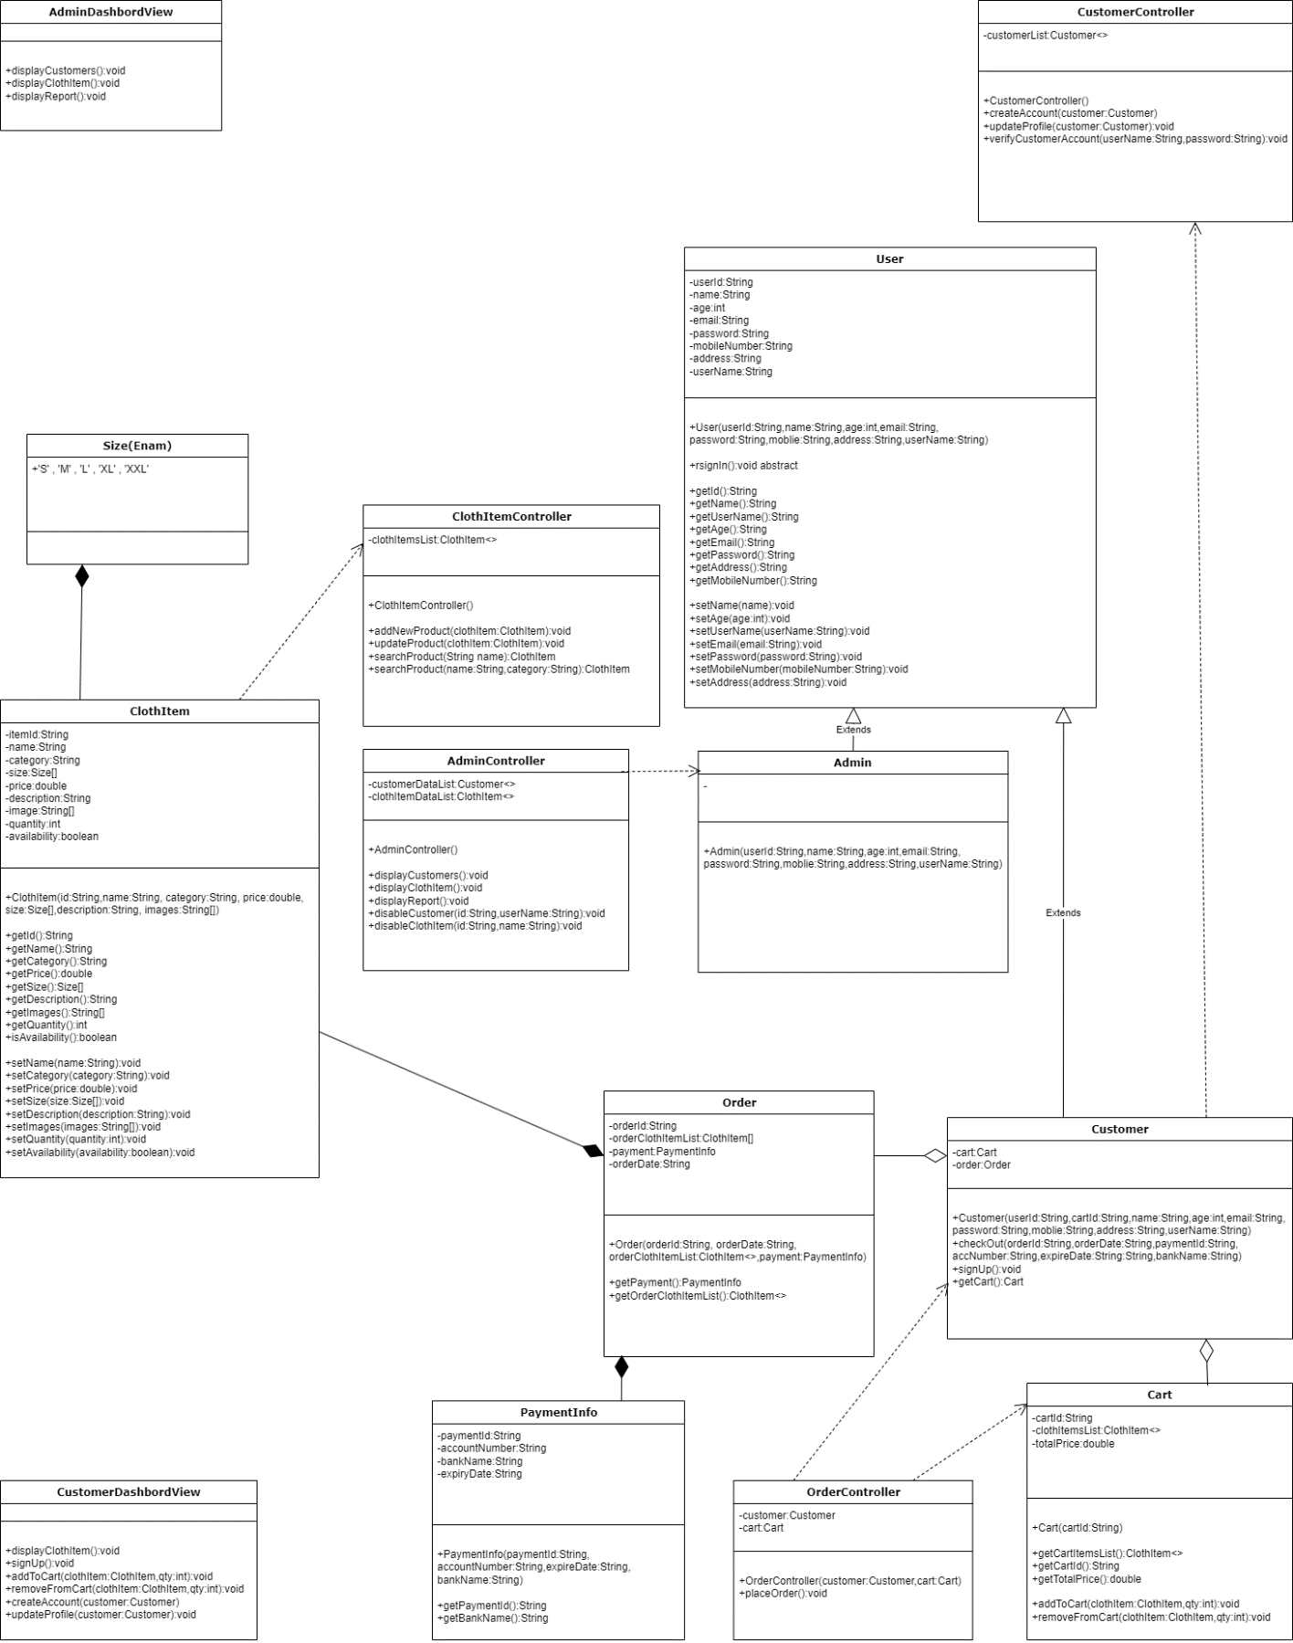

Figure - Class Diagram

### 2.3.11 EER Diagram

Through high-level models and tools, EER Diagram, also known as "Enhanced Entity-Relationship Diagram" assists us in building and maintaining comprehensive databases. Additionally, they are an extended form of the fundamental ER diagrams and were created from them

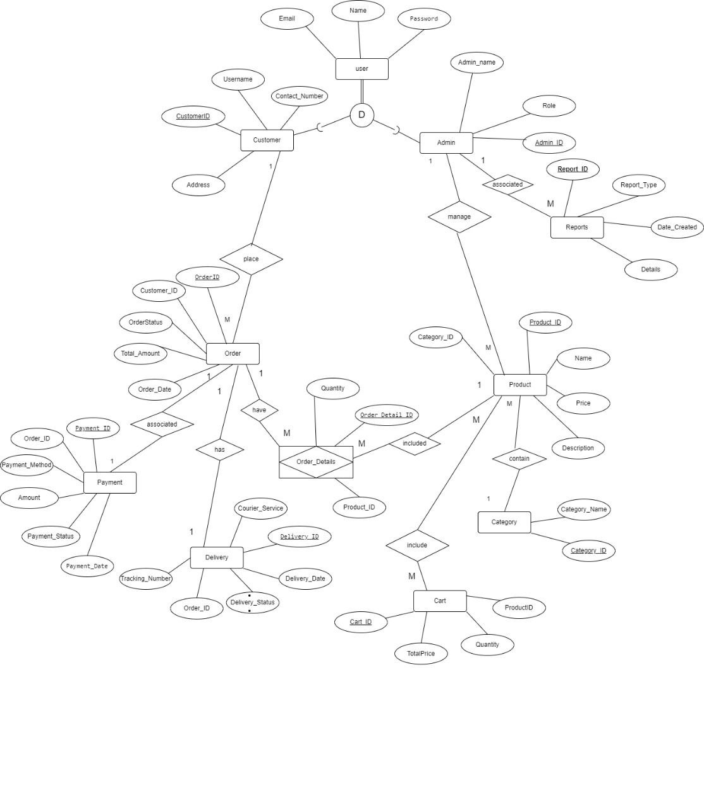

Figure - EER Diagram

**EER Diagram Assumptions**

* Each clothing item belongs to only one category and one subcategory (e.g., Men, Women, Kids).
* The Customer ID uniquely identifies each customer, order, cart, payment, and shipping information.
* Customers can browse clothing items, add them to the cart, and make purchases.
* Customers can browse specific clothing items, including size and availability options.
* After placing an order, customers can track their order status and shipping information.
* Customers can pay for their orders using various payment methods (e.g., credit card, COD) at checkout.
* Only registered customers can place orders and manage their profiles, but unregistered users can browse items.
* Each customer can save multiple shipping addresses but can only select one per order.
* Orders are processed once payment is confirmed, and customers receive a confirmation email.
* Administrators can manage, update product information, and handle customer inquiries.

## 2.4 Database

### 2.4.1 Relational Schema

**User Table**

|  |  |  |
| --- | --- | --- |
| Name | Email | Password |

**Customer Table**

|  |  |  |  |
| --- | --- | --- | --- |
| CustomerID | Username | Address | ContactNumber |

**Admin Table**

|  |  |  |
| --- | --- | --- |
| AdminID | AdminName | Role |

**Order Table**

|  |  |  |  |  |
| --- | --- | --- | --- | --- |
| OrderID | CustomerID | OrderStatus | TotalAmount | OrderDate |

**Reports Table**

|  |  |  |  |
| --- | --- | --- | --- |
| ReportID | ReportType | DateCreated | Details |

**Products Table**

|  |  |  |  |  |
| --- | --- | --- | --- | --- |
| ProductID | ProductName | Description | Price | CategoryID |

**Payment Table**

|  |  |  |  |  |  |
| --- | --- | --- | --- | --- | --- |
| PaymentID | OrderID | PaymentMethod | Amount | PaymentStatus | PaymentDate |

**Delivery Table**

|  |  |  |  |  |  |
| --- | --- | --- | --- | --- | --- |
| DeliveryID | OrderID | CourierService | DeliveryStatus | DeliveryDate | TrackingNumber |

**Category Table**

|  |  |
| --- | --- |
| CategoryID | CategoryName |

**Order Details Table**

|  |  |  |
| --- | --- | --- |
| OrderDetailsID | ProductID | Quantity |

**Cart Table**

|  |  |  |  |
| --- | --- | --- | --- |
| CartID | ProductID | Quantity | TotalAmount |

## 2.5 User Interface

### 2.5.1 Login Interface

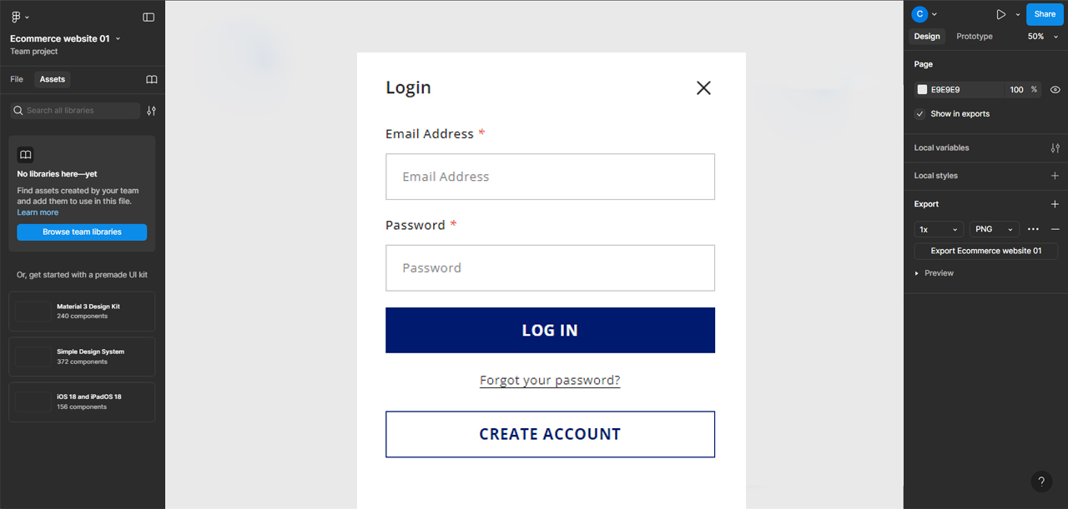

Figure - Login Interface

### 2.5.2 Products Interface

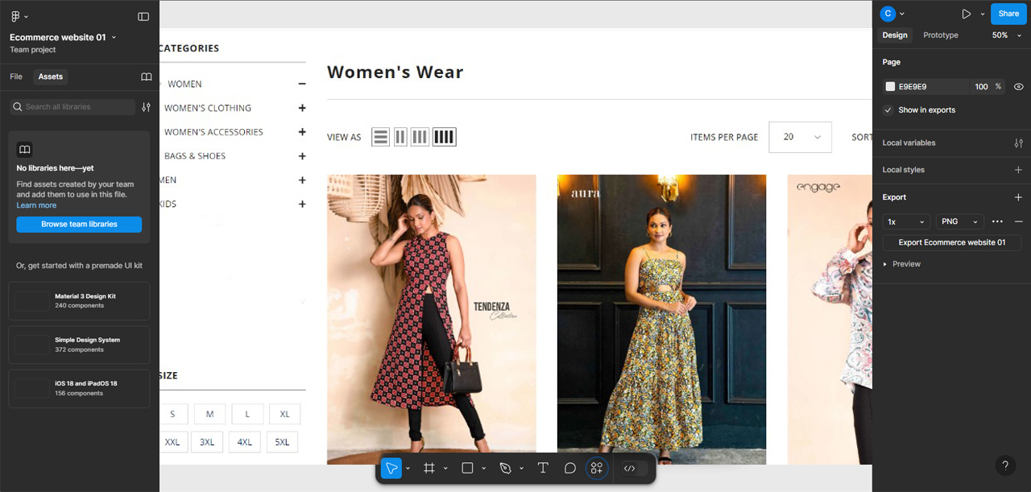

Figure - Products Interface

### 2.5.3 Product Details Interface

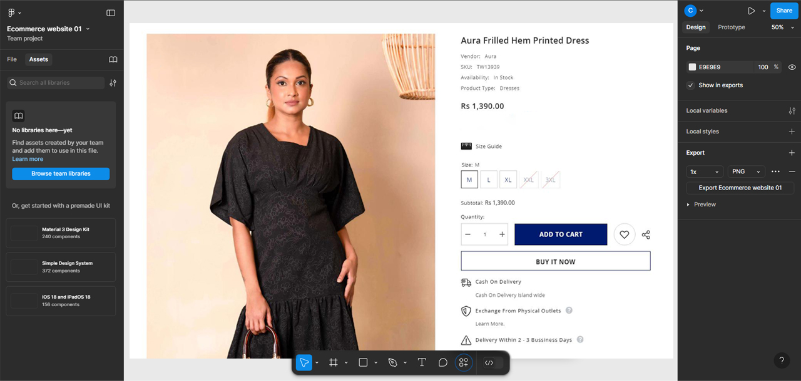

Figure - Product Details Interface

### 2.5.4 Search Option

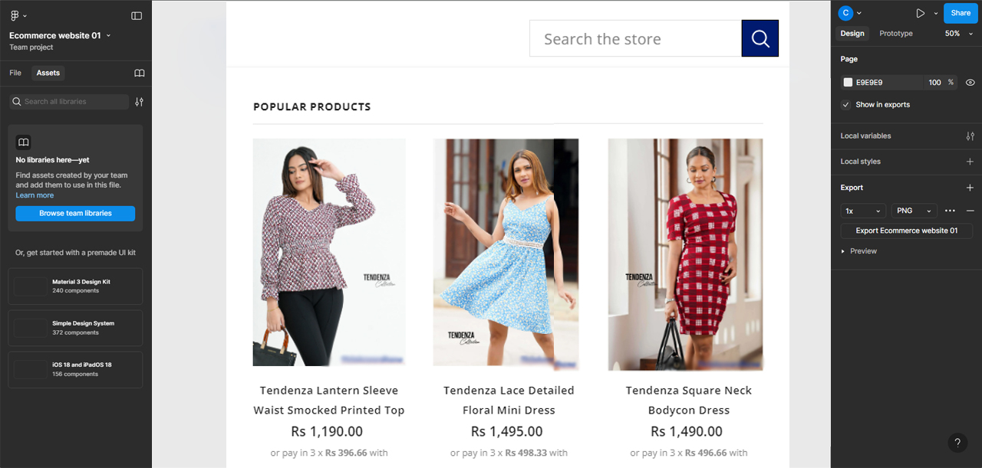

Figure - Search Option

### 2.5.5 Cart Interface

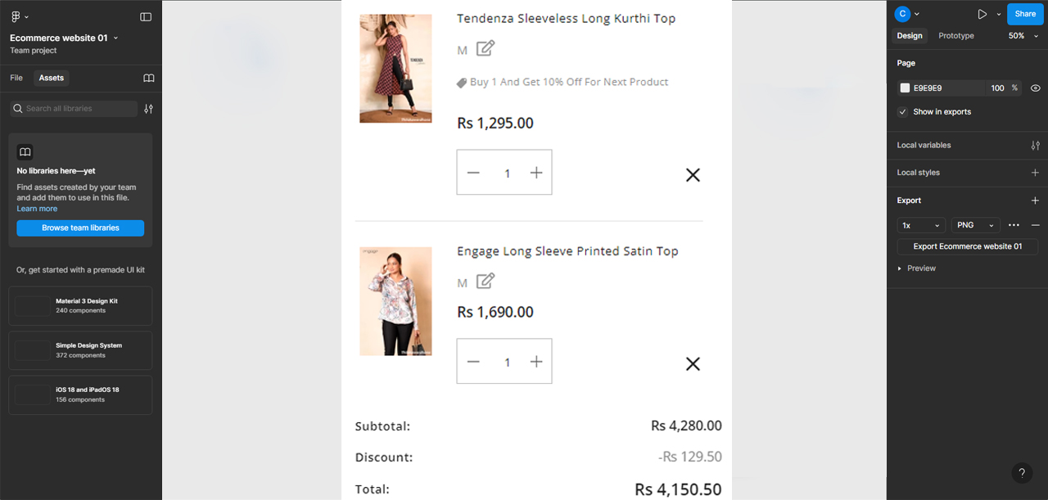

Figure - Cart Interface

# References

[1] “Depop - Buy, Sell, Discover Unique Fashion.” Accessed August 27, 2024. https://www.depop.com/

[2] “Fashion Bug | Online Dress Shopping in Sri Lanka.” Accessed August 27, 2024. https://www.fashionbug.lk/

[3] “GFLOCK Clothing Sri Lanka.” Accessed August 27, 2024. https://gflock.lk/

[4] “House of Fashions Sri Lanka.” Accessed August 27, 2024. https://houseoffashions.lk/ [5] “Kandy Selection.” Accessed August 27, 2024. https://kandyselection.lk/

[6] NOLIMIT. “Home.” Accessed August 27, 2024. https://www.nolimit.lk/

[7] “Poshmark: Buy and Sell Fashion, Home Decor, Beauty & More.” Accessed August 27, 2024. https://poshmark.com/

[8] “Shop Women’s Clothing, Footwear & Accessories Online | Nils Store.” Accessed August 27, 2024. https://nilsonline.lk/

[9] “Thilakawardhana | Online Store.” Accessed August 27, 2024. https://thilakawardhana.com/

[10] “Vinted | Sell and Buy Clothes, Shoes and Accessories.” Accessed August 27, 2024. https://www.vinted.com/