**SOFTWARE REQUIREMENTS SPECIFICATION WEB BASED CLOTHS ORDERING MANAGEMENT SYSTEM FOR**

**LITE FASHION STORE**

**Version 1.0**

Prepared by

Dark Devils

KGDME Jayarathna - E2240438

GSS Lakshan - E2240402

PVMC Wickramasinghe– E2240158

**Created: 30.08.2024**

# Table of Contents

Table of Contents i

List of Tables iii

List of Figures iv

1 Introduction 1

1.1 Purpose 1

1.2 Scope 1

1.3 Definition, Abbreviation and Acronyms 3

1.3.1 Definition 3

1.3.2 Abbreviation & Acronyms 4

1.4 References 5

1.5 Overview 6

2 Overall Description 6

2.1 Product Perspective 6

2.1.1 User Interfaces 6

2.1.2 Hardware Interfaces 11

2.1.3 Software Interfaces 11

2.1.4 Communications Interfaces 12

2.2 Product functions 13

2.2.1 Item and Category Management 13

2.2.2 User Management 13

2.2.3 Order Management 13

2.2.4 Invoice Management 13

2.2.5 Delivery Management 13

2.2.6 Administrator Functions 13

2.2.7 Customer Functions 13

2.3 User Characteristics 13

2.4 Constraints 14

2.5 Assumption and Dependencies 14

3 Specific requirements 15

3.1 Functional requirement 15

3.1.1 User Login / Registration 15

3.1.2 Change Password 15

3.1.3 View Products 16

3.1.4 Add to Cart 16

3.1.5 Manage Cart 17

3.1.6 Place Order 17

3.1.7 Handle Payment 18

3.1.8 Show Order Details 18

3.1.9 View Delivery Status 19

3.1.10 User Logout 19

3.1.11 Admin Login 20

3.1.12 Add, Edit, or Update Products 20

3.1.13 Managing Categories 21

3.1.14 Managing Customers 21

3.1.15 View Orders Details 22

3.1.16 View Delivery Details 22

3.1.18 View Customer Details 23

3.1.18 View Reports 23

3.1.19 Admin Logout 24

3.2 External Interface Requirements 24

3.2.1 User interfaces 24

3.2.2 Hardware interfaces 25

3.2.3 Software interfaces 25

3.2.4 Communication interfaces 25

3.3 System features 25

3.4 Non-Functional Requirement 26

3.5 Logical Database Requirements 27

3.6 Design Constrains 27

3.7 Software and System Attributes 27

3.8 Other requirements 28

4 Appendix 29

4.1 Wireframes 29

# List of Tables

Table 1 - Hardware Interface (Minimum Requirements) 11

Table 2 - User Login / Registration 15

Table 3 - Change Password 15

Table 4 - View Products 16

Table 5 - Add to Cart 16

Table 6 - Manage Cart 17

Table 7 - Place Order 17

Table 8 - Handle Payment 18

Table 9 - Show Order Details 18

Table 10 - View Delivery Status 19

Table 11 - User Logout 19

Table 12 - Admin Login 20

Table 13 - Add, Edit, or Update Products 20

Table 14 - Managing Categories 21

Table 15 - Managing Customers 21

Table 16 - View Orders Details 22

Table 17 - View Delivery Details 22

Table 18 - View Customer Details 23

Table 19 - View Reports 23

Table 20 - Admin Logout 24

# List of Figures

Figure 1 – Home Interface 7

Figure 2 - Login and Registration Interface 8

Figure 3 - Cart Interface 9

Figure 4 - Order History Interface 10

Figure 5 - Admin interface 11

Figure 6 - Communication Interface 12

Figure 7 - ER Diagram Logical Database 27

# 1 Introduction

## Purpose

The purpose of this Software Requirements Specification (SRS) is to provide a detailed and comprehensive description of the Online Clothing Shopping Store (OCSS). This document outlines all the functional and non-functional requirements of the system, serving as a blueprint for developers to build the software in alignment with the specified needs. It defines the features, behaviors, and constraints of the OCSS, ensuring that the software facilitates seamless interactions between customers and sellers, supports efficient order management, and provides a user-friendly shopping experience.

This SRS is intended for multiple audiences, including developers who will use it to understand the technical and functional requirements of the system, and project managers who will reference it to ensure the project is on track and within scope. Clients and stakeholders will use this document to validate that their expectations and needs are accurately captured. The Quality Assurance team will utilize the SRS to develop test cases and procedures for verifying the software's correctness, while administrators and end users can refer to it to understand the system's functionalities and provide feedback during development.

## 1.2 Scope

Users can easily browse collections, make orders, and monitor delivery using our platform's Online Ordering System, which provides a smooth and user-friendly experience. Users may safely establish accounts and access tailored services thanks to strong user registration and authentication capabilities. Clothing items are neatly categorized by the collection browsing functionality, making the selection process easier. Users can add items to their carts, define sizes and quantities, and complete transactions with ease thanks to our secure payment integration, which streamlines the ordering experience. Real-time order tracking increases transparency by letting customers know how their orders are progressing from placing to delivery. Furthermore, users are empowered to share their experiences and offer insightful feedback for ongoing improvement through our review and feedback system.

**Online Ordering System**  
Users can create profiles, browse clothing items, and provide feedback on the website, which also offers secure user registration, collection browsing, order processing, order tracking, and review.

**Point of Sale System**  
The system manages in-store purchases by processing transactions, enabling staff to assist customers, printing receipts, and managing in-store inventory. It also handles order pickups by notifying staff when orders are ready and confirming them before handing them over to customers.

**Report Generation**  
This module provides detailed insights into various aspects of sales reporting, including daily, , monthly, and yearly sales, stock reports, performance analysis, and custom reporting, allowing store owners to generate reports based on specific criteria.

**Goals**

* The primary goal of the clothes’ ordering system is to allow users to easily find clothing items and place orders.
* To provide the owner with straightforward access to employee information and sales reports.
* Providing reliable and high-quality service to all customers registered in the system is a key objective.
* To enhance customer engagement through a user-friendly interface and personalized recommendations.
* To optimize inventory management by providing real-time data on stock levels and product availability.

## 1.3 Definition, Abbreviation and Acronyms

### 1.3.1 Definition

**Customer**  
A customer is an individual or business that purchases clothing items or related products from the website.

**Admin**  
The admin is a key figure in the management and oversight of the clothes ordering system, responsible for ensuring the system functions efficiently. Admins oversee user roles, monitor transactions, manage inventory, and ensure that the platform meets organizational standards. They have full access to all system functionalities and are tasked with maintaining the integrity and security of the platform.

**Staff**  
Staff members are individuals employed by the company to assist with various operational tasks, including inventory management, order processing, customer service, and in-store assistance. They ensure smooth daily operations and contribute to a positive customer experience.

**Courier**  
A courier is responsible for delivering orders to customers. They play a crucial role in the last mile of the delivery process, ensuring that purchased clothing items reach customers in a timely and secure manner. Couriers track deliveries, manage logistics, and maintain communication with both the customer and the company to provide updates on delivery status.

**Supplier**  
A supplier is a vendor or manufacturer that provides clothing items and related products to the company. Suppliers maintain inventory levels, deliver stock as required, and collaborate with the company to ensure a steady supply of products that meet quality and demand standards.

### 1.3.2 Abbreviation & Acronyms

OCSS: Online Clothing Shopping Store

HTML: Hypertext markup language

CSS: Cascading style sheets

JS: JavaScript

PHP: Hypertext Preprocessor

SQL: Structured Query Language

SRS: Software requirement specification

DBMS: Database management system

UI: User Interface

UX: User Experience

SQA: Software quality assurance

GB: Giga byte

HTTP: Hypertext transfer protocol

## 1.4 References

[1] “Depop - Buy, Sell, Discover Unique Fashion.” Accessed August 27, 2024. <https://www.depop.com/>

[2] “Fashion Bug | Online Dress Shopping in Sri Lanka.” Accessed August 27, 2024. <https://www.fashionbug.lk/>

[3] “GFLOCK Clothing Sri Lanka.” Accessed August 27, 2024. <https://gflock.lk/>

[4] “House of Fashions Sri Lanka.” Accessed August 27, 2024. <https://houseoffashions.lk/>

[5] “Kandy Selection.” Accessed August 27, 2024. <https://kandyselection.lk/>

[6] NOLIMIT. “Home.” Accessed August 27, 2024. <https://www.nolimit.lk/>

[7] “Poshmark: Buy and Sell Fashion, Home Decor, Beauty & More.” Accessed August 27, 2024. <https://poshmark.com/>

[8] “Shop Women’s Clothing, Footwear & Accessories Online | Nils Store.” Accessed August 27, 2024. <https://nilsonline.lk/>

[9] “Thilakawardhana | Online Store.” Accessed August 27, 2024. <https://thilakawardhana.com/>

[10] “Vinted | Sell and Buy Clothes, Shoes and Accessories.” Accessed August 27, 2024. <https://www.vinted.com/>

## 1.5 Overview

In traditional manual systems, managing extensive product catalogs and processing orders can be difficult, leading to inefficiencies in data entry, updates, and access to vital management information. To overcome these challenges, we are developing a Clothes Ordering System. This System Requirements Specification (SRS) is directed at the project development team, which includes the project manager, developers, quality assurance specialists, designers, testers, and end-users. Their role is to ensure the system aligns with customer needs and expectations.

The clothes ordering web-based system is designed to streamline the process of managing and purchasing clothing items online. It encompasses several core functionalities, user management, order processing, invoice generation, and delivery coordination. The system provides administrative functions to oversee product listings, view detailed reports, and manage customer information. Customers can create accounts, browse products, add items to their cart, and complete purchases.

# 2 Overall Description

# 

## 2.1 Product Perspective

This product is tailored for individuals who prefer the convenience of shopping from home. It caters to those who may have a busy lifestyle, limited time, or simply a desire to avoid the hassle of in-store shopping and its associated formalities. By providing a seamless online shopping experience, this product allows users to browse, purchase, and manage their orders effortlessly from any location.

This system includes both a front-end interface for customers and a back-end interface for staff members. The back end is managed by staff, where they handle tasks such as inventory management, order processing, and report generation. These reports are crucial for management, providing insights into sales trends, inventory levels, and other metrics necessary for optimizing daily operations. The front end, on the other hand, is accessed by customers, allowing them to browse collections and place orders.

### 2.1.1 User Interfaces

The clothes ordering system prioritizes an intuitive graphical user interface (GUI) to enhance user engagement and satisfaction. A clear and user-friendly GUI is essential for attracting customers and ensuring a seamless shopping experience. The interface is designed with ease of navigation in mind, allowing users to effortlessly browse collections, select items, and complete their purchases. By maintaining a clean and straightforward design, the system ensures that users can interact with the platform without confusion, thereby improving overall usability and customer satisfaction.



Figure – Home Interface

#### 2.1.1.1 Login and Registration Interface

The clothes ordering system offers a seamless login and registration process designed to provide users with easy access to the platform. If the user is already registered, they can access the system by entering their username and password in the provided text fields and clicking the "Login" button. The system verifies the credentials, allowing access to the user's account if the information is valid.

For new users who are not yet registered, clicking the "Sign Up" button will direct them to the registration interface. Here, users can create an account by entering the required information in the provided text fields, including full name, username, phone number, email, address, province, and district. After completing the form and clicking the "Register" button, the user’s details are saved, allowing them to log in to the system using their newly created credentials.

**Requirements for Login:**

* The user must be registered.
* The user must enter a valid username and password, as specified during registration.

**Requirements for Registration:**

* A valid email address is required.
* The user must create a password that is secure and easy to remember.

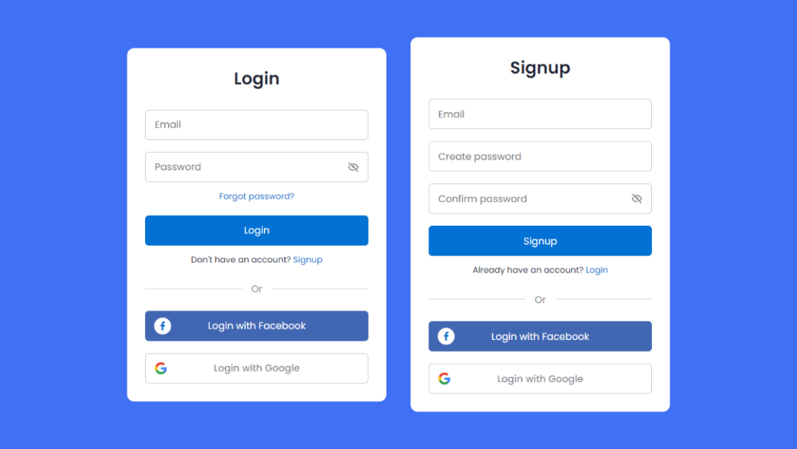

Figure - Login and Registration Interface

#### 2.1.1.2 Cart Interface

The Cart Interface in the clothes’ ordering system is designed to provide users with a convenient and organized way to manage their selected items before making a purchase. As users browse through the collections, they can add desired clothing items to their cart, where each item is displayed with its details, such as name, size, quantity, and price. The cart allows users to review their selections, update quantities, remove items, or save them for later. Additionally, the interface provides a clear summary of the total cost, including any applicable discounts or shipping fees. The Cart Interface ensures a smooth transition from shopping to checkout, offering users a streamlined and user-friendly experience as they finalize their orders.

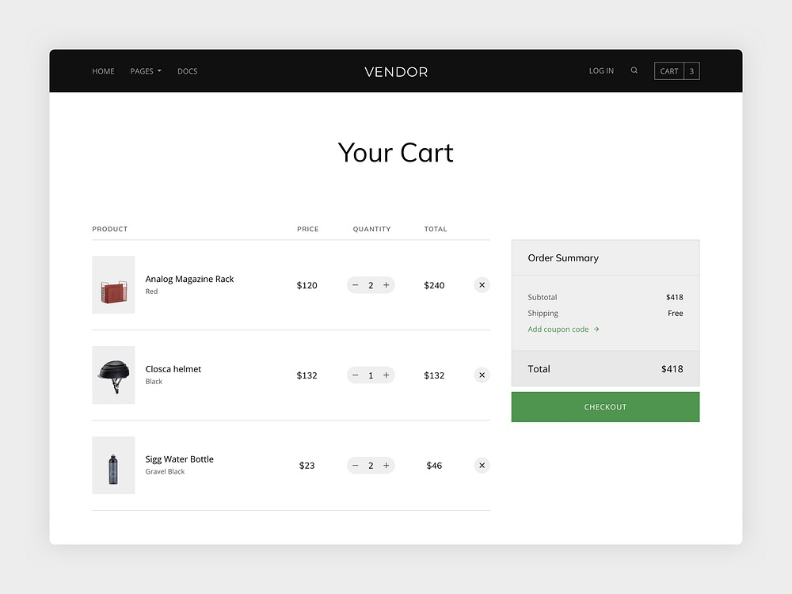

Figure - Cart Interface

##### 2.1.2.3 Order History Interface

The Order History Interface in the clothing ordering system allows users to view and manage their past orders. It displays a list of previous orders with details such as order date, items purchased, total cost, and order status. Users can view detailed order information. Additionally, the interface supports real-time status.

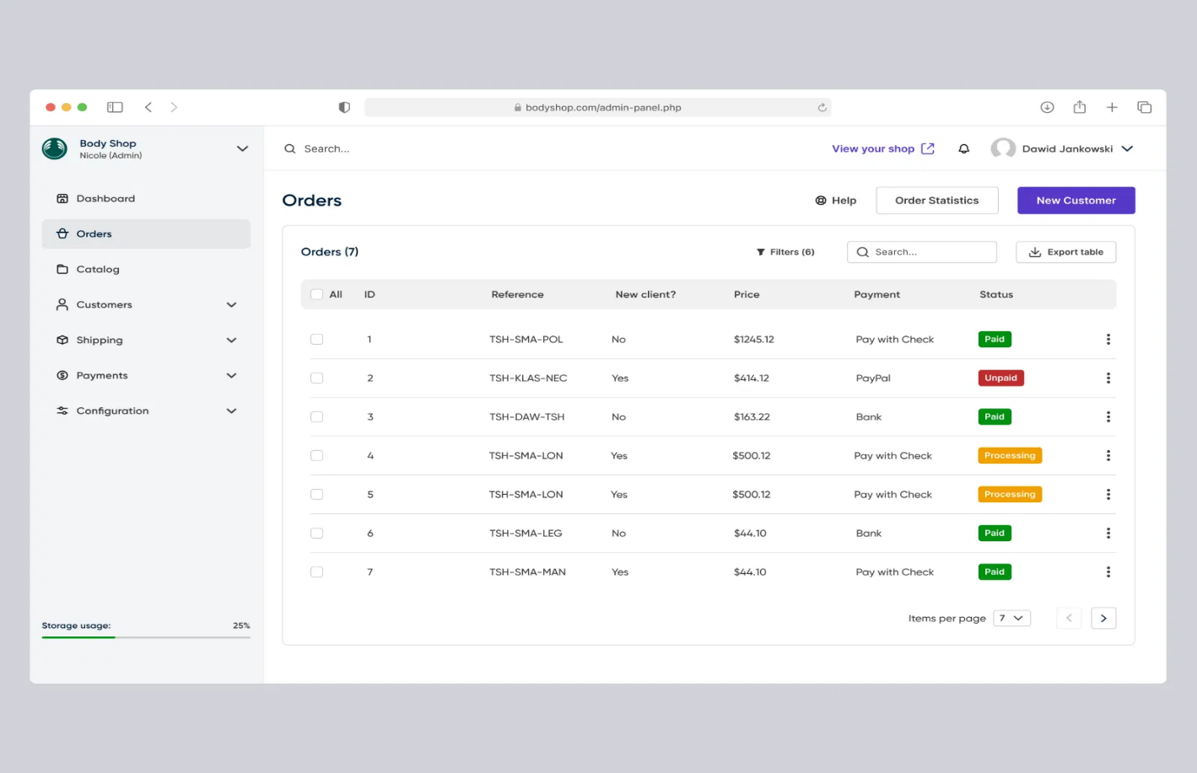

Figure - Order History Interface

##### 2.1.2.3 Admin Interface

The admin panel provides administrators with essential controls to manage and safeguard the clothes ordering system effectively. The main admin, who has access to the host database, holds the authority to:

* Add or remove staff members from the system.
* Add or remove product categories.
* Remove posts or content.

Sub-admins are granted permissions to manage various administrative tasks, except those specifically reserved for the main admin, such as database access and higher-level system controls.

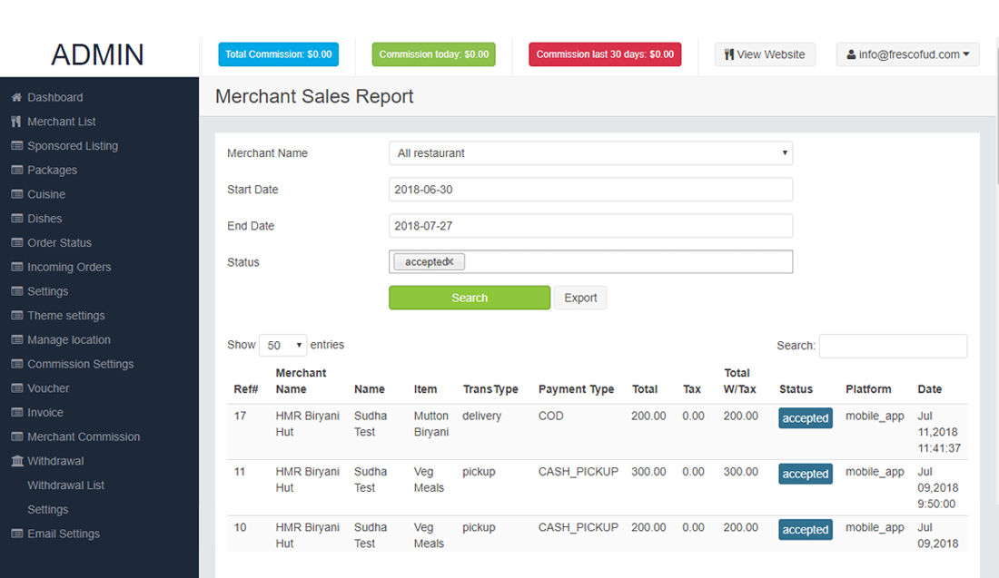

Figure - Admin interface

### 2.1.2 Hardware Interfaces

The hardware requirements are consistent for both users and administrators, ensuring compatibly and smooth operation across various devices:

|  |  |
| --- | --- |
| Processor Size | Intel(R) Core (TM) i3-3227U CPU @ 1.90GHz 1.90 GHz |
| Memory Size | 2.00 GB (1.88 GB usable) |
| Hard Disk Size | 128GB |
| Display Size | 11.6 inches or above |

Table - Hardware Interface (Minimum Requirements)

### 2.1.3 Software Interfaces

The Online Clothes Ordering System utilizes the following software interfaces and tools

* Front-End Technologies:
  + HTML5 for structuring web pages.
  + CSS for styling and layout.
  + JavaScript (JS) for dynamic and interactive features.
  + jQuery for simplified DOM manipulation and AJAX handling.
  + Bootstrap for responsive design and pre-designed components.
* Back-End Technologies:
  + PHP (version 7.4) for server-side scripting and database management.
  + MySQL for relational database management and data storage.
* Development and Collaboration Tools:
  + VS Code as the primary integrated development environment (IDE).
  + Git for version control and collaborative development.
* Design and Documentation Tools:
  + Pencil for wireframing and mockup creation.
  + Microsoft Word for documentation and specification writing.

### 2.1.4 Communications Interfaces

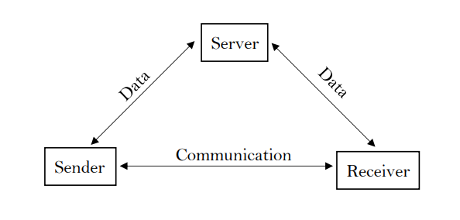

Figure 6 - Communication Interface

For seamless communication and data exchange, both owners and users must be connected to either a Local Area Network (LAN) or a Wide Area Network (WAN).

* **Data Transmission:** Communication between users and the server relies on a stable network connection to facilitate the transfer of data.
* **Server Communication:** The server acts as the central point of communication, receiving data from users, processing it, and then sending the appropriate responses back.
* **Sender and Receiver:** In the communication process, data is sent from a sender (client or user) and received by a receiver (server), ensuring real-time data flow and efficient interactions.

## 2.2 Product functions

### 2.2.1 Item and Category Management

Manage inventory by adding, updating, and removing products, and organize them into categories to enhance the shopping experience.

### 2.2.2 User Management

Oversee user accounts, including registration, login, profile updates, and view all registered customer details to ensure secure and personalized interactions.

### 2.2.3 Order Management

Handle the entire order lifecycle, from placement to fulfillment, ensuring smooth processing and customer satisfaction.

### 2.2.4 Invoice Management

Automate the creation and management of invoices for all transactions to maintain financial accuracy and clarity.

### 2.2.5 Delivery Management

Coordinate the shipping process, including tracking and delivery updates, to ensure timely and reliable order delivery.

### 2.2.6 Administrator Functions

Access detailed reports on sales, view and edit product details, and manage customer information to make informed decisions and maintain accurate records.

### 2.2.7 Customer Functions

Sign in, sign up, and manage account details, add products to the cart, checkout using cash-on-delivery, and provide feedback on their shopping experience.

## 2.3 User Characteristics

* Customers: Primarily individuals looking to purchase clothing items online. They are comfortable with browsing, selecting products, adding items to cart, and checking out securely.
* Administrators: Staff members responsible for managing the system, user accounts, orders, and generating reports. They require comprehensive access and control functionalities.
* Visitors: Users exploring the website without logging in, able to browse products and view basic information.
* Shop Owners: Individuals or entities managing product listings, pricing, and promotions through the system.
* Delivery Personnel: Responsible for ensuring timely and accurate delivery of orders to customers.

## 2.4 Constraints

* Database Implementation: Utilize a centralized database management system (DBMS) to store and manage all data related to products, orders, users, and transactions.
* Language Support: The system will operate primarily in English. Users should be comfortable interacting with the system in English.
* Security Standards: Implement robust security measures to password protect user data, and admin dashboard.
* Usability: Ensure the interface is intuitive and user-friendly, accommodating users with varying levels of technical proficiency.
* Performance: Optimize system performance to ensure fast loading times, smooth navigation, and responsive interactions across different devices and network conditions.

## 2.5 Assumption and Dependencies

It is assumed that the system is going to use both computers and mobile devices. Then it must be responsive to the device that the user uses (mobile responsive). It is assumed that customer has a working operating system that supports this developed Online Shopping System Application. And customer also has a working Internet Connection.

# 3 Specific requirements

## 3.1 Functional requirement

### 3.1.1 User Login / Registration

|  |  |
| --- | --- |
| Use Case | Registration |
| Actor | Customer |
| Description | |  | | --- | | The system shall allow users to register with unique usernames and passwords. |  |  |  | | --- | --- | |  | - Registered users shall be able to log in using their credentials securely. |  |  |  | | --- | --- | |  | - Passwords shall be encrypted for security purposes. |  |  |  | | --- | --- | |  | - Upon successful login, users shall be redirected to the homepage where they can browse products. | |
| Pre-Condition | User must have a device with internet access.  User must not already have an existing account for registration. |
| Post-Condition | User is logged into the system or registered successfully.  User’s session is securely initiated and maintained. |

Table - User Login / Registration

### 3.1.2 Change Password

|  |  |
| --- | --- |
| Use Case | Change Password |
| Actor | Customer |
| Description | |  | | --- | | Registered users shall have the capability to change their passwords. |  |  |  | | --- | --- | |  | - Password change process shall require current password authentication. |  |  |  | | --- | --- | |  | - Users shall receive a confirmation message upon successfully changing their password. | |
| Pre-Condition | |  |  | | --- | --- | |  | User must be logged in to change their password. |  |  |  | | --- | --- | |  | User must know their current password. | |
| Post-Condition | |  | | --- | | User's password is updated in the system. |  |  |  | | --- | --- | |  | A confirmation message is displayed to the user. | |

Table - Change Password

### 3.1.3 View Products

|  |  |
| --- | --- |
| Use Case | View Products |
| Actor | Customer |
| Description | |  | | --- | | Users shall be able to browse and view available products with details (name, price, description). |  |  |  | | --- | --- | |  | - The system shall allow users to filter and sort products based on categories and price ranges. |  |  |  | | --- | --- | |  | - High-resolution images of the products shall be displayed for better user experience. | |
| Pre-Condition | User must be logged in or have access to the public website. |
| Post-Condition | Products are displayed based on user preferences (filters and sorting). |

Table - View Products

### 3.1.4 Add to Cart

|  |  |
| --- | --- |
| Use Case | Add to Cart |
| Actor | Customer |
| Description | |  | | --- | | Users shall be able to add products to their shopping cart. |  |  |  | | --- | --- | |  | - The system shall update the cart total dynamically as items are added or removed. |  |  |  | | --- | --- | |  | - Users shall receive notifications when items are added to their cart successfully. | |
| Pre-Condition | User must be logged in and viewing a product. |
| Post-Condition | Selected products are added to the user's cart.  Cart details are updated in real-time. |

Table - Add to Cart

### 3.1.5 Manage Cart

|  |  |
| --- | --- |
| Use Case | Manage Cart |
| Actor | Customer |
| Description | |  | | --- | | Users shall be able to view their current cart contents, modify quantities, and remove items. |  |  |  | | --- | --- | |  | - The cart shall be saved for each user session, allowing users to return to their cart later. |  |  |  | | --- | --- | |  | - Users shall see an updated total cost immediately when cart contents are modified. | |
| Pre-Condition | User must have added at least one product to their cart. |
| Post-Condition | Cart is updated with the user’s desired changes.  The system shows an updated total amount. |

Table - Manage Cart

### 3.1.6 Place Order

|  |  |
| --- | --- |
| Use Case | Place Order |
| Actor | Customer |
| Description | |  | | --- | | Users shall be able to place orders for items in their cart. |  |  |  | | --- | --- | |  | - The system shall prompt users to confirm shipping details before finalizing the order. |  |  |  | | --- | --- | |  | - An order confirmation email shall be sent to users upon successful order placement. | |
| Pre-Condition | User must have items in their cart and be logged in. |
| Post-Condition | Order is successfully placed and recorded in the system.  User receives a confirmation email with order details. |

Table - Place Order

### 3.1.7 Handle Payment

|  |  |
| --- | --- |
| Use Case | Handle Payment |
| Actor | Customer |
| Description | |  | | --- | | The system shall support secure payment processing using standard payment gateways. |  |  |  | | --- | --- | |  | - Users shall receive confirmation of successful payment or failure with appropriate error handling. |  |  |  | | --- | --- | |  | - Multiple payment methods, such as credit cards, debit cards, and digital wallets, shall be supported. | |
| Pre-Condition | User must be logged in and have a valid payment method. |
| Post-Condition | Payment is processed, and user is notified of the payment status.  Order status is updated based on payment success or failure. |

Table - Handle Payment

### 3.1.8 Show Order Details

|  |  |
| --- | --- |
| Use Case | Show Order Details |
| Actor | Customer |
| Description | |  | | --- | | Users shall be able to view detailed information about their placed orders (items, quantities, total). |  |  |  | | --- | --- | |  | - The system shall allow users to print or download order receipts for their records. |  |  |  | | --- | --- | |  | - Order history shall be accessible from the user’s account dashboard. | |
| Pre-Condition | User must be logged in and have at least one order placed. |
| Post-Condition | Detailed order information is displayed to the user. |

Table - Show Order Details

### 3.1.9 View Delivery Status

|  |  |
| --- | --- |
| Use Case | View Delivery Status |
| Actor | Customer |
| Description | |  | | --- | | Users shall be able to track the status of their orders (processing, shipped, delivered). |  |  |  | | --- | --- | |  | - The system shall send users notifications when the status of their order changes. |  |  |  | | --- | --- | |  | - Detailed delivery information, such as courier service and tracking number, shall be provided. | |
| Pre-Condition | User must be logged in and have an active order. |
| Post-Condition | Current delivery status is shown to the user.  Notifications are sent to the user regarding status changes. |

Table - View Delivery Status

### 3.1.10 User Logout

|  |  |
| --- | --- |
| Use Case | User Logout |
| Actor | Customer |
| Description | |  | | --- | | Users shall have the option to securely log out from their accounts. |  |  |  | | --- | --- | |  | - The system shall automatically log out users after a period of inactivity for security purposes. |  |  |  | | --- | --- | |  | - Users shall receive a confirmation message upon successful logout. | |
| Pre-Condition | User must be logged in. |
| Post-Condition | User is securely logged out, and their session is terminated.  User is redirected to the login or home page. |

Table - User Logout

### 3.1.11 Admin Login

|  |  |
| --- | --- |
| Use Case | Admin Login |
| Actor | Admin |
| Description | |  | | --- | | Administrators shall have a secure login process with unique credentials. |  |  |  | | --- | --- | |  | - Admin accounts shall have multi-factor authentication for enhanced security. |  |  |  | | --- | --- | |  | - Successful login shall grant access to the admin dashboard with various management tools. | |
| Pre-Condition | Admin must have valid credentials and access rights.  Admin access given by the owner. |
| Post-Condition | User is logged into the system or registered successfully.  User’s session is securely initiated and maintained. |

Table - Admin Login

### 3.1.12 Add, Edit, or Update Products

|  |  |
| --- | --- |
| Use Case | Add, Edit, or Update Products |
| Actor | Admin |
| Description | |  | | --- | | Administrators shall be able to add new products, edit existing ones, or update product details. |  |  |  | | --- | --- | |  | - The system shall allow bulk product uploads using CSV files. |  |  |  | | --- | --- | |  | - Changes to products shall be reflected in the user interface in real-time. | |
| Pre-Condition | Admin must be logged in and have the necessary permissions. |
| Post-Condition | Product catalog is updated, and changes are visible to all users. |

Table - Add, Edit, or Update Products

### 3.1.13 Managing Categories

|  |  |
| --- | --- |
| Use Case | Managing Categories |
| Actor | Admin |
| Description | |  | | --- | | Administrators shall have the capability to manage product categories (add, edit, delete). |  |  |  | | --- | --- | |  | - Categories shall be displayed in a hierarchical structure for better organization. |  |  |  | | --- | --- | |  | - The system shall allow administrators to assign multiple products to a category at once. | |
| Pre-Condition | Admin must be logged in and have appropriate access rights. |
| Post-Condition | Categories are updated, and changes are reflected in the system. |

Table - Managing Categories

### 3.1.14 Managing Customers

|  |  |
| --- | --- |
| Use Case | Managing Customers |
| Actor | Admin |
| Description | |  | | --- | | Administrators shall be able to view and manage customer information (details, orders). |  |  |  | | --- | --- | |  | - The system shall allow administrators to search for customers by name, email, or order history. |  |  |  | | --- | --- | |  | - Admins shall be able to reset customer passwords and manage their account status. | |
| Pre-Condition | Admin must be logged in with the correct permissions. |
| Post-Condition | Customer data is managed and updated in the system. |

Table - Managing Customers

### 3.1.15 View Orders Details

|  |  |
| --- | --- |
| Use Case | View Orders Details |
| Actor | Admin |
| Description | |  | | --- | | Administrators shall have access to detailed information about all orders placed. |  |  |  | | --- | --- | |  | - The system shall provide filtering options for viewing orders based on date, status, or customer. |  |  |  | | --- | --- | |  | - Admins shall be able to generate invoices for orders directly from the order details page. | |
| Pre-Condition | Admin must be logged in and have access to order management functionalities. |
| Post-Condition | Detailed order information is displayed to the administrator. |

Table - View Orders Details

### 3.1.16 View Delivery Details

|  |  |
| --- | --- |
| Use Case | View Delivery Details |
| Actor | Admin |
| Description | |  | | --- | | Administrators shall be able to track delivery status and details for each order. |  |  |  | | --- | --- | |  | - The system shall allow admins to update delivery statuses manually if needed. |  |  |  | | --- | --- | |  | - Detailed delivery logs shall be maintained for auditing purposes. | |
| Pre-Condition | Admin must be logged in and have the appropriate permissions. |
| Post-Condition | Delivery details are updated and visible to administrators. |

Table - View Delivery Details

### 3.1.18 View Customer Details

|  |  |
| --- | --- |
| Use Case | View Customer Details |
| Actor | Admin |
| Description | |  | | --- | | Administrators shall be able to view detailed customer information (name, contact, address). |  |  |  | | --- | --- | |  | - Customer profiles shall include order history, payment methods, and saved addresses. |  |  |  | | --- | --- | |  | - The system shall allow administrators to export customer details for reporting purposes. | |
| Pre-Condition | Admin must be logged in with the necessary access rights. |
| Post-Condition | Customer details are displayed or exported as needed. |

Table - View Customer Details

### 3.1.18 View Reports

|  |  |
| --- | --- |
| Use Case | View Reports |
| Actor | Admin |
| Description | |  | | --- | | Administrators shall have access to generate and view various reports (sales, inventory, etc.). |  |  |  | | --- | --- | |  | - The system shall support custom report generation with selectable parameters (date range, category). |  |  |  | | --- | --- | |  | - Reports shall be exportable in multiple formats, such as PDF and Excel. | |
| Pre-Condition | Admin must be logged in and have the appropriate permissions. |
| Post-Condition | Reports are generated and displayed or exported as per the administrator's request. |

Table - View Reports

### 3.1.19 Admin Logout

|  |  |
| --- | --- |
| Use Case | Admin Logout |
| Actor | Admin |
| Description | |  | | --- | | Administrators shall have the option to securely log out from their accounts. |  |  |  | | --- | --- | |  | - The system shall automatically log out admins after a period of inactivity for security purposes. |  |  |  | | --- | --- | |  | - Admins shall receive a confirmation message upon successful logout. | |
| Pre-Condition | Admin is securely logged out, and their session is terminated. |
| Post-Condition | Admin is redirected to the login page. |

Table - Admin Logout

## 3.2 External Interface Requirements

The external interface requirements for the online clothes ordering system are outlined below, detailing all necessary inputs and outputs, their purpose, and their relationships to the system's functionality.

### 3.2.1 User interfaces

The user interface should provide a seamless and intuitive experience for customers and administrators. The interface will include various input fields, such as registration forms for new users, login credentials, and search fields for locating products. Each input must be accurately formatted, with fields accepting only valid data types (e.g., text for names, emails, and addresses, and numerical values for phone numbers and payment information). The output will display the results of searches, order confirmations, and user account details. The system will adhere to standard window and screen formats, ensuring consistency across devices, with clearly organized menus, buttons, and options that guide users through the process of searching for products, adding them to the cart, and placing an order. Error messages and end messages (e.g., "Order Successful") will provide clear feedback based on user actions.

### 3.2.2 Hardware interfaces

The system will operate on various hardware platforms, including desktops, laptops, tablets, and smartphones. Inputs will be received via standard hardware components such as keyboards, mice, and touchscreens. The system will also interface with external devices, such as printers for generating order invoices and receipt confirmations. The inputs and outputs will be formatted to accommodate different resolutions and device capabilities, ensuring that data is presented accurately regardless of the hardware being used. The system's performance should remain stable across all hardware interfaces, maintaining low latency and high responsiveness.

### 3.2.3 Software interfaces

Since this system operates on the web, it requires only an internet connection and a compatible web browser to function. On the server side, the front end is developed using HTML5, CSS, and JavaScript frameworks like jQuery 3.7.1, as well as web frameworks such as Bootstrap. For the back end, PHP version 8.3.10 and MySQL are essential components that support the system's operation.

### 3.2.4 Communication interfaces

The system will use several communication protocols to facilitate interactions between users and servers. It will rely on HTTP/HTTPS for all web-based communications, ensuring secure and encrypted data exchange. The system will use SMTP to send confirmation emails, notifications, and updates to users, requiring compatibility with various email service providers. The format and timing of these communications will be managed to ensure timely delivery, and messages will be clear and concise, with appropriate error handling for failed or delayed messages.

## 3.3 System features

**Description and Priorities**

* Customer registration
* Personalization of the user account
* Modifying or updating personal details
* Searching for or selecting products
* Adding items to the cart and choosing options required for placing an order
* Placing the order

**Stimulus/Response Sequence**

* Registering as a customer
* Logging into the user account
* Searching for desired clothing or viewing recommended items
* Selecting an item and clicking the "Add to Cart" button
* Adjusting size and other product attributes as needed
* Choosing a payment method (if a card is selected, linking the bank account to the site)
* Placing the order by clicking the “Order Now” button
* Initiating the delivery process to have the item shipped to the specified address

## 3.4 Non-Functional Requirement

#### Performance Requirements

To ensure optimal speed, the system must support a maximum number of uploads from individual customers, allowing simultaneous access by any number of users at any time. User connections to the servers will depend on user attributes, such

#### Safety Requirements

The application is protected by passwords, and only authorized users are permitted to update new product entries or process orders. Data security is maintained through a backup process to safeguard against data loss due to errors or viruses. In case of data loss, the backup service will facilitate the recovery of valuable user information and accounts.

#### Security Requirements

It uses encrypted methods to save users' passwords into the database and secure your details.

* **Usability Requirements**

The system should have an intuitive and user-friendly interface that enables customers to easily browse products, add items to the cart, and complete the checkout process with minimal effort. It should be accessible across multiple devices, such as desktops, tablets, and smartphones, and support multiple languages to cater to a diverse user base.

* **Scalability Requirements**

The system must be able to scale efficiently to accommodate an increasing number of users and transactions without degrading performance. It should support a growing inventory of products, and be able to handle additional server loads during peak shopping periods, such as holidays or sales events.

## 3.5 Logical Database Requirements

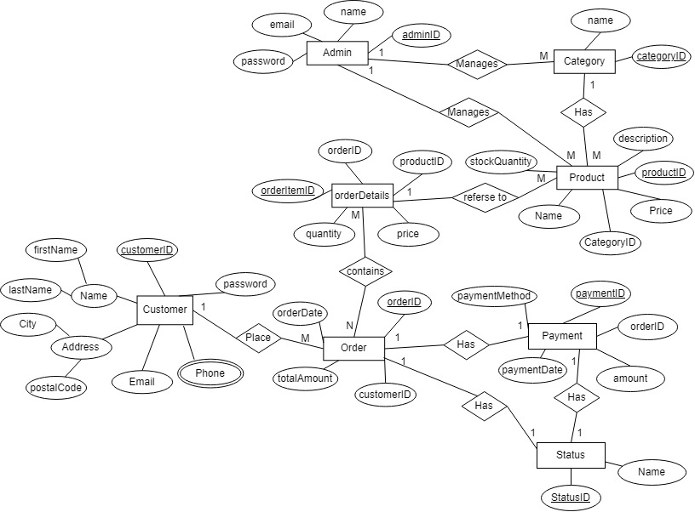

Figure - ER Diagram Logical Database

## 3.6 Design Constrains

The design of the clothes ordering web-based system must adhere to web accessibility standards to ensure usability for all users, including those with disabilities. It needs to be compatible with major web browsers and responsive on various devices. Data storage solutions must be robust and capable of handling large volumes of data, ensuring reliable access and retrieval.

## 3.7 Software and System Attributes

Flexibility, reusability, robustness, and maintainability are key attributes that should be optimized in the online clothes ordering system to improve user experience and system performance.

* **Reliability:** The system must consistently provide accurate and dependable results, ensuring that users can trust it for their clothing orders.
* **Availability:** The system should be accessible to users at all times, minimizing downtime and interruptions to maintain seamless service.
* **Accessibility:** The system must be usable by all customers, including those with disabilities, by adhering to established accessibility standards and best practices.

## 3.8 Other requirements

* An individual must formally request and be granted access before being assigned admin privileges in the system.
* Ensure a reliable internet connection is consistently available to maintain accurate and up-to-date status information.
* Profile data must be editable by users and saved permanently to ensure changes are retained.
* The system must provide real-time updates for inventory levels to prevent overselling.
* Regular backups of all critical data should be performed to safeguard against data loss.

# 4 Appendix

## 4.1 Wireframes

## 

