Code

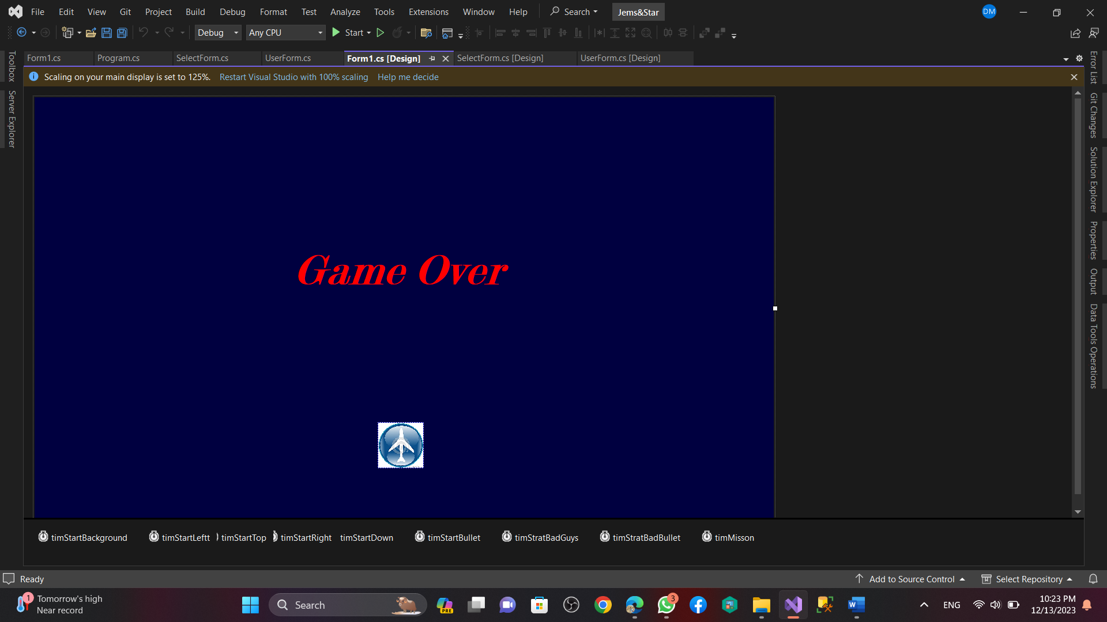

**using System;**

**using System.Collections.Generic;**

**using System.ComponentModel;**

**using System.Data;**

**using System.Drawing;**

**using System.Linq;**

**using System.Media;**

**using System.Text;**

**using System.Threading.Tasks;**

**using System.Windows.Forms;**

**using WMPLib;**

**namespace Jems_Star**

**{**

**public partial class Form1 : Form**

**{**

**//.................veriable**

**int missionComplete;**

**int PlayerSpeed;**

**int bulletSpeed;**

**int badBulletSpeed;**

**int badGuysSpeed;**

**int backgroundspeed;**

**int score;**

**int level;**

**int deficulty;**

**bool pause;**

**bool gameIsOver;**

**//.................veriable over**

**//........................................pic box..........**

**PictureBox[] bulet3;**

**PictureBox[] badGuys;**

**PictureBox[] badBullet;**

**PictureBox[] stars;**

**//........................................pic box over...........**

**//........................................miusic............**

**WindowsMediaPlayer backMusic;**

**WindowsMediaPlayer bulletSound;**

**WindowsMediaPlayer badGuysBoomMusic;**

**Random rnd;**

**//........................................music over..........**

**public Form1()**

**{**

**InitializeComponent();**

**}**

**public void startsTimer()**

**{**

**for (int i = 0; i < stars.Length / 2; i++)**

**{**

**stars[i].Top += backgroundspeed;**

**if (stars[i].Top >= this.Height)**

**{**

**stars[i].Top = stars[i].Height;**

**}**

**}**

**for (int i = stars.Length / 2; i < stars.Length; i++)**

**{**

**stars[i].Top += backgroundspeed - 2;**

**if (stars[i].Top >= this.Height)**

**{**

**stars[i].Top = stars[i].Height;**

**}**

**}**

**}**

**public void starts()**

**{**

**for (int i = 0; i < stars.Length; i++)**

**{**

**stars[i] = new PictureBox();**

**stars[i].BorderStyle = BorderStyle.None;**

**stars[i].Location = new Point(rnd.Next(20, 1300), rnd.Next(-10, 780));**

**if (i % 2 == 1)**

**{**

**stars[i].Size = new Size(4, 4);**

**stars[i].BackColor = Color.Wheat;**

**}**

**else**

**{**

**stars[i].Size = new Size(3, 3);**

**stars[i].BackColor = Color.DarkGray;**

**}**

**this.Controls.Add(stars[i]);**

**}**

**}**

**public void startsBullet()**

**{**

**// 4 .......**

**bulletSound.controls.play();**

**// 4 end....**

**for (int i = 0; i < bulet3.Length; i++)**

**{**

**if (bulet3[i].Top > 0)**

**{**

**bulet3[i].Visible = true;**

**bulet3[i].Top -= bulletSpeed;**

**collitions();**

**}**

**else**

**{**

**bulet3[i].Visible = false;**

**bulet3[i].Location = new Point(picStratMyAir.Location.X + 20, picStratMyAir.Location.Y - i * 30);**

**}**

**}**

**}**

**public void badBulletTimer()**

**{**

**for (int i = 0; i < (badBullet.Length - deficulty); i++)**

**{**

**if (badBullet[i].Top < this.Height)**

**{**

**badBullet[i].Visible = true;**

**badBullet[i].Top += badBulletSpeed;**

**collislonBadBullet();**

**}**

**else**

**{**

**badBullet[i].Visible = false;**

**int x = rnd.Next(0, 10);**

**badBullet[i].Location = new Point(badGuys[x].Location.X + 20, badGuys[x].Location.Y + 30);**

**}**

**}**

**}**

**private void timStratBadBullet_Tick(object sender, EventArgs e)**

**{**

**badBulletTimer();**

**}**

**private void timStartBullet_Tick(object sender, EventArgs e)**

**{**

**startsBullet();**

**}**

**private void timStartBackground_Tick(object sender, EventArgs e)**

**{**

**startsTimer();**

**}**

**private void timStartLeftt_Tick(object sender, EventArgs e)**

**{**

**if (picStratMyAir.Left > 10)**

**{**

**picStratMyAir.Left -= PlayerSpeed;**

**}**

**}**

**private void timStartTop_Tick(object sender, EventArgs e)**

**{**

**if (picStratMyAir.Top > 10)**

**{**

**picStratMyAir.Top -= PlayerSpeed;**

**}**

**}**

**private void timStartRight_Tick(object sender, EventArgs e)**

**{**

**if (picStratMyAir.Left < 1200)**

**{**

**picStratMyAir.Left += PlayerSpeed;**

**}**

**}**

**private void timStartDown_Tick(object sender, EventArgs e)**

**{**

**if (picStratMyAir.Top < 650)**

**{**

**picStratMyAir.Top += PlayerSpeed;**

**}**

**}**

**private void moveBadGuys(PictureBox[] array, int speed)**

**{**

**for (int i = 0; i < array.Length; i++)**

**{**

**array[i].Visible = true;**

**array[i].Top += speed;**

**if (array[i].Top > this.Height)**

**{**

**array[i].Location = new Point((i + 1) * 80, -200);**

**}**

**}**

**}**

**public void badGuyss()**

**{**

**//.............path link............**

**Image badguys1 = Image.FromFile("E:/My Project 2023/Game/Jems&Star/Jems&Star/bin/Debug/pic/badGuy1.png");**

**Image badguys2 = Image.FromFile("E:/My Project 2023/Game/Jems&Star/Jems&Star/bin/Debug/pic/badGuy2.png");**

**Image badguys3 = Image.FromFile("E:/My Project 2023/Game/Jems&Star/Jems&Star/bin/Debug/pic/badGuy3.png");**

**Image badguys4 = Image.FromFile("E:/My Project 2023/Game/Jems&Star/Jems&Star/bin/Debug/pic/badGuy4.png");**

**Image badguys5 = Image.FromFile("E:/My Project 2023/Game/Jems&Star/Jems&Star/bin/Debug/pic/badGuy5.png");**

**//..............path link over........**

**badGuys = new PictureBox[14];**

**for(int i=0; i<badGuys.Length; i++)**

**{**

**badGuys[i]=new PictureBox();**

**badGuys[i].Size = new Size(60, 60);**

**badGuys[i].SizeMode = PictureBoxSizeMode.Zoom;**

**badGuys[i].BorderStyle=BorderStyle.None;**

**badGuys[i].Visible = false;**

**this.Controls.Add(badGuys[i]);**

**badGuys[i].Location = new Point((i + 1) * 80, -50);**

**}**

**badGuys[0].Image = badguys1;**

**badGuys[1].Image = badguys2;**

**badGuys[2].Image = badguys3;**

**badGuys[3].Image = badguys4;**

**badGuys[4].Image = badguys5;**

**badGuys[5].Image = badguys4;**

**badGuys[6].Image = badguys3;**

**badGuys[7].Image = badguys2;**

**badGuys[8].Image = badguys1;**

**badGuys[9].Image = badguys2;**

**badGuys[10].Image = badguys3;**

**badGuys[11].Image = badguys4;**

**badGuys[12].Image = badguys5;**

**badGuys[13].Image = badguys1;**

**}**

**public void myBullet()**

**{**

**Image bullet3 = Image.FromFile(@"E:/My Project 2023/Game/Jems&Star/Jems&Star/bin/Debug/pic/bulet3.png");**

**bulet3 = new PictureBox[3];**

**for (int i = 0; i < bulet3.Length; i++)**

**{**

**bulet3[i] = new PictureBox();**

**bulet3[i].Size = new Size(20, 20);**

**bulet3[i].Image = bullet3;**

**bulet3[i].SizeMode = PictureBoxSizeMode.Zoom;**

**bulet3[i].BorderStyle = BorderStyle.None;**

**this.Controls.Add(bulet3[i]);**

**}**

**}**

**public void badBullets()**

**{**

**badBullet = new PictureBox[14];**

**for (int i = 0; i < badBullet.Length; i++)**

**{**

**badBullet[i] = new PictureBox();**

**badBullet[i].Size = new Size(8, 16);**

**badBullet[i].Visible = false;**

**badBullet[i].BackColor = Color.Red;**

**int x = rnd.Next(0, 10);**

**badBullet[i].Location = new Point(badGuys[i].Location.X, badGuys[i].Location.Y - 20);**

**this.Controls.Add(badBullet[i]);**

**}**

**}**

**private void Form1_Load(object sender, EventArgs e)**

**{**

**//............speed...............**

**backgroundspeed = 4;**

**badGuysSpeed = 4;**

**bulletSpeed = 20;**

**badBulletSpeed = 4;**

**PlayerSpeed = 4;**

**//.............speed over.........**

**//.....................music...........**

**backMusic = new WindowsMediaPlayer();**

**bulletSound = new WindowsMediaPlayer();**

**badGuysBoomMusic = new WindowsMediaPlayer();**

**//..................music over.................**

**//.............music link path..................**

**backMusic.URL = "E:/HND 1st Semester/week 10/Jems&Star sample/Jems&Star/Jems&Star/bin/Debug/sound/12.m4a";**

**bulletSound.URL = "E:/HND 1st Semester/week 10/Jems&Star sample/Jems&Star/Jems&Star/bin/Debug/sound/machgun2.mp3";**

**badGuysBoomMusic.URL = "E:/HND 1st Semester/week 10/Jems&Star sample/Jems&Star/Jems&Star/bin/Debug/sound/bullet3.mp3";**

**//...............link path.....................**

**//..................music controul...........**

**backMusic.settings.setMode("loop", true);**

**backMusic.settings.volume = 5;**

**bulletSound.settings.volume = 3;**

**badGuysBoomMusic.settings.volume = 6;**

**backMusic.controls.play();**

**//,....................music control over.......**

**pause = false;**

**gameIsOver = false;**

**score = 0;**

**level = 1;**

**deficulty = 9;**

**stars = new PictureBox[15];**

**rnd = new Random();**

**badGuyss();**

**myBullet();**

**starts();**

**badBullets();**

**}**

**private void Form1_KeyDown(object sender, KeyEventArgs e)**

**{**

**if (!pause)**

**{**

**if (e.KeyCode == Keys.Right)**

**{**

**timStartRight.Start();**

**}**

**if (e.KeyCode == Keys.Left)**

**{**

**timStartLeftt.Start();**

**}**

**if (e.KeyCode == Keys.Down)**

**{**

**timStartDown.Start();**

**}**

**if (e.KeyCode == Keys.Up)**

**{**

**timStartTop.Start();**

**}**

**}**

**}**

**private void Form1_KeyUp(object sender, KeyEventArgs e)**

**{**

**timStartTop.Stop();**

**timStartRight.Stop();**

**timStartLeftt.Stop();**

**timStartDown.Stop();**

**}**

**private void timStratBadGuys_Tick(object sender, EventArgs e)**

**{**

**moveBadGuys(badGuys, badGuysSpeed);**

**}**

**private void collitions()**

**{**

**for(int i=0;i<badGuys.Length;i++)**

**{**

**if (bulet3[0].Bounds.IntersectsWith(badGuys[i].Bounds) ||**

**bulet3[1].Bounds.IntersectsWith(badGuys[i].Bounds) ||**

**bulet3[2].Bounds.IntersectsWith(badGuys[i].Bounds))**

**{**

**badGuysBoomMusic.controls.play();**

**badGuys[i].Location = new Point((i + 1) * 80, -100);**

**}**

**if (picStratMyAir.Bounds.IntersectsWith(badGuys[i].Bounds))**

**{**

**badGuysBoomMusic.settings.volume = 30;**

**badGuysBoomMusic.controls.play();**

**picStratMyAir.Visible = false;**

**gameOve("");**

**}**

**}**

**}**

**//.........................7...................**

**//......................8.......................**

**private void gameOve(String str)**

**{**

**lblStartOver.Visible = true;**

**backMusic.controls.stop();**

**stopTimer();**

**}**

**private void stopTimer()**

**{**

**timStartBackground.Stop();**

**timStratBadGuys.Stop();**

**timStartBullet.Stop();**

**timStratBadBullet.Stop();**

**timMisson.Stop();**

**}**

**private void stratTimer()**

**{**

**timStratBadGuys.Start();**

**timStartBullet.Start();**

**timStartBackground.Start();**

**}**

**private void collislonBadBullet()**

**{**

**for(int i = 0;i<badBullet.Length;i++)**

**{**

**if (badBullet[i].Bounds.IntersectsWith(picStratMyAir.Bounds))**

**{**

**badBullet[i].Visible=false;**

**badGuysBoomMusic.settings.volume = 30;**

**badGuysBoomMusic.controls.play();**

**picStratMyAir.Visible = false;**

**gameOve("Game Over");**

**}**

**}**

**}**

**//................................8................**

**private void label1_Click(object sender, EventArgs e)**

**{**

**SelectForm menuForm=new SelectForm();**

**menuForm.Show();**

**this.Close();**

**//Environment.Exit(0);**

**}**

**private void timMisson_Tick(object sender, EventArgs e)**

**{**

**lblMitionTimeValue.Text = missionComplete++.ToString();**

**TimeCom();**

**}**

**public void TimeCom()**

**{**

**if (missionComplete == 5)**

**{**

**this.BackColor = Color.FromArgb(20 , 20, 99);**

**backgroundspeed += 3;**

**bulletSpeed += 9;**

**badGuysSpeed +=4;**

**} }**

**}**

**}**