Missing Values Analysis Report
Generated: 2026-04-24 05:41
Dataset: 370,731 rows × 13 columns

1. Executive Summary
This report presents a comprehensive analysis of missing values in the dataset.
Key findings include:
• Total missing values: 103 (0.0% of all data)
• Columns with missing data: 2 out of 13 columns
• Columns with >20% missing data: 0
• Best completed columns: ['Registered_District', 'Registered_Month', 'Registered_Year']

2. Summary Statistics
Metric | Value
Total Rows | 370731.0
Total Columns | 13.0
Columns with Missing Data | 2.0
Total Missing Values | 103.0
Overall Missing % | 0.0

3. Detailed Missing Values by Variable
The following table shows missing value counts and percentages for each variable. Variables are sorted by missing count (highest to lowest).
Variable | Missing Count | Missing % | Data Type | Unique Values | Non-Missing | Completion %
Birth_Order | 79 | 0.0% | str | 9 | 370,652 | 100.0%
Race_of_Mother | 24 | 0.0% | str | 12 | 370,707 | 100.0%
Registered_District | 0 | 0.0% | str | 25 | 370,731 | 100.0%
Registered_Month | 0 | 0.0% | str | 12 | 370,731 | 100.0%
Registered_Year | 0 | 0.0% | int64 | 1 | 370,731 | 100.0%
Birth_Month | 0 | 0.0% | str | 12 | 370,731 | 100.0%
Birh_Year | 0 | 0.0% | int64 | 64 | 370,731 | 100.0%
Hospital or Not | 0 | 0.0% | str | 2 | 370,731 | 100.0%
Gender | 0 | 0.0% | str | 2 | 370,731 | 100.0%
BORDER | 0 | 0.0% | int64 | 13 | 370,731 | 100.0%
Age of Mother | 0 | 0.0% | int64 | 41 | 370,731 | 100.0%
Marital_Status | 0 | 0.0% | str | 2 | 370,731 | 100.0%
District_of_Mother | 0 | 0.0% | str | 26 | 370,731 | 100.0%

4. Missing Values Visualization
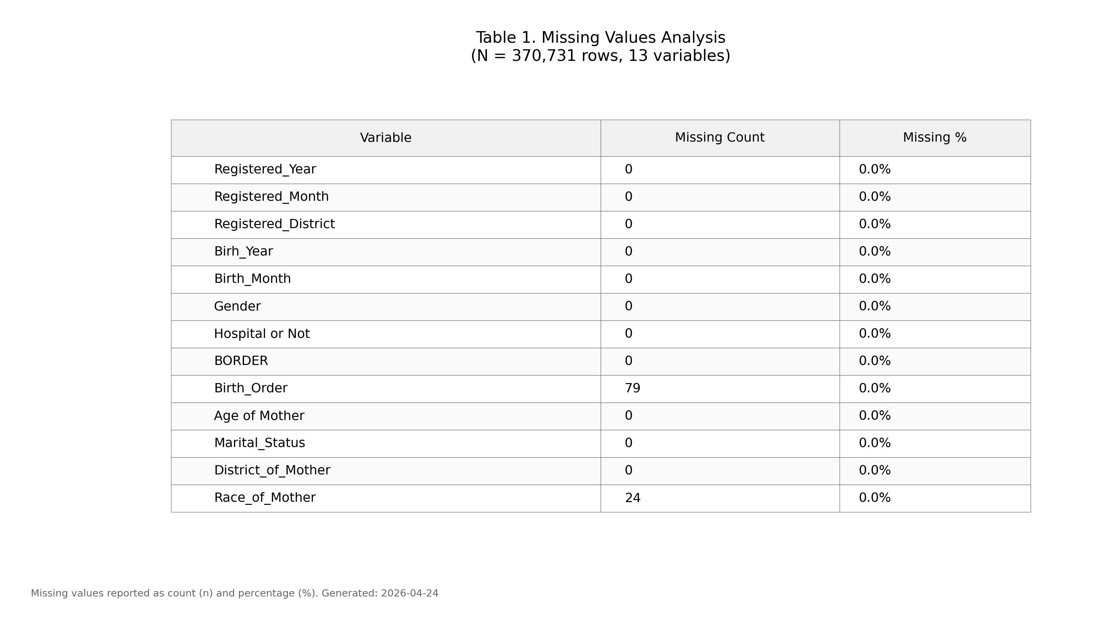
Figure 1. Missing values by variable (IUPAC compliant formatting).

5. Recommendations
- Based on the missing values analysis, the following approaches are recommended:
- Variables with <5% missing: Consider mean/median imputation or listwise deletion
- Variables with 5-20% missing: Multiple imputation recommended
- Variables with >20% missing: Consider exclusion or create "missing indicator" variable
- Review variables with high missing percentages to understand data collection issues

6. Methodology
Analysis performed according to IUPAC guidelines for data presentation:
- • Missing values reported as both count (n) and percentage (%)
- • Tables formatted with thin gray borders and alternating row shading
- • Sans-serif fonts (Arial) used for optimal readability
- • Figure saved at 300 DPI for publication quality
- • Complete data available in accompanying Excel file

