Section 3.2 — Maternal Age by Birth Order

Figure 2: Maternal Age by Birth Order
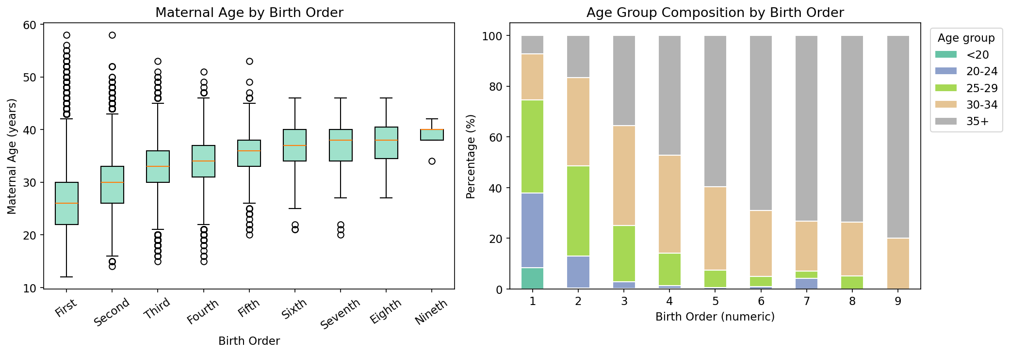

Table 1: Maternal Age Descriptive Statistics by Birth Order
Birth Order | Parity | N | Mean | Median | Std Dev | Min | Max | Q1 | Q3
First | 1 | 106,660 | 26.43 | 26.00 | 5.26 | 12 | 58 | 22.00 | 30.00
Second | 2 | 96,224 | 29.85 | 30.00 | 4.71 | 14 | 58 | 26.00 | 33.00
Third | 3 | 47,648 | 32.69 | 33.00 | 4.44 | 15 | 53 | 30.00 | 36.00
Fourth | 4 | 8,941 | 34.16 | 34.00 | 4.28 | 15 | 51 | 31.00 | 37.00
Fifth | 5 | 1,679 | 35.50 | 36.00 | 4.18 | 20 | 53 | 33.00 | 38.00
Sixth | 6 | 297 | 36.55 | 37.00 | 4.36 | 21 | 46 | 34.00 | 40.00
Seventh | 7 | 71 | 36.66 | 38.00 | 5.40 | 20 | 46 | 34.00 | 40.00
Eighth | 8 | 19 | 37.58 | 38.00 | 4.80 | 27 | 46 | 34.50 | 40.50
Nineth | 9 | 5 | 38.80 | 40.00 | 3.03 | 34 | 42 | 38.00 | 40.00

Note: N = number of births. Q1/Q3 = 25th/75th percentile of maternal age.

Table 2: Age Group Composition (%) by Birth Order
Birth Order | <20 | 20-24 | 25-29 | 30-34 | 35+
First | 8.45 | 29.33 | 36.70 | 18.28 | 7.24
Second | 0.49 | 12.60 | 35.39 | 34.88 | 16.64
Third | 0.12 | 2.85 | 22.01 | 39.50 | 35.51
Fourth | 0.13 | 1.13 | 12.85 | 38.65 | 47.23
Fifth | 0.00 | 0.66 | 6.85 | 32.94 | 59.56
Sixth | 0.00 | 1.01 | 4.04 | 25.93 | 69.02
Seventh | 0.00 | 4.23 | 2.82 | 19.72 | 73.24
Eighth | 0.00 | 0.00 | 5.26 | 21.05 | 73.68
Nineth | 0.00 | 0.00 | 0.00 | 20.00 | 80.00

Note: Values represent the percentage of mothers in each age group within each birth order category.

