Parity Distribution — Sri Lanka Birth Registration

Figure 1: Birth Order Distribution
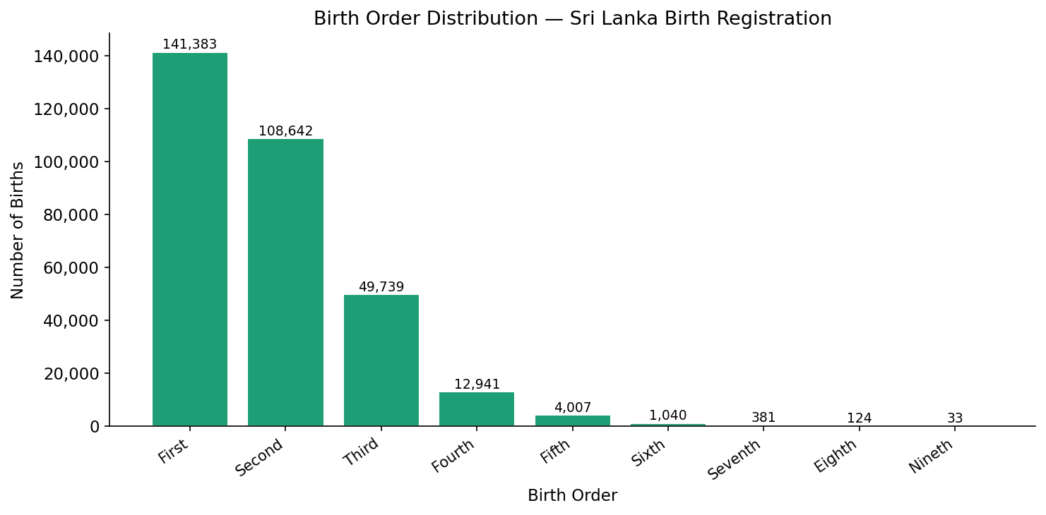

Table 1: Frequency Distribution of Birth Order
Birth Order | Parity | Frequency | Percentage % | Cumulative %
First | 1 | 141,383 | 44.42% | 44.42%
Second | 2 | 108,642 | 34.13% | 78.55%
Third | 3 | 49,739 | 15.63% | 94.18%
Fourth | 4 | 12,941 | 4.07% | 98.25%
Fifth | 5 | 4,007 | 1.26% | 99.50%
Sixth | 6 | 1,040 | 0.33% | 99.83%
Seventh | 7 | 381 | 0.12% | 99.95%
Eighth | 8 | 124 | 0.04% | 99.99%
Nineth | 9 | 33 | 0.01% | 100.00%
Total |  | 318,290 | 100.00% | 100.00%

Note: Parity refers to the number of live births a mother has had.

