Missing Values Analysis Report
Generated: 2026-03-22 07:28
Dataset: 301,712 rows × 18 columns

1. Executive Summary
This report presents a comprehensive analysis of missing values in the dataset.
Key findings include:
• Total missing values: 91,489 (1.68% of all data)
• Columns with missing data: 8 out of 18 columns
• Columns with >20% missing data: 0
• Best completed columns: ['Registered_Month2.0', 'Registered_Year', 'Hospital or Not']

2. Summary Statistics
Metric | Value
Total Rows | 301712.0
Total Columns | 18.0
Columns with Missing Data | 8.0
Total Missing Values | 91489.0
Overall Missing % | 1.68

3. Detailed Missing Values by Variable
The following table shows missing value counts and percentages for each variable. Variables are sorted by missing count (highest to lowest).
Variable | Missing Count | Missing % | Data Type | Unique Values | Non-Missing | Completion %
Birth_Weight(grams) | 33,542 | 11.1% | float64 | 1,853 | 268,170 | 88.9%
Birth_Order | 26,007 | 8.6% | float64 | 10 | 275,705 | 91.4%
Birth_Order - Copy | 26,007 | 8.6% | float64 | 10 | 275,705 | 91.4%
Multiple_Birth_Status | 4,163 | 1.4% | str | 5 | 297,549 | 98.6%
Race_of_Father | 1,231 | 0.4% | str | 6 | 300,481 | 99.6%
Race_of_Mother | 520 | 0.2% | str | 6 | 301,192 | 99.8%
Marital_Status | 17 | 0.0% | str | 2 | 301,695 | 100.0%
Gender | 2 | 0.0% | str | 2 | 301,710 | 100.0%
Registered_Month2.0 | 0 | 0.0% | int64 | 12 | 301,712 | 100.0%
Registered_Year | 0 | 0.0% | int64 | 1 | 301,712 | 100.0%
Hospital or Not | 0 | 0.0% | str | 2 | 301,712 | 100.0%
Birth_Month | 0 | 0.0% | str | 12 | 301,712 | 100.0%
Birh_Year | 0 | 0.0% | int64 | 63 | 301,712 | 100.0%
Birth_Month.0 | 0 | 0.0% | int64 | 12 | 301,712 | 100.0%
Registered_District | 0 | 0.0% | str | 25 | 301,712 | 100.0%
Registered_Month | 0 | 0.0% | str | 12 | 301,712 | 100.0%
Age of Mother | 0 | 0.0% | int64 | 47 | 301,712 | 100.0%
District_of_Mother | 0 | 0.0% | str | 27 | 301,712 | 100.0%

4. Missing Values Visualization
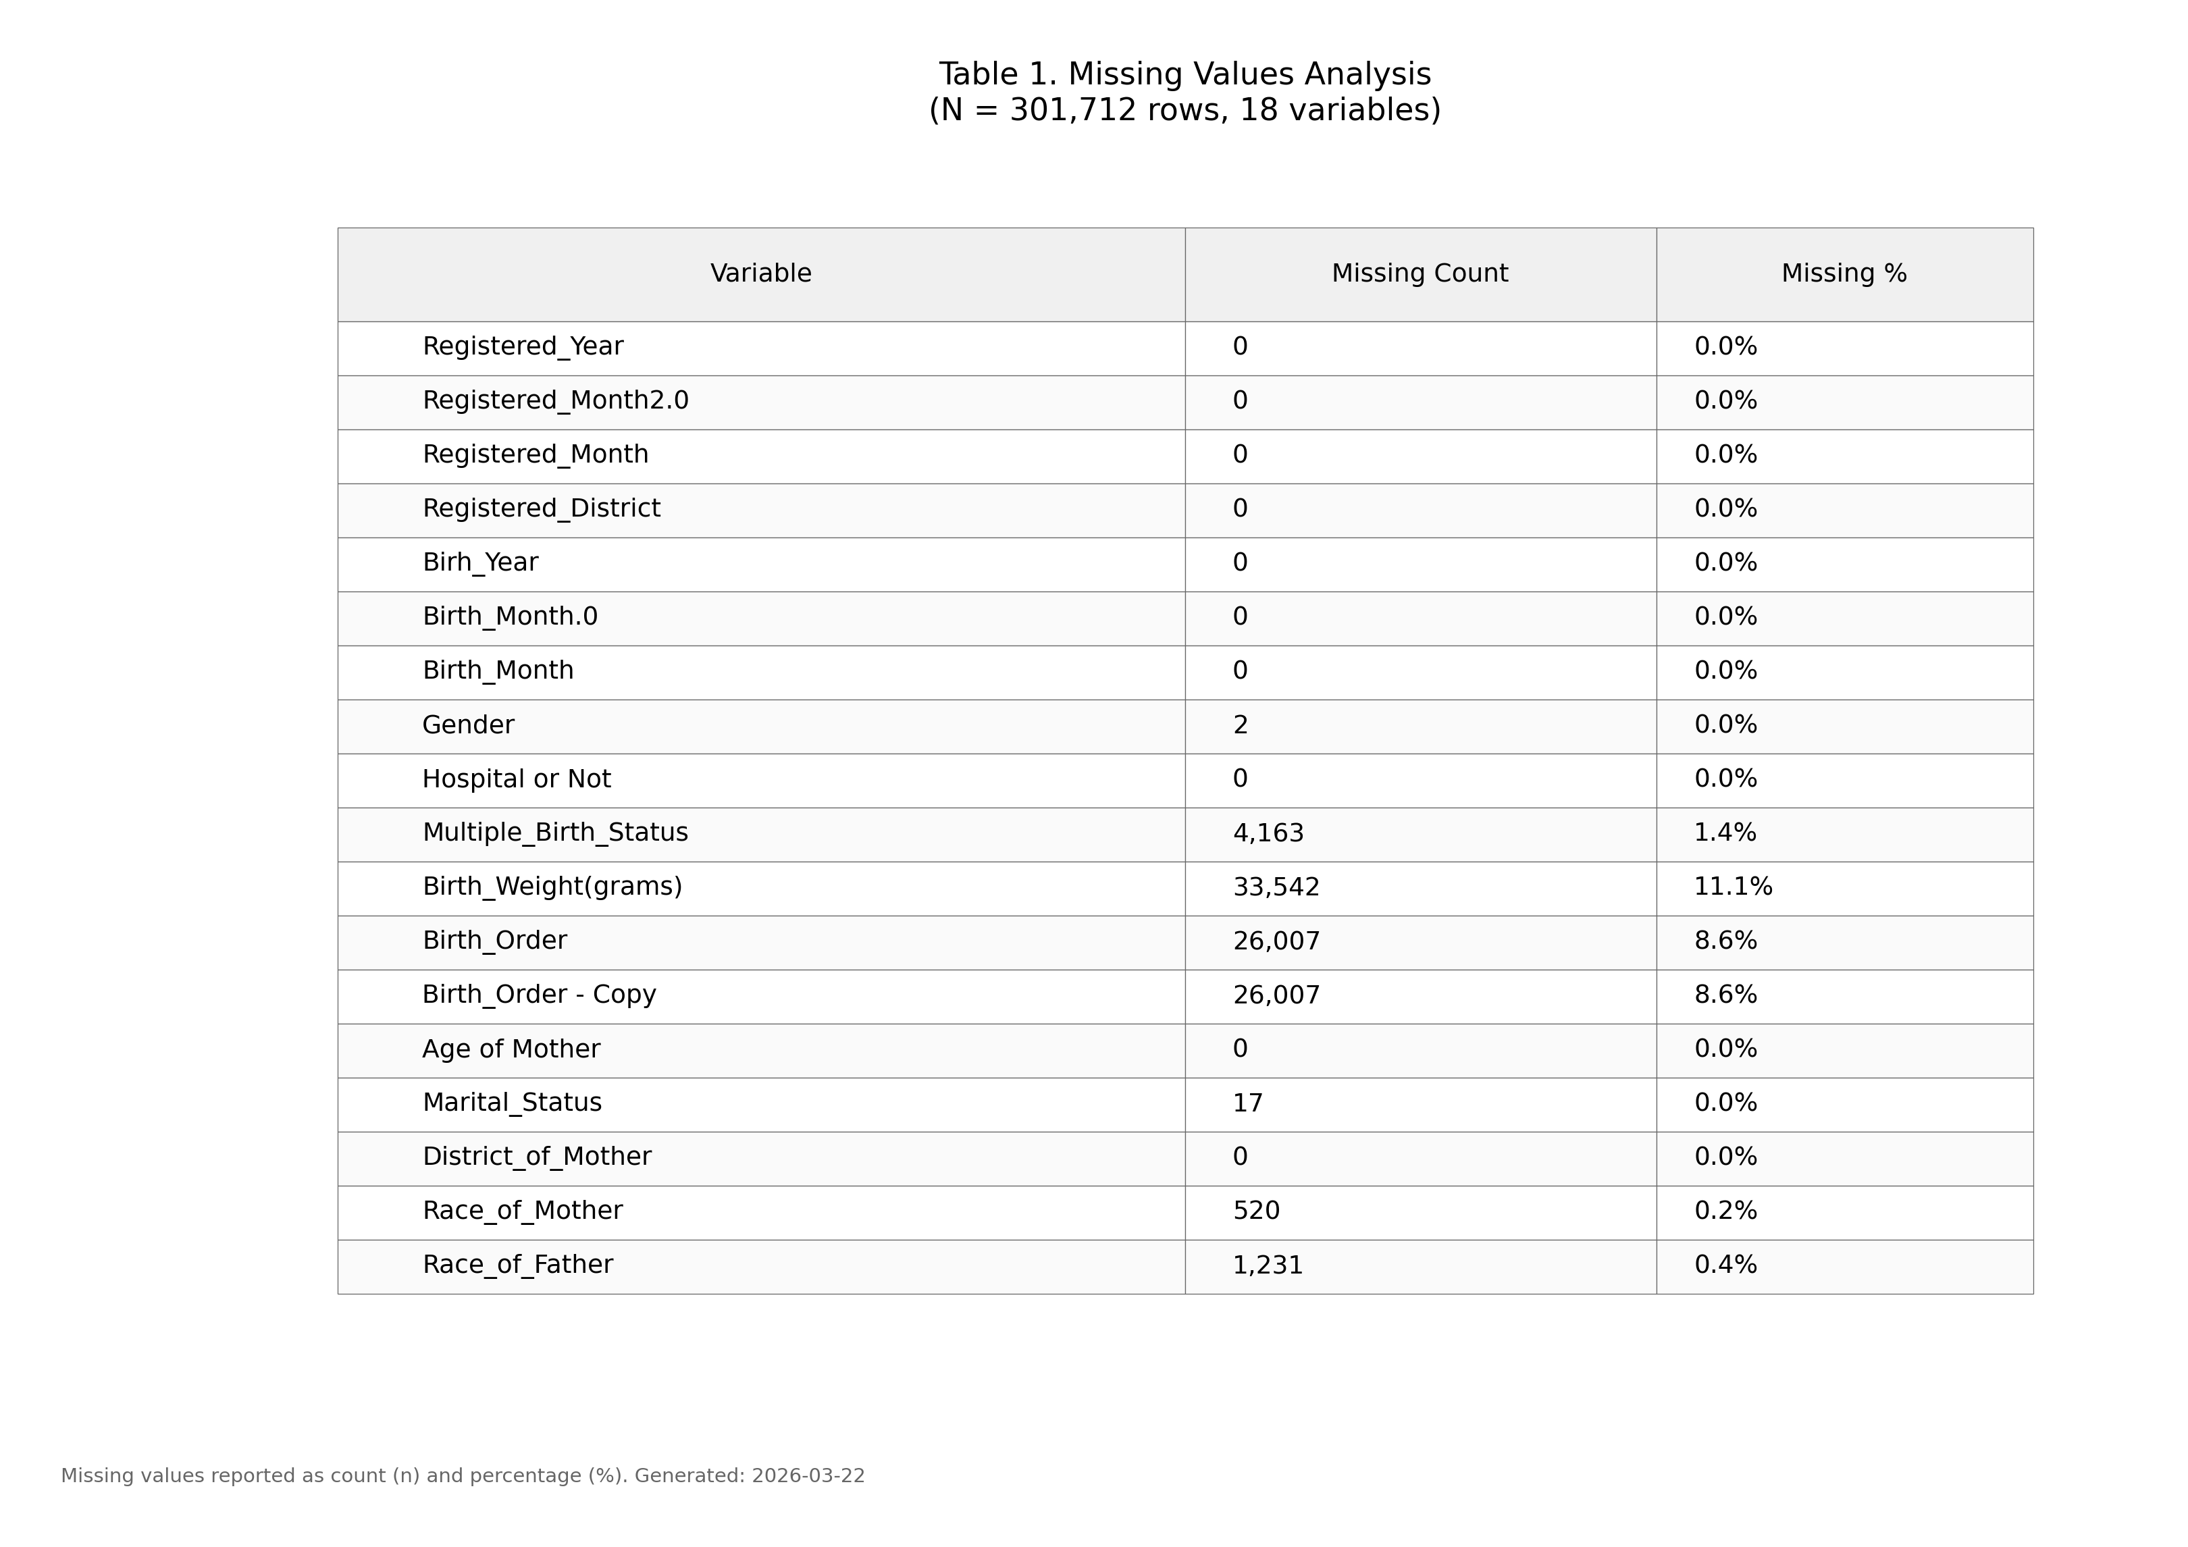
Figure 1. Missing values by variable (IUPAC compliant formatting).

5. Recommendations
- Based on the missing values analysis, the following approaches are recommended:
- Variables with <5% missing: Consider mean/median imputation or listwise deletion
- Variables with 5-20% missing: Multiple imputation recommended
- Variables with >20% missing: Consider exclusion or create "missing indicator" variable
- Review variables with high missing percentages to understand data collection issues

6. Methodology
Analysis performed according to IUPAC guidelines for data presentation:
- • Missing values reported as both count (n) and percentage (%)
- • Tables formatted with thin gray borders and alternating row shading
- • Sans-serif fonts (Arial) used for optimal readability
- • Figure saved at 300 DPI for publication quality
- • Complete data available in accompanying Excel file

