**SCREENSHOT 1 : Jenkins home page**

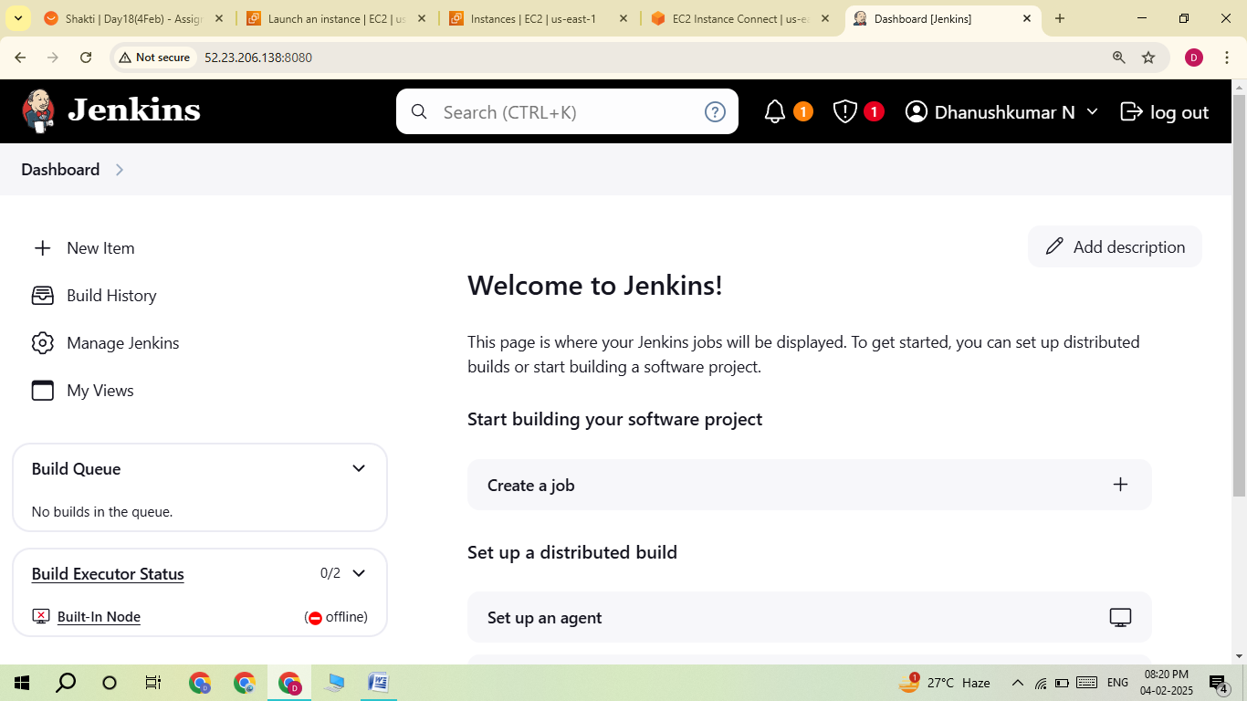

**SCREENSHOT 1 : Terminate the instance**

