**Screenshot 1 : Console log output**

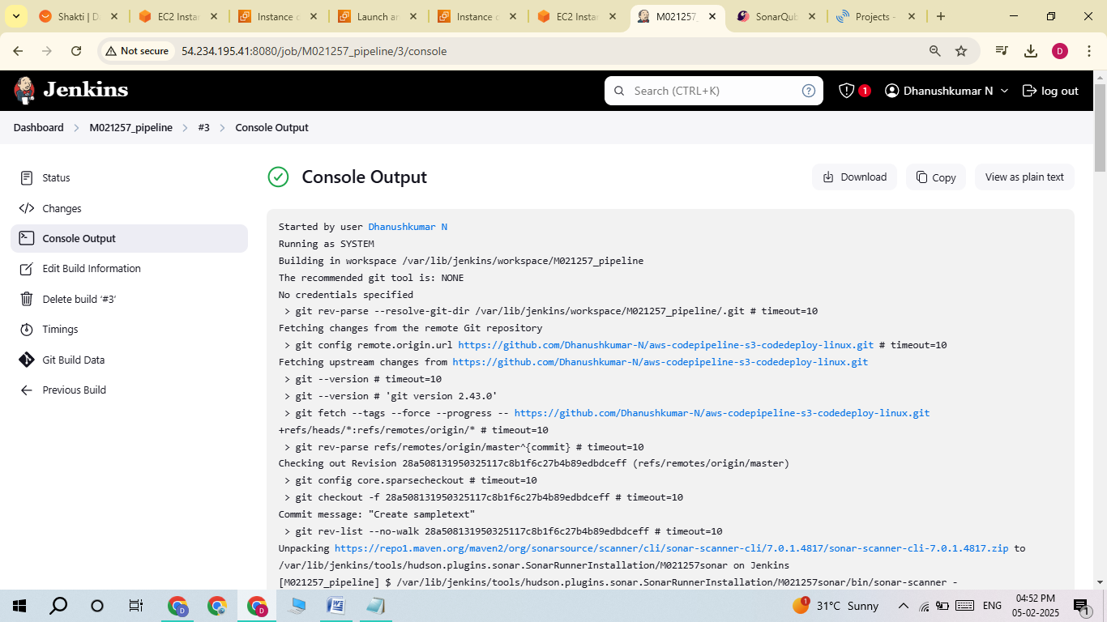

Started by user [Dhanushkumar N](http://54.234.195.41:8080/user/m021257)

Running as SYSTEM

Building in workspace /var/lib/jenkins/workspace/M021257_pipeline

The recommended git tool is: NONE

No credentials specified

> git rev-parse --resolve-git-dir /var/lib/jenkins/workspace/M021257_pipeline/.git # timeout=10

Fetching changes from the remote Git repository

> git config remote.origin.url <https://github.com/Dhanushkumar-N/aws-codepipeline-s3-codedeploy-linux.git> # timeout=10

Fetching upstream changes from <https://github.com/Dhanushkumar-N/aws-codepipeline-s3-codedeploy-linux.git>

> git --version # timeout=10

> git --version # 'git version 2.43.0'

> git fetch --tags --force --progress -- <https://github.com/Dhanushkumar-N/aws-codepipeline-s3-codedeploy-linux.git> +refs/heads/*:refs/remotes/origin/* # timeout=10

> git rev-parse refs/remotes/origin/master^{commit} # timeout=10

Checking out Revision 28a508131950325117c8b1f6c27b4b89edbdceff (refs/remotes/origin/master)

> git config core.sparsecheckout # timeout=10

> git checkout -f 28a508131950325117c8b1f6c27b4b89edbdceff # timeout=10

Commit message: "Create sampletext"

> git rev-list --no-walk 28a508131950325117c8b1f6c27b4b89edbdceff # timeout=10

Unpacking <https://repo1.maven.org/maven2/org/sonarsource/scanner/cli/sonar-scanner-cli/7.0.1.4817/sonar-scanner-cli-7.0.1.4817.zip> to /var/lib/jenkins/tools/hudson.plugins.sonar.SonarRunnerInstallation/M021257sonar on Jenkins

[M021257_pipeline] $ /var/lib/jenkins/tools/hudson.plugins.sonar.SonarRunnerInstallation/M021257sonar/bin/sonar-scanner -Dsonar.host.url=<http://35.172.215.128:9000/> ******** -Dsonar.projectKey=M021257 -Dsonar.projectBaseDir=/var/lib/jenkins/workspace/M021257_pipeline

11:17:17.740 INFO Scanner configuration file: /var/lib/jenkins/tools/hudson.plugins.sonar.SonarRunnerInstallation/M021257sonar/conf/sonar-scanner.properties

11:17:17.746 INFO Project root configuration file: NONE

11:17:17.761 INFO SonarScanner CLI 7.0.1.4817

11:17:17.762 INFO Java 17.0.14 Ubuntu (64-bit)

11:17:17.763 INFO Linux 6.8.0-1021-aws amd64

11:17:17.796 INFO User cache: /var/lib/jenkins/.sonar/cache

11:17:18.759 INFO JRE provisioning: os[linux], arch[x86_64]

11:17:21.487 INFO Communicating with SonarQube Community Build 25.2.0.102705

11:17:21.820 INFO Starting SonarScanner Engine...

11:17:21.822 INFO Java 17.0.13 Eclipse Adoptium (64-bit)

11:17:23.017 INFO Load global settings

11:17:23.114 INFO Load global settings (done) | time=97ms

11:17:23.119 INFO Server id: 147B411E-AZTVteJDchOj2HN43IkK

11:17:23.127 INFO Loading required plugins

11:17:23.128 INFO Load plugins index

11:17:23.176 INFO Load plugins index (done) | time=48ms

11:17:23.176 INFO Load/download plugins

11:17:23.868 INFO Load/download plugins (done) | time=690ms

11:17:24.265 INFO Process project properties

11:17:24.268 INFO Process project properties (done) | time=1ms

11:17:24.278 INFO Project key: M021257

11:17:24.281 INFO Base dir: /var/lib/jenkins/workspace/M021257_pipeline

11:17:24.281 INFO Working dir: /var/lib/jenkins/workspace/M021257_pipeline/.scannerwork

11:17:24.291 INFO Load project settings for component key: 'M021257'

11:17:24.311 INFO Load project settings for component key: 'M021257' (done) | time=21ms

11:17:24.339 INFO Load quality profiles

11:17:24.437 INFO Load quality profiles (done) | time=98ms

11:17:24.451 INFO Auto-configuring with CI 'Jenkins'

11:17:24.487 INFO Load active rules

11:17:25.248 INFO Load active rules (done) | time=763ms

11:17:25.256 INFO Load analysis cache

11:17:25.262 INFO Load analysis cache (404) | time=7ms

11:17:25.342 INFO Preprocessing files...

11:17:25.441 INFO 2 languages detected in 11 preprocessed files

11:17:25.441 INFO 0 files ignored because of scm ignore settings

11:17:25.445 INFO Loading plugins for detected languages

11:17:25.446 INFO Load/download plugins

11:17:27.932 INFO Load/download plugins (done) | time=2486ms

11:17:28.094 INFO Load project repositories

11:17:28.194 INFO Load project repositories (done) | time=100ms

11:17:28.221 INFO Indexing files...

11:17:28.226 INFO Project configuration:

11:17:28.245 INFO 11 files indexed

11:17:28.248 INFO Quality profile for web: Sonar way

11:17:28.250 INFO Quality profile for yaml: Sonar way

11:17:28.250 INFO ------------- Run sensors on module M021257

11:17:28.298 INFO Load metrics repository

11:17:28.327 INFO Load metrics repository (done) | time=27ms

11:17:28.811 INFO Sensor JaCoCo XML Report Importer [jacoco]

11:17:28.813 INFO 'sonar.coverage.jacoco.xmlReportPaths' is not defined. Using default locations: target/site/jacoco/jacoco.xml,target/site/jacoco-it/jacoco.xml,build/reports/jacoco/test/jacocoTestReport.xml

11:17:28.813 INFO No report imported, no coverage information will be imported by JaCoCo XML Report Importer

11:17:28.813 INFO Sensor JaCoCo XML Report Importer [jacoco] (done) | time=1ms

11:17:28.816 INFO Sensor IaC CloudFormation Sensor [iac]

11:17:28.838 INFO 0 source files to be analyzed

11:17:28.845 INFO 0/0 source files have been analyzed

11:17:28.849 INFO Sensor IaC CloudFormation Sensor [iac] (done) | time=34ms

11:17:28.849 INFO Sensor IaC Kubernetes Sensor [iac]

11:17:28.930 INFO 0 source files to be parsed

11:17:28.932 INFO 0/0 source files have been parsed

11:17:28.933 INFO 0 source files to be analyzed

11:17:28.933 INFO 0/0 source files have been analyzed

11:17:28.933 INFO 0 source files to be checked

11:17:28.934 INFO 0/0 source files have been checked

11:17:28.935 INFO Sensor IaC Kubernetes Sensor [iac] (done) | time=86ms

11:17:28.936 INFO Sensor Java Config Sensor [iac]

11:17:28.942 INFO 0 source files to be analyzed

11:17:28.942 INFO 0/0 source files have been analyzed

11:17:28.943 INFO Sensor Java Config Sensor [iac] (done) | time=10ms

11:17:28.943 INFO Sensor HTML [web]

11:17:29.064 INFO Sensor HTML [web] (done) | time=119ms

11:17:29.064 INFO Sensor JavaScript inside YAML analysis [javascript]

11:17:29.068 INFO No input files found for analysis

11:17:29.070 INFO Hit the cache for 0 out of 0

11:17:29.070 INFO Miss the cache for 0 out of 0

11:17:29.070 INFO Sensor JavaScript inside YAML analysis [javascript] (done) | time=8ms

11:17:29.070 INFO Sensor JavaScript inside HTML analysis [javascript]

11:17:29.222 INFO Detected os: Linux arch: amd64 alpine: false. Platform: LINUX_X64

11:17:29.223 INFO Deploy location /var/lib/jenkins/.sonar/js/node-runtime, tagetRuntime: /var/lib/jenkins/.sonar/js/node-runtime/node, version: /var/lib/jenkins/.sonar/js/node-runtime/version.txt

11:17:32.675 INFO Using embedded Node.js runtime.

11:17:32.679 INFO Using Node.js executable: '/var/lib/jenkins/.sonar/js/node-runtime/node'.

11:17:34.514 INFO Memory configuration: OS (3912 MB), Node.js (2004 MB).

11:17:34.671 INFO 1 source file to be analyzed

11:17:36.513 INFO 1/1 source file has been analyzed

11:17:36.514 INFO Hit the cache for 0 out of 1

11:17:36.514 INFO Miss the cache for 1 out of 1: ANALYSIS_MODE_INELIGIBLE [1/1]

11:17:36.514 INFO Sensor JavaScript inside HTML analysis [javascript] (done) | time=7444ms

11:17:36.514 INFO Sensor CSS Rules [javascript]

11:17:36.523 INFO 1 source file to be analyzed

11:17:36.607 INFO 1/1 source file has been analyzed

11:17:36.607 INFO Hit the cache for 0 out of 0

11:17:36.607 INFO Miss the cache for 0 out of 0

11:17:36.607 INFO Sensor CSS Rules [javascript] (done) | time=92ms

11:17:36.607 INFO Sensor IaC Docker Sensor [iac]

11:17:36.709 INFO 0 source files to be analyzed

11:17:36.712 INFO 0/0 source files have been analyzed

11:17:36.712 INFO Sensor IaC Docker Sensor [iac] (done) | time=104ms

11:17:36.712 INFO Sensor TextAndSecretsSensor [text]

11:17:36.713 INFO Available processors: 2

11:17:36.713 INFO Using 2 threads for analysis.

11:17:37.096 INFO The property "sonar.tests" is not set. To improve the analysis accuracy, we categorize a file as a test file if any of the following is true:

* The filename starts with "test"

* The filename contains "test." or "tests."

* Any directory in the file path is named: "doc", "docs", "test" or "tests"

* Any directory in the file path has a name ending in "test" or "tests"

11:17:37.115 INFO Using git CLI to retrieve untracked files

11:17:37.124 INFO Analyzing language associated files and files included via "sonar.text.inclusions" that are tracked by git

11:17:37.133 INFO 2 source files to be analyzed

11:17:37.153 INFO 2/2 source files have been analyzed

11:17:37.157 INFO Sensor TextAndSecretsSensor [text] (done) | time=445ms

11:17:37.160 INFO ------------- Run sensors on project

11:17:37.277 INFO Sensor Zero Coverage Sensor

11:17:37.279 INFO Sensor Zero Coverage Sensor (done) | time=2ms

11:17:37.279 INFO SCM Publisher SCM provider for this project is: git

11:17:37.280 INFO SCM Publisher 1 source file to be analyzed

11:17:37.445 INFO SCM Publisher 1/1 source file have been analyzed (done) | time=163ms

11:17:37.449 INFO CPD Executor Calculating CPD for 1 file

11:17:37.459 INFO CPD Executor CPD calculation finished (done) | time=7ms

11:17:37.463 INFO SCM revision ID '28a508131950325117c8b1f6c27b4b89edbdceff'

11:17:37.587 INFO Analysis report generated in 120ms, dir size=234.6 kB

11:17:37.599 INFO Analysis report compressed in 11ms, zip size=27.3 kB

11:17:37.672 INFO Analysis report uploaded in 71ms

11:17:37.673 INFO ANALYSIS SUCCESSFUL, you can find the results at: <http://35.172.215.128:9000/dashboard?id=M021257>

11:17:37.673 INFO Note that you will be able to access the updated dashboard once the server has processed the submitted analysis report

11:17:37.673 INFO More about the report processing at <http://35.172.215.128:9000/api/ce/task?id=2cc2eb8f-8ff7-4587-8298-d1613e7934fd>

11:17:37.746 INFO Analysis total time: 13.795 s

11:17:37.746 INFO SonarScanner Engine completed successfully

11:17:38.081 INFO EXECUTION SUCCESS

11:17:38.082 INFO Total time: 20.346s

Finished: SUCCESS

**Screenshot 2 : Sonarcube website and check your project status**

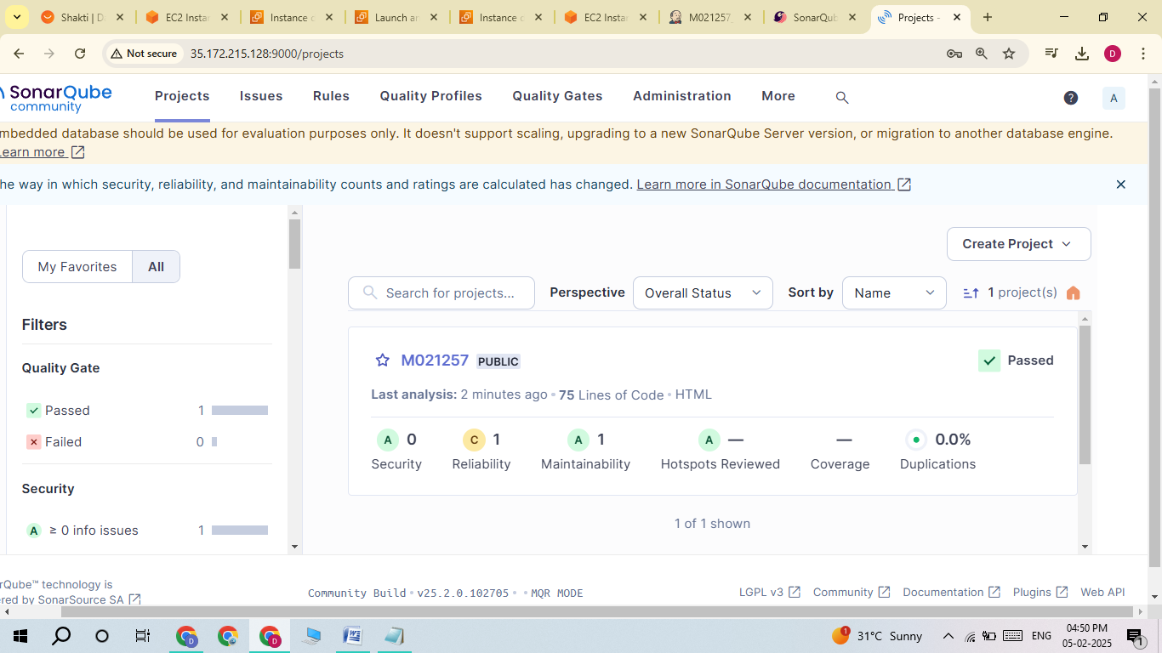

**Screenshot 3 : Terminate the Practicejenkins and Practicesonarqube instances**

