DAY-5

Task-1

package day5;

import org.openqa.selenium.By;

import org.openqa.selenium.WebDriver;

import org.openqa.selenium.WebElement;

import org.openqa.selenium.chrome.ChromeDriver;

import org.openqa.selenium.chrome.ChromeOptions;

import org.openqa.selenium.interactions.Actions;

import io.github.bonigarcia.wdm.WebDriverManager;

public class task1 {

public static void main(String[] args) {

// TODO Auto-generated method stub

WebDriverManager.chromedriver().setup();

ChromeOptions co=new ChromeOptions();

co.addArguments("--remote-allow-origin=*");

WebDriver driver=new ChromeDriver(co);

driver.get("https://demoqa.com/droppable/");

Actions a=new Actions(driver);

WebElement source_ele=driver.findElement(By.id("draggable"));

WebElement dest_ele=driver.findElement(By.id("droppable"));

a.clickAndHold(source_ele).release(dest_ele).build().perform();

a.dragAndDrop(source_ele, dest_ele).build().perform();

}

}

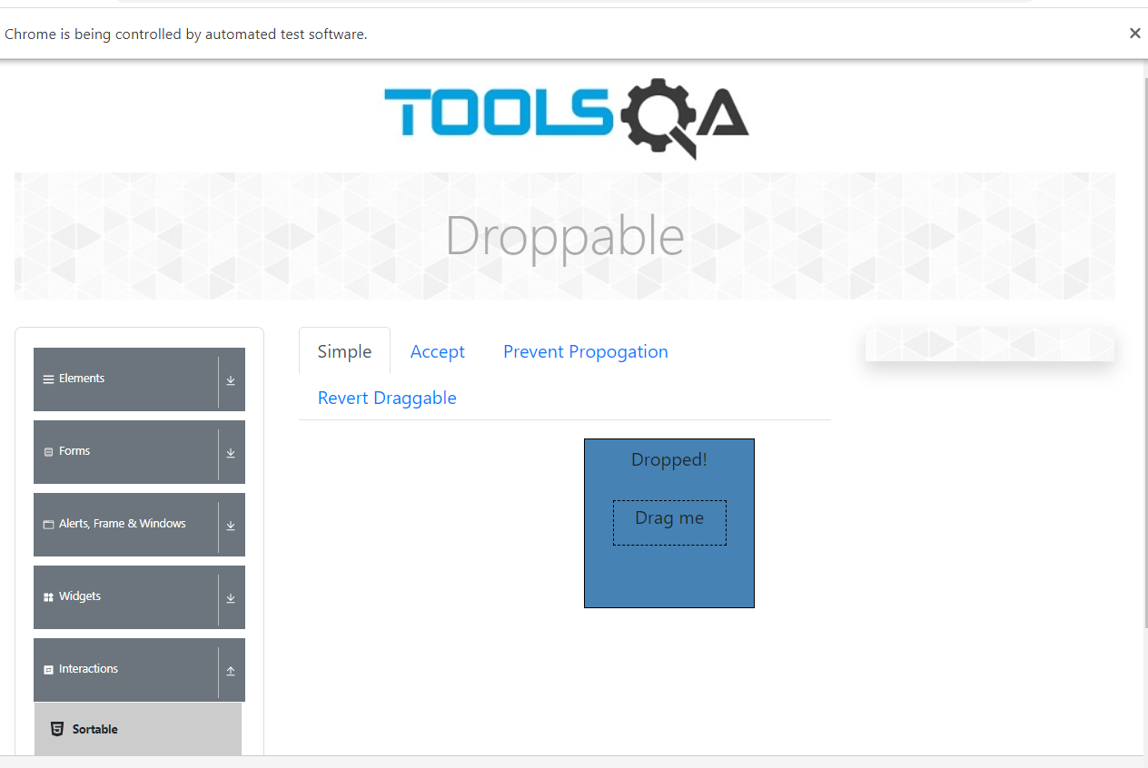

Task-2

package day5;

import org.openqa.selenium.By;

import org.openqa.selenium.WebDriver;

import org.openqa.selenium.WebElement;

import org.openqa.selenium.chrome.ChromeDriver;

import org.openqa.selenium.chrome.ChromeOptions;

import org.openqa.selenium.interactions.Actions;

import io.github.bonigarcia.wdm.WebDriverManager;

public class task2 {

public static void main(String[] args) {

// TODO Auto-generated method stub

WebDriverManager.chromedriver().setup();

ChromeOptions co=new ChromeOptions();

co.addArguments("--remote-allow-origin=*");

WebDriver driver=new ChromeDriver(co);

driver.get("https://jqueryui.com/droppable/");

driver.switchTo().frame(0);

Actions a=new Actions(driver);

WebElement source_ele=driver.findElement(By.id("draggable"));

WebElement dest_ele=driver.findElement(By.id("droppable"));

a.clickAndHold(source_ele).release(dest_ele).build().perform();

a.dragAndDrop(source_ele, dest_ele).build().perform();

}

}

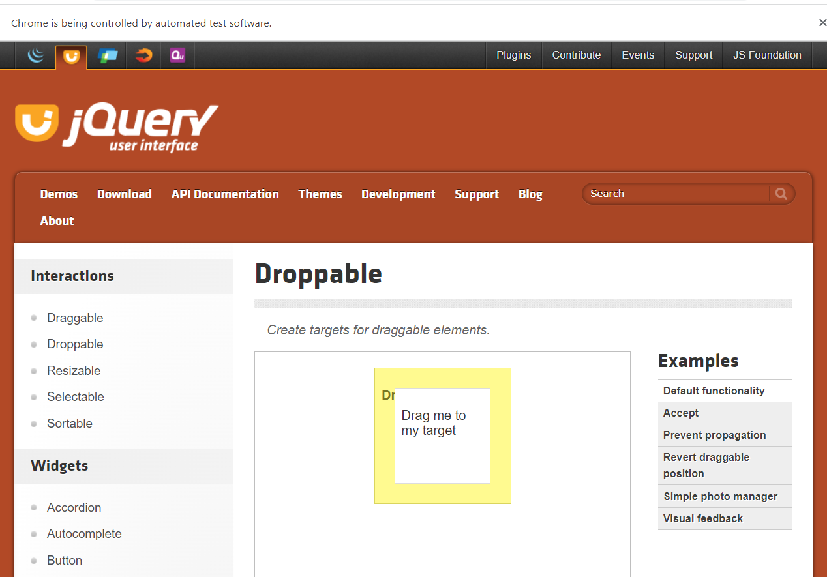

Task-3

package day5;

import org.openqa.selenium.Alert;

import org.openqa.selenium.By;

import org.openqa.selenium.WebDriver;

import org.openqa.selenium.WebDriver.Window;

import org.openqa.selenium.WebElement;

import org.openqa.selenium.chrome.ChromeDriver;

import org.openqa.selenium.chrome.ChromeOptions;

import io.github.bonigarcia.wdm.WebDriverManager;

public class task3 {

public static void main(String[] args) {

WebDriverManager.chromedriver().setup();

ChromeOptions co=new ChromeOptions();

co.addArguments("--remote-allow-origin=*");

WebDriver driver=new ChromeDriver(co);

driver.get("https://demo.guru99.com/test/delete_customer.php");

WebElement inp= driver.findElement(By.xpath("/html/body/form/table/tbody/tr[2]/td[2]/input"));

inp.sendKeys("401");

WebElement sub= driver.findElement(By.xpath("/html/body/form/table/tbody/tr[3]/td[2]/input[1]"));

sub.click();

Alert alert1=driver.switchTo().alert();

alert1.dismiss();

inp.clear();

inp.sendKeys("402");

sub.click();

Alert alert2=driver.switchTo().alert();

alert2.accept();

Alert alert3=driver.switchTo().alert();

String txt=alert3.getText();

alert3.accept();

}

}

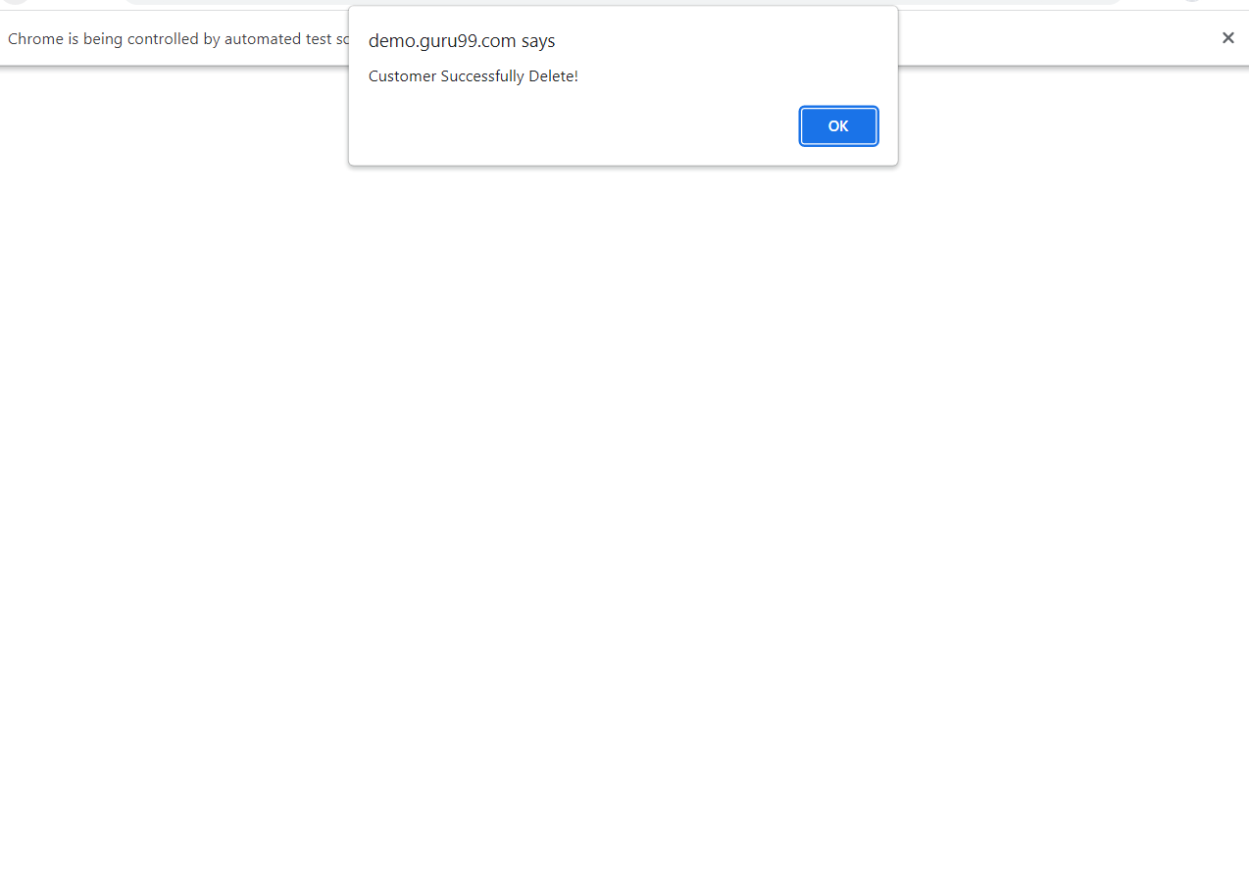

Task-4

package day5;

import org.openqa.selenium.By;

import org.openqa.selenium.JavascriptExecutor;

import org.openqa.selenium.Keys;

import org.openqa.selenium.WebDriver;

import org.openqa.selenium.WebElement;

import org.openqa.selenium.chrome.ChromeDriver;

import org.openqa.selenium.chrome.ChromeOptions;

import io.github.bonigarcia.wdm.WebDriverManager;

public class task4 {

public static void main(String[] args) throws InterruptedException {

// TODO Auto-generated method stubXj

WebDriverManager.chromedriver().setup();

ChromeOptions co=new ChromeOptions();

co.addArguments("--remote-allow-origin=*");

WebDriver driver=new ChromeDriver(co);

driver.get("https://www.abhibus.com/bus-ticket-booking");

WebElement src= driver.findElement(By.id("source"));

src.sendKeys("Coimbatore");

Thread.sleep(3000);

src.sendKeys(Keys.ENTER);

WebElement des= driver.findElement(By.id("destination"));

des.sendKeys("Bangalore");

Thread.sleep(3000);

des.sendKeys(Keys.ENTER);

WebElement date= driver.findElement(By.id("datepicker1"));

JavascriptExecutor js=(JavascriptExecutor)driver;

js.executeScript("arguments[0].setAttribute('value','04-05-2023')",date);

WebElement ser= driver.findElement(By.id("seo_search_btn"));

ser.click();

}

}

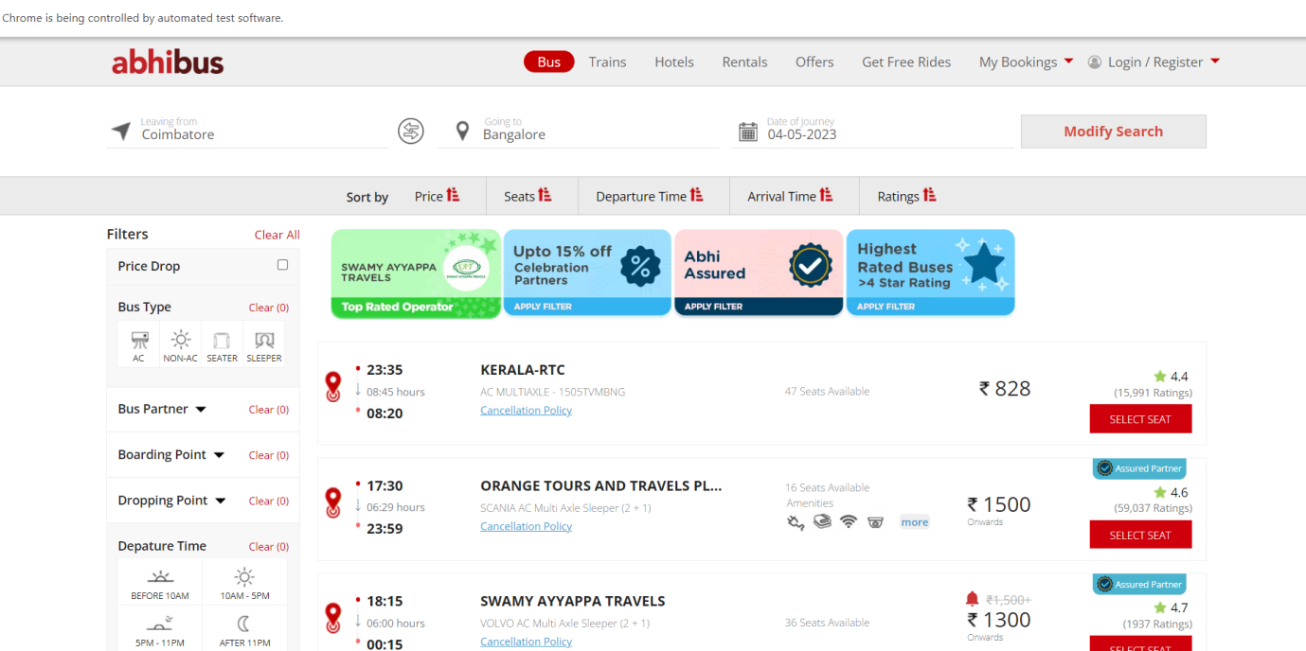

Task-5

package day5;

import java.util.Set;

import org.openqa.selenium.By;

import org.openqa.selenium.Keys;

import org.openqa.selenium.WebDriver;

import org.openqa.selenium.WindowType;

import org.openqa.selenium.chrome.ChromeDriver;

import org.openqa.selenium.chrome.ChromeOptions;

import io.github.bonigarcia.wdm.WebDriverManager;

public class task5 {

public static void main(String[] args) {

// TODO Auto-generated method stub

WebDriverManager.chromedriver().setup();

ChromeOptions co=new ChromeOptions();

co.addArguments("--remote-allow-origin=*");

WebDriver driver=new ChromeDriver(co);

driver.get("https://www.google.com");

driver.manage().window().maximize();

driver.findElement(By.name("q")).sendKeys("Apple");

driver.findElement(By.name("q")).sendKeys(Keys.ENTER);

System.out.print("\n"+driver.getWindowHandle());

System.out.print("\n"+driver.getTitle());

driver.switchTo().newWindow(WindowType.TAB);

driver.get("https://www.google.com");

driver.findElement(By.name("q")).sendKeys("Selenium");

driver.findElement(By.name("q")).sendKeys(Keys.ENTER);

System.out.print("\n"+driver.getWindowHandle());

System.out.print("\n"+driver.getTitle());

driver.switchTo().newWindow(WindowType.TAB);

driver.get("https://www.google.com");

driver.manage().window().maximize();

driver.findElement(By.name("q")).sendKeys("cucumber");

driver.findElement(By.name("q")).sendKeys(Keys.ENTER);

System.out.print("\n"+driver.getWindowHandle());

System.out.print("\n"+driver.getTitle());

Set<String>s=driver.getWindowHandles();

System.out.println("Number of windows opened="+s.size());

}

}

