PHASE 4:

INPUT:

import pandas as pd

import numpy as np

import matplotlib.pyplot as plt

import seaborn as sns

data=pd.read_csv(r"C:\Users\keccs\OneDrive\Documents\Covid_19_cases4.csv")

data.head()

OUTPUT:

dateRep day month year cases deaths countriesAndTerritories

0 31-05-2021 31 5 2021 366 5 Austria

1 30-05-2021 30 5 2021 570 6 Austria

2 29-05-2021 29 5 2021 538 11 Austria

3 28-05-2021 28 5 2021 639 4 Austria

4 27-05-2021 27 5 2021 405 19 Austria

INPUT:

sample_data = pd.read_csv('covid_19_cases4.csv')

sample_data

OUTPUT:

dateRep day month year cases deaths countriesAndTerritories

0 31-05-2021 31 5 2021 366 5 Austria

1 30-05-2021 30 5 2021 570 6 Austria

2 29-05-2021 29 5 2021 538 11 Austria

3 28-05-2021 28 5 2021 639 4 Austria

4 27-05-2021 27 5 2021 405 19 Austria

... ... ... ... ... ... ... ...

2725 06-03-2021 6 3 2021 3455 17 Sweden

2726 05-03-2021 5 3 2021 4069 12 Sweden

2727 04-03-2021 4 3 2021 4884 14 Sweden

2728 03-03-2021 3 3 2021 4876 19 Sweden

2729 02-03-2021 2 3 2021 6191 19 Sweden

2730 rows × 7 columns

INPUT:

Type(sample_data)

OUTPUT:

pandas.core.frame.DataFrame

INPUT:

sample_data.cases

OUTPUT:

0 366

1 570

2 538

3 639

4 405

...

2725 3455

2726 4069

2727 4884

2728 4876

2729 6191

Name: cases, Length: 2730, dtype: int64

INPUT:

sample_data.cases.iloc[2725]

OUTPUT:

3455

INPUT:

plt.plot(sample_data.day,sample_data.cases)

plt.show()

OUTPUT:

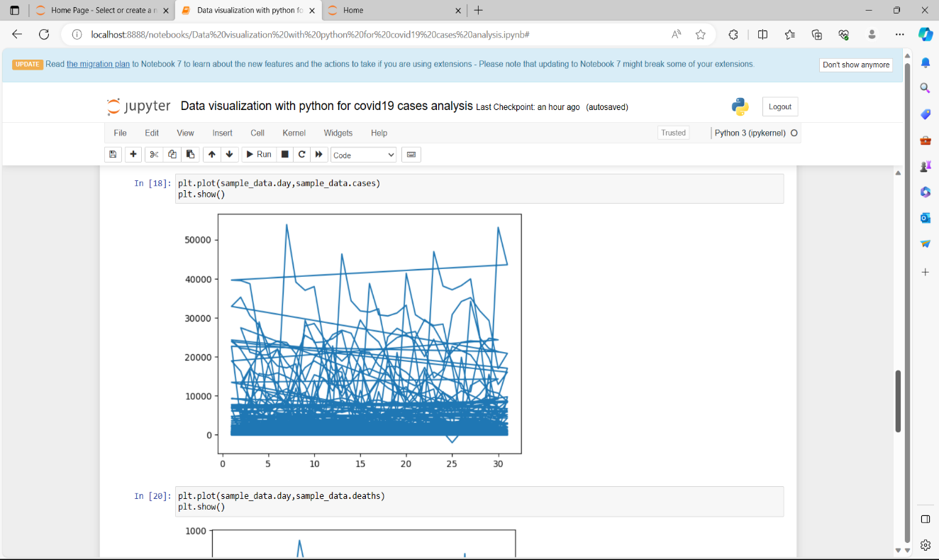

INPUT:

plt.plot(sample_data.day,sample_data.deaths)

plt.show()

OUTPUT:

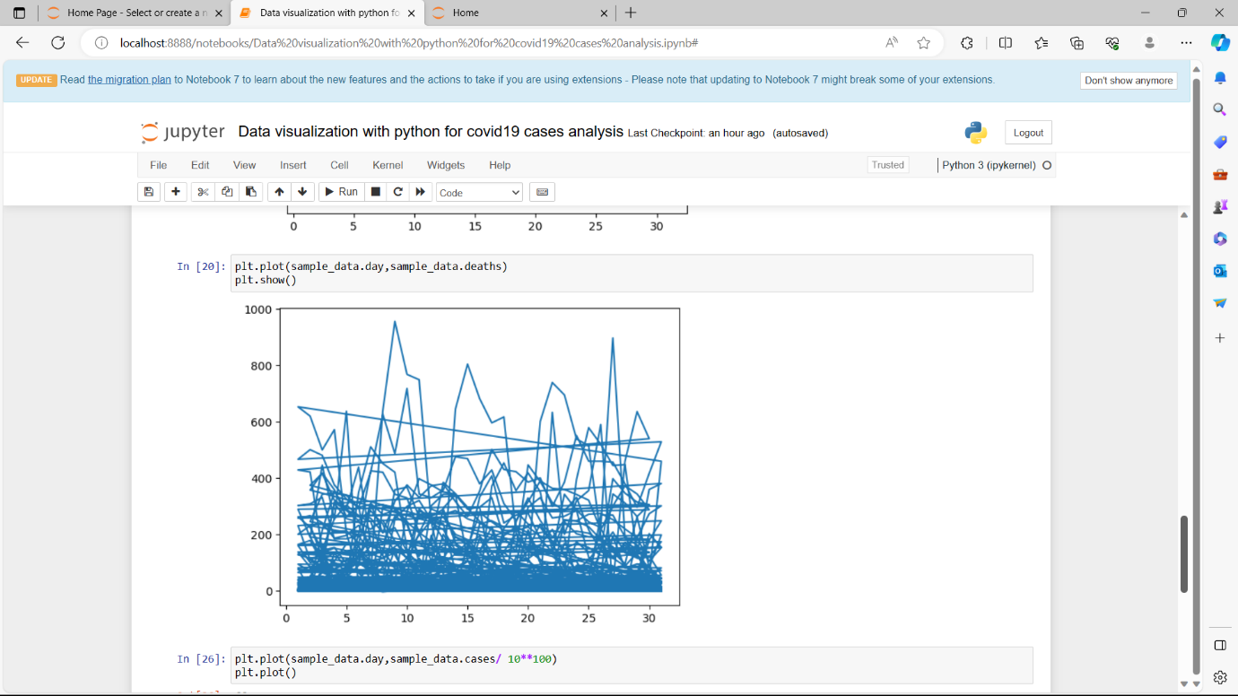

INPUT:

plt.plot(sample_data.day,sample_data.cases/ 10**100)

plt.plot()

OUTPUT:

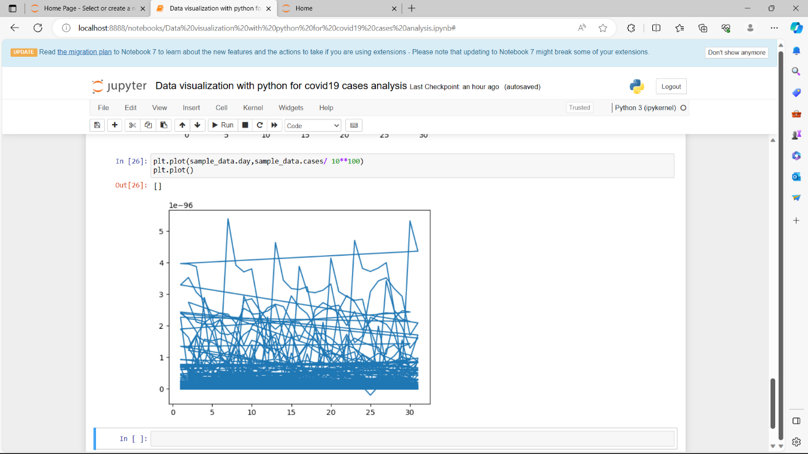

INPUT:

plt.figure(figsize=(12, 6))

plt.plot(total_cases, label='Total Cases')

plt.plot(total_deaths, label='Total Deaths')

plt.xlabel('Date')

plt.ylabel('Count')

plt.title('COVID-19 Cases and Deaths by Country')

plt.legend()

plt.show()

OUTPUT:

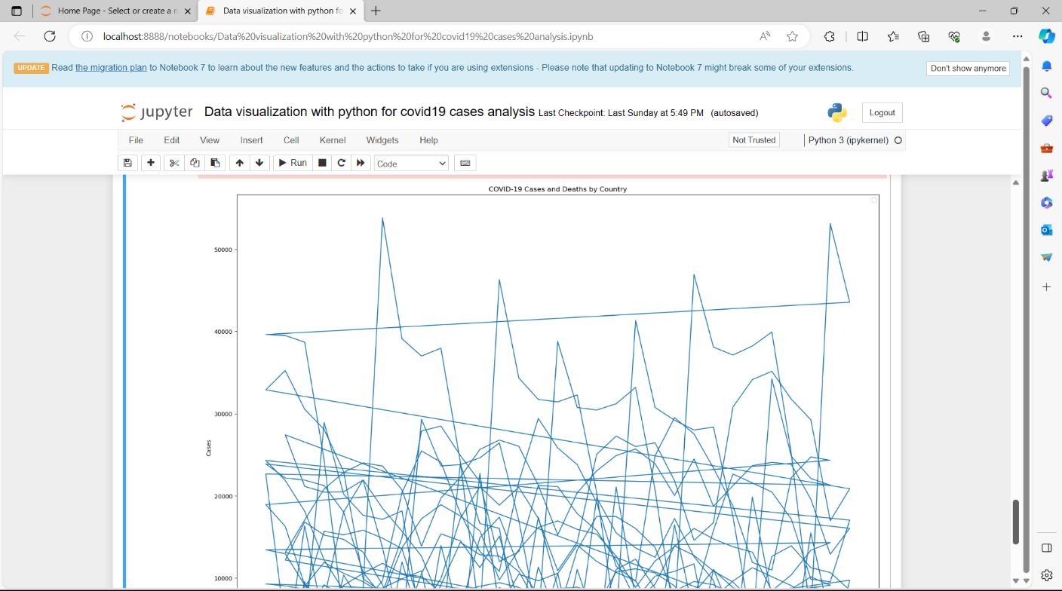

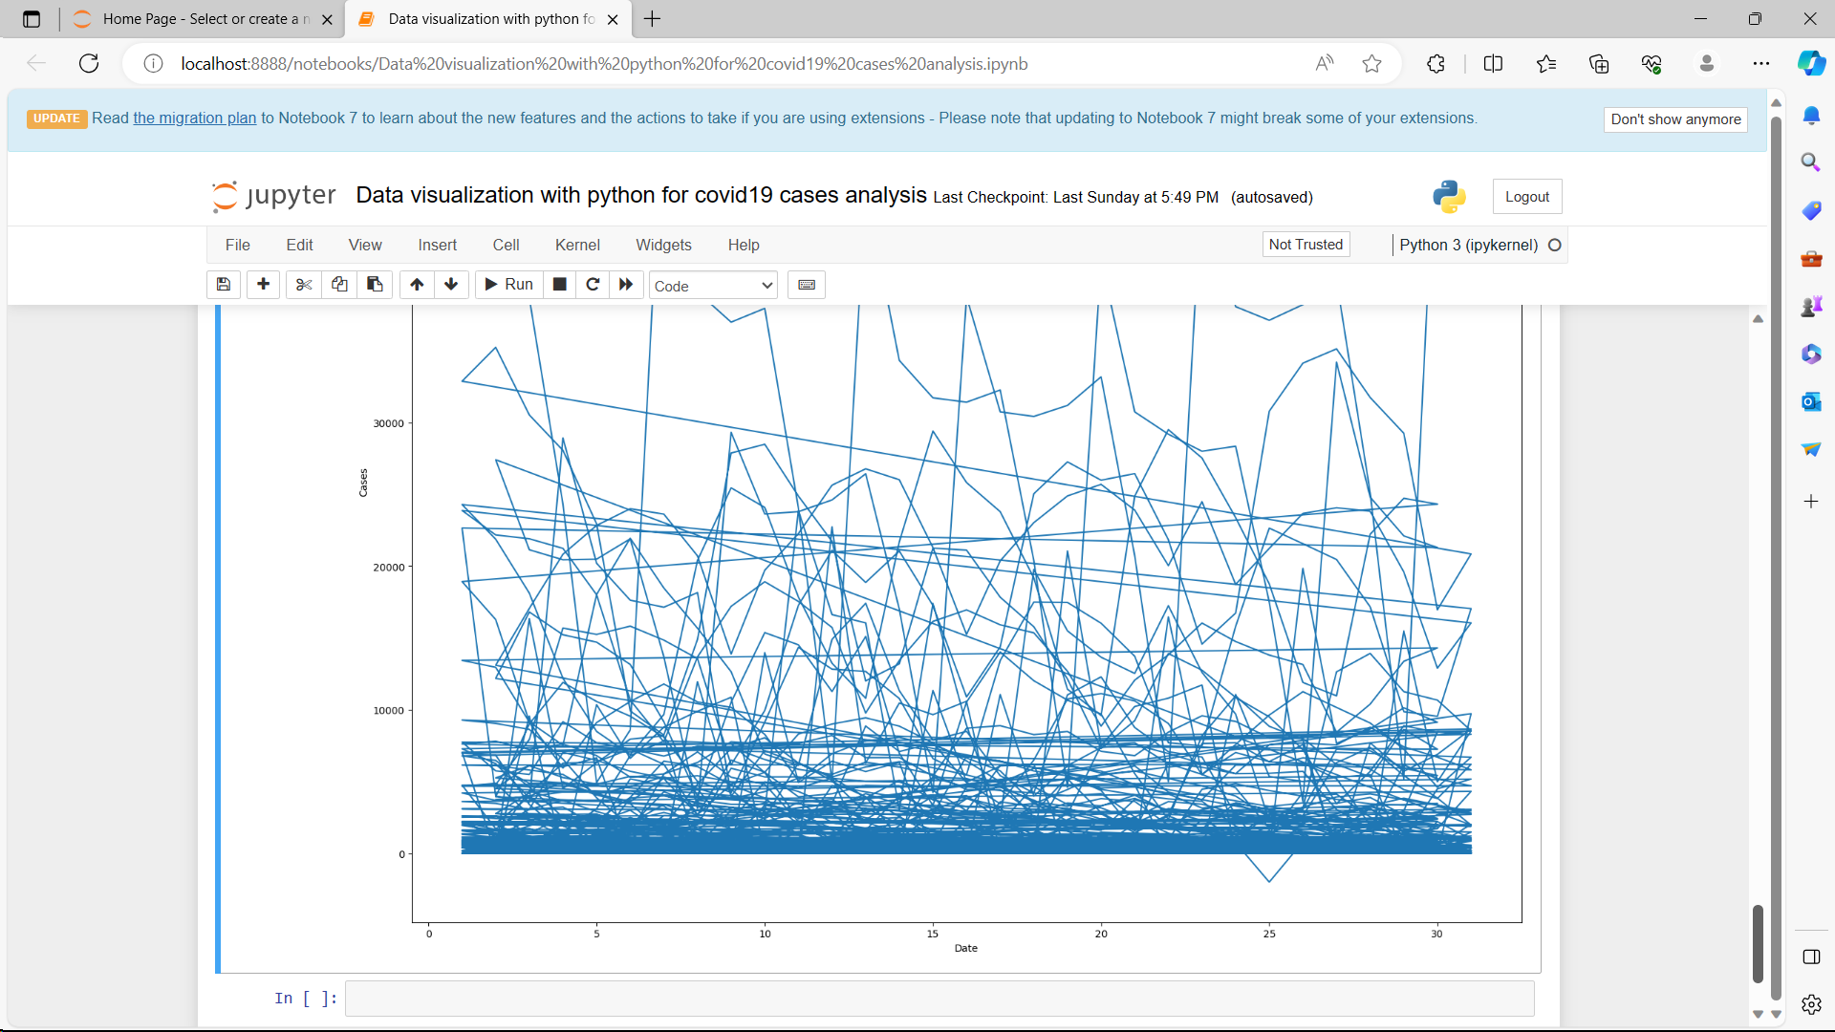

DONE BY

ABINASH.P

ABINASH.S

DHANUSH.M

DINESH.K