Inventory Management System (IMS)
Week 1 Task: Project Planning and Architecture Design — Junior Java Developer Internship
Prepared by: Dhanush P | Java Backend Developer (Spring Boot / REST APIs / MySQL)
Date: October 2026

1. Introduction and Objective
The purpose of this document is to present the planning and architecture design phase of a simple Inventory Management System (IMS) intended for use by a small retail business. The goal of Week 1 is not to write production code, but to think like a software architect: to identify the system's requirements, break it into well-defined modules, choose appropriate design patterns, and produce a feasible technical plan that can be implemented in Java during the following weeks of the internship.
A small retail business typically needs to track products, monitor stock levels, process sales and restocking orders, and generate reports that help the owner make purchasing decisions. The system must be simple enough for a small team to use, yet robust enough to keep data consistent and secure. To achieve this, I propose a backend built with Java 17 and Spring Boot, exposing REST APIs, secured with Spring Security and JWT-based role-based access control, persisting data in MySQL through Spring Data JPA/Hibernate, tested with JUnit 5 and Mockito, and packaged for deployment with Docker.

2. Requirement Analysis

2.1 Functional Requirements
- Product Management: add, update, delete, search, and list products. Each product has a name, unique SKU, category, supplier, unit price, current quantity, and reorder threshold.
- Stock Control: record stock movements (stock-in from suppliers, stock-out from sales/adjustments), automatically update product quantities, and flag products that fall below their reorder level.
- Order Processing: create customer orders, validate stock availability before confirming, decrement inventory atomically, and track order status (PENDING, CONFIRMED, CANCELLED).
- User & Role Management: ADMIN and STAFF roles. Admins manage products, suppliers, and users; staff create orders and record stock movements.
- Reporting: generate stock-level reports, low-stock alerts, and sales summaries. Reports can be exported (extensible to PDF/Excel formats).

2.2 Non-Functional Requirements
- Performance: indexed database columns on frequently queried fields (SKU, product name, order date) to keep API responses fast.
- Security: stateless JWT authentication, password hashing with BCrypt, endpoint-level authorization by role.
- Maintainability: layered architecture with clear separation of concerns so modules can evolve independently.
- Testability: unit tests for services and integration tests for controllers using JUnit 5, Mockito, and Spring Boot Test.
- Deployability: a single runnable JAR produced by Maven, containerized with Docker, with CI/CD via GitHub Actions.

3. Proposed Architecture
The system follows a classic Layered (N-tier) Architecture, which is the natural fit for a Spring Boot application and aligns with industry best practices for enterprise Java systems. Requests flow top-down through clearly separated layers, and each layer only communicates with the layer directly below it:
- Controller Layer (REST API): Spring Boot REST controllers expose HTTP endpoints, validate input with Bean Validation, and convert DTOs. It contains no business logic.
- Service Layer: the heart of the application. All business rules live here — stock deduction rules, reorder checks, order validation, price calculations.
- Repository Layer: Spring Data JPA interfaces provide CRUD and query methods. Hibernate maps Java entities to the MySQL schema.
- Database Layer: MySQL relational database, normalized to the third normal form (3NF), with indexes on hot columns.
- Cross-Cutting Concerns: a global exception handler (@ControllerAdvice), centralized logging (SLF4J), security filters, and DTO mapping.
The high-level architectural diagram below outlines the main modules and their interactions:
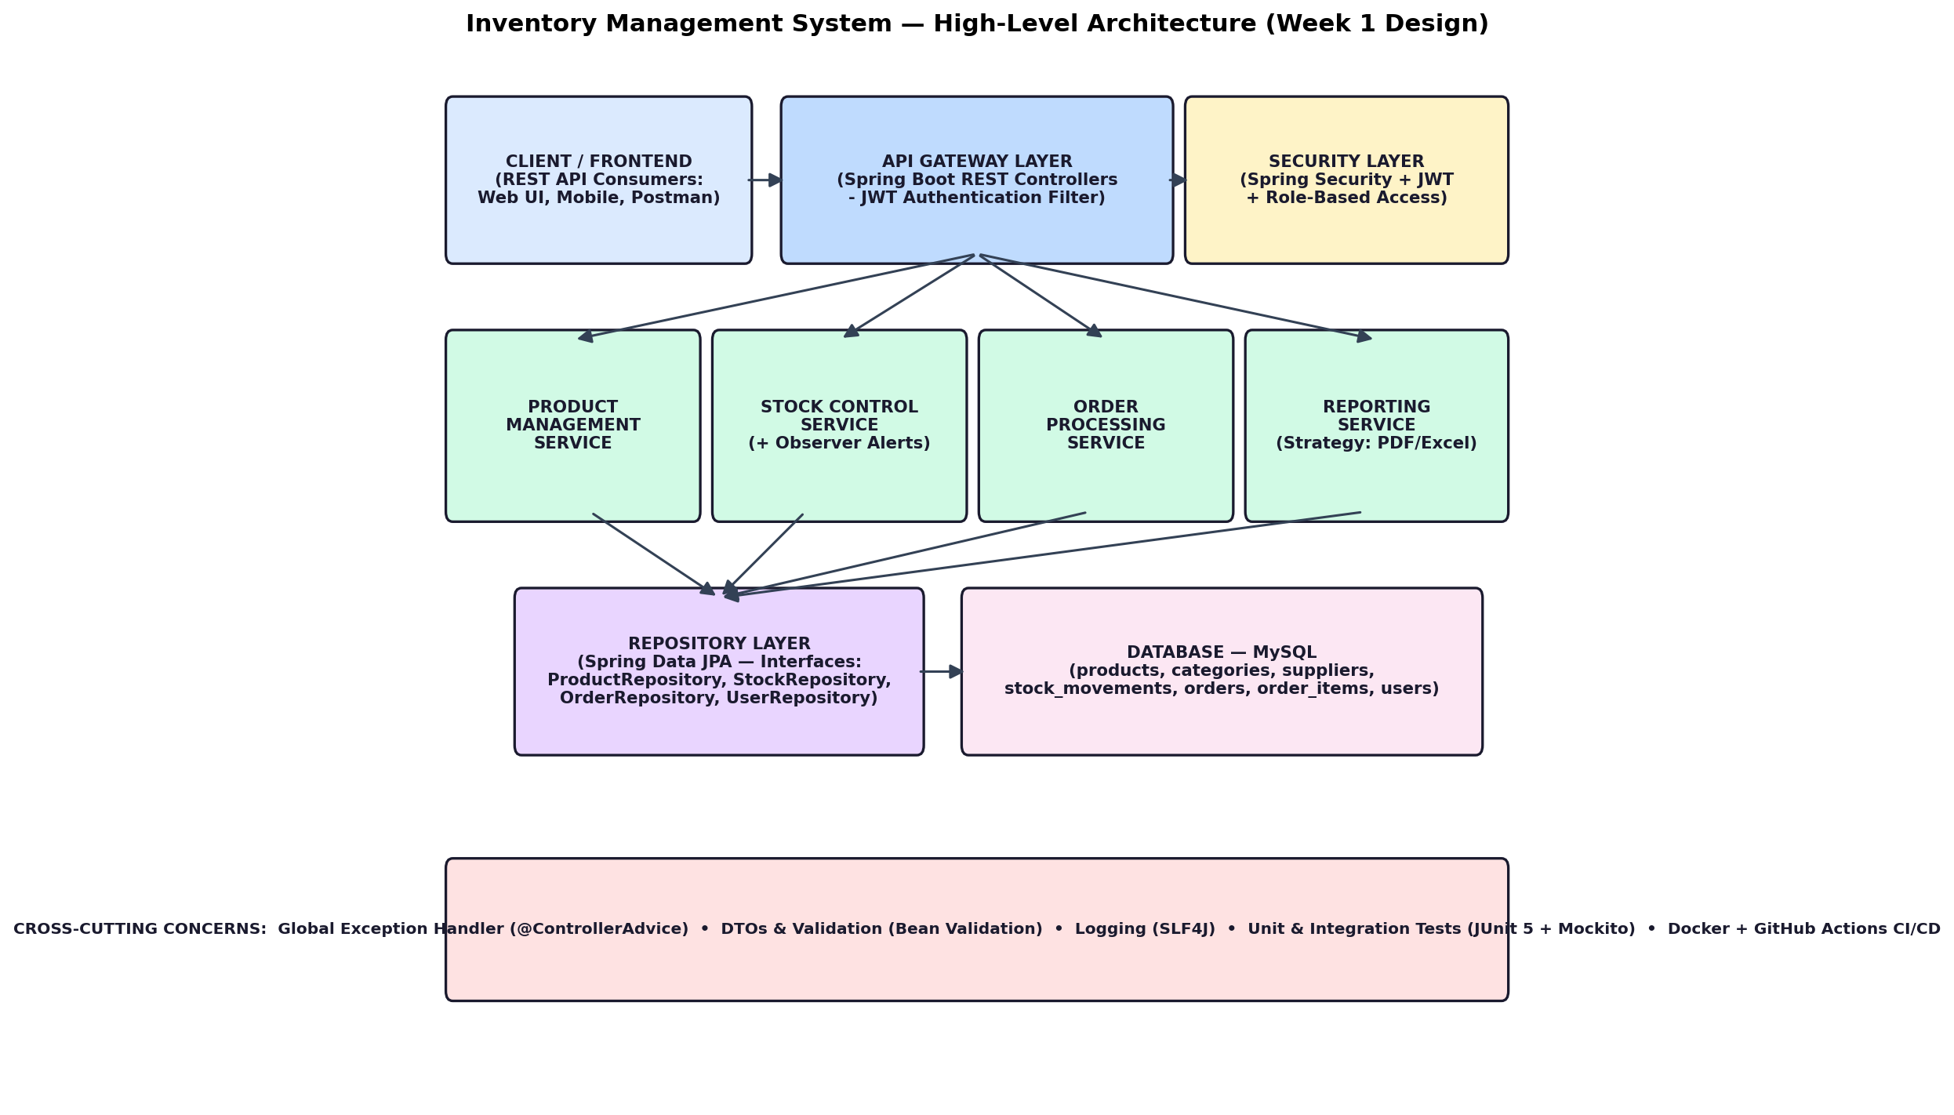

4. Module Descriptions

4.1 Product Management Module
This module owns the product catalog. It exposes endpoints to create, read, update, and delete products, and supports search by name, SKU, or category. Product data is modelled as a JPA entity with a unique constraint on SKU to prevent duplicates. All changes are audited through stock movements where relevant. The module delegates persistence to ProductRepository, which extends JpaRepository and adds derived query methods such as findBySku() and findByCategoryId().

4.2 Stock Control Module
Stock control tracks every change in inventory as an immutable StockMovement record (type IN or OUT, quantity, timestamp, reference to the product and the user who performed it). Current quantity on the product is derived/updated transactionally when a movement is recorded. When a product's quantity drops to or below its reorder level, the module notifies subscribers (Observer pattern) so a low-stock alert can be logged or surfaced in reports. This gives the business a full audit trail of every unit that entered or left the store.

4.3 Order Processing Module
The order module handles the sales workflow. Creating an order validates that each requested item has sufficient stock; if validation passes, the order and its items are persisted and stock is decremented atomically within a single transaction (@Transactional). If any line fails validation, the whole order is rejected — no partial writes. Order status transitions (PENDING → CONFIRMED/CANCELLED) are restricted: cancellation only restores stock while the order is still PENDING.

4.4 Reporting Module
Reporting aggregates data for business decisions: current stock levels per product, low-stock list, sales totals over a date range, and best-selling products. The report format is pluggable — a ReportGenerator interface with concrete PDF and Excel implementations chosen at runtime via the Factory pattern, making the module open for extension without modification.

4.5 Security Module
Authentication is stateless: clients obtain a JWT from /api/auth/login after presenting credentials, and send it in the Authorization header thereafter. A custom JWT filter populates the Spring Security context, and endpoints are authorized by role using @PreAuthorize (ADMIN-only endpoints for product/user management; STAFF allowed order and stock operations). Passwords are stored only as BCrypt hashes.

5. Database Design
The schema is normalized to 3NF with seven tables. Users and roles support RBAC; products reference categories and suppliers; orders reference users and contain order_items which reference products; stock_movements references products for the audit trail. An index is placed on products.sku, products.name, stock_movements.product_id, and orders.order_date to optimize the most frequent lookups — the same indexing approach I previously used to improve query response time by 40% in my earlier Spring Boot projects.
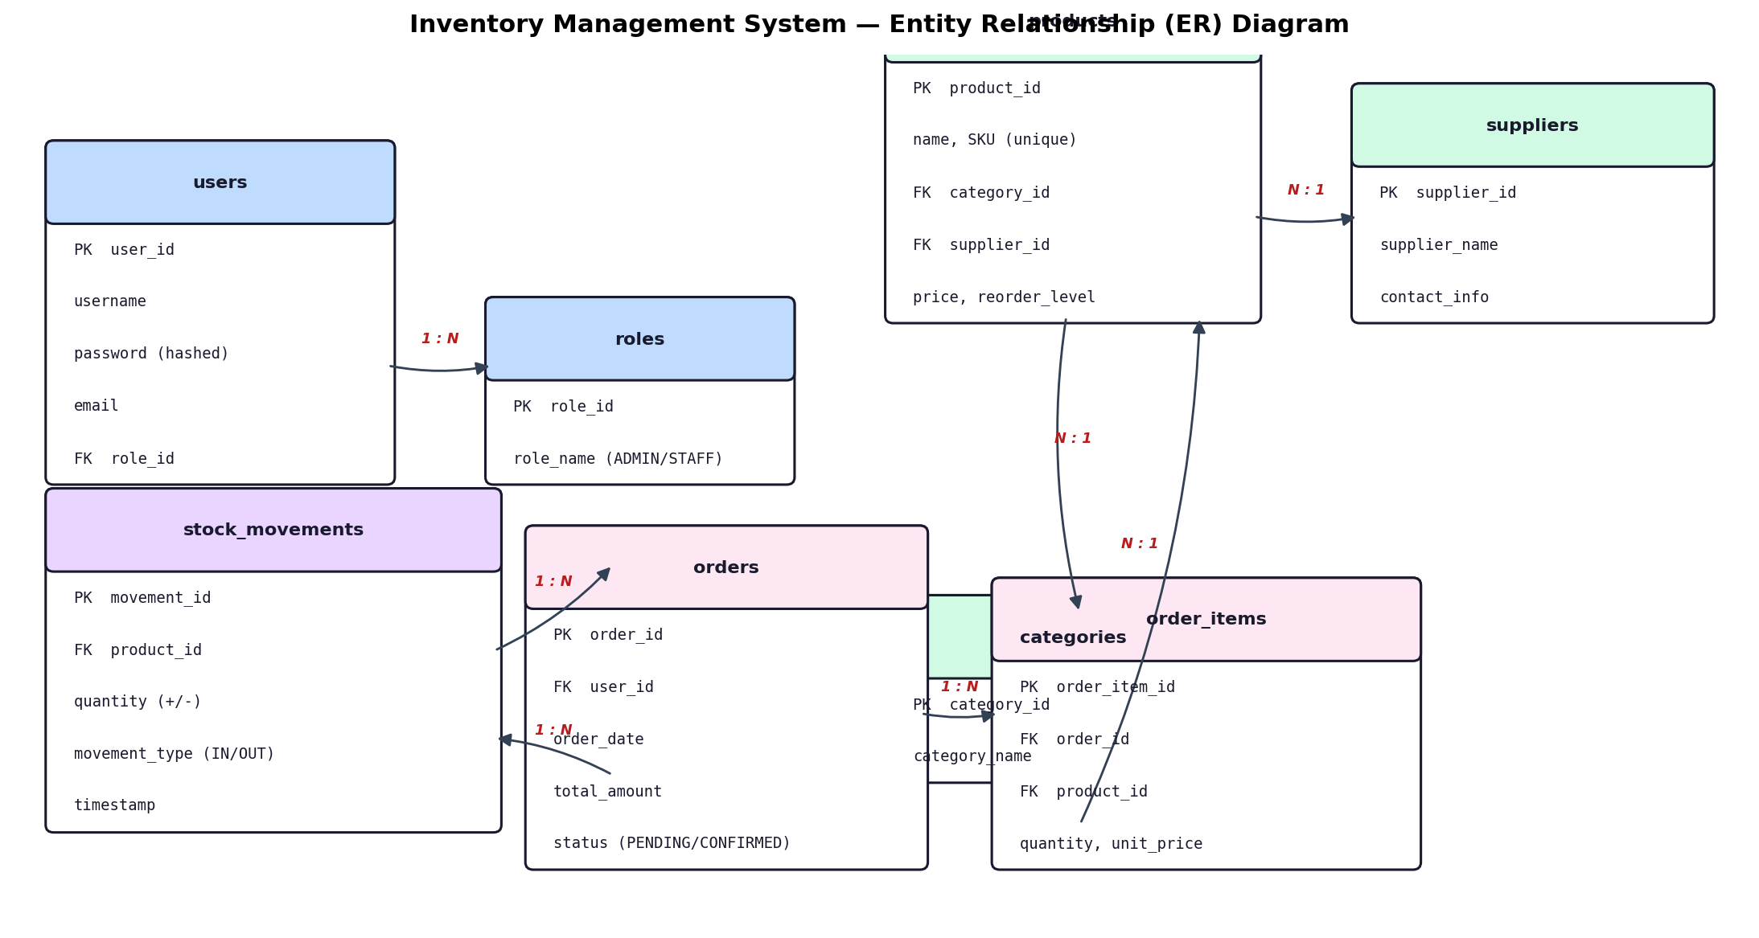

6. Design Patterns and Rationale
Design Pattern | Where Used & Why
Layered Architecture / MVC | Separates controllers, services, and repositories so each layer has a single responsibility — the foundation of maintainable Spring Boot apps.
Repository Pattern (Spring Data JPA) | Decouples business logic from data access; repositories are interfaces, so the service layer stays persistence-agnostic and easily unit-testable with Mockito.
Dependency Injection | Spring's IoC container wires components, enabling loose coupling and easy substitution of implementations (e.g., mock repositories in tests).
Builder (Lombok @Builder) | Used on Product, Order, and DTOs to construct complex objects safely and readably without telescoping constructors.
Singleton | Provided by Spring for services, configuration properties, and the logger — one managed instance per application context.
Factory | ReportFactory selects the correct ReportGenerator (PDF/Excel) at runtime based on a request parameter, hiding creation logic from callers.
Strategy | ReportGenerator and ReorderPolicy are interfaces with interchangeable implementations, letting the business change report formats or restock rules without touching existing code (Open/Closed principle).
Observer | StockEventPublisher notifies StockAlertListener whenever stock falls below the reorder level, decoupling the stock service from alert/report concerns.
DTO (Data Transfer Object) | Request/response DTOs decouple the API contract from JPA entities, preventing accidental exposure of internal fields (e.g., supplier margins) and allowing per-endpoint validation.
@ControllerAdvice (Template Method) | Centralizes exception-to-HTTP-response mapping so every error returned by the API has a consistent JSON structure.

7. Key API Endpoints
Method & Endpoint | Description | Role
POST /api/auth/login | Authenticate and receive JWT | Public
GET /api/products | List/search products (paged) | ADMIN, STAFF
POST /api/products | Create a product | ADMIN
PUT /api/products/{id} | Update a product | ADMIN
DELETE /api/products/{id} | Delete a product | ADMIN
POST /api/stock/movements | Record stock IN/OUT | ADMIN, STAFF
GET /api/stock/low-stock | Products at/below reorder level | ADMIN
POST /api/orders | Create and confirm an order | ADMIN, STAFF
PATCH /api/orders/{id}/cancel | Cancel a pending order (restores stock) | ADMIN, STAFF
GET /api/reports/sales?from=&to= | Sales summary report | ADMIN
GET /api/reports/stock.pdf | Download stock report (Factory/Strategy) | ADMIN

8. Code Scaffolding (Key Stubs)
The following stubs illustrate the planned module interactions. They are intentionally lightweight — Week 1 is about design, and these signatures will be fully implemented in Week 2 onward.
8.1 Product Entity (JPA)
@Entity @Table(name = "products", indexes = @Index(columnList = "sku", unique = true))
@Getter @Setter @Builder @NoArgsConstructor @AllArgsConstructor
public class Product {
@Id @GeneratedValue(strategy = GenerationType.IDENTITY)
private Long id;
@Column(nullable = false, unique = true) private String sku;
@Column(nullable = false) private String name;
private BigDecimal price;
private Integer quantity;
private Integer reorderLevel; // threshold for low-stock alerts
@ManyToOne(fetch = FetchType.LAZY) @JoinColumn(name = "category_id")
private Category category;
@ManyToOne(fetch = FetchType.LAZY) @JoinColumn(name = "supplier_id")
private Supplier supplier;
}
8.2 Repository (Spring Data JPA)
public interface ProductRepository extends JpaRepository<Product, Long> {
Optional<Product> findBySku(String sku);
List<Product> findByCategoryId(Long categoryId);
List<Product> findByQuantityLessThanEqual(Integer reorderLevel);
}
8.3 Stock Service with Observer + Transaction
@Service @RequiredArgsConstructor
public class StockService {
private final ProductRepository productRepository;
private final StockMovementRepository movementRepository;
private final ApplicationEventPublisher eventPublisher;
@Transactional
public StockMovement recordMovement(Long productId, int qty, MovementType type) {
Product product = productRepository.findById(productId)
.orElseThrow(() -> new ResourceNotFoundException("Product not found"));
if (type == MovementType.OUT && product.getQuantity() < qty)
throw new InsufficientStockException(productId);
product.setQuantity(product.getQuantity() + (type == MovementType.IN ? qty : -qty));
StockMovement movement = movementRepository.save(
StockMovement.of(product, qty, type));
if (product.getQuantity() <= product.getReorderLevel())
eventPublisher.publishEvent(new LowStockEvent(product)); // Observer
return movement;
}
}
8.4 REST Controller (validated, role-secured)
@RestController @RequestMapping("/api/products") @RequiredArgsConstructor
@PreAuthorize("hasRole('ADMIN')")
public class ProductController {
private final ProductService productService;
@PostMapping
public ResponseEntity<ProductResponse> create(@Valid @RequestBody ProductRequest request) {
return ResponseEntity.status(HttpStatus.CREATED)
.body(productService.create(request));
}
@GetMapping @PreAuthorize("hasAnyRole('ADMIN','STAFF')")
public Page<ProductResponse> list(@RequestParam(required = false) String search,
Pageable pageable) {
return productService.search(search, pageable);
}
}
8.5 Factory + Strategy for Reports
public interface ReportGenerator { byte[] generate(ReportRequest request); }
@Component("pdf") class PdfReportGenerator implements ReportGenerator { /* iText */ }
@Component("excel") class ExcelReportGenerator implements ReportGenerator { /* Apache POI */ }
@Service
public class ReportService {
private final Map<String, ReportGenerator> generators; // injected by Spring by bean name
public byte[] export(String format, ReportRequest request) {
return generators.getOrDefault(format, generators.get("pdf")).generate(request);
}
}
8.6 Unit Test Sketch (JUnit 5 + Mockito)
@ExtendWith(MockitoExtension.class)
class StockServiceTest {
@Mock ProductRepository productRepository;
@Mock StockMovementRepository movementRepository;
@Mock ApplicationEventPublisher eventPublisher;
@InjectMocks StockService stockService;
@Test
void shouldThrowWhenStockIsInsufficient() {
Product p = Product.builder().id(1L).quantity(3).reorderLevel(5).build();
when(productRepository.findById(1L)).thenReturn(Optional.of(p));
assertThrows(InsufficientStockException.class,
() -> stockService.recordMovement(1L, 10, MovementType.OUT));
verify(eventPublisher, never()).publishEvent(any());
}
}

9. Testing Strategy
- Unit tests: service-layer logic (stock rules, order validation) with Mockito to isolate dependencies — target 80%+ coverage on services.
- Integration tests: @SpringBootTest with TestContainers (MySQL) verifying controller → service → repository flow and security filters.
- API validation: Postman collections run against every endpoint; positive and negative cases documented.

10. Deployment and CI/CD Plan
The application is packaged as an executable JAR via Maven. A multi-stage Dockerfile builds the JAR in a Maven image and runs it on a slim JRE image. A GitHub Actions pipeline runs on every push: check out → run unit tests → build JAR → build Docker image → deploy to the cloud. This mirrors the Docker + CI/CD workflow I have already used to ship my previous Spring Boot projects.

11. Project Folder Structure (planned for GitHub)
inventory-management-system/
├── docs/
│ ├── Week1_Design_Document.docx <-- this document
│ └── diagrams/ (architecture, ER)
├── src/main/java/com/dhanush/inventory/
│ ├── config/ (SecurityConfig, JwtAuthFilter, OpenAPI)
│ ├── controller/ (ProductController, OrderController, StockController, ReportController)
│ ├── service/ (ProductService, StockService, OrderService, ReportService)
│ ├── repository/ (ProductRepository, OrderRepository, ...)
│ ├── model/entity/ (Product, Order, StockMovement, User, Role, ...)
│ ├── dto/ (request/response DTOs)
│ ├── exception/ (GlobalExceptionHandler + custom exceptions)
│ └── observer/ (LowStockEvent, StockAlertListener)
├── src/main/resources/ (application.yml, schema.sql)
├── src/test/java/... (unit + integration tests)
├── .github/workflows/ci.yml
├── Dockerfile
├── pom.xml
└── README.md

12. Feasibility and Conclusion
The proposed design is deliberately pragmatic: it uses a proven stack (Spring Boot, Spring Security/JWT, Spring Data JPA, MySQL) that is well documented, widely used in industry, and matches my existing skills as a Java backend developer, which de-risks implementation. The layered architecture keeps each module small and testable; the chosen design patterns address concrete needs — Strategy/Factory for extensible reporting, Observer for decoupled low-stock alerts, Repository and DTO patterns for testability and API safety — without over-engineering a system for a small retail business. During Week 2, the scaffolding presented here will be turned into a running application, module by module, with tests written alongside the code.
This Week 1 exercise demonstrates that good software starts with deliberate design: understanding requirements before coding, choosing patterns that solve real problems, and planning a structure that the whole team can build on.

