Library Book Inventory Manager - CLI Application
Week 2 Task: Java Application Development - Core Functionality Implementation
Prepared by: Dhanush P | Junior Java Developer Internship
Date: October 2026

1. Introduction and Objective
Week 2 of the internship moves from planning into implementation. The task was to build a command-line Java application that manages a library's book inventory, supporting full CRUD (Create, Read, Update, Delete) operations. The application is menu-driven, stores all data in memory using Java collections, handles invalid input gracefully, and is documented with meaningful comments.
This report explains the design decisions behind the implementation, walks through each source file, demonstrates a sample run of every feature, and describes how the application was tested. The complete, fully commented source code is packaged in the accompanying ZIP file and is also available in the GitHub repository.

2. Design Decisions and Rationale

2.1 Data structure: LinkedHashMap keyed by ISBN
The inventory is stored as Map<String, Book> implemented with a LinkedHashMap. Every book has an ISBN, which is internationally unique, so it is the natural key. A map gives O(1) lookup by ISBN, which is used by the search, update and delete operations. LinkedHashMap (rather than plain HashMap) was chosen because it preserves insertion order, so the book list is always displayed in the order the books were added - behaviour users expect from a simple inventory tool.

2.2 ISBN is immutable
The isbn field in the Book class is declared final and has no setter. The ISBN identifies the book; allowing it to change would silently break the map key and make lookup unreliable. Update operations therefore only touch the title, author and publication year.

2.3 Custom exceptions instead of magic values
Two small custom unchecked exceptions are defined: BookNotFoundException (unknown ISBN) and DuplicateIsbnException (ISBN already registered). Throwing typed exceptions keeps error handling out of the data structure and lets the CLI layer catch them and print friendly, specific messages, instead of propagating confusing null-checks or returning error codes.

2.4 Separation of concerns: CLI vs business logic
LibraryApp handles ALL user interaction - printing menus, reading input, validating formats. BookService contains the business rules - no System.out calls, no Scanner. This mirrors the layered thinking from the Week 1 architecture (controller/service split) and makes BookService unit-testable without simulating keyboard input.

2.5 Input validation strategy
All input is read with scanner.nextLine() and then parsed. This deliberately avoids mixing nextInt()/nextLine(), which is a well-known source of skipped-input bugs. Empty titles, authors and ISBNs are rejected with re-prompting; publication years must be numeric and within a realistic range (1400-2026); menu choices outside 0-5 are rejected. In update mode, a blank field means keep the current value, which makes quick edits pleasant to use.

2.6 Defensive copying
getAllBooks() returns a new ArrayList built from the map's values, so callers can iterate or sort the result without any chance of corrupting the internal inventory.

3. Project Structure
library-inventory-cli/
|-- README.md how to compile and run
|-- src/main/java/com/library/
|-- Book.java book entity (ISBN is the unique id)
|-- BookService.java CRUD logic + in-memory inventory
|-- BookNotFoundException.java unknown ISBN handling
|-- DuplicateIsbnException.java duplicate ISBN handling
|-- LibraryApp.java menu-driven CLI (main class)

4. Module Walkthrough

4.1 Book.java - the entity
A simple POJO with four fields (title, author, isbn, publicationYear), a constructor, getters, setters for the three editable fields, and a toString() that formats each book as an aligned table row. The isbn field is final, enforcing immutability of the identity as described above.

4.2 BookService.java - the inventory
Wraps the LinkedHashMap and exposes six small methods: addBook (rejects duplicate ISBNs), getAllBooks (returns a defensive copy), findByIsbn (throws BookNotFoundException when absent), updateBook (locates the book then applies the three setters), deleteBook (removes by key, throwing if absent) and count(). Each method is a few lines long and does exactly one thing.

4.3 LibraryApp.java - the command-line interface
Contains main() and a run loop that prints the menu, reads the choice, and dispatches to one of five private handler methods (addBook, listBooks, searchBook, updateBook, deleteBook). The loop exits cleanly on option 0, closing the Scanner. Three private helpers centralise validation: readNonEmpty (re-prompts until input is given), readKeepCurrent (blank input keeps the existing value during updates) and readYear (numeric check plus realistic range, with NumberFormatException caught and explained). The delete flow asks the user to type YES before removing a book, preventing accidental deletions.

4.4 Program flow
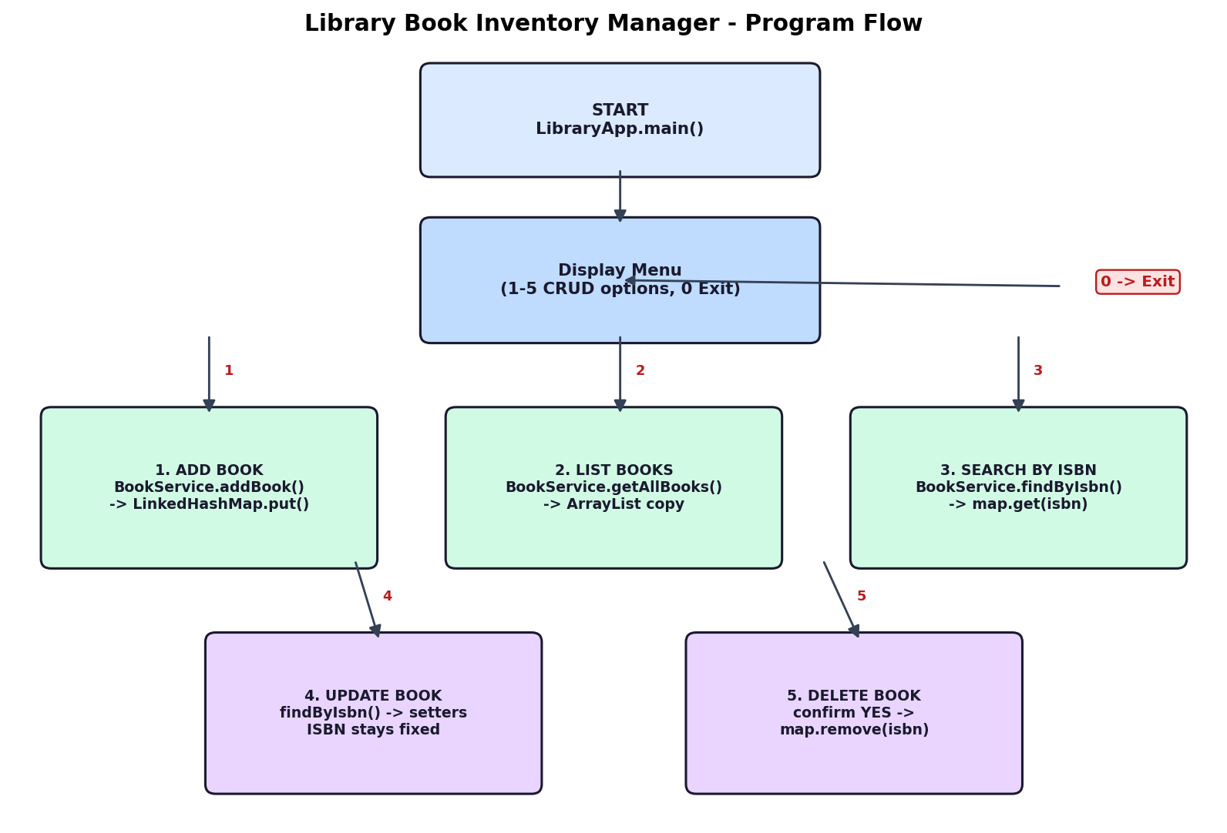

5. Sample Run
The session below demonstrates every feature: adding two books, listing, searching, updating (only the title changes), duplicate-ISBN rejection, not-found handling, deletion with confirmation, an invalid menu choice, and a clean exit.
========================================
Library Book Inventory Manager
========================================
---------- MAIN MENU ----------
1. Add a new book
2. List all books
3. Search book by ISBN
4. Update a book
5. Delete a book
0. Exit
Enter your choice:
1
--- Add a new book ---
Title: Clean Code
Author: Robert C. Martin
ISBN: 9780132350884
Publication year: 2008
Book added successfully.
---------- MAIN MENU ----------
1. Add a new book
2. List all books
3. Search book by ISBN
4. Update a book
5. Delete a book
0. Exit
Enter your choice:
1
--- Add a new book ---
Title: Effective Java
Author: Joshua Bloch
ISBN: 9780134685991
Publication year: 2018
Book added successfully.
---------- MAIN MENU ----------
1. Add a new book
2. List all books
3. Search book by ISBN
4. Update a book
5. Delete a book
0. Exit
Enter your choice:
2
--- Book list (2 book(s)) ---
ISBN | TITLE | AUTHOR | YEAR
--------------------------------------------------------------------------------
9780132350884 | Clean Code | Robert C. Martin | 2008
9780134685991 | Effective Java | Joshua Bloch | 2018
---------- MAIN MENU ----------
1. Add a new book
2. List all books
3. Search book by ISBN
4. Update a book
5. Delete a book
0. Exit
Enter your choice:
3
--- Search book by ISBN ---
Enter ISBN: 9780132350884
ISBN | TITLE | AUTHOR | YEAR
--------------------------------------------------------------------------------
9780132350884 | Clean Code | Robert C. Martin | 2008
---------- MAIN MENU ----------
1. Add a new book
2. List all books
3. Search book by ISBN
4. Update a book
5. Delete a book
0. Exit
Enter your choice:
4
--- Update a book ---
Enter ISBN of the book to update: 9780132350884
Leave a field blank and press Enter to keep the current value.
Current title: Clean Code
New title: Clean Code: A Handbook of Agile Software Craftsmanship
Current author: Robert C. Martin
New author:
Current publication year: 2008
New publication year:
Book updated successfully.
---------- MAIN MENU ----------
1. Add a new book
2. List all books
3. Search book by ISBN
4. Update a book
5. Delete a book
0. Exit
Enter your choice:
1
--- Add a new book ---
Title: Duplicate Test
Author: Someone
ISBN: 9780132350884
Publication year: 2020
Error: A book with ISBN 9780132350884 already exists.
---------- MAIN MENU ----------
1. Add a new book
2. List all books
3. Search book by ISBN
4. Update a book
5. Delete a book
0. Exit
Enter your choice:
3
--- Search book by ISBN ---
Enter ISBN: 9990001112223
Error: No book found with ISBN: 9990001112223
---------- MAIN MENU ----------
1. Add a new book
2. List all books
3. Search book by ISBN
4. Update a book
5. Delete a book
0. Exit
Enter your choice:
5
--- Delete a book ---
Enter ISBN of the book to delete: 9780134685991
About to delete: Effective Java (9780134685991)
Type YES to confirm: YES
Book deleted successfully.
---------- MAIN MENU ----------
1. Add a new book
2. List all books
3. Search book by ISBN
4. Update a book
5. Delete a book
0. Exit
Enter your choice:
2
--- Book list (1 book(s)) ---
ISBN | TITLE | AUTHOR | YEAR
--------------------------------------------------------------------------------
9780132350884 | Clean Code: A Handbook of Agile Software Craftsmanship | Robert C. Martin | 2008
---------- MAIN MENU ----------
1. Add a new book
2. List all books
3. Search book by ISBN
4. Update a book
5. Delete a book
0. Exit
Enter your choice:
9
Invalid option. Please choose a number from 0 to 5.
---------- MAIN MENU ----------
1. Add a new book
2. List all books
3. Search book by ISBN
4. Update a book
5. Delete a book
0. Exit
Enter your choice:
0
Thank you for using the Library Manager. Goodbye!

6. Testing Performed
# | Scenario | Expected / Observed Result
1 | Add a valid book | Book stored; success message shown
2 | Add a book with an existing ISBN | DuplicateIsbnException caught; clear error message, no duplicate stored
3 | List books (empty and non-empty) | Empty state message when no books; aligned table otherwise
4 | Search existing / unknown ISBN | Book row printed for existing; friendly error for unknown
5 | Update: change title only, blank author/year | Only the title changes; current values retained on blank input
6 | Update a non-existent ISBN | BookNotFoundException handled gracefully
7 | Delete with YES / with anything else | Removed on YES; cancelled otherwise
8 | Non-numeric year input | Re-prompts: 'That is not a valid number'
9 | Out-of-range year (e.g. 999 or 3000) | Re-prompts with the 1400-2026 range message
10 | Menu option outside 0-5 | 'Invalid option' message; menu reprints
11 | Empty title/author/ISBN | Re-prompts: 'This field cannot be empty'
12 | Exit (option 0) | Goodbye message; Scanner closed; program terminates cleanly

7. How to Compile and Run
javac -d out src/main/java/com/library/*.java
java -cp out com.library.LibraryApp
Requirements: JDK 17 or newer. From the project root (the folder containing src), compile with the first command, then run the second. Full step-by-step instructions are also in the README.md inside the ZIP.

8. Known Limitations and Future Improvements
- Data is in-memory only, so the inventory is lost when the program exits - file or database persistence would be the natural next step.
- Search is by exact ISBN only; title or author (partial) search could be added with streams and filters.
- The list could support sorting by title or year using a Comparator.
These are deliberate scope decisions for a Week 2 task focused on collections, CRUD and validation; they map cleanly onto the Spring Boot / MySQL design documented in Week 1, where the same BookService contracts could be reused behind REST endpoints.

9. Conclusion
The application implements all required functionality - create, read (list and single search), update and delete - on an in-memory LinkedHashMap, with layered responsibilities between the CLI and the service, typed exceptions for the two business error cases, thorough input validation, and comments that explain the logic and data flow in every file. Building it reinforced how Java collections, exception handling and simple method decomposition combine into a clean, working command-line tool, and it keeps the project consistent with the architecture planned in Week 1.

