WHATSNEXT VISION MOTORS
Salesforce CRM Project Documentation
Shaping the Future of Mobility with Innovation and Excellence
A project report on the WhatsNext Vision Motors CRM built on Salesforce. It describes the data model, automation flows and Apex components developed to streamline vehicle ordering, dealer assignment, stock control and test drive communication.
Submitted by
DHANUSHREE G – 24CSR054

Executive Summary
WhatsNext Vision Motors is revolutionizing its customer experience and operational efficiency with a Salesforce CRM implementation. The project streamlines the vehicle ordering process by auto-assigning orders to the nearest dealer based on customer location and by preventing orders for out-of-stock vehicles.
Automated workflows update order statuses dynamically and send scheduled email reminders for test drives. The key technical implementations are Apex triggers for stock validation, batch jobs for stock updates, and scheduled Apex for automated order processing. This initiative enhances customer satisfaction, improves order accuracy and boosts overall operational efficiency.
The solution consists of six custom objects, a Lightning app for navigation, two record-triggered flows, an Apex trigger with a handler class, a batch class and a scheduler class that runs the batch job automatically every night.

User Stories
- As a customer, I want my order to be assigned to the dealer nearest to me so that I receive faster service.
- As a customer, I want a reminder before my test drive so that I do not miss the appointment.
- As a dealer, I want orders for out-of-stock vehicles to be blocked so that I do not accept orders that cannot be fulfilled.
- As an administrator, I want pending orders to be confirmed automatically once stock is replenished so that no manual follow-up is needed.

Project Objectives
Objective | Project contribution
Centralize records | Vehicle, dealer, customer, order, test drive and service request data are held in Salesforce custom objects.
Automate dealer assignment | The Auto Assign Dealer flow links each new pending order to a dealer based on the customer's location.
Protect stock accuracy | An Apex trigger blocks orders for out-of-stock vehicles and reduces stock when an order is confirmed.
Improve communication | The Test Drive Reminder flow emails customers one day before their scheduled test drive.
Automate order processing | A batch class and scheduler confirm pending orders every night once stock is available.

Document Map
The report moves from the project overview and requirements to solution design, then the data model, flow automation, Apex development, testing, and finally the conclusion and future enhancements.

1 Project Overview and Requirements

1.1 Project Overview
The WhatsNext Vision Motors CRM is a custom-object solution for managing the core records of a vehicle sales and service business. The data model connects vehicles, dealers, customers, orders, test drives and service requests. Flow Builder handles dealer assignment and test drive reminders, while Apex code enforces stock rules and processes pending orders in bulk.

1.2 Ideation
Manual order handling in a vehicle business leads to orders being routed to the wrong dealer, vehicles being sold without stock, and customers missing test drive appointments. The project addresses these problems by moving the rules into Salesforce: dealer routing and reminders are handled by flows, and stock rules are enforced in Apex so they apply no matter how an order is created.

1.3 Functional Requirements
ID | Requirement | Salesforce area
FR-01 | Maintain vehicle records with model and stock quantity, linked to a dealer. | Vehicle__c
FR-02 | Maintain authorized dealer information. | Vehicle_Dealer__c
FR-03 | Maintain customer details including address and email. | Vehicle_Customer__c
FR-04 | Auto-assign new pending orders to the nearest dealer. | Auto Assign Dealer flow
FR-05 | Prevent orders for vehicles with no stock. | VehicleOrderTrigger
FR-06 | Reduce vehicle stock when an order is confirmed. | VehicleOrderTriggerHandler
FR-07 | Confirm pending orders automatically after restocking. | VehicleOrderBatch
FR-08 | Run order processing automatically every night. | VehicleOrderBatchScheduler
FR-09 | Email customers a reminder one day before a test drive. | Test Drive Reminder flow

1.4 Quality and Access Requirements
- Stock integrity: an order must never be accepted for a vehicle with zero stock.
- Bulk safety: Apex logic is written to handle multiple records at once and queries data outside loops.
- Usability: all project objects are available from one Lightning app.
- Access: the app is assigned to the System Administrator profile.

2 Solution Design

2.1 Data Flow
A customer's order moves through the system as follows. The order is created with the status Pending. The Auto Assign Dealer flow reads the customer's address and assigns the matching dealer. Before the order is saved, the Apex trigger checks the vehicle's stock and rejects the order if none is available. When an order reaches the Confirmed status, the trigger reduces the vehicle's stock by one. Orders that remain Pending are picked up by the nightly batch job, which confirms them once stock has been added. Separately, test drives with the status Scheduled cause a reminder email to be sent one day before the test drive date.

2.2 Relationship Map
Object | Purpose | Relationships
Vehicle__c | Stores vehicle details | Related to Dealer and Orders
Vehicle_Dealer__c | Stores authorized dealer information | Related to Orders
Vehicle_Customer__c | Stores customer details | Related to Orders and Test Drives
Vehicle_Order__c | Tracks vehicle purchases | Related to Customer and Vehicle
Vehicle_Test_Drive__c | Tracks test drive bookings | Related to Customer and Vehicle
Vehicle_Service_Request__c | Tracks vehicle servicing requests | Related to Customer and Vehicle

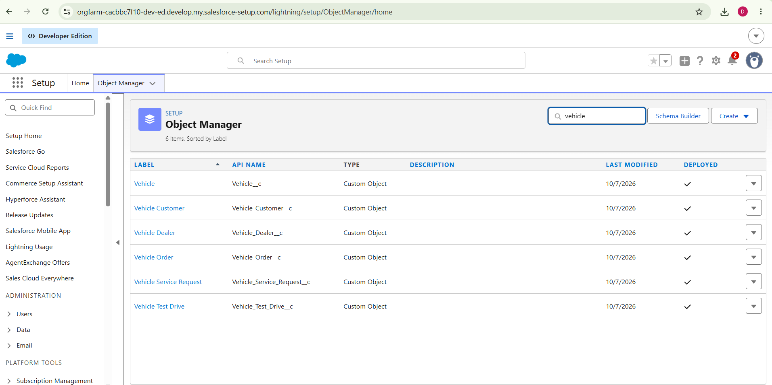
Figure 1: Schema Builder / Object Manager showing the custom objects

2.3 Salesforce Components
Component | Role in the project
Custom objects and fields | Data model for vehicles, dealers, customers, orders, test drives and service requests
Custom tab and Lightning app | Navigation across all project records
Record-triggered flows | Dealer assignment and test drive email reminders
Apex class and trigger | Stock validation and stock update on orders
Batch Apex | Bulk confirmation of pending orders
Schedulable Apex | Automatic nightly execution of the batch job

3 Custom Objects and Field Configuration

3.1 Vehicle Object
The Vehicle custom object was created to hold a clear picture of each vehicle's details. It is the central object of the project: orders and test drives refer to it, and its stock quantity drives the stock rules in the Apex code.
Setting | Value
Label | Vehicle
Plural label | Vehicles
Record name | Vehicle Name
Record name data type | Text
Allow reports | Enabled
Allow search | Enabled

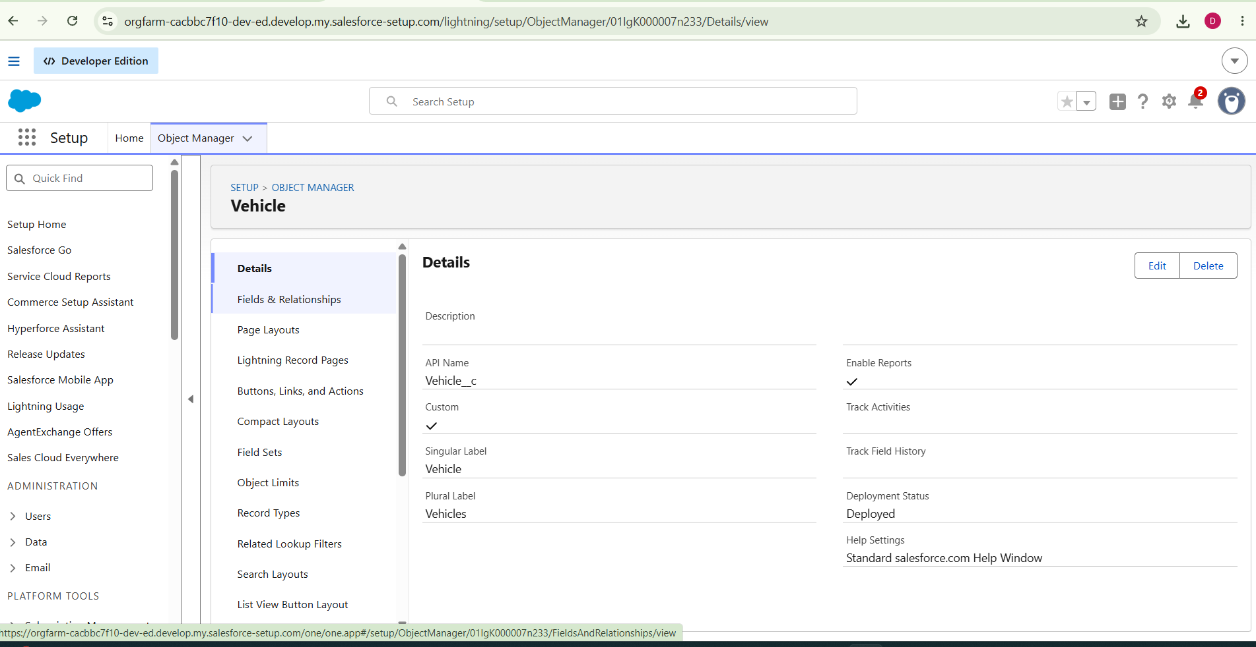Figure 2: Vehicle object details

3.2 Vehicle Fields and Relationships
Field | Type | Purpose
Vehicle Name | Text (record name) | Identifies each vehicle record
Vehicle Model | Picklist | Holds the model of the vehicle from a controlled list of values
Stock Quantity (Stock_Quantity__c) | Number | Tracks the available stock; read by the trigger and reduced when orders are confirmed
Dealer | Lookup to Vehicle_Dealer__c | Links each vehicle to the dealer that holds it

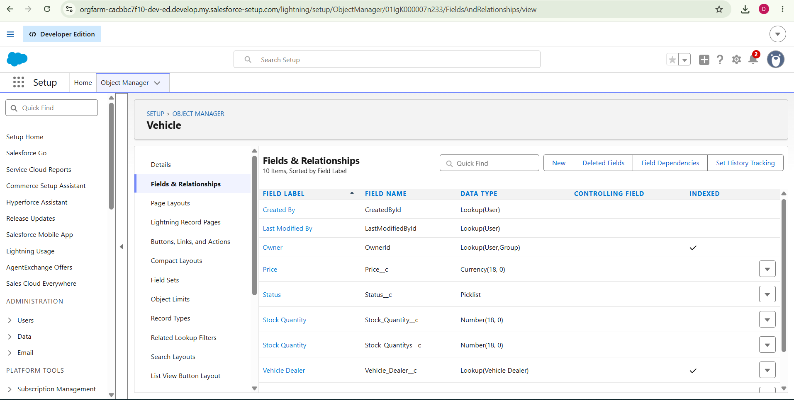Figure 3: Vehicle fields and relationships list
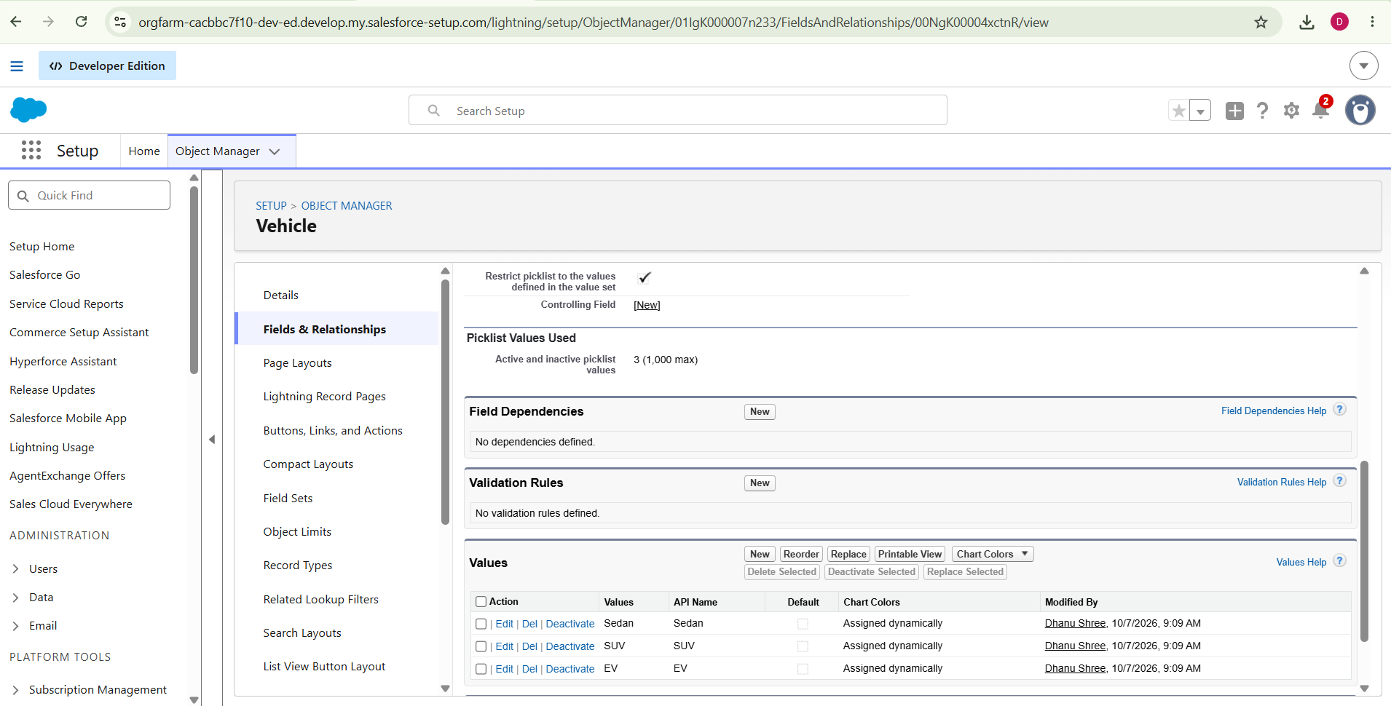Figure 4: Vehicle Model picklist values

3.3 Other Objects
The Dealer, Customer, Order, Test Drive and Service Request objects were created as custom objects. Key fields referenced by the automation are shown below.
Object | Fields used by the project
Vehicle_Order__c | Status__c (Pending / Confirmed), Vehicle__c (lookup to Vehicle), Vehicle_Customer__c (lookup to Customer), dealer lookup
Vehicle_Customer__c | Address__c, Email__c
Vehicle_Dealer__c | Dealer_Location__c
Vehicle_Test_Drive__c | Status__c (Scheduled), Test_Drive_Date__c, Customer__c (lookup to Customer)

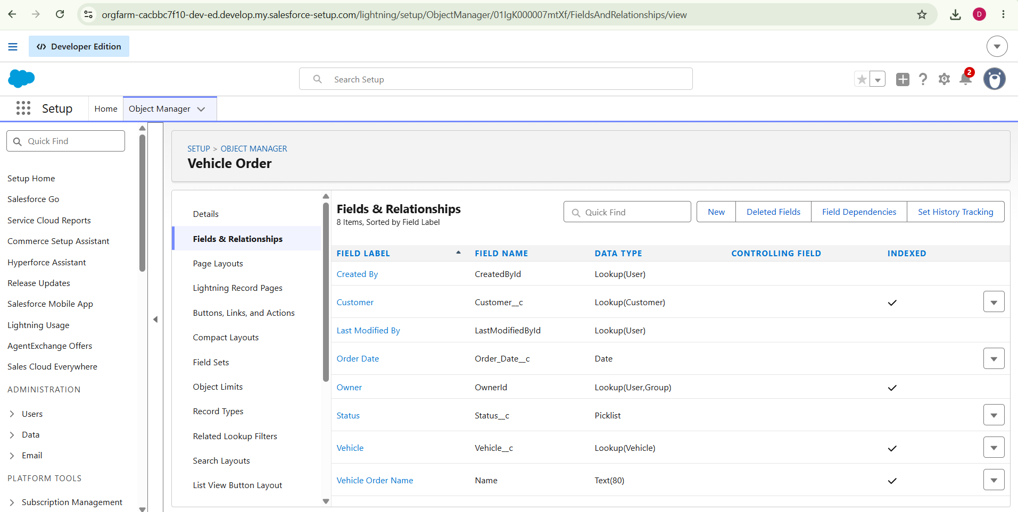Figure 5: Vehicle Order object fields
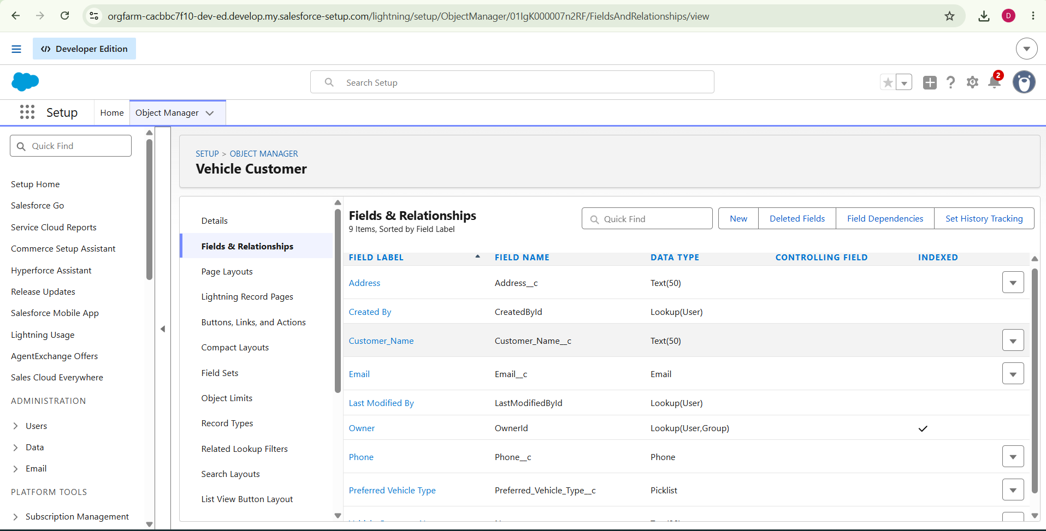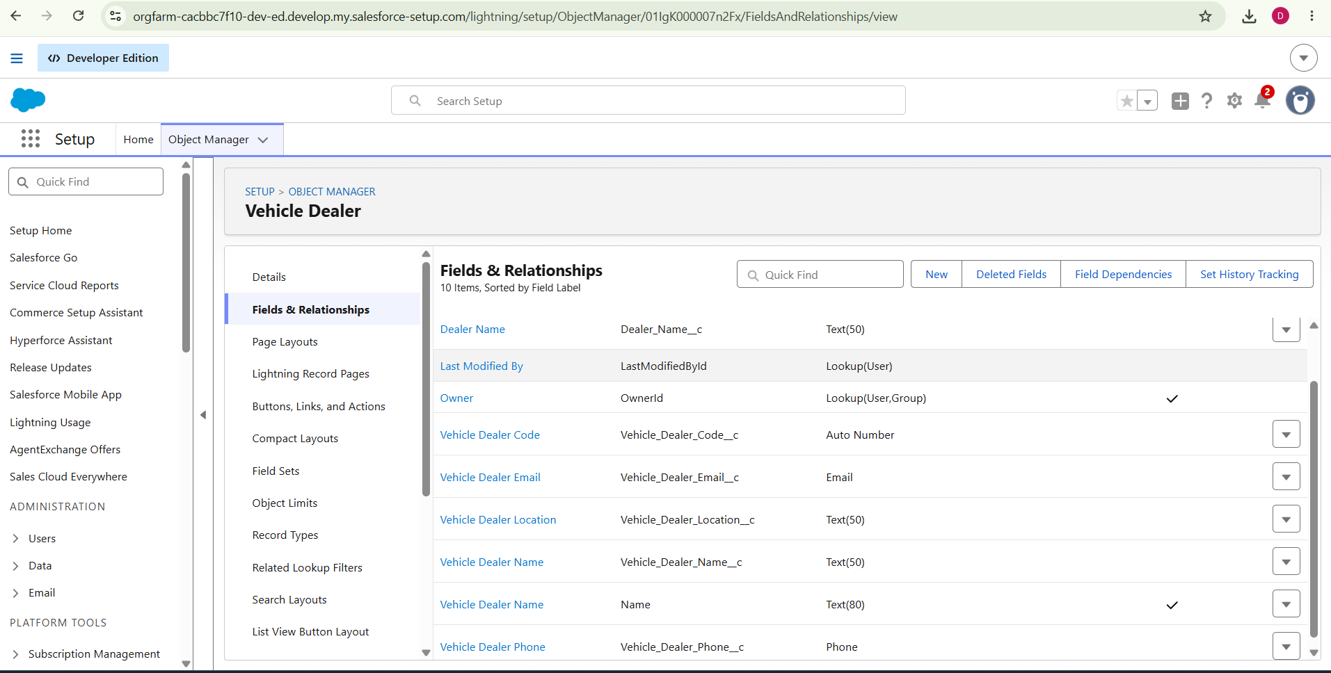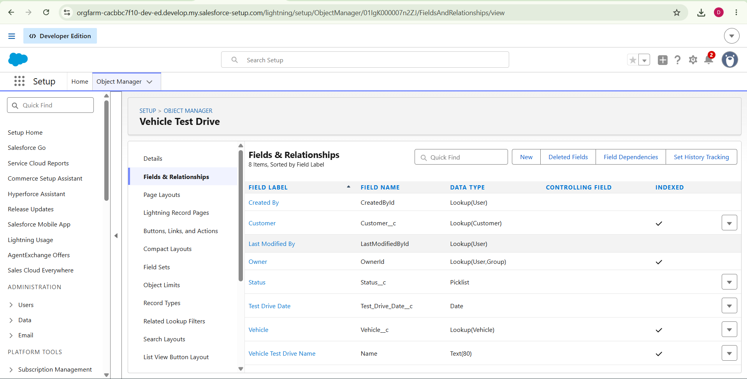Figure 6: Vehicle Customer, Dealer and Test Drive objects

3.4 Custom Tab
A custom object tab was created for the Vehicle object so that vehicle records can be opened directly from the app. The default settings were kept for tab visibility on profiles and for adding the tab to custom apps.
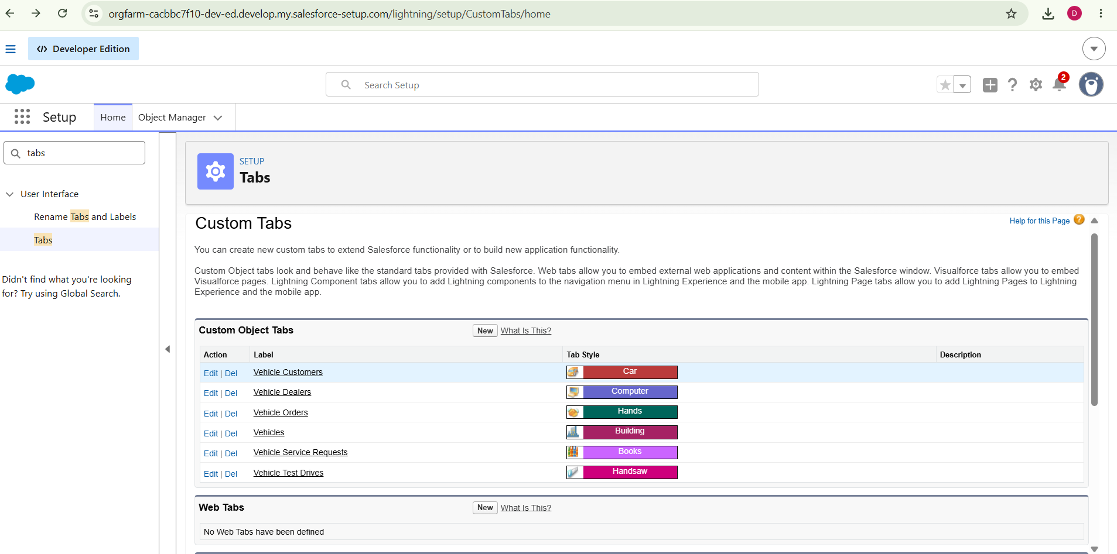Figure 7: Vehicle custom tab

3.5 Lightning App
A Lightning app named WhatNext Vision Motors was created in App Manager to bring all project records into one workspace.
Setting | Value
App name | WhatNext Vision Motors
Navigation items | Vehicle, Dealer, Customer, Order, Test Drive, Service Request, Reports, Dashboard
User profile access | System Administrator
App options / utility items | Default

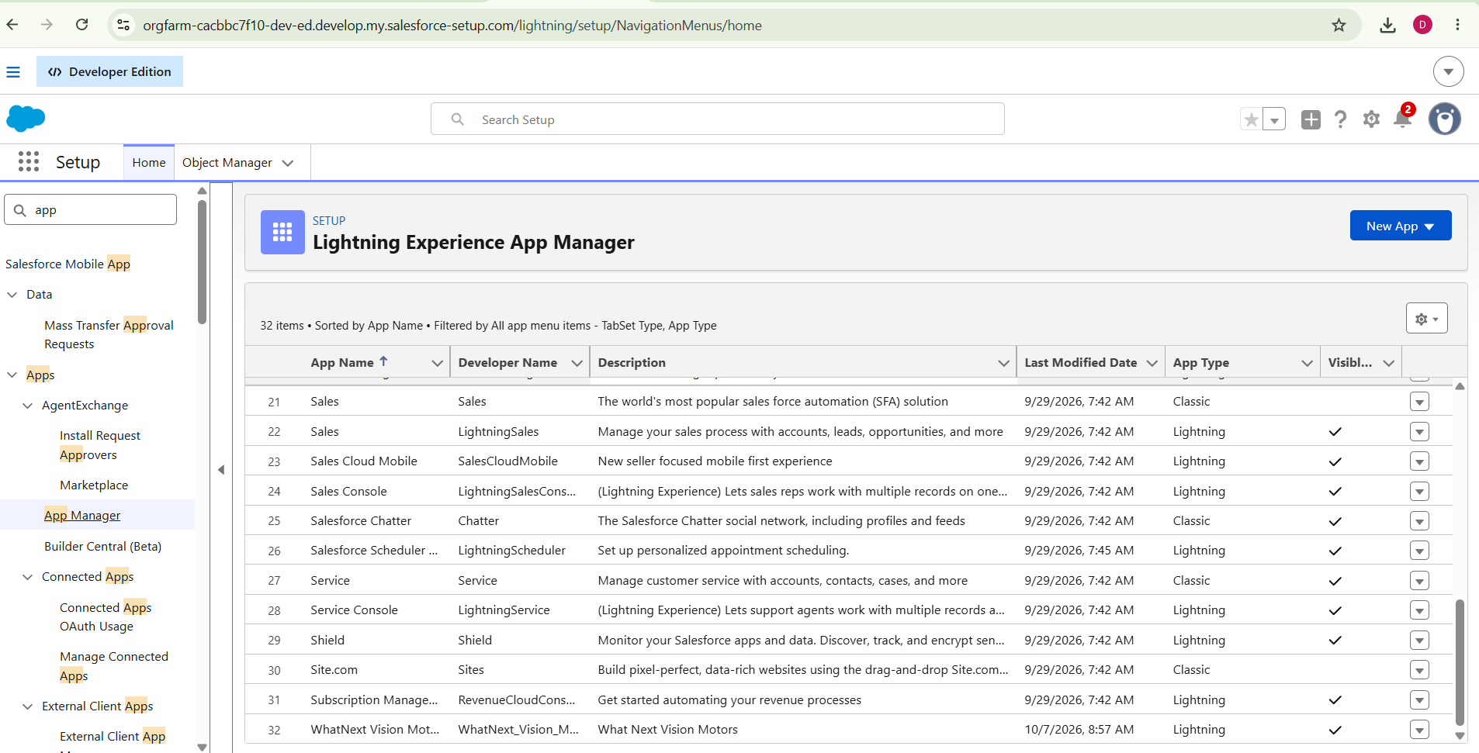Figure 8: App Manager showing the WhatNext Vision Motors app
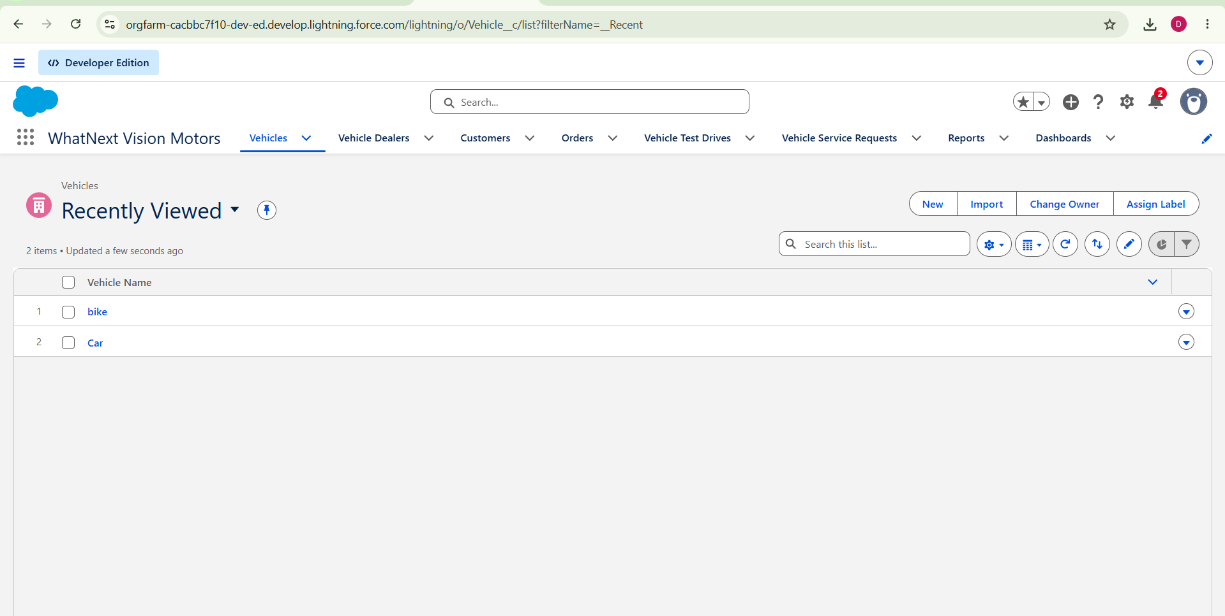Figure 9: WhatNext Vision Motors app navigation bar

4 Flow Automation

4.1 Auto Assign Dealer Flow
Auto Assign Dealer is a record-triggered flow on the Vehicle Order object. It runs when an order is created with the status Pending and assigns the order to the dealer whose location matches the customer's address.
Element | Type | Configuration
Start | Record-triggered (created) | Object: Vehicle Order. Entry condition: Status__c Equals Pending
Get Customer Information | Get Records | Object: Vehicle Customer. Condition: Id Equals {!$Record.Vehicle_Customer__c}
Get Nearest Dealer | Get Records | Object: Vehicle Dealer. Condition: Dealer_Location__c Equals {!Get_Customer_Information.Address__c}
Assign Dealer to Order | Update Records | Updates the order using the record found in {!Get_Nearest_Dealer}

The flow was saved as Auto Assign Dealer and activated.
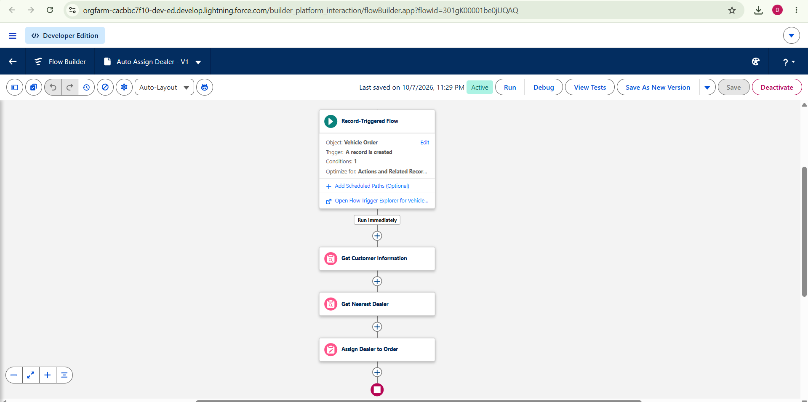Figure 10: Auto Assign Dealer flow canvas
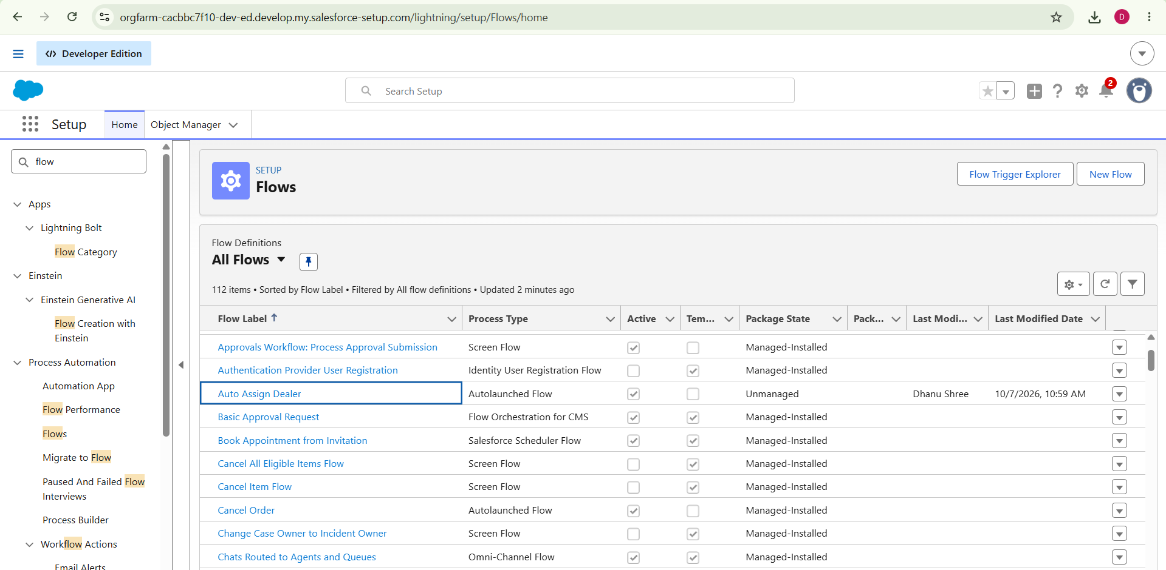Figure 11: Auto Assign Dealer flow details (active)

4.2 Test Drive Reminder Flow
Test Drive Reminder is a record-triggered flow on the Vehicle Test Drive object. It uses a scheduled path so that the reminder email is sent one day before the test drive date.
Element | Type | Configuration
Start | Record-triggered (created or updated) | Object: Vehicle Test Drive. Entry condition: Status__c Equals Scheduled
Reminder Before Test Drive | Scheduled path | Time source: Test_Drive_Date__c. Offset: 1 day before
Get Customer Information | Get Records | Object: Vehicle_Customer__c. Condition: Id Equals {!$Record.Customer__c}. First record only, all fields stored
Send Test Drive Reminder | Action: Send Email | Subject: Reminder: Your Test Drive is Tomorrow! Recipient: {!Get_Customer_Information.Email__c}. Rich-text body. Variable: EmailSent

The flow was saved as Test Drive Reminder and activated.
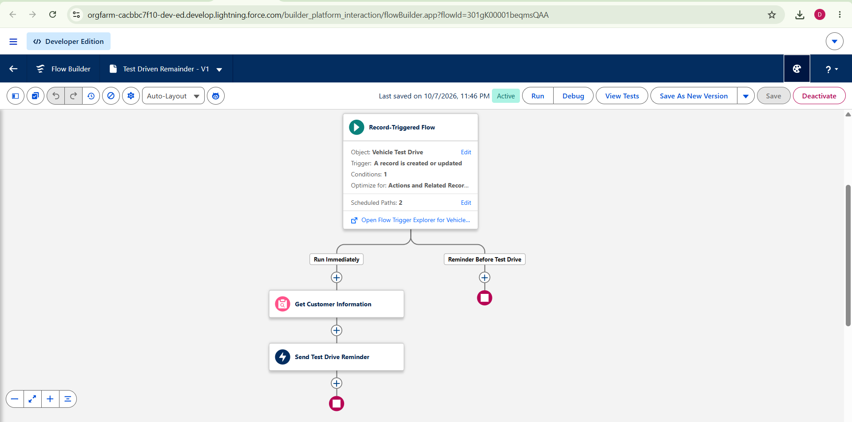Figure 12: Test Drive Reminder flow canvas
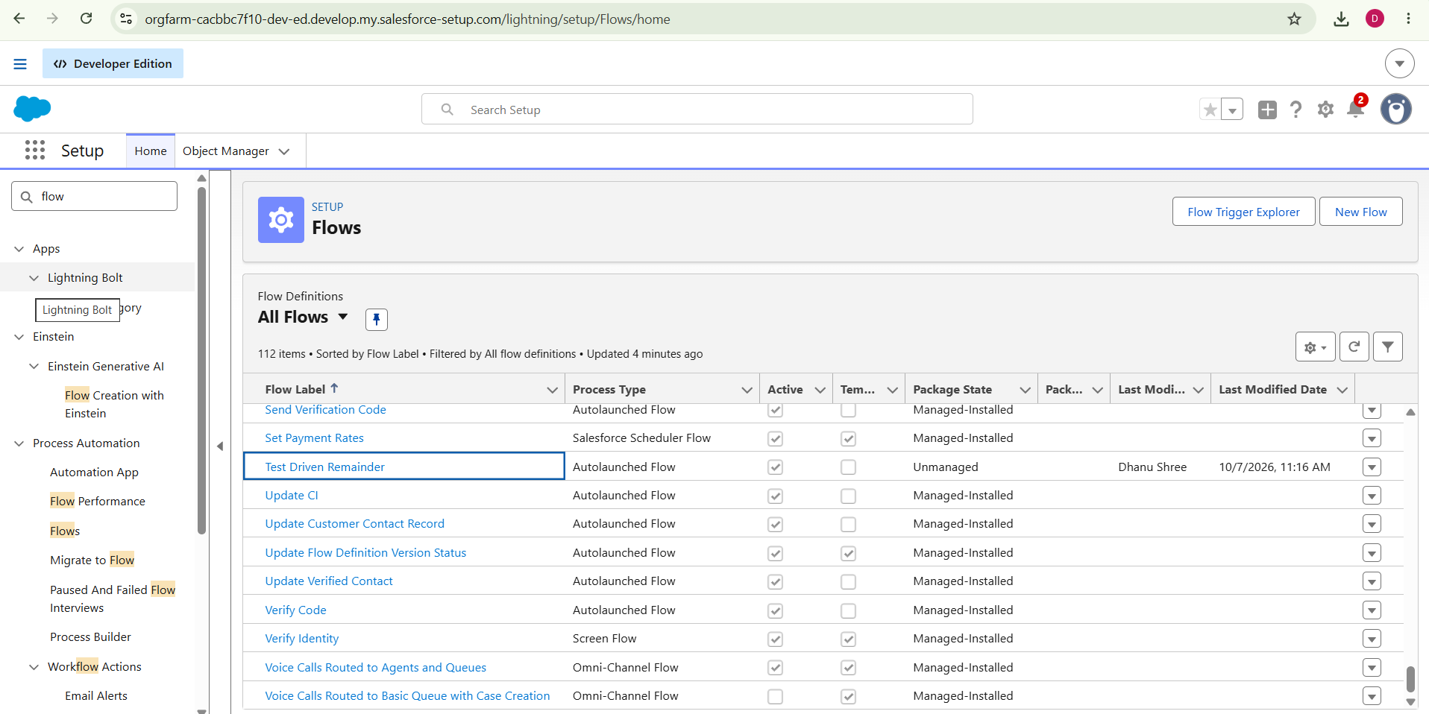Figure 13: Test Drive Reminder flow details (active)

5 Apex Development

5.1 Apex Components
Component | Type | Role
VehicleOrderTrigger | Apex trigger | Runs before and after insert and update on Vehicle Order and calls the handler
VehicleOrderTriggerHandler | Apex class | Blocks out-of-stock orders and reduces stock on confirmation
VehicleOrderBatch | Batch Apex | Confirms pending orders when stock is available
VehicleOrderBatchScheduler | Schedulable Apex | Runs the batch job with a batch size of 50
Daily Vehicle Order Processing | Scheduled job | Runs the scheduler automatically every night at midnight

5.2 Trigger Handler Class
VehicleOrderTriggerHandler holds the business logic. Before an order is inserted or updated, preventOrderIfOutOfStock collects the vehicle Ids on the orders, queries the stock once, and calls addError on any order whose vehicle has a stock quantity of zero or less. The message shown to the user is: This vehicle is out of stock. Order cannot be placed.
After an order is inserted or updated, updateStockOnOrderPlacement looks at orders whose status is Confirmed and reduces the stock quantity of the related vehicle by one, provided stock is above zero.
public class VehicleOrderTriggerHandler {
public static void handleTrigger(List<Vehicle_Order__c> newOrders, Map<Id, Vehicle_Order__c> oldOrders, Boolean isBefore, Boolean isAfter, Boolean isInsert, Boolean isUpdate) {
if (isBefore) {
if (isInsert || isUpdate) {
preventOrderIfOutOfStock(newOrders);
}
}

if (isAfter) {
if (isInsert || isUpdate) {
updateStockOnOrderPlacement(newOrders);
}
}
}
// Method to prevent orders when the vehicle is out of stock
private static void preventOrderIfOutOfStock(List<Vehicle_Order__c> orders) {
Set<Id> vehicleIds = new Set<Id>();
for (Vehicle_Order__c order : orders) {
if (order.Vehicle__c != null) {
vehicleIds.add(order.Vehicle__c);
}
}
if (!vehicleIds.isEmpty()) {
Map<Id, Vehicle__c> vehicleStockMap = new Map<Id, Vehicle__c>();
for (Vehicle__c vehicle : [SELECT Id, Stock_Quantity__c FROM Vehicle__c WHERE Id IN :vehicleIds]) {
vehicleStockMap.put(vehicle.Id, vehicle);
}
for (Vehicle_Order__c order : orders) {
if (vehicleStockMap.containsKey(order.Vehicle__c)) {
Vehicle__c vehicle = vehicleStockMap.get(order.Vehicle__c);
if (vehicle.Stock_Quantity__c <= 0) {
order.addError('This vehicle is out of stock. Order cannot be placed.');
}
}
}
}
}
// Method to update vehicle stock when an order is placed
private static void updateStockOnOrderPlacement(List<Vehicle_Order__c> orders) {
Set<Id> vehicleIds = new Set<Id>();
for (Vehicle_Order__c order : orders) {
if (order.Vehicle__c != null && order.Status__c == 'Confirmed') {
vehicleIds.add(order.Vehicle__c);
}
}
if (!vehicleIds.isEmpty()) {
Map<Id, Vehicle__c> vehicleStockMap = new Map<Id, Vehicle__c>();
for (Vehicle__c vehicle : [SELECT Id, Stock_Quantity__c FROM Vehicle__c WHERE Id IN :vehicleIds]) {
vehicleStockMap.put(vehicle.Id, vehicle);
}
List<Vehicle__c> vehiclesToUpdate = new List<Vehicle__c>();
for (Vehicle_Order__c order : orders) {
if (vehicleStockMap.containsKey(order.Vehicle__c)) {
Vehicle__c vehicle = vehicleStockMap.get(order.Vehicle__c);
if (vehicle.Stock_Quantity__c > 0) {
vehicle.Stock_Quantity__c -= 1;
vehiclesToUpdate.add(vehicle);
}
}
}
if (!vehiclesToUpdate.isEmpty()) {
update vehiclesToUpdate;
}
}
}
}

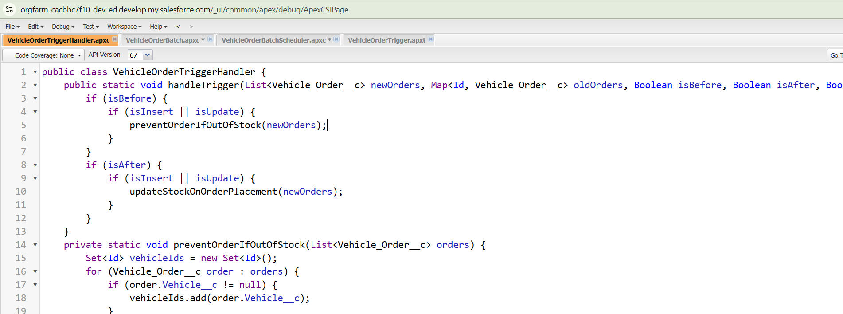Figure 14: VehicleOrderTriggerHandler class in Developer Console

5.3 Trigger
VehicleOrderTrigger is defined on the Vehicle Order object for before insert, before update, after insert and after update. It contains no logic of its own and passes the trigger context to the handler class.
trigger VehicleOrderTrigger on Vehicle_Order__c (before insert,before update, after insert, after update) {
VehicleOrderTriggerHandler.handleTrigger(Trigger.new, Trigger.oldMap, Trigger.isBefore,Trigger.isAfter, Trigger.isInsert, Trigger.isUpdate);
}

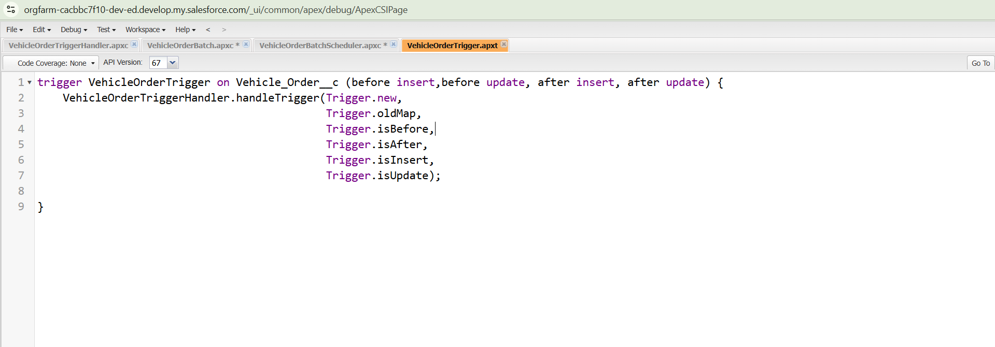Figure 15: VehicleOrderTrigger in Developer Console

5.4 Batch Class
The batch class addresses this scenario: a customer places an order but the vehicle is out of stock, so the order remains Pending. After new stock is added, the batch job updates the order to Confirmed and reduces the vehicle's stock.
The start method selects all orders with the status Pending. The execute method loads the stock of the related vehicles, and for each order whose vehicle has stock above zero it sets the status to Confirmed and reduces the stock by one. Both the orders and the vehicles are then updated. The finish method writes a completion message to the debug log.
global class VehicleOrderBatch implements Database.Batchable<sObject> {
global Database.QueryLocator start (Database.BatchableContext bc) {
return Database.getQueryLocator([
SELECT Id, Status_c, Vehicle___c
FROM Vehicle_Order___c
WHERE Status__c
'Pending'
]);
}
global void execute(Database.BatchableContext bc, List<Vehicle_Order_c> orderList) {
Set<Id> vehicleIds = new Set<Id>();
for (Vehicle_Order_c order orderList) {
if (order.Vehicle_c != null) {
vehicleIds.add(order.Vehicle__c);
}
}
if (!vehicleIds.isEmpty()) {
Map<Id, Vehicle___c> vehicleStockMap = new Map<Id, Vehicle___c>();
for (Vehicle_c vehicle: [SELECT Id, Stock Quantity_c FROM Vehicle_c WHERE Id IN vehicleIds]) {
vehicleStockMap.put(vehicle. Id, vehicle);
}
List<Vehicle_Order_c> ordersToUpdate = new List<Vehicle_Order_c>(); List<Vehicle__c> vehiclesToUpdate = new List<Vehicle__c>();
for (Vehicle_Order_c order orderList) {
if (vehicleStockMap.containsKey(order. Vehicle__c)) {
Vehicle_c vehicle = vehicleStockMap.get(order. Vehicle__c);
if (vehicle.Stock_Quantity___c > 0) {
order.Status___c = 'Confirmed';
vehicle.Stock_Quantity___c -= 1;
ordersToUpdate.add(order);
vehiclesToUpdate.add(vehicle);
}
}
}
if (!ordersToUpdate.isEmpty()) {
update ordersToUpdate;
}
if (!vehicles ToUpdate.isEmpty()) {
update vehiclesToUpdate;
}
}
global void finish(Database.BatchableContext bc) {
System.debug('Vehicle order batch job completed.');
}
}

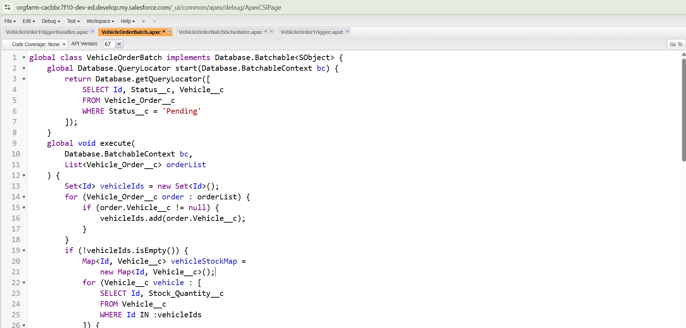Figure 16: VehicleOrderBatch class in Developer Console

5.5 Scheduler Class and Scheduled Job
VehicleOrderBatchScheduler implements Schedulable and starts the batch class with a batch size of 50. The job was scheduled from the Anonymous Apex window with a cron expression so that it runs every night at midnight, under the job name Daily Vehicle Order Processing.

global class VehicleOrderBatchScheduler implements Schedulable {
global void execute(SchedulableContext sc) {
VehicleOrderBatch batchJob = new VehicleOrderBatch();
Database.executeBatch(batchJob, 50); // 50 is the batch size
}
}
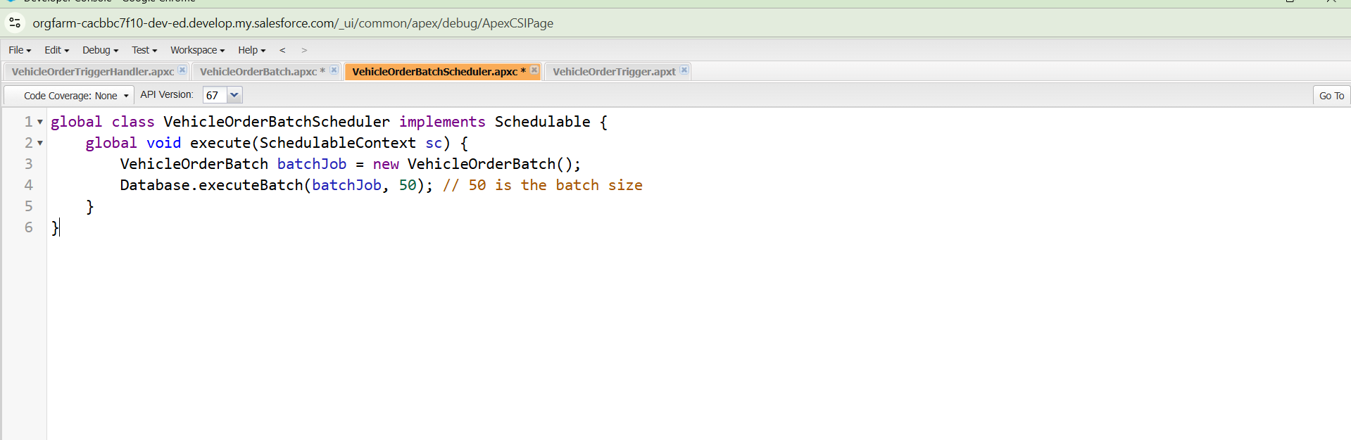Figure 17: VehicleOrderBatchScheduler class in Developer Console

String cronExp = '0 0 12 * * ?'; // Runs daily at 12:00 PM
System.schedule('Daily Vehicle Order Processing', cronExp, new VehicleOrderBatchScheduler());

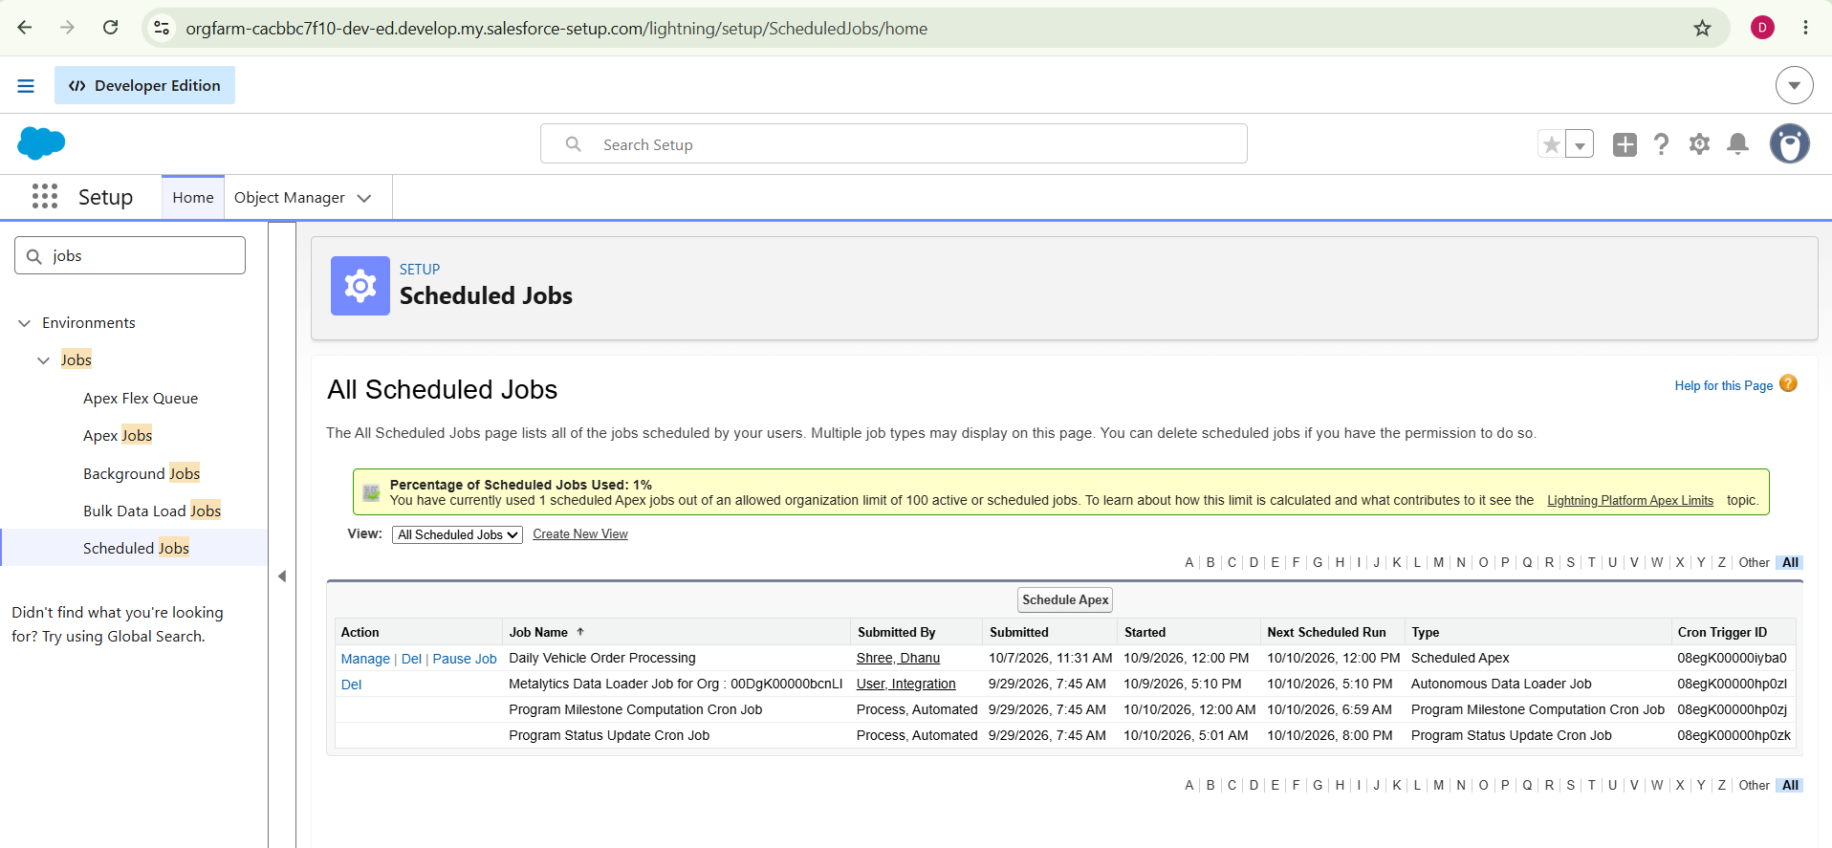Figure 18: Scheduled Jobs page showing Daily Vehicle Order Processing

6 Testing and Verification
The following scenarios were used to check that each component behaves as intended.
Scenario | Action | Expected outcome
Dealer assignment | Create a Vehicle Order with status Pending for a customer. | The order is linked to the dealer whose location matches the customer's address.
Out-of-stock block | Set a vehicle's Stock Quantity to 0 and create an order for it. | The error 'This vehicle is out of stock. Order cannot be placed.' is shown and the order is not saved.
Stock reduction | Create or update an order with status Confirmed for an in-stock vehicle. | The vehicle's Stock Quantity decreases by 1.
Batch confirmation | Leave an order Pending, add stock to the vehicle, and run the batch job. | The order status changes to Confirmed and stock decreases by 1.
Scheduled job | Open Scheduled Jobs in Setup. | Daily Vehicle Order Processing is listed with its next run time.
Test drive reminder | Create a Test Drive with status Scheduled and a future date. | The customer receives the reminder email one day before the date.

7 Conclusion and Future Enhancements

7.1 Conclusion
The WhatsNext Vision Motors CRM brings vehicles, dealers, customers, orders, test drives and service requests into a single Salesforce application. Flow automation assigns dealers and reminds customers of test drives, while Apex code protects stock accuracy and processes pending orders automatically every night. The result is a more accurate, efficient and customer-friendly vehicle ordering process.

7.2 Future Enhancements
- Use geolocation fields or a distance calculation to find the genuinely nearest dealer instead of an exact location match.
- Add Apex test classes with sufficient code coverage for the handler, batch class and scheduler.
- Send a confirmation email to the customer when a pending order is confirmed by the batch job.
- Build reports and dashboards for stock levels, order status and dealer performance.
- Extend automation to service requests, such as service reminders and status updates.

