**Uploading via Jupyter notebook in Google collab**

Sample code trial:

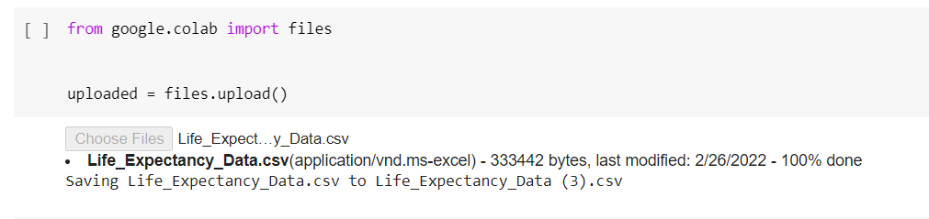

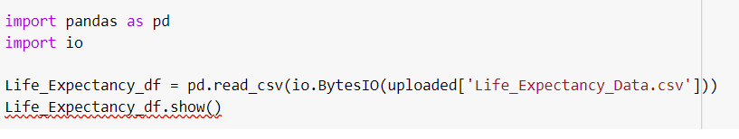

**Loading from github into dataframe via Jupyter notebook in Google collab**

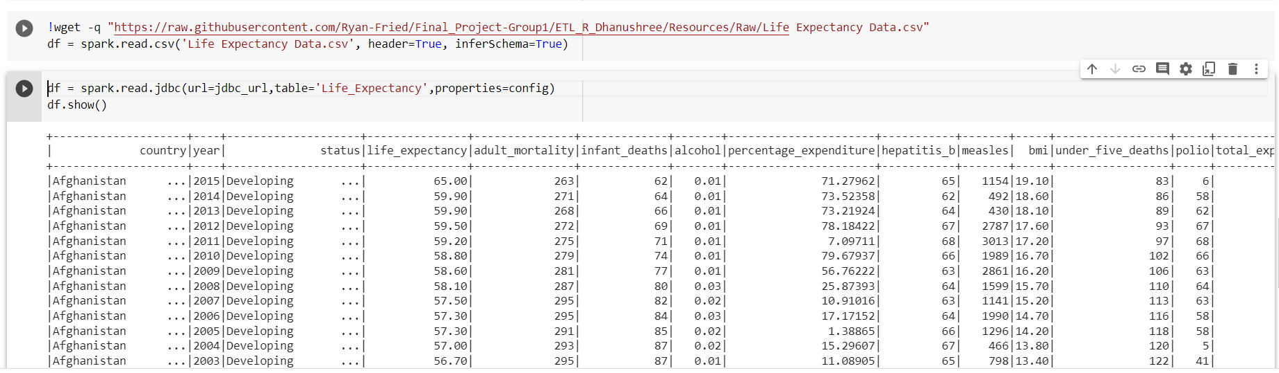

**Reading from s3 into dataframe Jupyter notebook in Google collab**

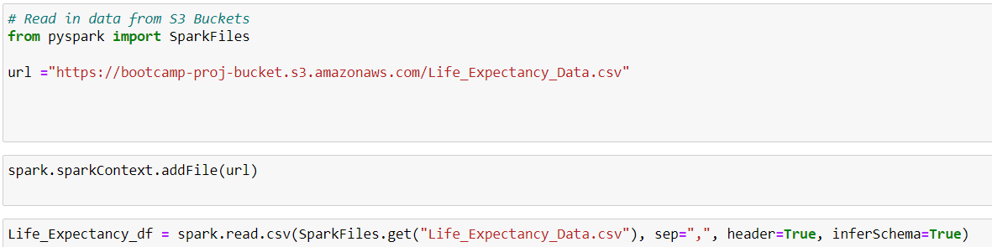

**Importing csv file into Postgres (Using aws s3.table im[port from s3 command)**

CREATE EXTENSION aws_s3

SELECT aws_s3.table_import_from_s3(  
'POSTGRES_TABLE_NAME', 'event_id,event_name,event_value', '(format csv, header true)',  
'BUCKET_NAME',  
'FOLDER_NAME(optional)/FILE_NAME',  
'REGION',  
'AWS_ACCESS_KEY', 'AWS_SECRET_KEY', 'OPTIONAL_SESSION_TOKEN'  
)

Fyi—We have to make sure s3 talks to RDS by following steps as listed below:

<https://www.sqlshack.com/integrating-aws-s3-buckets-with-aws-rds-sql-server/>