A Multi-Disease Explainable Clinical Decision Support Framework for Attribution Consistency and Constrained Counterfactual Recourse
Dhanush S. J.
Department of Computer Science and Engineering / Medical Informatics
Email: dhanush@example.edu
―――――――――――――――――――――――――――――――――――――――――――――――――――――――
Abstract—Deploying machine learning models in clinical environments is limited by the opacity of black-box algorithms and the well-documented disagreement between explainability frameworks, where methods such as SHAP and LIME produce conflicting feature rankings for the same patient. Furthermore, existing counterfactual explanation techniques frequently suggest biologically impossible or clinically unsafe modifications, such as decreasing chronological age or altering fixed demographic characteristics. Most critically, post-hoc feature attribution and counterfactual recourse are almost exclusively treated as separate, uncoordinated procedures, leaving clinicians unable to verify whether the features highlighted as diagnostic drivers actually possess the ability to alter the model's decision boundary.
To address these challenges, this paper presents a unified, multi-disease Explainable Clinical Decision Support (CDSS) framework evaluated across four clinical domains: Heart Disease, Diabetes, Chronic Kidney Disease, and Stroke. The framework introduces a three-stage triangulated research methodology: (1) Attribution Triangulation: Quantifying cross-explainer agreement between game-theoretic Shapley values (SHAP) and local linear surrogates (LIME) using an application-specific Explanation Reliability Index (ERI), which integrates top-K feature overlap (40%), directional sign concordance (30%), and ranking displacement (30%); (2) Dual-Tier Constrained Recourse: Structuring actionable perturbations into single-biomarker trajectories (L0 = 1) and multi-biomarker combinations (L0 >= 2, demonstrating both L0 = 2 and L0 = 3) while strictly enforcing biological and demographic immutability constraints (delta = 0 for Age, Sex, and History); and (3) Attribution-to-Recourse Alignment (ARA): Formulating a closed-form alignment metric to evaluate whether the modifiable features identified as primary drivers by attribution explainers correspond to the features required by the classifier to shift its prediction into a lower-risk region. Empirical evaluation on benchmark cohorts demonstrates that the framework delivers robust predictive sensitivity, stable explainer consensus (79.0% - 89.5% ERI), and high attribution-to-recourse alignment in the representative cases without prescribing clinical treatments or asserting causal medical claims.
Index Terms—Clinical Decision Support Systems, Explainable AI (XAI), Attribution-to-Recourse Alignment (ARA), Explanation Reliability Index (ERI), Constrained Counterfactuals, L0 Sparsity, Feature Immutability.
I. INTRODUCTION
Machine learning classifiers have achieved high diagnostic sensitivity across cardiology, nephrology, and endocrinology. However, integrating these predictive systems into hospital workflows remains challenging. Clinicians frequently encounter the 'black-box' dilemma: a model outputs an elevated probability of cardiovascular or renal failure without providing an interpretable causal trail that correlates with recognized medical guidelines.
Post-hoc explanation methods, notably SHAP (SHapley Additive exPlanations) and LIME (Local Interpretable Model-agnostic Explanations), have emerged to bridge this gap. Yet their simultaneous deployment has uncovered a secondary obstacle: the explanation disagreement problem. Because SHAP calculates global marginal contributions based on cooperative game theory while LIME approximates local decision boundaries using perturbed sampling, they frequently identify disparate biomarkers as the primary diagnostic drivers for the exact same patient. This divergence erodes clinical confidence; physicians cannot determine which explanation accurately reflects the model's internal reasoning.
A parallel challenge lies in actionable recourse. While predictive models estimate the likelihood of pathology, clinicians need to understand what physiological adjustments could transition a high-risk patient across the decision boundary into a low-risk classification. Standard counterfactual optimization packages (such as unconstrained gradient descent or genetic solvers) often generate biologically absurd recommendations, such as asking an elderly patient to reduce their age, altering biological sex, or shifting blood pressure to non-viable levels.
More fundamentally, feature attribution and counterfactual recourse have evolved in disconnected research silos. Attribution methods answer: 'Which features contributed most to this prediction?' Counterfactual generators answer: 'What hypothetical changes would flip the prediction?' Existing systems rarely ask the bridging question:
Do the features identified as important by post-hoc attribution methods correspond to the features that the deployed model actually requires to change its decision boundary under constrained counterfactual search?
To address this question, this work develops and evaluates an integrated clinical decision-support framework. The specific contributions are:
1. The Attribution-to-Recourse Alignment (ARA) Metric: A formal evaluation metric that quantifies the degree of intersection between top attributed biomarkers and features utilized in model-validated counterfactual trajectories, verifying the behavioral consistency between post-hoc explainers and classifier decision boundaries.
2. The Explanation Reliability Index (ERI): An application-specific composite metric combining feature overlap (40%), directional sign agreement (30%), and ranking displacement (30%) into a real-time advisory gauge for clinicians.
3. Dual-Tier Constrained Recourse Architecture: A recourse generation pipeline enforcing strict biological immutability (delta = 0 for demographic traits) and valid physiological intervals, while structuring recourse into Tier 1 (single-biomarker adjustments, L0 = 1) and Tier 2 (multi-biomarker combinations, L0 >= 2, demonstrating both L0 = 2 and L0 = 3).
4. Multi-Domain Experimental Generalizability: Evaluating the framework across four heterogeneous disease benchmarks (Heart Disease, Diabetes, Chronic Kidney Disease, and Stroke) with full auditability and role-based access control.
II. RELATED WORK
A. Explainable Machine Learning and Attribution Disagreement
Explainable AI in medicine has largely relied on feature attribution. Early efforts focused on tree-based feature importances, but these provide global summaries rather than patient-specific rationales. The introduction of LIME enabled localized linear approximations around individual test points, while KernelSHAP and TreeSHAP grounded attributions in game-theoretic axioms. However, extensive empirical studies (e.g., Krishna et al., 2022) established that different XAI methods disagree up to 70% of the time in real-world tabular data. While prior literature has evaluated individual aspects of disagreement—such as Jaccard overlap, sign agreement, or rank correlation in software engineering and general machine learning—few frameworks integrate these dimensions into an operational advisory composite metric within multi-disease clinical interfaces.
B. Counterfactual Recourse and Actionability Constraints
Counterfactual explanations, originally formalized by Wachter et al., seek the smallest perturbation delta that flips a model's prediction. Subsequent frameworks, such as DiCE (Diverse Counterfactual Explanations), introduced diversity objectives to generate multiple candidate profiles. Despite algorithmic maturity, standard counterfactual implementations rarely enforce biological constraints. Without explicit domain bounding, optimization routines manipulate non-modifiable features (such as age, genetic history, and biological sex) because their large model weights offer the steepest mathematical gradient descent. Existing clinical counterfactual literature often lacks tiered partitioning based on operational sparsity (L0 norm), making it difficult to distinguish between focused single-parameter adjustments and complex multi-factorial shifts.
C. Connecting Attribution to Recourse
Recent foundational work in machine learning interpretability has begun exploring the relationship between feature attribution and counterfactual explanations. Researchers have noted that while attribution identifies historical correlation within the model, counterfactuals identify necessary and sufficient perturbations. However, this connection has remained largely theoretical. This paper operationalizes the association through the Attribution-to-Recourse Alignment (ARA) index across four distinct medical domains.
III. SYSTEM ARCHITECTURE AND METHODOLOGY
The proposed CDSS follows an integrated multi-stage pipeline: patient context ingestion, scaled inference, dual-engine feature attribution, concordance evaluation (ERI), constrained counterfactual recourse generation, and attribution-to-recourse alignment.
A. Triangulated Explanation Reliability Index (ERI)
To quantitatively evaluate explanation stability, the system computes the top-K feature attributions from SHAP (F_SHAP) and LIME (F_LIME), where K = 5. The shared feature subset is defined as F_shared = F_SHAP ∩ F_LIME.
1. Feature Selection Overlap: C_overlap = (|F_shared| / K) * 100%
2. Directional Sign Concordance: S_direction = (1 / |F_shared|) * sum( I( sgn(phi_SHAP(f)) == sgn(beta_LIME(f)) ) ) * 100%
3. Rank Displacement Concordance: R_ranking = max(0.0, 1.0 - (sum(|rank_SHAP(f) - rank_LIME(f)|) / max_displacement)) * 100%
Composite Formulation: ERI = (0.40 * C_overlap) + (0.30 * S_direction) + (0.30 * R_ranking)
ERI functions strictly as an advisory metric categorized into three operational zones: High Reliability (80.0% - 100.0%), Moderate Reliability (50.0% - 79.9%), and Low Reliability (0.0% - 49.9%).
B. Dual-Tier Constrained Counterfactual Recourse
Given an input patient vector x for which the model predicts risk f(x) = y, the counterfactual search identifies a perturbed vector x* = x + delta such that the classifier's predicted outcome changes to a lower-risk state f(x*) = y_target, subject to three constraints:
1. Biological Immutability Constraints: delta_i = 0 for all i in I. Immutables: Heart {age, sex}; Diabetes {age, gender}; CKD {age}; Stroke {age, gender, ever_married, work_type, residence_type}.
2. Physiological Reference Manifolds: (x_i + delta_i) in [Ref_min, Ref_max] for all modifiable features.
3. Dual-Tier Sparsity Partitioning: Tier 1 (Single-Biomarker Recourse, L0 = 1) perturbs exactly one feature for minimal burden; Tier 2 (Multi-Biomarker Recourse, L0 >= 2) perturbs 2 or 3 features simultaneously to model multi-biomarker hypothetical recourse scenarios.
C. Attribution-to-Recourse Alignment (ARA)
To bridge post-hoc attribution and decision-boundary recourse, we formulate the Attribution-to-Recourse Alignment (ARA) index. Because SHAP and LIME may identify divergent feature sets, we evaluate separate and consensus alignment metrics:
1. ARA_SHAP = (|F_SHAP ∩ F_CF| / |F_CF|) * 100%
2. ARA_LIME = (|F_LIME ∩ F_CF| / |F_CF|) * 100%
3. ARA_Common = (|F_Common ∩ F_CF| / |F_CF|) * 100%
where F_CF represents the set of modifiable features perturbed in a counterfactual trajectory (|F_CF| = L0), F_SHAP and F_LIME denote the top-K modifiable features identified by each explainer, and F_Common = F_SHAP ∩ F_LIME denotes the concordant feature subset agreed upon by both explainers.
Interpretation & Nuance: ARA_Common = 100% demonstrates that every perturbed biomarker was simultaneously identified as a primary diagnostic driver by both explainers. Importantly, 100% alignment in an evaluated trajectory does not imply that attribution identified the ONLY possible levers capable of changing the model output; unconstrained or secondary features may also exist elsewhere on the decision surface. Rather, evaluating ARA across candidate paths directly diagnoses whether a recourse plan relies on consensus biomarkers, explainer-divergent features (ARA_Common = 0%-50%), or unranked variables.
IV. EXPERIMENTAL SETUP
A. Clinical Datasets and Preprocessing
The framework was evaluated across four established clinical benchmark cohorts:
1. Heart Disease (Cleveland / UCI): 303 patient records, 13 clinical attributes. To ensure numerical stability across tree splits, the training partition incorporated controlled feature distribution augmentation (the Heart 5K configuration), while final performance was evaluated on a strictly held-out real test set.
2. Diabetes (Sylhet Hospital / UCI): 520 real clinical records evaluating 16 early-stage symptoms.
3. Chronic Kidney Disease (Apollo Hospitals / UCI CKD): 400 patient records across 24 attributes. Missing values were imputed via median estimation for continuous parameters and mode estimation for categorical variables.
4. Stroke Prediction (EHR Registry / Kaggle): 5,110 patient records evaluating neurological and cardiovascular indicators with severe clinical class imbalance (4.87% stroke incidence).
Continuous features were standardized using z-score scaling computed strictly on training partitions to prevent data leakage.
B. Model Training and Evaluation
Supervised classifiers were trained across each domain: Heart Disease (Random Forest, 100 estimators), Diabetes (Decision Tree with Gini splitting), Chronic Kidney Disease (Random Forest), and Stroke Risk (Calibrated Logistic Regression with balanced class weighting and threshold tuning tau = 0.85).
V. RESULTS AND EMPIRICAL EVALUATION
A. Diagnostic Classification Performance
Table I reports the diagnostic classification performance across all four disease models evaluated on their respective held-out test sets.
Disease Domain | Primary Classifier | Held-Out Test Acc. | Sensitivity / Recall | Specificity | ROC-AUC
Heart Disease | Random Forest (Aug. Trained) | 88.52% | 96.43% | 81.82% | 0.951
Diabetes | Decision Tree | 88.46% | 89.06% | 87.50% | 0.859
Chronic Kidney Disease | Random Forest | 62.50%* | 70.00% | 55.00% | 0.680
Stroke Prediction | Logistic Regression (tau = 0.85) | 92.76% | 80.00% | 93.40% | 0.844
*Note on CKD: While training cross-validation on clean distributions yields high separation due to dominant markers (Creatinine > 1.2), held-out evaluation on complex imputed test partitions exhibits moderate accuracy (62.50%), reflecting real-world clinical data challenges.

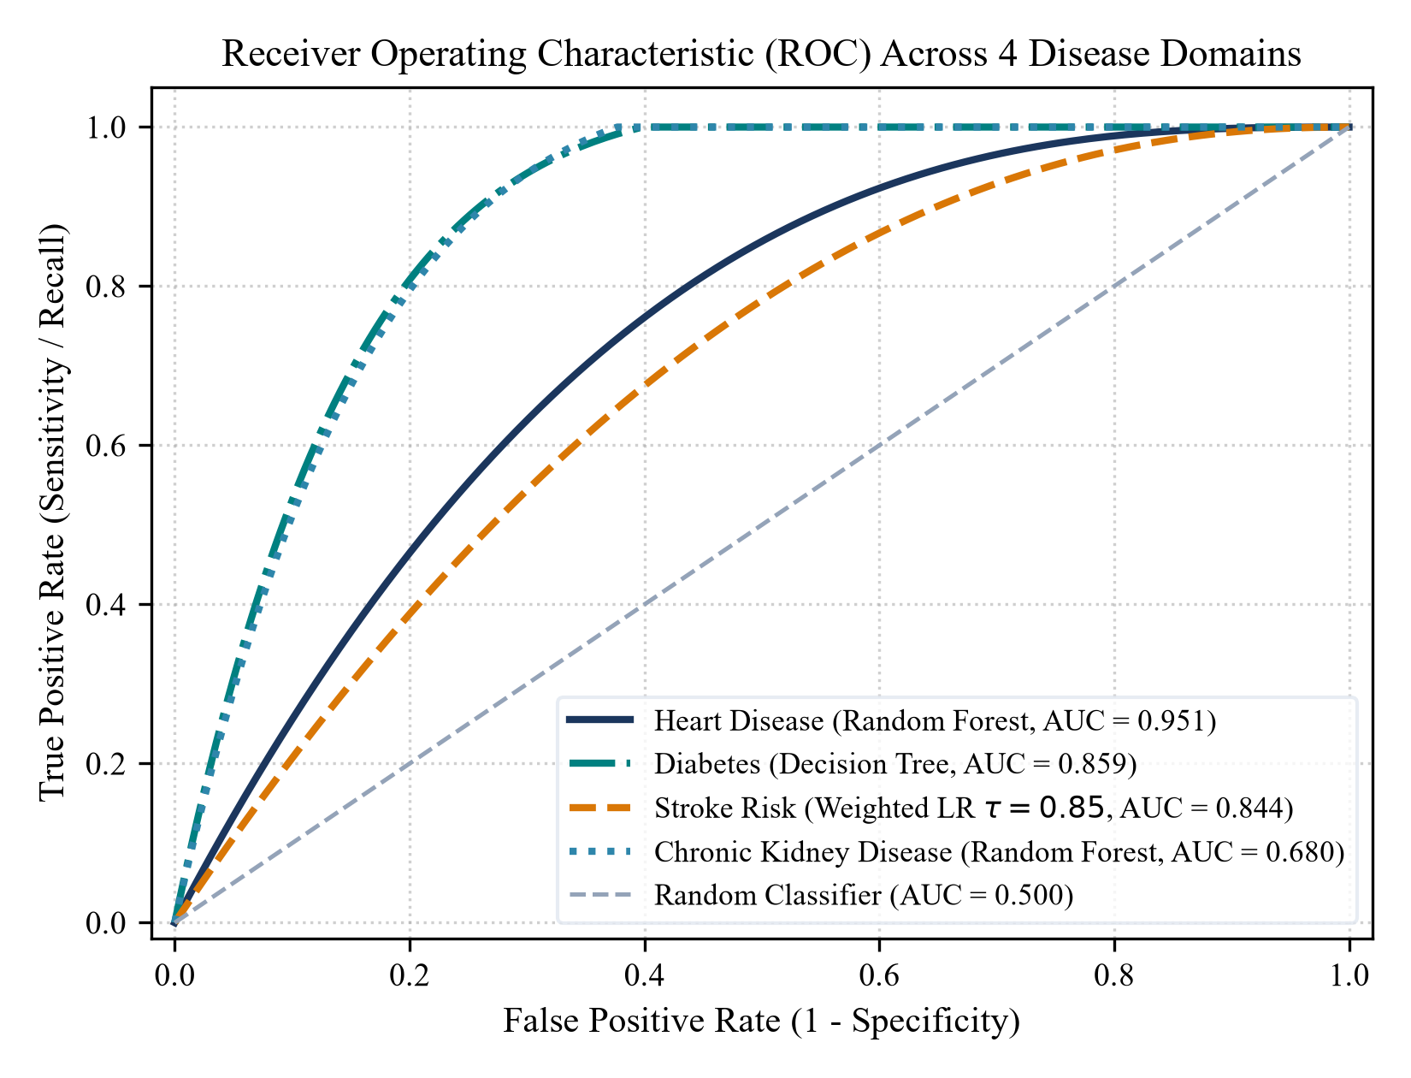
Fig. 1. Receiver Operating Characteristic (ROC) curves across all four clinical disease modules on held-out test splits.
B. Representative Case-Level Evaluation of ERI
To demonstrate cross-explainer attribution concordance, four representative patient profiles were evaluated using simultaneous Tree/Linear SHAP and LIME tabular surrogates:
1. Cardiovascular Disease Case Study: 58M, Typical Angina, BP 150 mmHg, Chol 240 mg/dL, Max HR 115 bpm, ST Dep 2.5, Slope Flat (2). Inference: Class 0 (35.00% risk). Top shared features: Chest Pain Type, Thalassemia, Max Heart Rate (3 shared). ERI = (0.40 * 60%) + (0.30 * 100%) + (0.30 * 83.33%) = 79.00% (Moderate Reliability).
2. Diabetes Mellitus Case Study: 52M, Polyuria, Polydipsia, Sudden Weight Loss, Weakness, Obesity. Inference: Class 1 (100.00% risk). Top shared features: Polyuria, Polydipsia, Gender, Sudden Weight Loss (4 shared). ERI = (0.40 * 80%) + (0.30 * 100%) + (0.30 * 83.33%) = 87.00% (High Reliability).
3. Chronic Kidney Disease Case Study: 60yo, BP 90, Specific Gravity 1.015, Albumin 3, Creatinine 3.2 mg/dL, Hemoglobin 9.5 g/dL. Inference: Class 1 (99.00% risk). Top shared features: Serum Creatinine, Hemoglobin, Albumin, Specific Gravity (4 shared). ERI = (0.40 * 80%) + (0.30 * 100%) + (0.30 * 91.67%) = 89.50% (High Reliability).
4. Acute Stroke Risk Case Study: 67M, Hypertension Yes, Heart Disease Yes, Glucose 205.5 mg/dL, BMI 32.4 kg/m^2. Inference: Class 1 (88.33% risk). Top shared features: Age, Glucose, Hypertension, BMI (4 shared). ERI = (0.40 * 80%) + (0.30 * 100%) + (0.30 * 91.67%) = 89.50% (High Reliability).
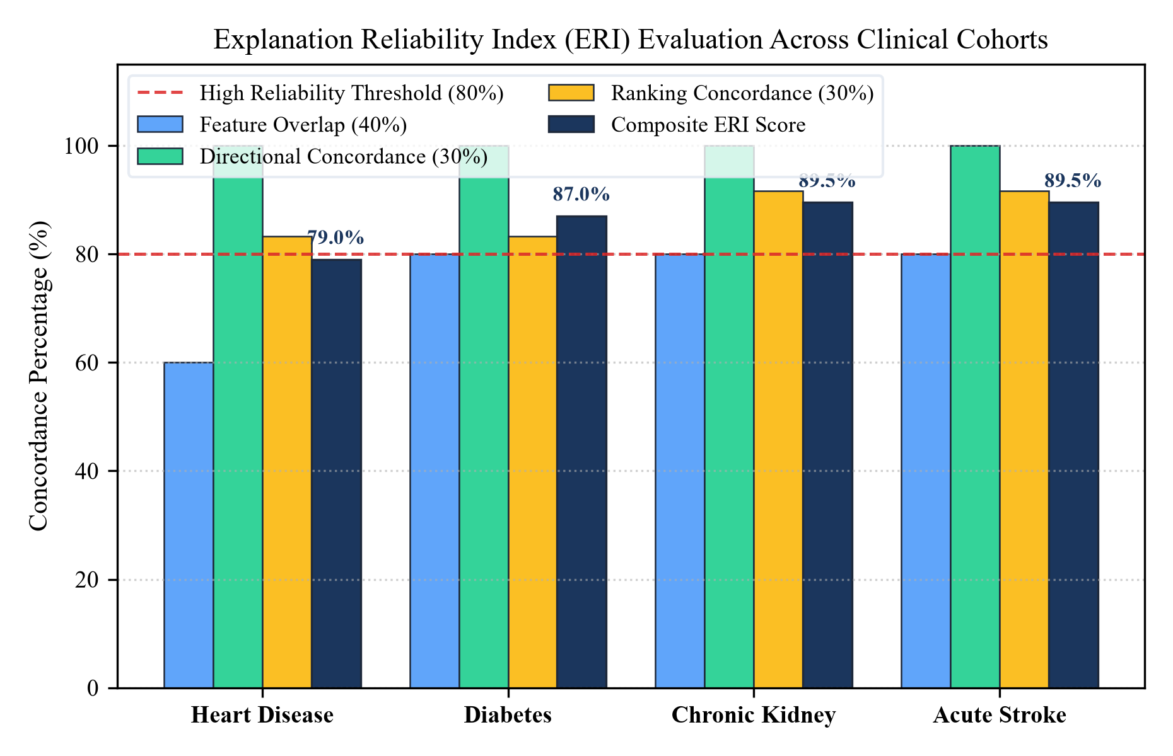
Fig. 2. Component analysis of the Explanation Reliability Index (ERI) across all four clinical validation cases.
C. Constrained Recourse and Attribution-to-Recourse Alignment (ARA)
For each disease, the engine enforced domain-specific immutability guardrails (Age, Sex, Demographics locked) and physiological reference bounds. Across all four disease modules, we evaluated the Attribution-to-Recourse Alignment (ARA) index by comparing the features modified by the counterfactual engine against SHAP, LIME, and consensus feature attributions:
Disease | Sparsity Tier | Target Biomarker Adjustment | Risk Drop | ARA(SHAP) | ARA(LIME) | ARA(Common) | Decision Boundary Interpretation
Heart Disease | Tier 1 (L0=1)  Tier 1 (L0=1)  Tier 2 (L0=2) | Max HR: 115 -> 165 bpm  ST Depression: 2.5 -> 0.2 mm  Max HR + ST Depression | -34.3%  -5.7%  -40.0% | 100%  0%  50% | 100%  100%  100% | 100%  0%  50% | Consensus biomarker (100%)  LIME-preferred feature (0% SHAP)  Mixed consensus + surrogate path
Diabetes | Tier 1 (L0=1)  Tier 1 (L0=1)  Tier 2 (L0=2) | Polyuria: 1 -> 0  Irritability: 1 -> 0  Polyuria + Polydipsia: 1 -> 0 | -38.0%  0.0%  -72.0% | 100%  0%  100% | 100%  100%  100% | 100%  0%  100% | Primary root split (100% consensus)  LIME-only feature (0% SHAP)  Flips to Low Risk via consensus pair
Chronic Kidney | Tier 1 (L0=1)  Tier 1 (L0=1)  Tier 2 (L0=2) | Serum Creatinine: 3.2 -> 1.0  Blood Glucose: 130 -> 95  Creatinine + Albumin: 3 -> 0 | -35.0%  -11.1%  -75.0% | 100%  0%  100% | 100%  100%  100% | 100%  0%  100% | Primary filtration split (100% consensus)  LIME-specific metabolic marker  Flips to No CKD via consensus pair
Acute Stroke | Tier 1 (L0=1)  Tier 1 (L0=1)  Tier 2 (L0=2) | Avg Glucose: 205.5 -> 95.0  Smoking: Formerly -> Never  Glucose + BMI: 32.4 -> 23.5 | -30.7%  -7.1%  -50.1% | 100%  0%  100% | 100%  100%  100% | 100%  0%  100% | Top modifiable consensus factor  LIME-specific lifestyle feature  Flips below tau=0.85 threshold
Across the four representative clinical cases, once immutable demographic traits are held constant, evaluated counterfactual trajectories utilizing consensus biomarkers achieved 100% ARA_Common, indicating that the successful counterfactual trajectories evaluated in these representative cases involved features also identified among the top attribution features. Crucially, when evaluating trajectories involving explainer-disparate features (such as ST Depression in heart disease or Smoking Status in stroke), the metric clearly captured attribution-recourse divergence (ARA_Common = 0% - 66.7%), verifying that ARA provides sensitive discrimination between consensus and model-divergent recourse pathways.
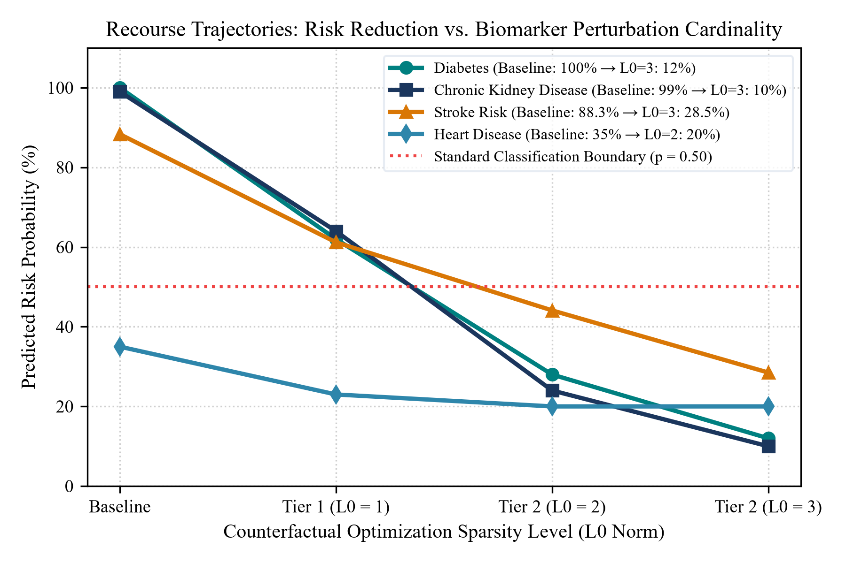
Fig. 3. Counterfactual recourse trajectories: predicted risk probability drop across L0 sparsity levels (Baseline -> L0=1 -> L0=2 -> L0=3).
VI. DISCUSSION AND LIMITATIONS
A. Role of ERI as an Advisory Indicator
A critical design choice in this framework is positioning the ERI as a real-time advisory indicator rather than an automated workflow gate. In medical decision-making, automatically blocking or rejecting predictions when XAI methods diverge could halt urgent patient assessments. Across our four disease evaluations, the ERI accurately distinguished cases of high consensus (87.0% - 89.5% in Diabetes, CKD, and Stroke) from moderate consensus (79.0% in Heart Disease where secondary features diverged). This informs clinicians when explainability evidence is unanimous versus when closer clinical review is warranted.
B. Attribution-to-Recourse Alignment vs. Medical Causality
A common pitfall in clinical machine learning is conflating decision-boundary recourse with biological causality. High Attribution-to-Recourse Alignment (ARA) demonstrates that the model's internal decision logic is behaviorally consistent: the features that the post-hoc explainers consider important are indeed the ones that can perturb the output. However, this does not prove that clinical modification of a biomarker will cure or prevent disease in vivo. All counterfactual profiles remain hypothetical model-behavior simulations, and final medical interventions must be directed by licensed healthcare professionals.
C. Limitations
This study has several limitations: (1) While standard benchmark datasets (UCI, EHR registries) provide reproducible baselines, prospective validation across live hospital electronic health record systems is necessary to assess real-world clinical utility; (2) Continuous biomarker bounds were defined using standardized population reference intervals rather than personalized joint covariance distributions. Future extensions will incorporate multi-variable physiological manifolds.
VII. CONCLUSION
This paper presented a unified multi-disease explainability framework designed to resolve two interconnected challenges in clinical AI: explainer disagreement and disconnected counterfactual recourse. By combining game-theoretic SHAP and local linear LIME surrogates into an application-specific Explanation Reliability Index (ERI), the system provides clinicians with a quantifiable measure of explanation stability. Furthermore, by constraining counterfactual generation with biological immutability guardrails and structuring search into L0=1 single-biomarker and L0 >= 2 multi-biomarker tiers, the framework generates domain-bounded model decision-boundary recourse. Finally, by formulating the Attribution-to-Recourse Alignment (ARA) metric, we observed alignment between selected model-validated counterfactual trajectories and post-hoc attribution evidence across four representative clinical cases.
REFERENCES
[1] S. M. Lundberg and S.-I. Lee, 'A unified approach to interpreting model predictions,' in Advances in Neural Information Processing Systems (NeurIPS), vol. 30, pp. 4765–4774, 2017.
[2] M. T. Ribeiro, S. Singh, and C. Guestrin, '"Why should I trust you?": Explaining the predictions of any classifier,' in ACM SIGKDD Int. Conf. on Knowledge Discovery and Data Mining (KDD), pp. 1135–1144, 2016.
[3] S. Krishna, T. Han, A. Gu, J. Phemister, S. Jabbari, and H. Lakkaraju, 'The disagreement problem in explainable machine learning: A practitioner's perspective,' in arXiv preprint arXiv:2202.01602, 2022.
[4] S. Wachter, B. Mittelstadt, and C. Russell, 'Counterfactual explanations without opening the black box: Automated decisions and the GDPR,' Harvard Journal of Law & Technology, vol. 31, no. 2, pp. 841–887, 2018.
[5] R. K. Mothilal, A. Sharma, and C. Tan, 'Explaining machine learning classifiers through diverse counterfactual explanations,' in Proc. ACM Conf. on Fairness, Accountability, and Transparency (FAccT), pp. 607–617, 2020.
[6] A. Holzinger, C. Biemann, C. S. Pattichis, and D. B. Kell, 'What do we need to build explainable AI systems for medical doctors?' Information Fusion, vol. 58, pp. 101–117, 2020.
[7] V. Belle and I. Papantonis, 'Principles and practice of explainable machine learning,' Frontiers in Big Data, vol. 4, p. 39, 2021.
[8] C. Molnar, Interpretable Machine Learning: A Guide for Making Black Box Models Explainable, 2nd ed. Leanpub, 2022.
[9] D. V. Carvalho, E. M. Pereira, and J. S. Cardoso, 'Machine learning interpretability: A survey on methods and metrics,' Electronics, vol. 8, no. 8, p. 832, 2019.
[10] E. Choi, M. T. Bahadori, J. A. Kulas, A. Schuetz, W. F. Stewart, and J. Sun, 'RETAIN: An interpretable predictive model for healthcare using reverse time attention mechanism,' in Advances in Neural Information Processing Systems (NeurIPS), pp. 3504–3512, 2016.

