NAME: DHANUSH S.J.
Email id: dhanushsj2004@gmail.com
Contact no: 8870659991
Github link: https://github.com/Dhanushsj12/orbitdesk-support-agent

OrbitDesk AI Support Agent: A Retrieval-Augmented Generation (RAG) System for Intelligent Customer Support

ABSTRACT
Customer support teams often spend significant time answering repetitive questions related to product features, user permissions, API usage, and troubleshooting. While knowledge base articles contain the required information, searching through multiple documents manually can be time-consuming. This project aims to simplify that process by developing an AI-powered support assistant capable of retrieving relevant information and generating accurate responses.
The OrbitDesk AI Support Agent combines Retrieval-Augmented Generation (RAG) with a local Large Language Model to answer user queries based only on the available documentation. Instead of relying on general knowledge, the system searches a vector database containing knowledge base articles and resolved support cases, retrieves the most relevant documents, and generates responses supported by those documents.
The application also verifies generated answers before presenting them to the user and supports different workflows such as clarification requests, escalation handling, and out-of-scope detection. This approach improves response reliability while reducing the possibility of incorrect or unsupported answers.

1. INTRODUCTION
Artificial Intelligence has transformed the way organizations provide customer support. Traditional chatbot systems generally depend on predefined rules or keyword matching, which limits their ability to answer complex questions. Recent advancements in Large Language Models (LLMs) have improved conversational capabilities, but these models may generate responses that are inaccurate or unsupported by official documentation.
To overcome this limitation, Retrieval-Augmented Generation (RAG) combines document retrieval with language generation. Instead of relying solely on the language model's knowledge, the system first retrieves relevant documents and then generates responses based only on the retrieved information.
The OrbitDesk AI Support Agent follows this approach. It uses a local language model together with semantic document retrieval to answer technical support questions accurately while ensuring that responses remain grounded in official documentation.

2. PROBLEM STATEMENT
Customer support engineers frequently receive repeated questions regarding user permissions, API credentials, workspace settings, and troubleshooting procedures. Searching through documentation manually increases response time and may lead to inconsistent answers.
General-purpose AI models can answer such questions but often produce responses that are not supported by the organization's documentation. This creates a risk of misinformation, especially in enterprise support environments.
The objective of this project is to build an intelligent support assistant capable of retrieving relevant documentation, generating accurate responses, verifying those responses, and handling situations where escalation or clarification is required.

3. OBJECTIVES
The main objectives of this project are:
- Develop an AI-powered support assistant for OrbitDesk documentation.
- Implement Retrieval-Augmented Generation (RAG).
- Retrieve relevant knowledge base documents using semantic search.
- Generate responses using a local Large Language Model.
- Verify generated responses before displaying them.
- Detect questions that require clarification.
- Identify issues requiring human escalation.
- Detect requests outside the scope of available documentation.
- Return structured responses with confidence scores and supporting sources.

4. SYSTEM ARCHITECTURE

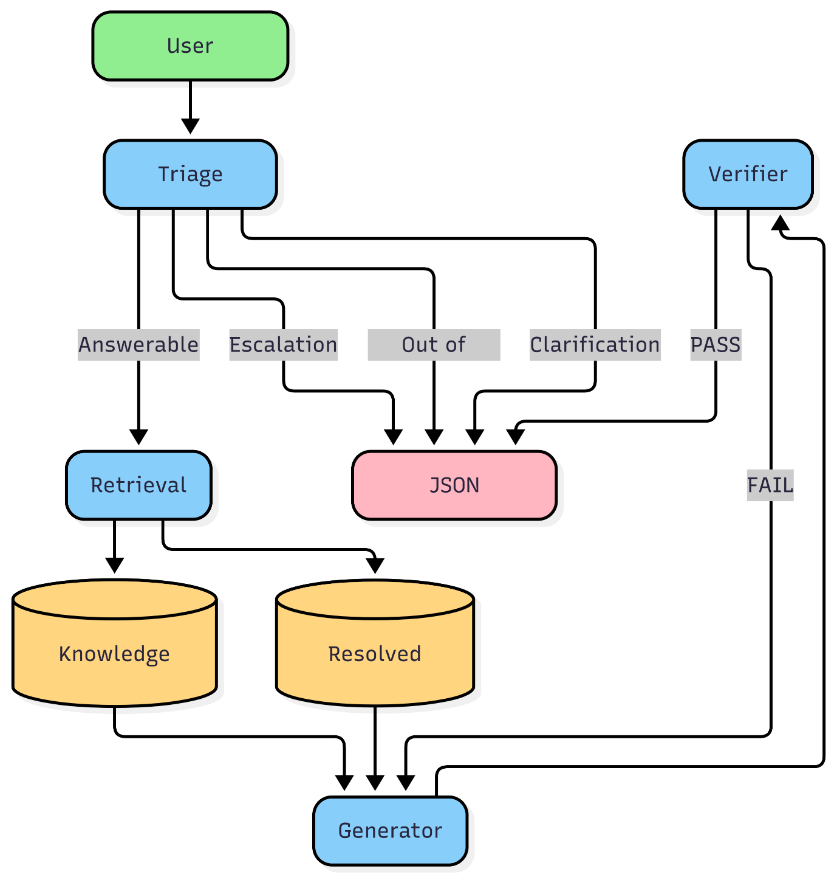
The OrbitDesk AI Support Agent follows a modular workflow implemented using LangGraph. The architecture is divided into four main processing stages: Triage, Retrieval, Generation, and Verification.
Initially, the user submits a support query to the system. The query is processed by the Triage Node, which determines the appropriate execution path. Based on predefined classification rules, the request is categorized as Answerable, Requires Escalation, Requires Clarification, or Out of Scope.
If the request is classified as Answerable, it is forwarded to the Retrieval Node. The Retrieval Node performs semantic similarity search over two data sources: the Knowledge Base and previously Resolved Support Cases. The most relevant documents are selected and passed to the Generator.
The Generator Node receives both the user query and the retrieved documents. Using the local language model, it generates a response that is grounded only in the retrieved evidence.
The generated response is then passed to the Verifier Node. The verifier checks whether the answer is supported by the retrieved documentation. If verification succeeds, the system returns the final structured JSON response. If verification fails, the answer generation process is retried until the configured retry limit is reached.
For requests classified as Requires Escalation, Requires Clarification, or Out of Scope, the system bypasses the retrieval and generation stages and directly returns an appropriate JSON response to the user.
This modular architecture improves maintainability, reduces unnecessary processing, and ensures that only verified, evidence-based responses are returned.

. TECHNOLOGIES USED
Technology | Purpose
Python | Application development
LangGraph | Workflow orchestration
FAISS | Vector similarity search
Sentence Transformers | Text embedding generation
TinyLlama | Local language model
PyTorch | Model execution
Logging Module | Application logging

6. METHODOLOGY
The implementation follows a Retrieval-Augmented Generation pipeline.
Initially, knowledge base articles and resolved support cases are converted into vector embeddings using the Sentence Transformer model. These embeddings are stored in a FAISS vector index.
When a user submits a question, the triage component classifies the request. If the request is answerable, semantic similarity search retrieves the most relevant documents. The retrieved information is then supplied to the language model, which generates a response based solely on the available documentation.
Finally, the generated response undergoes verification before being returned to the user in a structured JSON format.

Hardware Configuration
Component | Specification
Laptop | Samsung Galaxy Book2
Processor | 12th Gen Intel® Core™ i5-1235U (10 Cores, 12 Threads, Base Clock 1.30 GHz)
RAM | 16 GB
Storage | SSD
Graphics | Intel® Iris® Xe Graphics (Integrated)
Operating System | Windows 11
Execution Device | CPU

Software Configuration
Component | Specification
Programming Language | Python 3.11
IDE | Visual Studio Code
Workflow Framework | LangGraph
Embedding Model | sentence-transformers/all-MiniLM-L6-v2
Language Model | TinyLlama-1.1B-Chat-v1.0
Deep Learning Framework | PyTorch
Transformers Library | Version 4.57.6
Vector Database | FAISS (CPU)
Version Control | Git & GitHub

Screenshots:
