**A CRM Application to Manage the Services offered by an Institution**

**Output:**

**Lookup Relationship among the objects**

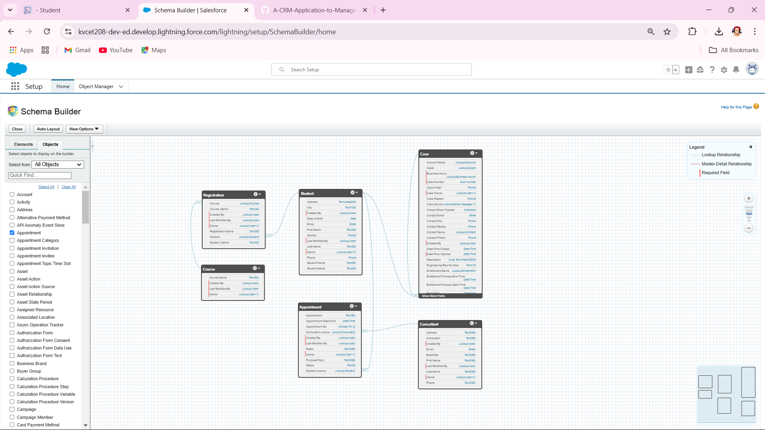

**Adding items to EduConsultPro**

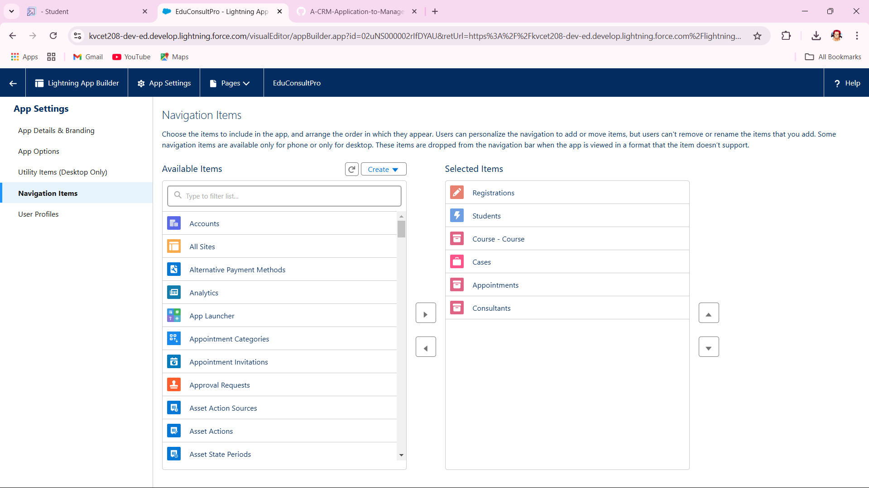

**EduConsultPro Student Flow**

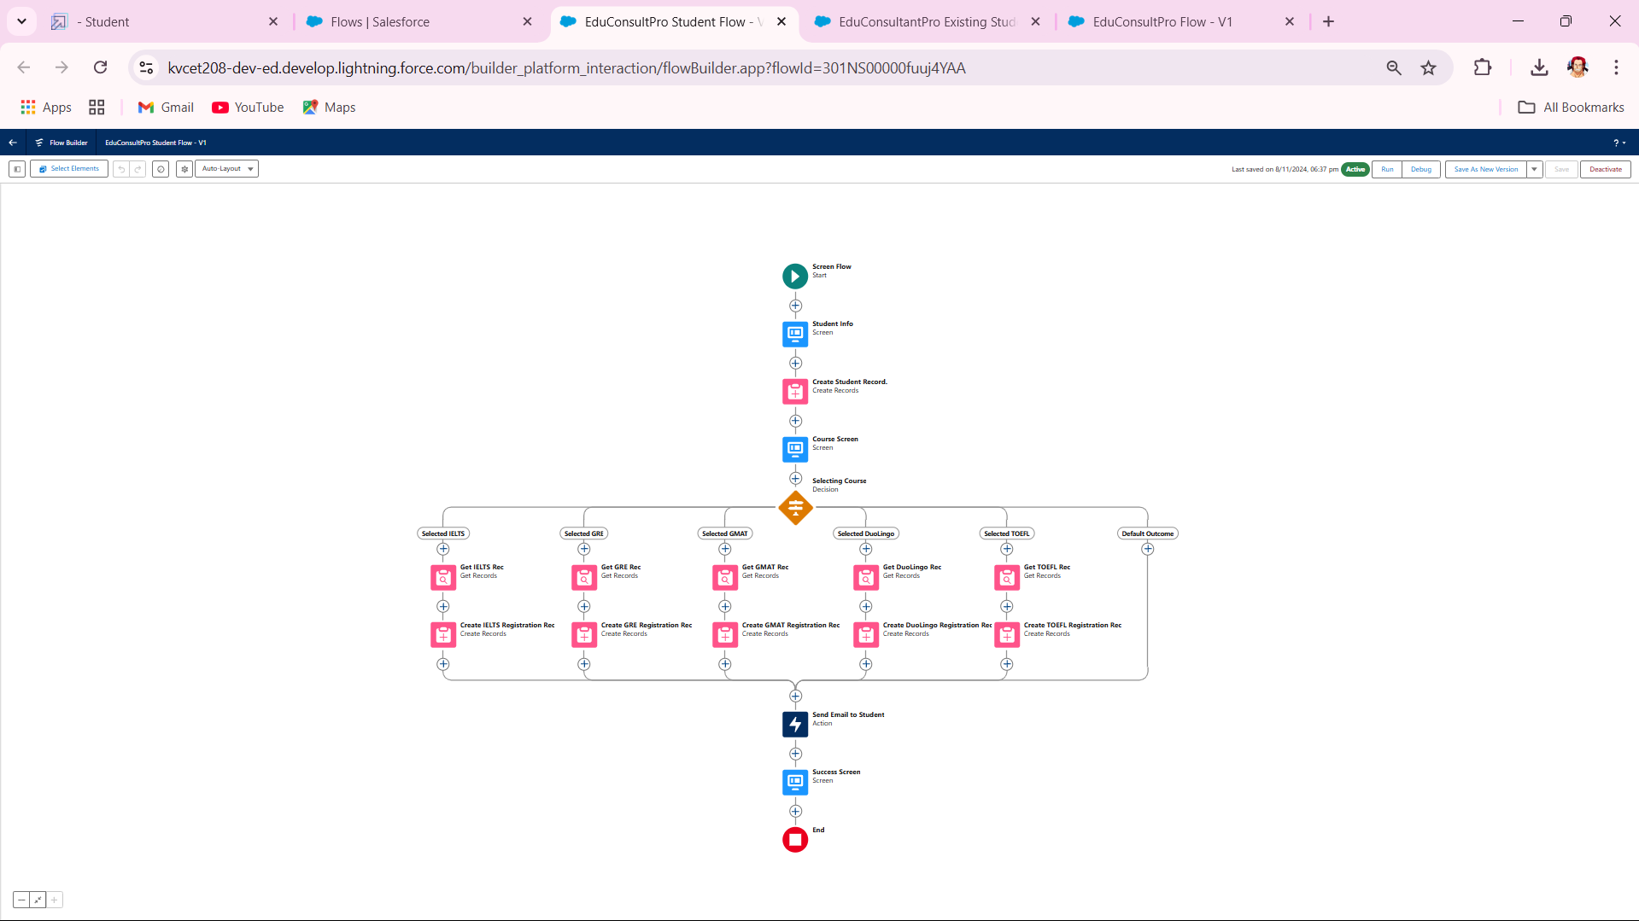

**EduConsultPro Approval Flow**

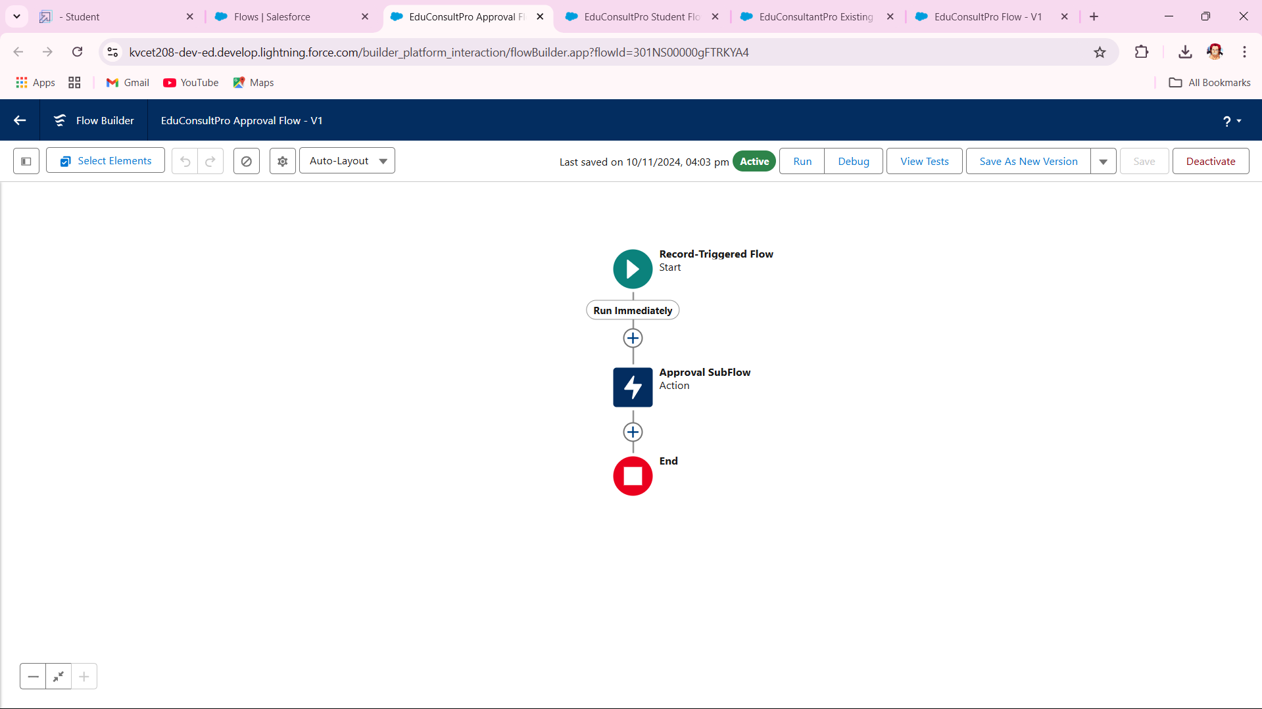

**EduConsultantPro Existing Student Flow**

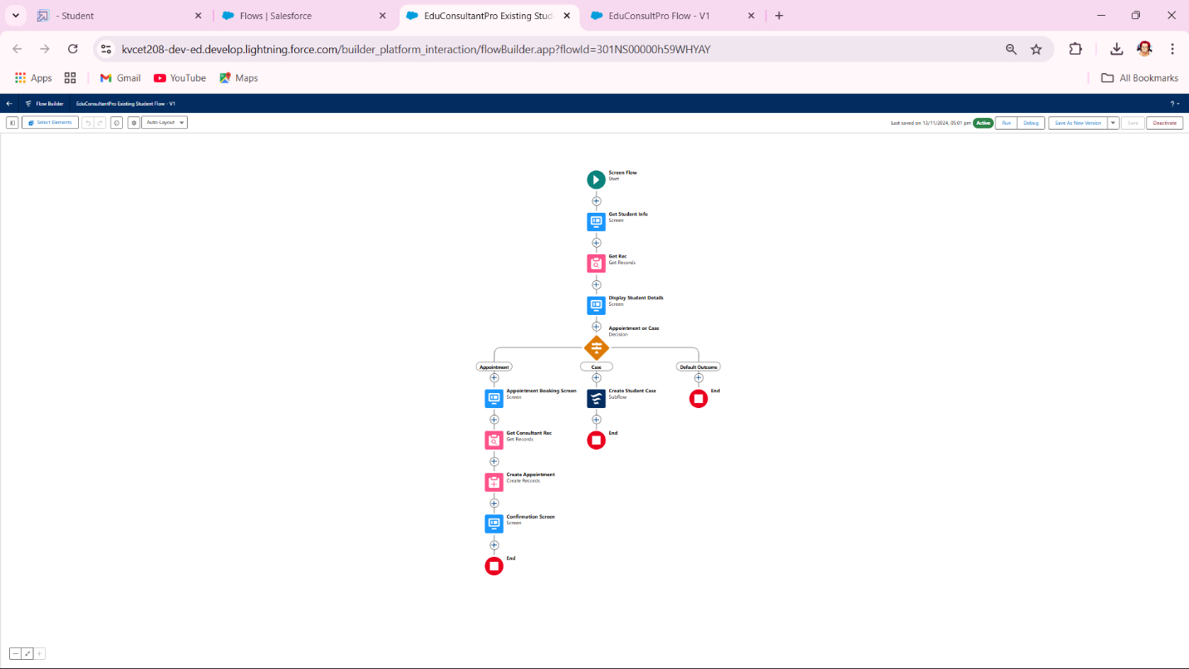

**EduConsultPro Flow**

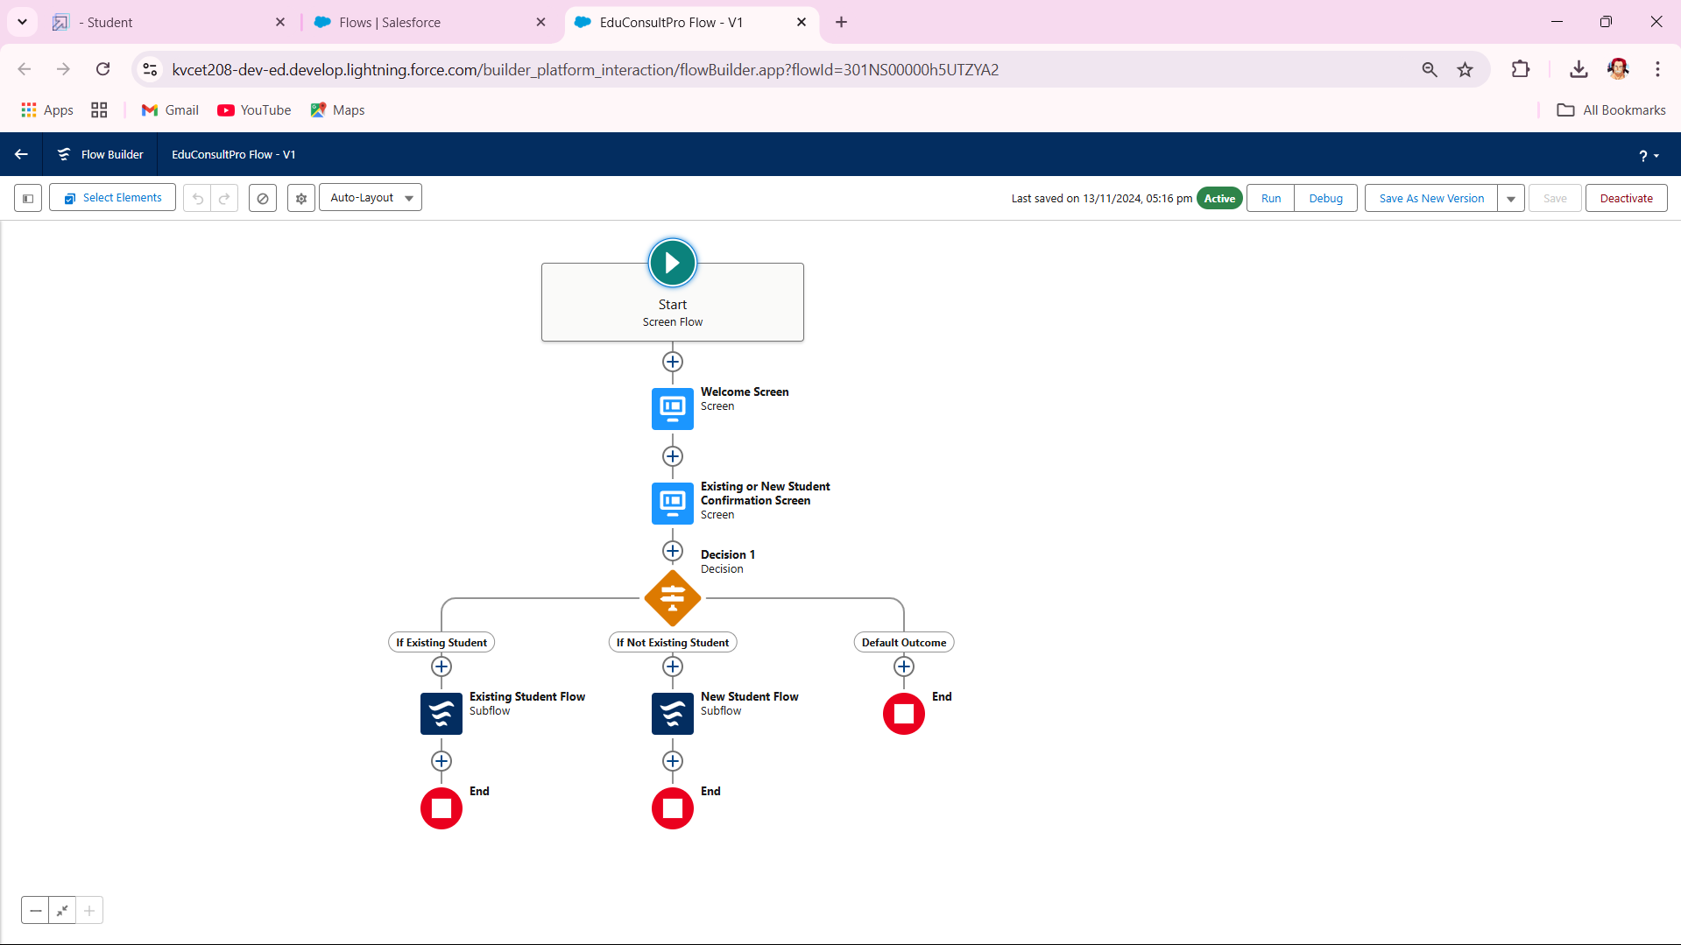

**Lightning app page**

