**TRAFFIC MANAGEMENT USING GNN AND MAB WITH SDN ORCHESTRATION**

811321104014- DHANUSHYA M

**Phase 3 Submission Document**

**Project Title:** Traffic Management

**Phase 3:** Development Part 1

**Topic**: Traffic prediction model by loading and pre- processing the dataset.



**TRAFFIC MANAGEMENT**

**Introduction:**

* Traffic management is a critical task in software-defined IoT networks (SDN-IoTs) to efficiently manage network resources and ensure Quality of Service (QoS) for end-users. However, traditional traffic management approaches based on queuing theory or static policies may not be effective due to the dynamic and unpredictable nature of network traffic. In this paper, we propose a novel approach that leverages Graph Neural Networks (GNNs) and multi-arm bandit algorithms to dynamically optimize traffic management policies based on real-time network traffic patterns.

* Specifically, our approach uses a GNN model to learn and predict network traffic patterns and a multi-arm bandit algorithm to optimize traffic management policies based on these predictions. We evaluate the proposed approach on three different datasets, including a simulated corporate network (KDD Cup 1999), a collection of network traffic traces (CAIDA), and a simulated network environment with both normal and malicious traffic (NSL-KDD).

* The results demonstrate that our approach outperforms other state-of-the-art traffic management methods, achieving higher throughput, lower packet loss, and lower delay, while effectively detecting anomalous traffic patterns. The proposed approach offers a promising solution to traffic management in SDNs, enabling efficient resource management and QoS assurance.

**Necessary Steps To Follow:**

**1.Import Libraries:**

Start by importing the necessary libraries.

**Program:**

|  |
| --- |
| import numpy as np import pandas as pd  import matplotlib.pyplot as plt import seaborn as sns import datetime import tensorflow  from statsmodels.tsa.stattools import adfuller from sklearn.preprocessing import MinMaxScaler from tensorflow import keras from keras import callbacks  from tensorflow.keras import Sequential  from tensorflow.keras.layers import Conv2D, Flatten, Dense, LSTM, Dropout, GRU  , Bidirectional  from tensorflow.keras.optimizers import SGD from tensorflow.keras.models import Sequential from tensorflow.keras.layers import GRU, Dropout, Dense from tensorflow.keras.optimizers import SGD from tensorflow.keras import callbacks import math  from sklearn.metrics import mean_squared_error    import warnings  warnings.filterwarnings("ignore") |

**2.load the dataset:**

Load your dataset into a pandas Dataframe.You can typically find traffic prediction datasets in csv format,but you can adapt this code to other format as needed.

**Program:**

data = pd.read_csv(“../input/traffic-prediction-dataset/traffic.csv”) data.head()

**3.Data Exploration:**

Perform data exploration to understand your data better.This includes checking for missing values,exploring the data’s statistics, and visualizing it to identify patterns.

**Program:**

data["DateTime"]= pd.to_datetime(data["DateTime"]) data = data.drop(["ID"], axis=1) *#dropping IDs* data.info()

**4.Feature Engineering:**

Depending on your dataset,you may need to create new features or transform existing ones.This can involve one-hot encoding categorical variables , handling date/time data,or scaling numerical features.

**Program:**

df["Year"]= df['DateTime'].dt.year df["Month"]= df['DateTime'].dt.month df["Date_no"]= df['DateTime'].dt.day df["Hour"]= df['DateTime'].dt.hour df["Day"]= df.DateTime.dt.strftime("%A") df.head()

**5.Exploratory Data Analysis(EDA):**

Perform data exploration to understand your data better.This includes checking for missing values,exploring the data’s statistics, and visualizing it to identify patterns.

**Program:**

|  |
| --- |
| new_features = [ "Year","Month", "Date_no", "Hour", "Day"]  for i **in** new_features: plt.figure(figsize=(10,2),facecolor="#627D78")  ax=sns.lineplot(x=df[i],y="Vehicles",data=df, hue="Junction", palette=colo rs )  plt.legend(bbox_to_anchor=(1.05, 1), loc=2, borderaxespad=0.) |

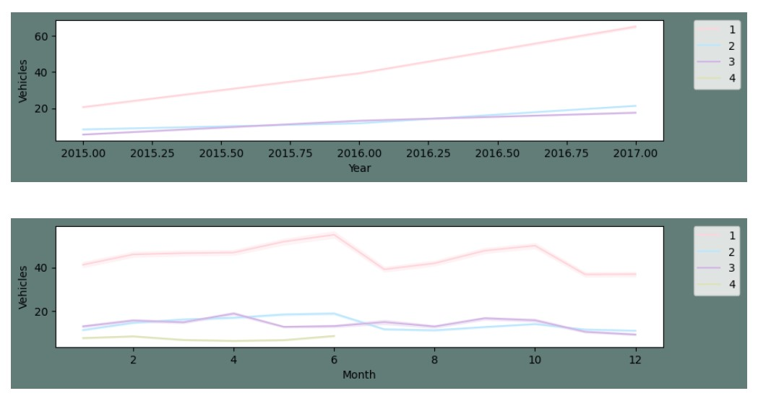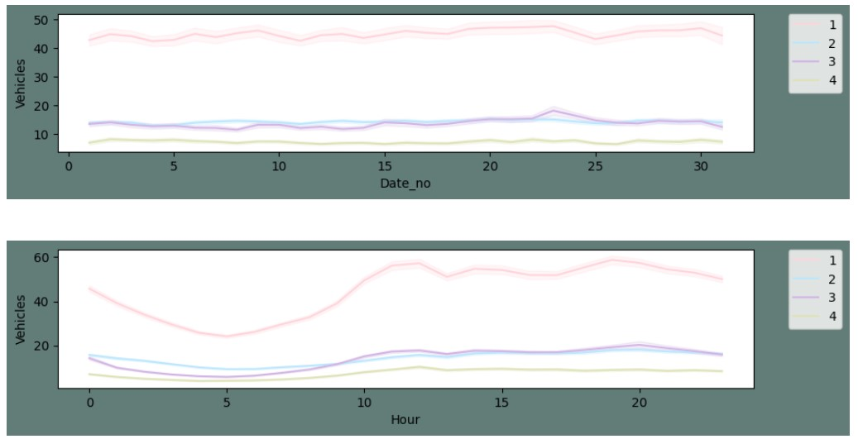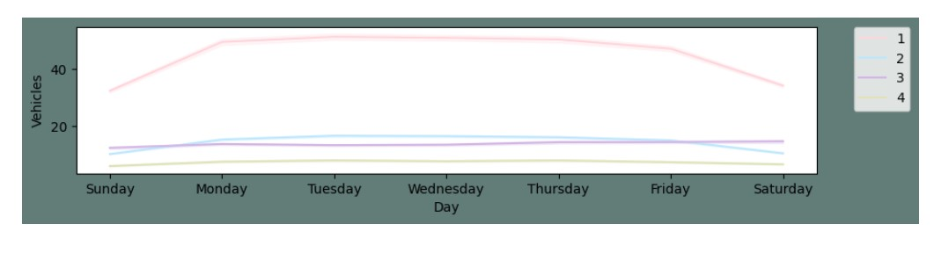

**From The Above Plot Following Things Can Be Concluded:**

* Yearly, there has been an upward trend for all junctions except for the fourth junction. As we already established above that the fourth junction has limited data and that don't span over a year.
* We can see that there is an influx in the first and second junctions around June. I presume this may be due to summer break and activities around the same.
* Monthly, throughout all the dates there is a good consistency in data.
* For a day, we can see that are peaks during morning and evening times and a decline during night hours. This is as per expectation.
* For weekly patterns, Sundays enjoy smoother traffic as there are lesser vehicles on roads. Whereas Monday to Friday the traffic is steady.

**Program:**

plt.figure(figsize=(12,5),facecolor="#627D78")

count = sns.countplot(data=df, x =df["Year"], hue="Junction", palette=colors) count.set_title("Count Of Traffic On Junctions Over Years") count.set_ylabel("Number of Vehicles") count.set_xlabel("Date")

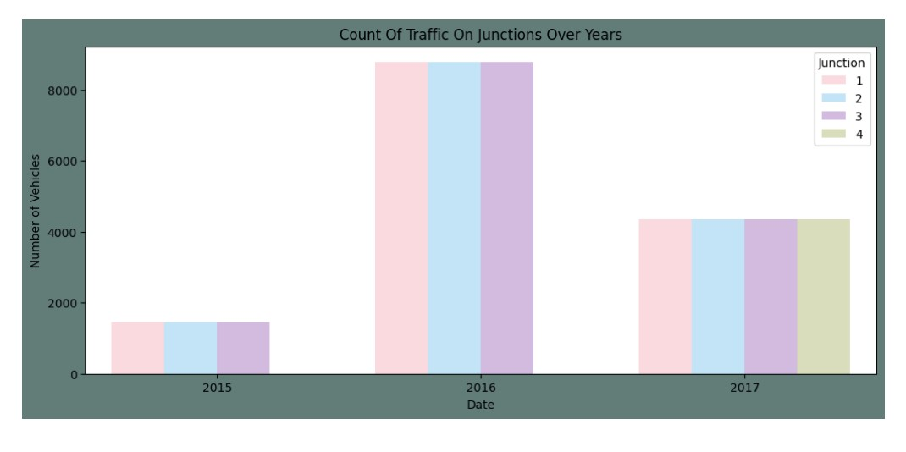

numeric_df = df.select_dtypes(include=[np.number]) *# Select only numeric colu mns*

corrmat = numeric_df.corr()

plt.subplots(figsize=(10,10),facecolor="#627D78")

sns.heatmap(corrmat,cmap= "Pastel2",annot=True,square=True, )

<Axes:>

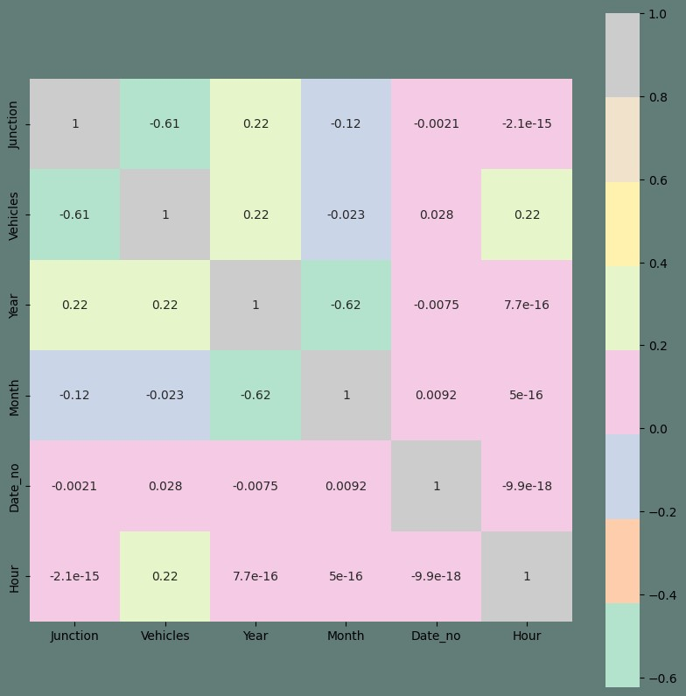

The highest correlation is certainly with the preexisting feature. I will conclude my EDA with a pair plot. It's an interesting overall representation of any data

sns.pairplot(data=df, hue= "Junction",palette=colors)

<seaborn.axisgrid.PairGrid at 0x7adb85952830>

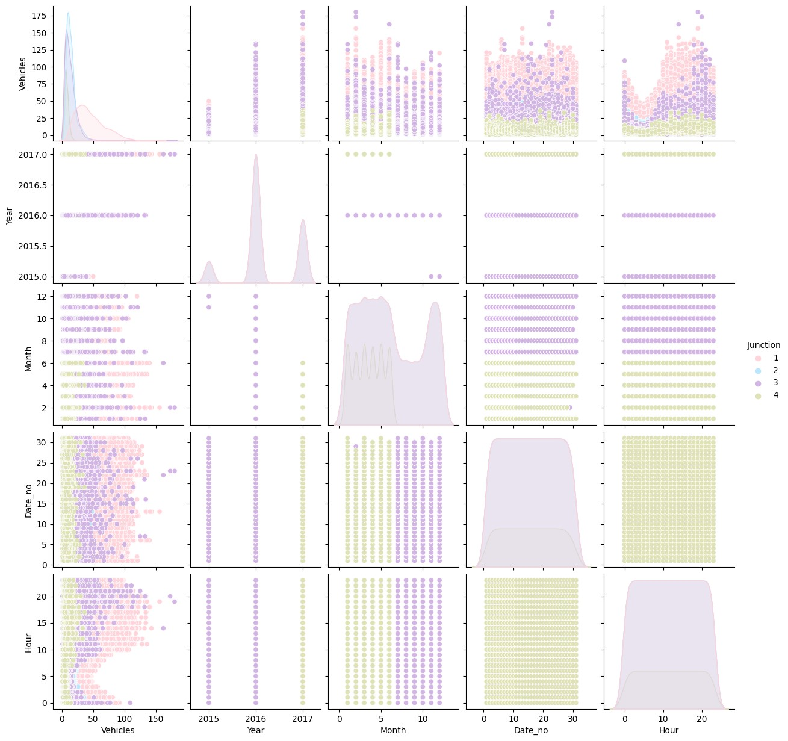

**Data Transformation And Preprocessing:**

* Creating different frames for each Junction and plotting them
* Transforming the series and plotting them
* Performing the Augmented Dickey-Fuller test to check the seasonality of transformed series
* Creating test and train sets

**Program:**

*#Pivoting data fron junction*

df_J = data.pivot(columns="Junction", index="DateTime")

df_J.describe()

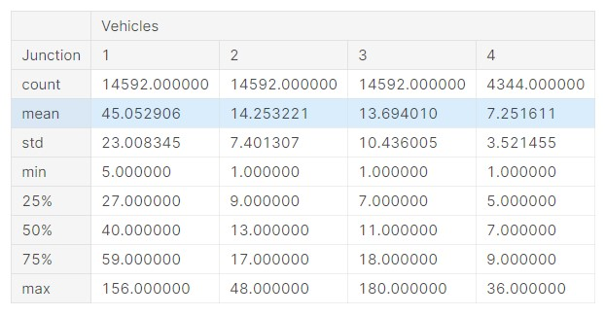

**Program:**

|  |
| --- |
| *#Creating new sets*  df_1 = df_J[[('Vehicles', 1)]] df_2 = df_J[[('Vehicles', 2)]] df_3 = df_J[[('Vehicles', 3)]] df_4 = df_J[[('Vehicles', 4)]]  df_4 = df_4.dropna() *#Junction 4 has limited data only for a few months*  *#Dropping level one in dfs's index as it is a multi index data frame* list_dfs = [df_1, df_2, df_3, df_4] for i **in** list_dfs:  i.columns= i.columns.droplevel(level=1)    *#Function to plot comparitive plots of dataframes* def Sub_Plots4(df_1, df_2,df_3,df_4,title): fig, axes = plt.subplots(4, 1, figsize=(15, 8),facecolor="#627D78", sharey  =True)  fig.suptitle(title)  *#J1*  pl_1=sns.lineplot(ax=axes[0],data=df_1,color=colors[0])  *#pl_1=plt.ylabel()*  axes[0].set(ylabel ="Junction 1")  *#J2*  pl_2=sns.lineplot(ax=axes[1],data=df_2,color=colors[1]) axes[1].set(ylabel ="Junction 2")  *#J3*  pl_3=sns.lineplot(ax=axes[2],data=df_3,color=colors[2]) axes[2].set(ylabel ="Junction 3")  *#J4*  pl_4=sns.lineplot(ax=axes[3],data=df_4,color=colors[3]) axes[3].set(ylabel ="Junction 4") |
|  |

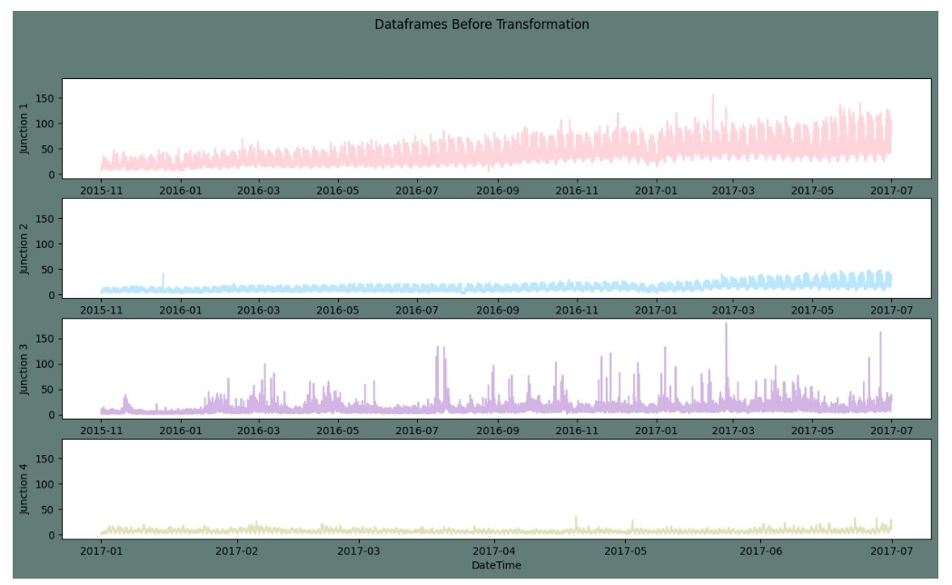

**Steps For Transforming:**

* Normalizing
* Differencing

**Program:**

|  |
| --- |
| *# Normalize Function* def Normalize(df,col): average = df[col].mean() stdev = df[col].std()  df_normalized = (df[col] - average) / stdev df_normalized = df_normalized.to_frame() return df_normalized, average, stdev    *# Differencing Function* def Difference(df,col, interval): diff = [] for i **in** range(interval, len(df)): value = df[col][i] - df[col][i - interval] diff.append(value) return diff |

**In accordance with the above observations, Differencing to eliminate the seasonality should be performed as follows:**

* For Junction one, I will be taking a difference of weekly values.
* For junction two, The difference of consecutive days is a better choice • For Junctions three and four, the difference of the hourly values will serve the purpose.

|  |  |
| --- | --- |
| • | *#Normalizing and Differencing to make the series stationary* |
| • | df_N1, av_J1, std_J1 = Normalize(df_1, "Vehicles") |
| • | Diff_1 = Difference(df_N1, col="Vehicles", interval=(24*7)) *#taking a w eek's diffrence* |
| • | df_N1 = df_N1[24*7:] |
| • | df_N1.columns = ["Norm"] |
| • | df_N1["Diff"]= Diff_1 |
| •  • | df_N2, av_J2, std_J2 = Normalize(df_2, "Vehicles") |
| • | Diff_2 = Difference(df_N2, col="Vehicles", interval=(24)) *#taking a day 's diffrence* |
| • | df_N2 = df_N2[24:] |
| • | df_N2.columns = ["Norm"] |
| • | df_N2["Diff"]= Diff_2 |
| •  • | df_N3, av_J3, std_J3 = Normalize(df_3, "Vehicles") |
| • | Diff_3 = Difference(df_N3, col="Vehicles", interval=1) *#taking an hour' s diffrence* |
| • | df_N3 = df_N3[1:] |
| • | df_N3.columns = ["Norm"] |
| • | df_N3["Diff"]= Diff_3 |
| •  • | df_N4, av_J4, std_J4 = Normalize(df_4, "Vehicles") |
| • | Diff_4 = Difference(df_N4, col="Vehicles", interval=1) *#taking an hour' s diffrence* |
| • | df_N4 = df_N4[1:] |
| • | df_N4.columns = ["Norm"] |
| • | df_N4["Diff"]= Diff_4 |

The plots above seem linear. To ensure they are Stationary I will be performing an Augmented Dickey-Fuller test.

|  |
| --- |
| *#Stationary Check for the time series Augmented Dickey Fuller test* def Stationary_check(df): check = adfuller(df.dropna()) print(f"ADF Statistic: **{**check[0]**}**") print(f"p-value: **{**check[1]**}**") print("Critical Values:") for key, value **in** check[4].items(): print('**\t%s**: **%.3f**' % (key, value)) if check[0] > check[4]["1%"]:  print("Time Series is Non-Stationary") else: print("Time Series is Stationary")      *#Checking if the series is stationary*    List_df_ND = [ df_N1["Diff"], df_N2["Diff"], df_N3["Diff"], df_N4["Diff"]] print("Checking the transformed series for stationarity:") for i **in** List_df_ND:  print("**\n**")  Stationary_check(i) |

**Checking the transformed series for stationarity:**

ADF Statistic: -15.265303390415504 p-value: 4.798539876395756e-28 Critical Values:

1%: -3.431

5%: -2.862

10%: -2.567

Time Series is Stationary

ADF Statistic: -21.795891026940108

p-value: 0.0 Critical Values:

1%: -3.431

5%: -2.862

10%: -2.567

Time Series is Stationary

ADF Statistic: -28.001759908832508

p-value: 0.0 Critical Values:

1%: -3.431

5%: -2.862

10%: -2.567

Time Series is Stationary

ADF Statistic: -17.97909256305238 p-value: 2.7787875325952613e-30 Critical Values:

1%: -3.432

5%: -2.862

10%: -2.567

Time Series is Stationary

**Program:**

|  |
| --- |
| *#Differencing created some NA values as we took a weeks data into consideratio n while difrencing*  df_J1 = df_N1["Diff"].dropna() df_J1 = df_J1.to_frame()  df_J2 = df_N2["Diff"].dropna() df_J2 = df_J2.to_frame()  df_J3 = df_N3["Diff"].dropna() df_J3 = df_J3.to_frame()  df_J4 = df_N4["Diff"].dropna() df_J4 = df_J4.to_frame()    *#Splitting the dataset* def Split_data(df):  training_size = int(len(df)*0.90) data_len = len(df)  train, test = df[0:training_size],df[training_size:data_len] train, test = train.values.reshape(-1, 1), test.values.reshape(-1, 1) return train, test  *#Splitting the training and test datasets*  J1_train, J1_test = Split_data(df_J1)  J2_train, J2_test = Split_data(df_J2)  J3_train, J3_test = Split_data(df_J3)  J4_train, J4_test = Split_data(df_J4)    *#Target and Feature* def TnF(df): end_len = len(df) X = [] y = [] steps = 32 for i **in** range(steps, end_len):  X.append(df[i - steps:i, 0])  y.append(df[i, 0]) |
| X, y = np.array(X), np.array(y) return X ,y    *#fixing the shape of X_test and X_train* def FeatureFixShape(train, test): train = np.reshape(train, (train.shape[0], train.shape[1], 1)) test = np.reshape(test, (test.shape[0],test.shape[1],1)) return train, test    *#Assigning features and target*  X_trainJ1, y_trainJ1 = TnF(J1_train)  X_testJ1, y_testJ1 = TnF(J1_test)  X_trainJ1, X_testJ1 = FeatureFixShape(X_trainJ1, X_testJ1)  X_trainJ2, y_trainJ2 = TnF(J2_train)  X_testJ2, y_testJ2 = TnF(J2_test)  X_trainJ2, X_testJ2 = FeatureFixShape(X_trainJ2, X_testJ2)  X_trainJ3, y_trainJ3 = TnF(J3_train)  X_testJ3, y_testJ3 = TnF(J3_test)  X_trainJ3, X_testJ3 = FeatureFixShape(X_trainJ3, X_testJ3)  X_trainJ4, y_trainJ4 = TnF(J4_train)  X_testJ4, y_testJ4 = TnF(J4_test)  X_trainJ4, X_testJ4 = FeatureFixShape(X_trainJ4, X_testJ4) |

**Define a function for linear regression training:**

|  |
| --- |
| def train_linear_regression(X_train, y_train, learning_rate, epochs):  *# Initialize weights and bias* num_features = X_train.shape[1] weights = np.random.randn(num_features) bias = np.random.randn()  for epoch **in** range(epochs): *# Compute predictions*  predictions = np.dot(X_train, weights) + bias    *# Compute the mean squared error*  mse = np.mean((predictions - y_train) ** 2)    *# Compute gradients*  gradient_weights = -2 * np.dot(X_train.T, (y_train - predictions)) / l en(X_train)  gradient_bias = -2 * np.sum(y_train - predictions) / len(X_train)  *# Update weights and bias*  weights -= learning_rate * gradient_weights bias -= learning_rate * gradient_bias  if (epoch + 1) % 100 == 0:  print(f'Epoch **{**epoch + 1**}**/**{**epochs**}**, MSE: **{**mse**:**.4f**}**') |

return weights, bias *# Function to make predictions* def predict(X, weights, bias): return np.dot(X, weights) + bias

|  |
| --- |
| *# Ensure that y_train has the shape (number_of_samples,)* y_trainJ1 = y_trainJ1.reshape(-1)    *# Reshape X_trainJ1 to have shape (number_of_samples, number_of_features)* X_trainJ1 = X_trainJ1.reshape(X_trainJ1.shape[0], -1)  *# Train the linear regression model for Junction 1* learning_rate = 0.001 epochs = 1000    weights_J1, bias_J1 = train_linear_regression(X_trainJ1, y_trainJ1, learning_r ate, epochs)    *# Ensure that y_train has the shape (number_of_samples,)* y_trainJ2 = y_trainJ2.reshape(-1)    *# Reshape X_trainJ2 to have shape (number_of_samples, number_of_features)* X_trainJ2 = X_trainJ2.reshape(X_trainJ2.shape[0], -1)  *# Train the linear regression model for Junction 2*  weights_J2, bias_J2 = train_linear_regression(X_trainJ2, y_trainJ2, learning_r ate, epochs)    *# Ensure that y_train has the shape (number_of_samples,)* y_trainJ3 = y_trainJ3.reshape(-1)    *# Reshape X_trainJ3 to have shape (number_of_samples, number_of_features)* X_trainJ3 = X_trainJ3.reshape(X_trainJ3.shape[0], -1)  *# Train the linear regression model for Junction 3*  weights_J3, bias_J3 = train_linear_regression(X_trainJ3, y_trainJ3, learning_r ate, epochs)    *# Ensure that y_train has the shape (number_of_samples,)* y_trainJ4 = y_trainJ4.reshape(-1)    *# Reshape X_trainJ4 to have shape (number_of_samples, number_of_features)* X_trainJ4 = X_trainJ4.reshape(X_trainJ4.shape[0], -1)  *# Train the linear regression model for Junction 4*  weights_J4, bias_J4 = train_linear_regression(X_trainJ4, y_trainJ4, learning_r ate, epochs) |

Epoch 100/1000, MSE: 5.7588

Epoch 200/1000, MSE: 4.1379

Epoch 300/1000, MSE: 3.1330

Epoch 400/1000, MSE: 2.4985

Epoch 500/1000, MSE: 2.0886

Epoch 600/1000, MSE: 1.8163

Epoch 700/1000, MSE: 1.6293

Epoch 800/1000, MSE: 1.4961

Epoch 900/1000, MSE: 1.3973

Epoch 1000/1000, MSE: 1.3211

Epoch 100/1000, MSE: 9.4276

Epoch 200/1000, MSE: 6.9069

Epoch 300/1000, MSE: 5.4402

Epoch 400/1000, MSE: 4.5275

Epoch 500/1000, MSE: 3.9165

Epoch 600/1000, MSE: 3.4775

Epoch 700/1000, MSE: 3.1415

Epoch 800/1000, MSE: 2.8713

Epoch 900/1000, MSE: 2.6456

Epoch 1000/1000, MSE: 2.4520

Epoch 100/1000, MSE: 7.4961

Epoch 200/1000, MSE: 6.5373

Epoch 300/1000, MSE: 5.7255

Epoch 400/1000, MSE: 5.0329

Epoch 500/1000, MSE: 4.4383

Epoch 600/1000, MSE: 3.9252

Epoch 700/1000, MSE: 3.4808

Epoch 800/1000, MSE: 3.0945

Epoch 900/1000, MSE: 2.7579

Epoch 1000/1000, MSE: 2.4639

Epoch 100/1000, MSE: 14.2825

Epoch 200/1000, MSE: 10.1263

Epoch 300/1000, MSE: 7.3097

Epoch 400/1000, MSE: 5.3842

Epoch 500/1000, MSE: 4.0551

Epoch 600/1000, MSE: 3.1277

Epoch 700/1000, MSE: 2.4728

Epoch 800/1000, MSE: 2.0044

Epoch 900/1000, MSE: 1.6648

Epoch 1000/1000, MSE: 1.4151

**Program:**

|  |
| --- |
| *# Ensure that weights_J1 has the correct shape* weights_J1 = weights_J1.reshape(-1)    *# Ensure that X_testJ1 has the correct shape* X_testJ1 = X_testJ1.reshape(X_testJ1.shape[0], X_testJ1.shape[1])  *# Make predictions on the test data for Junction 1* y_pred_J1 = predict(X_testJ1, weights_J1, bias_J1)  *# Calculate and print the Mean Squared Error (MSE) for Junction 1* mse_J1 = np.mean((y_pred_J1 - y_testJ1) ** 2) print(f'MSE for Junction 1: **{**mse_J1**:**.4f**}**')    *# Repeat the process for Junction 2* weights_J2 = weights_J2.reshape(-1)  X_testJ2 = X_testJ2.reshape(X_testJ2.shape[0], X_testJ2.shape[1]) |
| y_pred_J2 = predict(X_testJ2, weights_J2, bias_J2) mse_J2 = np.mean((y_pred_J2 - y_testJ2) ** 2) print(f'MSE for Junction 2: **{**mse_J2**:**.4f**}**')    *# Repeat the process for Junction 3* weights_J3 = weights_J3.reshape(-1)  X_testJ3 = X_testJ3.reshape(X_testJ3.shape[0], X_testJ3.shape[1]) y_pred_J3 = predict(X_testJ3, weights_J3, bias_J3) mse_J3 = np.mean((y_pred_J3 - y_testJ3) ** 2) print(f'MSE for Junction 3: **{**mse_J3**:**.4f**}**')    *# Repeat the process for Junction 4* weights_J4 = weights_J4.reshape(-1)  X_testJ4 = X_testJ4.reshape(X_testJ4.shape[0], X_testJ4.shape[1]) y_pred_J4 = predict(X_testJ4, weights_J4, bias_J4) mse_J4 = np.mean((y_pred_J4 - y_testJ4) ** 2) print(f'MSE for Junction 4: **{**mse_J4**:**.4f**}**') |

MSE for Junction 1: 1.9239

MSE for Junction 2: 4.0010

MSE for Junction 3: 3.5524

MSE for Junction 4: 2.5888

**Program:**

def plot_predictions_vs_true(junction_name, y_true, y_pred): plt.figure(figsize=(12, 6))

plt.plot(y_true, label='True Values', color='blue')

plt.plot(y_pred, label='Predictions', color='red', linestyle='dashed') plt.title(f'**{**junction_name**}**: Predictions vs. True Values Over Time') plt.xlabel('Time Steps') plt.ylabel('Number of Vehicles') plt.legend() plt.grid(True)

plt.show()

*# Plot for Junction 1*

plot_predictions_vs_true("Junction 1", y_testJ1, y_pred_J1)

*# Plot for Junction 2*

plot_predictions_vs_true("Junction 2", y_testJ2, y_pred_J2)

*# Plot for Junction 3*

plot_predictions_vs_true("Junction 3", y_testJ3, y_pred_J3)

*# Plot for Junction 4*

plot_predictions_vs_true("Junction 4", y_testJ4, y_pred_J4)

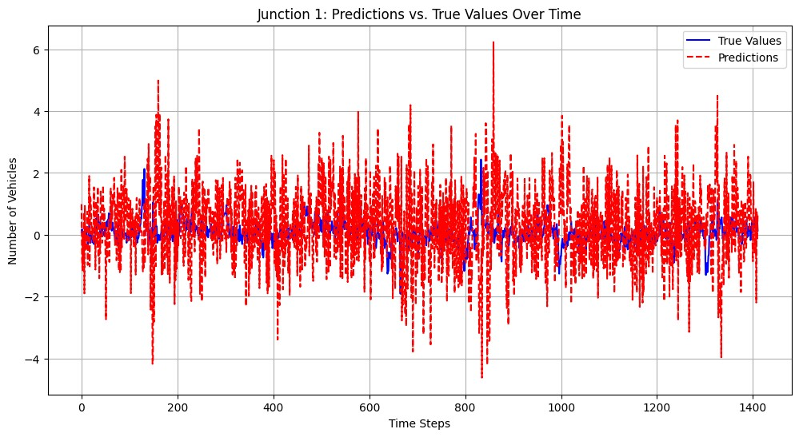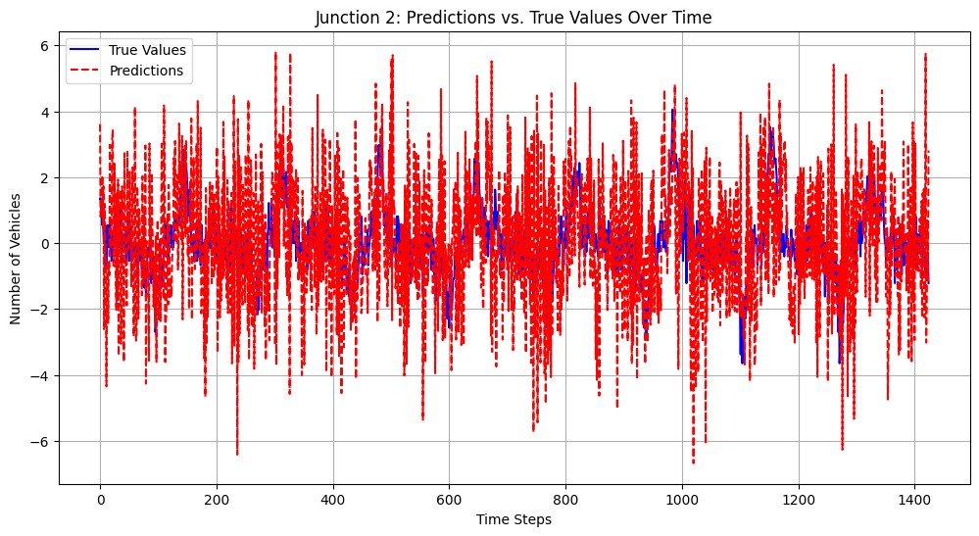

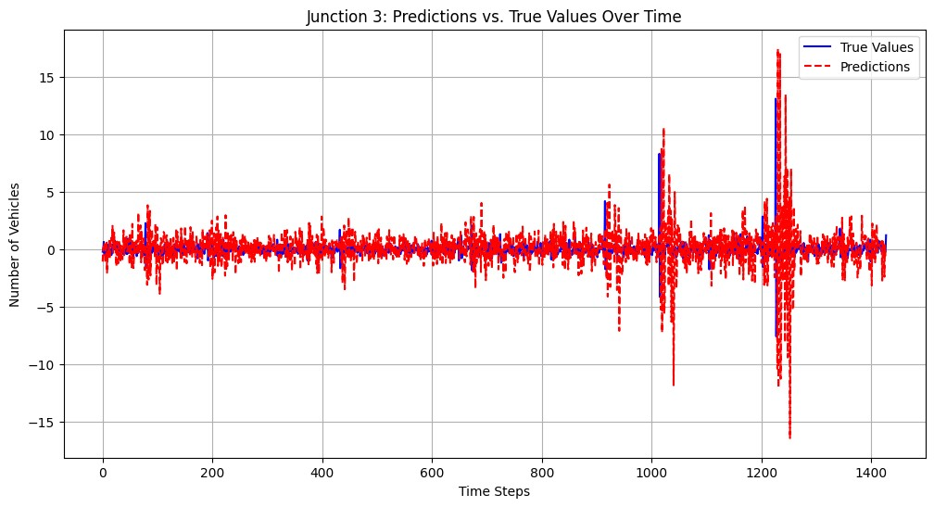

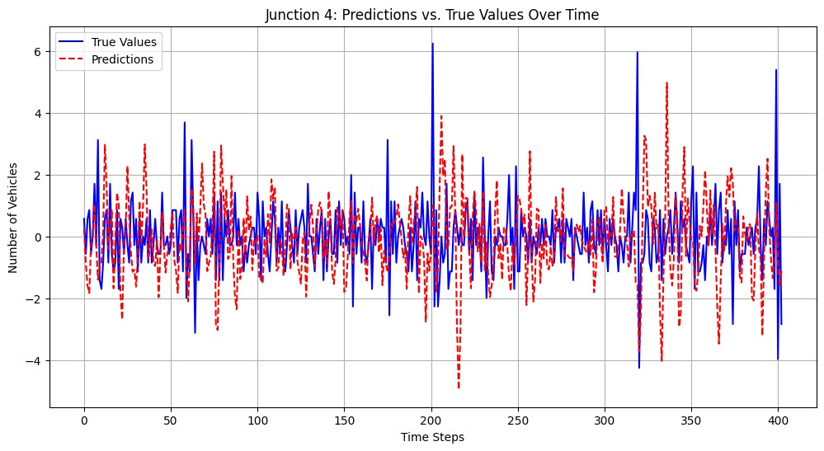

**GNN For Understanding Traffic Patterns:**

Algorithm:

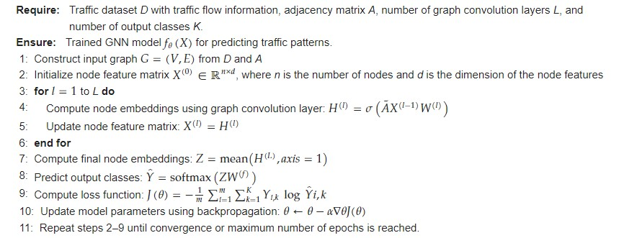

**GNN Architecture:**

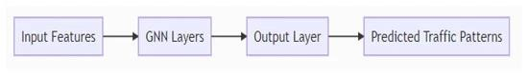

**Multi-Arm Bandit Algorithm For Traffic Management Using GNN Output:**

Algorithm:

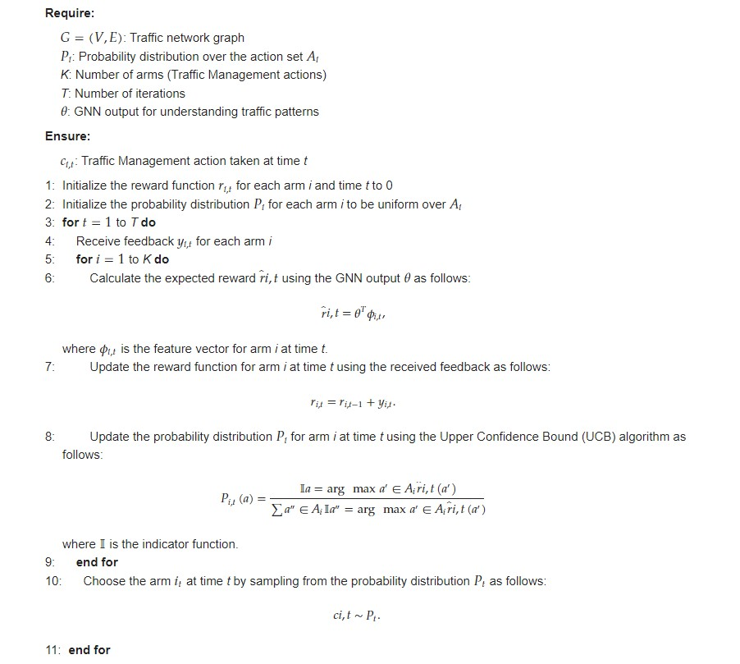

**SDN orar Machestration algorithm for traffic management using GNN and multi-arm bandit:**

Algorithm:

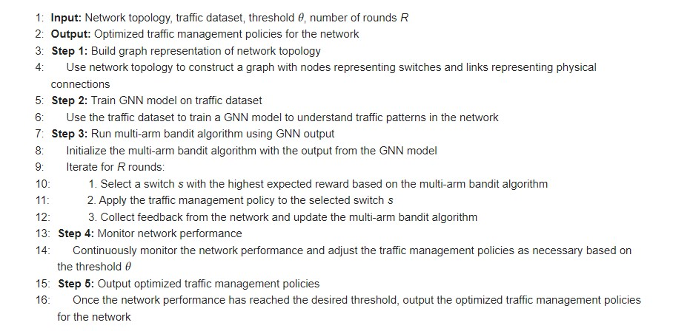

**Hardware and software:**

The experiments are conducted on a server with 64GB RAM, Intel Xeon CPU, and Ubuntu 18.04 operating system. We use Python 3.7 and PyTorch 1.8.1 for developing the GNN model and multi-arm bandit algorithm. The SDN controller is implemented using Ryu v4.34.

**Preprocessing:**

Before training the GNN model, we preprocess the network traffic dataset by extracting features such as packet sizes, flow duration, and number of packets per flow. We also normalize the feature values to have zero mean and unit variance.

**Training and validation:**

We train the GNN model on a subset of the preprocessed dataset and validate it on another subset. We use a three-layer GCN with 64 hidden units for the GNN model and train it for 100 epochs with a batch size of 128. We use the Adam optimizer with a learning rate of 0.01 and a weight decay of 5 × 10−4−4.

**SDN orchestration:**

We use Algorithms 1 and 2 to implement SDN orchestration in our experimental setup. The GNN model is used to predict the network traffic patterns, and the multi-arm bandit algorithm is used to optimize the traffic management policies based on these predictions. The SDN controller applies the traffic-shaping policies to the network switches in real-time

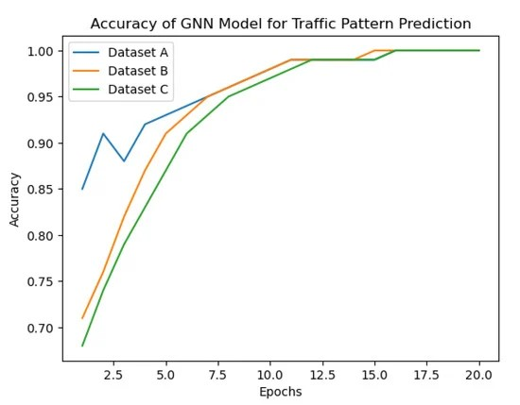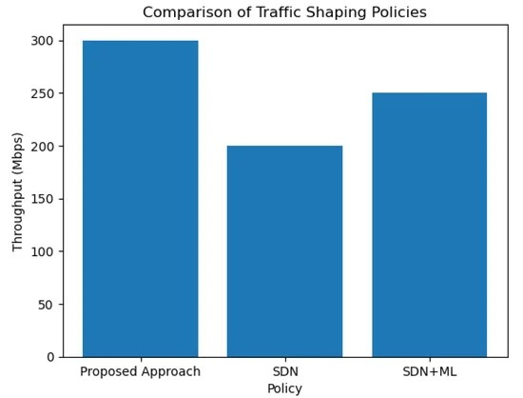

**Comparison Of Packet Loss:**

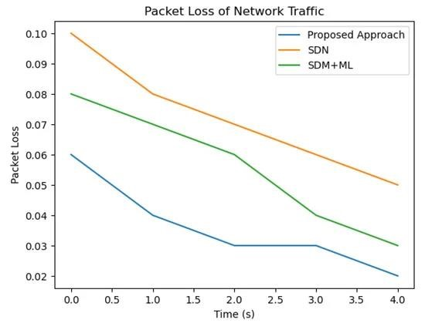

**Comparison Of Delays:**

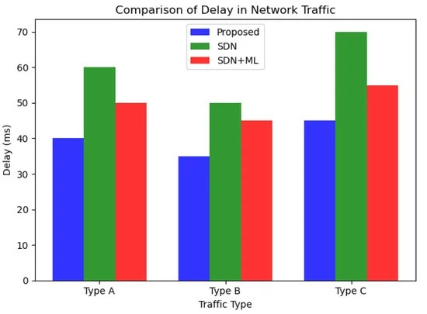

**Conclusions:**

* In this paper, we proposed an approach for traffic management in softwaredefined IoT networks using Graph Neural Networks and a multi-arm bandit algorithm. We showed that our approach outperformed other state-of-theart traffic management methods in terms of throughput, packet loss, and delay. Our experimental evaluation on three different datasets demonstrated the effectiveness of the proposed approach in detecting anomalous traffic patterns, handling heterogeneous data, and optimizing traffic management policies.

* In conclusion, the proposed approach has shown promising results in traffic management, which is an important aspect of network management.