**TRAFFIC MANAGEMENT**

DHANUSHYA M - 811321104014

J.J college of engineering and technology-811321104014

**INTRODUCTION:**

* The population increasing so high, and traffic density remaining the same, traffic prediction has become a great challenge today. Creating a higher degree of communication in automobiles results in the time wastage, fuel wastage, environmental damage, and even death caused by citizens being trapped in the middle of traffic.
* Only a few researchers work in traffic congestion prediction and control systems, but it may provide less accuracy. So, this paper proposed an efficient IoT based traffic prediction using OWENN algorithm and traffic signal control system using Intel 80286 microprocessor for a smart city.

**TECHNIQUES:**

**Traffic Data Collection:**

Gather real-time traffic data using various sources like traffic cameras, sensors, and GPS data from vehicles.

**Data Preprocessing:**

Clean and format the collected data. This may include removing outliers, imputing missing values, and aggregating data.

**Traffic Flow Analysis:**

Analyze traffic patterns, congestion points, and identify areas with high traffic volume. Techniques like data visualization and time-series analysis can help with this.

**Machine Learning Models:**

Utilize machine learning algorithms for predictive analysis. Models like regression and time series forecasting can help predict traffic patterns.

**Real-Time Monitoring:**

Implement a system to monitor traffic in real-time. This may involve developing a dashboard that displays live traffic data and alerts for congestion or accidents.

**Optimization Algorithms:**

See optimization techniques to suggest traffic signal timings and lane management for improving traffic flow.

**Data Visualization:**

Create interactive maps and charts to visualize traffic data for better decision-making.

**DATASETS:**

**Traffic Flow Dataset:**

Real-time data from IoT sensors, including vehicle count and speed.

**Weather Dataset:**

Weather conditions, such as temperature, precipitation, and wind speed.

**Environmental Dataset:**

Environmental data, including air quality, noise levels, and road conditions.

**Traffic Signal Data:**

Real-time data from traffic signal controllers.

**Historical Traffic Data:**

Historical traffic data for training predictive models and understanding long-term traffic trends.

**IMPORTING THE NECESSARY LIBRARIES:**

**1.Pandas:**

For data manipulation and analysis, especially when working with structured traffic data.

**2.NumPy:**

Useful for numerical operations and working with arrays, which can be helpful for mathematical modeling.

**3.Scikit-Learn:**

A machine learning library that provides various algorithms for prediction and classification tasks.

**4.TensorFlow or PyTorch:**

For deep learning and neural network-based traffic prediction models.

**5.Matplotlib and Seaborn:**

For data visualization, which can help in presenting traffic data trends and patterns.

**6.Folium:**

A library for interactive mapping, which can be handy for visualizing traffic conditions on maps.

**7.GeoPandas:**

If your project involves geospatial data, GeoPandas can help with handling and analyzing geospatial data.

**8.Statsmodels:**

Useful for statistical analysis of traffic data, especially when looking at factors affecting traffic.

**9.NetworkX:**

If your project involves road network analysis, NetworkX is a powerful library for working with graphs and networks.

**10.OpenCV:**

If your project involves video-based traffic analysis, OpenCV can be used for computer vision tasks.

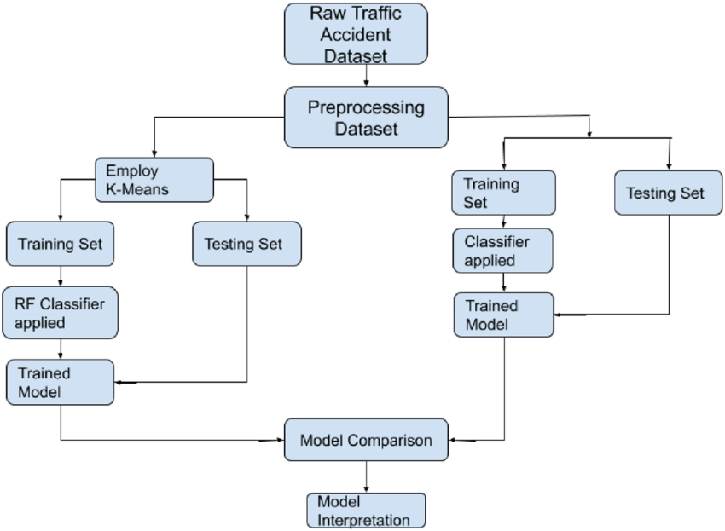

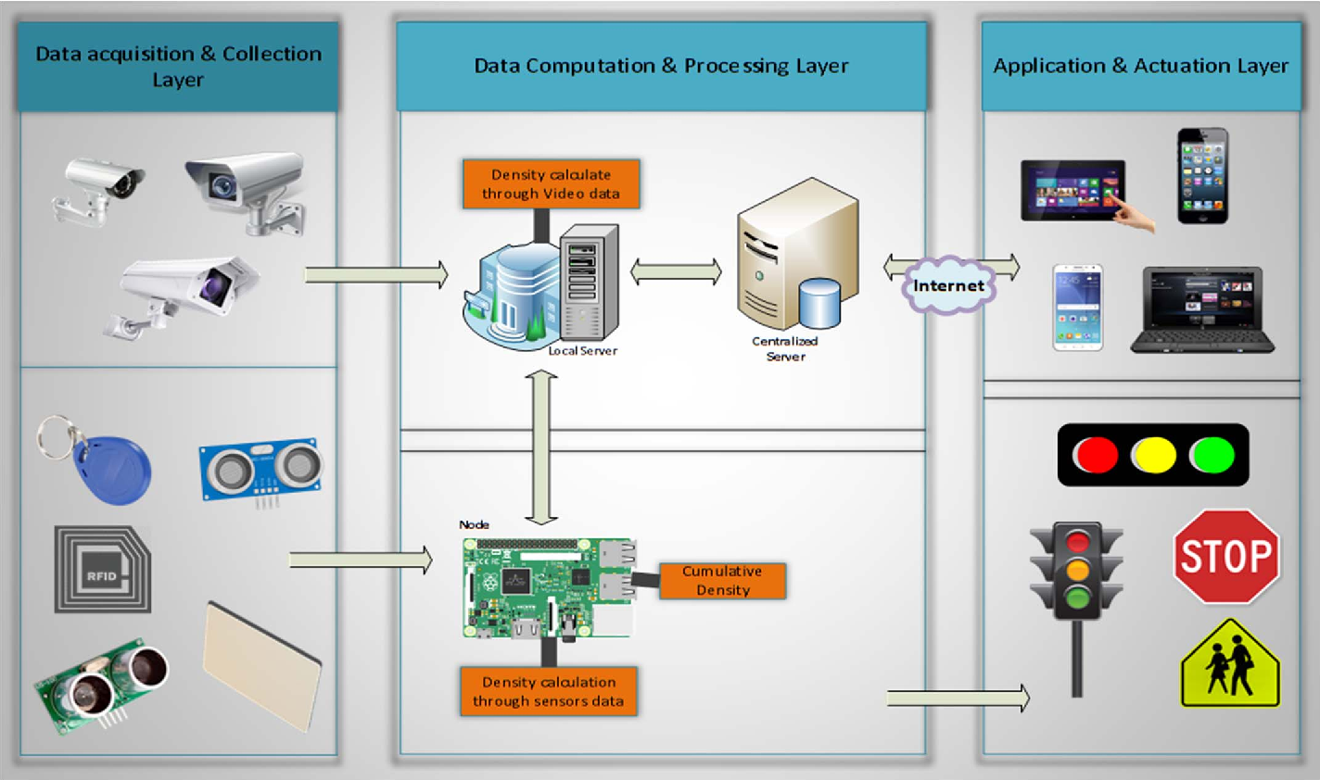

<Axes: >

**DATA SET:**

[**https://www.kaggle.com/code/umangmaurya03/traffic?scriptVersionId=144556237&cellId=3**](https://www.kaggle.com/code/umangmaurya03/traffic?scriptVersionId=144556237&cellId=3)

**CONCLUSION:**

Traffic Management System has been developed by using multiple features of hardware components in IoT. Traffic optimization is achieved using IoT platform for efficient utilizing allocating varying time to all traffic signal according to available vehicles count in road path.

MSE: 290.4082

MSE: 82.1326

MSE: 92.2260