1. ADDITION OF 2 ARRAYS
#include<stdio.h>
int main()
{
int a[5],b[5],c[5];
int i;
printf("enter a[i]\n");
printf("enter b[i]\n");
for(i=0;i<5;i++)
{
scanf("%d",&a[i]);
}
for(i=0;i<5;i++)
{
scanf("%d",&b[i]);
}
for(i=0;i<5;i++)
{
c[i]=a[i]+b[i];
printf("c[%d] is %d\n",i,c[i]);
}
}
2.PRINT FROM 10 TO 1
#include<stdio.h>
int main()
{
int i;
for(i=10;i>0;i--)
{
printf("%d\n",i);
}
}
3.PRINT FROM Z TO A
#include<stdio.h>
int main()
{
char a;
for(a=90;a>=65;a--)
{
printf("%c\n",a);
}

}
4.SQRT
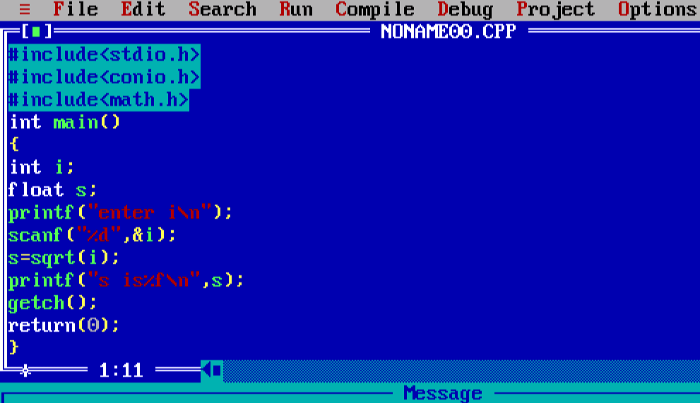

EXCERCISES:
1)Write a program in C to display the first 10 natural numbers.
#include<stdio.h>
int main() {
int i;
for(i=1;i<=10;i++)
{
printf("%d\t",i);
}
}
2.Write a C program to find the sum of first 10 natural numbers.
#include<stdio.h>
int main() {
int i,s=0;
printf("The first 10 natural number is :\n");
for(i=1;i<=10;i++)
{
printf("%d\t",i);
s=s+i;
}
printf("\nThe sum is %d",s);
}
3.Write a program in C to read 10 numbers from keyboard and find their sum and average.
#include<stdio.h>
int main() {
int i,n,s=0;
float a=0;
printf("input the 10 numbers :\n");
for(i=1;i<=10;i++)
{
scanf("%d",&n);
printf("number%d:%d\n",i,n);

s=s+n;
a=s/10;
}
printf("\nThe sum is %d",s);
printf("\nThe avg is %f",a);
}
4. Write a program in C to display the cube of the number upto given an integer.
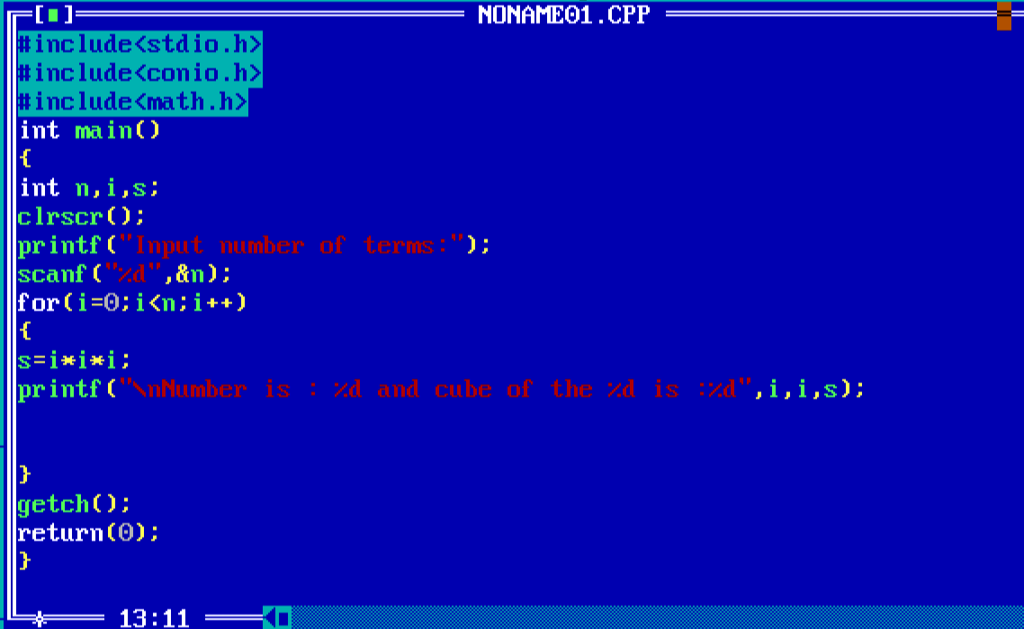

5. Write a program in C to make such a pattern like right angle triangle with a number which will repeat a number in a row.
#include<stdio.h>
int main() {
int n;
int i,j;
printf("no of rows:\n");
scanf("%d",&n);
for(i=1;i<=n;i++)
{
for(j=1;j<=i;j++)
{
printf("%d",i);

}
printf("\n");
}
}
6. Write a C program to convert a string to a long integer.
#include <stdio.h>
#include<stdlib.h>
int main(void)
{
long s;
s = atol("2222");
printf("%ld\n", s);
return 0;
}

