**Project Title: E-commerce Application on IBM Cloud Foundry**

:

**Abstract:**

For this project, we need to develop an online store for IBM Cloud Foundry with some techniques. The website strives to connect skilled artisans with a global audience by showcasing their handmade goods and providing services like secure shopping carts, payment gateways, and a simple checkout process. To do this, an e-commerce platform must be developed, the necessary functionality must be added, and a seamless client experience must be maintained.

**Technological stacks that are incorporate from IBM Cloud Foudry:**

**Databases:**

IBM Db2 on Cloud: Store product data, user profiles, and wishlists securely.

IBM Cloudant: Use this NoSQL database for storing user-generated content like product reviews.

**Authentication and Authorization**:

IBM App ID: Implement user authentication and authorization to manage user profiles and access to features.

**Serverless Computing:**

IBM Cloud Functions: Use serverless functions to handle tasks such as sending notifications when products in wishlists are on sale.

**Data Analytics and AI:**

IBM Watson Natural Language Understanding: Analyze product reviews for sentiment analysis.

IBM Watson Machine Learning: Build personalized recommendation models.

**Content Delivery and CDN:**

IBM Cloud Content Delivery Network (CDN): Deliver images and content quickly to users.

**Push Notifications**:

IBM Cloud Push Notifications: Send alerts to users when items in their wishlist are updated or on sale.

**Message Broker:**

IBM MQ: Use a message broker for real-time communication, especially for notifying users about changes in their wishlists.

**Monitoring and Analytics:**

IBM Cloud Monitoring and Application Performance Management (APM): Monitor the performance of your web application and user interactions.

IBM Watson Customer Experience Analytics: Track user behavior and gather insights.

**Frameworks:**

React.js and node.js are used as framework for our website

**Responsive Design:**

Ensure that the **website is responsive and mobile-friendly** for a seamless user experience.

**Scalability and Load Balancing:**

Use IBM Cloud's load balancers and auto-scaling capabilities to handle traffic spikes.

**User Notifications:**

Implement real-time notifications using **WebSockets** or cloud-based notification services.

**Data Security and Compliance:**

Ensure that you handle customer data securely and in compliance with data protection regulations.

**Flow Chart:** 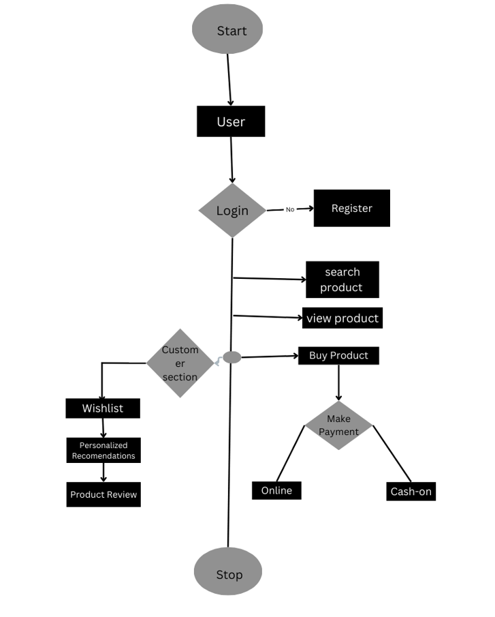

**Working:**

homepage layout that is both aesthetically pleasing and responsive, with sections for featured products, artisan profiles, and a search bar for simple navigation.

* **Contents**: Log-in and sign-up buttons, terms and conditions, navigation bar is available for showing the detailed information of another webpages.
* Filters are also available for search efficiently
* To understand user grievances, we often collect feedbacks to correct i

Data Privacy: Ensure compliance with data privacy regulations (e.g., GDPR) by anonymizing or aggregating user data.

Transparency: Provide clear information to users about how their data is used to generate recommendations.

**Product Showcase**:

**Web Development:**

Building a custom e-commerce website from scratch, you can use web development tools and libraries like HTML, CSS, JavaScript, and modern frontend frameworks (Node.js and react.js) to create customized product showcase components.

**Content Delivery Networks (CDN):**

CDNs can be used to optimize the delivery of product images, ensuring fast loading times and a seamless product showcase experience. Create a database structure to keep track of product details such pictures, descriptions, costs, and classifications. Ensure effective data storage and retrieval

**Personalization and Recommendations(Customer Section):**

Utilize AI and machine learning tools and services to personalize product showcases for users based on their preferences and behavior

IBM Cloud Push Notifications: Send alerts to users when items in their wishlist are updated or on sale.

message broker are used for real-time communication and notifying users about changes in their wishlists .

IBM Cloud Monitoring and Application Performance Management (APM).

IBM Watson Customer Experience Analytics: Track user behavior

• **Navigation and Categories**: To make it easier for clients to find what they're looking for, implement a simple, user-friendly navigation menu with product categories.

• **Artisan Profiles**: Give artisans the ability to personalize and construct their own profiles that highlight their abilities, educational background, and a portfolio of their work.

**User Authentication:**

**Tools:**

IBM Cloud ID,IBM Cloud identity and Access Management, Monitoring and log-in services

**• User Registration**: Create a simple registration procedure with few details needed. Verify your email to add an extra layer of security.

• **User accounts:** Both buyers and craftsmen can create user accounts with the possibility to include personal data, shipping addresses, and payment methods.

**Shopping Cart and Checkout:**

**Tools:**

**IBM Watson commerce,IBM cloud Function**

**• Shopping Cart**: Create a feature for the shopping cart that makes it simple for customers to add, remove, and update things. Give a detailed list of what's in their cart.

• **Checkout procedure**: Create an easy-to-use checkout procedure with a variety of payment choices. Features like the order summary, shipping choices, and order confirmation should be included.

**Payment Integration:**

* **IBM Payment Gateway** is a cloud-based payment processing solution that enables businesses to securely process online and mobile payments. It supports various payment methods, including credit cards and digital wallets.
* **Payment Confirmation**: Implement instant payment confirmation notifications to both customers and artisans to enhance transparency.

**User Experience:**

We have created a separate section for customer satisfaction. On that section, there are three main sections that are used to find the mistakes we have made. They are Customer Section, Product Review, and Wishlist. Our website is entirely based on user reviews. They will change anything in our website. We can modify anything at any time if the user needs to change something.

**Advantages:**

Customer Support-review and ratings

Feedback Mechanism

Mobile App –Responsible design

Analytics and Reporting

Marketing and Promotion.

Security Measures

Scalability, Filter for search