TITLE 1: Dell Inventory Management System Using JavaScript Arrays
Introduction
The Dell Inventory Management System is a web-based application developed using HTML, CSS, and JavaScript. The purpose of this project is to manage Dell product information and check product availability.
Development Process
Step 1: Creating the User Interface
An HTML page was created to provide a user-friendly interface. Input fields, buttons, and inventory display sections were added.
Step 2: Styling the Application
CSS was used to improve the appearance of the application. Colors, layouts, buttons, and containers were styled to create a professional user interface.
Step 3: Implementing Inventory Management
JavaScript arrays were used to store Dell product names. Functions were created to:
- Display inventory
- Add products
- Remove products
- Check product availability
Step 4: Event Handling
Button click events were implemented using JavaScript to allow users to interact with the application.
Step 5: Testing
The application was tested to ensure that products were displayed correctly and availability checking worked as expected.

Output screenshorts
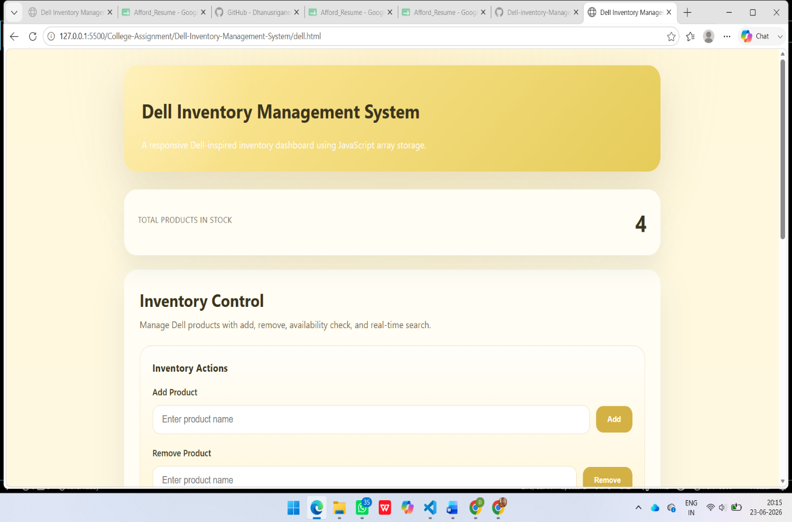
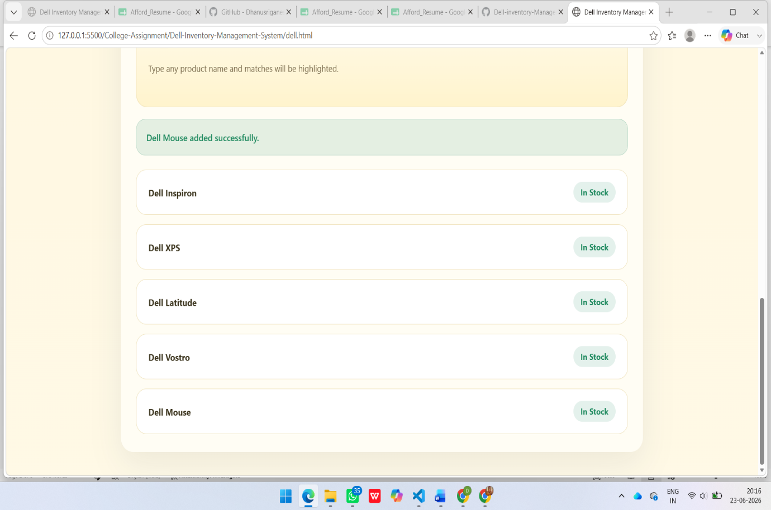

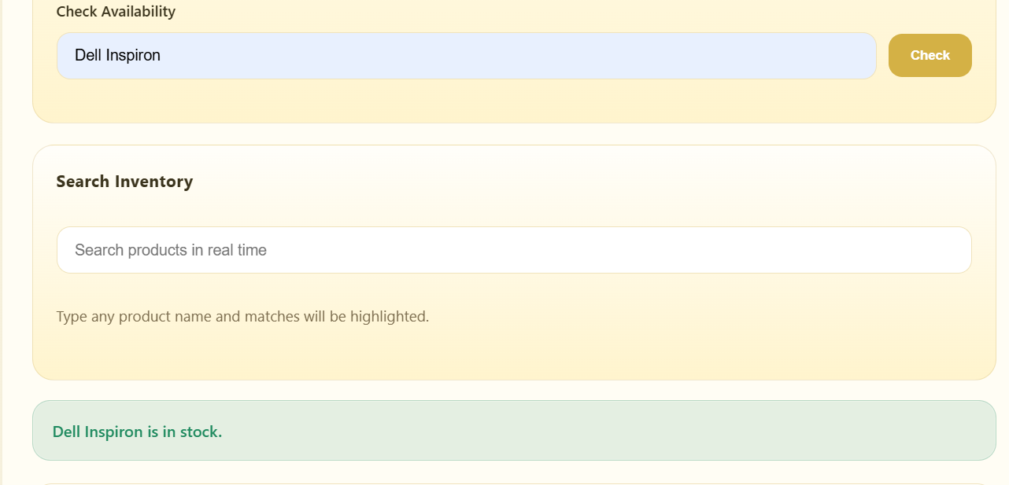
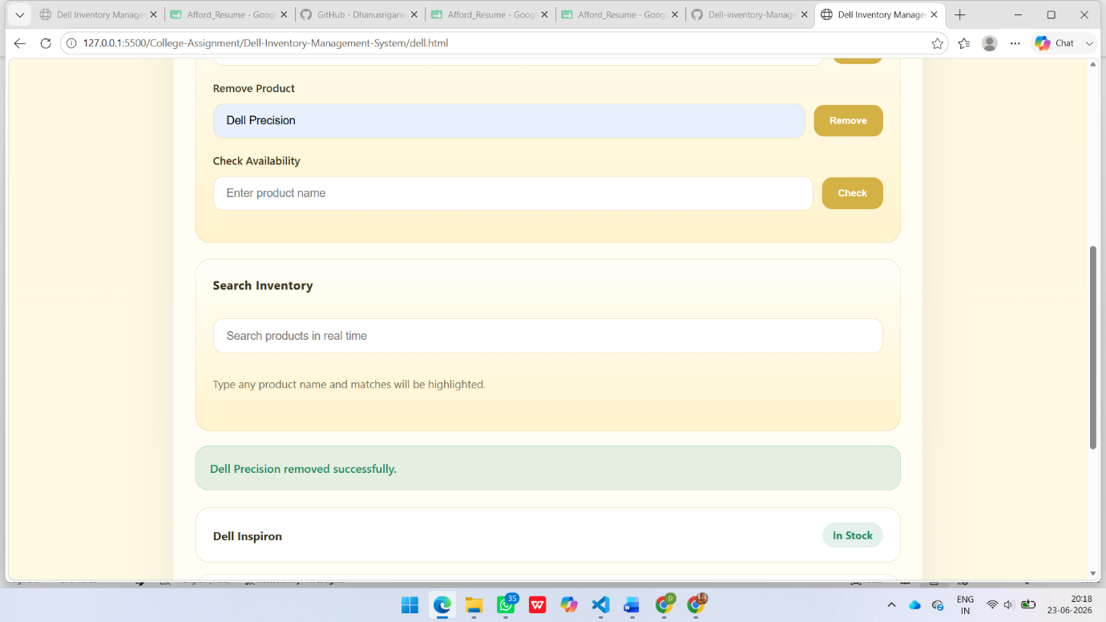
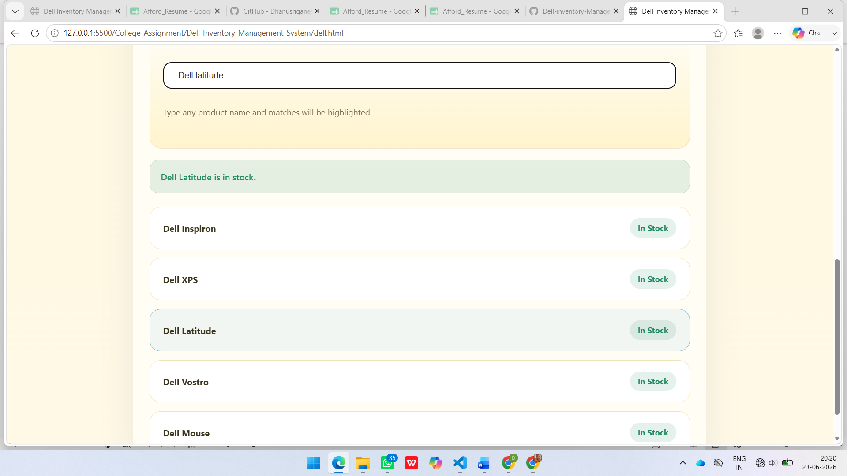

Result
The Dell Inventory Management System was successfully developed and tested. The application correctly manages products and checks inventory availability.

TITLE 2: ZigZag Conversion
Introduction
ZigZag Conversion is a string manipulation problem in which characters of a string are arranged in a zigzag pattern across a specified number of rows and then read row by row.
Development Process
Step 1: Designing the Interface
An HTML page was created with:
- String input field
- Number of rows input field
- Convert button
- Result display section
Step 2: Styling the Page
CSS was used to create a clean and responsive user interface.
Step 3: Implementing the Algorithm
JavaScript was used to implement the ZigZag Conversion algorithm.
The algorithm:
- Creates rows based on the given number.
- Places characters in zigzag order.
- Changes direction at the first and last rows.
- Combines all rows to generate the final output.
Step 4: Displaying the Result
When the user clicks the Convert button, the algorithm processes the input and displays the converted string.
Step 5: Testing
The application was tested using:
Input:
PAYPALISHIRING
Rows:
3
Output:
PAHNAPLSIIGYIR
The output matched the expected result.
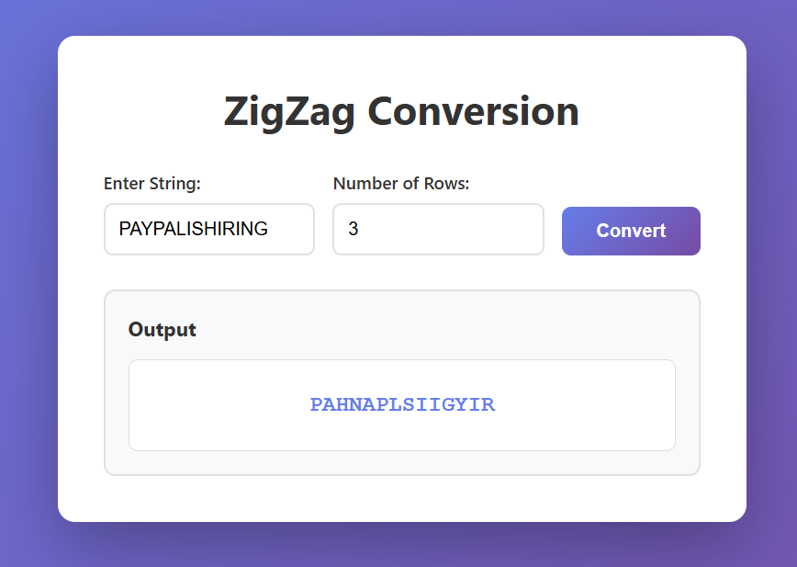
Output Screenshot:
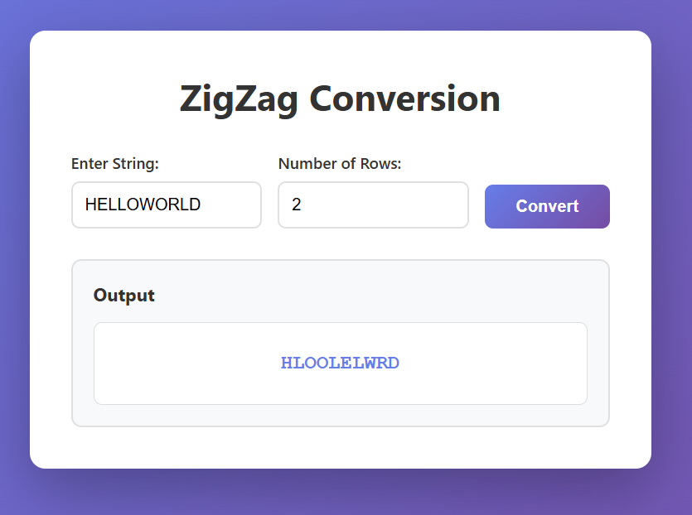

Result
The ZigZag Conversion application was successfully developed using HTML, CSS, and JavaScript. The algorithm produced the correct output for the given test cases.

