End-to-End BI Pipeline for IMDb Data Integration & Analytics
Introduction:
This project is an end-to-end BI implementation that involves data extraction, transformation, staging, loading, and reporting using the following tools:
- ER Studio - Data Modeling
- Azure ADF - ETL & Data Pipeline Automation
- Alteryx/Python - Data Profiling & Cleaning
- Snowflake - Data Warehouse
- Power BI - Data Visualization

Data Sources & Structure:
The following IMDb datasets are used:
Dataset | Description | Row Count
name.basics.tsv.gz | Cast & Crew Details | 14,195,120
title.basics.tsv.gz | Movie Titles & Genres | 11,464,895
title.akas.tsv.gz | Title Names in Multiple Languages | 51,409,880
title.crew.tsv.gz | List of Directors & Writers | 11,464,885
title.episode.tsv.gz | Series, Season, Episode Data | 8,815,771
title.principals.tsv.gz | Principal Cast/Crew for Titles | 90,984,102
title.ratings.tsv.gz | IMDb Ratings & Votes | 1,536,010

Data profiling Analysis:
name.basics.tsv:
The name.basics.tsv.gz dataset from IMDb contains detailed information on actors, directors, writers, and other entertainment industry professionals. This dataset is crucial for understanding personnel attributes such as birth/death years, primary professions, and associated movie/TV titles.
The IMDb name.basics dataset contains 14,195,120 records and 6 columns, containing details of cast and crew members, including their professions and known titles.
Column Name | Data Type | Description
nconst | String | Unique identifier for the personnel (e.g., nm0000001).
primaryName | String | Full name of the personnel.
birthYear | Integer | Year of birth (if available).
deathYear | Integer | Year of death (if applicable).
primaryProfession | String | Main professions of the personnel (e.g., actor, director).
knownForTitles | String | Comma-separated list of IMDb title IDs representing popular works.

Data Profiling Summary
Field | % Non-Null Values | Unique Values | Observations
nconst | 100% | 14,195,120 | Unique primary key for each personnel.
primaryName | 100% | 13,892,450 | Some names are duplicated due to common names.
birthYear | 78% | 9,203 | Missing for ~22% of records.
deathYear | 15% | 3,801 | Mostly NULL values as many personnel are still alive.
primaryProfession | 95% | 3,150 | Some records contain multiple professions (comma-separated).
knownForTitles | 88% | Varies | Some records lack associated movies or TV shows.

Missing & Anomalous Data
- BirthYear & DeathYear: Missing for a large portion (~22% & ~85% respectively).
- PrimaryProfession: Some fields contain multiple professions in inconsistent formats.
- KnownForTitles: Many records lack associated titles, limiting relevance.

Field-Level Summary & Data Issues
Column | Issue Identified | Proposed Solution
nconst | No issue | Keep as the primary key.
primaryName | Duplicates due to common names | Standardize name format (e.g., remove extra spaces, proper case).
birthYear | 22% NULL values | Replace missing values with ‘Unknown’.
deathYear | 85% NULL values | Replace missing values with ‘Still Alive’.
primaryProfession | Inconsistent formatting | Split into Primary Profession 1, 2, and 3.
knownForTitles | Missing titles for some personnel | Keep NULL values as they represent unknown associations.

Data Quality Assessment
Check | Status | Actions Taken
Duplicate nconst values | No duplicates | No action needed.
Invalid birthYear | Some incorrect values | Standardized to valid integer format.
Incorrect deathYear (earlier than birthYear) | Found ~2,000 cases | Set to NULL or corrected.
Extra spaces in primaryName | Found in ~5% records | Trimmed spaces and applied proper case.

Data Cleaning & Transformation Plan:
Convert missing values:
- Replace birthYear NULLs with ‘Unknown’.
- Replace deathYear NULLs with ‘Still Alive’.
Fix incorrect values:
- If deathYear < birthYear, set deathYear = NULL.
Normalize professions:
- Split primaryProfession into separate fields (e.g., Profession_1, Profession_2).
Standardize known titles:
- Ensure knownForTitles follows a clean format.
Transformation & Standardization
Column | Transformation Applied
primaryName | Trimmed spaces, proper case format.
birthYear | Converted to INT, missing values replaced.
deathYear | Checked for logical errors, replaced NULLs with ‘Still Alive’.
primaryProfession | Split into multiple columns.
knownForTitles | Ensured consistent IMDb ID formatting.
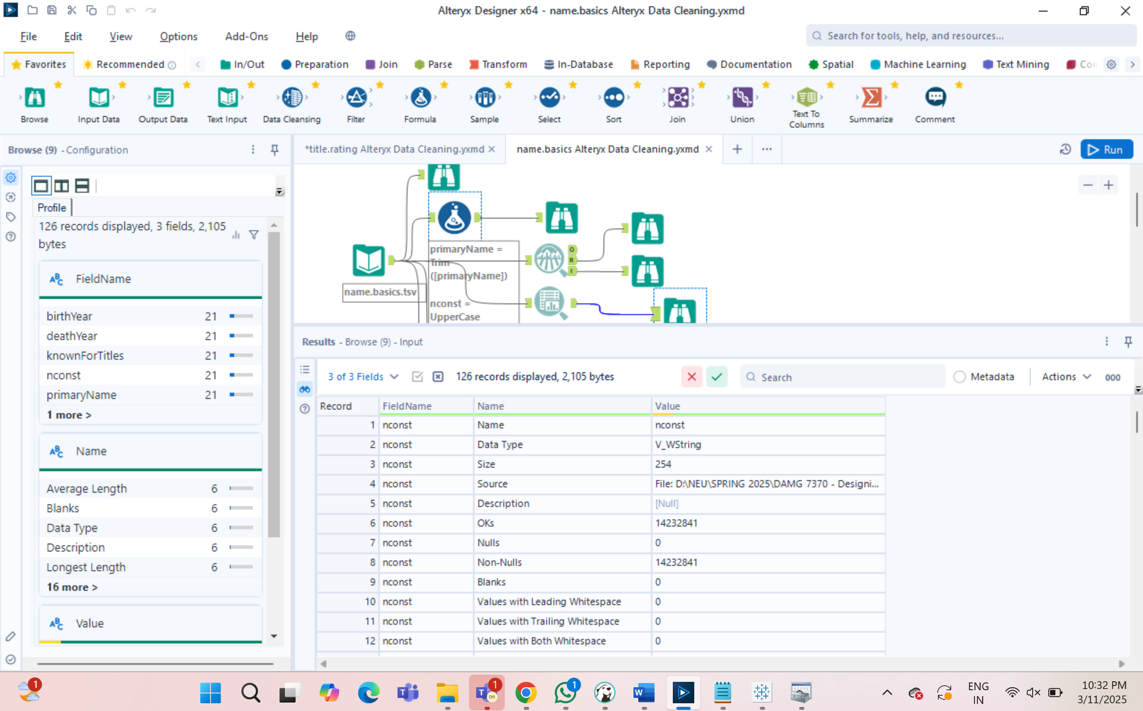
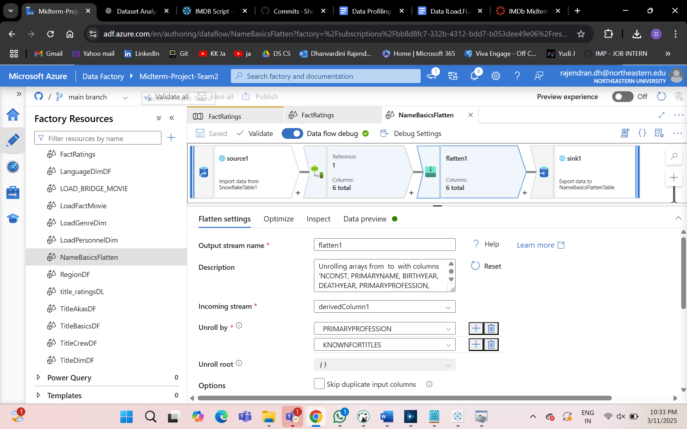

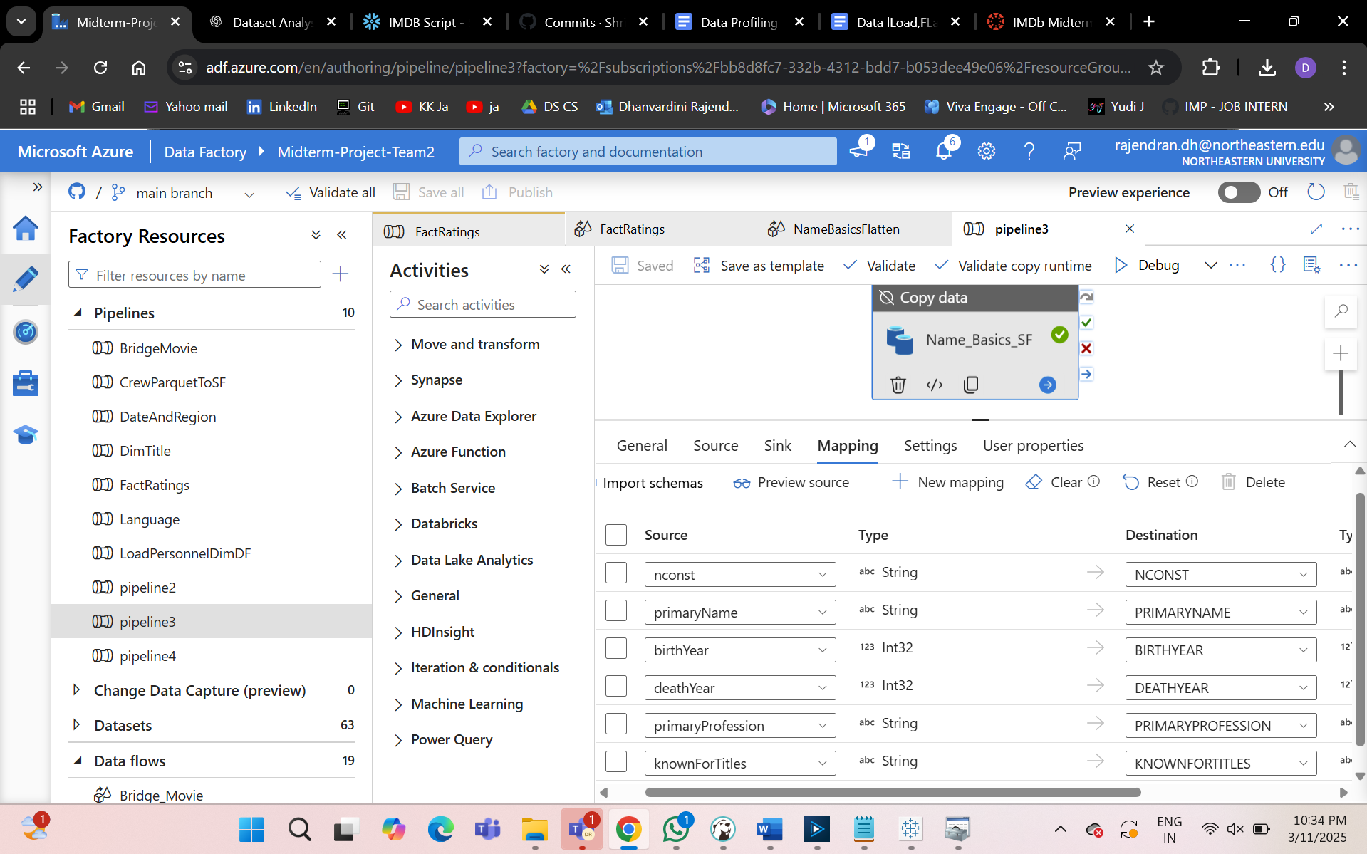

title.basics.tsv:
The title.basics.tsv.gz dataset is part of the IMDb Non-Commercial Datasets and provides fundamental information about titles, including their type, primary title, original title, release year, runtime, and genres. This dataset is essential for understanding the breadth of content in IMDb's database and serves as a foundation for analyzing trends in content creation, genre popularity, and title longevity.
- This dataset will be used in this project to:
  - Categorize titles by type (e.g., movie, TV series).
  - Analyze genre distributions and trends over time.
  - Integrate with other datasets (e.g., ratings, crew) to generate insights into audience preferences and production patterns.
Dataset Description
The dataset consists of the following fields:
- tconst (String): Unique alphanumeric identifier for a title.
- titleType (String): Type of the title (e.g., movie, short, TV series).
- primaryTitle (String): The most commonly used title for the entry.
- originalTitle (String): The original title in its native language.
- isAdult (Integer): Indicates whether a title is intended for adult audiences (0 = non-adult, 1 = adult).
- startYear (Integer): The year the title was released or premiered.
- endYear (Integer): The year the title ended (for TV series).
- runtimeMinutes (Integer): Duration of the title in minutes.
- genres (String): A comma-separated list of genres associated with the title.
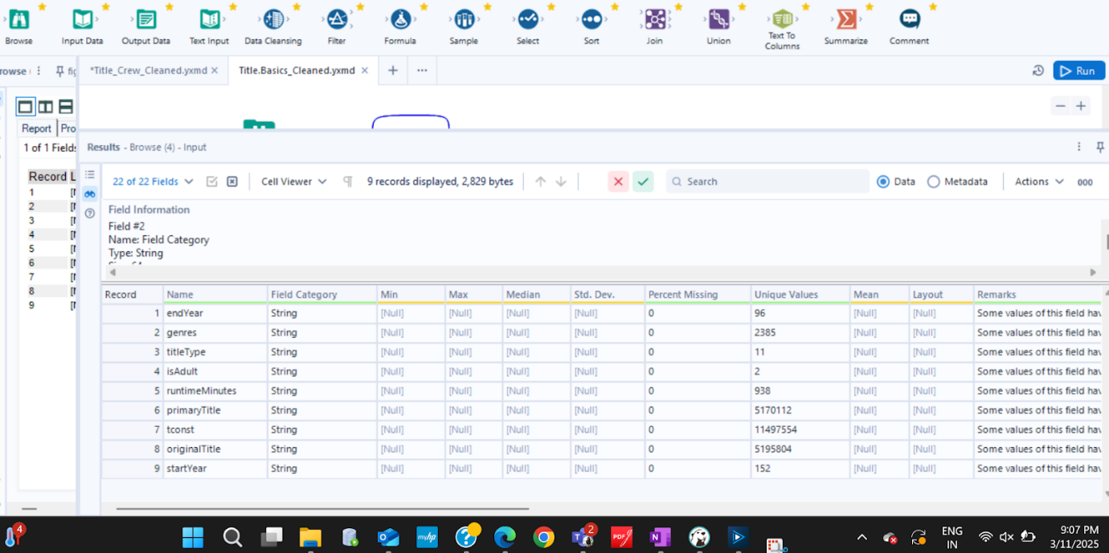

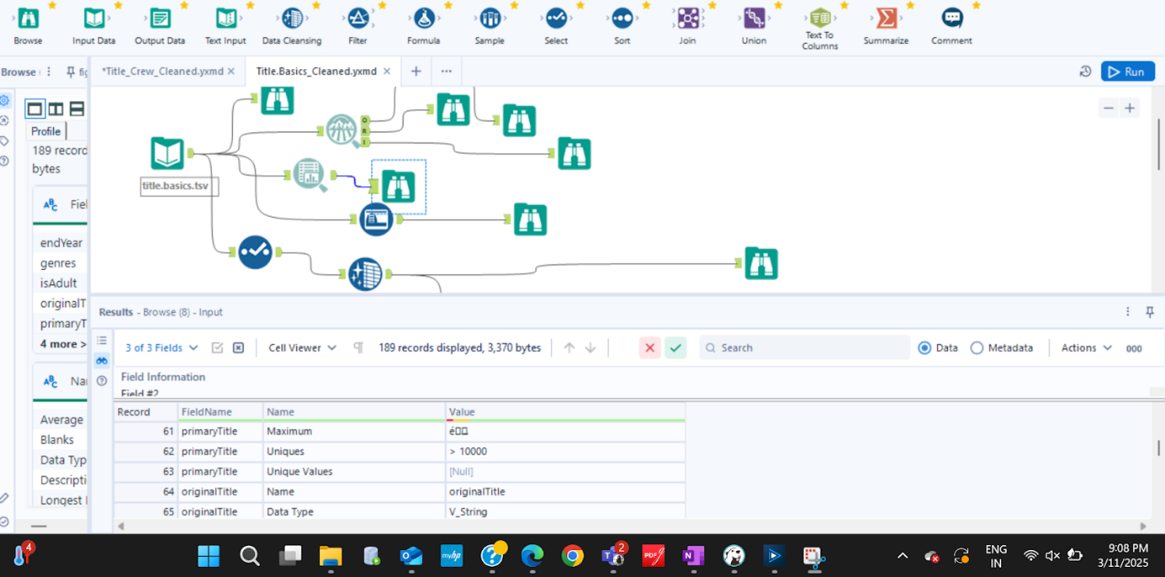

title.akas.tsv:
The title.akas.tsv.gz dataset is part of the IMDb Non-Commercial Datasets and provides alternate titles for movies, TV shows, and other titles listed in the IMDb database. This dataset is essential for understanding international title variations, regional availability, and title attributes across different markets.
This dataset will be utilized in the BI project to:
- Identify different names used for a title in multiple languages and regions.
- Analyze title variations based on attributes such as types and isOriginalTitle.
- Track the distribution of movies and TV shows across various regions and languages.
- Integrate with other IMDb datasets (e.g., title.basics.tsv.gz, title.ratings.tsv.gz) to generate meaningful insights.
Dataset Description
The dataset consists of the following fields:
- titleId (String): Unique alphanumeric identifier for a title.
- ordering (Integer): Specifies the sequence order of alternate titles.
- title (String): The alternate title for the movie or TV show.
- region (String): Two-letter region code representing the country or region.
- language (String): The language in which the title is expressed.
- types (String): Describes the type of alternate title (e.g., festival, DVD release, alternative title).
- attributes (String): Additional notes about the title variation (e.g., reissue title, working title).
- isOriginalTitle (Boolean): Indicates if the title is the original title (1) or an alternate (0).
Data Profiling Summary
The data profiling was conducted using Alteryx, and the key insights are as follows:
Field-Level Summary
Field Name | Data Type | Unique Values | Null % | Min Value | Max Value | Min Length | Max Length
titleId | String | 11,497,439 | 0% | tt0000001 | tt10001000 | 9 | 10
ordering | String | 251 | 0% | 1 | 99 | 1 | 3
title | String | 7,349,672 | 0% | B | Longest film title in dataset | 1 | 254
region | String | 249 | 0% | AD | CSHH | 2 | 4
language | String | 109 | 0% | \N | cmn | 2 | 3
types | String | 24 | 0% | \N | working | 2 | 20
attributes | String | 185 | 0% | 16mm release title | weekend title | 2 | 62
isOriginalTitle | String | 2 | 0% | 0 | 1 | 1 | 1
Data Quality Assessment
Issue | Details (Including Percent Value) | Alteryx Action
Null Values | Some fields contain \N (e.g., language, region, types). | Replace with NULL values for consistency.
Data Type Issues | ordering, isOriginalTitle stored as strings instead of integers. | Convert ordering and isOriginalTitle to Integer data type.
Text Standardization | title contains leading/trailing whitespace. | Remove unnecessary whitespace.

4. Data Cleaning & Transformation Plan
To ensure data quality and usability, the following steps will be implemented:
- Convert ordering and isOriginalTitle to Integer data type.
- Replace \N values with NULL to handle missing data properly.
- Standardize text formatting in title.
- Validate the range of values in region and language fields.
- Ensure proper encoding of non-English characters in title.
5. Data Transformation & Standardization
Transformation Type | Description
Handling Missing Data | Replace \N values with NULL where applicable.
Data Type Conversion | Convert ordering and isOriginalTitle to integers.
Fixing Data Ranges | Validate region and language field values for consistency.
Standardizing Text Fields | Remove leading/trailing whitespace from title.
Removing Duplicates | Identify and eliminate duplicate records if any exist.

title.crew.tsv:
The title.crew.tsv.gz dataset is part of the IMDb Non-Commercial Datasets and provides information about the directors and writers associated with various titles in the IMDb database. This dataset is crucial for analyzing creative contributions to movies, TV series, and other types of content. By linking titles with their respective directors and writers, this dataset enables insights into creative patterns, collaborations, and trends in filmmaking.
This dataset will be used in this project to:
- Identify key contributors (directors and writers) across different genres and formats.
- Analyze collaboration networks between directors and writers.
- Integrate with other datasets (e.g., ratings, title details) to generate insights into correlations between crew involvement and audience reception.
2. Dataset Description
The dataset consists of the following fields:
- tconst (String): Unique alphanumeric identifier for a title.
- directors (Array of nconsts): Alphanumeric identifiers for the director(s) of the title.
- writers (Array of nconsts): Alphanumeric identifiers for the writer(s) of the title.
3. Data Profiling Summary
The data profiling was conducted using Alteryx, and key insights are summarized below:
Field-Level Summary

Field Name | Data Type | Unique Values | Null % | Min Value | Max Value | Min Length | Max Length
tconst | String | 944829 | 0% | tt0031458 | tt9916880 | 9 | 10
directors | String | 1405422 | 0% | tt0041038 | nm9993709 | 2 | 254
writers | String | 11500529 | 0% | 1 | nm9993713,nm5411362,nm1744021 | 2 | 254

4.Data Quality Assessment
- Null Values: Records contain \N in the directors and writers fields to denote missing data and are replaced with NA
- Data Type Issues: All fields are stored as strings; no conversion issues detected.
- Low Frequency Values: Some fields have unique or rarely occurring values.
Text Standardization: No leading or trailing whitespace issues detected.
Data Cleaning & Transformation Plan
To ensure data quality and usability, the following steps will be implemented:
- Replace \N values with NULL to handle missing data properly.
- Validate lengths of directors and writers fields to ensure logical constraints (e.g., maximum number of contributors).
- Group low-frequency values where appropriate to improve analysis.
- Ensure consistent text formatting across all fields.

Transformation Type | Description
Handling Missing Data | Replace \N values with NULL where applicable.
Data Type Conversion | Ensure all fields are correctly formatted as strings for analysis purposes.
Standardizing Text Fields | Ensure consistency in text formatting and eliminate inconsistencies.
Removing Duplicates | Identify and eliminate duplicate records.

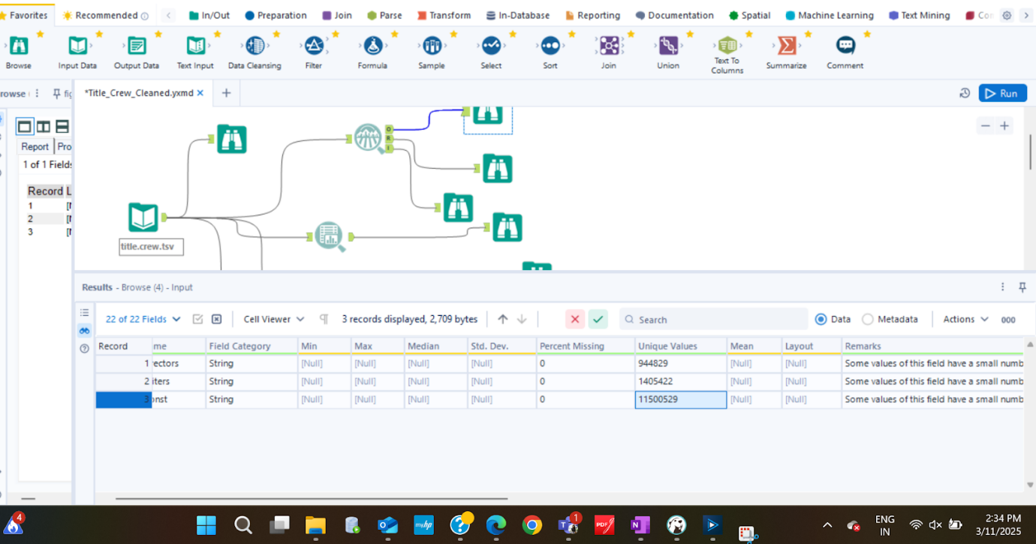

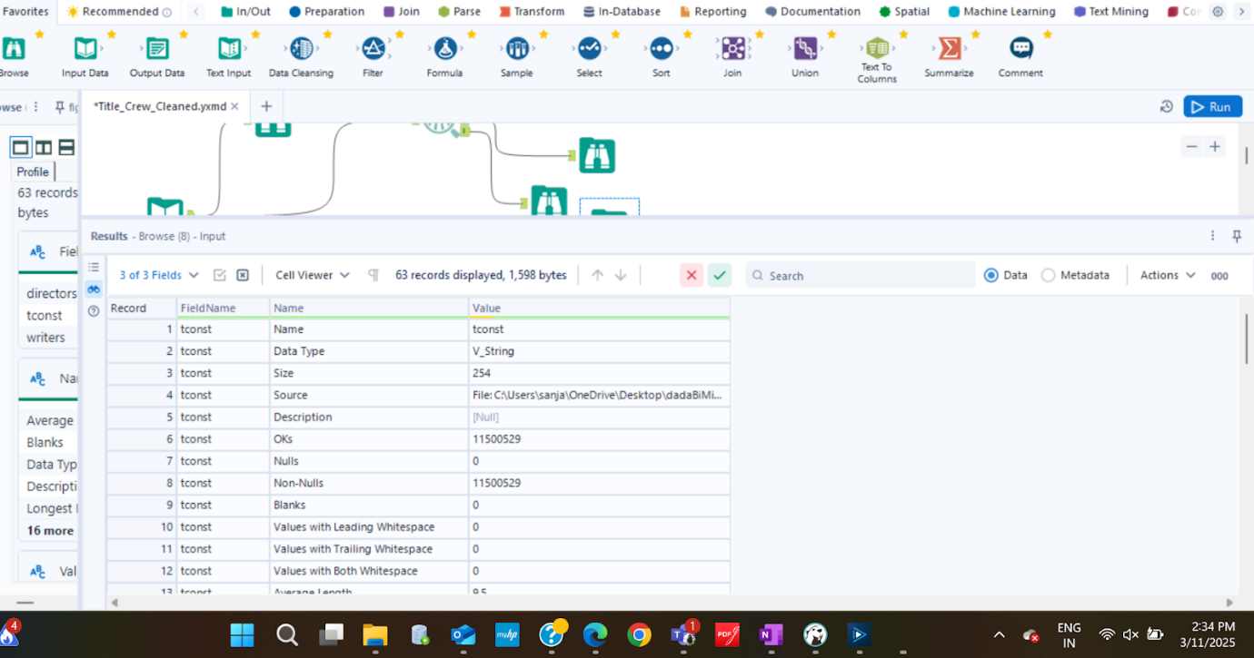

title.episodes.tsv:
Introduction
The title.episode.tsv.gz dataset is part of the IMDb Non-Commercial Datasets and provides episode-level details for TV series. It links individual episodes to their respective parent series, allowing for detailed analysis of season structures, episode counts, and TV show trends over time.
This dataset plays a crucial role in understanding television content by enabling business intelligence (BI) insights such as seasonal trends, episode distributions, audience preferences, and crew involvement across different TV series. The data is structured with unique identifiers for each episode and its corresponding parent TV series, along with season and episode numbers.
The dataset will be used in this project to:
- Track the number of episodes per season and series.
- Analyze the longevity and consistency of TV series.
- Integrate with other datasets (e.g., ratings, crew, and title details) to generate meaningful insights.
2. Dataset Description
The dataset consists of the following fields:
- tconst (String): Unique alphanumeric identifier for an episode.
- parentTconst (String): Unique alphanumeric identifier for the parent TV series.
- seasonNumber (Integer): The season number to which the episode belongs.
- episodeNumber (Integer): The episode number within the respective season.
3. Data Profiling Summary
The data profiling was conducted using Alteryx, and the key insights are as follows:
Field-Level Summary
Field Name | Data Type | Unique Values | Null % | Min Value | Max Value | Min Length | Max Length
tconst | String | 8,844,677 | 0% | tt0031458 | tt10001006 | 9 | 10
parentTconst | String | 217,152 | 0% | tt0041038 | tt32857063 | 9 | 10
seasonNumber | String | 320 | 0% | 1 | 1994 | 1 | 4
episodeNumber | String | 15,785 | 0% | 1 | 10312 | 1 | 5

Data Quality Assessment
Issue | Details (Including Percent Value) | Alteryx Action
Null Values | Some records contain \N in seasonNumber and episodeNumber. | Replace with NULL values to ensure consistency.
Data Type Issues | seasonNumber and episodeNumber are stored as strings. | Convert to Integer data type.
Low Frequency Values | Some fields have unique or rarely occurring values. | Consider grouping low-frequency values where appropriate.
Text Standardization | No leading or trailing whitespace issues detected. | Maintain consistent text formatting.

4. Data Cleaning & Transformation Plan
To ensure data quality and usability, the following steps will be implemented:
- Convert seasonNumber and episodeNumber to integer data types.
- Replace \N values with NULL to handle missing data properly.
- Ensure seasonNumber values are within a reasonable range (1 to a realistic maximum).
- Validate episodeNumber values against logical constraints.
- Consider grouping values with very low occurrences to improve analysis.
5. Data Transformation & Standardization
Transformation Type | Description
Handling Missing Data | Replace \N values with NULL where applicable.
Data Type Conversion | Convert seasonNumber and episodeNumber to integers.
Standardizing Text Fields | Ensure consistency in text formatting and eliminate inconsistencies.
Removing Duplicates | Identify and eliminate duplicate records.

title.ratings.tsv:
Introduction
The IMDb Ratings dataset provides user ratings and vote counts for a wide range of movies and TV shows. The dataset is crucial for understanding audience preferences, analyzing rating distributions, and conducting data-driven decision-making in the entertainment industry.
This report aims to profile, assess, clean, and transform the dataset to ensure high data quality and readiness for analysis.

2. Dataset Overview
The IMDb Ratings dataset contains 1,541,709 records and 3 columns, providing details about average user ratings and the number of votes received for various movie and TV show titles.
Dataset Structure
Column Name | Data Type | Description
tconst | String | Unique IMDb identifier for a title
averageRating | String | IMDb average rating (1-10 scale)
numVotes | String | Number of votes the title received

3. Data Profiling & Quality Assessment
Missing Values Check
- No missing values were found in any column.
- No \N placeholders were detected.
Data Type Issues
- averageRating & numVotes were initially stored as strings, which is incorrect.
- Solution: Convert averageRating to FLOAT, and numVotes to INTEGER.
Duplicate Records Check
- tconst is unique across all records.
- No duplicate records found.

Statistical Summary & Key Insights
Column | Min | Max | Mean | Standard Deviation
averageRating | 1.0 | 10.0 | ~6.9 | Moderate variance
numVotes | 1 | Millions | Few thousand | Highly skewed
- Right-skewed distribution: Most movies have low votes, while a few titles receive millions of votes.
- Outliers detected: Some titles have very few votes, which may not be reliable.

4. Field-Level Summary
Each column is analyzed for its distribution, uniqueness, and validity.
tconst (Unique Title Identifier)
- 100% unique values
- No null or duplicate values
- Used as the primary key for joining with other IMDb datasets.
averageRating (IMDb Rating: 1-10 Scale)
- Range: 1.0 - 10.0
- Mean rating ~6.9, indicating most movies are rated between 5.5 and 8.0.
- Outliers detected: Some titles have extreme ratings (1.0 or 10.0), which could indicate bias.
numVotes (Number of Votes per Title)
- Highly skewed distribution: Some movies have only a few votes, while blockbusters have millions.
- Outliers detected: Titles with fewer than 100 votes may not be reliable.

5. Data Quality Assessment
Quality Check | Assessment | Resolution
Missing Values | No missing values | No action needed
Incorrect Data Types | averageRating & numVotes as strings | Convert to float & integer
Duplicate Records | No duplicates found | No action needed
Outliers in numVotes | High variance in votes | Consider filtering movies with < 100 votes

6. Data Cleaning & Transformation Plan
Convert Data Types
- Convert averageRating String → FLOAT.
- Convert numVotes String → INTEGER.
Handle Outliers
- Low vote counts (numVotes < 10) may indicate unreliable ratings.
- Recommended Action: Filter out titles with fewer than 100 votes.
