Unsupervised Learning and Clustering Analysis
Customer Segmentation of Mall Shoppers Using K-Means and Hierarchical Clustering
Prepared by: Dhanya B K
B.E. — Artificial Intelligence and Machine Learning
Vivekananda College of Engineering and Technology, Puttur, Karnataka
Week 3 Task — Unsupervised Learning and Clustering Analysis

Contents
- 1. Objective
- 2. Dataset Selection & Description
- 3. Methodology Overview
- 4. Data Preprocessing
- 5. Determining the Optimal Number of Clusters
- 6. K-Means Clustering Implementation
- 7. Hierarchical Clustering (Comparison Method)
- 8. Cluster Visualization
- 9. Cluster Interpretation & Characteristics
- 10. Business Implications
- 11. Challenges Faced and How They Were Overcome
- 12. Conclusion

1. Objective
This report applies unsupervised learning — specifically clustering — to segment mall customers into distinct, meaningful groups based on their demographic and spending behavior. The goal is not just to run a clustering algorithm, but to justify every methodological choice (which features to use, how many clusters to form, which algorithm to apply) and to translate the resulting clusters into actionable business interpretations.
Two clustering techniques are implemented and compared: K-Means (the primary method) and Agglomerative Hierarchical Clustering (used as a validation/comparison method), both from scikit-learn / scipy.

2. Dataset Selection & Description
Dataset: Mall Customer Segmentation Data — 200 customer records, 5 columns.
Source: Public GitHub mirror — https://raw.githubusercontent.com/erkansirin78/datasets/master/Mall_Customers.csv (a widely used open dataset, originally shared for a Kaggle customer-segmentation tutorial).
Column | Description
CustomerID | Unique identifier for each customer
Gender | Male / Female
Age | Customer's age in years
AnnualIncome_k | Annual income, in thousands of dollars
SpendingScore | Score from 1–100 assigned by the mall based on customer spending behavior

Why this dataset?
- It is small and clean (200 rows, no missing values) — well suited to a focused clustering exercise rather than a data-cleaning exercise.
- It contains a genuine mix of demographic (Age, Gender) and behavioral (Income, Spending Score) variables, which is exactly the kind of data real businesses use for customer segmentation.
- It has no predefined labels — a true unsupervised learning setting, since 'Spending Score' is a behavioral score, not a segment label.

3. Methodology Overview
The analysis follows six stages: exploratory data analysis, feature preprocessing, determining the optimal number of clusters (via the Elbow Method and Silhouette Score), K-Means clustering, Hierarchical clustering as a comparison/validation method, and finally cluster visualization and interpretation.
import pandas as pd, numpy as np
from sklearn.preprocessing import StandardScaler
from sklearn.cluster import KMeans, AgglomerativeClustering
from sklearn.metrics import silhouette_score, silhouette_samples
from sklearn.decomposition import PCA
from scipy.cluster.hierarchy import dendrogram, linkage
Exploratory analysis (pairplot, distributions, correlation heatmap) confirmed that Income and Spending Score are the two variables that separate customers most distinctly, while Age varies fairly independently of both. This directly informed the feature selection decision in Section 4.
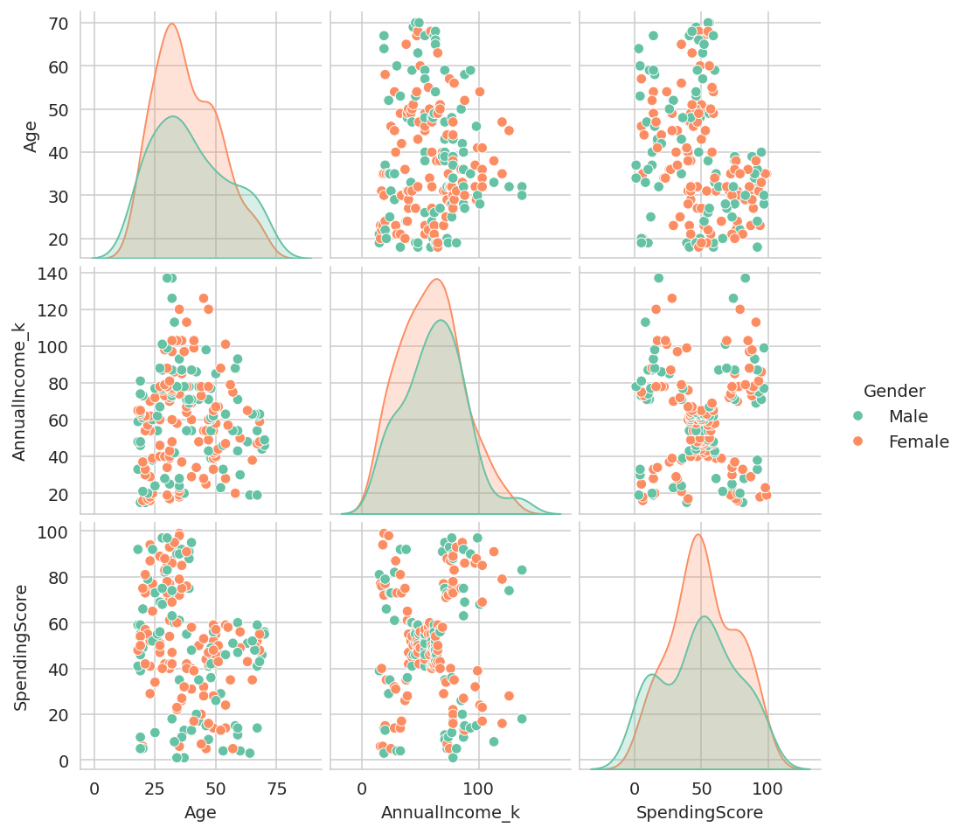
Figure 1 — Pairplot of Age, Annual Income, and Spending Score, colored by gender.
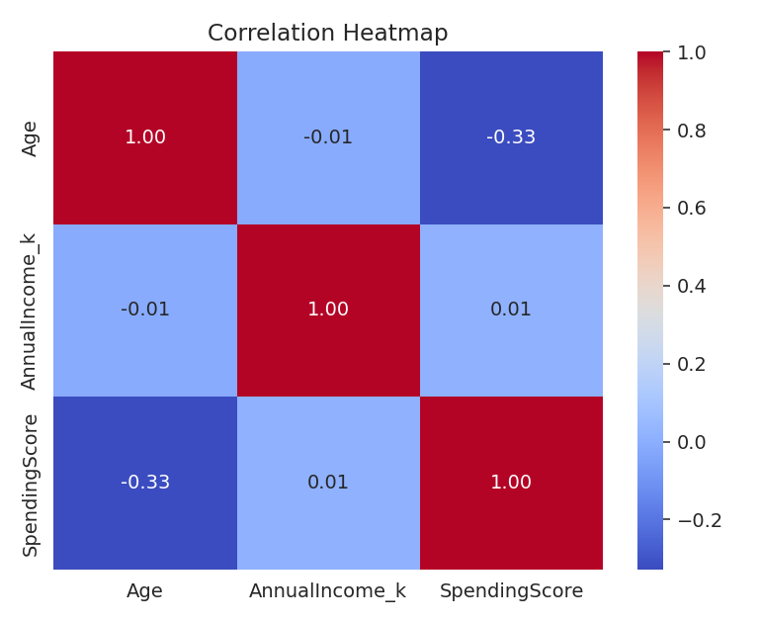
Figure 2 — Correlation heatmap: Income and Spending Score show negligible linear correlation with each other or with Age, meaning each variable adds independent information.

4. Data Preprocessing
No missing values, duplicate rows, or invalid entries were found in this dataset (verified via df.isnull().sum() and df.duplicated().sum()), so preprocessing focused on preparing features for distance-based clustering rather than data cleaning.

4.1 Feature selection
The primary clustering uses Annual Income and Spending Score. These two variables are what actually separate customers into distinct, actionable spending behaviors. Age was deliberately left out of the primary clustering and instead analyzed as an extended view (Section 8.3) — including it directly blurred the otherwise clean segmentation, since Age varies fairly independently of income and spending in this dataset (consistent with the near-zero correlations in Figure 2).

4.2 Feature scaling
K-Means and Hierarchical clustering are both distance-based algorithms, so features on different scales (Income in thousands of dollars vs. Spending Score from 1–100) would otherwise distort distance calculations. All features were standardized using StandardScaler (zero mean, unit variance) before clustering.
features = ['AnnualIncome_k', 'SpendingScore']
X = df[features].copy()

scaler = StandardScaler()
X_scaled = scaler.fit_transform(X)

5. Determining the Optimal Number of Clusters
Two complementary methods were used to choose K rather than picking a number arbitrarily: the Elbow Method (looking for the point of diminishing returns in within-cluster variance) and the Silhouette Score (a direct measure of how well-separated and internally cohesive the clusters are, ranging from -1 to 1).
inertias, sil_scores = [], []
for k in range(2, 11):
km = KMeans(n_clusters=k, init='k-means++', n_init=10, random_state=42)
labels = km.fit_predict(X_scaled)
inertias.append(km.inertia_)
sil_scores.append(silhouette_score(X_scaled, labels))
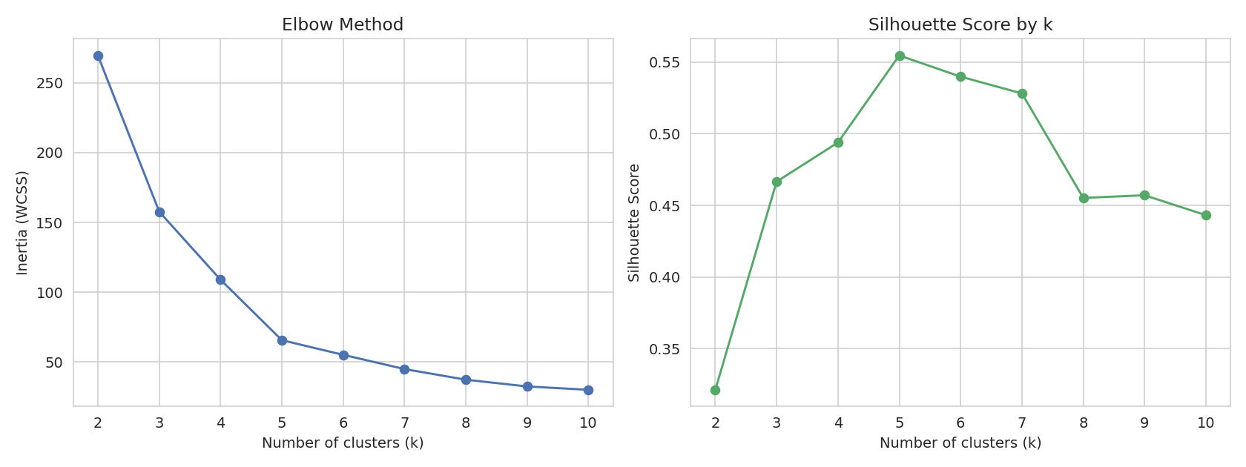
Figure 3 — Elbow Method (left) and Silhouette Score (right) across k = 2 to 10.
k | Inertia (WCSS) | Silhouette Score
2 | 269.69 | 0.321
3 | 157.70 | 0.467
4 | 108.92 | 0.494
5 | 65.57 | 0.555 (best)
6 | 55.06 | 0.540
7 | 44.86 | 0.528

Both methods agree clearly: the elbow in the WCSS curve occurs at k = 5, and the silhouette score peaks at k = 5 (0.555) before declining. K = 5 was therefore chosen for the main analysis — a decision backed by both a geometric heuristic (elbow) and a quantitative cluster-quality metric (silhouette), rather than either alone.

6. K-Means Clustering Implementation
K-Means was run with k = 5, the k-means++ initialization (which spreads initial centroids apart for more stable convergence), and 10 random restarts (n_init=10) to reduce sensitivity to initialization.
kmeans = KMeans(n_clusters=5, init='k-means++', n_init=10, random_state=42)
df['Cluster_KMeans'] = kmeans.fit_predict(X_scaled)

silhouette_score(X_scaled, df['Cluster_KMeans'])
# -> 0.555
A silhouette score of 0.555 indicates reasonably well-separated, cohesive clusters (scores above 0.5 are generally considered a good clustering structure). The per-cluster silhouette plot below confirms this holds consistently across all five clusters, not just on average.
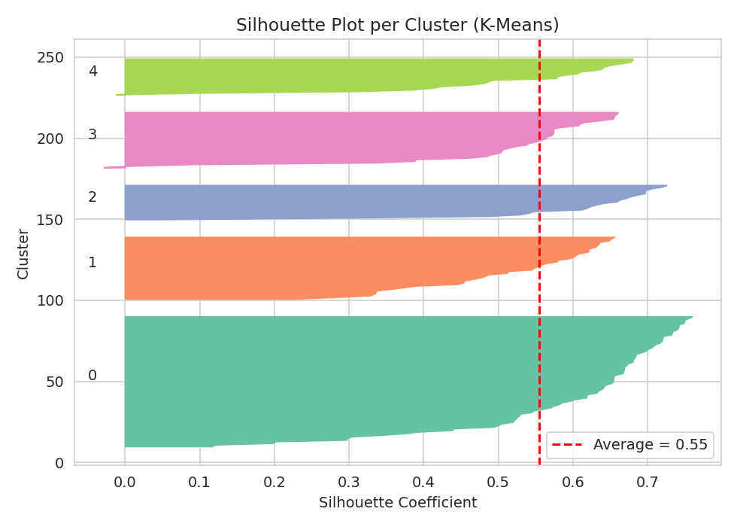
Figure 4 — Per-sample silhouette coefficients by cluster. All five clusters sit mostly above the average line (0.55) with few negative values, indicating few misclassified points.
Cluster | Size | % of Customers
0 | 81 | 40.5%
1 | 39 | 19.5%
2 | 22 | 11.0%
3 | 35 | 17.5%
4 | 23 | 11.5%

7. Hierarchical Clustering (Comparison Method)
As a second, independent method, Agglomerative Hierarchical Clustering with Ward linkage (which minimizes within-cluster variance at each merge, similar in spirit to K-Means) was applied to the same scaled features. This serves two purposes: validating that the 5-cluster structure is not an artifact of K-Means specifically, and visualizing the nested merge structure via a dendrogram.
linked = linkage(X_scaled, method='ward')

hc = AgglomerativeClustering(n_clusters=5, linkage='ward')
df['Cluster_Hierarchical'] = hc.fit_predict(X_scaled)

silhouette_score(X_scaled, df['Cluster_Hierarchical'])
# -> 0.554
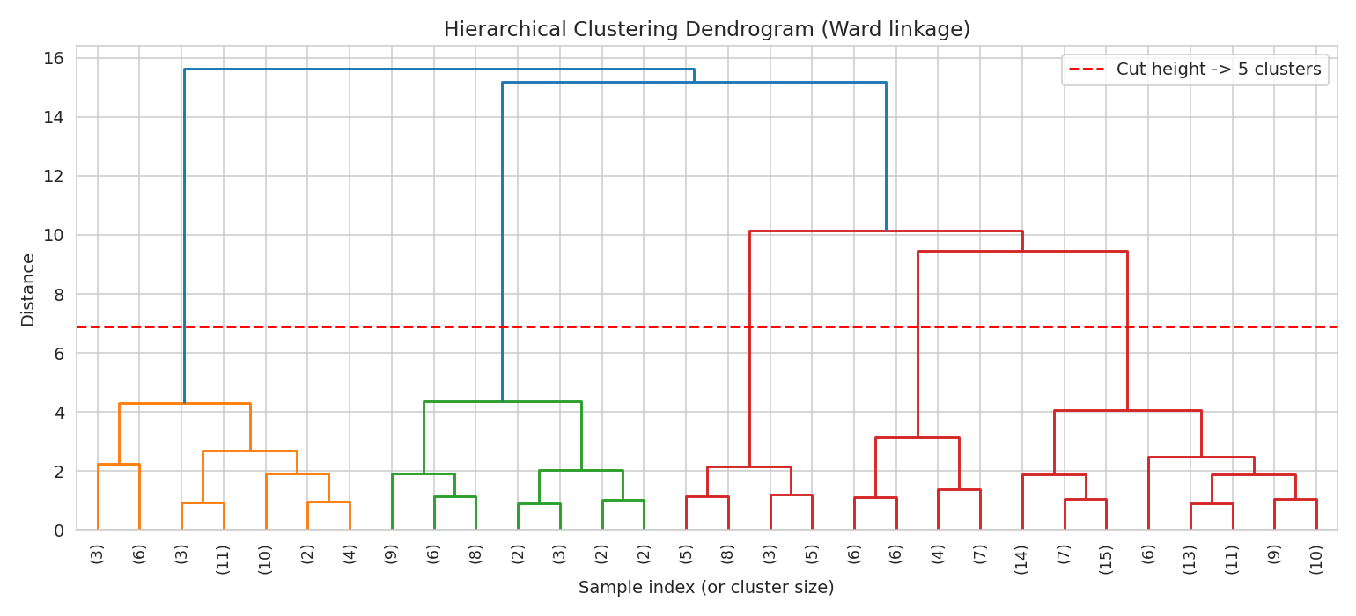
Figure 5 — Ward-linkage dendrogram. The dashed line marks the distance threshold that yields exactly 5 clusters, mirroring the K chosen for K-Means.
Hierarchical clustering achieved an almost identical silhouette score (0.554 vs. 0.555 for K-Means), and the dendrogram's natural merge structure supports 5 clusters at a sensible cut height — strong evidence that 5 is a genuine structural property of the data rather than an artifact of one particular algorithm. (Raw label agreement between the two methods is not meaningful to compare directly, since cluster ID numbers are assigned arbitrarily by each algorithm — what matters is that both achieve the same cluster count with comparable quality.)

8. Cluster Visualization

8.1 Income vs. Spending Score (primary view)
This is the clearest and most business-interpretable visualization, since it plots the two features actually used for clustering.
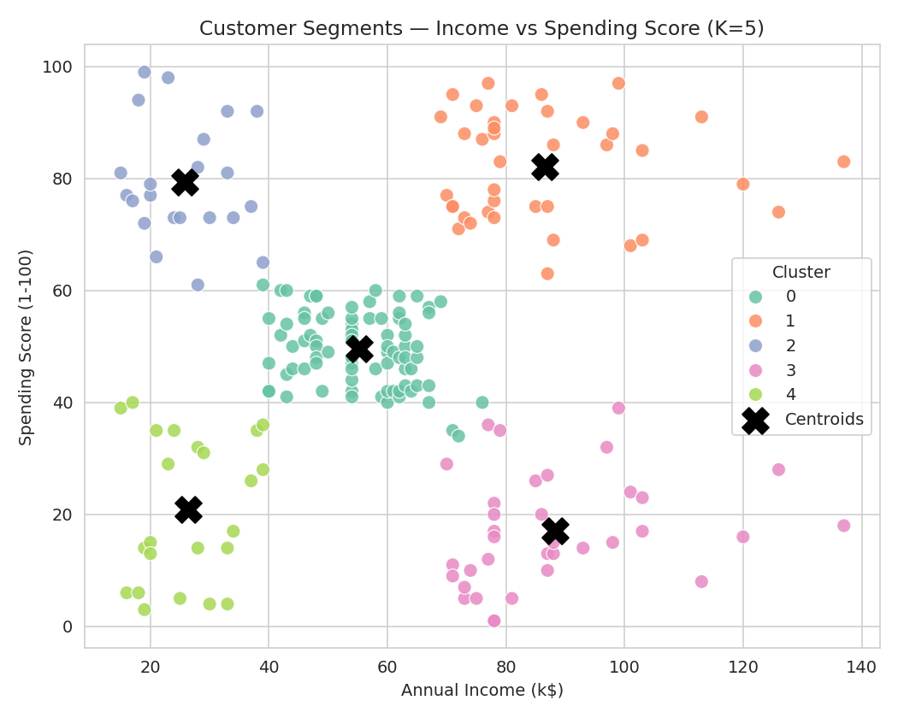
Figure 6 — The five customer segments in Income–Spending space, with centroids marked. The segmentation forms five visually distinct, well-separated groups.

8.2 All three numeric features
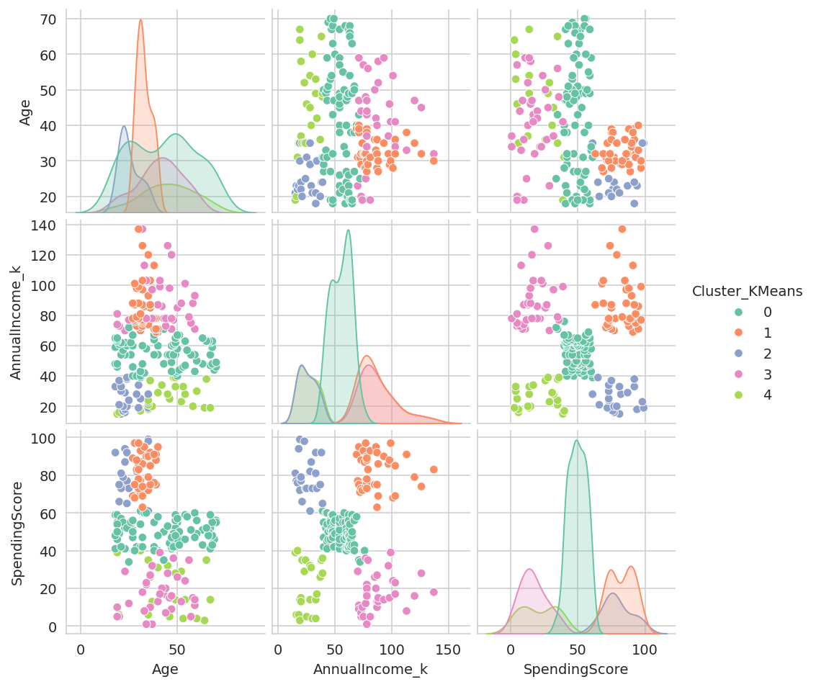
Figure 7 — Pairwise relationships between Age, Income, and Spending Score, colored by cluster.

8.3 Extended view with Age (PCA projection)
To check whether Age adds further separating structure, a PCA projection of all three standardized features (Age, Income, Spending Score) was plotted, still colored by the original Income/Spending-based cluster assignment.
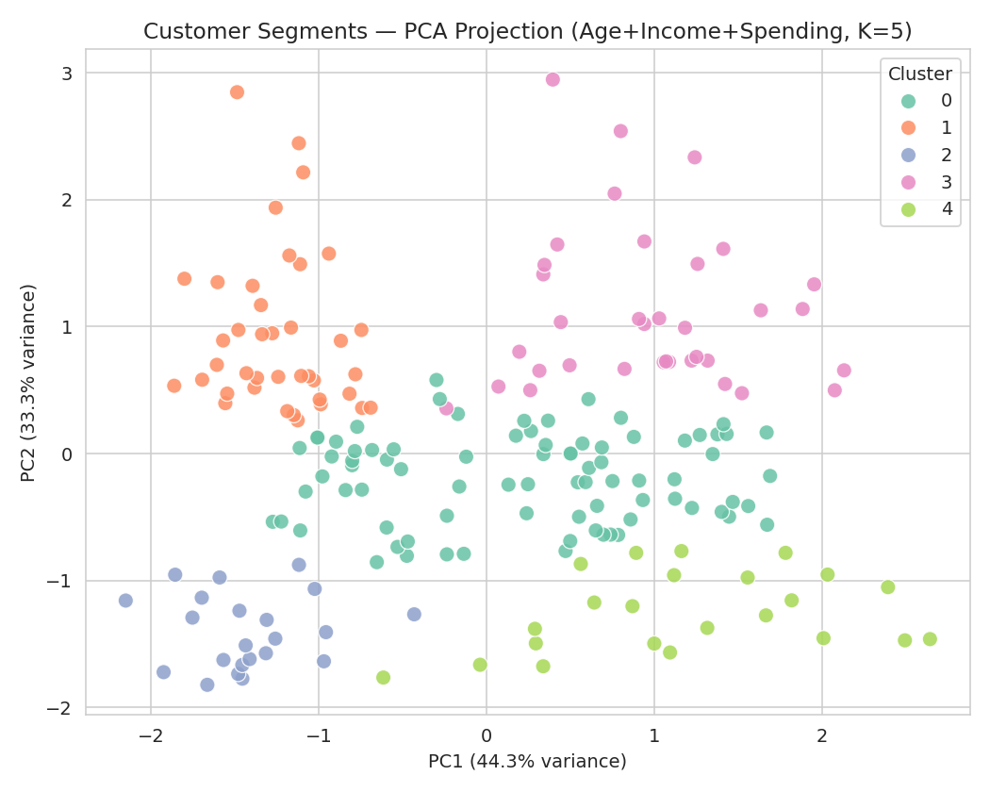
Figure 8 — PCA projection of Age + Income + Spending Score (77.6% of variance captured in 2 components), colored by the 5 clusters. The clusters remain visibly distinct even with Age reintroduced, and additionally separate somewhat along the Age-influenced axis (PC2).
The two principal components together explain 77.6% of the total variance (44.3% + 33.3%), and the clusters remain visually distinguishable — confirming that the Income/Spending-based segmentation is also broadly consistent with each group's age profile, not contradicted by it.

9. Cluster Interpretation & Characteristics
Each cluster's mean Age, Income, and Spending Score (Figure 9) was used to build a business-facing persona for each segment.
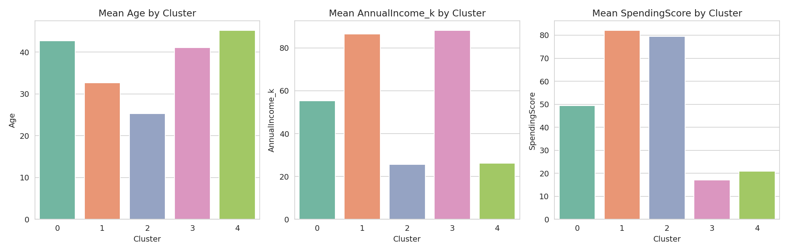
Figure 9 — Mean Age, Annual Income, and Spending Score by cluster.

Cluster 0 — "Average / Mainstream Customers" (81 customers, 40.5%)
Mid-range income (~$55k) and mid-range spending score (~50), average age ~43. The largest segment — a broad middle ground of customers who spend roughly in proportion to their income, without extreme behavior in either direction.

Cluster 1 — "High-Value Target Customers" (39 customers, 19.5%)
High income (~$87k) and high spending score (~82), relatively young (~33). These customers both can afford to spend and choose to — the most commercially valuable segment per capita.

Cluster 2 — "Young Aspirational Spenders" (22 customers, 11%)
Low income (~$26k) but high spending score (~79), the youngest segment (~25). These customers spend disproportionately to their income — likely students or early-career shoppers prioritizing discretionary spending.

Cluster 3 — "High Income, Low Engagement" (35 customers, 17.5%)
High income (~$88k) but low spending score (~17), middle-aged (~41). These customers can clearly afford to spend at the mall but currently choose not to — the segment with the largest untapped revenue potential.

Cluster 4 — "Budget-Conscious Customers" (23 customers, 11.5%)
Low income (~$26k) and low spending score (~21), the oldest segment (~45). Spending is consistent with limited income — a price-sensitive segment with little discretionary spending.
Gender composition was checked across all five clusters and found to be fairly balanced (roughly 46–61% female in every cluster, close to the dataset's overall 56% female / 44% male split) — gender does not appear to be a distinguishing factor in this segmentation, which is a useful negative finding in itself.

10. Business Implications

Cluster 1 (High-Value Target) — Retain and reward
- Loyalty programs, early access to sales, and premium services to protect this already-high-value relationship.
- Highest priority for personalized marketing given the highest return per customer.

Cluster 3 (High Income, Low Engagement) — Highest growth opportunity
- Investigate why spending is low despite high income — likely a competitor, a mismatch in product offering, or lack of awareness rather than inability to spend.
- Targeted re-engagement campaigns (e.g. personalized offers, premium product lines) could convert this segment toward Cluster 1's behavior.

Cluster 2 (Young Aspirational Spenders) — Nurture long-term value
- Currently high spenders despite lower income — a segment worth retaining as their income grows over time.
- Student/young-professional discounts or credit-based promotions could sustain engagement without relying on high current income.

Cluster 0 (Mainstream) — Volume-driven strategies
- The largest segment; broad promotions and general marketing campaigns are more cost-effective here than deep personalization.

Cluster 4 (Budget-Conscious) — Value-oriented offerings
- Focus on discount events, value bundles, and essential goods rather than premium marketing, which is unlikely to convert this segment.

11. Challenges Faced and How They Were Overcome

Challenge 1 — Deciding which features to cluster on
Initially, all three numeric features (Age, Income, Spending Score) were used together, but this blurred the otherwise clean segmentation structure (silhouette score dropped from 0.555 to 0.417) because Age varies fairly independently of the other two. This was resolved by clustering on Income and Spending Score directly — the two variables that actually drive the segmentation — and treating Age as a secondary, descriptive dimension analyzed afterward via PCA and cluster profiling rather than as a primary clustering input.

Challenge 2 — Choosing K objectively
Rather than picking a round number, two independent methods (Elbow Method and Silhouette Score) were used and cross-checked — both pointed clearly to k = 5, which added confidence that this was a genuine data pattern rather than an arbitrary choice.

Challenge 3 — Validating that clusters aren't algorithm-specific artifacts
K-Means makes a spherical-cluster assumption, so a second, differently-structured algorithm (Hierarchical clustering with Ward linkage) was run on the same data to confirm the 5-cluster structure holds regardless of algorithm choice — both achieved nearly identical silhouette scores (0.555 vs 0.554).

Challenge 4 — Setting an accurate dendrogram cut height
An initial dendrogram cut line was placed by visual estimate and did not cleanly separate exactly 5 branches. This was corrected by computing the cut height mathematically — as the midpoint between the merge distances that produce 5 versus 6 clusters — directly from the linkage matrix, rather than eyeballing it.

12. Conclusion
This task applied K-Means and Hierarchical clustering to segment 200 mall customers into five distinct, well-separated groups (silhouette score 0.555), using Annual Income and Spending Score as the primary clustering features and Age as a secondary descriptive dimension. Each cluster was translated into a business-relevant persona — from high-value target customers to an underserved, high-income-but-low-engagement segment — with concrete implications for marketing strategy. The consistency between K-Means and Hierarchical clustering results, together with the elbow and silhouette diagnostics, gives strong confidence that five is a genuine, data-driven segment count rather than an arbitrary modeling choice.

Deliverable files
File | Description
mall_customers.csv | Original raw dataset (200 × 5)
mall_customers_clustered.csv | Original data with K-Means and Hierarchical cluster labels, PCA coordinates
customer_segmentation_pipeline.py | Full Python pipeline: EDA, preprocessing, clustering, visualization

