Supervised Learning Model Implementation
Binary Classification of Breast Cancer Diagnosis Using Logistic Regression
Prepared by: Dhanya B K
B.E. — Artificial Intelligence and Machine Learning
Vivekananda College of Engineering and Technology, Puttur, Karnataka
Week 4 Task — Supervised Learning Model Implementation

Contents
- 1. Objective
- 2. Problem Definition & Dataset
- 3. Exploratory Data Analysis
- 4. Feature Engineering
- 5. Train/Test Split & Preprocessing
- 6. Model Selection via Cross-Validation
- 7. Hyperparameter Tuning
- 8. Final Model Evaluation
- 9. Feature Importance & Interpretability
- 10. Strengths and Limitations
- 11. Possible Improvements
- 12. Conclusion

1. Objective
This report designs, implements, and evaluates a supervised learning classification model on a publicly available medical dataset. The goal is to predict whether a breast tumor is malignant or benign from digitized measurements of cell nuclei, while documenting and justifying every step of the process — problem framing, feature engineering, model selection, validation, and evaluation — rather than treating model-building as a single black-box step.
A classification problem was chosen over regression because the target variable (diagnosis) is categorical, and because classification performance metrics (precision, recall, ROC-AUC) map naturally onto a real decision-making context: minimizing missed malignant diagnoses matters more than raw accuracy alone.

2. Problem Definition & Dataset
Problem: Binary classification — predict whether a breast mass is malignant (cancerous) or benign (non-cancerous) from measurements computed from a digitized image of a fine needle aspirate (FNA) of the mass.
Dataset: Breast Cancer Wisconsin (Diagnostic) Dataset — 569 samples, 30 numeric features, sourced from the UCI Machine Learning Repository (accessed via scikit-learn's built-in loader, which bundles this well-known public dataset directly).
Property | Value
Samples | 569
Raw features | 30 (10 measurements x 3 statistics: mean, standard error, worst)
Target classes | Malignant (212, 37.3%) / Benign (357, 62.7%)
Missing values | 0
Duplicate rows | 0

The 30 features are derived from 10 base measurements of cell nuclei (radius, texture, perimeter, area, smoothness, compactness, concavity, concave points, symmetry, fractal dimension), each reported as a mean, standard error, and 'worst' (largest) value — a structure that directly shapes the feature-engineering decisions in Section 4.
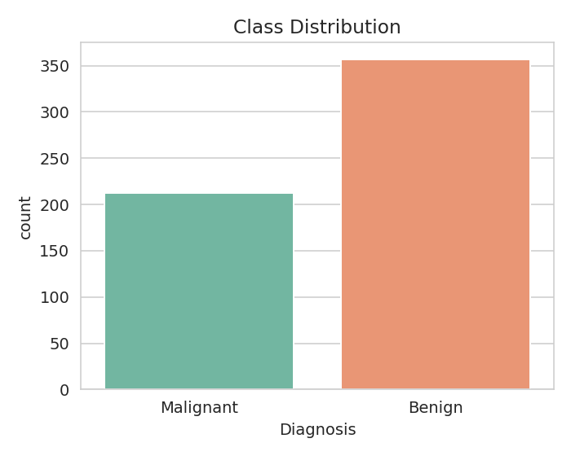
Figure 1 — Class distribution: moderately imbalanced (63% benign / 37% malignant), addressed via stratified splitting (Section 5) rather than resampling.

3. Exploratory Data Analysis
Before modeling, the distributions of key features were compared across the two classes to check whether they carry separating signal.
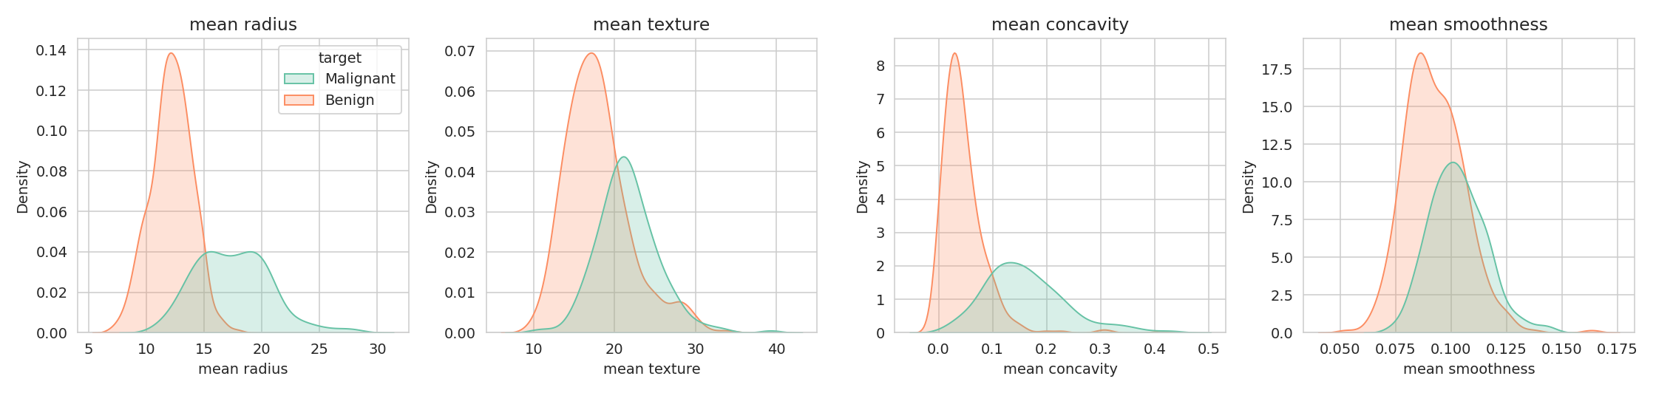
Figure 2 — Distributions of four representative features, split by diagnosis. Malignant tumors show a clear rightward shift in radius and concavity — a strong early signal that these features will matter to the model.
This early visual check already shows that malignant and benign cases separate reasonably well on several individual features, which is a good sign that a relatively simple, interpretable model may perform competitively against more complex alternatives.

4. Feature Engineering

4.1 Redundancy removal via correlation analysis
Because each of the 10 base measurements is reported in 3 related forms (mean, error, worst), several feature pairs are near-duplicates by construction — for example, 'mean radius', 'mean perimeter', and 'mean area' all describe the same underlying property (tumor size) and are almost perfectly correlated. This redundancy adds no new information but can destabilize coefficient-based models. A correlation matrix was computed, and one feature from every pair with |correlation| > 0.95 was dropped.
corr_matrix = X_full.corr().abs()
upper = corr_matrix.where(
np.triu(np.ones(corr_matrix.shape), k=1).astype(bool))
to_drop = [col for col in upper.columns if any(upper[col] > 0.95)]
# -> ['mean perimeter', 'mean area', 'perimeter error', 'area error',
# 'worst radius', 'worst perimeter', 'worst area']
X_reduced = X_full.drop(columns=to_drop)
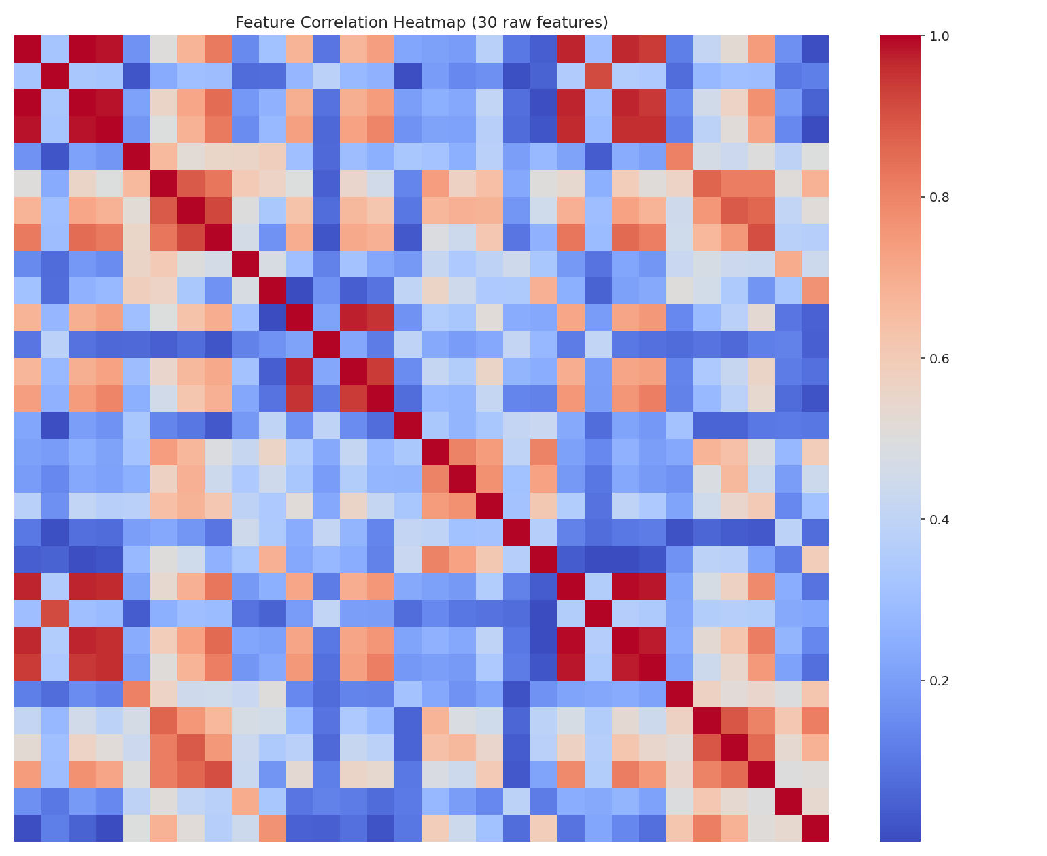
Figure 3 — Correlation heatmap of all 30 raw features. The bright red blocks show the highly redundant size-related feature groups that were pruned.
This step reduced the feature count from 30 to 23, removing redundancy without losing information (each dropped feature has a near-perfect substitute remaining in the set).

4.2 Engineered feature: concavity-to-size ratio
A new feature, concavity_to_radius_worst, was engineered as the ratio of worst concavity to worst radius. The rationale: a small tumor with highly irregular (concave) borders may be clinically different from a large tumor with the same absolute concavity — the ratio captures shape irregularity independent of overall size, which the raw features do not directly express.
X_reduced['concavity_to_radius_worst'] = (
df['worst concavity'] / (df['worst radius'] + 1e-6)
)
Final feature set: 24 features (23 retained originals + 1 engineered ratio).

5. Train/Test Split & Preprocessing
The data was split 80/20 into training and test sets, using stratified sampling on the target to preserve the same class balance (roughly 63/37) in both sets — important given the moderate class imbalance.
X_train, X_test, y_train, y_test = train_test_split(
X_reduced, y, test_size=0.2, stratify=y, random_state=42)

scaler = StandardScaler()
X_train_scaled = scaler.fit_transform(X_train)
X_test_scaled = scaler.transform(X_test) # transform only — no leakage
Features were standardized (zero mean, unit variance) using StandardScaler, fitted only on the training set and then applied to the test set — fitting on the full dataset before splitting would leak test-set statistics into training, inflating apparent performance.
Split | Samples | Malignant % | Benign %
Train | 455 | 37.4% | 62.6%
Test | 114 | 36.8% | 63.2%

6. Model Selection via Cross-Validation
Three model families, spanning different algorithmic approaches, were compared using 5-fold stratified cross-validation on the training set: Logistic Regression (linear, highly interpretable), Random Forest (non-linear, ensemble of trees), and Support Vector Machine with an RBF kernel (non-linear, margin-based).
models = {
'Logistic Regression': LogisticRegression(max_iter=5000),
'Random Forest': RandomForestClassifier(n_estimators=200),
'SVM (RBF kernel)': SVC(kernel='rbf', probability=True),
}
cv = StratifiedKFold(n_splits=5, shuffle=True, random_state=42)
scoring = ['accuracy','precision','recall','f1','roc_auc']

for name, model in models.items():
scores = cross_validate(model, X_train_scaled, y_train,
cv=cv, scoring=scoring)
Model | Accuracy | Precision | Recall | F1 | ROC-AUC
Logistic Regression | 0.9714 | 0.9731 | 0.9825 | 0.9775 | 0.9950
Random Forest | 0.9495 | 0.9490 | 0.9719 | 0.9602 | 0.9903
SVM (RBF kernel) | 0.9692 | 0.9723 | 0.9789 | 0.9756 | 0.9942

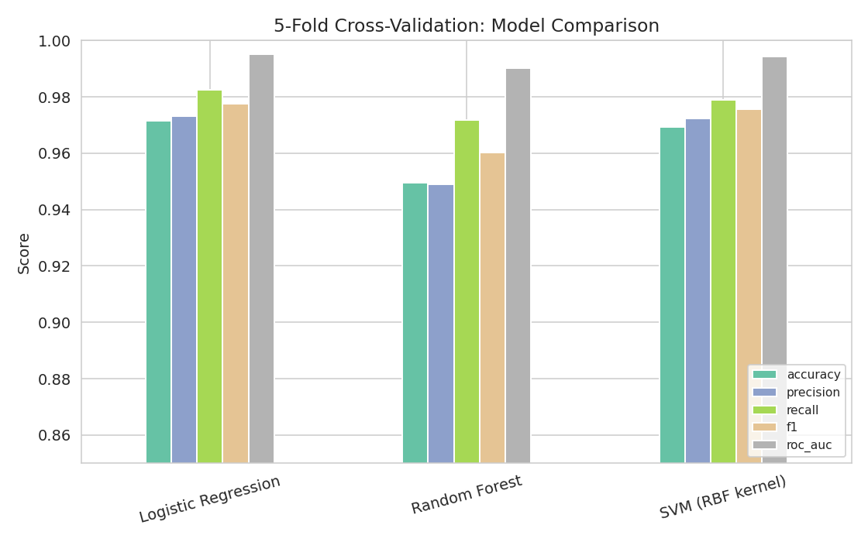
Figure 4 — 5-fold cross-validation scores across all three candidate models. Logistic Regression is at or near the top on every metric.
Logistic Regression achieved the best or near-best cross-validated score on every metric, including the highest ROC-AUC (0.995). This was a genuinely useful result: the simplest, most interpretable model was not a compromise choice here — it was also the best-performing one, which is not guaranteed to happen in practice but strengthens the case for choosing it.

7. Hyperparameter Tuning
Logistic Regression was selected for tuning and final deployment for two combined reasons: its cross-validated performance matched or exceeded the alternatives, and its coefficients are directly interpretable — a meaningful advantage in a medical-diagnosis context, where a clinician needs to understand why a model flagged a case, not just trust a black-box output.
A grid search over the regularization strength C was performed, optimizing for F1 score (a balanced metric given the class imbalance) via the same 5-fold stratified cross-validation.
param_grid = {'C': [0.01, 0.1, 0.5, 1, 5, 10, 50]}
grid = GridSearchCV(LogisticRegression(max_iter=5000),
param_grid, cv=cv, scoring='f1', n_jobs=-1)
grid.fit(X_train_scaled, y_train)
# Best params: {'C': 1}
# Best CV F1 score: 0.9775
The default regularization strength (C=1) was confirmed as optimal — neither stronger nor weaker regularization improved cross-validated F1 score, suggesting the model is neither over- nor under-regularized for this feature set.

8. Final Model Evaluation
The tuned model was evaluated once on the held-out test set (which played no role in feature selection, training, or hyperparameter tuning).
Metric | Test Score
Accuracy | 0.9737
Precision | 0.9859
Recall | 0.9722
F1 Score | 0.9790
ROC-AUC | 0.9940

Train accuracy was 0.9846 versus test accuracy of 0.9737 — a gap of only 0.011, indicating the model generalizes well and is not meaningfully overfitting the training data.
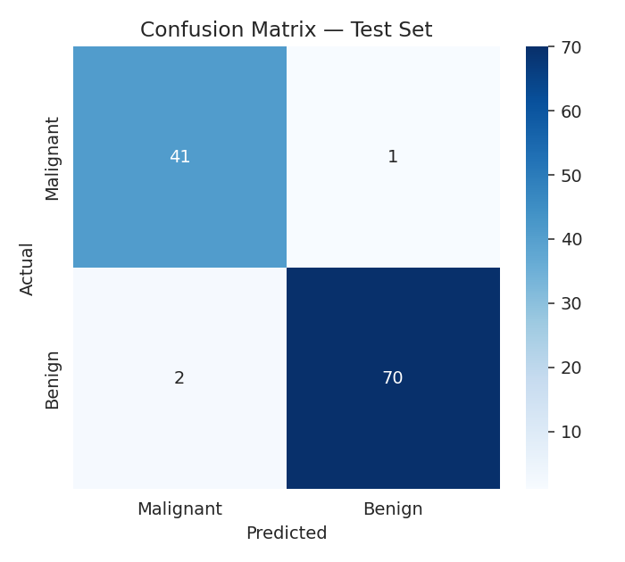
Figure 5 — Confusion matrix on the test set: 41/42 malignant cases correctly identified, 70/72 benign cases correctly identified.
Of the 114 test cases, only 3 were misclassified: 1 malignant case predicted as benign (a false negative) and 2 benign cases predicted as malignant (false positives). In a diagnostic setting, false negatives are the more costly error type (a missed cancer diagnosis), and the model's recall on the malignant class was 0.98 — it missed only one malignant case out of 42.
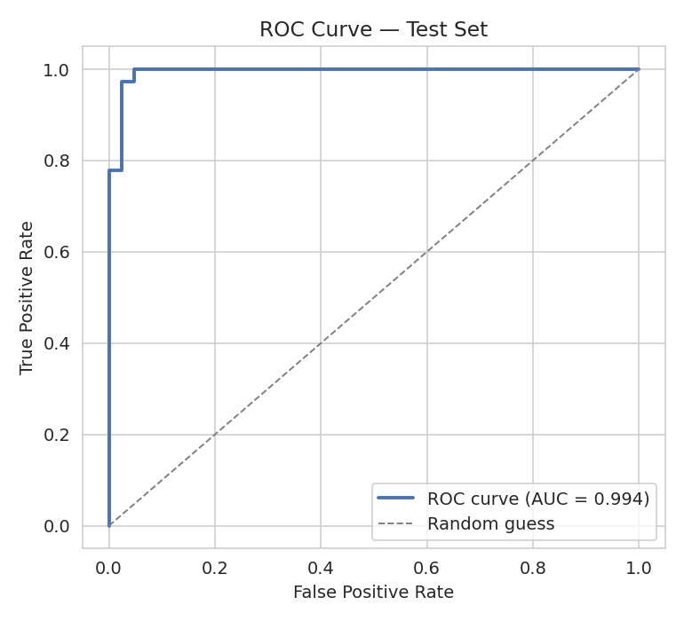
Figure 6 — ROC curve on the test set (AUC = 0.994), showing the model separates the two classes almost perfectly across all decision thresholds.

9. Feature Importance & Interpretability
Because Logistic Regression was the final model, its coefficients (on standardized features) directly indicate both the direction and relative strength of each feature's influence on the prediction.
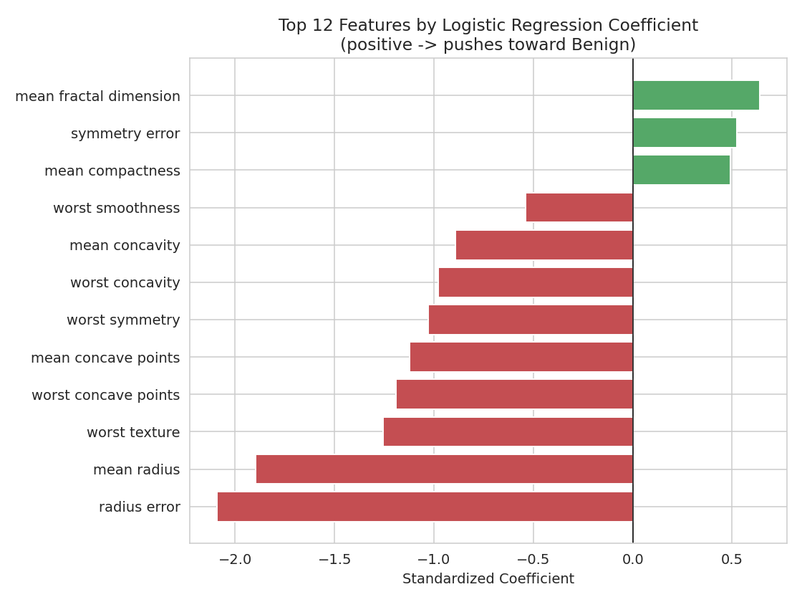
Figure 7 — Top 12 features by standardized coefficient magnitude. Negative coefficients push toward Malignant; positive coefficients push toward Benign (the model's positive class).
Radius error and mean radius carry the strongest influence, both negative — larger and more variable tumor size strongly pushes the prediction toward malignant, which matches clinical intuition (larger, less uniform masses are more concerning). Concavity- and concave-point-related features also contribute strongly in the same direction, reflecting that irregular, non-smooth tumor borders are a hallmark of malignancy. This alignment between statistical importance and known clinical reasoning is a strong sign the model has learned genuine signal rather than dataset artifacts.

10. Strengths and Limitations

Strengths
- Very high discriminative performance (ROC-AUC 0.994) with a simple, fully interpretable linear model — no complexity trade-off was needed.
- Small train/test performance gap (1.1 percentage points) indicates good generalization, not memorization of the training set.
- Feature engineering (redundancy removal) makes the model's coefficients more stable and easier to interpret, since collinear features no longer compete for weight.
- Coefficient signs and magnitudes align with established clinical knowledge about tumor malignancy indicators, adding confidence beyond the raw metrics.

Limitations
- The dataset is moderately small (569 samples) and drawn from a single imaging source/institution; performance on data from different hospitals, scanners, or populations is not verified here and would require external validation.
- Class imbalance (63/37) was handled via stratified splitting but not via reweighting or resampling; on a more imbalanced dataset this could understate the importance of the minority (malignant) class.
- The single false negative in the test set, while statistically minor (2.4% of malignant cases), represents the highest-stakes error type in a real diagnostic pipeline and would need a human-in-the-loop safety net before any clinical deployment.
- Logistic Regression assumes a linear decision boundary in the (standardized) feature space; although it performed best here, this may not generalize to datasets with more complex, non-linear class boundaries.

11. Possible Improvements
- Collect or source external validation data from a different institution to test generalization beyond this single dataset.
- Explore class-weighted or cost-sensitive variants of Logistic Regression that explicitly penalize false negatives more heavily than false positives, given the asymmetric real-world cost of a missed malignant diagnosis.
- Apply feature selection techniques beyond simple correlation pruning (e.g. recursive feature elimination or L1-regularized logistic regression) to test whether an even smaller, equally predictive feature set exists.
- Report confidence intervals (e.g. via bootstrapping) around the test-set metrics, since a single 114-sample test set gives a noisy point estimate of true generalization performance.
- Calibrate predicted probabilities (e.g. via Platt scaling) if the model's output probabilities — not just class labels — are intended to inform clinical decision thresholds.

12. Conclusion
This task implemented a complete supervised learning pipeline for breast cancer diagnosis classification: correlation-based feature engineering reduced 30 features to a leaner, less redundant set of 24; three candidate model families were compared via 5-fold cross-validation; Logistic Regression was selected based on both top-tier cross-validated performance and interpretability; and the tuned model achieved 97.4% test accuracy and 0.994 ROC-AUC, with coefficients that align with established clinical understanding of malignancy indicators. The small train-test performance gap and the alignment between statistical and clinical interpretation both support that the model has learned genuine, generalizable signal rather than overfitting to this particular dataset — while the limitations discussed above (single-source data, one false negative in testing) make clear that further validation would be required before any real diagnostic use.

Deliverable files
File | Description
breast_cancer.csv | Original dataset (569 x 31, UCI Breast Cancer Wisconsin)
test_predictions.csv | Test-set predictions with predicted probabilities
breast_cancer_pipeline.py | Full Python pipeline: EDA, feature engineering, modeling, evaluation

