SE Lab 5: Static Code Analysis
Supplier Orders Application

1. Objective
The objective of this lab is to analyze a Python supplier-order program using static-analysis tools, identify code-quality and security concerns, correct the issues, and compare the before-and-after results.

2. Tools Used
- Pylint — checks Python code quality, naming, documentation, and common programming issues.
- Flake8 — checks style and formatting issues.
- Bandit — scans Python code for common security problems.
- Git and GitHub — track and publish code changes.

3. Issues Identified and Corrections
The initial analysis identified missing module/function documentation, non-snake_case function names, use of global state, a parameter that was not used, long lines, whitespace/indentation problems, and security-related concerns in the original implementation.
The code was revised by adding docstrings, using snake_case names, creating the SQLite connection within the main workflow and passing it to functions, removing the global order-total variable, removing the unused remarks parameter, splitting long SQL statements, and correcting whitespace. SQL statements use parameter placeholders, and the unsafe shell-command use was removed.

4. Final Verification
Observed program output:
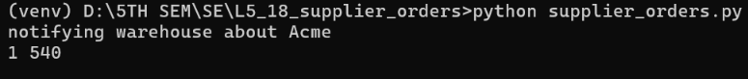

5. Conclusion
Static analysis helped improve maintainability, consistency, and security of the supplier-order program. The final version achieved a Pylint score of 10.00/10, produced no Flake8 errors, and had no issues identified by the final Bandit scan. The application was executed to confirm that the expected output remained correct. The before-and-after tool reports and issue spreadsheet should be submitted together in the Lab5 folder.

Submission note: Review the report against your instructor's exact template and fill in any required student details or course-specific headings before submission.

