23CSE202 DATABASE MANAGEMENT SYSTEMS
S3 B.Tech CSE
Department of Computer Science and Engineering
Amrita School of Computing, Amritapuri Campus
PROJECT REPORT
Group No: B7
Team Members:
Roll No | Student Name
AM.SC.U4CSE25115 | Dhanya Krishna
AM.SC.U4CSE25114 | Devika B
AM.SC.U4CSE25130 | Lakshmi V S
Project Title:
FoodExpress – An Online Food Delivery and Restaurant Management System
GitHub Repository:
https://github.com/Dhanya-Krishna/DBMS-Project

CONTENTS
Sl. No | Chapter | Page No
1 | Abstract
2 | Introduction
3 | Requirements (Functional & Non-functional)
4 | UI Design
5 | Database Design
6 | Database Selection & Justification
7 | Implementation
8 | Testing & Validation
9 | Results & Screenshots
10 | Challenges Faced & Solutions
11 | Conclusion & Future Enhancements
 | References

1. Abstract
This project proposes FoodExpress, an Online Food Delivery and Restaurant Management System designed to provide a centralized database for managing all major operations involved in food ordering and delivery. The primary objective is to design a normalized relational database capable of handling multiple users, restaurants, delivery agents, and customer transactions while ensuring data consistency, integrity, and efficient retrieval. The system serves three major stakeholders: customers, restaurant partners, and delivery personnel. Customers can browse restaurants, search for food items, place orders, make payments, and track deliveries. Restaurant owners can manage menus, pricing, availability, and incoming orders. Delivery agents receive delivery assignments, update delivery status, and complete deliveries.
The proposed database consists of interconnected entities such as Customers, Restaurants, Food Items (MenuItem), Cuisines, Orders, Order Items, Payments, Delivery Partners, Reviews, Addresses, Combined Order. These entities are linked using primary keys and foreign keys to maintain referential integrity and eliminate redundancy through normalization up to BCNF. Major functionalities include customer registration and authentication, restaurant and menu management, multi-restaurant cart and checkout, payment recording, order tracking, delivery allocation, customer feedback, and analytics. The system is implemented using a PostgreSQL database hosted on Supabase, with a responsive multi-role web frontend built in HTML, CSS, Bootstrap, and vanilla JavaScript. The project demonstrates practical application of ER modeling, normalization, relational schema design, constraints, and SQL query processing in a realistic multi-stakeholder food delivery domain.

2. Introduction

2.1 Problem Domain and Background
The food delivery industry has grown rapidly with the proliferation of smartphones and on-demand services. Platforms such as Swiggy, Zomato, and Uber Eats rely on robust database systems to coordinate customers, restaurants, and delivery partners in real time. For educational purposes, building a scaled-down yet functionally complete food delivery system provides an excellent opportunity to apply database design principles to a complex, multi-entity domain with concurrent operations, status workflows, and analytical reporting.
In many local or small-scale settings, restaurants still manage orders through phone calls, paper notes, or simple spreadsheets. This leads to lost orders, incorrect pricing, difficulty tracking delivery status, lack of historical data for business decisions, and poor customer experience. A centralized database-driven application addresses these pain points by providing a single source of truth for menus, orders, payments, and delivery assignments.

2.2 Existing Scenario and Limitations
Traditional order management approaches suffer from several limitations:
- Manual order taking is error-prone and does not scale.
- No real-time visibility of order status for customers or restaurants.
- Difficulty in maintaining consistent menu and pricing data across channels.
- Lack of structured feedback and rating systems.
- Absence of integrated analytics (top-selling items, revenue trends, delivery performance).
- Separate systems for customers, restaurants, and delivery partners lead to data silos and inconsistency.

2.3 Proposed System
FoodExpress is a multi-role online food delivery platform built around a shared PostgreSQL database (Supabase). It supports:
- Customers: registration/login, browsing restaurants and menus, multi-restaurant cart, checkout with optional merge of orders, payment, order tracking, profile and address management, and reviews.
- Restaurant partners: login, view and update order statuses (Accept → Mark Ready), manage menu items, and view basic analytics.
- Delivery partners: login, accept delivery jobs, update status (Pick Up → Delivered), and view history/earnings.
The system demonstrates a normalized relational schema, referential integrity, multi-table transactions at checkout, and live data sharing across all three roles from a single cloud database. The frontend is a static web application that talks directly to Supabase via the JavaScript client, eliminating the need for a custom application server for this project scope.

3. Requirements (Functional & Non-functional)

3.1 Functional Requirements

User and Account Management
- Customer registration with name, email, phone, and password; login and session handling.
- Customer profile viewing and updating; multiple delivery addresses with default flag.
- Restaurant partner and delivery partner login using demo credentials.

Restaurant and Menu Management
- List restaurants with ratings, cuisine tags, and images loaded from the database.
- Display menu items (name, description, price, category, vegetarian flag, availability, image) filtered by restaurant.
- Restaurant partner can view and manage their menu and incoming orders.

Order Processing
- Add/remove items to a client-side cart (localStorage); support items from multiple restaurants.
- Checkout creates CombinedOrder, one or more Order rows, OrderItem rows, and Payment records.
- Merge of multi-restaurant cart into a single combined delivery (higher delivery fee).
- Order status workflow: Placed → Confirmed/Accepted → Preparing → Ready → Out for Delivery → Delivered (and Cancelled).

Delivery and Feedback
- Delivery partners see available jobs, accept them, and update status through pickup and delivery.
- Customers can track order status and view past orders.
- Customers can leave ratings and reviews for restaurants after delivery.

Reporting and Insights
- SQL-based analytics: top-selling items, most active customers, restaurant revenue, daily revenue, pending deliveries.

3.2 Non-functional Requirements
- Performance: Query responses for menu and order lists should complete within acceptable interactive times (typically under 1–2 seconds under normal load).
- Security: Password storage as hashes; use of parameterized queries via Supabase client to avoid SQL injection; demo mode may disable RLS for evaluation.
- Reliability & Data Integrity: Primary keys, foreign keys, NOT NULL and UNIQUE constraints, and transactional writes at checkout to keep CombinedOrder, Order, OrderItem, and Payment consistent.
- Usability: Responsive layout (desktop and mobile), clear navigation for three roles, consistent editorial visual design.
- Scalability: Schema designed for growth in restaurants, menu items, and orders; PostgreSQL and Supabase support horizontal scaling and connection pooling.
- Maintainability: Clear separation of HTML pages, shared CSS, and modular JS (db.js, cart.js, supabaseClient.js).

4. UI Design

4.1 Design Theme and Navigation Flow
The interface follows an editorial hospitality style inspired by refined restaurant websites. Display typography uses Cormorant Garamond; body text uses Outfit. The color palette uses warm paper backgrounds (#FAF9F7 / #F5F2EC), dark ink (#1C1917), and a terracotta accent (#9A3412). The design emphasizes photo-forward heroes, minimal chrome, and soft motion (Ken Burns, scroll reveal).
High-level navigation flow:
- Public landing (index.html) → Login / Register.
- Logged-in customer: Home → Restaurants → Menu → Cart → Checkout → Order Tracking / Profile.
- Restaurant partner: Restaurant Login → Dashboard (Orders, My Menu, Analytics).
- Delivery partner: Delivery Login → Dashboard (Available jobs, Active deliveries, History, Earnings).

4.2 Important Screens

Customer-facing
- index.html – Fullscreen hero, categories, featured restaurants, call-to-action.
- login.html / register.html – Customer authentication; registration writes to the customer table.
- home.html – Logged-in home with search banner.
- restaurants.html – Dynamic list of restaurants from Supabase.
- menu.html – Menu items with images; add-to-cart.
- cart.html – Cart managed in localStorage until checkout.
- checkout.html – Places real orders into CombinedOrder, orders, orderitem, and payment.
- order_tracking.html – Track current order status.
- profile.html – Profile and past orders from the database.

Partner-facing
- restaurant_login.html / restaurant_dashboard.html – Accept orders, mark ready, menu and analytics.
- delivery_login.html / delivery_dashboard.html – Accept jobs, pick up, mark delivered, history and earnings.

4.3 User Interaction Summary
Customers interact primarily through browse–cart–checkout. Restaurant partners act on a queue of incoming orders and update status. Delivery partners claim jobs and progress them to delivered. All roles read and write the same PostgreSQL tables, so changes appear across dashboards without a separate messaging layer. The cart remains client-side until checkout, at which point a multi-table write creates the persistent order structure.
List of main project files:
- HTML: index, login, register, home, restaurants, menu, cart, checkout, order_tracking, profile, restaurant_login, restaurant_dashboard, delivery_login, delivery_dashboard.
- CSS: style.css, dashboard.css, responsive.css.
- JS: supabaseClient.js, db.js, cart.js, script.js.

Database Design

5.1 ER Diagram

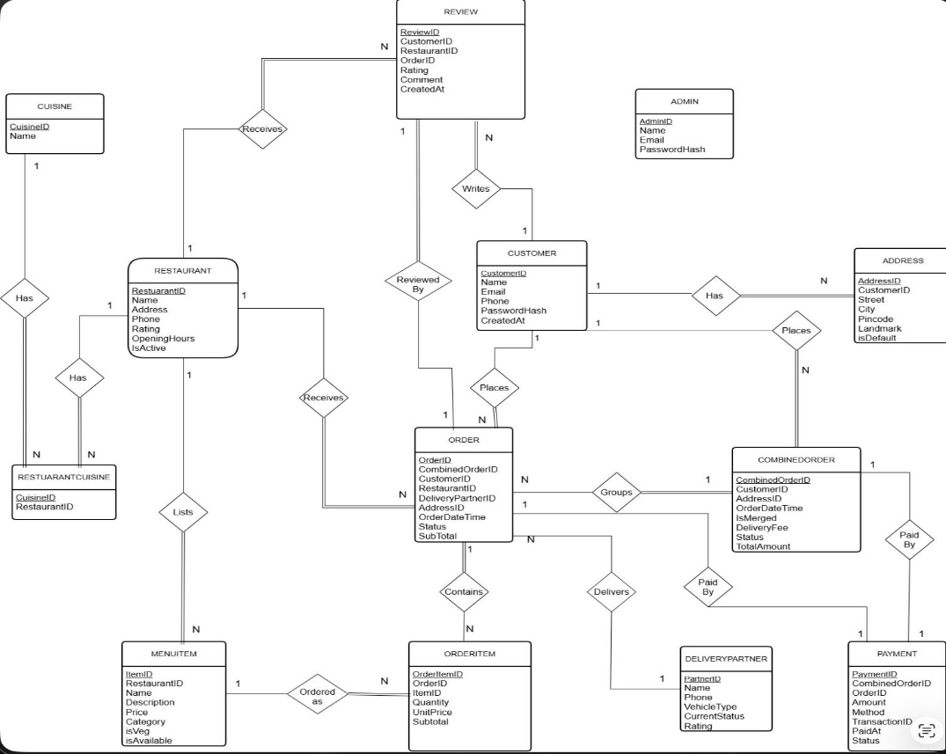

5.2 Entities, Attributes, and Relationships
Core entities and key attributes:
- Customer (CustomerID PK, Name, Email UNIQUE, Phone, PasswordHash, CreatedAt)
- Address (AddressID PK, CustomerID FK, Street, City, PinCode, Landmark, IsDefault)
- Restaurant (RestaurantID PK, Name, Address, Phone, Rating, OpeningHours, IsActive, ImageURL, Cuisine)
- Cuisine (CuisineID PK, Name UNIQUE)
- RestaurantCuisine (RestaurantID FK, CuisineID FK) – composite PK; many-to-many
- MenuItem (ItemID PK, RestaurantID FK, Name, Description, Price, Category, IsVeg, IsAvailable, ImageURL)
- DeliveryPartner (PartnerID PK, Name, Phone, CurrentStatus, Rating)
- CombinedOrder (CombinedOrderID PK, CustomerID FK, AddressID FK, OrderDateTime, IsMerged, DeliveryFee, OverallStatus, TotalAmount)
- Order / orders (OrderID PK, CombinedOrderID FK, CustomerID FK, RestaurantID FK, DeliveryPartnerID FK, AddressID FK, OrderDateTime, Status, SubTotal, DeliveryFee, PaymentStatus)
- OrderItem (OrderItemID PK, OrderID FK, ItemID FK, Quantity, UnitPrice, Subtotal)
- Payment (PaymentID PK, CombinedOrderID FK, OrderID FK, Amount, Method, TransactionID, PaidAt, Status)
- Review (ReviewID PK, CustomerID FK, RestaurantID FK, OrderID FK, Rating, Comment, CreatedAt)
- Admin (AdminID PK, Name, Email, PasswordHash) – optional oversight entity
Important cardinalities: Customer 1:N Address; Customer 1:N CombinedOrder; CombinedOrder 1:N Order; Restaurant 1:N MenuItem; Restaurant N:M Cuisine via RestaurantCuisine; Order 1:N OrderItem; Order N:1 DeliveryPartner (nullable until assigned); Customer/Restaurant/Order linked to Review.

5.3 Relational Schema and Conversion from ER
Each entity becomes a relation. Many-to-many Restaurant–Cuisine is resolved by the RestaurantCuisine junction table. Weak or dependent concepts (order lines) become OrderItem with foreign keys to Order and MenuItem. CombinedOrder was introduced to support multi-restaurant carts and optional merge semantics while still allowing per-restaurant Order rows for kitchen and delivery workflows.

5.4 Functional Dependencies and Normalization
Selected functional dependencies:
- CustomerID → Name, Email, Phone, PasswordHash, CreatedAt; Email → CustomerID
- AddressID → CustomerID, Street, City, PinCode, Landmark, IsDefault
- RestaurantID → Name, Address, Phone, Rating, OpeningHours, IsActive, …
- CuisineID → Name
- (RestaurantID, CuisineID) → ∅
- ItemID → RestaurantID, Name, Description, Price, Category, IsVeg, IsAvailable, ImageURL
- CombinedOrderID → CustomerID, AddressID, OrderDateTime, IsMerged, DeliveryFee, OverallStatus, TotalAmount
- OrderID → CombinedOrderID, CustomerID, RestaurantID, DeliveryPartnerID, AddressID, OrderDateTime, Status, SubTotal, DeliveryFee, PaymentStatus
- OrderItemID → OrderID, ItemID, Quantity, UnitPrice, Subtotal; also (OrderID, ItemID) → Quantity, UnitPrice, Subtotal
- PaymentID → CombinedOrderID, OrderID, Amount, Method, TransactionID, PaidAt, Status
- ReviewID → CustomerID, RestaurantID, OrderID, Rating, Comment, CreatedAt
Normalization steps:
- 1NF: All attributes atomic. Multi-valued cuisines and addresses extracted into separate relations and junction/detail tables.
- 2NF: No partial dependency on composite keys; OrderItem non-key attributes depend on the full key.
- 3NF: Transitive dependencies removed (e.g., address attributes moved out of Customer; cuisine names isolated).
- BCNF: Every determinant is a candidate key. The final schema satisfies BCNF.
This design minimizes redundancy and update/insert/delete anomalies while supporting the required multi-role workflows.

6. Database Selection & Justification
The project uses PostgreSQL as the DBMS, accessed through Supabase (a hosted PostgreSQL platform with a REST/Realtime API and JavaScript client).

6.1 Why PostgreSQL / Supabase
- Open-source, mature, and widely used for transactional applications.
- Strong support for constraints (PRIMARY KEY, FOREIGN KEY, UNIQUE, CHECK, NOT NULL), transactions, and ACID properties—critical for order/payment consistency.
- Rich SQL (joins, aggregates, window functions) for analytics queries such as top-selling items and daily revenue.
- Supabase provides a managed instance, table editor, SQL editor, and a simple JS client, which fits a student project without requiring a custom backend server.
- Scalability and performance suitable for moderate concurrent load; connection pooling and indexes can be added as needed.
- Cost: free tier sufficient for development and demonstration.
- Ease of use: SQL-first, excellent documentation, and integration with static frontends.
Alternatives such as MySQL or SQLite were considered. MySQL would also have been viable; SQLite is less suitable for concurrent multi-user cloud access. Oracle was unnecessary for scope and cost. PostgreSQL via Supabase offered the best balance of features, cost, and rapid integration with the HTML/JS UI.

7. Implementation

7.1 Technology Stack
- Frontend: HTML5, CSS3, Bootstrap 5.3, Bootstrap Icons, vanilla JavaScript, Google Fonts (Cormorant Garamond, Outfit).
- Backend/Database: Supabase (PostgreSQL) with Supabase JS client v2.
- No custom application server; the browser talks directly to Supabase.

7.2 Database Creation and Tables
Tables were created in the Supabase SQL editor with lowercase names (PostgreSQL convention). The reserved word “order” was avoided by naming the table orders. Representative structure (simplified):
CREATE TABLE customer (
customerid SERIAL PRIMARY KEY,
name VARCHAR(100) NOT NULL,
email VARCHAR(150) UNIQUE NOT NULL,
phone VARCHAR(20),
passwordhash TEXT,
createdat TIMESTAMP DEFAULT CURRENT_TIMESTAMP
);

CREATE TABLE address (
addressid SERIAL PRIMARY KEY,
customerid INT REFERENCES customer(customerid),
street TEXT, city VARCHAR(50), pincode VARCHAR(10),
landmark TEXT, isdefault BOOLEAN DEFAULT false
);

CREATE TABLE restaurant (
restaurantid SERIAL PRIMARY KEY,
name VARCHAR(100) NOT NULL,
address TEXT, phone VARCHAR(20), rating NUMERIC(3,2),
openinghours VARCHAR(50), isactive BOOLEAN DEFAULT true,
imageurl TEXT, cuisine TEXT
);

CREATE TABLE menuitem (
itemid SERIAL PRIMARY KEY,
restaurantid INT REFERENCES restaurant(restaurantid),
name VARCHAR(100), description TEXT, price NUMERIC(10,2),
category VARCHAR(50), isveg BOOLEAN, isavailable BOOLEAN,
imageurl TEXT
);

CREATE TABLE combinedorder (
combinedorderid SERIAL PRIMARY KEY,
customerid INT REFERENCES customer(customerid),
addressid INT REFERENCES address(addressid),
orderdatetime TIMESTAMP DEFAULT CURRENT_TIMESTAMP,
ismerged BOOLEAN, deliveryfee NUMERIC(10,2),
overallstatus VARCHAR(30), totalamount NUMERIC(10,2)
);

CREATE TABLE orders (
orderid SERIAL PRIMARY KEY,
combinedorderid INT REFERENCES combinedorder(combinedorderid),
customerid INT, restaurantid INT, deliverypartnerid INT,
addressid INT, orderdatetime TIMESTAMP DEFAULT CURRENT_TIMESTAMP,
status VARCHAR(30) DEFAULT 'Placed',
subtotal NUMERIC(10,2), deliveryfee NUMERIC(10,2),
paymentstatus VARCHAR(20) DEFAULT 'Pending'
);

CREATE TABLE orderitem (
orderitemid SERIAL PRIMARY KEY,
orderid INT REFERENCES orders(orderid),
itemid INT REFERENCES menuitem(itemid),
quantity INT, unitprice NUMERIC(10,2), subtotal NUMERIC(10,2)
);

CREATE TABLE payment (
paymentid SERIAL PRIMARY KEY,
combinedorderid INT, orderid INT,
amount NUMERIC(10,2), method VARCHAR(30),
transactionid VARCHAR(100), paidat TIMESTAMP, status VARCHAR(20)
);

7.3 Sample Data and Seeding
Seed scripts (seed_full_data.sql, seed_cuisine.sql, seed_coupon.sql) insert delivery partners, sample customers and addresses, nine restaurants with images, cuisine links, and over 100 menu items. Demo restaurant and delivery credentials are documented in the README.

7.4 CRUD Operations and Application Logic
All database access is centralized in js/db.js using the Supabase client. Examples of operations:
- Create: insert into customer on register; multi-table insert of combinedorder, orders, orderitem, payment on checkout.
- Read: select restaurants, menuitems by restaurant, orders by status for dashboards, past orders for profile.
- Update: order status transitions (restaurant Accept/Ready; delivery Pick Up/Delivered); profile fields.
- Delete: optional cleanup scripts for addresses or test data.
Joins are used in analytics, for example:
-- Top-selling items
SELECT m.name, SUM(oi.quantity) AS units
FROM orderitem oi
JOIN menuitem m ON m.itemid = oi.itemid
GROUP BY m.itemid, m.name
ORDER BY units DESC LIMIT 10;

-- Restaurant revenue
SELECT r.name, COUNT(o.orderid) AS orders,
COALESCE(SUM(o.subtotal), 0) AS revenue
FROM restaurant r
LEFT JOIN orders o ON o.restaurantid = r.restaurantid
GROUP BY r.restaurantid, r.name
ORDER BY revenue DESC;

INSERT INTO customer (name, email, phone, passwordhash)
VALUES ('Devika B', 'devika@example.com', '9876543210', 'hash1')
RETURNING *;

UPDATE customer
SET name = 'New Name', phone = '9999999999'
WHERE customerid = 1
RETURNING *;

DELETE FROM address
WHERE addressid = 5;
SELECT *
FROM restaurant
WHERE isactive = true
ORDER BY rating DESC;

7.5 End-to-End Flow
- Customer registers/logs in → browses restaurants → adds items to cart → checkout.
- Checkout writes CombinedOrder + Order(s) + OrderItem(s) + Payment to Supabase.
- Restaurant dashboard loads pending orders → Accept → Mark Ready.
- Delivery dashboard shows ready jobs → Accept → Pick Up → Mark Delivered.
- Profile, history, and analytics reflect the same rows.

8. Testing & Validation
Testing focused on functional correctness of the three roles and on database constraints and integrity.

8.1 Sample Test Cases
ID | Input / Action | Expected Output | Actual Output | Result
TC01 | Register new customer with unique email | Row inserted in customer; redirect/login success | Customer created; login works | Pass
TC02 | Register with duplicate email | UNIQUE constraint error / user message | Insert rejected by DB | Pass
TC03 | Add items from two restaurants to cart and checkout (merge) | One CombinedOrder, two Order rows, OrderItems, Payment | All tables populated correctly | Pass
TC04 | Restaurant Accept → Mark Ready | orders.status updated; visible on delivery side | Status updated live | Pass
TC05 | Delivery Accept → Pick Up → Delivered | Status progression; history/earnings update | As expected | Pass
TC06 | Insert OrderItem with invalid OrderID | FOREIGN KEY violation | Constraint enforced | Pass
TC07 | Analytics: top-selling items query | Ordered list of items with unit counts | Correct aggregates | Pass
TC08 | Customer views past orders on profile | Orders for that customerid listed | Correct history shown | Pass

8.2 Constraint and Integrity Validation
Primary keys and serial IDs ensure uniqueness. Foreign keys link Address→Customer, MenuItem→Restaurant, Order→CombinedOrder/Customer/Restaurant, OrderItem→Order/MenuItem, etc. UNIQUE on customer.email and cuisine.name prevent duplicates. NOT NULL on essential fields (e.g., name, email) blocks incomplete rows. Checkout is implemented as a sequence of inserts that maintain consistency between combined and individual order amounts. For demos, RLS was turned off or open policies used so the static frontend could operate; production would enable role-based policies.

9. Results & Screenshots
The implemented system successfully supports the full order lifecycle across three roles on a shared PostgreSQL database. Key outcomes:
- Nine restaurants and 100+ menu items seeded with images and cuisine associations.
- Customers can register, place multi-restaurant orders, and track status.
- Restaurant and delivery dashboards operate on the same order rows and reflect status changes in near real time.
- Analytics queries return top-selling items, revenue by restaurant, and daily revenue

Landing page
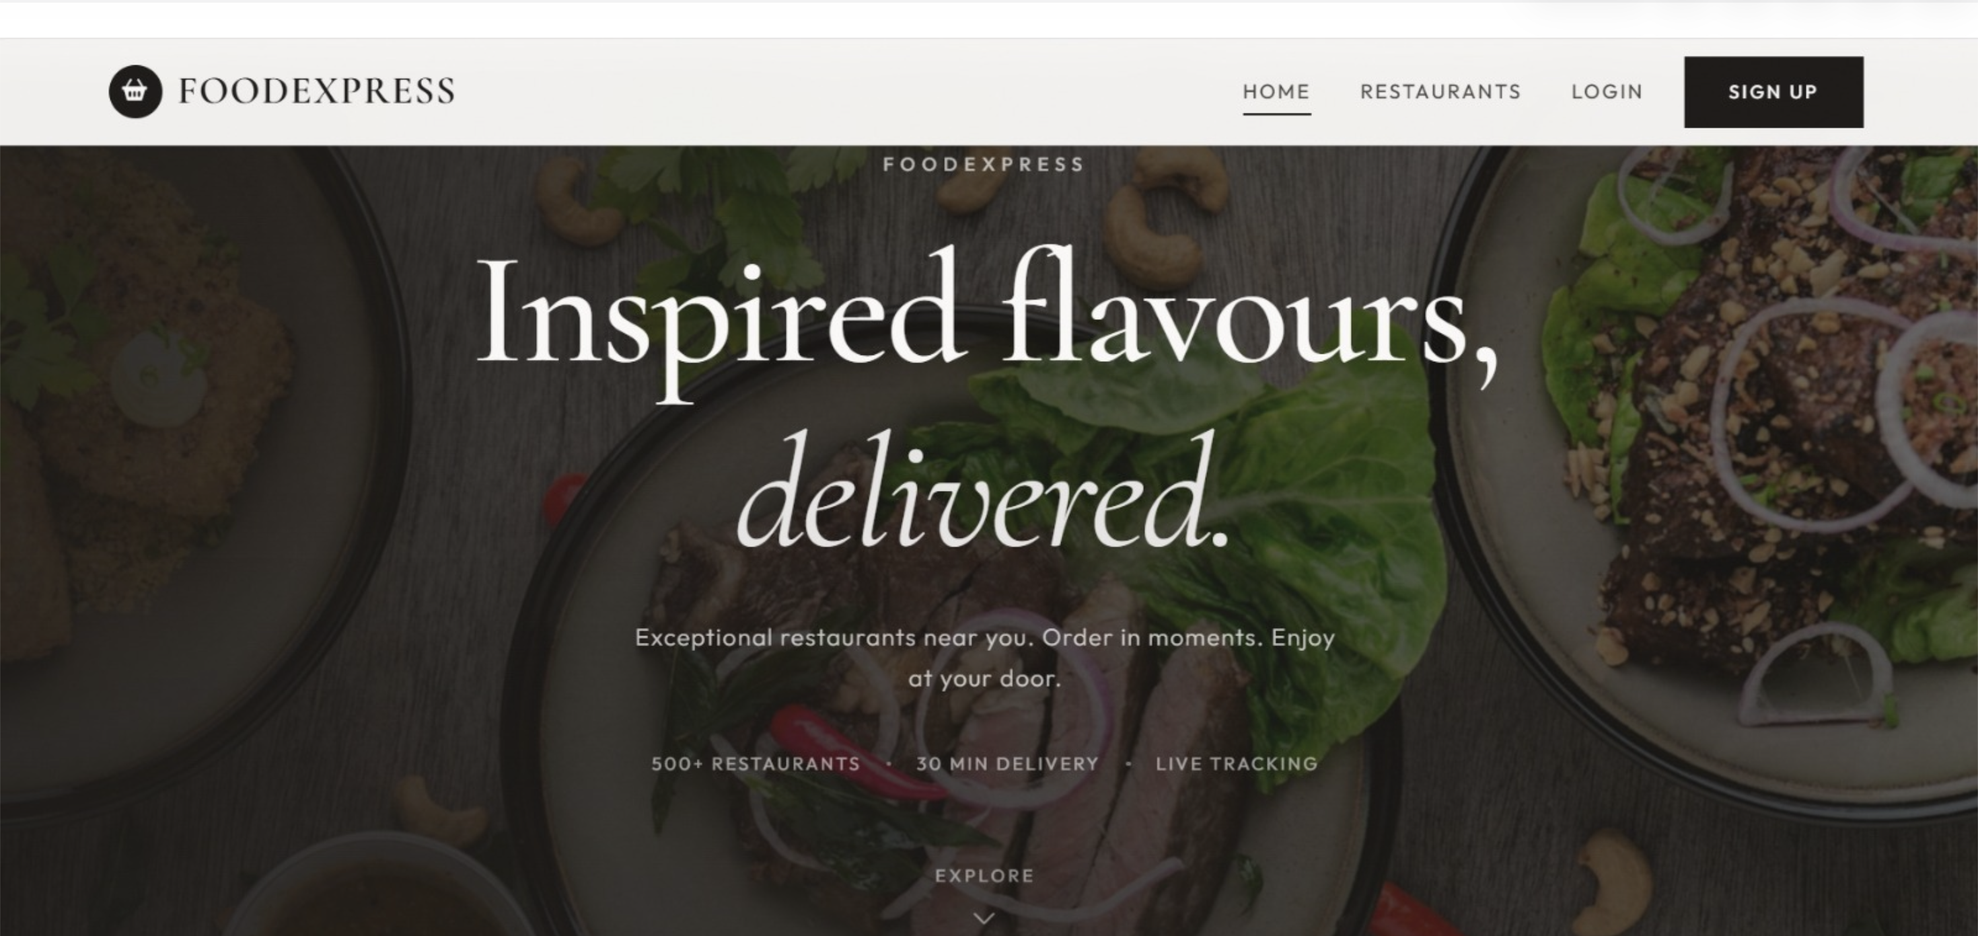
Public entry screen of FoodExpress. Shows the brand header, hero section, and navigation to Restaurants, Orders, and Cart. Introduces the platform before the user logs in or browses data loaded from the database.

Customer Account Creation
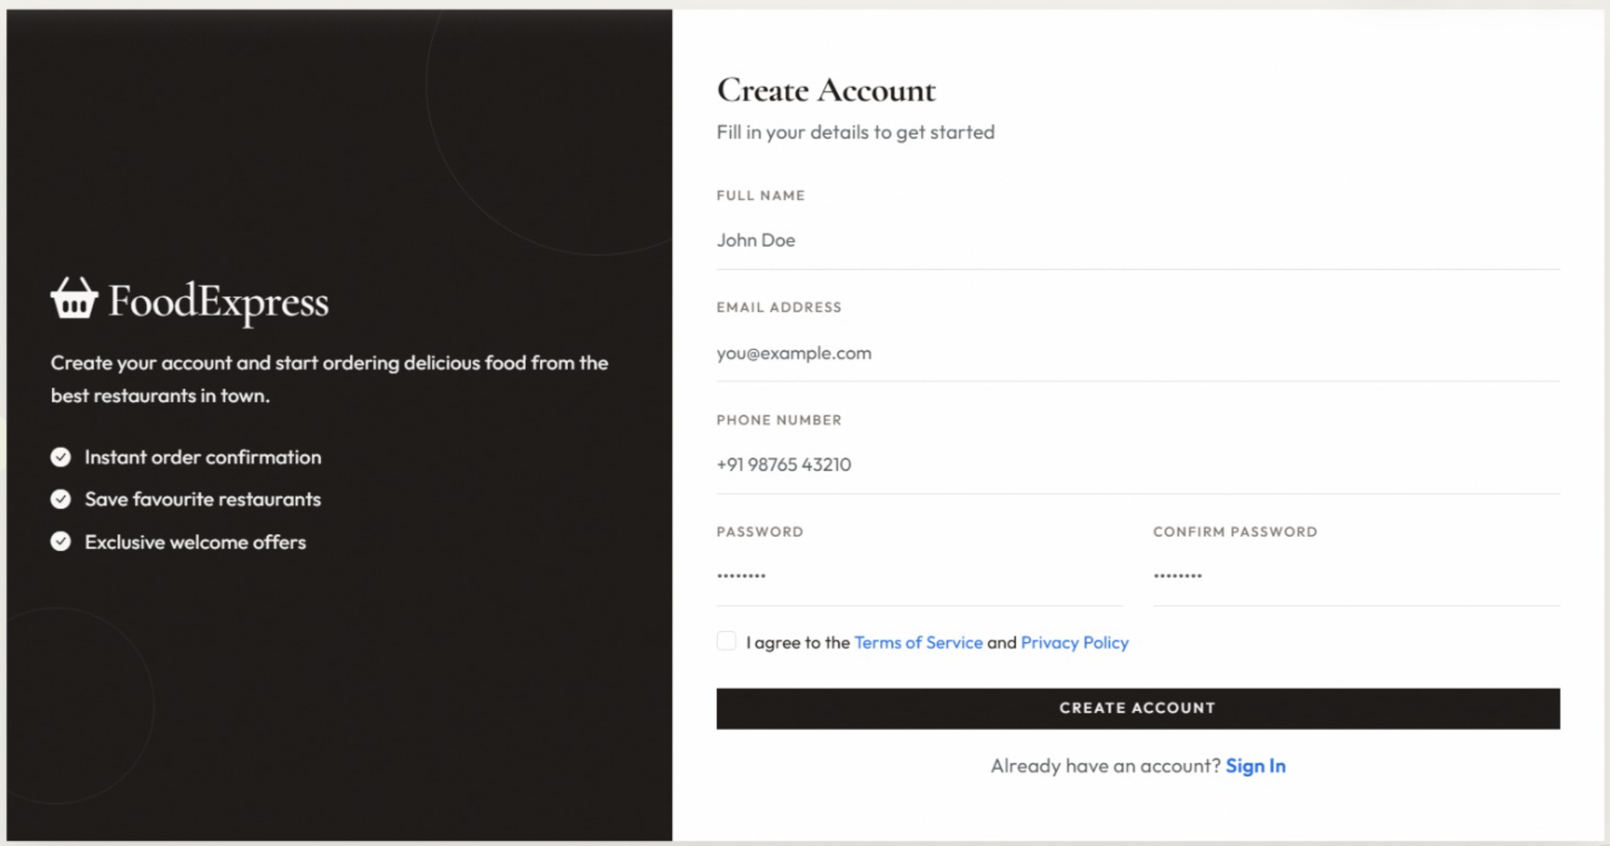
New customer form. On submit, a row is inserted into the customer table (name, email, phone, password hash), enforcing uniqueness on email.

Customer login
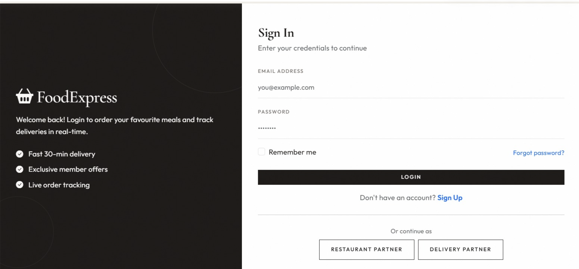Customer login screen. The user enters email and password; credentials are checked against the customer table. Successful login starts the session and allows browsing, ordering, and tracking. Links are also provided for Restaurant Partner and Delivery Partner login.

Restaurant Listing
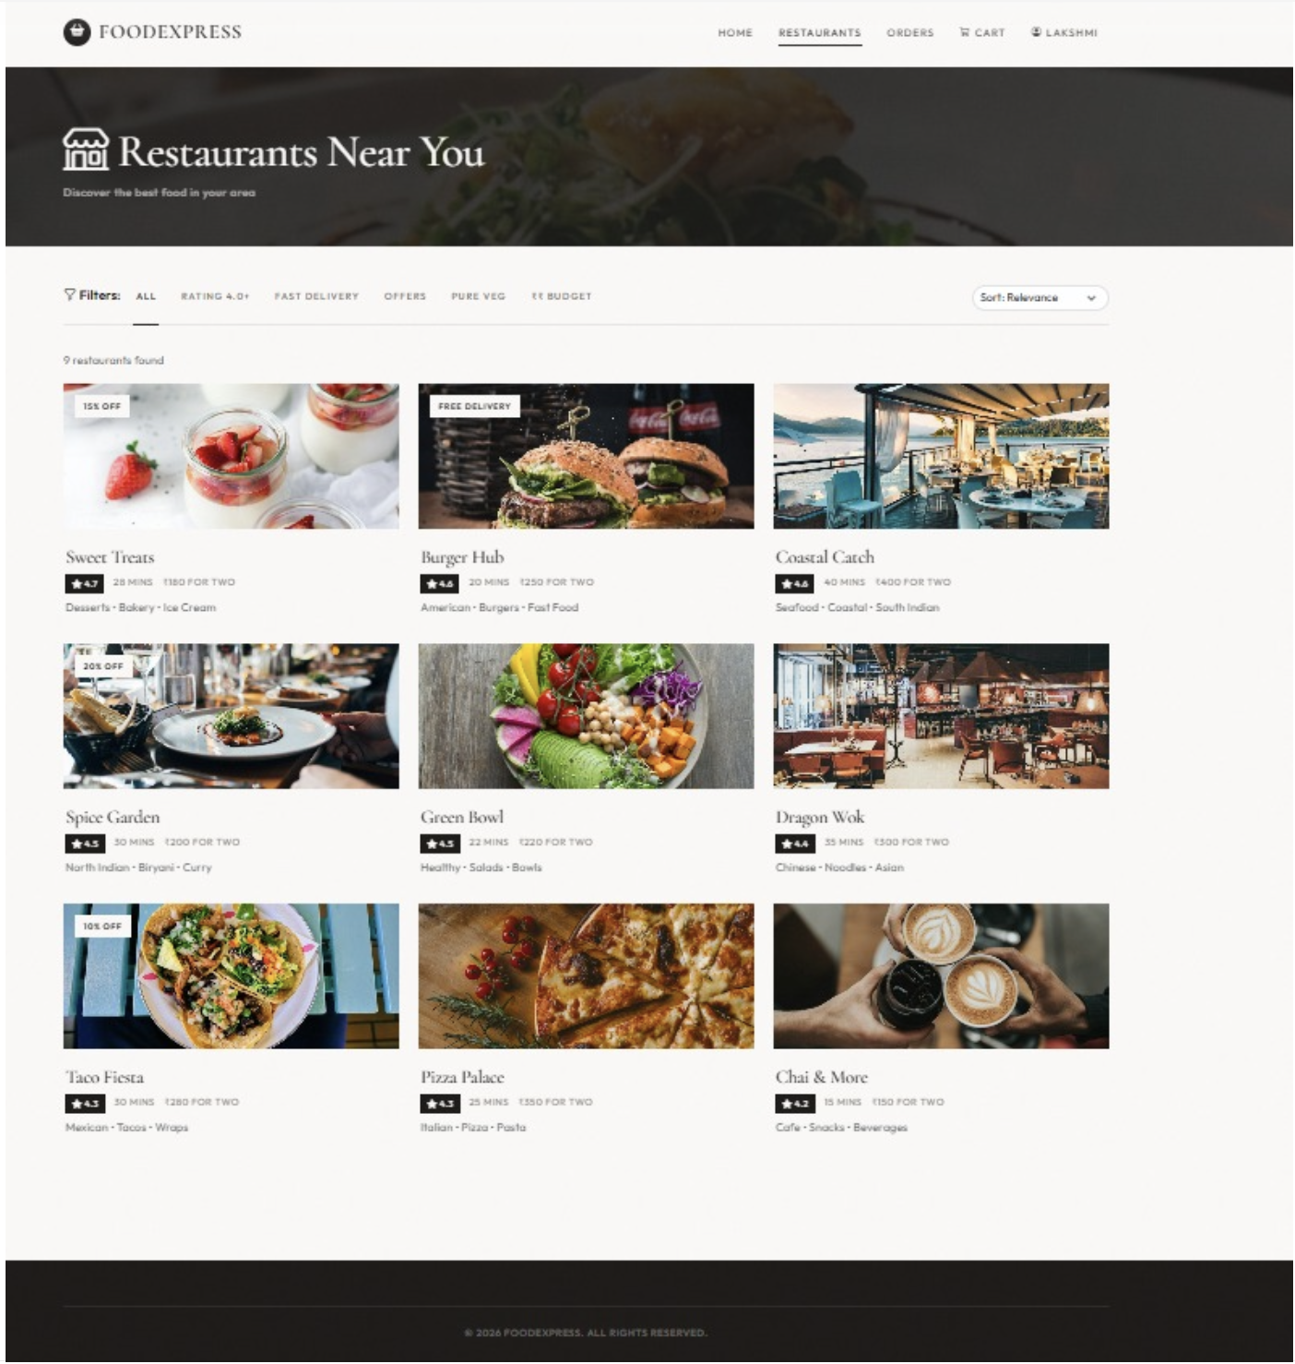
Shows restaurants loaded from the restaurant table (name, rating, delivery time, cuisine tags, images). Filters and sort options demonstrate dynamic querying of live database data.

Add to Cart
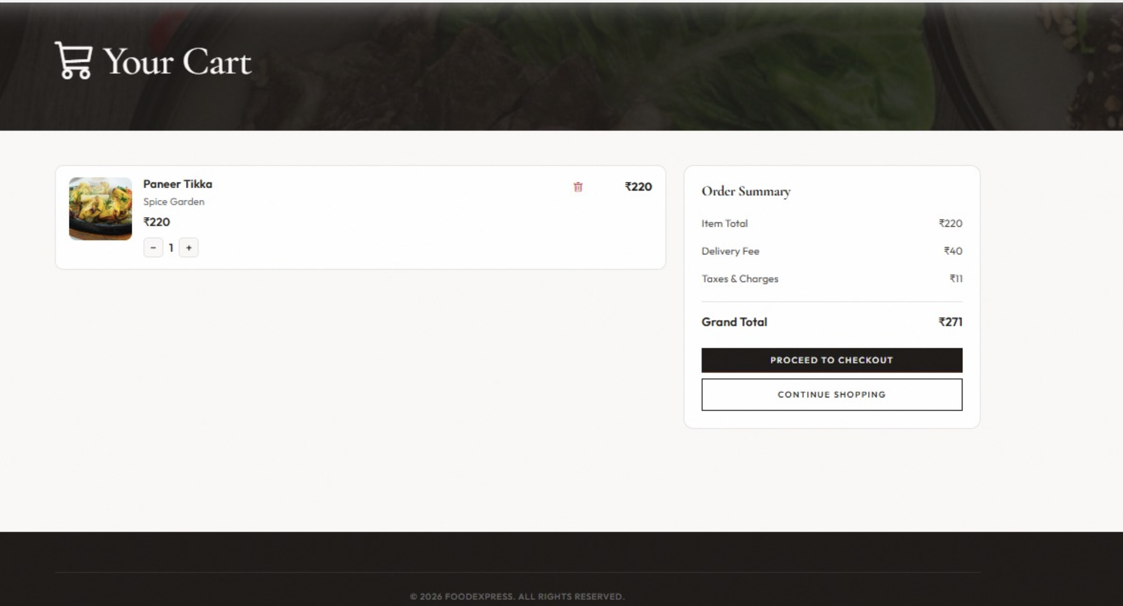
Cart with Paneer Tikka from Spice Garden. Item details and price are taken from menuitem; quantity controls are client-side until checkout writes rows into orders and orderitem.
Checkout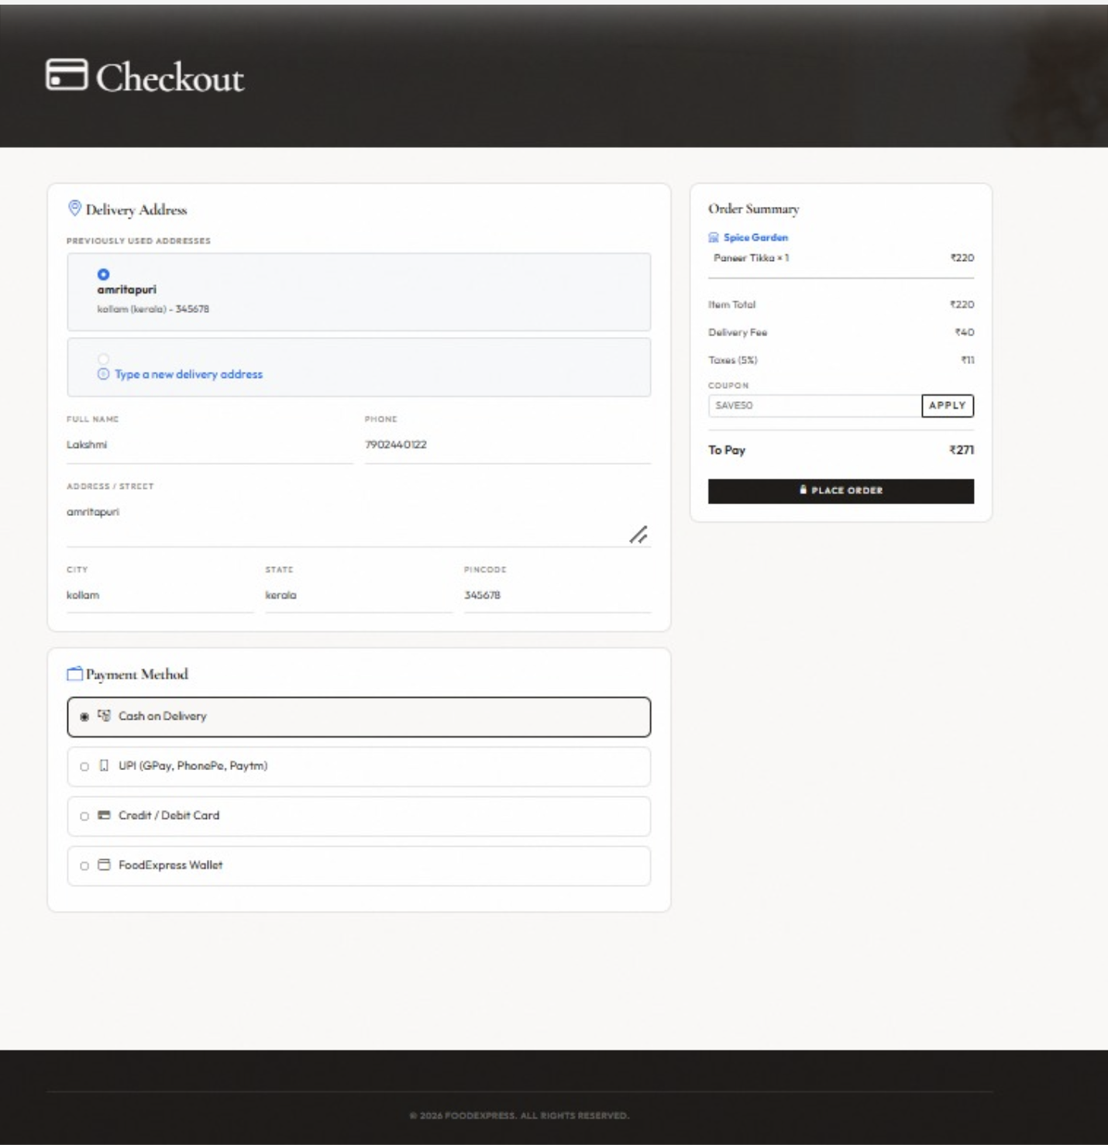
Final step before placing an order. The customer selects a delivery address (from the address table or a new one), chooses a payment method, and reviews the order summary. Clicking Place Order inserts linked rows into combinedorder, orders, orderitem, and payment, and stores the chosen address and totals.

Order Tracking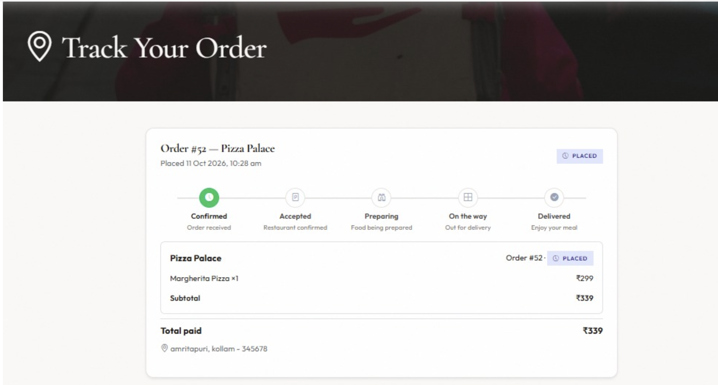Customer view of Order #52 (Pizza Palace). Status timeline (Confirmed → Accepted → Preparing → On the way → Delivered) is driven by the orders.status column. Order items and totals come from orderitem and related payment data.

Profile with Past Orders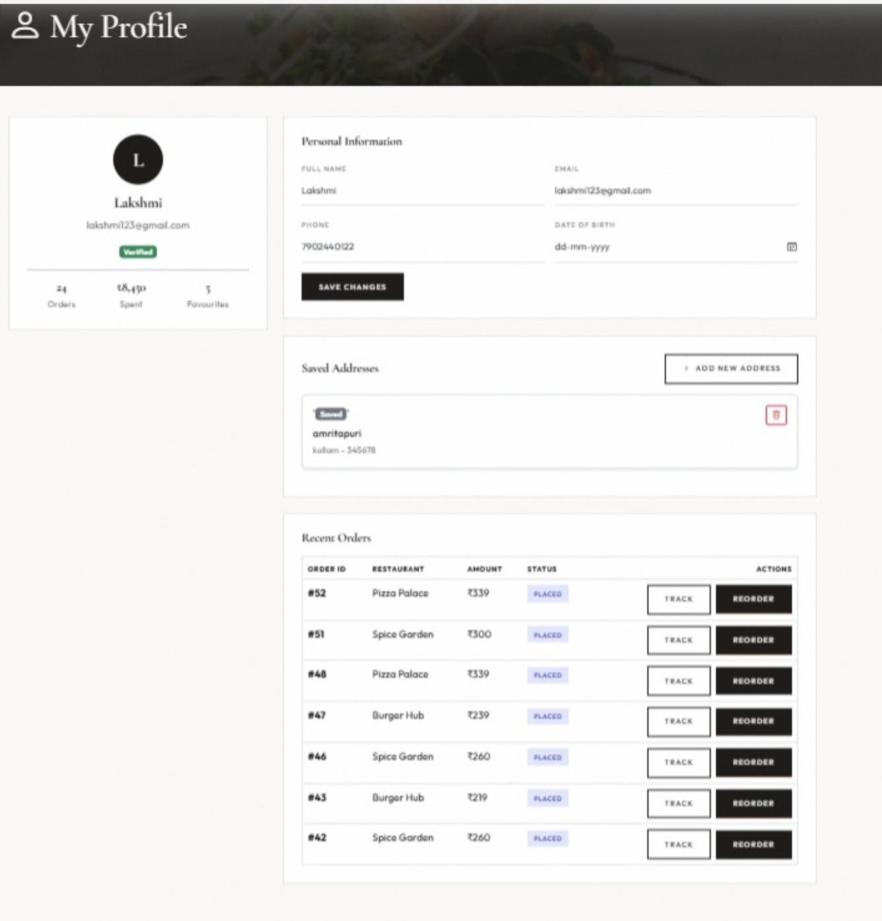
Shows the logged-in customer’s details from the customer table (name, email, phone), saved addresses from the address table, and recent orders from the orders table with status and amount. The user can update profile fields, manage addresses, and track or reorder past orders.

Restaurant Dashboard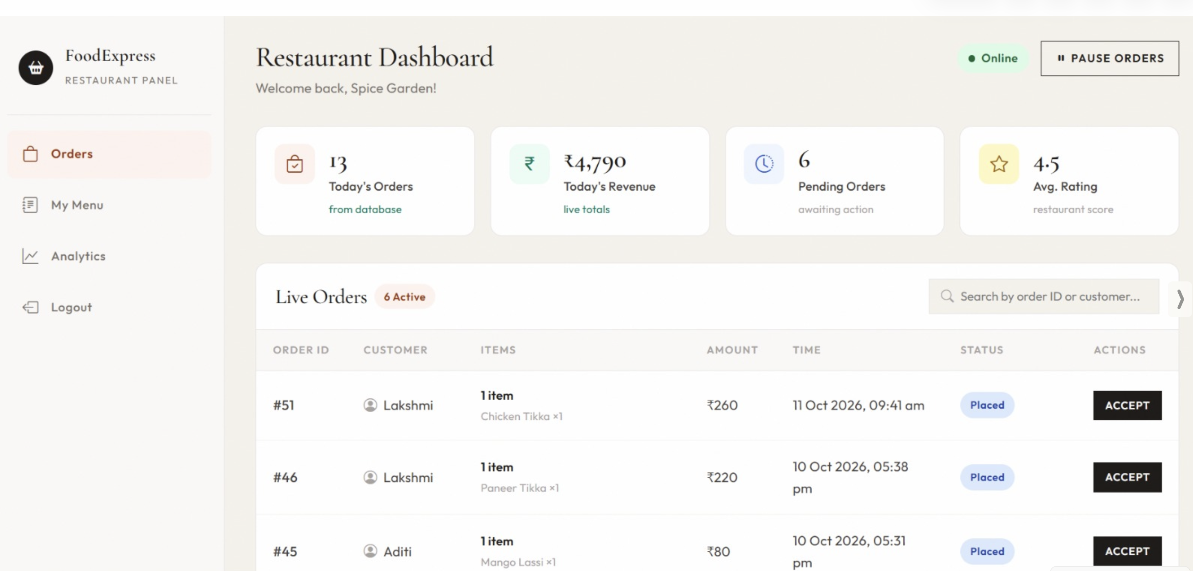
Spice Garden partner view. Today’s orders and revenue are aggregated from the orders table. Pending orders (e.g. #51, #46, #45) appear with Accept actions that update orders status.

Delivery partner dashboard
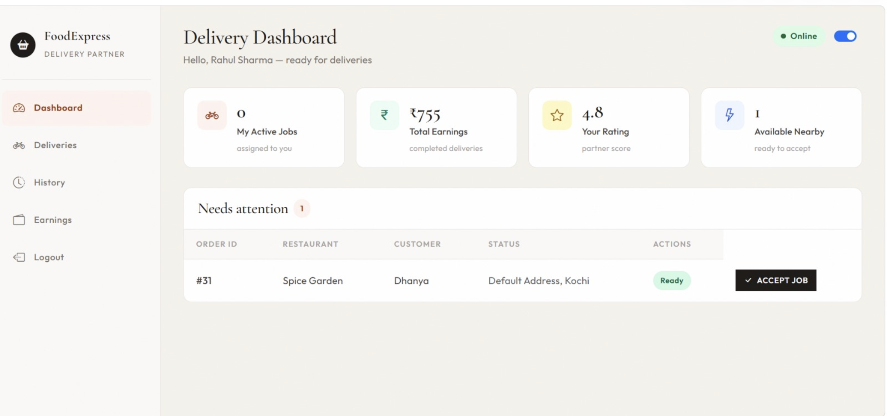
Live delivery view for Rahul Sharma. Shows earnings, rating, and a job ready to accept (Order #31, Spice Garden). Accepting the job updates orders.deliverypartnerid and status in the database

Customer table
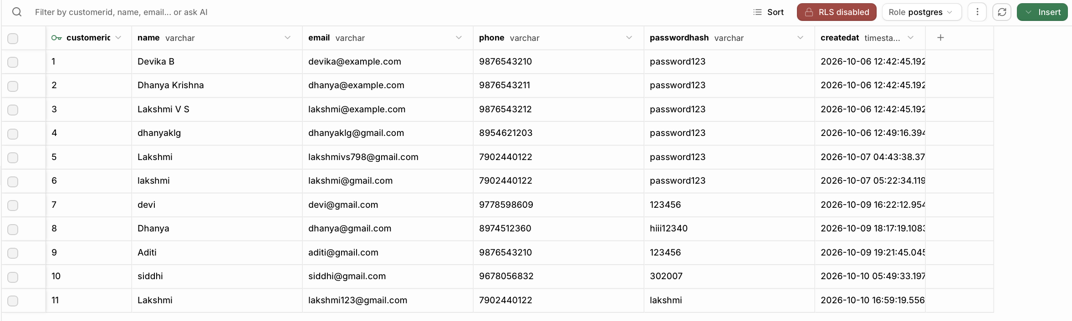Live view of the customer table in the PostgreSQL database. Each row stores customerid (primary key), name, email (unique), phone, password hash, and creation timestamp. Rows are created during registration and used for login and profile display.

Orders table
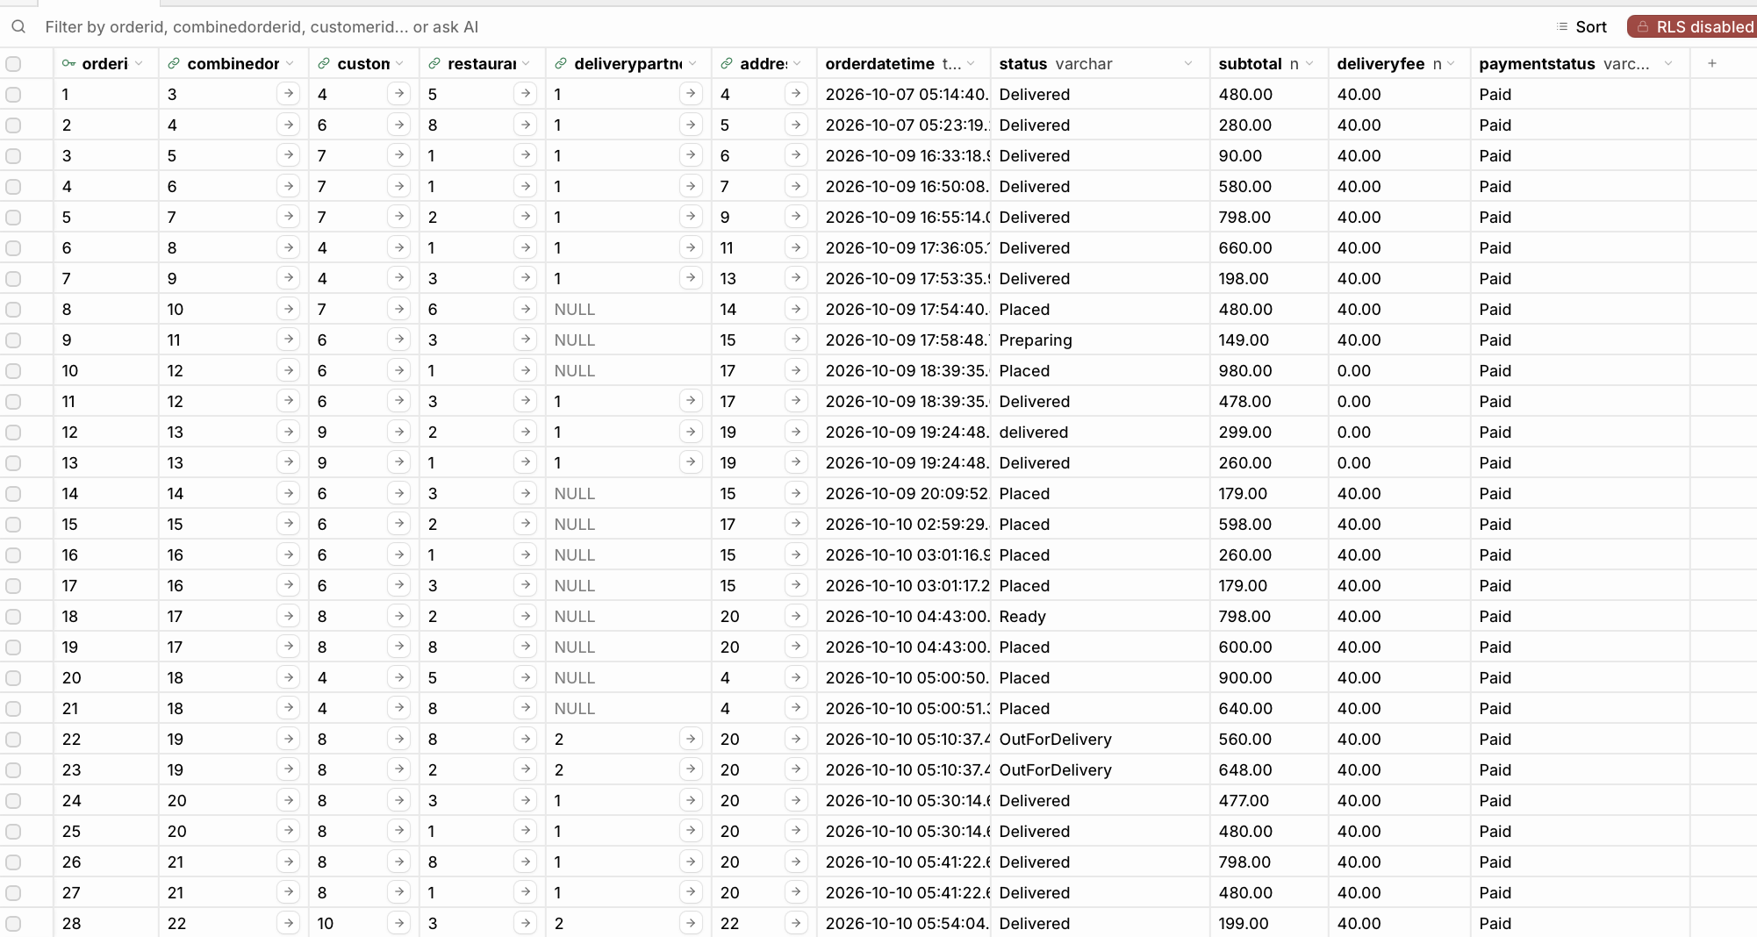Live view of the orders table. Each row links a customer, restaurant, delivery partner, and address through foreign keys, and stores status, subtotal, delivery fee, and payment status. Status values (Placed, Preparing, Ready, OutForDelivery, Delivered) are updated by restaurant and delivery partners and shown on tracking and dashboard screens.
OrderItem
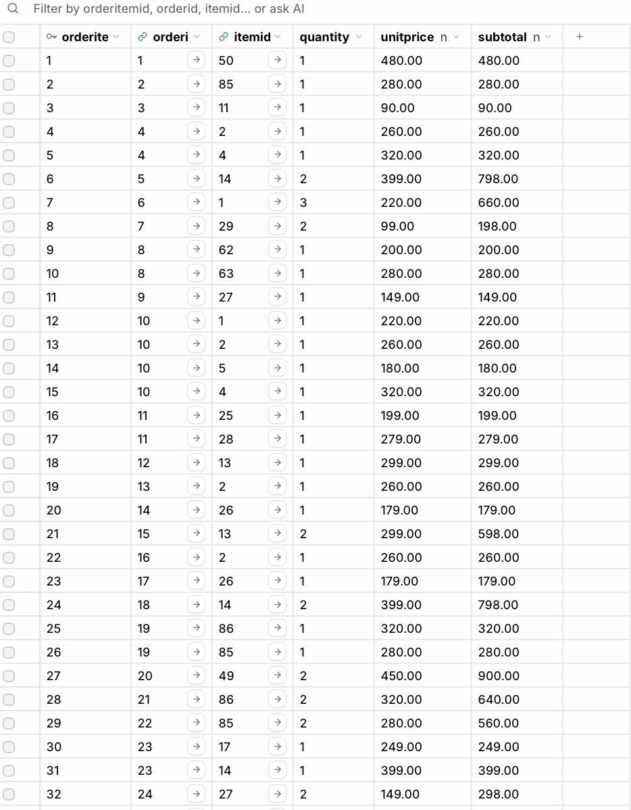
Live view of the orderitem table. Each row links an order to a menu item (itemid) and stores quantity, unit price at the time of purchase, and line subtotal. This table implements the many-to-many relationship between orders and menu items and is filled during checkout.

Payment
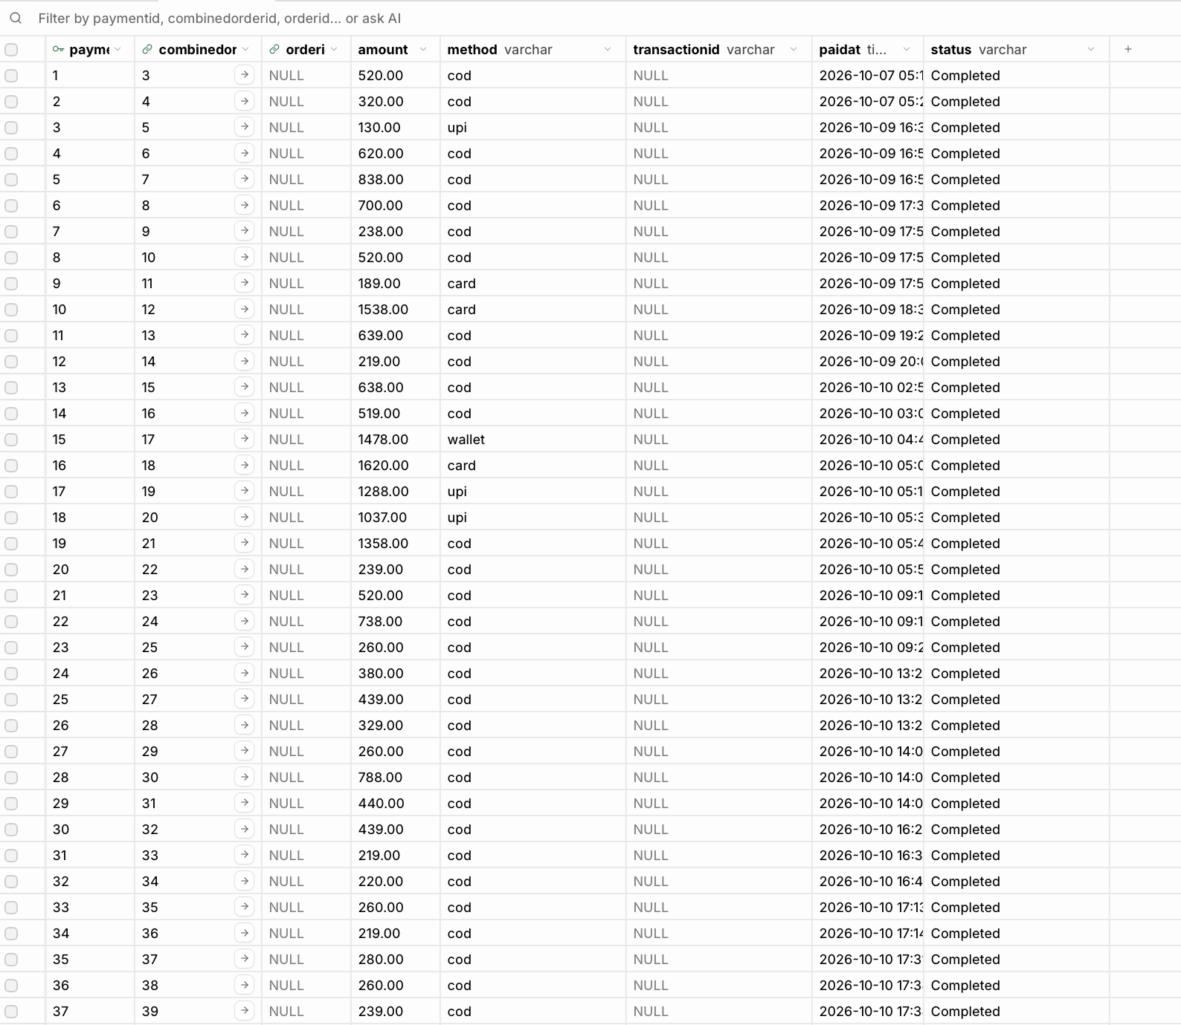Live view of the payment table. Each row records the amount paid, payment method (COD, UPI, card, wallet), and status for a combined order. Rows are created at checkout and linked to combinedorder, completing the order–payment part of the transaction.

10. Challenges Faced & Solutions

10.1 Reserved Word for Order Table
Challenge: Naming a table order caused issues with PostgreSQL/PostgREST. Solution: Renamed the table to orders and provided fix_order_table.sql to migrate existing deployments; application code was updated to use the new name.

10.2 Multi-Restaurant Cart and Combined Orders
Challenge: Supporting items from multiple restaurants while still allowing per-kitchen order processing. Solution: Introduced CombinedOrder as a parent of one or more Order rows, with an IsMerged flag and delivery-fee rules; OrderItem remains tied to individual Order rows.

10.3 Shared Live Data Across Roles
Challenge: Ensuring restaurant and delivery UIs see the same order state without a custom backend. Solution: All roles use the Supabase JS client against the same tables; status updates are simple UPDATEs that other dashboards re-query or listen for.

10.4 Normalization vs. Display Convenience
Challenge: Cuisine filters and address lists required careful separation to stay in 3NF/BCNF. Solution: Cuisine and RestaurantCuisine tables plus Address as a separate entity; denormalized display fields (e.g., a cuisine text on restaurant) used only where helpful for seeding/UI and kept consistent with the normalized model.

10.5 Constraints and Demo Access
Challenge: Enforcing integrity while allowing a static frontend to write data during demos. Solution: Full PK/FK/UNIQUE constraints retained; RLS disabled or opened for evaluation, with a note that production should use proper policies and hashed passwords.

10.6 Frontend–Database Integration
Challenge: Coordinating multi-table inserts at checkout and handling async errors. Solution: Centralized logic in db.js with clear sequential inserts and user-facing error messages; seed and fix SQL scripts for reproducible setup.

11. Conclusion & Future Enhancements

11.1 Conclusion
FoodExpress successfully demonstrates the design and implementation of a normalized relational database for a multi-stakeholder online food delivery system. The project covers ER modeling, conversion to relational schema, functional dependencies, normalization to BCNF, constraint enforcement, CRUD and join queries, and a working multi-role UI backed by PostgreSQL (Supabase). Objectives of supporting customers, restaurants, and delivery partners on a single consistent data store were achieved. The system illustrates how database management systems organize complex real-world business operations involving concurrent roles, status workflows, and analytical reporting.

11.2 Future Enhancements
- Enable and refine Row Level Security (RLS) policies per role; strengthen password hashing and session management.
- Real-time subscriptions (Supabase Realtime) so dashboards update without manual refresh.
- Admin module for restaurant verification, coupon management, and platform-wide metrics.
- Mobile-responsive progressive web app (PWA) or native mobile clients.
- Payment gateway integration (instead of simulated payment records).
- Advanced analytics and recommendations (frequent items, surge pricing hints).
- Cloud deployment of the static frontend (e.g., Netlify) with CI and environment-based Supabase keys.
- Indexing and query optimization for high-volume order history and search.
- Support for partial refunds, cancellations with inventory/availability rules, and delivery partner geo-assignment.

References
- Elmasri, R., & Navathe, S. B. Fundamentals of Database Systems. Pearson.
- Silberschatz, A., Korth, H. F., & Sudarshan, S. Database System Concepts. McGraw-Hill.
- PostgreSQL Official Documentation. https://www.postgresql.org/docs/
- Supabase Documentation. https://supabase.com/docs
- Supabase JavaScript Client Reference. https://supabase.com/docs/reference/javascript
- Bootstrap 5 Documentation. https://getbootstrap.com/docs/5.3/
- FoodExpress Project Repository. https://github.com/Dhanya-Krishna/DBMS-Project
- MDN Web Docs – HTML, CSS, JavaScript. https://developer.mozilla.org/

