IntelliJ IDEA

Introduction

IntelliJ IDEA is an integrated development environment (IDE) written in Java for developing computer software. It is developed by JetBrains (formerly known as IntelliJ), and is available as an Apache 2 Licensed community edition, and in a proprietary commercial edition. Both can be used for commercial development.

History

The first version of IntelliJ IDEA was released in January 2001, and was one of the first available Java IDEs with advanced code navigation and [code refactoring](https://en.wikipedia.org/wiki/Code_refactoring) capabilities integrated.

In a 2010 [*InfoWorld*](https://en.wikipedia.org/wiki/InfoWorld) report, IntelliJ received the highest test center score out of the four top Java programming tools: [Eclipse](https://en.wikipedia.org/wiki/Eclipse_(software)), IntelliJ IDEA, [NetBeans](https://en.wikipedia.org/wiki/NetBeans) and [JDeveloper](https://en.wikipedia.org/wiki/JDeveloper).

In December 2014, Google announced version 1.0 of [Android Studio](https://en.wikipedia.org/wiki/Android_Studio), an [open-source](https://en.wikipedia.org/wiki/Open-source_software) IDE for [Android](https://en.wikipedia.org/wiki/Android_(operating_system)) apps, based on the open source community edition of IntelliJ IDEA.[[9]](https://en.wikipedia.org/wiki/IntelliJ_IDEA#cite_note-9) Other development environments based on IntelliJ's framework include [AppCode](https://en.wikipedia.org/wiki/AppCode), [CLion](https://en.wikipedia.org/wiki/JetBrains#CLion), [DataGrip](https://en.wikipedia.org/wiki/JetBrains#DataGrip), [GoLand](https://en.wikipedia.org/wiki/JetBrains#GoLand), [PhpStorm](https://en.wikipedia.org/wiki/PhpStorm), [PyCharm](https://en.wikipedia.org/wiki/PyCharm), [Rider](https://en.wikipedia.org/wiki/JetBrains#Rider), [RubyMine](https://en.wikipedia.org/wiki/RubyMine), [WebStorm](https://en.wikipedia.org/wiki/WebStorm), and [MPS](https://en.wikipedia.org/wiki/JetBrains_MPS).

# Create your first Java application﻿

In this tutorial, you will learn how to create, run, and package a simple Java application that prints Hello, World! to the system output. Along the way, you will get familiar with IntelliJ IDEA features for boosting your productivity as a developer: coding assistance and supplementary tools.

## Create a new project﻿

### Install the JDK﻿

To develop Java applications in IntelliJ IDEA, you need the Java SDK (JDK). If Java is not installed on your computer, you need to download a JDK package.

1. Open the [jdk.java.net](https://jdk.java.net/) website.

There, you'll find the Oracle's OpenJDK binaries for Windows, macOS, and Linux as .tar.gz and .zip archives.

1. Select and download the necessary JDK version.

If you're not sure which version you need, select the latest stable version.

1. Unzip the archive and place the folder with Java to the Java home directory on your computer.

The default path on Windows: C:\Program Files\Java, on macOS: /Library/Java/JavaVirtualMachines.

On Linux, the default location for Java might differ depending on the distribution that you use.

### Create a new Java project﻿

In IntelliJ IDEA, a [project](https://www.jetbrains.com/help/idea/creating-and-managing-projects.html) helps you organize your source code, tests, libraries that you use, build instructions, and your personal settings in a single unit.

1. Launch IntelliJ IDEA.

If the Welcome screen opens, click **Create New Project**.

Otherwise, from the main menu, select **File | New | Project**.

1. In the **New Project** wizard, select **Java** from the list on the left.
2. From the **Project SDK** list, select the JDK that you want to use in your project.

If the list is empty, click **New** and specify the path to the Java home directory (for example, jdk-11.0.0.jdk)

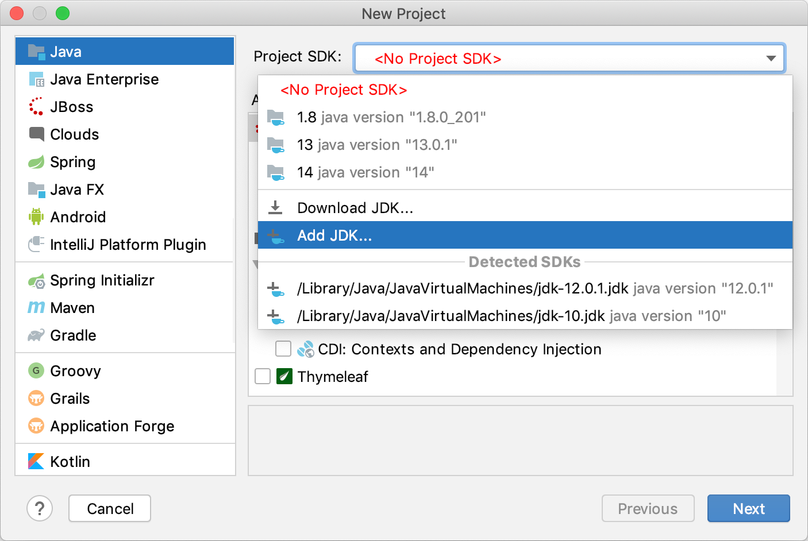

1. We're not going to use any additional libraries or frameworks for this tutorial, so click **Next**.
2. Don't create a project from the template. In this tutorial, we're going to do everything from scratch, so click **Next**.
3. Name the project, for example: HelloWorld.
4. If necessary, change the default project location and click **Finish**.

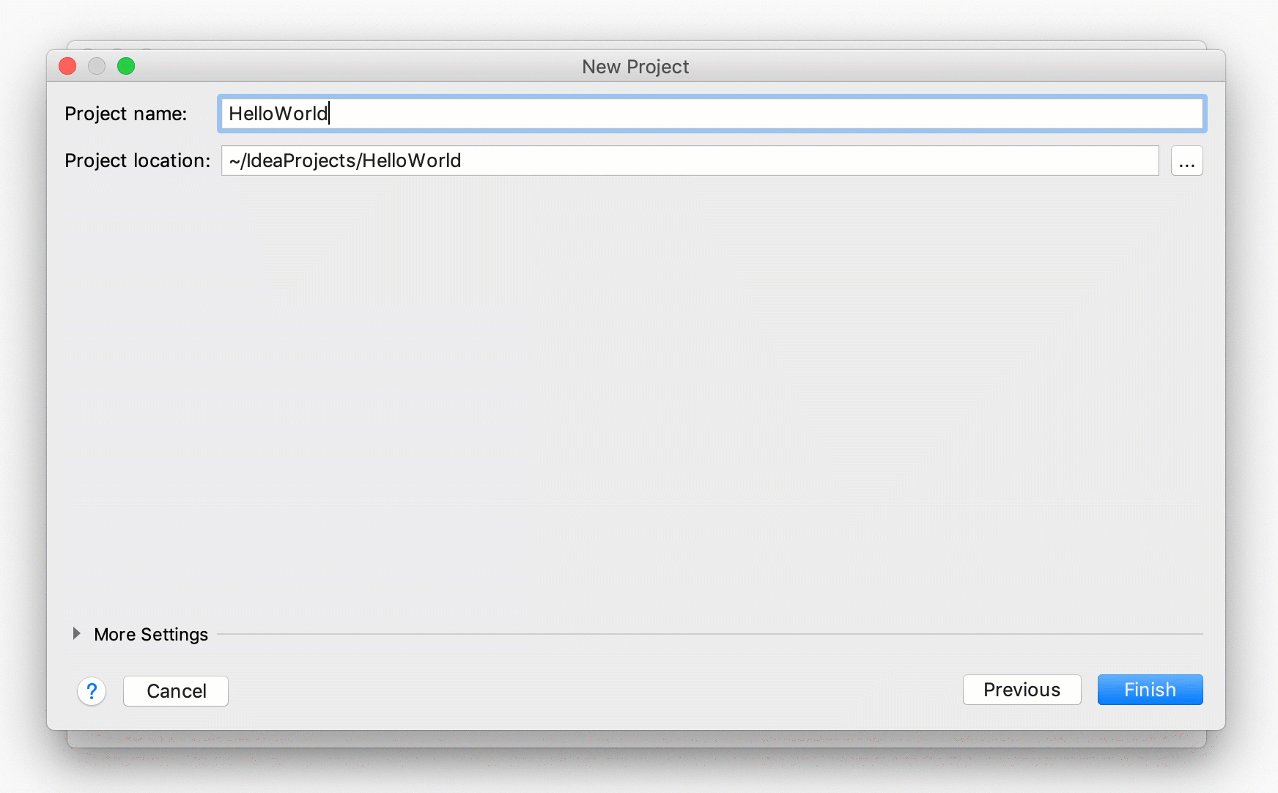

### Create a package and a class﻿

Packages are used for grouping together classes that belong to the same category or provide similar functionality, for structuring and organizing large applications with hundreds of classes.

1. In the **Project** tool window, select the src folder, press Alt+Insert, and select **Java Class**.
2. In the **Name** field, type com.example.helloworld.HelloWorld and click **OK**.

IntelliJ IDEA creates the com.example.helloworld package and the HelloWorld class.

In Java, there's a [naming convention](https://www.oracle.com/technetwork/java/codeconventions-135099.html) that you should follow when you name packages and classes.

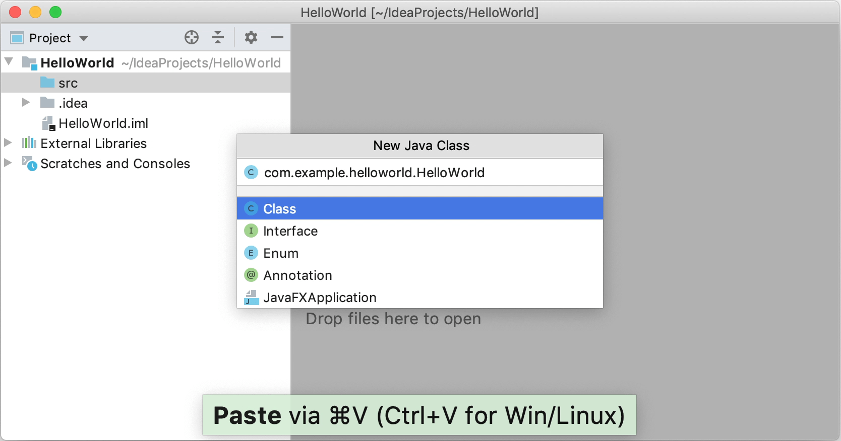

Together with the file, IntelliJ IDEA has automatically generated some contents for your class. In this case, the IDE has inserted the package statement and the class declaration.

This is done by means of file templates. Depending on the type of the file that you create, the IDE inserts initial code and formatting that is expected to be in all files of that type. For more information on how to use and configure templates, refer to [File and code templates](https://www.jetbrains.com/help/idea/using-file-and-code-templates.html).

## Write the code﻿

### Add the main() method using live templates﻿

1. Place the caret at the class declaration string after the opening bracket { and press Shift+Enter.

In contrast to Enter, Shift+Enter starts a new line without breaking the current one.

1. Type main and select the template that inserts the main() method declaration.

As you type, IntelliJ IDEA suggests various constructs that can be used in the current context. You can see the list of available live templates using Ctrl+J.

Gif

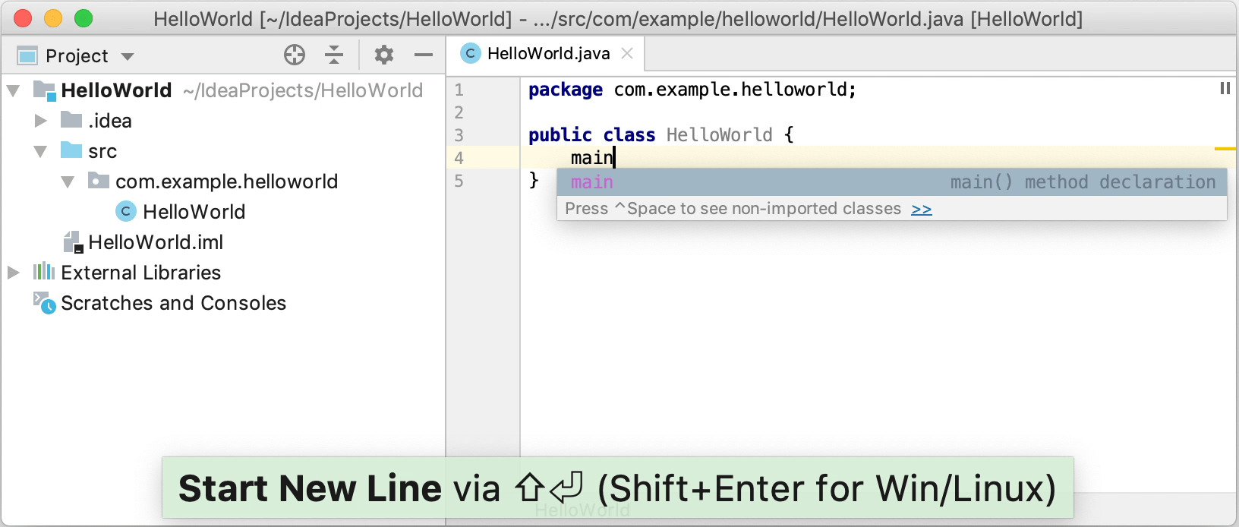

Live templates are code snippets that you can insert into your code. main is one of such snippets. Usually, live templates contain blocks of code that you use most often. Using them can save you some time as you don't have to type the same code over and over again.

For more information on where to find predefined live templates and how to create your own, refer to [Live templates](https://www.jetbrains.com/help/idea/using-live-templates.html).