**WEB TECHNOLOGY- PROJECT REPORT**

**PROJECT TITLE:** ShoppingMart

**PROJECT OBJECTIVE:**

The objective of this project is to develop a **web-based e-commerce platform (ShoppingMart)** that provides users with a convenient and interactive shopping experience while allowing administrators to efficiently manage products, categories, and customer interactions. The system aims to:

**1. Display Products Effectively**

* Present all available products with details such as **name**, **price**, **category**, **description**, and **image**.
* Organize products under various **categories or themes** (e.g., Electronics, Fashion, Groceries) for easier browsing and discovery.
* Provide search and filter options to help users quickly find desired products.

**2. Product Management and Storage**

* Maintain a **digital record** of all products, including stock quantity, category, and related information.
* Enable administrators to **add, update, or remove products** from the platform through a secure admin interface.
* Ensure proper **database integration (MySQL)** for reliable data storage and retrieval.

**3. User Interaction and Cart Management**

* Allow users to **browse products**, view details, and **add items to a virtual cart** for purchase.
* Provide a **cart interface** for users to review, modify, or remove items before checkout.
* Ensure a smooth **checkout process** with accurate order summaries.

**4. User Authentication and Profile Handling**

* Facilitate **secure registration and login** for customers and administrators.
* Allow users to **manage their profiles**, update personal details, and view order history.
* Restrict administrative functions to authorized personnel only.

**5. Order Processing and Transaction Handling**

* Process customer orders and record details such as items purchased, date, and total cost.
* Enable administrators to **verify and approve transactions**, ensuring accurate inventory management.
* Provide users with order confirmation and tracking features.

**6. Admin Verification and Control**

* Provide an **admin panel** to manage users, products, and orders.
* Allow administrators to **monitor sales**, **track stock levels**, and **analyze performance**.
* Support efficient handling of **user requests** and **system maintenance**.

**7. Enhanced User Experience**

* Offer a **responsive and intuitive interface** using HTML, CSS, and JavaScript.
* Ensure smooth **navigation**, **search**, and **filtering** for all users.
* Deliver a **visually appealing layout** that works across different devices.

**FRONT END AND BACK END DETAILS:**

**1. Front-End Infrastructure**

The **front-end** is the part of the ShoppingMart platform that directly interacts with users — customers and administrators. It is responsible for the visual presentation, user experience, and dynamic interactions.

**Technologies / Tools:**

* **HTML / CSS / JavaScript:**
  + Used for designing product pages, forms, and overall layout.
  + Example: product listing grids, shopping cart interface, signup/login pages, category sections.
* **AJAX / XMLHttpRequest:**
  + Enables **asynchronous communication** between client and server.
  + Example: validating user registration form, adding products to the cart without page reload, fetching category-based products dynamically.
* **Bootstrap (optional):**
  + For responsive design and modern UI components like modals, navbars, and cards.
  + Ensures compatibility across mobile, tablet, and desktop devices.
* **Browser:**
  + Users access the platform via standard web browsers such as Google Chrome, Mozilla Firefox, or Edge.

**Front-End Components:**

1. **Product Display Page:**
   * Displays all available products with details such as name, price, image, category, and availability.
   * Includes Add to Cart and View Details options.
2. **Cart Interface:**
   * Allows users to add, update, or remove items in their cart.
   * Shows total price, quantity, and checkout button for final purchase.
3. **User Forms:**
   * Signup / Login Pages for user authentication.
   * Search bar and filter options to browse products by category, name, or price range.
4. **Admin Dashboard (UI):**
   * Provides an interface for administrators to add/edit products, update stock, and manage categories.
   * Displays pending orders and customer activity for verification.

**2. Back-End Infrastructure**

The back-end is responsible for the system’s logic, database management, and processing of all client requests. It ensures data validation, business logic, and secure interactions between the user interface and the database.

**Technologies / Tools:**

* **JSP / Java Servlets:**
  + Handle server-side logic such as user registration, login validation, order processing, and admin management.
  + Servlets communicate with the database and return dynamic responses to JSP pages.
* **MySQL:**
  + Acts as the database to store and manage all application data.
  + Tables include:
    - **Users:** userID, name, email, password, role (user/admin)
    - **Products:** productID, name, category, price, stock, image
    - **Cart:** cartID, userID, productID, quantity
    - **Orders:** orderID, userID, totalAmount, status
* **XAMPP :**
  + Provides **Apache server** and **MySQL** integration.
  + Useful for local testing and database connectivity.
* **Tomcat Server:**
  + Hosts and executes **JSP and Servlet files**.
  + Manages all server-side logic for user and admin operations.

**Back-End Components:**

1. **Database:**
   * Centralized storage of all application data.
   * Ensures data integrity and supports CRUD operations (Create, Read, Update, Delete).
2. **Server-side Scripts:**
   * **PHP:** validate input fields, add items to cart, retrieve product lists
   * **JSP/Servlets:** handle registration, cart verification by admin, check our processing
3. **AJAX Endpoints:**

* Validate.php for field validation
* JSP endpoints for registration and admin actions

**SCREEN SHOTS:**

**Home page**

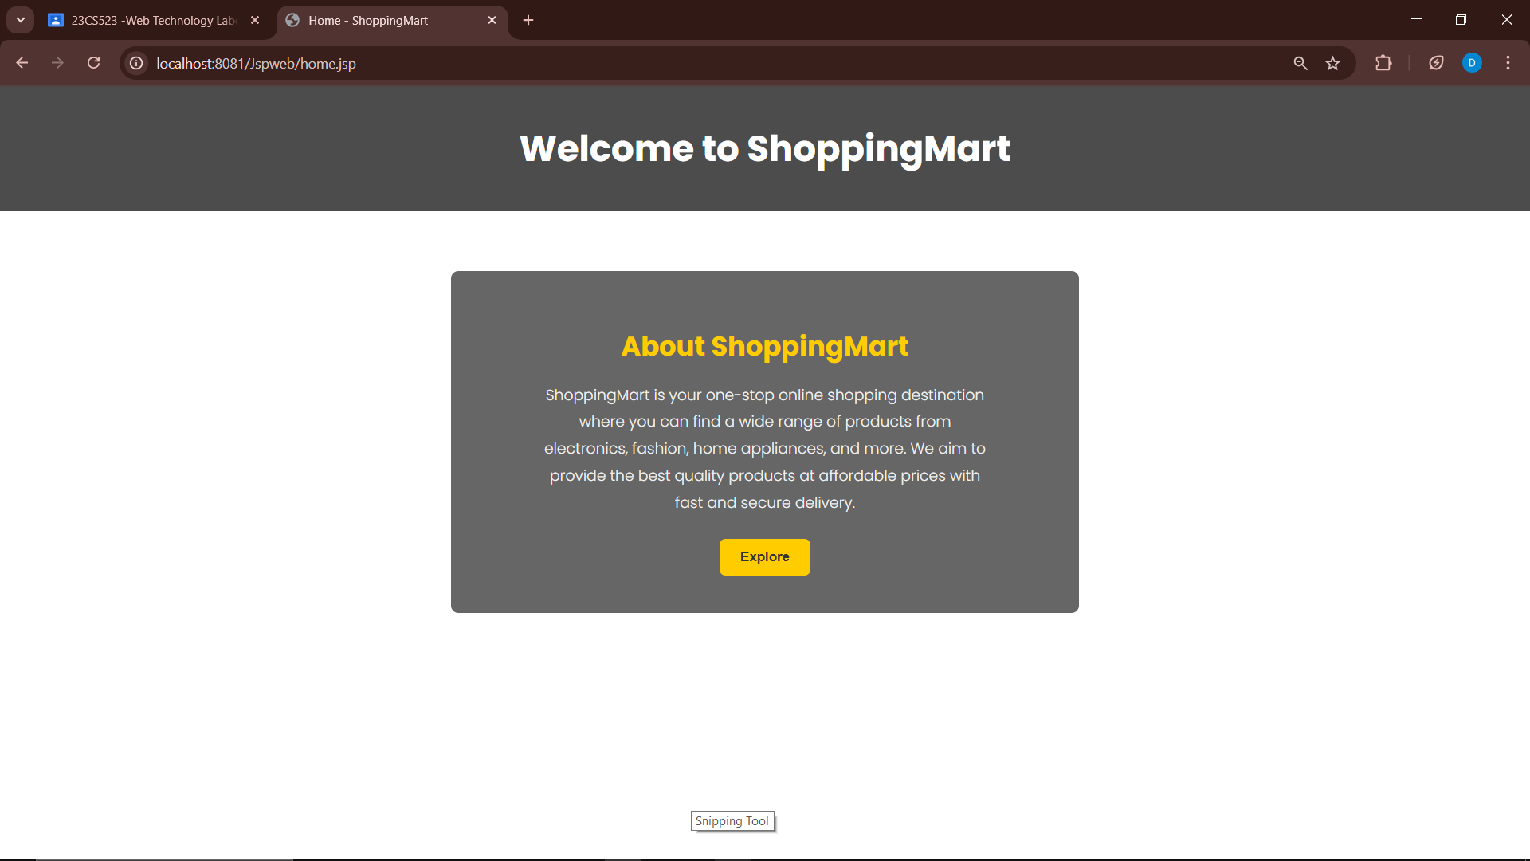

**Front page**

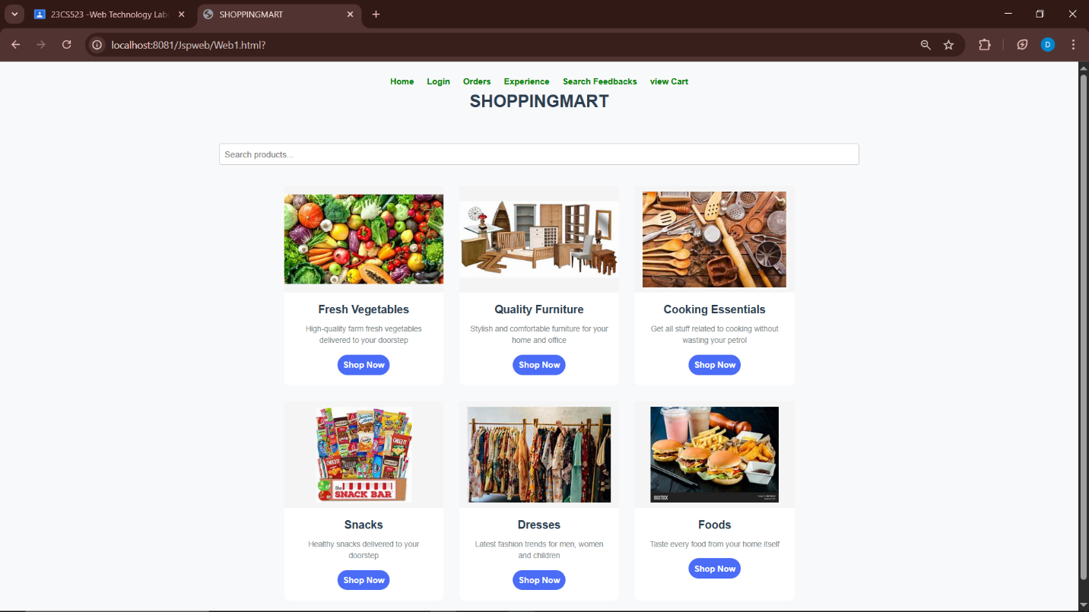

**Login**

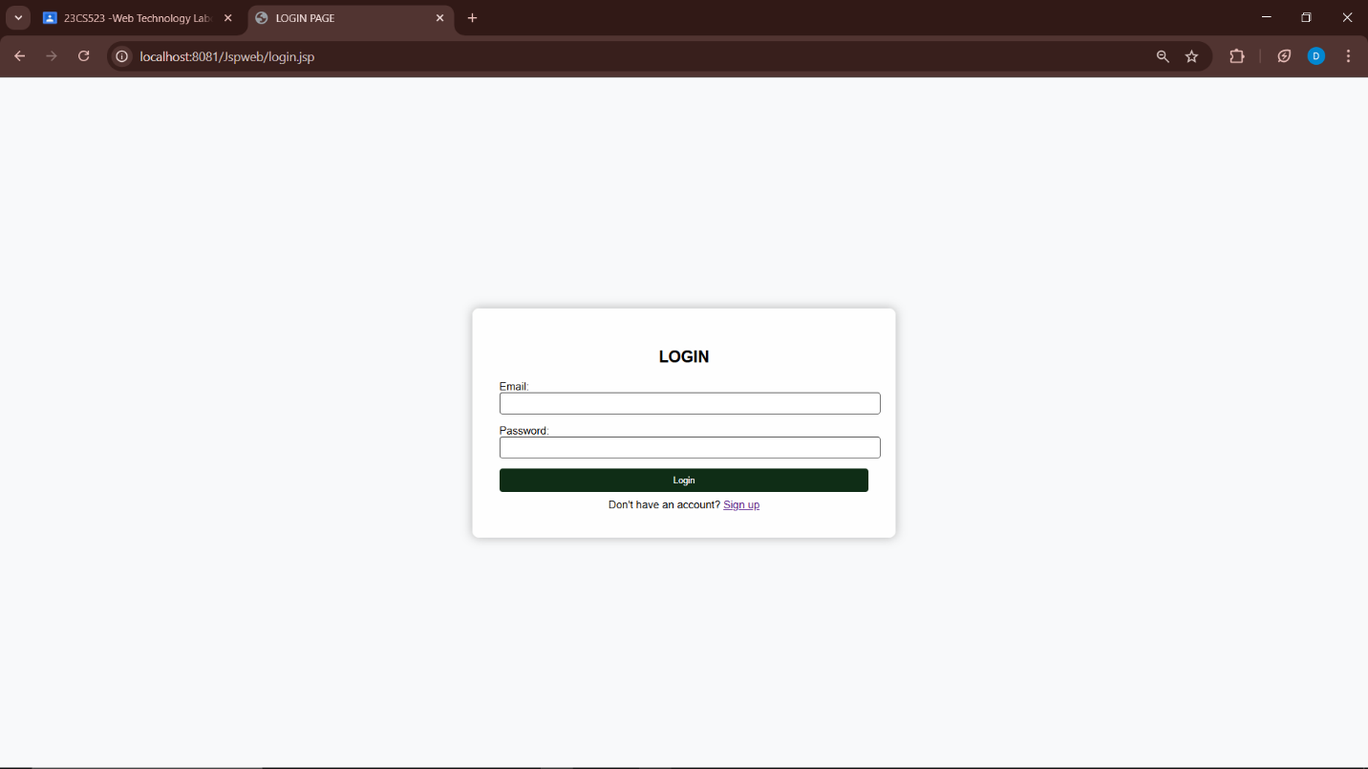

**Signup**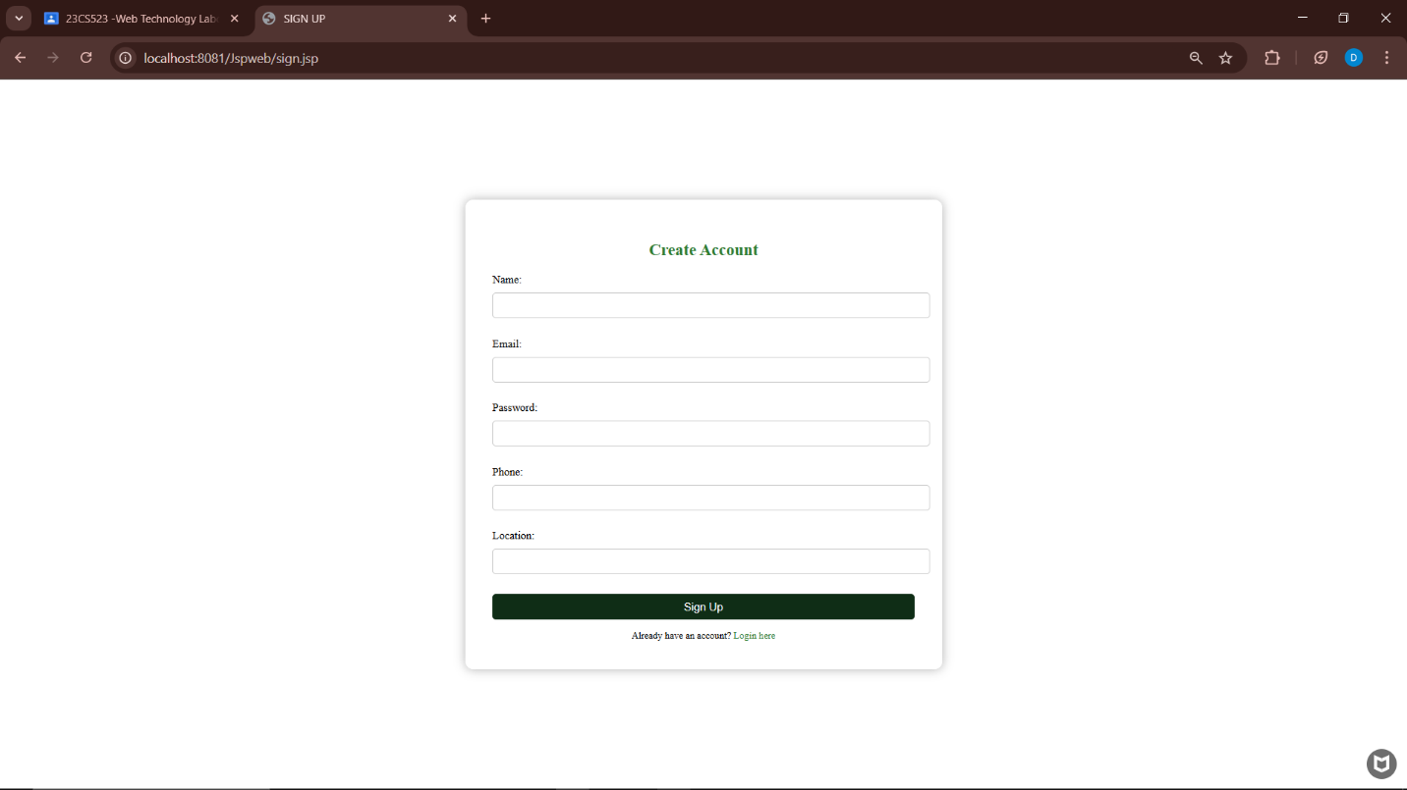

**Product section(vegetable section)**

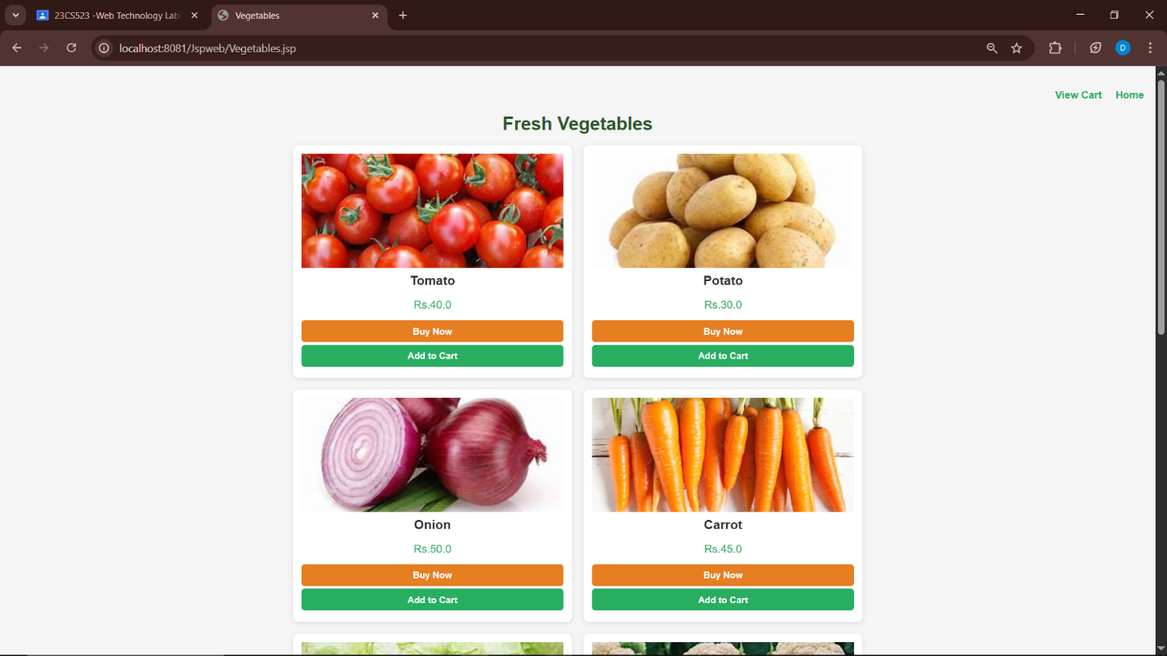

**Add to cart:**

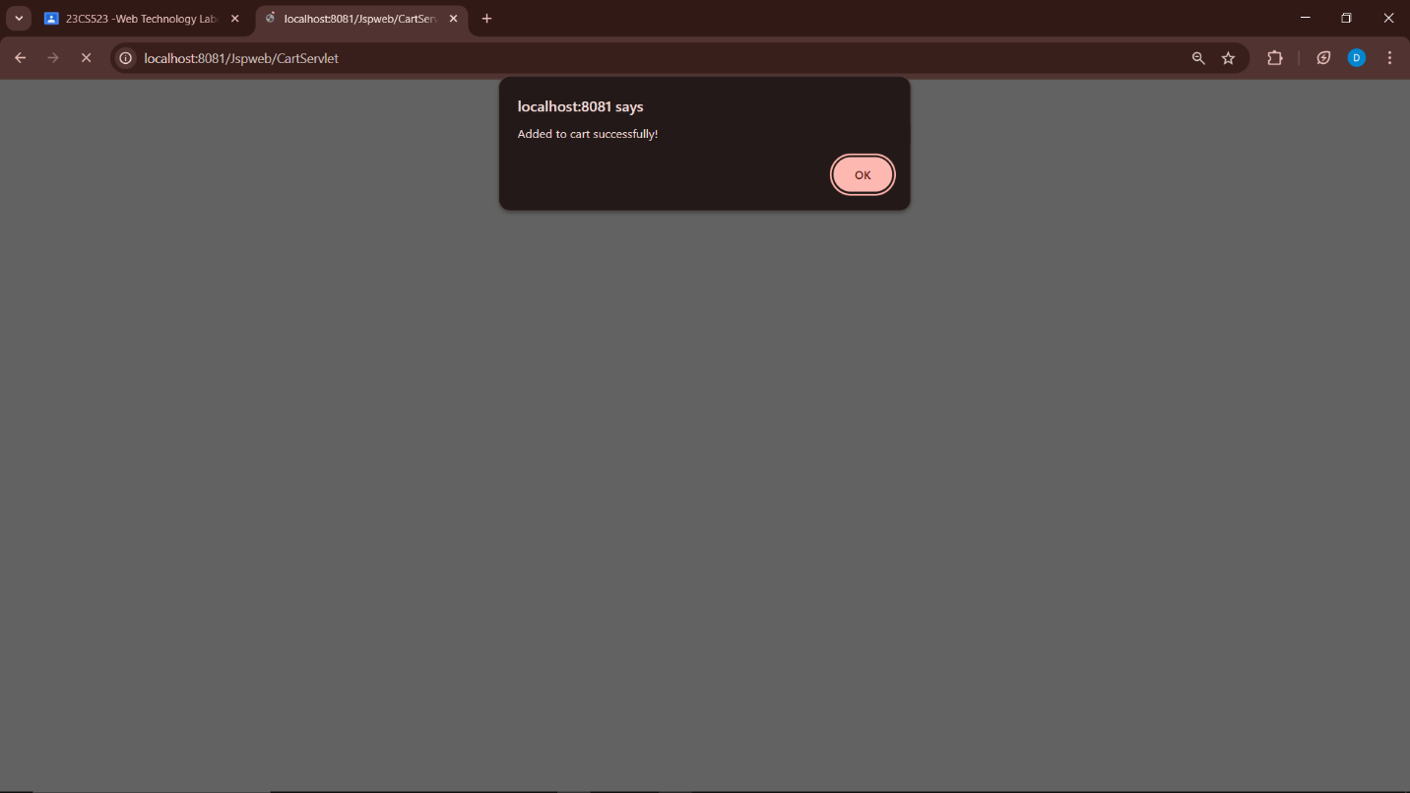

**Cart page:**

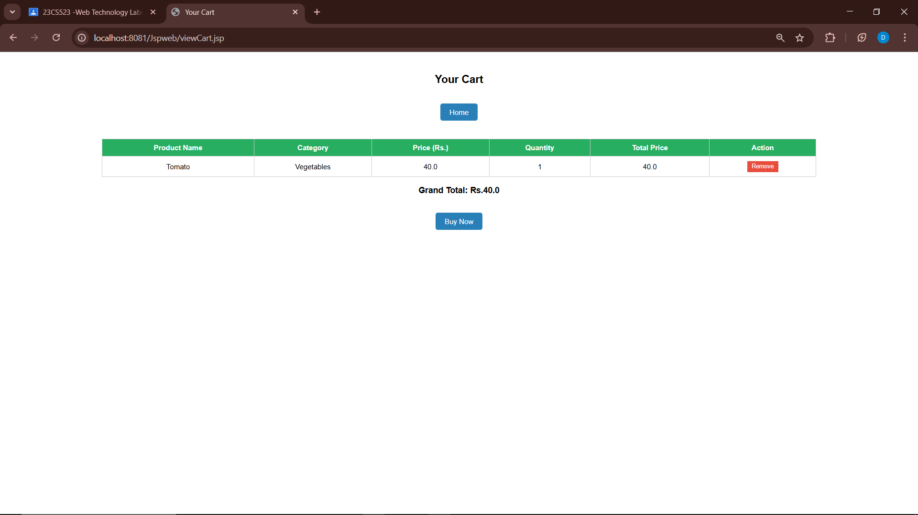

**Orders:**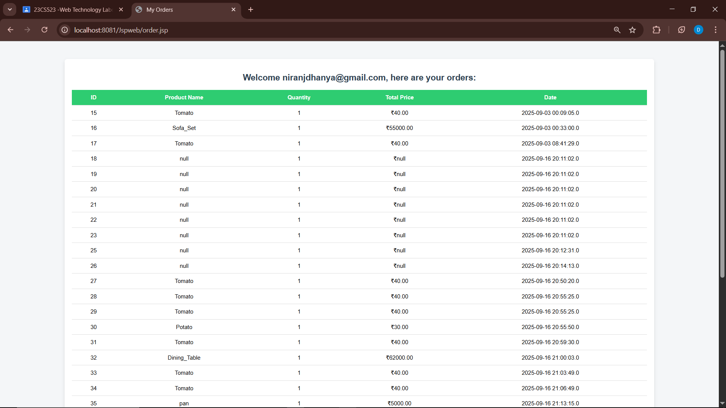

**Order details:**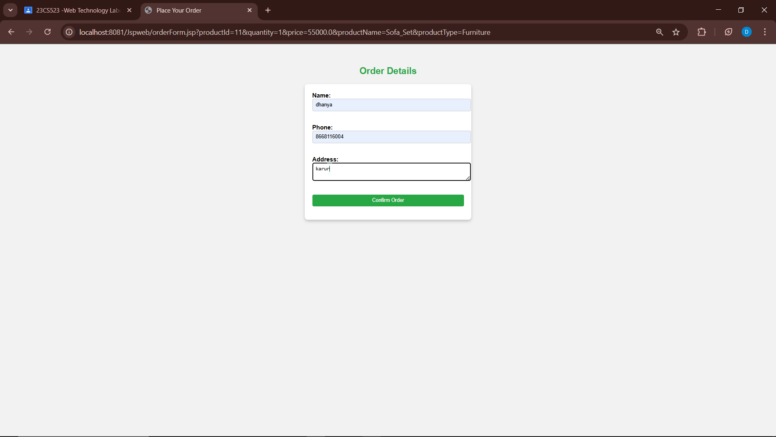

**Order placed:**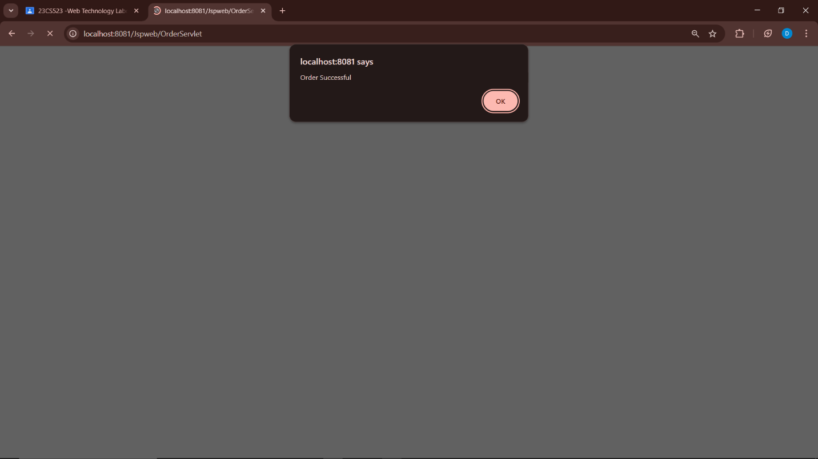

**Feedback:**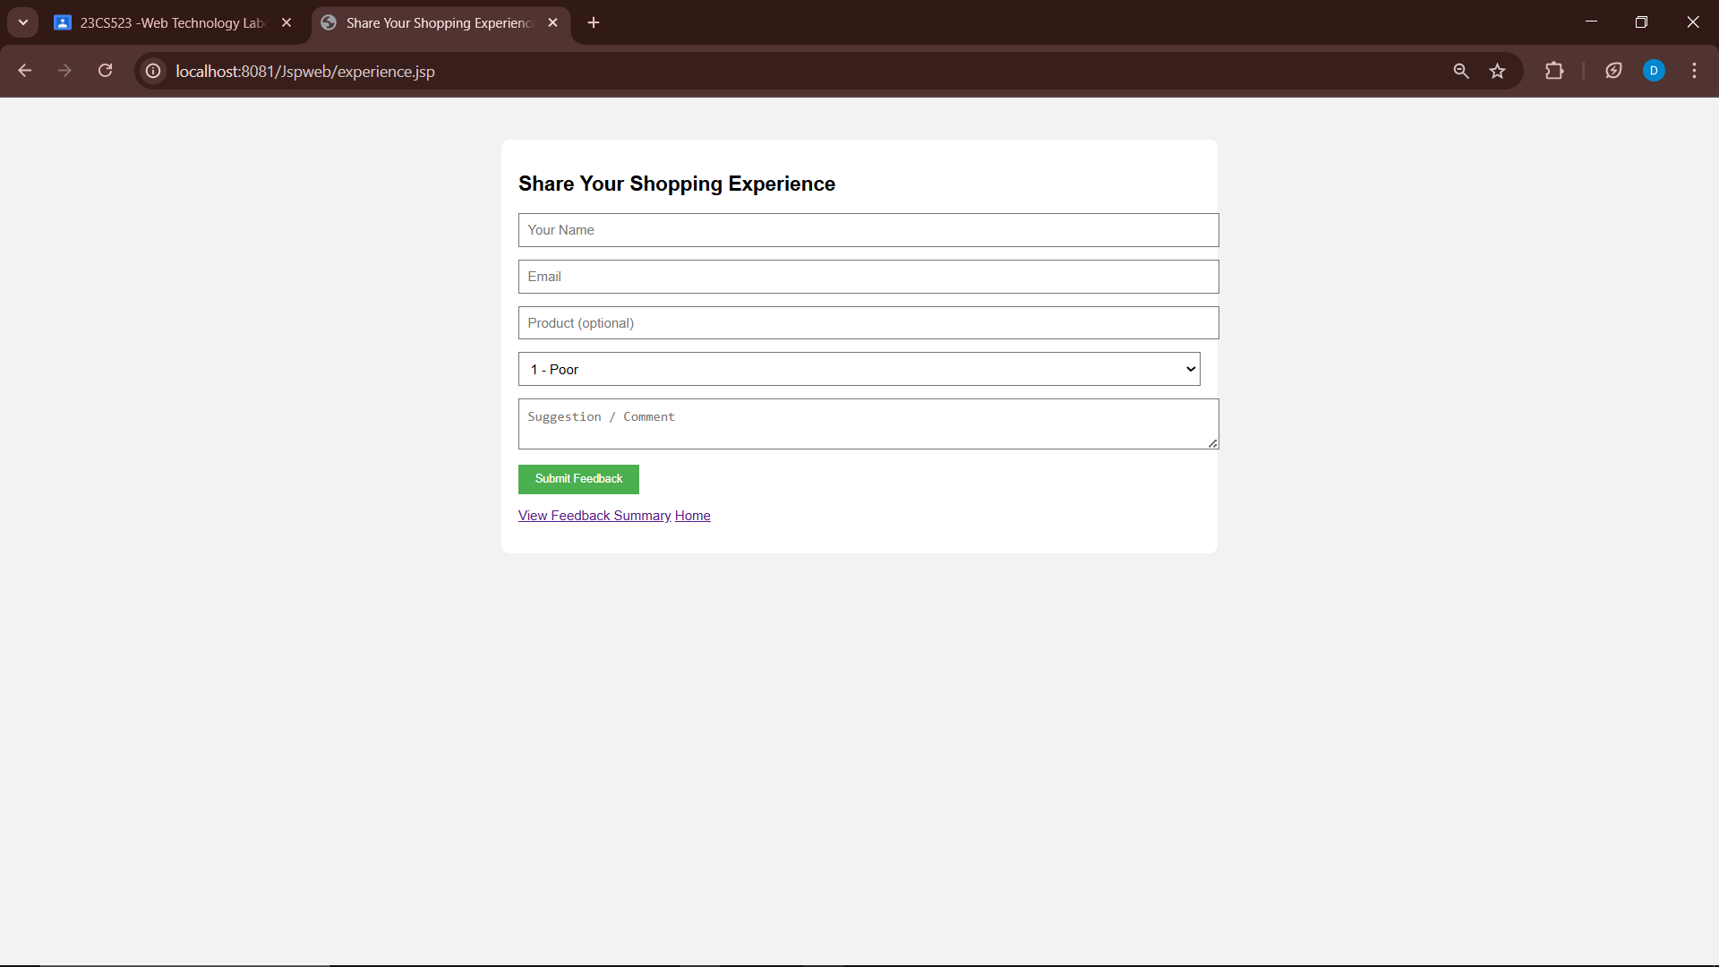

**Feedback Summary:**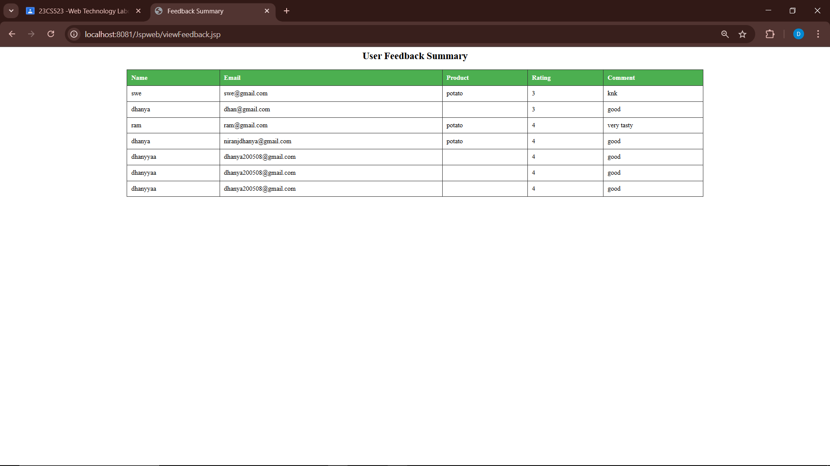

**Filter by Rating(Feedback):**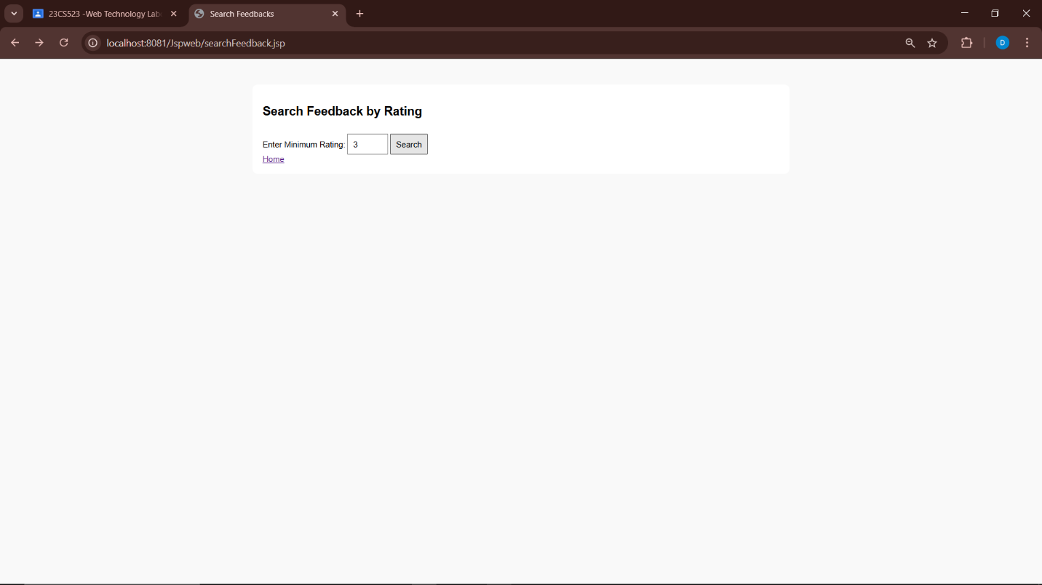

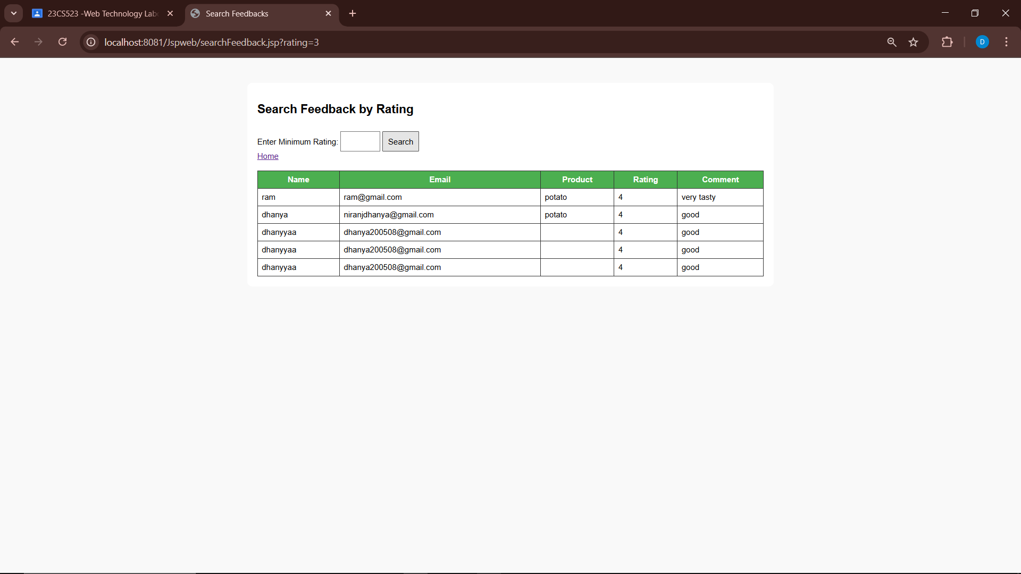

**Search box:**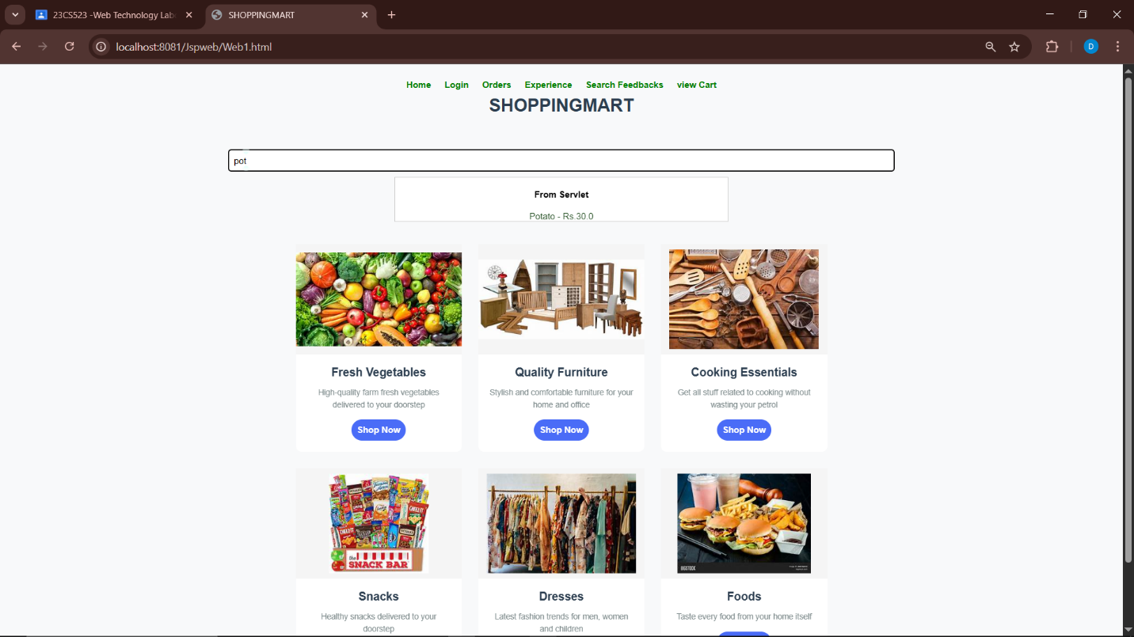

**Backend ScreenShots:**

