alias python=python3 is used to make python3 default;
polylogyx:

To create node in polylogyx server:
1.Type http://<polylogyx server ip>:5000/manage on browser.
2. Download linux cpt file from the server
1.go to dashboard -> download polylogyx installer ->select plateform(linux or windows).
2.download cpt file .

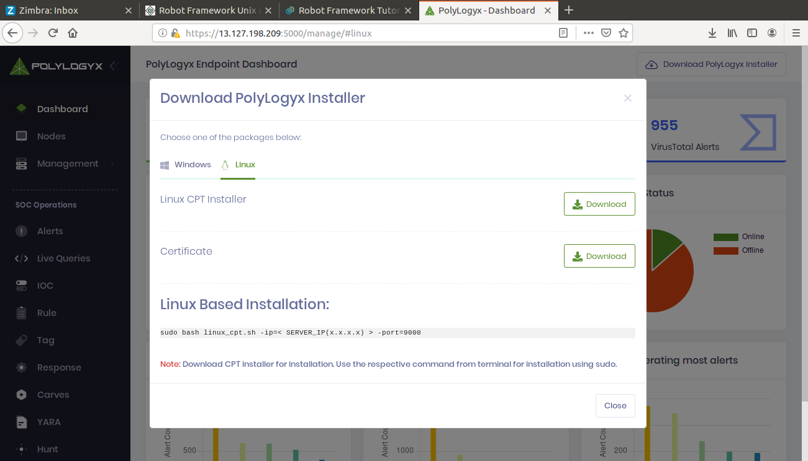
3. copy the linux based installation and paste it in terminal and in the place ip give polylogyx server ip and enter. Then your node will be created on polylogyx Nodes.

