JENKINS

1.What is Jenkins?
Jenkins is a self-contained, open source automation server which can be used to automate all sorts of tasks related to building, testing, and delivering or deploying software.
2.What is Pipeline?
A pipeline has an extensible automation server for creating simple or complex delivery pipelines "as code," via pipeline DSL (Domain-specific Language).

3.What is Jenkins pipelinig?
Jenkins Pipeline is a combination of plugins that support the integration and implementation of continuous delivery pipelines using Jenkins.

Step 1 — Installing Jenkins
1.First, we'll add the repository key to the system.

$ wget -q -O - https://pkg.jenkins.io/debian/jenkins-ci.org.key | sudo apt-key add -

2.When the key is added, the system will return OK. Next, we'll append the Debian package repository address to the server's sources.list:

$echo deb https://pkg.jenkins.io/debian-stable binary/ | sudo tee /etc/apt/sources.list.d/jenkins.list

3.When both of these are in place, we'll run update so that apt-get will use the new repository:
$ sudo apt-get update

4.Finally, we'll install Jenkins and its dependencies, including Java:
$ sudo apt-get install jenkins

Step 2 — Starting Jenkins
Using systemctl we'll start Jenkins:

$ sudo systemctl start jenkins

Since systemctl doesn't display output, we'll use its status command to verify that it started successfully:

$sudo systemctl status jenkins

Output
● jenkins.service - LSB: Start Jenkins at boot time
Loaded: loaded (/etc/init.d/jenkins; bad; vendor preset: enabled)
Active:active (exited) since Thu 2017-04-20 16:51:13 UTC; 2min 7s ago
Docs: man:systemd-sysv-generator(8)

Step 3 — Opening the Firewall
By default, Jenkins runs on port 8080, so we'll open that port using ufw:
$ sudo ufw allow 8080
We can see the new rules by checking UFW's status.
sudo ufw status

Step 4 — Setting up Jenkins
To set up our installation, we'll visit Jenkins on its default port, 8080, using the server domain name or IP address: http://ip_address_or_localhost:8080/

We should see "Unlock Jenkins" screen, which displays the location of the initial password
In the terminal window, we'll use the cat command to display the password:
$ sudo cat /var/lib/jenkins/secrets/initialAdminPassword

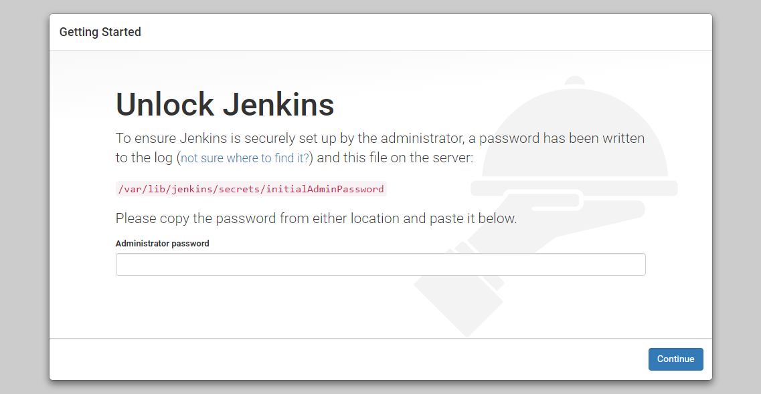

We'll copy the 32-character alphanumeric password from the terminal and paste it into the "Administrator password" field, then click "Continue". The next screen presents the option of installing suggested plugins or selecting specific plugins.
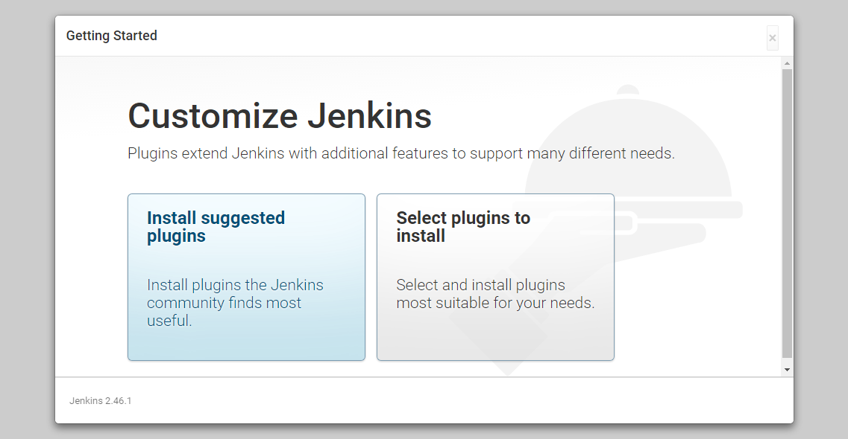

We'll click the "Install suggested plugins" option, which will immediately begin the installation process:
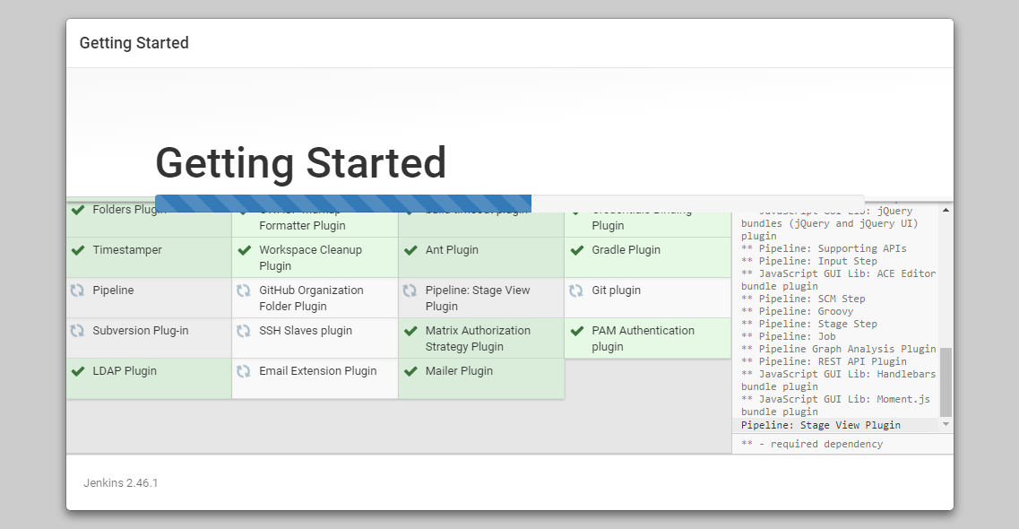
When the installation is complete, we'll be prompted to set up the first administrative user. It's possible to skip this step and continue as admin using the initial password we used above, but we'll take a moment to create the user.
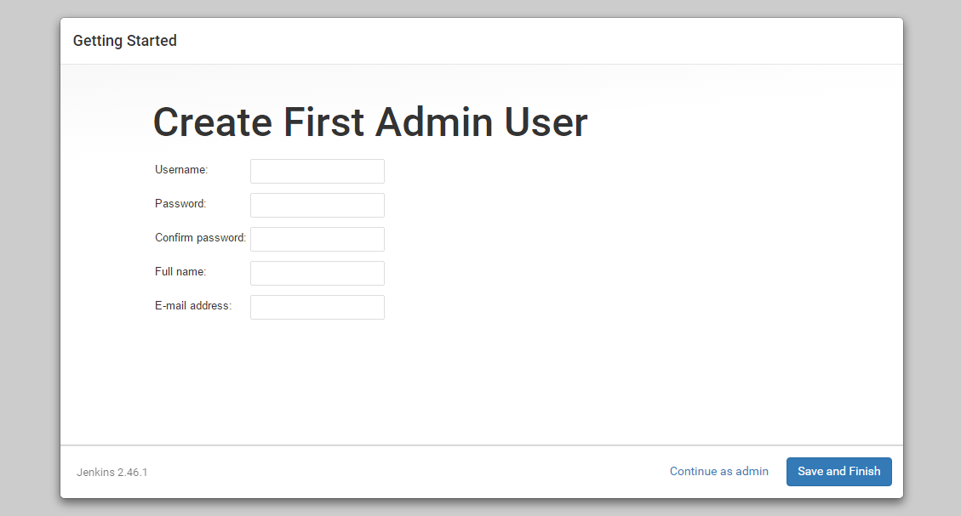
Once the first admin user is in place, you should see a "Jenkins is ready!" confirmation screen.
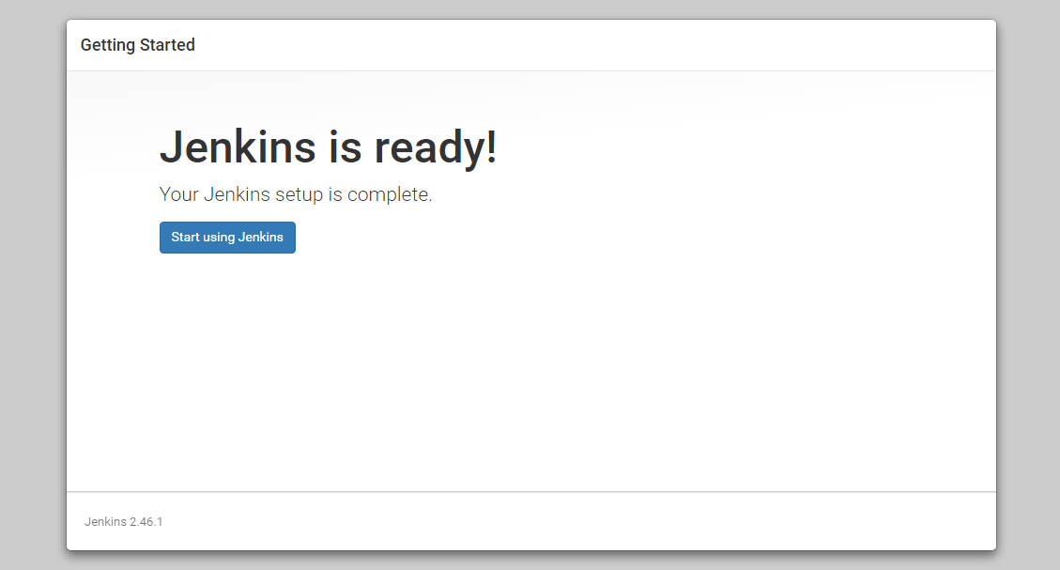
Click "Start using Jenkins" to visit the main Jenkins dashboard:
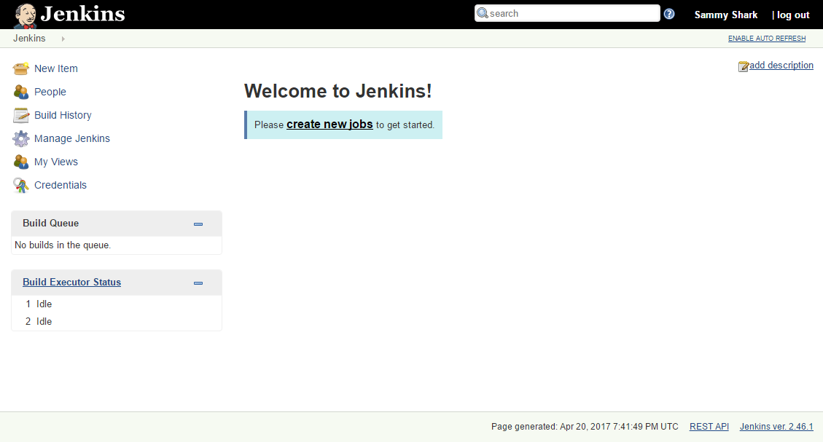
creating new pipeline:
1.Go to new item.
2.Give name and select pipeline.
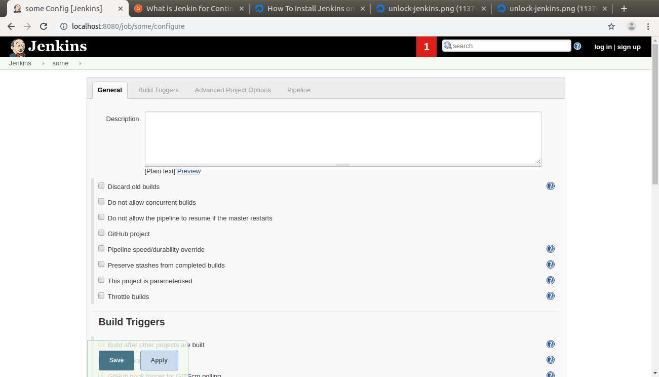
3.

