MINI PROJECT – Marine Plastic Pollution Estimator

Cohort – 12
Sl.No | Member Name | Assigned Role
1 | Dhanyashree K | Model Training
2 | Shreelatha G | Data Cleaning and Feature Engineering
3 | Peeyush Suryan | Documentation
4 | Gurugula Surya Chenna Siva Sankar Reddy | Data Collection
5 | Rajendra Gowda M | Data Collection
6 | Rohan M E | Data Collection
7 | Sukhi R | Data Cleaning and Feature Engineering
8 | Sowjanya B M | Data Cleaning and Feature Engineering
9 | Gagan H R | Data Cleaning and Feature Engineering
10 | Bharath M | Model Training
11 | Saniya Kausar T | Model Training
12 | Tasbeeha F | Model Training
13 | Madan b d | Model Training
14 | Nandish R | Data cleaning
15 | Imrankhan Ghori | Not Active

DAY 1 – Problem Statement Allocation and Initial Research
Date: 25th February 2026
Present Members: Dhanyashree k, Shreelatha G, Peeyush Suryan, Surya Reddy, Sukhi R, Saniya Kausar T, Rajendra gowda M, Sowjanya B M, Madan b d, Bharath M, Rohan, Gagan, nandish
Absent Members: Imrankhan Ghori
Work Done:
- The mini-project problem statement was officially assigned to the team on this day.
- Due to limited time, a formal team meeting could not be conducted.
- All team members independently began researching the assigned problem statement to understand:
The project objective
- Expected outputs
- Possible datasets
- Suitable machine learning approaches
- Initial exploration and background study were initiated to prepare for structured planning from the next day onward.
Note : The members listed under Present Members are those who attended the daily meeting on this date.

DAY 2 – Role Allocation and Environmental Data Acquisition
Date: 26th February 2026
Present Members: Dhanyashree k, Shreelatha G, Peeyush Suryan, Surya Reddy, Sukhi R, Saniya Kausar T, Rajendra gowda M, Madan b d, Bharath M, Rohan, Gagan, nandish, Sowjanya
Absent Members: Imrankhan Ghori, Tasbeeha
Work Done:
1. Project Structuring and Role Allocation
- A one-hour team meeting was conducted to formally initiate the project. Roles were distributed under the following categories:
- Documentation
- Data Collection
- Data Cleaning and Feature Engineering
- Model Training and Testing
The project scope was aligned with SDG 14 – Life Below Water, focusing on estimating ocean plastic leakage using environmental indicators.
The President created a new git hub repository and members instructed to push their respective contributions.
Link: https://github.com/DhanyaSvit/Marine-Plastic-Pollution-Estimator

2. Dataset Collection from Authentic Sources
- The Data Collection team explored and gathered datasets from reliable global sources, including:
Kaggle
Our World in Data
NASA SEDAC
World Bank Open Data
Environmental research portals
- Datasets were shortlisted based on their alignment with the problem statement.
The collected dataset included the following key features:
- Total Population
- Coastal Population
- Coastal Population Density
- % Mismanaged Waste (from total regional waste)
- Mismanaged Waste (tonnes)
- Ocean Plastic Leakage

3. Technical Relevance Assessment
- The team analyzed whether the collected features support the estimation objective:
- Coastal Population Density: Represents the exposure level of waste entering marine systems.
- % Mismanaged Waste: Indicates inefficiency in waste management.
- Mismanaged Waste (tonnes): Direct quantitative contributor to ocean leakage.
- Ocean Plastic Leakage: Target variable for estimation.
Initial validation included:
- Checking feature completeness
- Verifying units of measurement
- Assessing consistency across years/regions
- Confirming suitability for regression modelling

4. Documentation
The documentation team recorded the following:
- Meeting details
- Dataset sources explored
- Feature relevance discussion
- Initial technical validation process
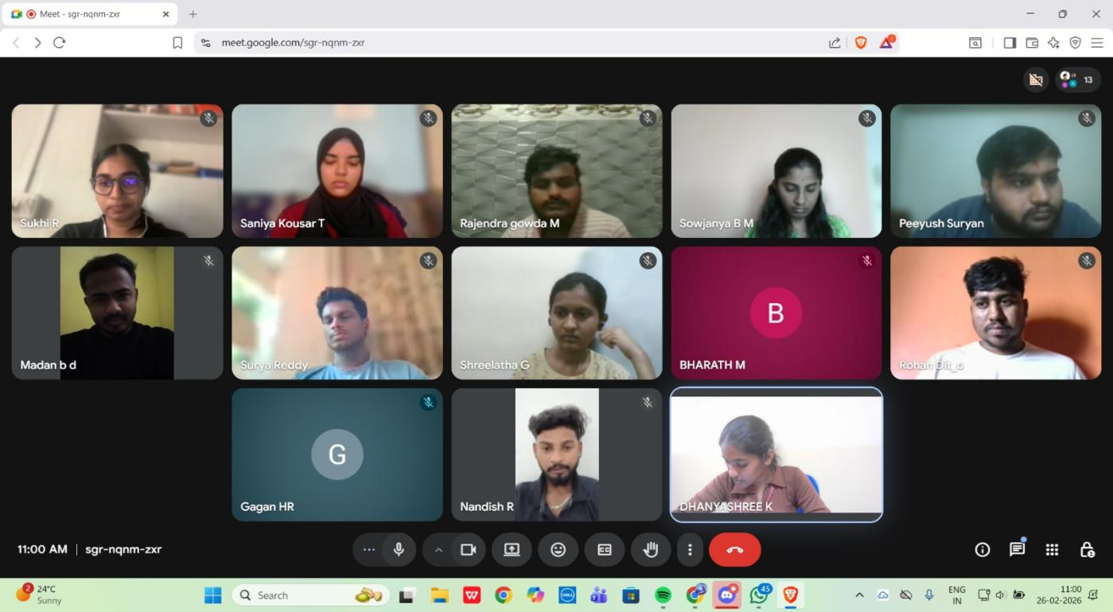

DAY 3 – Data Cleaning, Feature Engineering and Preprocessing
Date: 27th February 2026
Present Members: Dhanyashree k, Shreelatha G, Peeyush Suryan, Surya Reddy, Sukhi R, Saniya Kausar T, Rajendra gowda M, Madan b d, Bharath M, Rohan, Gagan, nandish, Tasbeeha
Absent Members: Imrankhan Ghori, Sowjanya B M
Work Done:
1. Workflow Discussion
- A team meeting (approximately 1 hour) was conducted to discuss the data preprocessing workflow, modeling readiness, and feature preparation strategy.
- All teams continued working on their respective responsibilities.

2. Data Cleaning and Preprocessing Activities
- The Data Cleaning Team conducted a focused working session to preprocess the dataset and prepare it for modeling.
The following technical steps were performed:
- Checked for missing values and handled inconsistencies
- Verified and standardized units of measurement across features
- Checked for duplicate entries
- Validated numerical formatting
3. Statistical Analysis and Transformations
- To ensure suitability for regression modeling:
- Skewness of numerical features was calculated to analyze data distribution.
- Log transformations were explored for highly skewed variables to improve normality and model performance (final usage to depend on model evaluation).
- Distribution patterns were analyzed to decide appropriate preprocessing techniques.
4. Feature Engineering
- A new feature, Mismanaged Waste Index, was derived from the existing % Mismanaged Waste column to create a more model-friendly numerical representation.
- Feature relationships were analyzed to identify multicollinearity risks.
- Dataset structure was finalized for regression modeling.
5. Repository Update
- The preprocessed dataset and preprocessing code were pushed to the GitHub repository.

The documentation team recorded the following:
- Cleaning steps performed
- Feature engineering details
- Statistical analysis conducted
- Repository updates
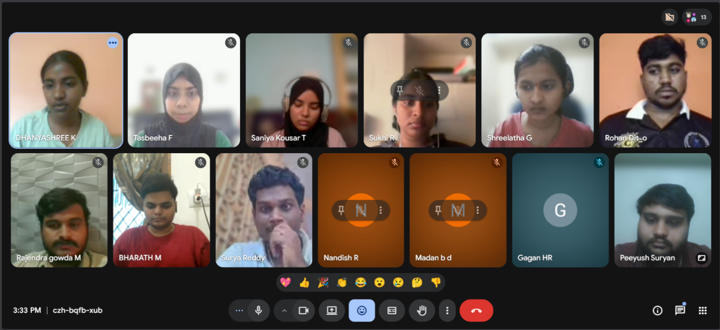

DAY 4 – Model Training and Comparative Analysis
Date: 2nd March 2026
Present Members: Dhanyashree k, Shreelatha G, Peeyush Suryan, Surya Reddy, Saniya Kausar T, Rajendra gowda M, Madan b d, Bharath M
Absent Members: Nandish R, Sowjanya B M, Sukhi R, Rohan, Imrankhan Ghori, Gagan, Tasbeeha F
Work Done:
1. Team Meeting
A one-hour team meeting was conducted to discuss the following:
- Model selection strategy
- Baseline model implementation
- Comparison of different regression approaches
- Evaluation methodology
2. Model Training and Implementation
The Model Training Team implemented and experimented with multiple regression models to estimate ocean plastic leakage.
- Linear Regression (Baseline Model)
- Polynomial Regression (to capture non-linear relationships)
- Decision Tree Regressor
- Random Forest Regressor
- Each model was trained using the preprocessed dataset.
3. Comparative Model Analysis
- Model performance was evaluated using appropriate regression metrics such as:
- MAE
- MSE
- RMSE
- R2 Score
- Performance differences were analyzed to understand:
- Linear vs. non-linear behavior
- Overfitting risks (especially in Polynomial and Tree-based models)
- Generalization capability
4. Repository Update
- Model implementation scripts were pushed to the GitHub repository.

The documentation team recorded the following:
- Models implemented
- Evaluation metrics obtained
- Observations from comparative analysis
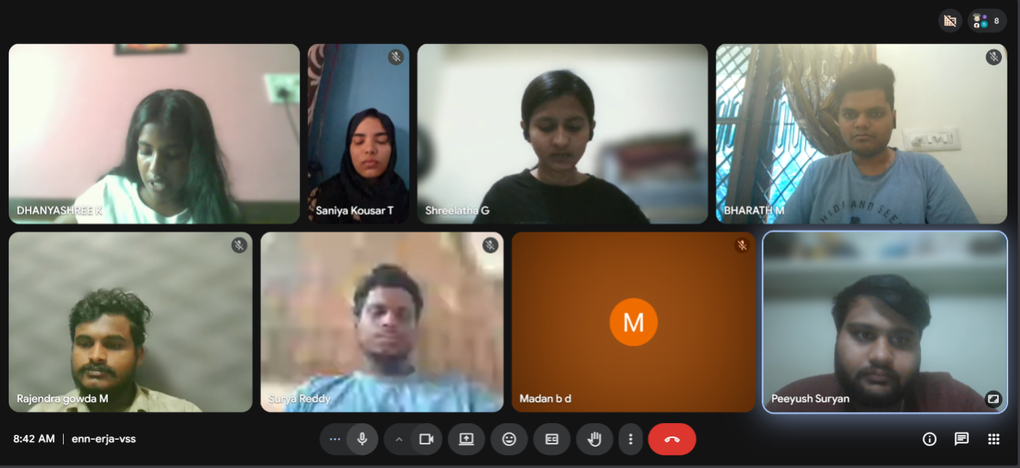

DAY 5 – Model Finalization and Performance Review
Date: 03rd March 2026
Present Members: Dhanyashree K, Shreelatha G, Peeyush Suryan, Surya reddy, Saniya Kausar T, Bharath M, Sowjanya B M , Rajendra Gowda M, Madan B D, Tasbeeha
Absent Members: Sukhi R, Gagan, Rohan, Nandish R, Imrankhan Ghori
Work Done:
1. Project Review Meeting
A team meeting was conducted to review and compare the performance of all implemented models:
- Linear Regression
- Polynomial Regression
- Decision Tree Regressor
- Random Forest Regressor
Each model's performance was discussed in detail based on:
- Evaluation metrics (R2, MSE)
- Generalization capability
- Stability across training and testing datasets
- Handling of feature complexity and non-linearity
2. Evaluation and Model Selection Discussion
During experimentation, when only the two parameters mentioned in the problem statement (Coastal Population Density and Mismanaged Waste Index) were used with Linear Regression, the following results were observed:
- Train R2: 0.9312
- Test R2: 0.639
This significant gap between training and testing performance indicated:
- Poor generalization
- Model instability
- Underfitting/feature insufficiency
After discussion, the team decided to include all relevant features in the model:
- Total Population
- Coastal Population
- Coastal Population Density
- % Mismanaged Regional Waste
- Mismanaged Waste (tonnes)
These features were used as independent variables (X), and Ocean Plastic Leakage was used as the dependent variable (y).
To ensure feature scaling consistency, StandardScaler was applied before model training.
3. Final Model Selection and Performance Evaluation
After comparative analysis, the team finalized the Random Forest Regressor as the final model due to its:
- Better handling of non-linear relationships
- Reduced overfitting compared to Decision Trees
- Higher accuracy and stability
- Improved generalization performance
Final Evaluation Metrics (Random Forest Regressor)
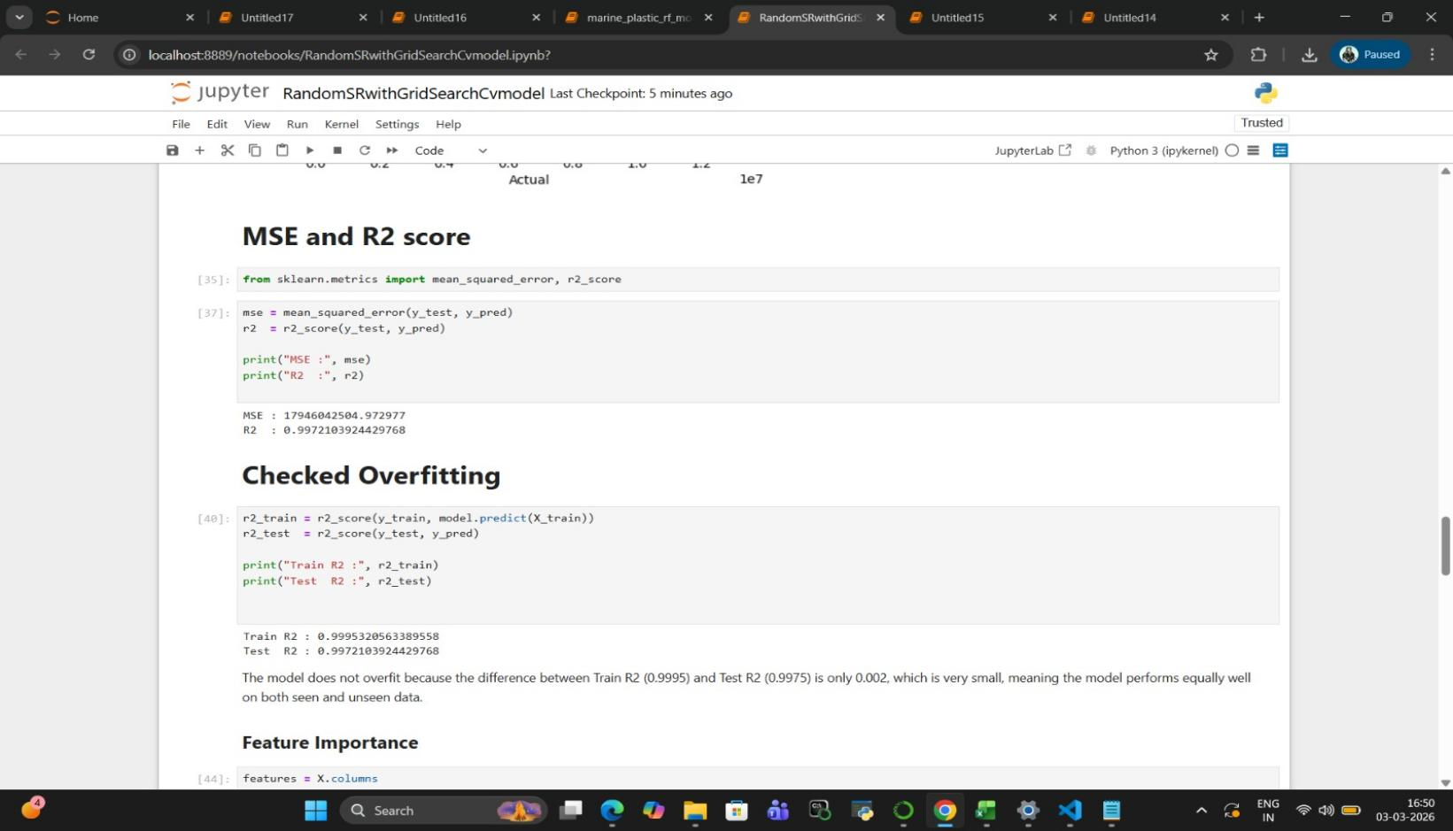
Test Performance:
- Mean Squared Error (MSE): 17,946,042,504.97
- R2 Score (Test): 0.99721
Overfitting Check:
- Train R2: 0.99953
- Test R2: 0.99721
Difference: approximately 0.002
Since the difference between training and testing R2 is extremely small, the model demonstrates:
- Strong generalization
- Minimal overfitting
- High predictive accuracy

Model Performance Visualization
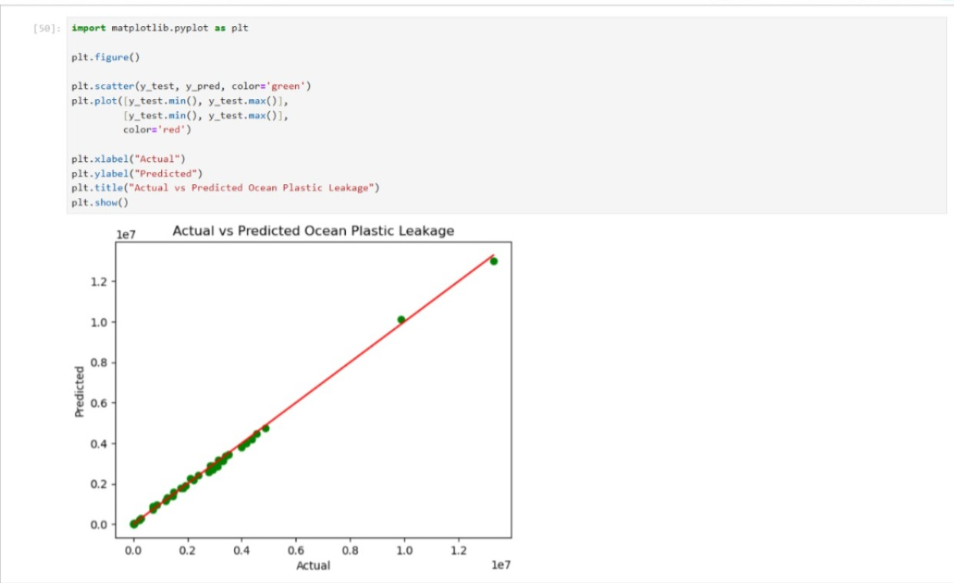
Figure: Actual vs Predicted Ocean Plastic Leakage
- The scatter plot compares actual values with predicted values.
- The red diagonal line represents ideal predictions (y = x).
Observation:
- Most data points lie very close to the reference line
- Very small deviation is observed
- Confirms high model accuracy and consistency
4. Documentation and Submission
Since this was the final day before submission:
- Documentation was finalized and structured
- Implementation details were consolidated
- Model comparison observations were recorded
- Evaluation metrics were updated
- Performance graphs were included
- GitHub repository was verified and finalized
Final Outcome of Day 5
- Final model selected: Random Forest Regressor
- Evaluation metrics computed and validated
- Overfitting analysis completed
- Performance visualization added
- Documentation finalized
- Project prepared for submission
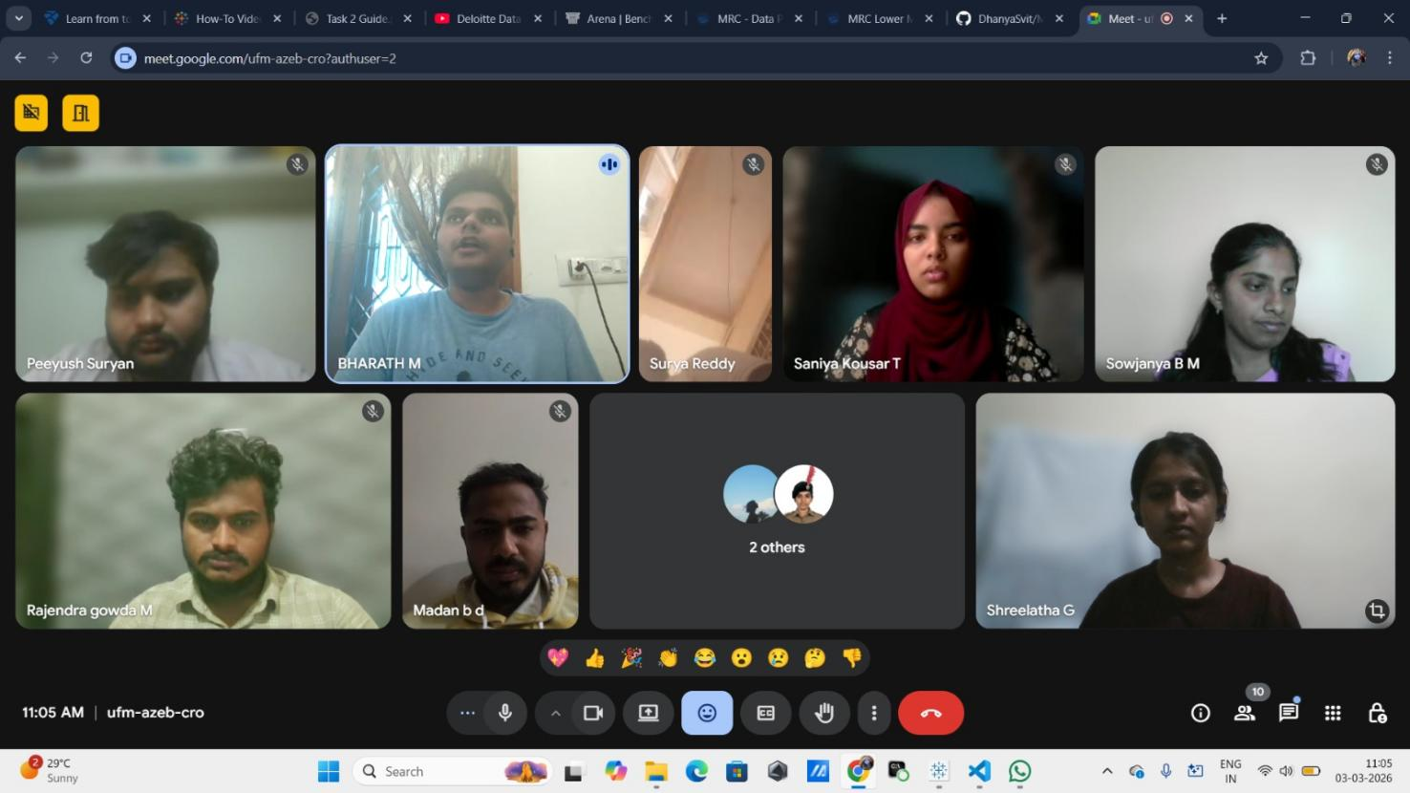

Sl.No | Member Name | Role | Rating (0–5) | Remarks
1 | Dhanyashree K | Modelling Training | 4.8 | Played a key role in organizing meetings and coordinating task distribution within the team alongwith successfully training two models.
2 | Shreelatha G | Data Cleaning and feature Engineering | 4.7 | Played a valuable role in data cleaning, preprocessing, and feature engineering, supporting the overall model development process while demonstrating strong leadership skills.
3 | Peeyush Suryan | Documentation | 4.7 | Managed documentation exceptionally well, consistently delivering clear and timely updates with high reliability.
4 | Gurugula Surya Chenna Siva Sankar Reddy | Data Collection | 4.3 | Demonstrated consistency and reliability by collecting a substantial and steady volume of quality data.
5 | Rajendra Gowda M | Data Collection | 4.3 | Contributed effectively to the project by providing a significant number of valuable datasets and maintained excellent documentation of daily reports.
6 | Rohan M E | Data Collection | 3 | Actively participated in meetings and supported data collection efforts, though overall data contribution was limited.
7 | Sukhi R | Data Cleaning and feature Engineering | 5 | Made a strong impact through data cleaning, feature engineering, and successfully sourcing and processing an additional dataset.
8 | Sowjanya B M | Data Cleaning and feature Engineering | 4.8 | Contributed effectively to the project through data cleaning, preprocessing, and feature engineering efforts.
9 | Gagan H R | Data Cleaning and feature Engineering | 3 | Assigned to data cleaning; however, contributions were not reflected in deliverables and lacked regular progress updates.
10 | Bharath M | Modelling Training | 4.8 | Demonstrated strong commitment in model training by successfully training multiple models and maintaining active and reliable engagement.
11 | Saniya Kousar T | Modelling Training | 4.8 | Contributed effectively to model training and proactively extended her work by generating cross-validation performance graphs also actively participated in team meetings and discussions.
12 | Tasbeeha F | Modelling Training | 4.8 | Actively contributed to model training by developing a Linear Regression model, maintained excellent documentation of daily reports, and proved to be highly reliable.
13 | Madan b d | Model Training | 3 | Involved in model training, though measurable contributions were limited despite reported model development efforts.
14 | Nandish R | Data Cleaning | 3 | Assigned to data cleaning; however, overall contribution and visible participation were limited.
15 | Imrankhan Ghori | Not active | -------- | ------------------------------------------------------------

