QUANTUMSHIELD AI-POWERED PHISHING DETECTION
Ashwini K A Dr. Dharamvir
PG student Professor and HOD
Dept. of Master of Computer Application Dept. of Master of Computer Application
The Oxford College of Engineering (of The Oxford College of Engineering (of
Visvesvaraya Technological University Visvesvaraya Technological University)
Bengaluru, India Bengaluru, India
ashwinikamca2026@gmail.com hodmcatoce@theoxford.edu

Abstract— Phishing continues to pose a genuine threat to the security of digital information systems. Phishing is accomplished by persuading individuals into giving out private or otherwise confidential information via fake sites. Traditional phishing detection remedies are usually slow, do not adjust for changing phishing tactics, and do not provide a usable interface. The development of quantumShield was established to solve these problems through its implementation of an entirely new solution method. Figuring out how to fix these issues led to the creation of quantumShield, built on a fresh way of tackling them. One part runs in Heuristic Mode, another in Machine Learning Mode - both shape how it works. Time gets examined closely here, using methods inspired by behaviors seen in quantum systems. Think simulated superposition, modeled entanglement, along with studying wave-like overlaps. One way the QuantumShield system works is by checking several parts of a web address at once. It looks into how certain elements relate, spotting anything unusual along the way. Instead of just one method, it learns through techniques such as Random Forest combined with Isolation Forest setups. Website material matters, so does where it runs and what actions happen there - these things get studied closely. What sets it apart is the visual layout it offers, walking you through each moment of finding threats while breaking down why those risks exist.
Keywords— URL Analysis, Cybersecurity, Quantum-Inspired Algorithms, Machine Learning, Heuristic Analysis, DNS and WHOIS

I. Introduction

Phishing is the leading online threat to individuals and organizations around the world.Attackers produce phony web addresses and clone sites they have developed that mimic valid sites in an effort to deceive users into disclosing their credentials. The volume and complexity of Phishing attacks have been on the rise as online services have expanded to include banking, education, healthcare, and social networking. Current Phishing Detection Techniques utilize two primary methods which include blacklists and assessments of subject matter experts. Based on my research, the techniques that produce immediate results are not particularly beneficial for new sites that have recently gone live.Danger spreads wide because so many daily tasks need web access. Although some tools rely on blacklists and advice from anti-phishing experts, others take a different path entirely.When testing responses to fresh domains, slow reactions turned out worse than expected. Systems built on machine learning often learn from history, though even pros struggle to explain how they really work. The Web Address and Host are also verified for accuracy prior to the confirmation that the site is secure.Through conducting these types of checks, QuantumShield can determine if a given website/URL is secured enough that QuantumShield will be able to let people know if they should visit the site. One of the methods that they use in conducting these checks is through content analysis, which includes evaluating word meanings to determine if a brand name is being used in an inappropriate manner and how frequently consumers have been scammed by similar patterns that are commonly seen while conducting phishing attacks. This type of analysis is beneficial in understanding how phishing scams are derived and how consumers can be deceived. It also aids in ease of maintenance of the system and adding future enhancements.

II. BACKGROUND

The basis for the dissection of QuantumShield includes four broad levels that are all differently categorized to accommodate a unique element of a URL. Honestly, every element of a url gets a thorough examination as a result through levels.
- Lexical Analysis (URL Structure-Based Analysis) : The other is lexical analysis, which focuses on the analysis through URLs and the determination of the components of URLs rather than accessing the website's data. This takes a short time and is employed for analysis of the patterns for phishing attacks.

- Host-Based Analysis (Domain and Registration Analysis) : Host-based analysis involves the scrutiny of data associated with domain hosting the URL in question. The analysis can help in knowing the legitimacy and trustability of a website. Phishing pages are typically hosted on newly registered domains or “suspicious” top-level domains. Hosting analysis assists in detecting trusted versus possibly malicious domains.

- Network-Based Analysis (Protocol and Connectivity Analysis) : Analysis of networks examines URL network characteristics in regard to connectivity and complexity. Trustworthy sites use proper security networking practices. IIII. Risk-Based Analysis By using Network Analysis on insecure URLs, it is possible to locate URLs with little or no security settings.

- Content-Based Analysis (Keyword and Semantic Analysis) : The Content based Analysis Method utilizes the common textual cues (keywords, phrases) found in phishing attacks to identify the text associated with these attacks. Instead of searching a Google Search Engine and downloading the entire page, the Content based Analysis System only looks for tokens with a Domain Name (URL) and the keywords and phrases that related to Phishing attack.

III. LITERATURE REVIEW

The initial phishing detection systems from their early period only used two methods which involved matching [3]blacklists and applying static rules. The system detects all known threats successfully through its detection methods but it does not detect new phishing attacks which have not yet been discovered.[5]Researchers developed machine learning models which included decision trees and support vector machines and neural networks to create patterns for phishing detection based on previous data[1]. The latest investigations show that combined detection methods which use heuristic evaluation and machine learning systems work effectively together.[7]The methods used in URL lexical analysis and DNS inspection and WHOIS verification and anomaly detection achieved successful results. The current solutions present two major issues because they do not provide explainability and their visualizations lack user-friendly design which results in reduced trust and adoption from users.
A.Existing system
These systems wer capable because it is fast and can give answers quickly. [8]They are not very flexible. If someone tries to trick people through phishing method that do not repeat the old rules phishing detection systems often do not catch it means they are poor at stopping new types of attacks. phishing detection systems like these have a problem, with phishing techniques.

B.Proposed system
The quantumshield phishing detection system is better because it uses these two methods together. The heuristic mode is made for looking at website address in time without needing to train the system first. It uses ideas from physics like simulating many things at once modeling how things are connected and looking at patterns but it does this on regular computer.

The research base of QuantumShield expands through its development of quantum-inspired heuristic evaluation and ensemble learning models and adaptive switching systems and visual explanations which enhance detection efficiency and user learning.
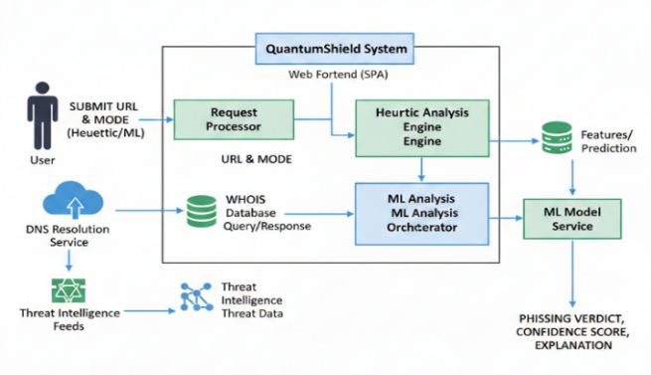
IV. METHODOLOGY

Fig 1. System Architecture

The proposed system detects phishing websites by analysing URL characteristics using a hybrid approach that combines heuristic rules and machine learning techniques. This approach supports offline analysis while also providing accurate real-time detection.

A. System Overview
The system takes a URL as input and classifies it as either Legitimate or Phishing. It operates in two modes:
- Heuristic Mode for offline analysis
- Machine Learning Mode for online, real-time analysis
The output includes the classification result with a brief explanation of the associated risk.

Heuristic-Based Analysis
This mode uses predefined rules to identify phishing indicators without internet access. It analyses factors such as URL length, special characters, IP address usage, suspicious keywords, uncommon TLDs, and URL randomness. A cumulative risk score is calculated to classify the URL as legitimate or phishing.

Machine Learning-Based Analysis
This mode improves detection accuracy by learning patterns from labelled URL data and requires internet access for domain verification.

- Feature Extraction: Key numerical features such as URL composition, subdomain count, HTTPS usage, DNS resolution, and domain age are extracted for analysis.

- Model Training: A supervised learning approach is used with a Random Forest classifier. Feature scaling is applied, and the trained model is stored for real-time prediction.

- Classification Process: Extracted features are evaluated by the trained model to assign a binary classification: Legitimate or Phishing.

Result Interpretation
The system presents the classification result along with a short explanatory message to help users understand the potential risk of the URL.
A fresh look at security begins with QuantumShield scanning every angle. One moment it probes encryption strength. Next up, trust certificates get a close examination. Sometimes redirects reveal hidden risks - those never slip past. Pages loading over questionable connections? Automatically flagged.Each check runs without fanfare. Safety emerges through quiet precision.

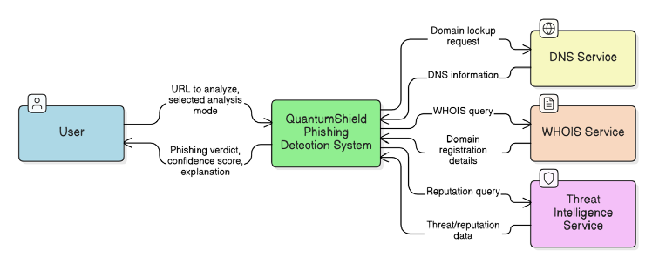
V. SYSTEM WORKFLOW
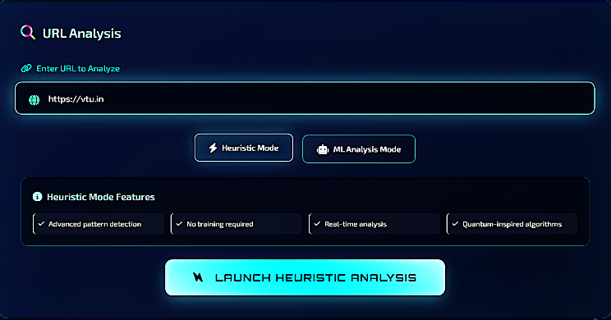
The QuantumShield system follows a structured multi-stage workflow that ensures both efficiency and accuracy in phishing detection.
Fig 2. Heuristic-Based URL Inspection Workflow
Fig. 2 illustrates the heuristic analysis workflow where URLs are evaluated using lexical patterns, entropy measures, and structural characteristics. This stage enables instant screening without relying on prior training data.
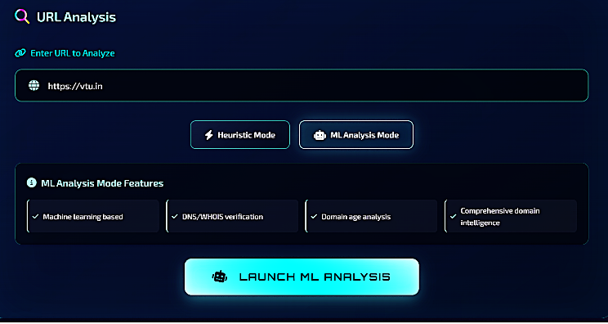
Fig. 3. Machine Learning-Based URL Classification Pipeline
Fig. 3 represents the machine learning pipeline where extracted features are classified using ensemble models. DNS and WHOIS verification enhance contextual awareness.
A prediction forms when the phishing detector uses machine learning methods. Pulling clues from sources such as DNS and WHOIS, it taps into threat data feeds too. After gathering these details, a score emerges - shaped by how the model weighs what it finds.
VI. IMPLEMENTATION
QuantumShield is implemented using Python as the core programming language. Flask is used to develop the backend services, enabling real-time URL analysis. Feature extraction is performed using NumPy and pandas, while machine learning models are implemented using scikit-learn.Isolation Forest is used to identify anomalous URL behavior by learning normal patterns from legitimate URLs.

Fig 4. Context diagram of QuantumShield

1.Superposition Simulation
The Superposition simulation demonstrates a quantum-inspired algorithm which simultaneously applies multiple hash functions to a single URL.
The system can conduct simultaneous analysis of various structural representations for the same URL, which enhances its ability to detect hidden phishing patterns.
2. Entropy Measurement
The measurement of entropy uses information theory to determine the degree of random elements which exist within a URL. Phishing URLs typically use randomly generated characters to evade detection, while higher entropy values indicate suspicious activities.
3.Pattern interference
employee pattern interference demonstrates quantum behavior through the examination of extracted URL features. The algorithm achieves pattern matching improvements through its analysis of multiple features which determine their impact on each other.
4. Random Forest
The Random Forest algorithm operates as a supervised machine learning system which uses multiple decision trees to identify URL classifications. The system achieves better accuracy through its ability to combine different predictions while remaining resistant to excessive fitting.
5. Isolation Forest
The system uses Isolation Forest to detect anomalies by isolating abnormal URL patterns. The system identifies URLs which show extreme variations from typical patterns as potentially dangerous.
6. Fuzzy Logic
Fuzzy Logic operates through its capacity to create partial membership between authentic and phishing distinctions which exist within uncertain circumstances.
7. Similarity Scoring
The process of measuring similarity uses Levenshtein distance to evaluate domain names against established legitimate domains. This helps detect typosquatting and brand impersonation, which are common phishing techniques.

8. Entropy-Based Randomness Detection
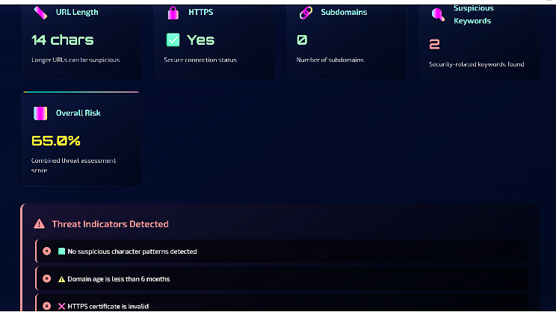
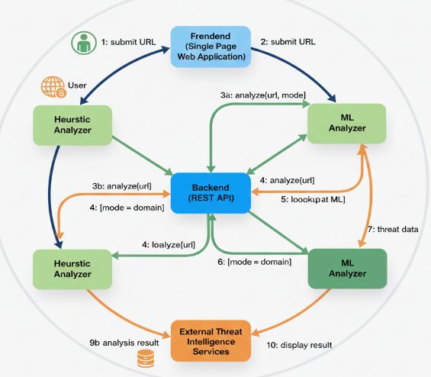
The algorithm analyzes character distribution patterns to evaluate URL structure randomness through its randomization assessment method. The method identifies hidden URLs and machine-created URLs which improve phishing detection capabilities.
Fig 5. Collaborative diagram
Each analysis module contributes a confidence value rather than a binary decision. The mapped values create fuzzy membership functions that depict three levels of phishing risk which are low, medium, and high. The fuzzy inference system uses these membership elements to generate a final classification that includes confidence weights. The system improves its performance by reducing sudden classification errors while maintaining stability in its evaluations of borderline situations. The system implements gradual risk evaluation instead of immediate URL blocking which enables users to make better choices about security threats. The aggregation method which provides clear explanations of its process improves both user confidence and analyst verification activities.

VII. RESULT AND DISCUSSION

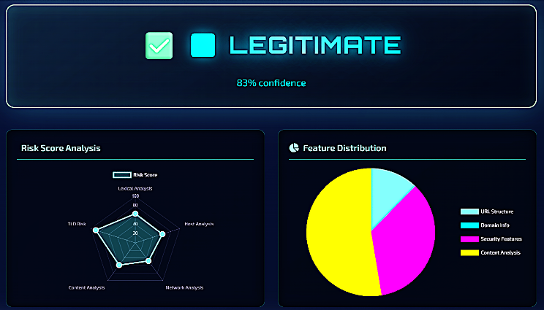
The testing used a collection of real and phishing URLs for its experimental evaluation process.
Fig. 6. Heuristic Analysis Output

The heuristic analysis stage plays a critical role in enabling real-time phishing detection without relying on historical training data. This approach is particularly effective against zeroday phishing attacks, where newly generated URLs are not present in existing datasets or blacklists. Heuristic inspection focuses on identifying suspicious characteristics commonly observed in phishing URLs. These include excessive URL length, abnormal use of special characters, random-looking strings, misleading subdomain structures, and entropy irregularities. Attackers often use such obfuscation techniques to bypass traditional filtering mechanisms.
Fig 7. Confidence factors detected by heuristic mode
QuantumShield enhances heuristic analysis by applying quantum-inspired evaluation principles. Instead of checking rules sequentially, multiple heuristic indicators are evaluated in parallel, similar to quantum superposition. Each indicator contributes a weighted influence toward the final suspicion score. By aggregating heuristic evidence in real time, the system can rapidly classify simple phishing URLs with minimal computational overhead. This significantly improves response time while maintaining acceptable detection accuracy.
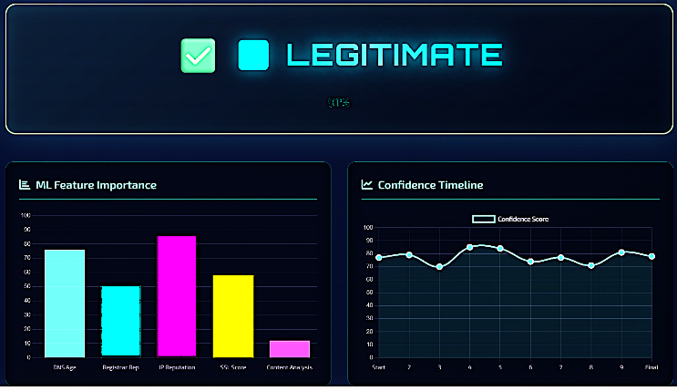
Fig. 8. Machine Learning Classification Result

The machine learning analysis stage is designed to handle complex and borderline phishing URLs that cannot be confidently classified using heuristics alone. The current stage uses ensemble learning methods together with domain-specific contextual checks to conduct thorough assessments. The Random Forest classifier system detects known phishing threats through its analysis of labeled training datasets. The models evaluate different feature combinations which include URL structure, domain attributes, and lexical analysis. Random Forest achieves better system stability through its multiple tree decision aggregation method which also decreases model overfitting.Isolation Forest stands as an additional method for anomaly detection alongside its primary function of supervised machine learning. This unsupervised model identifies URLs that deviate significantly from normal browsing behavior. Detection through deviation-based methods proves effective for discovering new phishing threats. The DNS and WHOIS verification methods establish domain classification accuracy through their assessment of domain registration details and hosting pattern verification together with domain age verification. The system considers any domain which has been registered recently or which changes its registrar frequently as a higher-risk indicator.

The system achieves better accuracy results with fewer false positive errors through its integration of heuristic analysis together with machine learning methods. The experimental results demonstrate the effectiveness of the dualmode detection strategy employed by QuantumShield. The system detects clearly malevolent URLs through heuristic analysis while machine learning analysis delivers precise results for complicated situations.

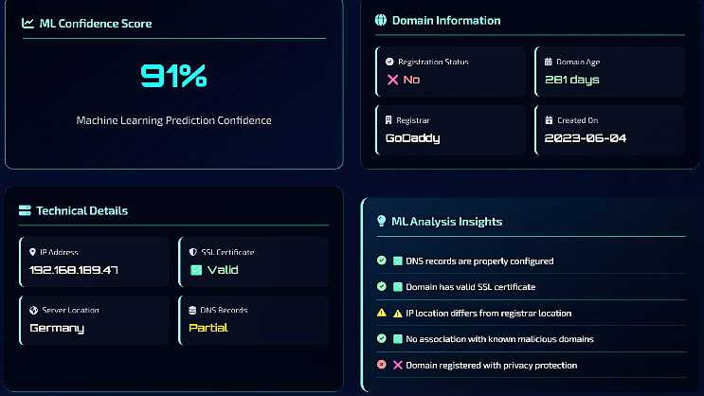
Fig. 9. Phishing Probability Score Visualization

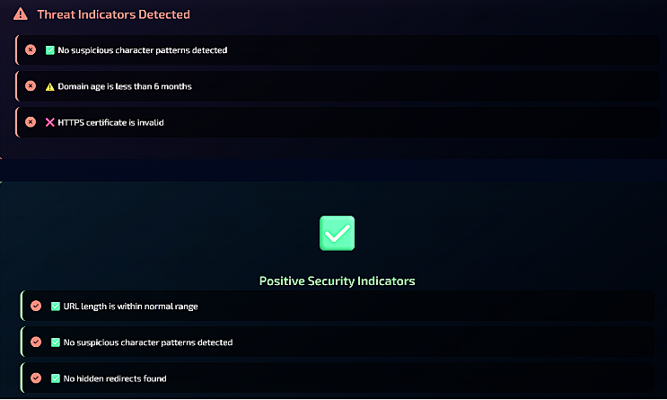
The heuristic output confirms that suspicious lexical patterns are detected efficiently without delay. This is particularly beneficial in real-time environments such as email gateways and browser-based protection systems.Machine learning outputs provide probability-based classification rather than simple binary labels. Risk scores enable analysts to understand the severity of threats and prioritize responses accordingly. This layered interpretation reduces false positives and prevents unnecessary blocking of legitimate websites.
Fig. 10. Final URL Classification Output

The integration of visualization further enhances interpretability by allowing users to visually assess phishing risk. Such transparency bridges the gap between automated detection and human understanding.The dashboard provides explainable insights, risk scores, and detailed output interpretation. The QuantumShield dashboard acts as a centralized interface for monitoring phishing detection activities. It displays URL classification results, confidence scores, and detailed explanations generated by the system.
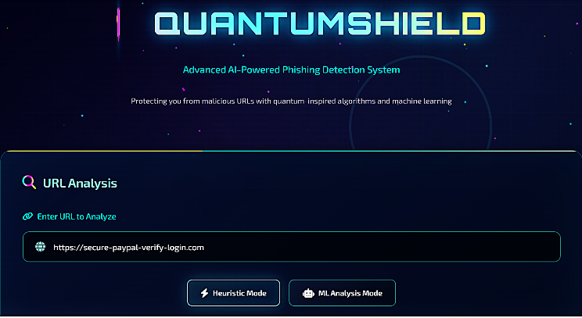
Fig 11. QuantumShield Dashboard Interface

By presenting analysis outcomes in a structured visual format, the dashboard enables faster decision-making. Security analysts can review flagged URLs, verify detection reasoning, and take appropriate action. Non-technical users also benefit from simplified risk indicators.

The dashboard supports explainable security by ensuring that automated decisions are not hidden from users. This transparency improves adoption and trust in phishing detection systems.
VIII. TESTING AND VALIDATION
Unit testing validated individual modules such as preprocessing, heuristic analysis, and classification. Integration testing ensured smooth interaction between modules. System testing confirmed correct behavior under real-world URL inputs. The system development team conducted testing experiments with a collection of authentic websites and phishing websites to determine system performance accuracy and system performance reliability. The two evaluation methods of heuristic testing and machine learning testing were assessed through separate testing procedures. The test group used heuristic mode in an offline environment to assess URLs which displayed suspicious behavior through their use of IP addresses and special characters and uncommon domain names while testing legitimate URLs to find false positive results. The machine learning mode was tested online using real-time domain information and previously unseen URLs. Standard evaluation measures such as accuracy, precision, and recall were used to validate performance. The results showed consistent and reliable classification, and the explanatory output correctly reflected the detected risk level.

IX. COMPARATIVE ANALYSIS
The implementation of QuantumShield provides superior detection capabilities against zero-day phishing attacks when compared to traditional methods which utilize blacklist-based detection systems. The system of blacklist-based systems depends on URL database which contains known threats so it cannot identify fresh phishing websites that have emerged or those that alter their content rapidly. QuantumShield uses structural and behavioral URL analysis to detect threats which lack established records. The system developed by QuantumShield provides enhanced protection against evolving security threats because of its dynamic operational capabilities.
The proposed system utilizes multiple predictive methods to achieve both fast detection and accurate results because it switches between operational modes. The heuristic mode provides fast, offline detection for immediate risk assessment, while the machine learning mode offers deeper analysis using real-time domain information. The system achieves reliable classification results through its combination which eliminates unnecessary waiting times.
Explainable detection process which QuantumShield provides serves as another important benefit for users. Existing phishing detection systems function as black-box models which provide classification results to users without revealing the underlying decision process. The final decision of QuantumShield includes clear explanations which solve this problem. The system provides users with verification methods which security analysts can utilize to confirm results, which builds trust in the system and prevents misclassification that happens because of hidden decision processes.
X. CONCLUSION
Phishing attacks continue to pose a serious threat to digital systems because attackers use social engineering techniques to create fake online services that impersonate trustworthy websites. The study introduces QuantumShield as a hybrid phishing detection system which combines quantum-inspired algorithms with existing heuristic methods and machine learning approaches. The system uses URL characteristics to determine whether websites are legitimate or phishing sites because it overcomes the detection limitations of existing methods.QuantumShield supports two operational modes which allow users to adapt the system according to their specific environmental requirements. The heuristic mode provides fast and offline detection by applying rule-based analysis which makes it suitable for scenarios with limited or no internet connectivity. The machine learning mode enhances detection accuracy by learning complex patterns from labelled data and validating domains using real-time information such as DNS resolution and domain age. This combination improves protection against both recognized phishing attacks and first-time phishing attacks.
The proposed system establishes its main contribution through its detection method which provides clear explanations of results. QuantumShield displays its reasoning process which leads to each classification decision because users and security analysts can examine the system's results. The system provides transparency which helps to build trust while enabling users to make educated choices. Experimental results show that QuantumShield functions as an efficient phishing detection system which organizations can use to protect their web security systems in different environments.

XI. REFERENCES

[1] APWG, “Phishing activity trends report,” Anti-Phishing Working Group, 2023.

[2]Scikit-learn Developers. (2023). Scikit-learn: Machine learning in Python.

[3]R. Verma and A. Das, “What works and what does not: A study of blacklisted URLs,” Proceedings of the IEEE Conference on Communications and Network Security, pp. 377–385, 2017.

[4] J. Ma, L. K. Saul, S. Savage, and G. M. Voelker, “Beyond blacklists: Learning to detect malicious web sites from suspicious URLs,” Proceedings of the ACM SIGKDD International Conference on Knowledge Discovery and Data Mining, pp. 1245–1254, 2009.

[5] L. Breiman, “Random forests,” Machine Learning, vol. 45, no. 1, pp. 5–32, 2001.

[6] F. T. Liu, K. M. Ting, and Z. H. Zhou, “Isolation forest,” Proceedings of the IEEE International Conference on Data Mining, pp. 413–422, 2008.

[7] A. K. Jain and R. C. Dubes, Algorithms for Clustering Data, Prentice Hall.

[8] A. O. Adebowale, N. B. Jantan, and O. I. Abiola, “Detection of phishing websites using machine learning techniques,” International Journal of Computer Science and Information Security, vol. 15, no. 12, pp. 223–229, 2017.

[9] S. Garera, N. Provos, M. Chew, and A. D. Rubin, “A framework for detection and measurement of phishing attacks,” Proceedings of the ACM Workshop on Recurring Malcode, pp. 1–8, 2007.

[10]Flask Documentation.

