# INTRODUCTION :

Fresh bites catering, a catering service, utilizies zoho books to manage their sales,track inventory and handle invoicing. They can generate professional invoices for clients and track expenses related to ingredients and supplies. Zoho books helps them maintain accurate financial records and streamline their catering operations.

**PURPOSE :**

**purpose of fresh bites catering, are to provide convenient, high quality food and beverage services for events and occasions while offering customization, professionalism, and a variety of options to meet the specific needs and preferences of their clients.**

EMPATHY MAP :

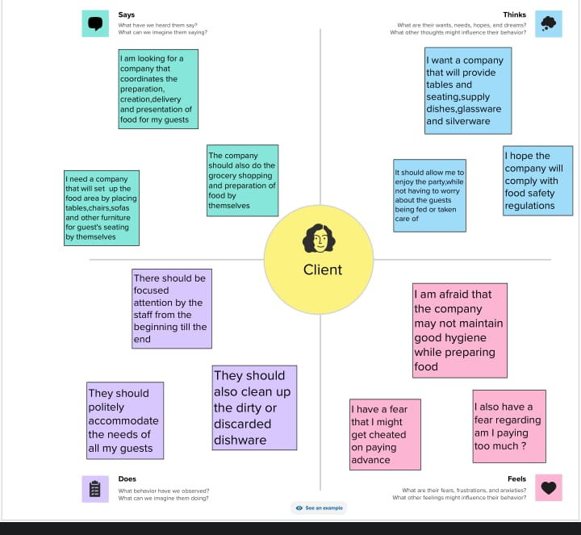**BRAINSTORMING MAP :**

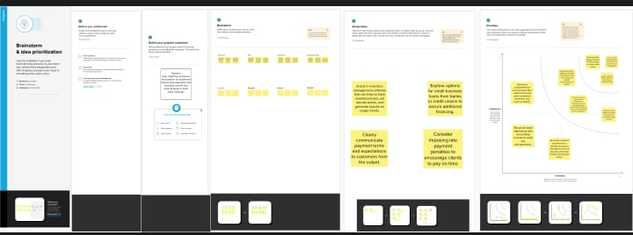**PROFIT AND LOSS SHEET :**

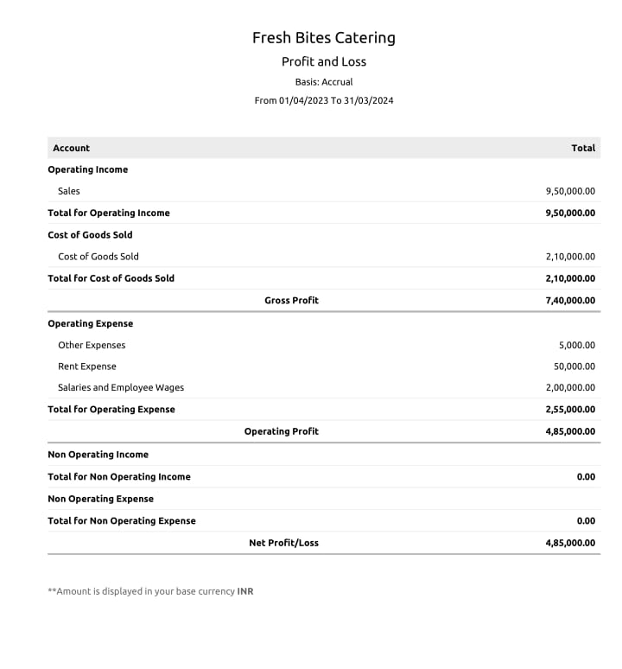 **BALANCE SHEET :**

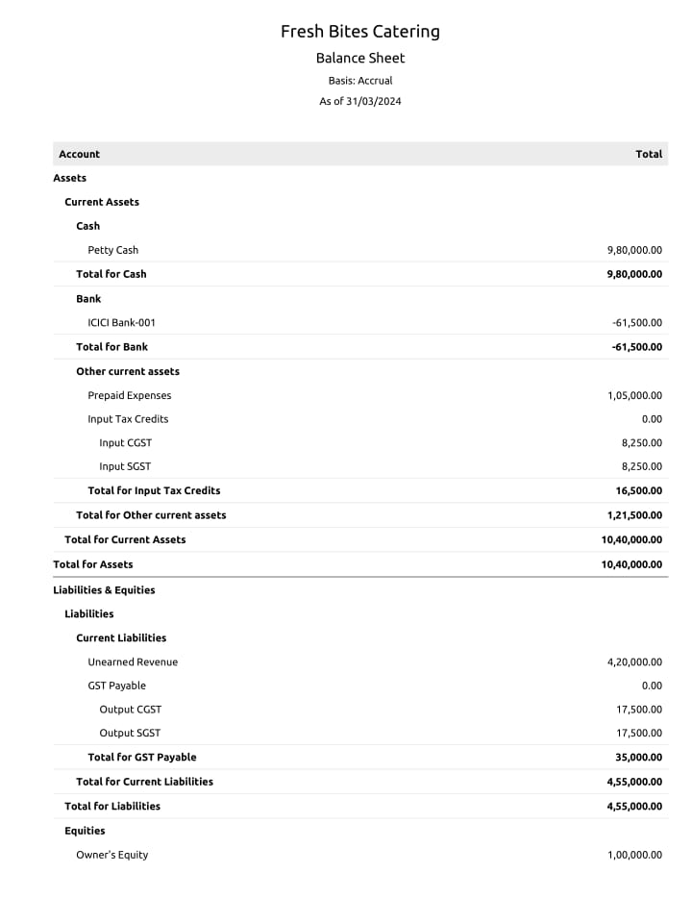

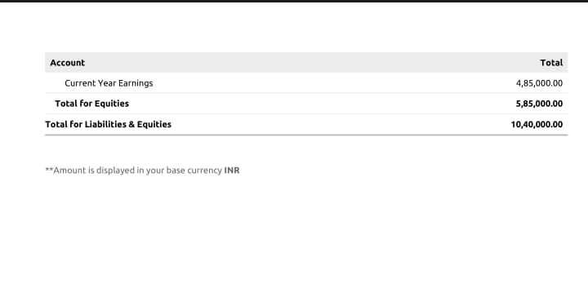

# ADVANTAGES :

* Accounting software like zoho Books can assist in tax compliance by providing features such as tax calculations and the ability to generate and file tax-related documents.
* Zoho Books is cloud-based, allowing FreshBites to access financial data from anywhere with an internet connection. This can be Particularly valuable for mobile catering services.
* Zoho Books helps Fresh Bites maintain efficient financial records. It simplifies tasks like invoicing, expense tracking, and bank reconciliation, making it easier to monitor income and expenses in real time.

# **DISADVANTAGES :**

* While Accounting software reduces the risk of errors, there is still a possibility of data entry mistakes, which can lead to inaccuracies in financial records.
* Accounting software needs to be updated to remain complaint with changing tax laws and regulations. Staying informed about these updates and implementing them can be challenging.
* Zoho books is cloud-based, which means it relies on internet access. In areas with unreliable or slow internet connections, this can be a disadvantage as it may hinder access to financial data.

**CONCLUSION :**

By adopting Zoho books for maintaining accounts, Fresh Bites Catering can enhance its financial transparency, accuracy, and efficiency. The software allows for real-time tracking of income and expenses, automates many financial processes, and provides essential reporting tools for data analysis. This not only saves time and effort but also enables the business to make informal financial decisions.