Create a Eclipse Project using Spring Initializer
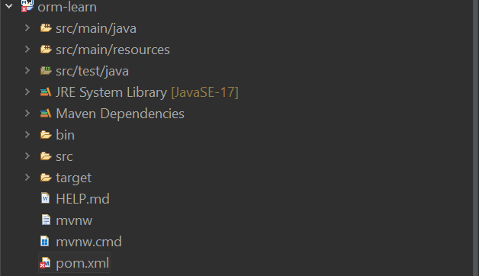
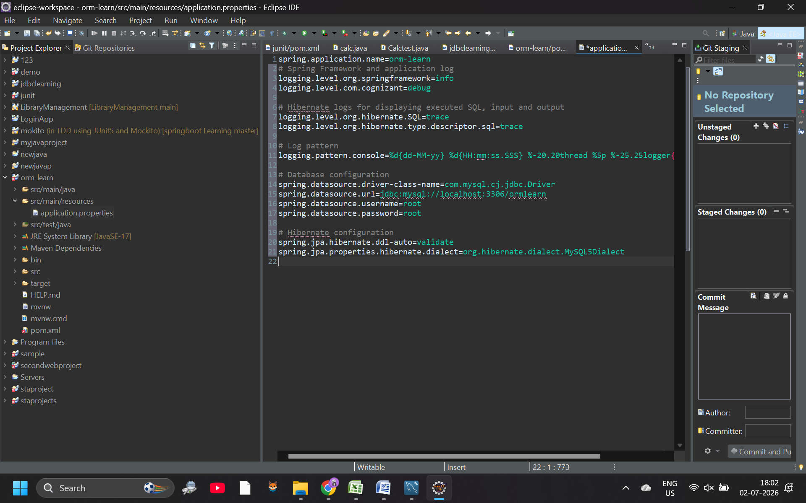
Output: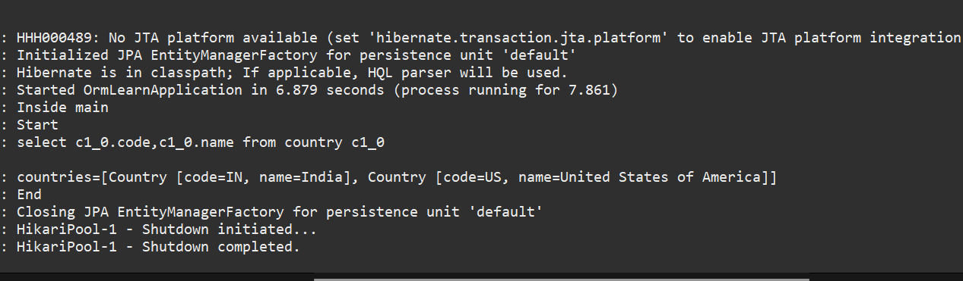
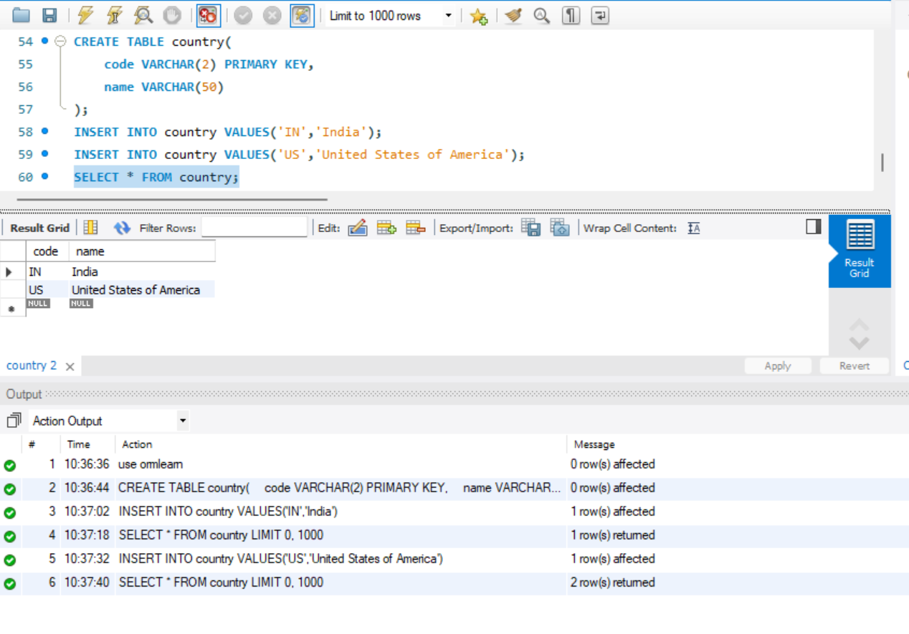
Difference between JPA, Hibernate and Spring Data JPA
Java Persistence API (JPA)
- JSR 338 Specification for persisting, reading and managing data from Java objects
- Does not contain concrete implementation of the specification
- Hibernate is one of the implementation of JPA
Hibernate
- ORM Tool that implements JPA
Spring Data JPA
- Does not have JPA implementation, but reduces boiler plate code
- This is another level of abstraction over JPA implementation provider like Hibernate
- Manages transactions
Refer code snippets below on how the code compares between Hibernate and Spring Data JPA
Hibernate
/* Method to CREATE an employee in the database */
public Integer addEmployee(Employee employee){
Session session = factory.openSession();
Transaction tx = null;
Integer employeeID = null;

try {
tx = session.beginTransaction();
employeeID = (Integer) session.save(employee);
tx.commit();
} catch (HibernateException e) {
if (tx != null) tx.rollback();
e.printStackTrace();
} finally {
session.close();
}
returnemployeeID;
}
Spring Data JPA
EmployeeRespository.java
public interface EmployeeRepository extends JpaRepository<Employee, Integer> {

}
EmployeeService.java
@Autowire
privateEmployeeRepositoryemployeeRepository;

@Transactional
public void addEmployee(Employee employee) {
employeeRepository.save(employee);
}
​​​​​​​

