
Speech Signal ClassiFIcation Via Convolutional Neural Network
Final Project: Option 7

Dhara Rana
CS634 Data Mining
1 December 2018
Table of Contents
Problem Statement 1
About Data 2
Environment/Knowledge Requirements 2
Data Pre-Processing 3
Extracting MFCC 3
Reshaping data and label for CNN 4
Data Augmentation 5
Creation of Validation Set 8
Algorithm 9
Results 12
Average Class Accuracy 12
Per Class Accuracy 12
Confusion Matrix 13
Improvements and Discussion 15
Code 16
Retrieving and Reading Data on Google Colaboratory 16
Pre-Processing Data and Feature Extraction 18
Training the CNN model 22

Problem Statement
The purpose of this project is to build an algorithm that can understand 10 simple speech commands. The 10 speech commands are [down, go, left, no, off, on, right, stop, up, yes]. This project will utilize knowledge of audio signal processing.

About Data
The dataset I will be using is from a previous Kaggle competition (TensorFlow Speech Recognition Challenge), which contains short (~1 sec) audio clip of thirty different speech commands.
For the 10 speech commands for the interest of this project, the train set contains about 2577 audio clips and the test set contains about 2567. The training data set will be augmented by adding 3 different type of background noise (white noise, pink noise, and noise of doing the dishes)
The train folder in the entire dataset is mostly used to train and test the model. The folder contains two txt files: testing_list.txt and validation_list.txt. The testing_list.txt contains the list of the audio clip and corresponding labels that would be used as the test set. Similar to the testing_list.txt, the validation_list.txt contains all the audio clips used for the training and corresponding labels.
Data can be found:
https://www.kaggle.com/c/tensorflow-speech-recognition-challenge/data
Example of how it looks:
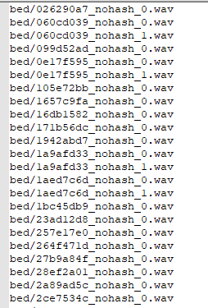

Environment/Knowledge Requirements
- OS: Windows or Mac
- Hardware: PC or Laptop
- Google Chrome Browser
  - Firefox gives some error when using Google Colaboratory
- Google Drive Account to create the Google Colaboratory project
  - Google Colaboratory environment is similar to the Python Jupiter Notebook
  - My project can be found here:
https://colab.research.google.com/drive/1aYnZmLreGIgM2PoDh7nu1ZLjengbYmm-
- Python Skill
- An Kaggle Account to download the kaggle.json, which helps downloading the data directly from Kaggle to the Google Colaboratory environment.
  - See video for more help: https://www.youtube.com/watch?v=eEgZtNOCJhk
- Some sources to help understand about audio signal and convolutional neural network
  - https://blog.manash.me/building-a-dead-simple-word-recognition-engine-using-convnet-in-keras-25e72c19c12b
  - https://www.kaggle.com/davids1992/speech-representation-and-data-exploration
  - http://practicalcryptography.com/miscellaneous/machine-learning/guide-mel-frequency-cepstral-coefficients-mfccs/
  - Schnupp, J., Nelken, I., & King, A. (2011). Auditory neuroscience: Making sense of sound. MIT press.
  - Salamon, J., & Bello, J. P. (2017). Deep convolutional neural networks and data augmentation for environmental sound classification. IEEE Signal Processing Letters, 24(3), 279-283.

Data Pre-Processing

Extracting MFCC
The feature that will be used from to get meaning from the data is mel-frequency cepstral coefficients (MFCC) from the times series audio data. MFCC are extracted from cepstral analysis from a Mel-power spectrogram, which prepared using triangular filers on a Mel-scale. The Mel-scale aims to mimic the non-linear human ear perceptions of sound. MFCC represent the shape of the vocal tract that manifests itself in the envelope of the short time power spectrum. Thus, the job of the MFCC is to accurately represent it envelope. Moreover, the Mel-Frequency Cepstral Coefficients is a two-dimensional, one-channel representation so it can be treated like an image of the sound.
Source: http://practicalcryptography.com/miscellaneous/machine-learning/guide-mel-frequency-cepstral-coefficients-mfccs/
The following function is used to extract the MFCC form the audio clip. A padding is added to sound files so that the length of each sound file will be the same. The function uses the librosa package to extract the mfcc.

def wav2mfcc(wave,sr, max_pad_len=11):
wave = wave[::3]
mfcc = librosa.feature.mfcc(wave, sr=16000)
pad_width = max_pad_len - mfcc.shape[1]
mfcc = np.pad(mfcc, pad_width=((0, 0), (0, pad_width)), mode='constant')
return mfcc

The output of the wav2mfcc function would be a 20 x 11 matrix of MFCC (see image below).
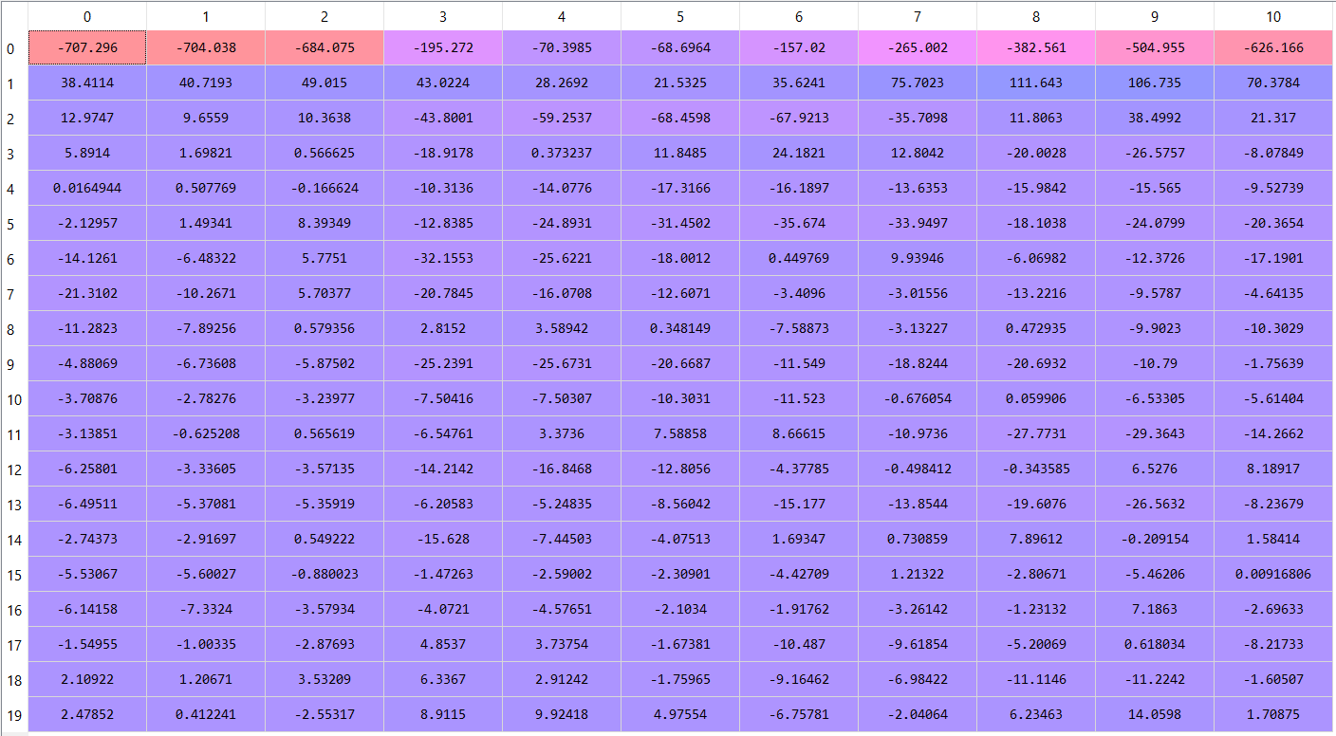

Reshaping data and label for CNN
After the audio signal is converted to MFCC, it is important to reshape the input data as a 3D array, since that is the input required by the Keras model. The wave2mfcc returns a 20 by 11 matrix shape per audio sound. So, the input shape will be Total Number of Audioclip by 20 by 11 by 1. The following function extract_mfcc will read each of the .wav sound files and extract the mfcc. Then will convert the list of 20x11 mfcc into a numpy of Total Number of Audioclip by 20 by 11 by 1. Another important aspect of the function is to convert the labels into one-hot encoding. Note extracting the mfcc takes about 4hrs.
def one_hot_encode(labels,classes):
labels=np.array(labels, dtype=np.int)
n_labels = len(labels)
n_unique_labels =len(classes)
one_hot_encode = np.zeros((n_labels, n_unique_labels))
one_hot_encode[np.arange(n_labels),labels] = 1
return one_hot_encode

def extract_mfcc(parent_dir, sub_dirs,classes,backgroundNoisePath):
mfcc_vectors=[]
labels=[]
for l, sub_dir in enumerate(sub_dirs):
print('parsing %s...' % sub_dir)
for file in sub_dirs[sub_dir]:
for fn in glob.glob(os.path.join(parent_dir, sub_dir,file)):
print('fn is ', fn)
audio_clip, sr = librosa.load(fn, mono=True, sr=None)
label = sub_dir # TODO change to fn.split('/').pop().split('-')[1]
#print(len(audio_clip))
for b in range(0,len(backgroundNoisePath)+1):
if b >=1:
print("Adding Background Noise: ",backgroundNoisePath[b-1])
bkgrndNoise,srWBN =librosa.load(backgroundNoisePath[b-1])
sound_clip=add_background_noises(audio_clip, bkgrndNoise, volume_range=0.9)
mfcc=wav2mfcc(sound_clip, sr, max_pad_len=11)
mfcc_vectors.append(mfcc)
else:
mfcc=wav2mfcc(audio_clip, sr, max_pad_len=11)
mfcc_vectors.append(mfcc)
labels.append(classes[label])

mfcc_vectors=np.array(mfcc_vectors)
mfcc_specs=mfcc_vectors.reshape(len(mfcc_vectors),20, 11,1)
labels = one_hot_encode(labels,classes)
return mfcc_specs,labels
This is how the output shape of the train data and label looks like:
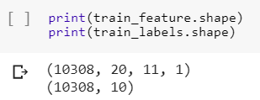
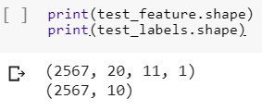

Data Augmentation
Another pre-processing is to data augment that training set. Data augmentation is a technique to create new additional training data by change or deforming a current labeled training sample. For example, in taking a clean audio clip with the speech signal “down” and adding background noise to it. Now, there are two training sample with the label ‘down’: one audio signal with someone just saying down and another signal with someone just saying down with background noise. Thus, data augmentation will increase the training set by four time it current size. This would be to 10308 training sample from the current 2577 samples. The ratio of training to test set would be roughly 80% to 20%.
This is the code snippet of add background noise to the audio files.
TARGET_DURATION=22050
SAMPLE_RATE= 22050
def add_background_noises(audio, background_wav, volume_range=0.1):
"""
Given audio and background noise, mixes the two together giving the background noise a
volume between 0 and volume_range
:param audio: A list of floating point values representing a wav file.
:param background_wav: A list of floating point values representing a silence wav file.
:param volume_range: A floating point value for the max volume of the background noise
:return: audio: An audio representation with the background noise mixed in.
"""
bg_audio = background_wav
bg_audio_start_idx = np.random.randint(bg_audio.shape[0] - TARGET_DURATION)
bg_audio_slice = bg_audio[bg_audio_start_idx: bg_audio_start_idx + len(audio)] * np.random.uniform(0, volume_range)
return audio + bg_audio_slice
The following code snippet is an example of the audio signal for down (099d52ad_nohash_0.wav in the down folder in train folder) with white noise in the background being added. The code adds a volume of 0.5 white noise to the speech signal down. One can see the noise added in the graphs. The first time series graph is the speech signal of down, the second graph is the white noise and the last graph is of down and white noise overlapped.
import IPython.display as ipd
import matplotlib.pyplot as plt
import soundfile as sf

def plot_time_series(data,title):
fig = plt.figure(figsize=(14, 8))
plt.title('Raw wave: '+title)
plt.ylabel('Amplitude')
plt.plot(np.linspace(0, 1, len(data)), data)
plt.show()
noiseFN=file_path+"\\train\\audio\\_background_noise_\\white_noise.wav"
file_path = os.path.dirname(os.path.abspath('__file__'))
downfile=file_path+"\\train\\audio\\down\\"+validOne['down'][0]
down,sr=librosa.load(downfile)
noise,sr=librosa.load(noiseFN)
down_white=add_background_noises(down, noise, volume_range=0.5)
sf.write('down_white.wav', down_white, sr)
plot_time_series(down,'down')
plot_time_series(noise,'white noise')
plot_time_series(down_white,'down + white noise')
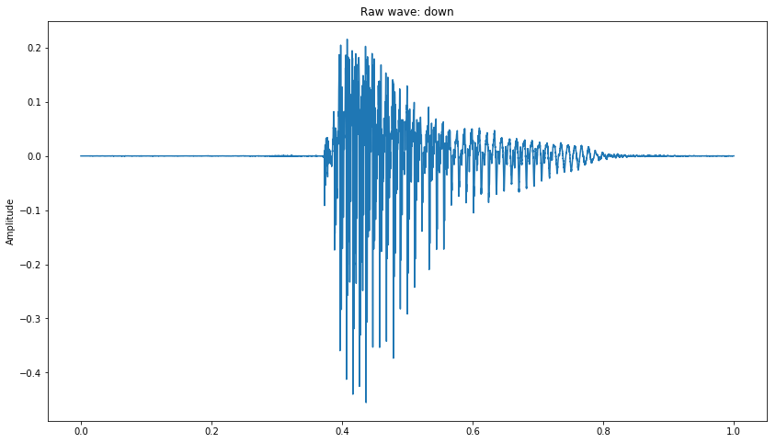
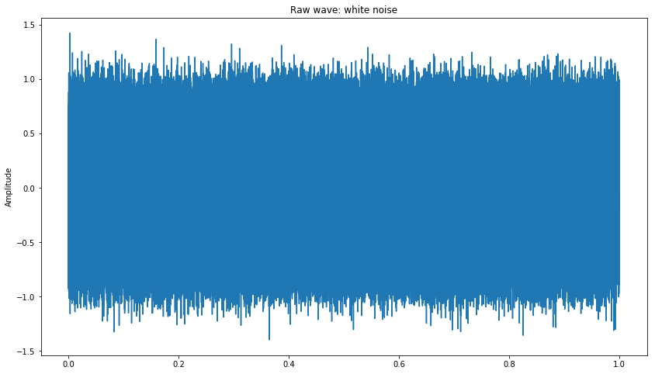

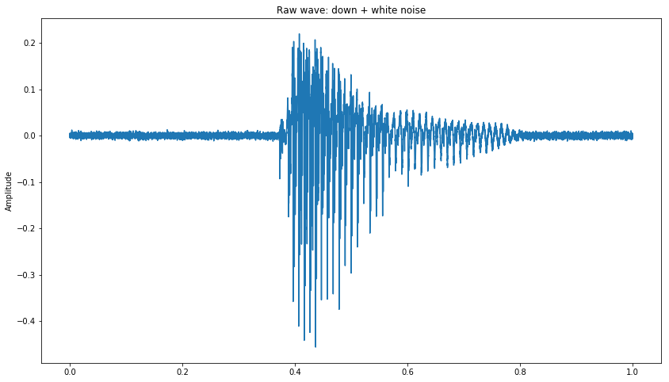

Creation of Validation Set
Ten percent (10%) of the training set will be used to as a validation set to ensure the accuracy of the convolutional neural network. This validation set would be used in the CNN model to validate the trained model. See the output of the function.
def create_vaildationSet(mfcc_specs,labels,split_ratio,random_state=42 ):
X_train, X_valid, y_train, y_valid=train_test_split(mfcc_specs, labels, test_size= split_ratio, random_state=random_state, shuffle=True)
return X_train, X_valid, y_train, y_valid
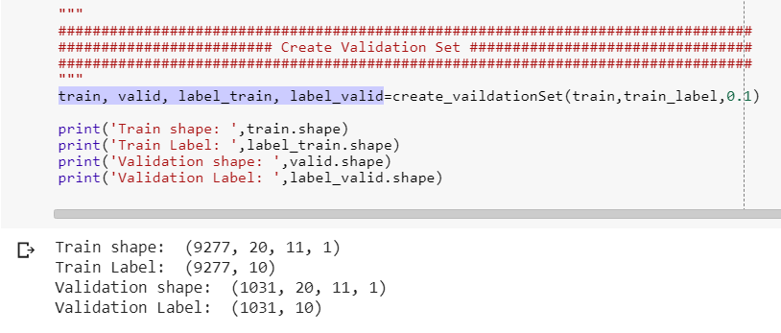

Algorithm
A convolutional neural network would be used to classify the 10 speech commands. It contains three layers. Each layer followed with a max pooling, expect of the first layer and RELU for each convolutional layer. Moreover, I created three other models called create_model5(), create_model6(), create_model7() in addition to create_model8() (see Code section). However, create_model8() was the best model in terms of classification accuracy. Each layer and output shape can be seen in the image below the code snippet. Furthermore, the lr or learning rate parameter was changed to increase the accuracy as well as the optimizer.
The following architecture would be used:
def create_model8():
model = Sequential()
model.add(Conv2D(64, kernel_size=(2, 2), activation='relu',padding='same', input_shape=(20, 11, 1)))
model.add(Conv2D(32, kernel_size=(2, 2), activation='relu',padding='same', input_shape=(20, 11, 1)))
model.add(MaxPooling2D(pool_size=(2, 2)))
model.add(Conv2D(32, kernel_size=(2, 2), activation='relu', input_shape=(20, 11, 1)))
model.add(MaxPooling2D(pool_size=(2, 2)))
model.add(Dropout(0.25))
model.add(Flatten())
model.add(Dense(128, activation='relu'))
model.add(Dropout(0.25))
model.add(Dense(10, activation='softmax'))

model.summary()
return model

model =create_model8()

model.compile(loss='categorical_crossentropy',
optimizer=SGD(lr=0.0003, momentum=0.9, nesterov=True),
metrics=['accuracy'])

epochs = 500 #25 #
batch_size = 100#

his=model.fit(train, label_train,
batch_size=batch_size,
epochs=epochs,
verbose=1,
validation_data=(valid, label_valid) )

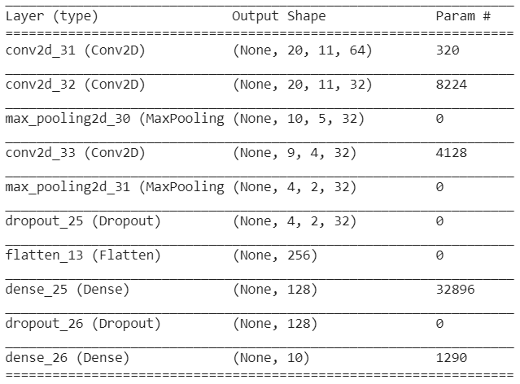
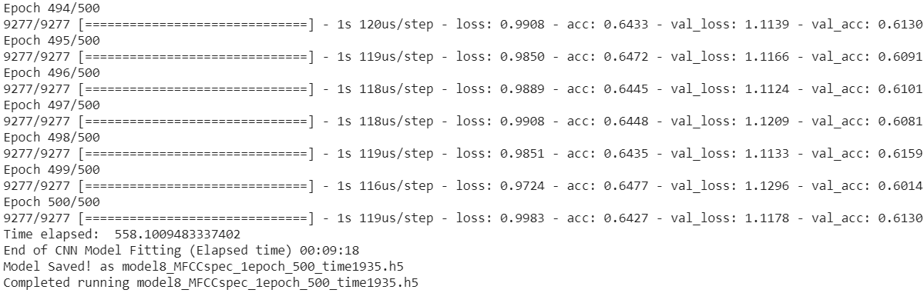
The above is the output from training the model. It shows the last few epoch of the model. The below two graph is how the training validation accuracy and loss looks as the training progressed. After training the model for 500 epochs with a batch size of 100. The validation accuracy compared to the training accuracy looks as follows. From the graph below, the training accuracy of the model is 64.27% and the validation accuracy is about 61.3%. The little discrepancy between the training and validation accuracy shows there is a slight high variance and consequently the model may be overfitting. However, the test set results show that accuracy is close to the training accuracy of 73.08%. Regardless, the loss of the both the validation and train decreases. The model took 9 minutes and 18 second to be trained.
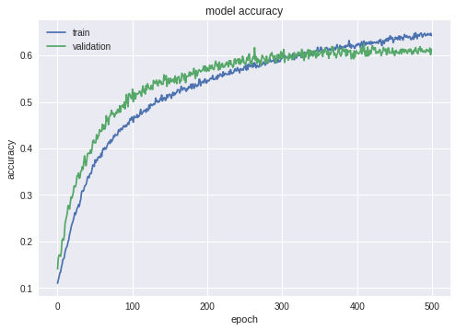
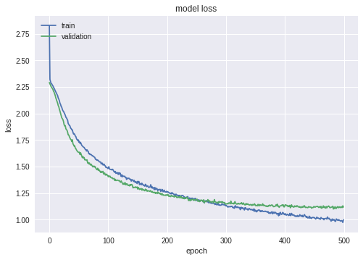

Results

Average Class Accuracy
The results the above model produces an average accuracy across the classes of 73.08%.
###########################################################################
################### Evaluate the model ####################################
###########################################################################
scores = model.evaluate(test, test_label,batch_size=batch_size)
print("\n%s: %.2f%%" % (model.metrics_names[1], scores[1]*100))

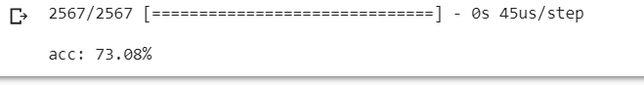

Per Class Accuracy
The per class accuracy was calculated by using the classification report function from sklearn.metrics. This outputted the metrics such as accuracy and precision.
##########################################################
### Per class accuracy and other metrics
##########################################################

print(classification_report(y_true, y_pred))

#Total count per predicted class
list_classes=[0,1,2,3,4,5,6,7,8,9]
count_list = []
for c in range(0,len(list_classes)):
for i in range(0,len(cm)):
if c==i:
dia=cm[c][i]
count_list.append(dia)

#Total count per True class
Truecount_list = []
sumTot=0
for c in list_classes:
sumTot=0
for i in y_true:
#print(i)
if i==c:
sumTot=sumTot+1
Truecount_list.append(sumTot)

# per class accuracy
classAcc=[]
for i in range(0,len(Truecount_list)):
c_Acc=count_list[i]/Truecount_list[i]
classAcc.append(c_Acc)
print("Per Class Acc: ",classAcc)

# Accuracy
sumTot=0
for i in classAcc:
sumTot=sumTot+i
print('Avg Accuracy: ',sumTot/len(classAcc) )

Classes | index | Accuracy | Precision | Recall | F1-score
down | 0 | 0.679842 | 0.75 | 0.68 | 0.72
go | 1 | 0.59761 | 0.64 | 0.6 | 0.62
left | 2 | 0.700375 | 0.75 | 0.7 | 72
no | 3 | 0.698413 | 0.55 | 0.7 | 0.62
off | 4 | 0.736641 | 0.73 | 0.74 | 0.73
on | 5 | 0.772358 | 0.88 | 0.77 | 0.82
right | 6 | 0.830116 | 0.81 | 0.83 | 0.82
stop | 7 | 0.722892 | 0.79 | 0.72 | 0.76
up | 8 | 0.75 | 0.71 | 0.75 | 0.73
yes | 9 | 0.816406 | 0.76 | 0.82 | 0.79

Confusion Matrix
The confusion matrix was also created to understand which classes the classification model was getting confusion in classifying. From the confusion matrix (see below), one can see that classifier had a tough time distinguishing the words pairs ‘no’ and ‘go’; 58 misclassifications.
Code snippet:
def plot_confusion_matrix(cm, classes,
normalize=False,
title='Confusion matrix',
cmap=plt.cm.Blues):
"""
This function prints and plots the confusion matrix.
Normalization can be applied by setting `normalize=True`.
"""
if normalize:
cm = cm.astype('float') / cm.sum(axis=1)[:, np.newaxis]
print("Normalized confusion matrix")
else:
print('Confusion Matrix')

print("confusion matrix:\n%s" % cm)

plt.imshow(cm, interpolation='nearest', cmap=cmap)
plt.title(title)
plt.colorbar()
tick_marks = np.arange(len(classes))
plt.xticks(tick_marks, classes, rotation=85)
plt.yticks(tick_marks, classes)
plt.grid(False)
fmt = '.2f' if normalize else 'd'
thresh = cm.max() / 2.
for i, j in itertools.product(range(cm.shape[0]), range(cm.shape[1])):
plt.text(j, i, format(cm[i, j], fmt),
horizontalalignment="center",
color="white" if cm[i, j] > thresh else "black")

#plt.tight_layout()
plt.ylabel('True label')
plt.xlabel('Predicted label')

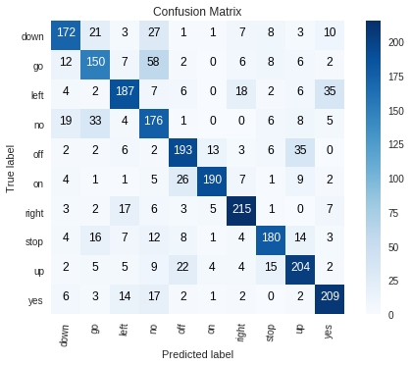

Improvements and Discussion
The classification model can be further improved by further data augmenting such as doing a time stretch, or changing the pitch of the signal. Thus, adding more variance. Another improvement is making the convolutional neural network denser maybe have 6 layers instead of 3 layers. According to the paper Deep convolutional neural networks and data augmentation for environmental sound classification by Salamon and Bello, the accuracy they received in classifying urban sound signal was about 0.74 accuracy without data augmentation and 0.79 with data augmentation of adding noise in the background, changing pitch and stretching the time. Thus, this means adding more augmentation to the sound file can make the model a better predictor.
Reference:
Salamon, J., & Bello, J. P. (2017). Deep convolutional neural networks and data augmentation for environmental sound classification. IEEE Signal Processing Letters, 24(3), 279-283.

Code

Retrieving and Reading Data on Google Colaboratory
"""

Automatically generated by Colaboratory.

Original file is located at
https://colab.research.google.com/drive/1aYnZmLreGIgM2PoDh7nu1ZLjengbYmm-
"""

!pip install librosa

!pip install kaggle

from google.colab import files
files.upload()

!mkdir -p ~/.kaggle
!cp kaggle.json ~/.kaggle/

!chmod 600 ~/.kaggle/kaggle.json

!kaggle competitions download -c tensorflow-speech-recognition-challenge

!ls

!7z x train.7z

!rm test.7z
!rm train.7z
!rm sample_submission.7z
!rm link_to_gcp_credits_form.txt

import tensorflow as tf
device_name = tf.test.gpu_device_name()
if device_name != '/device:GPU:0':
raise SystemError('GPU device not found')
print('Found GPU at: {}'.format(device_name))

"""
##############################################################
###Read the Validation.txt and testing.txt and create a dictionary######### #########################################################
"""
import os
import re
import glob
import librosa
import numpy as np
import pandas as pd
from IPython import get_ipython
import pickle
from sklearn.preprocessing import normalize, MinMaxScaler
from os import listdir
from os.path import isfile, join
from sklearn.model_selection import train_test_split

TRAIN_WORDS = ['yes', 'no', 'up', 'down', 'left', 'right', 'on', 'off', 'stop', 'go']

# Validation lists
file_path = os.path.dirname(os.path.abspath('__file__'))
print(file_path)
filename = "validation_list.txt"
file_path_full=file_path+"/" +filename

validation={}
f=open(file_path_full,'r')
l=f.readline()
while(l !=''):
label=re.findall('[a-z]*/',l)
filename=re.findall('/[a-z0-9_]*.wav',l)
label=label[0][:-1]
filename=filename[0][1:]
if label in TRAIN_WORDS:
if(label not in validation):
validation[label]=[filename]
else:
validation[label].append(filename)

l=f.readline()
f.close()

for k in validation:
print(k,len(validation[k]))

# Testing lists

filename = "/testing_list.txt"
file_path_full=file_path+"/" +filename

test={}
f=open(file_path_full,'r')
l=f.readline()
while(l !=''):
label=re.findall('[a-z]*/',l)
filename=re.findall('/[a-z0-9_]*.wav',l)
label=label[0][:-1]
filename=filename[0][1:]
if label in TRAIN_WORDS:
if(label not in test):
test[label]=[filename]
else:
test[label].append(filename)

l=f.readline()
f.close()

for k in test:
print(k,len(test[k]))

"""Store all the class in a dictionary with index values"""

classes={}
for i, k in enumerate(validation):
classes[k]=i
classes

Pre-Processing Data and Feature Extraction
"""
##############################################################
#########**Data Pre-Pocessing**
##############################################################
"""

"""
##############################################################
####### Function used for Pre-Processing ##############################################################
"""
def one_hot_encode(labels,classes):
labels=np.array(labels, dtype=np.int)
n_labels = len(labels)
n_unique_labels =len(classes)
one_hot_encode = np.zeros((n_labels, n_unique_labels))
one_hot_encode[np.arange(n_labels),labels] = 1
return one_hot_encode

def wav2mfcc(wave,sr, max_pad_len=11):
wave = wave[::3]
mfcc = librosa.feature.mfcc(wave, sr=16000)
pad_width = max_pad_len - mfcc.shape[1]
mfcc = np.pad(mfcc, pad_width=((0, 0), (0, pad_width)), mode='constant')
return mfcc

TARGET_DURATION=22050
SAMPLE_RATE= 22050

def add_background_noises(audio, background_wav, volume_range=0.1):
"""
Given audio and background noise, mixes the two together giving the background noise a
volume between 0 and volume_range
:param audio: A list of floating point values representing a wav file.
:param background_wav: A list of floating point values representing a silence wav file.
:param volume_range: A floating point value for the max volume of the background noise
:return: audio: An audio representation with the background noise mixed in.
"""
bg_audio = background_wav
bg_audio_start_idx = np.random.randint(bg_audio.shape[0] - TARGET_DURATION)
bg_audio_slice = bg_audio[bg_audio_start_idx: bg_audio_start_idx + len(audio)] * np.random.uniform(0, volume_range)
return audio + bg_audio_slice

def create_vaildationSet(mfcc_specs,labels,split_ratio,random_state=42 ):
X_train, X_valid, y_train, y_valid=train_test_split(mfcc_specs, labels, test_size= split_ratio, random_state=random_state, shuffle=True)
return X_train, X_valid, y_train, y_valid

def extract_mfcc_No_Noise(parent_dir, sub_dirs,classes,backgroundNoisePath):
mfcc_vectors=[]
labels=[]
for l, sub_dir in enumerate(sub_dirs):
print('parsing %s...' % sub_dir)
for file in sub_dirs[sub_dir]:
for fn in glob.glob(os.path.join(parent_dir, sub_dir,file)):
print('fn is ', fn)
audio_clip, sr = librosa.load(fn, mono=True, sr=None)
label = sub_dir # TODO change to fn.split('/').pop().split('-')[1]
#print(len(audio_clip))
mfcc=wav2mfcc(audio_clip, sr, max_pad_len=11)
mfcc_vectors.append(mfcc)
labels.append(classes[label])

mfcc_vectors=np.array(mfcc_vectors)
mfcc_specs=mfcc_vectors.reshape(len(mfcc_vectors),20, 11,1)
labels = one_hot_encode(labels,classes)
return mfcc_specs,labels

def extract_mfcc(parent_dir, sub_dirs,classes,backgroundNoisePath):
mfcc_vectors=[]
labels=[]
for l, sub_dir in enumerate(sub_dirs):
print('parsing %s...' % sub_dir)
for file in sub_dirs[sub_dir]:
for fn in glob.glob(os.path.join(parent_dir, sub_dir,file)):
print('fn is ', fn)
audio_clip, sr = librosa.load(fn, mono=True, sr=None)
label = sub_dir # TODO change to fn.split('/').pop().split('-')[1]
#print(len(audio_clip))
for b in range(0,len(backgroundNoisePath)+1):
if b >=1:
print("Adding Background Noise: ",backgroundNoisePath[b-1])
bkgrndNoise,srWBN =librosa.load(backgroundNoisePath[b-1])
sound_clip=add_background_noises(audio_clip, bkgrndNoise, volume_range=0.9)
mfcc=wav2mfcc(sound_clip, sr, max_pad_len=11)
mfcc_vectors.append(mfcc)
else:
mfcc=wav2mfcc(audio_clip, sr, max_pad_len=11)
mfcc_vectors.append(mfcc)
labels.append(classes[label])

mfcc_vectors=np.array(mfcc_vectors)
mfcc_specs=mfcc_vectors.reshape(len(mfcc_vectors),20, 11,1)
labels = one_hot_encode(labels,classes)
return mfcc_specs,labels

def getTestTrain(file_path_full):
validation={}
f=open(file_path_full,'r')
l=f.readline()
while(l !=''):
label=re.findall('[a-z]*/',l)
filename=re.findall('/[a-z0-9_]*.wav',l)
label=label[0][:-1]
filename=filename[0][1:]

if(label not in validation):
validation[label]=[filename]
else:
validation[label].append(filename)

l=f.readline()
f.close()
return validation

def dump_data(path, objects, names, ext='.pkl'):
for i, o in enumerate(objects):
print('dumping %s...' % names[i])
pklfile=open(names[i] + ext, "wb")
pickle.dump(o,pklfile)
pklfile.close()

def dump_features(name, extractor,sub_dir,classes,backgroundNoisePath,audio_dir,save_dir):
print('Extracting %s' % name)
fnames = ['features_' + name, 'labels_' + name]
test_features, test_labels = extractor(audio_dir, sub_dir,classes,backgroundNoisePath)
data = [( test_features), (test_labels)]
dump_data(save_dir, data, fnames)
return test_features,test_labels

"""
#########################################################
############ Execution Of Code ##########################
#########################################################
"""
# needed file
file_path = os.path.dirname(os.path.abspath('__file__'))
audio_dir=file_path+"/train/audio"
save_dir=file_path

backgroundNoisePath=[file_path+"/train/audio/_background_noise_/pink_noise.wav",
file_path+"/train/audio/_background_noise_/doing_the_dishes.wav",
file_path+"/train/audio/_background_noise_/white_noise.wav"]

# This process takes about 4hrs
train_feature, train_labels=dump_features('train_MFCCspecs', extract_mfcc,validation,classes,backgroundNoisePath,audio_dir,save_dir)

print(train_feature.shape)
print(train_labels.shape)

test_feature, test_labels=dump_features('test_MFCCspecs', extract_mfcc_No_Noise,test,classes,backgroundNoisePath,audio_dir,save_dir)

print(test_feature.shape)
print(test_labels.shape)

Training the CNN model
"""
############################################################################
####### Training TIME: CNN MODEL
############################################################################
"""

import numpy as np
import pandas as pd
from keras.models import Sequential
from keras.layers import Conv2D, MaxPooling2D, Flatten, Dense, Dropout, Activation,GlobalMaxPool2D,BatchNormalization
from keras.optimizers import SGD, Adamax,Adadelta
from keras import regularizers
import pickle
from keras.models import load_model
from sklearn.metrics import precision_recall_fscore_support, roc_auc_score, confusion_matrix
import matplotlib.pyplot as plt
import itertools
from sklearn.metrics import classification_report
from sklearn.model_selection import train_test_split
from sklearn import svm
import os
import time

"""**Load the Data and Create Validation Set**"""

def load_data(filename):
print('loading %s...' % filename)
return pickle.load(open(filename, "rb"), encoding="latin1")

VERSION=1
"""
############################################################################
######################### Read in Data
############################################################################
"""

#Get Train Data
file_path = os.path.dirname(os.path.abspath('__file__'))

train_filename=file_path+"/features_train_MFCCspecs.pkl"
train=load_data(train_filename)

train_label_filename=file_path+"/labels_train_MFCCspecs.pkl"
train_label=load_data(train_label_filename)
print('Train shape: ',train.shape)
print('Train Label: ',train_label.shape)

#Get test Data

train_filename=file_path+"/features_test_MFCCspecs.pkl"
test=load_data(train_filename)

train_label_filename=file_path+"/labels_test_MFCCspecs.pkl"
test_label=load_data(train_label_filename)

print('Test shape: ',test.shape)
print('Test Label: ',test_label.shape)

def create_vaildationSet(mfcc_specs,labels,split_ratio,random_state=42 ):
X_train, X_valid, y_train, y_valid=train_test_split(mfcc_specs, labels, test_size= split_ratio, random_state=random_state, shuffle=True)
return X_train, X_valid, y_train, y_valid

"""
#################################################################################
######################### Create Validation Set #################################
#################################################################################
"""
train, valid, label_train, label_valid=create_vaildationSet(train,train_label,0.1)

print('Train shape: ',train.shape)
print('Train Label: ',label_train.shape)
print('Validation shape: ',valid.shape)
print('Validation Label: ',label_valid.shape)

"""
#######################################################################################
############################## CNN Model ##############################################
#######################################################################################
"""

from keras.optimizers import SGD, Adamax,Adam,Adadelta

def create_model5():
model = Sequential()
model.add(Conv2D(filters=80, kernel_size=(57, 6), strides=(1, 1), padding='valid', input_shape=(20, 11, 1)))
model.add(Activation('relu'))
model.add(MaxPooling2D(pool_size=(4, 3), strides=(1, 3)))
model.add(Dropout(0.5))
model.add(Conv2D(filters=80, kernel_size=(1, 3), strides=(1, 1), padding='valid'))
model.add(Activation('relu'))
model.add(Dropout(0.5))
model.add(MaxPooling2D(pool_size=(1, 3), strides=(1, 3)))
model.add(Flatten())
model.add(Dense(units=5000, activation='relu'))
model.add(Dropout(0.5))
model.add(Dense(units=5000, activation='relu'))
model.add(Dropout(0.5))
model.add(Dense(units=10, activation='softmax'))

model.summary()

def create_model6():
model = Sequential()
model.add(Conv2D(32, kernel_size=(2, 2), activation='relu', input_shape=(20, 11, 1)))
model.add(MaxPooling2D(pool_size=(2, 2)))
model.add(Conv2D(32, kernel_size=(2, 2), activation='relu',input_shape=(20, 11, 1)))
model.add(MaxPooling2D(pool_size=(2, 2)))
model.add(Dropout(0.25))
model.add(Flatten())
model.add(Dense(128, activation='relu'))
model.add(Dropout(0.25))
model.add(Dense(10, activation='softmax'))

model.summary()
return model

#acc: 65.52% -- adadelta 400 epoch
#67.51% - Admamx lr=0.0003 epoch:600
def create_model7():
model = Sequential()
model.add(Conv2D(32, kernel_size=(2, 2), activation='relu', input_shape=(20, 11, 1)))
model.add(MaxPooling2D(pool_size=(2, 2)))
model.add(Conv2D(24, kernel_size=(2, 2), activation='relu', input_shape=(20, 11, 1)))
model.add(MaxPooling2D(pool_size=(2, 2)))
model.add(Conv2D(24, kernel_size=(2, 2), activation='relu',padding='same', input_shape=(20, 11, 1)))
model.add(MaxPooling2D(pool_size=(2, 2)))
model.add(Dropout(0.25))
model.add(Flatten())
model.add(Dense(128, activation='relu'))
model.add(Dropout(0.25))
model.add(Dense(10, activation='softmax'))
#61.08%
model.summary()
return model
def create_model8():
model = Sequential()
model.add(Conv2D(64, kernel_size=(2, 2), activation='relu',padding='same', input_shape=(20, 11, 1)))
model.add(Conv2D(32, kernel_size=(2, 2), activation='relu',padding='same', input_shape=(20, 11, 1)))
model.add(MaxPooling2D(pool_size=(2, 2)))
model.add(Conv2D(32, kernel_size=(2, 2), activation='relu', input_shape=(20, 11, 1)))
model.add(MaxPooling2D(pool_size=(2, 2)))
model.add(Dropout(0.25))
model.add(Flatten())
model.add(Dense(128, activation='relu'))
model.add(Dropout(0.25))
model.add(Dense(10, activation='softmax'))

model.summary()
#73.08%
return model
print('Creating Model')

model=create_model8()

#model.compile(loss='categorical_crossentropy',
# optimizer=Adamax(lr=0.0003, beta_1=0.9, beta_2=0.999, epsilon=1e-08, decay=0.0),
# metrics=['accuracy'])

#model.compile(loss='categorical_crossentropy', optimizer=Adam(), metrics=['accuracy'])

model.compile(loss='categorical_crossentropy',
optimizer=SGD(lr=0.0003, momentum=0.9, nesterov=True),
metrics=['accuracy'])

#model.compile(loss='categorical_crossentropy',
# optimizer=Adadelta(),
# metrics=['accuracy'])

epochs = 500 #25 #
batch_size = 100#

start_time = time.time()
print('Starting Model fitting',time.strftime("%H:%M:%S", time.gmtime(start_time)))

his=model.fit(train, label_train,
batch_size=batch_size,
epochs=epochs,
verbose=1,
validation_data=(valid, label_valid) )

elapsed_time = time.time() - start_time
print('Time elapsed: ',elapsed_time)
clocktime=time.strftime("%H:%M:%S", time.gmtime(elapsed_time))
print('End of CNN Model Fitting (Elapsed time)',time.strftime("%H:%M:%S", time.gmtime(elapsed_time)))

import datetime
now = datetime.datetime.now()

#SAVE Model
modelName='model8_MFCCspec_'+str(VERSION)+'epoch_'+str(epochs)+'_time'+str(now.hour)+str(now.minute)+'.h5'
model.save(modelName) # creates a HDF5 file 'my_model.h5'
print('Model Saved! as '+modelName)
print('Completed running '+modelName)

"""
############################################################################
################################ Show the Epochs vs ACC
############################################################################"""
# summarize history for accuracy
plt.plot(his.history['acc'])
plt.plot( his.history['val_acc'])
plt.title('model accuracy')
plt.ylabel('accuracy')
plt.xlabel('epoch')
plt.legend(['train', 'validation'], loc='upper left')
plt.show()
# summarize history for loss
plt.plot( his.history['loss'])
plt.plot( his.history['val_loss'])
plt.title('model loss')
plt.ylabel('loss')
plt.xlabel('epoch')
plt.legend(['train', 'validation'], loc='upper left')
plt.show()

"""
###########################################################################
################### Evaluate the model ####################################
###########################################################################
"""
scores = model.evaluate(test, test_label,batch_size=batch_size)
print("\n%s: %.2f%%" % (model.metrics_names[1], scores[1]*100))

"""
############################################################################
################ Accuracy and Confusion Matrix
############################################################################
"""

def plot_confusion_matrix(cm, classes,
normalize=False,
title='Confusion matrix',
cmap=plt.cm.Blues):
"""
This function prints and plots the confusion matrix.
Normalization can be applied by setting `normalize=True`.
"""
if normalize:
cm = cm.astype('float') / cm.sum(axis=1)[:, np.newaxis]
print("Normalized confusion matrix")
else:
print('Confusion Matrix')

print("confusion matrix:\n%s" % cm)

plt.imshow(cm, interpolation='nearest', cmap=cmap)
plt.title(title)
plt.colorbar()
tick_marks = np.arange(len(classes))
plt.xticks(tick_marks, classes, rotation=85)
plt.yticks(tick_marks, classes)
plt.grid(False)
fmt = '.2f' if normalize else 'd'
thresh = cm.max() / 2.
for i, j in itertools.product(range(cm.shape[0]), range(cm.shape[1])):
plt.text(j, i, format(cm[i, j], fmt),
horizontalalignment="center",
color="white" if cm[i, j] > thresh else "black")

#plt.tight_layout()
plt.ylabel('True label')
plt.xlabel('Predicted label')

###########################################################################
# Compute confusion matrix
#########################################################################

# labels

command_class=classes.keys()
command_class=list(command_class)

#prediction= model.predict_proba(test,batch_size=batch_size, verbose=1)
y_prob = model.predict_proba(test, verbose=1)
#y_pred = np_utils.probas_to_classes(y_prob)
y_pred = y_prob.argmax(axis=-1)
y_true = np.argmax(test_label, 1)
cm = confusion_matrix(y_true, y_pred, labels=None)
np.set_printoptions(precision=2)
# Plot non-normalized confusion matrix
plt.figure()
plot_confusion_matrix(cm, classes=command_class,
title='Confusion Matrix')
plt.show()
#print("confusion matrix:\n%s" % cm)

##########################################################
### Per class accuracy and other metrics
##########################################################

print(classification_report(y_true, y_pred))

#Total count per predicted class
list_classes=[0,1,2,3,4,5,6,7,8,9]
count_list = []
for c in range(0,len(list_classes)):
for i in range(0,len(cm)):
if c==i:
dia=cm[c][i]
count_list.append(dia)

#Total count per True class
Truecount_list = []
sumTot=0
for c in list_classes:
sumTot=0
for i in y_true:
#print(i)
if i==c:
sumTot=sumTot+1
Truecount_list.append(sumTot)

# per class accuracy
classAcc=[]
for i in range(0,len(Truecount_list)):
c_Acc=count_list[i]/Truecount_list[i]
classAcc.append(c_Acc)
print("Per Class Acc: ",classAcc)

# Accuracy
sumTot=0
for i in classAcc:
sumTot=sumTot+i
print('Avg Accuracy: ',sumTot/len(classAcc) )

