OBJECT ORIENTED PROGRAMING-JAVA
PRACTICAL-1
1. | Vending machine (VendingMachine.java, main in this file)  (a) Define an enum Coin with constants ONE, TWO, FIVE, TEN.  (b) In main, set a snack price of 15 and a running total of 0; create a Scanner.  (c) Loop: read a coin name, use a switch expression to convert the Coin to its value (ONE→1, TWO→2, FIVE→5, TEN→10), add it to the total, and print the total so far.  (d) Stop the loop once the total reaches 15 or more.  (e) Print the change to return (total − 15).  Expected output: TEN then FIVE prints “Paid. Change: 0”; TEN then TEN prints “Paid. Change: 5”.
code | import java.util.Scanner;  public class VendingMachine {  // These are the coin names accepted by the machine.  enum Coin {  ONE, TWO, FIVE, TEN  }  public static void main(String[] args) {  final int price = 15; // Price of the snack  int total = 0;  Scanner scanner = new Scanner(System.in);  // Keep accepting coins until enough money is inserted.  while (total < price) {  System.out.print("Enter coin (ONE, TWO, FIVE, TEN): ");  Coin coin = Coin.valueOf(scanner.next().toUpperCase());  // Convert the selected coin into its numeric value.  int value = switch (coin) {  case ONE -> 1;  case TWO -> 2;  case FIVE -> 5;  case TEN -> 10;  };  total += value;  System.out.println("Total so far: " + total);  }  // If the user paid extra, return the remaining amount as change.  System.out.println("Paid. Change: " + (total - price));  }  }
output | 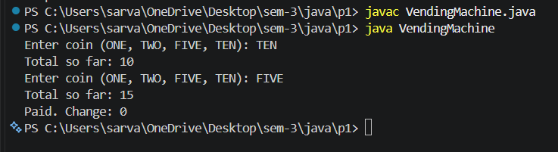
2. | Toll booth (TollBooth.java, main in this file)  (a) Define a record Vehicle(String number, String type).  (b) In main, keep a running toll total and three counters (bike, car, truck).  (c) Loop until the user types “done” for the number: build a Vehicle, use a switch expression on its type for the toll (bike→20, car→50, truck→150), add to the total, and increment that type’s counter.  (d) After the loop, print the total toll and the type with the highest count.  Expected output: two cars + one bike → “Total toll: 120”, “Most frequent: car”.
code | import java.util.Scanner;  public class TollBooth {  // A record stores the vehicle number and vehicle type.  record Vehicle(String number, String type) {  }  public static void main(String[] args) {  Scanner scanner = new Scanner(System.in);  int total = 0; // Total toll collected  int bikeCount = 0;  int carCount = 0;  int truckCount = 0;  while (true) {  System.out.print("Enter vehicle number or done: ");  String number = scanner.next();  // The word done ends the input loop.  if (number.equalsIgnoreCase("done")) {  break;  }  System.out.print("Enter vehicle type (bike, car, truck): ");  String type = scanner.next().toLowerCase();  Vehicle vehicle = new Vehicle(number, type);  // Calculate the toll and increase the matching counter.  int toll = switch (vehicle.type()) {  case "bike" -> {  bikeCount++;  yield 20;  }  case "car" -> {  carCount++;  yield 50;  }  case "truck" -> {  truckCount++;  yield 150;  }  default -> throw new IllegalArgumentException("Invalid vehicle type");  };  total += toll;  }  System.out.println("Total toll: " + total);  // Compare the counters to find the most common vehicle type.  if (carCount >= bikeCount && carCount >= truckCount) {  System.out.println("Most frequent: car");  } else if (bikeCount >= truckCount) {  System.out.println("Most frequent: bike");  } else {  System.out.println("Most frequent: truck");  }  }  }
output | 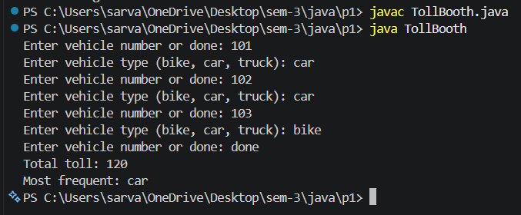
3. | Rock-Paper-Scissors-Lizard-Spock (RPSLS.java)  (a) Define an enum Move with ROCK, PAPER, SCISSORS, LIZARD, SPOCK.  (b) Write winner(Move a, Move b) returning 1 if a beats b, -1 if b beats a, 0 for a tie — use a switch expression listing what each move beats (Scissors cut Paper, Paper covers Rock, Rock crushes Lizard, Lizard poisons Spock, Spock smashes Scissors, and the five mirror cases).  (c) In main, play 5 rounds: pick a random computer Move, read the player’s Move, call winner(), print the round result and keep score.  (d) After 5 rounds, print the overall winner.  Expected output: each round prints both moves and the round winner; ends with a “You win 3–2” summary.
code | import java.util.Random;  import java.util.Scanner;  public class ROCK {  // The five possible moves in the game.  enum Move {  ROCK, PAPER, SCISSORS, LIZARD, SPOCK  }  // Return 1 when the first move wins, -1 when the second wins,  // and 0 when both moves are the same.  static int winner(Move a, Move b) {  if (a == b) {  return 0;  }  // Each move defeats exactly two other moves.  return switch (a) {  case ROCK -> (b == Move.SCISSORS || b == Move.LIZARD) ? 1 : -1;  case PAPER -> (b == Move.ROCK || b == Move.SPOCK) ? 1 : -1;  case SCISSORS -> (b == Move.PAPER || b == Move.LIZARD) ? 1 : -1;  case LIZARD -> (b == Move.PAPER || b == Move.SPOCK) ? 1 : -1;  case SPOCK -> (b == Move.SCISSORS || b == Move.ROCK) ? 1 : -1;  };  }  public static void main(String[] args) {  Scanner scanner = new Scanner(System.in);  Random random = new Random();  int playerScore = 0;  int computerScore = 0;  // The game has five rounds.  for (int round = 1; round <= 5; round++) {  // Choose a random move for the computer.  Move computerMove = Move.values()[random.nextInt(Move.values().length)];  System.out.print("Enter your move (ROCK, PAPER, SCISSORS, LIZARD, SPOCK): ");  Move playerMove = Move.valueOf(scanner.next().toUpperCase());  int result = winner(playerMove, computerMove);  System.out.println("Round " + round);  System.out.println("You: " + playerMove);  System.out.println("Computer: " + computerMove);  if (result == 1) {  playerScore++;  System.out.println("Round winner: You");  } else if (result == -1) {  computerScore++;  System.out.println("Round winner: Computer");  } else {  System.out.println("Round winner: Tie");  }  }  // Display the final result after all five rounds.  if (playerScore > computerScore) {  System.out.println("You win " + playerScore + "-" + computerScore);  } else if (computerScore > playerScore) {  System.out.println("Computer wins " + computerScore + "-" + playerScore);  } else {  System.out.println("Draw " + playerScore + "-" + computerScore);  }  }  }
output | 

