EXPERIMENT-1
ROLL NO:240701117 NAME:M.N.Dharaan
USER INTERFACE AND DESIGN
COMAPARSION OF UI DESIGN BETWEEN TWO FIGMA CREATION
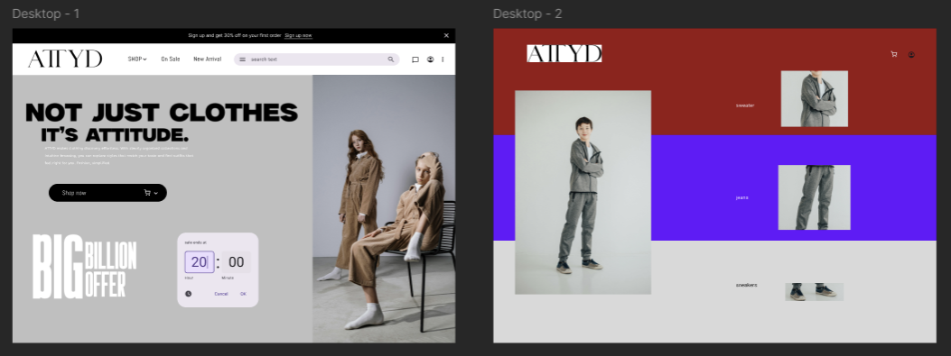
Experiment 1:

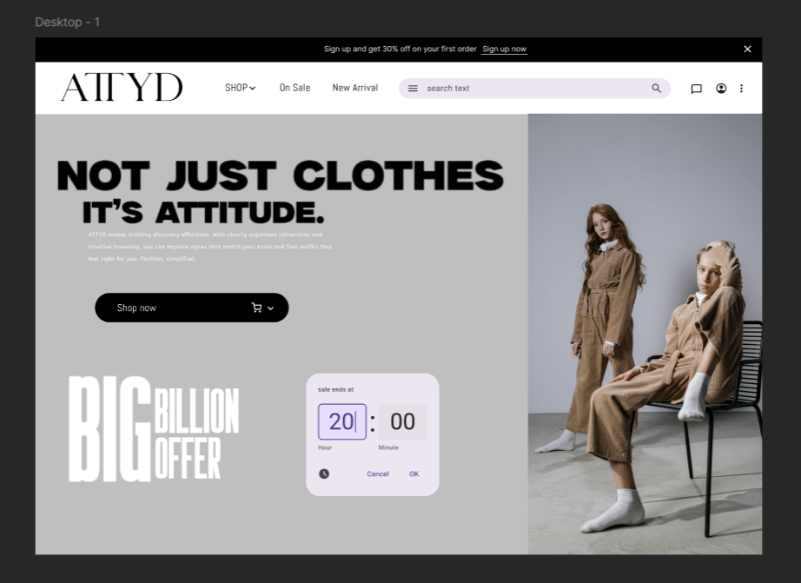
Good Website:
Bad Website:
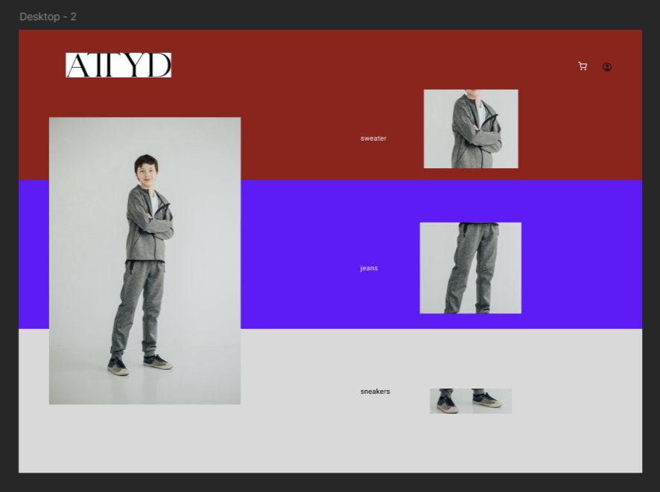

Good Website:
- Has proper texts and icons to help the users to navigate and chucking has been handled properly, information has been given properly
- Colours are more appealing and appears neat
- The content has been given properly for better experience

Bad Website:
- Doesn’t have any proper colour code and a single picture is used in multiple places.
- With bad fount and navigation will be extremely hard
- Overall the whole website looks less appealing and does not look user friendly
- There is no search bar which woul help in navigation

Differences:
- Icons have been handled well which helps the users more and makes the website more user friendly
- There are search bars which help in the navigation in the good website
- The colour code on both website is so different one is pleasing and the other one has contrasting colours.
- The bad website has one picture cropped as reference which makes it looks less pleasing

