EXPERIMENT-2
Name : M.N.Dharaan
Roll no : 240701117

FRAME 1: INSTRUCTION PAGE
“HOW TO PLAY” Screen
Chunking Analysis of the Instruction Page

The instruction screen introduces the rules of the chess memory game using clear chunking principles to reduce cognitive load and improve understanding.

1. Clear and Step-by-Step Instructions

- The instructions are broken down into short bullet points.

- Each line communicates one action, making it easy for users to follow.

2. Logical Flow of Information

- Observation Phase – Users are informed that they will see a set of images.

- Memorisation Phase – Users are asked to memorize the chess pieces carefully.

- Recall Phase – Users are instructed to select the pieces they saw earlier.

- Scoring Rule – Users are informed that each correct selection increases their score.

3. Visual Hierarchy and Readability

- Bold heading “HOW TO PLAY” immediately sets context.

- Bullet points improve scanning and readability.

- The PLAY button is clearly highlighted, guiding the user to the next step.

4. Simplicity and Clarity

- Instructions are short and direct.
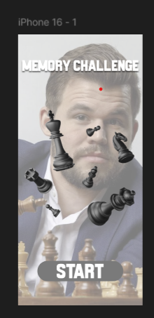
FRAME 2: MEMORISING PHASE
Analysis of the Memorising Phase Screen

This screen represents the visual encoding stage, where users observe and memorize chess pieces within a limited time.

1. Purpose of the Screen

- To allow users to encode visual information into short-term memory.

- Users mentally group chess pieces using chunking strategies.

2. Key UI Components

⏳ Progress Bar (Top)

- Visually represents the remaining time for memorization.

- Encourages users to stay focused and manage time effectively.

♟ Grid of Chess Pieces

- Chess pieces such as king, queen, rook, bishop, knight, and pawn are displayed.

- Pieces vary in color and type, encouraging chunking methods like:

- Grouping by piece type (major vs minor pieces)

- Grouping by color (white vs black pieces)

- Recognizing symmetrical patterns

3. How Chunking Works Here

- Users do not memorize pieces individually.

- Instead, they remember groups (e.g., “two rooks and one knight”).

4. Cognitive Benefits

- Reduces memory overload.

- Improves recall accuracy.
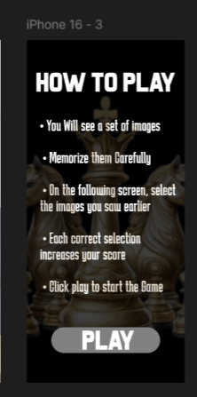
FRAME 3: RECALL PHASE
Analysis of the Recall Phase Screen

This screen tests how well users can retrieve previously memorized information.

1. Purpose of the Screen

- To evaluate short-term memory retention.

- To test the effectiveness of chunking strategies used earlier.

2. Key UI Components

📝 Title – “RECALL PHASE”

- Clearly indicates the memory retrieval stage.

♟ Selection Grid of Chess Pieces

- Displays multiple chess pieces.

Includes both:

- Pieces shown in the memorising phase

- Distractor pieces that were not shown earlier

⚪ Selection Indicators (Dots)

- Users tap/select the pieces they remember.

🔘 SUBMIT Button

- Confirms the user’s final recall choices.

3. How the Recall Phase Works

- Users analyze the displayed pieces.

- They recall which pieces were shown earlier.

- They select remembered pieces.

- Distractors test false memory recognition.

4. UX & Cognitive Benefits

- Encourages focused decision-making.

- Tests memory accuracy rather than guessing.

- Simple interaction reduces confusion.

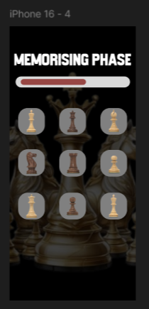

FRAME 4: SCORE / RESULT PAGE
Analysis of the Score Screen

This screen provides feedback based on user performance.

1. Purpose of the Screen

- To show recall accuracy.

- To motivate replay and improvement.

2. Key UI Components

🏆 Score Display

Example: “SCORE 4/6”

- Shows number of correct selections out of total.

🔁 PLAY AGAIN Button

- Allows users to retry the game.

- Encourages repeated learning and engagement.

3. How This Phase Works

- The system compares selected pieces with memorised pieces.

- The score is calculated.

- The result is displayed clearly.

- Users can replay to improve performance.

4. UX & Learning Benefits

- Instant feedback helps users assess memory strength.

- Replay option supports learning through repetition.


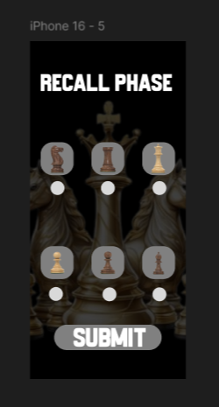
- Minimal UI keeps focus on results.

