EXPERIMENT-3
NAME: Dharaan M N ROLL NO: 240701117

1.COMMAND LINE INTERFACE

PYTHON CODE:
import sys
# Default numbers
a = 10
b = 5
while True:
command = input("Enter command (add/sub/mul/div/exit): ").lower()
if command == "add":
print("Result:", a + b)
elif command == "sub":
print("Result:", a - b)
elif command == "mul":
print("Result:", a * b)
elif command == "div":
if b == 0:
print("Cannot divide by zero")
else:
print("Result:", a / b)
elif command == "exit":
sys.exit()
else:
print("Invalid command")

OUTPUT:
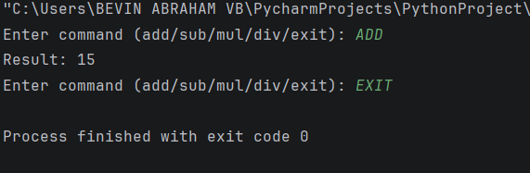

2.GRAPHICAL USER INTERFACE:
PYTHON CODE:
import tkinter as tk
# Default numbers
a = 10
b = 5
def calculate(operation):
if operation == "add":
result.set(a + b)
elif operation == "sub":
result.set(a - b)
elif operation == "mul":
result.set(a * b)
elif operation == "div":
if b != 0:
result.set(a / b)
else:
result.set("Error")
root = tk.Tk()
root.title("Simple Calculator GUI")
root.geometry("300x250")
tk.Label(root, text="Default Numbers: 10 and 5").pack(pady=10)
result = tk.StringVar()
result.set("Result")
tk.Button(root, text="Add", width=15, command=lambda: calculate("add")).pack(pady=5)
tk.Button(root, text="Subtract", width=15, command=lambda: calculate("sub")).pack(pady=5)
tk.Button(root, text="Multiply", width=15, command=lambda: calculate("mul")).pack(pady=5)
tk.Button(root, text="Divide", width=15, command=lambda: calculate("div")).pack(pady=5)
tk.Label(root, textvariable=result, font=("Arial", 14)).pack(pady=15)
root.mainloop()
OUTPUT:
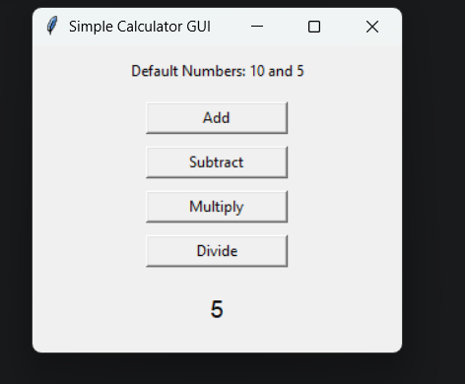

3.VOICE USER INTERFACE:
PYTHON CODE:
import speech_recognition as sr
import os
def rename_file_from_voice_command(command):
try:
words = command.lower().split(" ")
if "rename" in words and "to" in words:
rename_index = words.index("rename")
to_index = words.index("to")
# Extract old and new filenames
old_name = words[rename_index + 1]
new_name = words[to_index + 1]
# Check if file exists
if not os.path.exists(old_name):
print(f"Error: File '{old_name}' not found.")
return
os.rename(old_name, new_name)
print(f"✅ File renamed from '{old_name}' to '{new_name}'")
else:
print("Invalid command format. Say: 'Rename oldfile.txt to newfile.txt'")
except Exception as e:
print(f"Error: {e}")
def listen_for_command():
recognizer = sr.Recognizer()
mic = sr.Microphone()
print("🎤 Listening for command to rename a file...")
with mic as source:
recognizer.adjust_for_ambient_noise(source)
audio = recognizer.listen(source)
try:
command = recognizer.recognize_google(audio)
print(f"🎙️ Command received: {command}")
rename_file_from_voice_command(command)
except sr.UnknownValueError:
print("❌ Sorry, I couldn't understand the command.")
except sr.RequestError as e:
print(f"⚠️ Could not request results from Google Speech Recognition service; {e}")
if __name__ == "__main__":
listen_for_command()

OUTPUT :

