# 2021_01_11

* **What is OTP for? I think it should be removed.-> done**
* **Change Item description to location description -> done**
* **Put choose file after the description -> done**
* Make the screen narrower
  + ->which screen you want to narrow down please attach screenshot for reference. – The screen that displays the items or put all four columns in one line 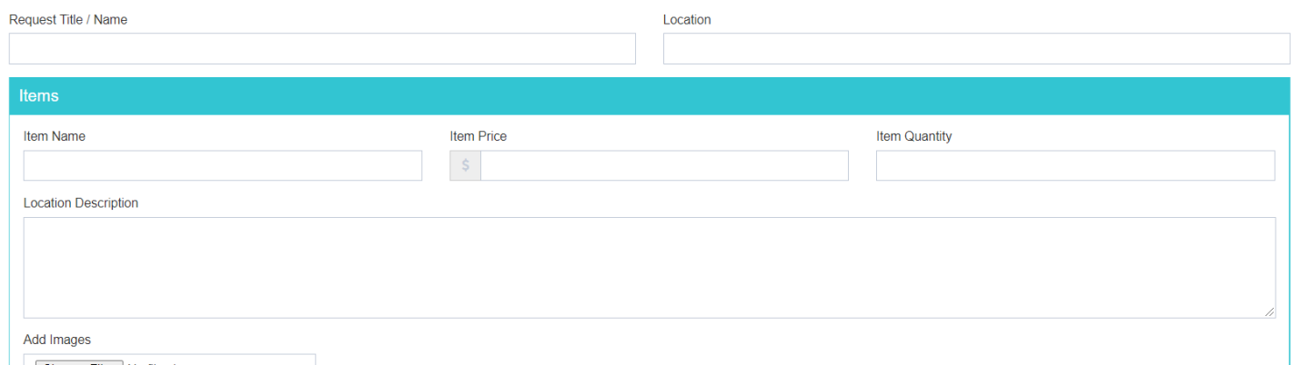
* Allow to edit item in the list.-> **done**
* **Remove Captcha from the form used to add items -> done**
* **Display the dollar amount with currency formatting -> done**
* **Keep the added list less height ->** [**http://prntscr.com/wlsg6e**](http://prntscr.com/wlsg6e) **-> done**
* Make two terms & conditions sections on the page with a check box for the user to check of and confirm they read it. For now you can fil it with Lorem Ipsum
  + -> how we can two terms and conditions . Like this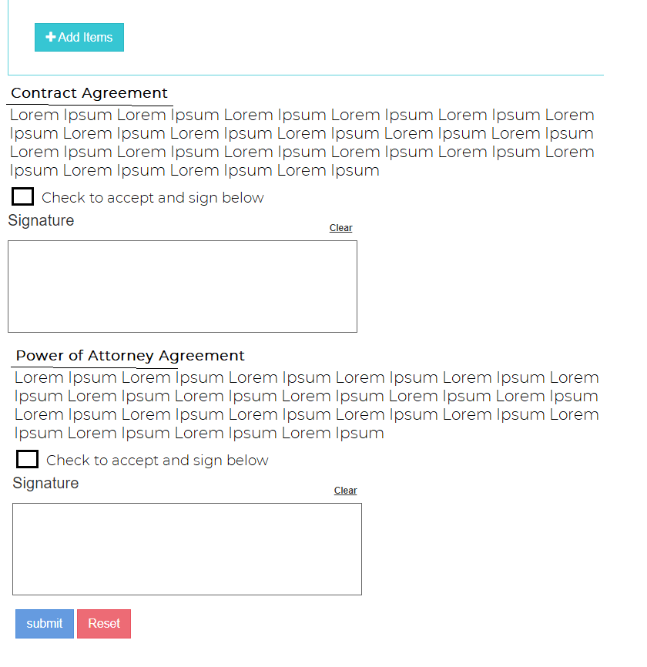
* Each section will need a signature and check box
  + -> are you refraining that user terms and conditions section or something else please describe. => Working See image above
* Where can I create an order based off of a previous order? I should be able to copy a previous order, modify it ay editing, deleting and adding items. => **Pending**
* The **admin** user should be able to print the order.
  + Each terms & conditions is a different document to be printed.
  + The way it should print is as follows.
    - For the first terms & conditions section print the name and location and the text of the terms & conditions. Then print the items that were sold on the next page. Each page should have the signature.
    - For the second terms & conditions print the terms & conditions on the first page. The next page should print all the signatures from all the Processed orders
  + I will give the header and exact language for the terms & conditions -> **Send me this INformation**

-> need more description on how the whole terms and condition feature work. Since each terms & conditions is a different agreement there needs to be two different documents. The items that are listed should be part of only one of the terms and conditions. The first page will display the contract which includes the name and location. The second page will have the items listed. Each one need to have the signature on it.

The second terms & condition is the power of attorney. It is enough to print the power of attorney and all the signatures from all sales can be printed on a separate page.

Here is an image: 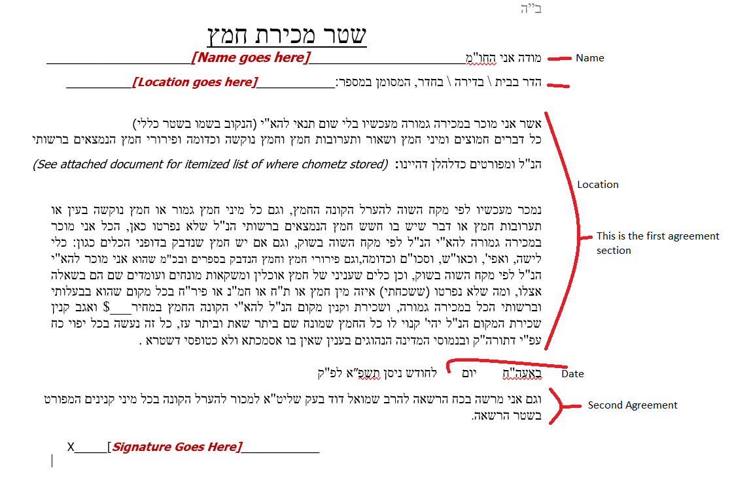

* **I could not change the status of an order -> done**

# 2021_16_02

1. How can I add multiple locations?
2. Add cell phone field to the form.