Packages

1. Tax Return File-income tax Return-Packages-

-Salary@499

-Business@1599

1. GST Retrun Filling-GST Return-

-Basic@199

-standard@999 (With this Matters:- A Single GST Return filing carrying transactions up to  100 during the relevant period.

-Annual Packages@4999 (With this Matters:-GST Returns filing  
for the complete financial year.

1. TDS Return File-

Basic@1199

Standard@1999

Annual Packages@4999

1. Annual Compliances-Private Limited Company

Basic@14999

Standard@19999

Premium@24999

1. Annual Compliances- Limited Liability Company

Basic@7999

Standard@12999

Premium@14999

1. Annual Compliances- INC

Basic@1499

Standard@3499

Premium@5999

1. Annual Compliances-Form Dir-3 KYC

Basic@1399

Standard@1799

Premium@2999

1. Company Formation-Private Limited Company

Basic@5999

Standard@7999

Premium@14999(Delete this line:-GST Invoicing Software valid for 1 Year and Add:- Import Export Code Registration +MSME Certificate.)

1. Company Formation-Public Limited Company

Basic@19999

Standard@24999

Premium@29999 (Delete this line:- GST Invoicing Software valid for 1 Year and Add:- Import Export Code Registration +MSME Certificate.)

1. Company Formation-One Person Company

Basic@3999

Standard@4999

Premium@9999 (Delete this line:- GST Invoicing Software valid for 1 Year and Add:- Import Export Code Registration +MSME Certificate.)

1. Company Formation-Partnership Firm

Basic@1999

Standard@2999

Premium@ 7999(Delete this line:- GST Invoicing Software valid for 1 Year and Add:- Import Export Code Registration +MSME Certificate.)

1. Company Formation-Limited Liability Partnership

Basic@4999

Standard@6999

Premium@11999 (Delete this line:- GST Invoicing Software valid for 1 Year and Add:- Import Export Code Registration +MSME Certificate.)

1. Company Formation-Sole Proprietorship

Basic@499

Standard@999

Premium@1499

1. Goods and Service Tax-GST Registration

Basic@999

Standard@1999 (Delete this line:- GST Billing Software for 1 year subscription*[Desktop + Mobile App] and Add:-MSME Certificate.)

Premium@6999 (Delete this line:-GST Billing Software for 1 year subscription*[Desktop + Mobile App] and Add:- MSME Certificateand Add:- MSME Certificate)

1. Goods and Service Tax-GST Modification No changes Required.
2. Goods and Service Tax-GST Cancellationn No changes Required.
3. Import & Export -Import Export Code

Basic@1999

Standard@2499

Premium@3999

1. Import & Export –IEC Modification

Basic@499

Standard@999

Premium@1499

1. Import & Export –FIEO Registration

Basic@4999

Standard@6999

Premium@7999

1. Import & Export -APEDA Registration

Basic@9999

Standard@11999

Premium@12999

1. Import & Export- Letter of Undertaking

Basic@999

Standard@2999

Premium@14999

1. IPR-Trademark

Basic@1399 (Add: - Govt. Fee Extra)

Standard@1999 (Add: - Govt. Fee Extra)

Premium@3999 (Add: - Govt. Fee Extra)

1. IPR-Copyright

Basic@4499

Standard@9999

Premium@13999

1. IPR-Patent

Basic@24999

Standard@39999

Premium@44999

1. IPR-Trademark Objection Reply

Basic@1999

Standard@2999

Premium@7999

1. IPR-Logo Designing

Basic@1999

Standard@3499

Premium@4999

1. IPR-Design Registration

Basic@5999

Standard@9999

Premium@16999

1. Labour Laws-PF Registration

Basic@4999

Standard@5999

Premium@14999

1. Labour Laws-ESI Registration

Basic@3999

Standard@8999

Premium@19999

1. Business Registration- ISO (no Changes Required)
2. Business Registration-MSME
3. Basic@499
4. Standard@1999
5. Premium@9999
6. Business Registration-FSSAI (No Changes)
7. Business Registration-DSC (No Changes Required)
8. Business Registration-Shop Establishment (No Changes required)

Further No required changes in Business Registration Packages.

In home Pages

Add What We Do :- 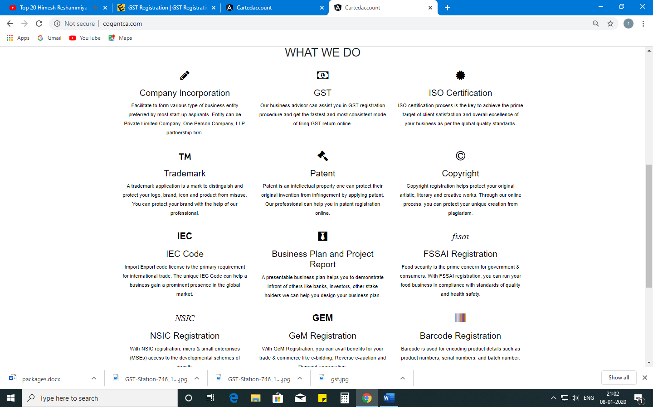

1. Annual Compliances-

We will assign you a dedicated Compliance Manager who will help you maintain all the compliances for your company. The Compliance Manager will help your company maintain accounts and will prepare the financial statement for your business at the end of financial year. Our Compliance Manager will also help you prepare minutes of board meetings and create all secretarial reports such as Directors Report and Annual Report each financial year.

1. Income Tax Return-

At the end of each financial year, the Income-tax return of a proprietorship must be filed. Our professional and competent Compliance Manager will prepare all the documents required under your knowledge and file your business income tax return.

1. TDS Return-

TDS returns filling are mandatory for those who are having TAN Registration. TDS returns are expected the quarterly. **Great solutions** can enable you to electronically file your TDS returns online. Our highly skilled and professional experts can enable you to process TDS returns and payment for the TDS return and keep you updated with TDS rules. The returns have to be filed for every quarter i.e. May 31, July 31, October 31 and January 31 for every coming year.

Video Slider for Home Pages

1st page – Company Formation



**Tag line With Light Blue Colour :-  REGISTER A COMPANY IN INDIA AT JUST 3,999 (ALL INCLUSIVE)\***

**2nd Page- Trademark**



**Tag line With Light Blue Colour :- PROTECT YOUR BRAND, SLOGAN AND LOGO AT JUST 1399* (GOVT. FEE EXTRA)**

**3 rd Page- GST**



##### **Tag line With Light Blue Colour :-** GET GST REGISTRATION FREE WITH GST RETURN ANNUAL RETURN PACKAGE

4 th page- MSME

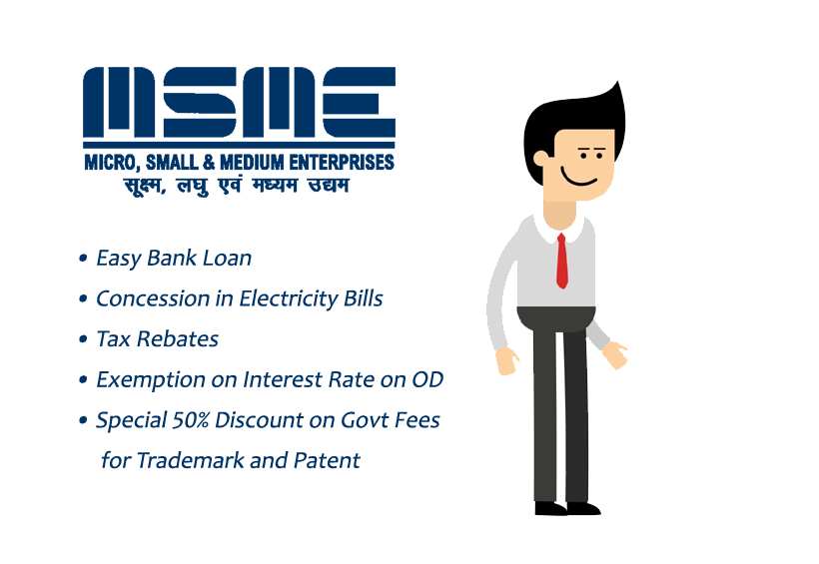

##### **Tag line With Light Blue Colour :-** GET MSME REGISTRATION AT JUST 999

*Bhaiya please remove this animate boy.

5 th page :-



**Tag line With Light Blue Colour ON LEFT CORNER :-** PICK THE MONTHLY PACKAGE THAT SUITE YOU

MONTHLY PACKGE AT JUST 6499 FOR HAVING TURNOVER UP TO 2 CRORES

* Tax Audits
* ROC Filing
* GST Returns
* Book Keeping
* Expert Tax Advice
* Income Tax Returns
* Half Yearly Balance Sheet