Hallucination Reduction Experiment Report
This report includes tables and figures generated by the benchmark. Lower detector scores mean less hallucination.

Overall Results (All Models)
Overall hallucination scores
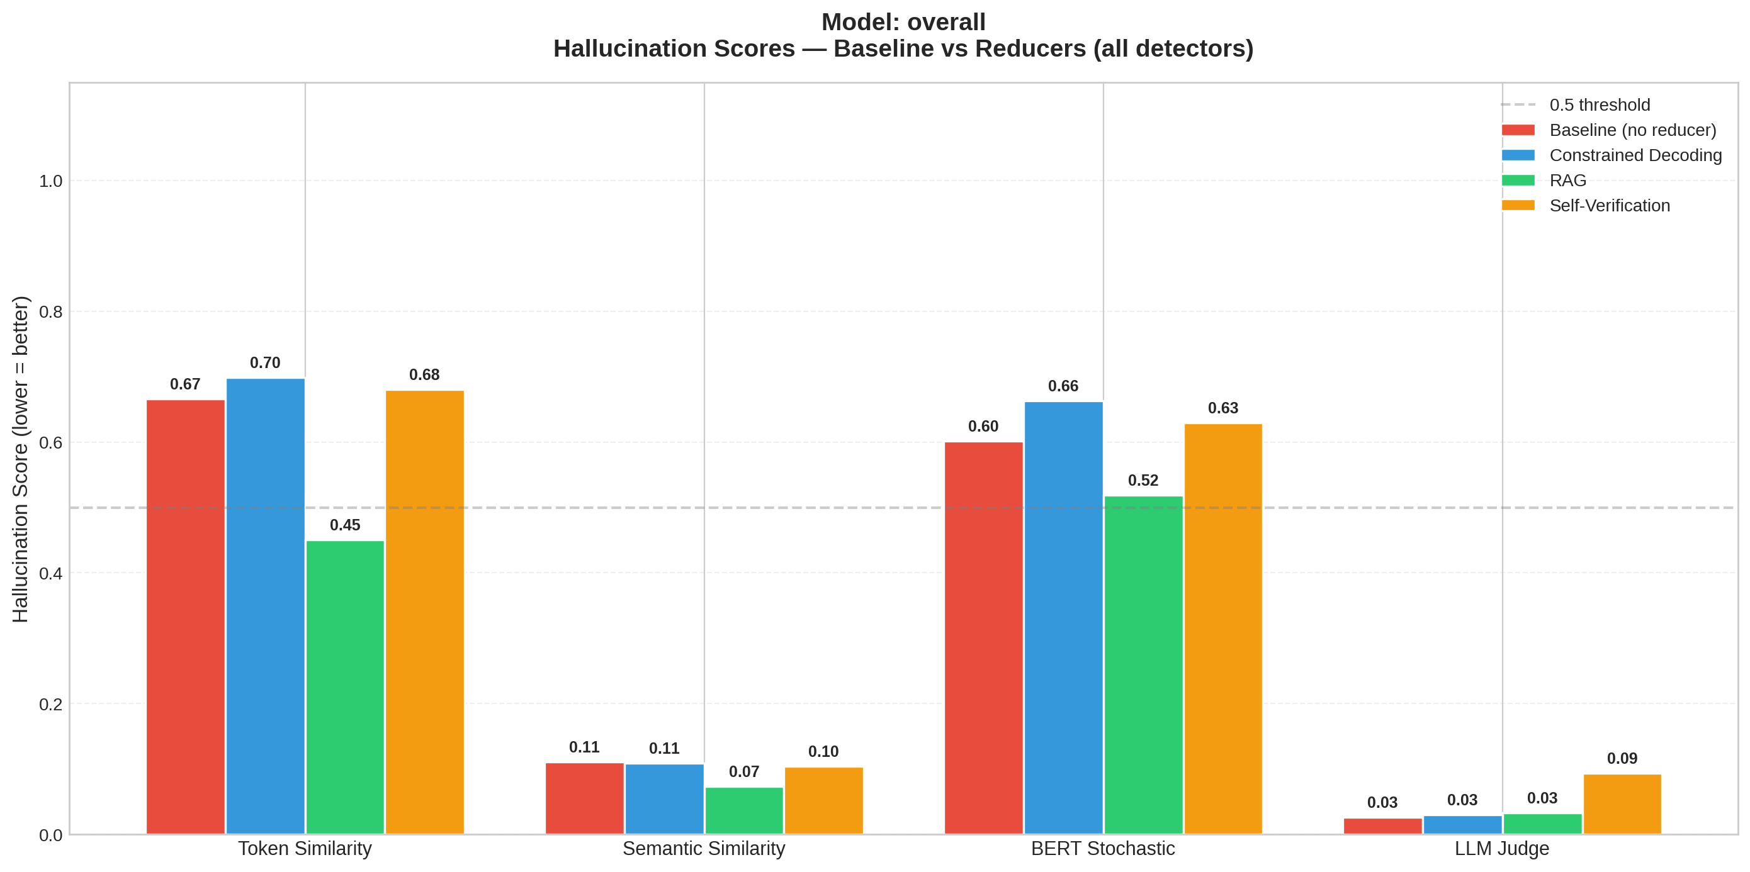
Overall per-detector scores
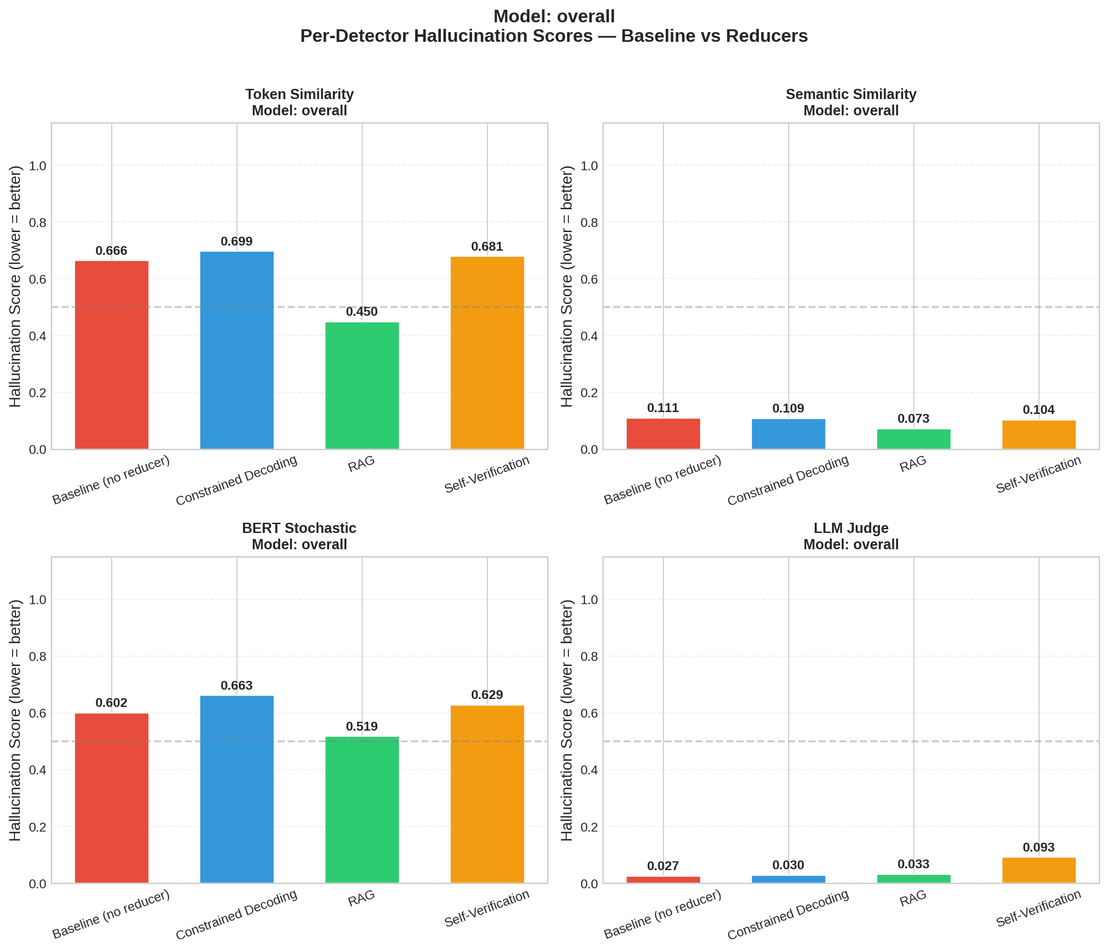
Overall score reductions vs baseline
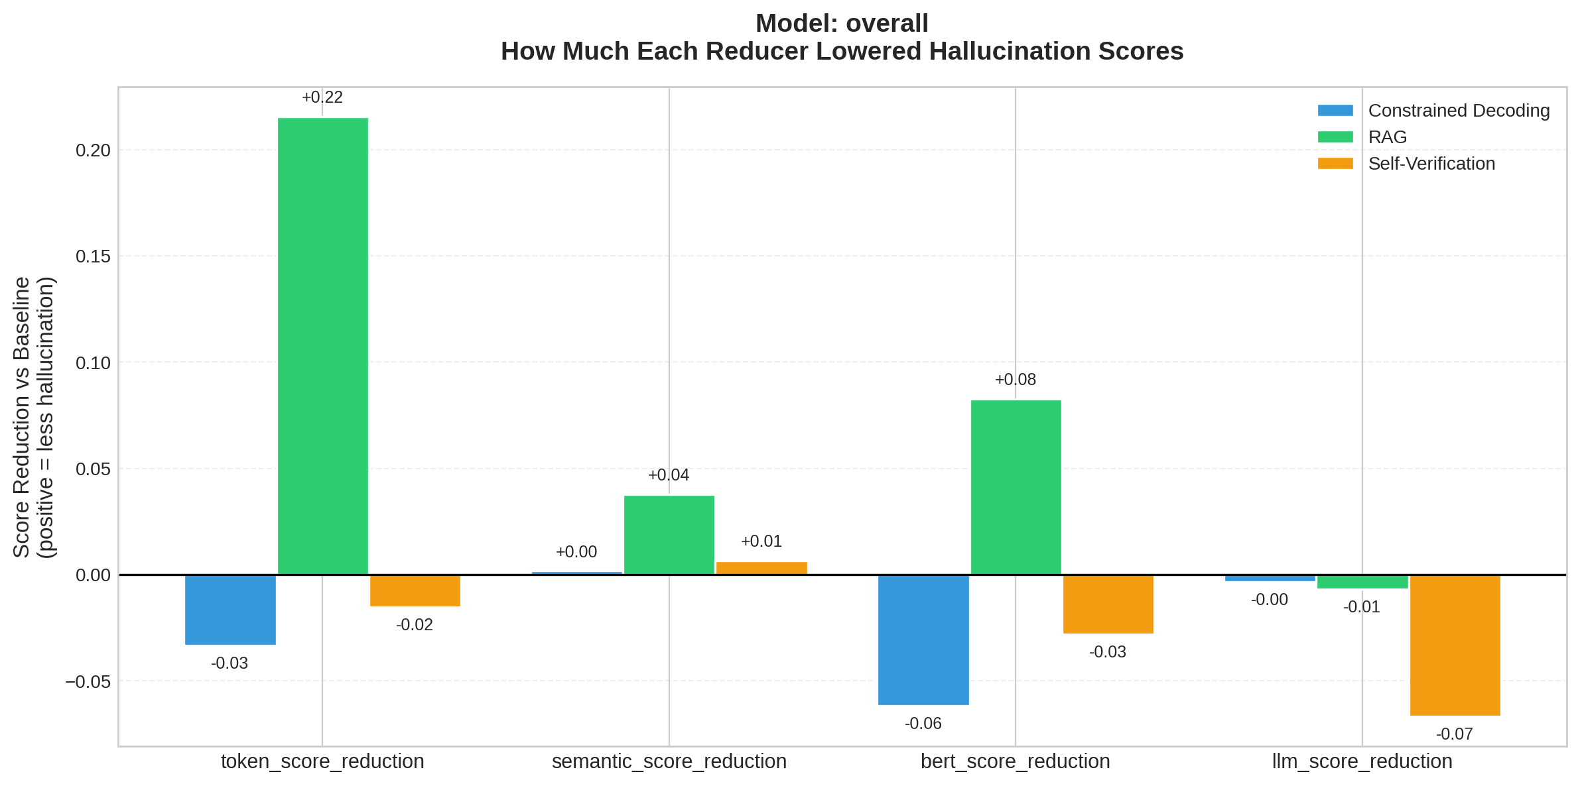
Overall latency
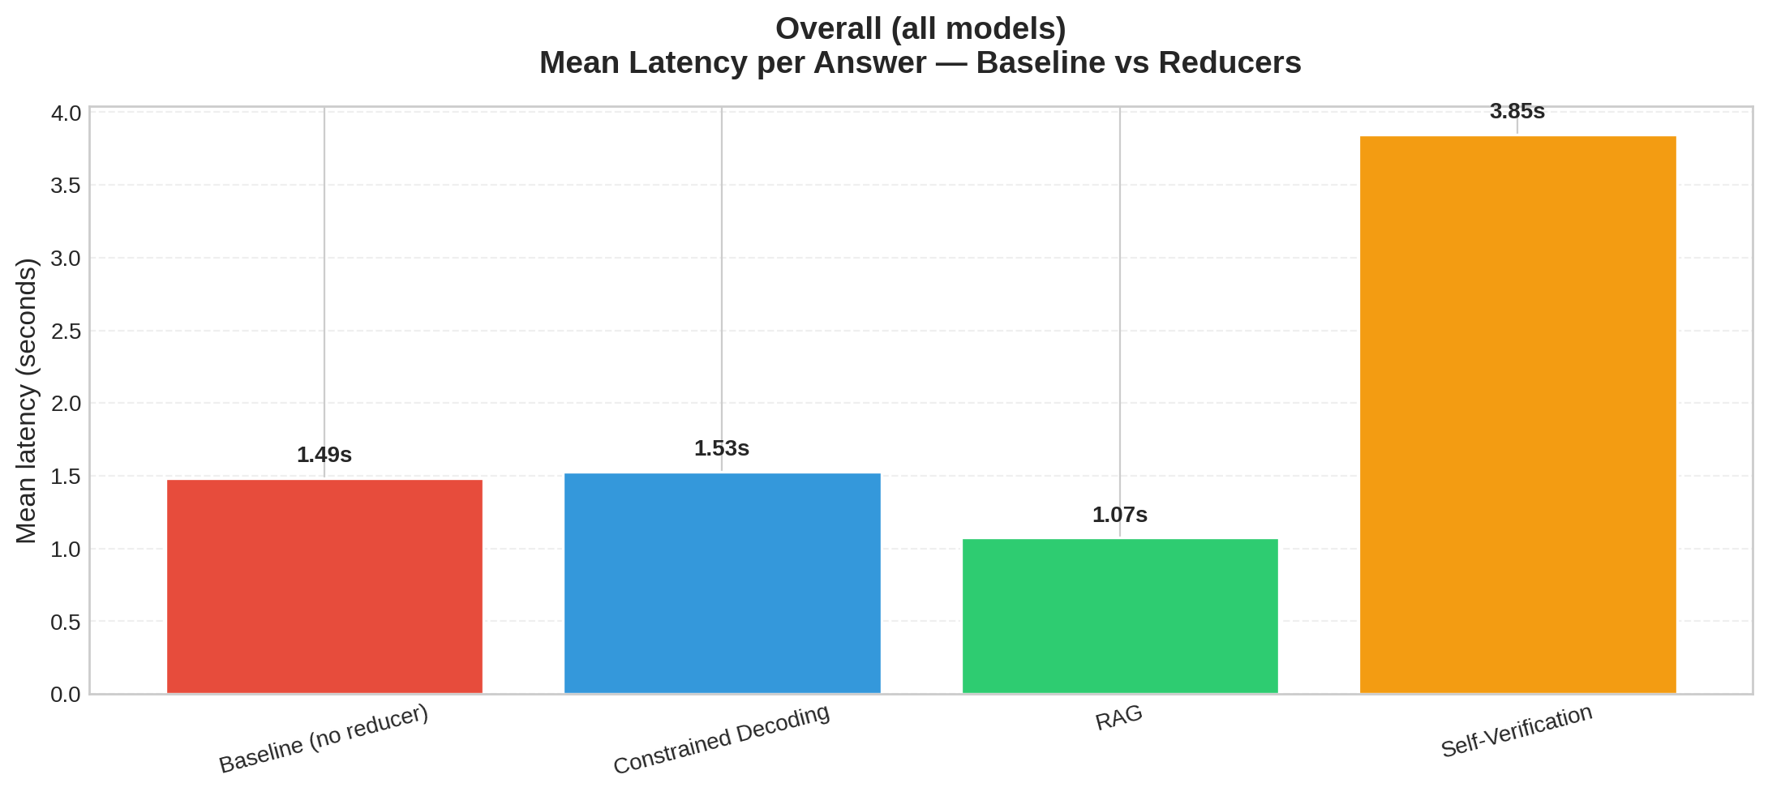

Per-Model Results

Model: llama3:latest
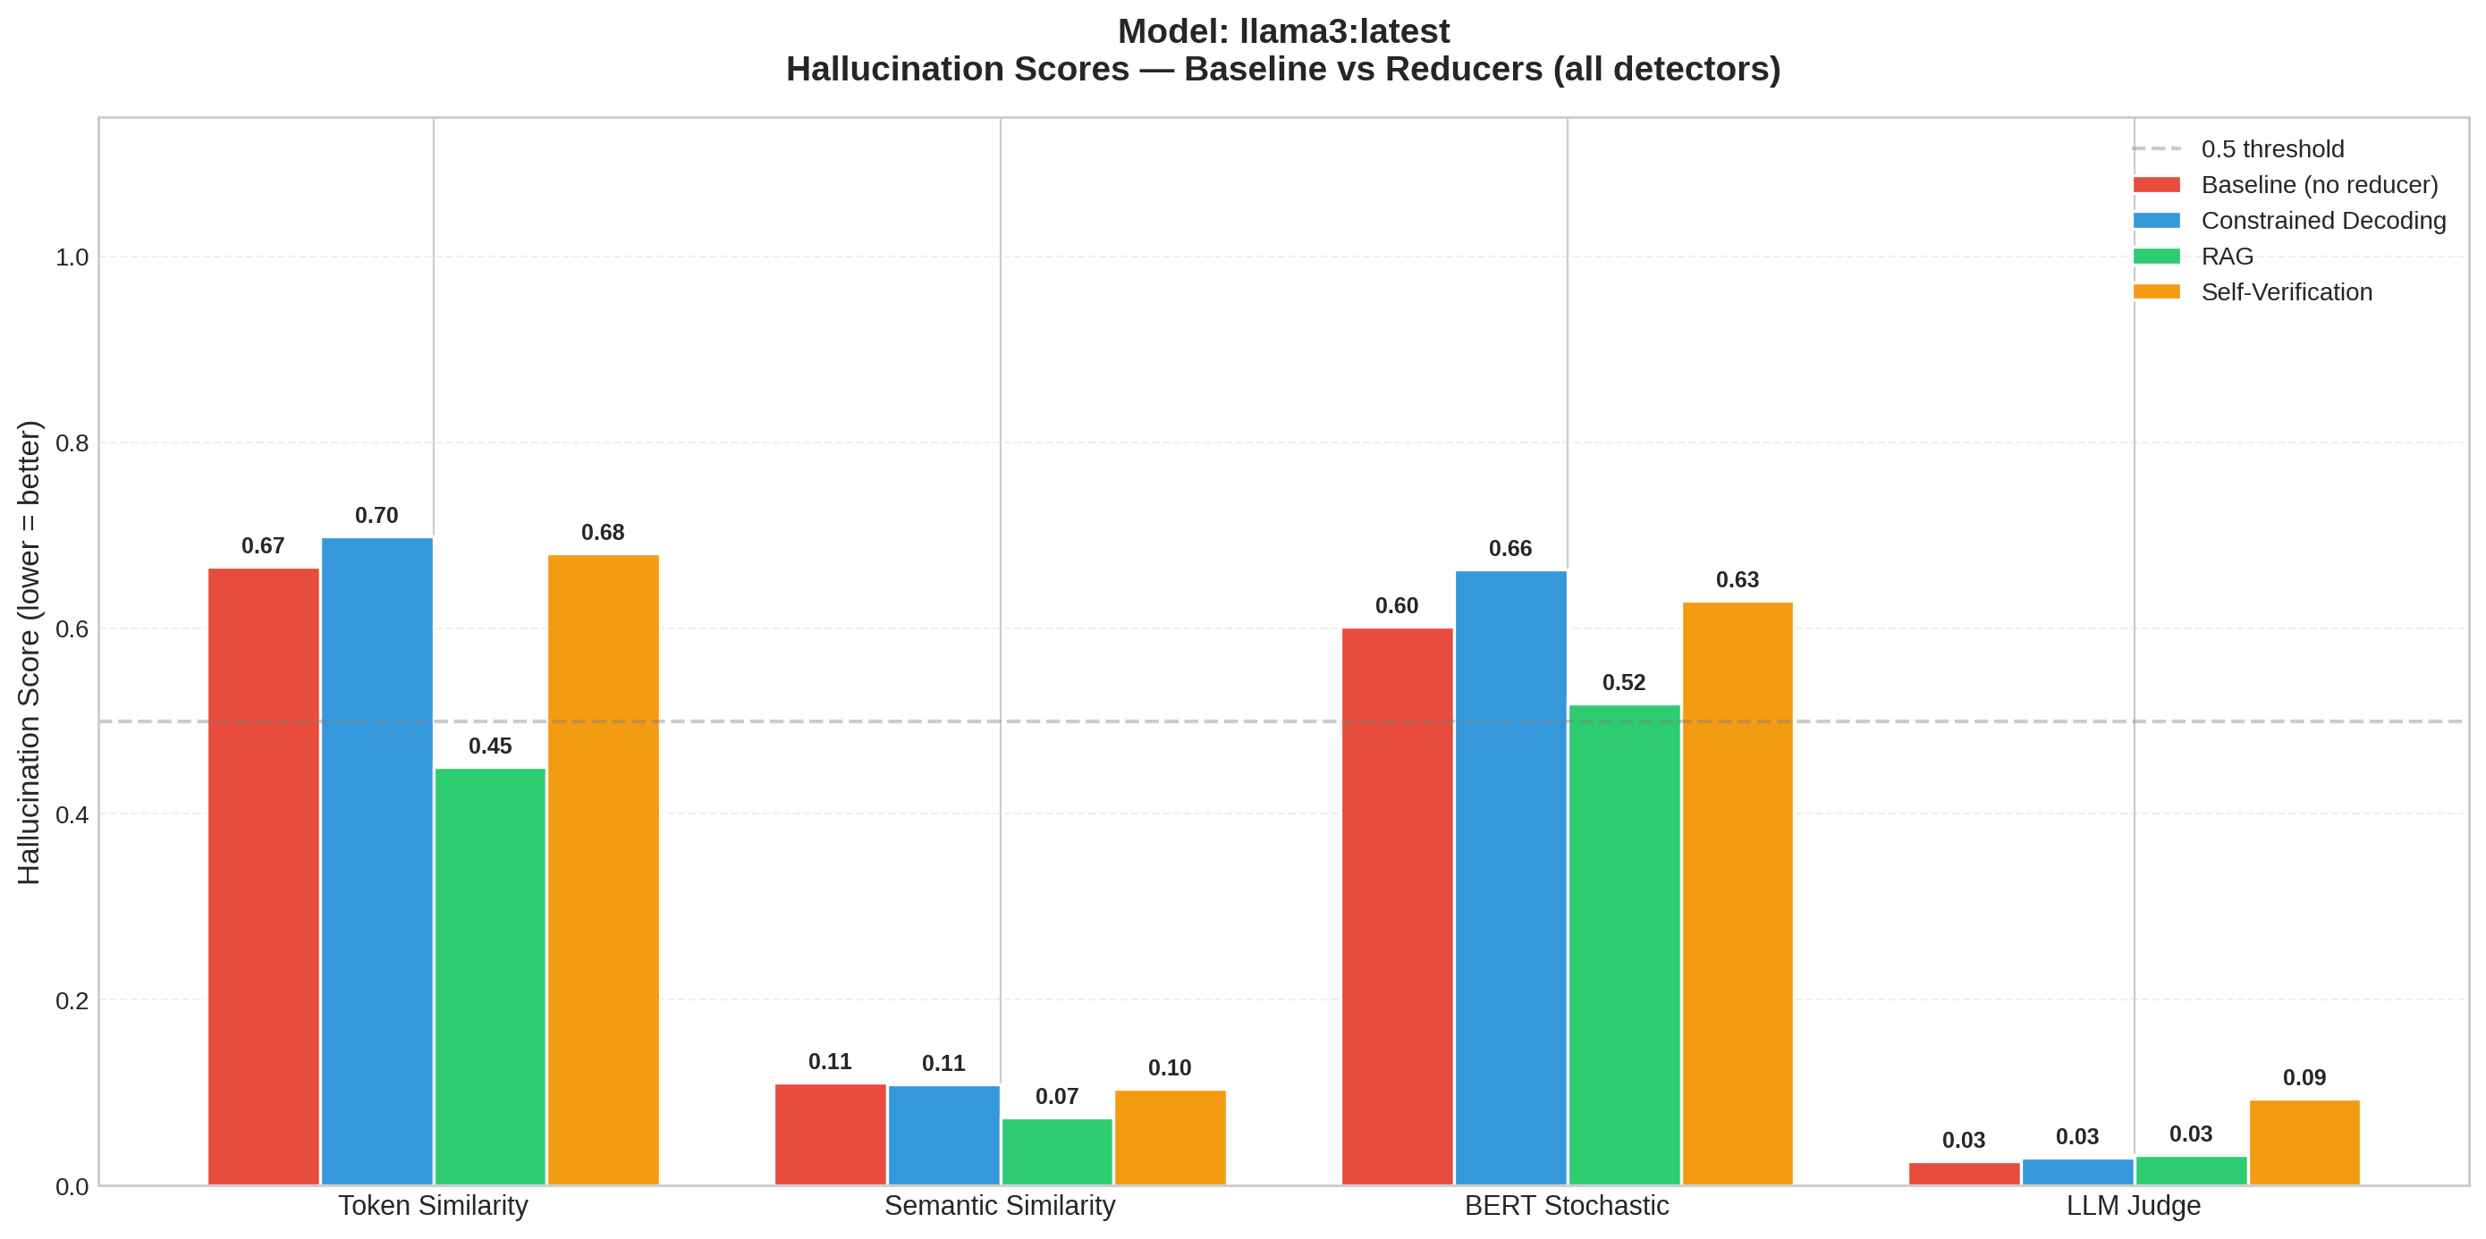
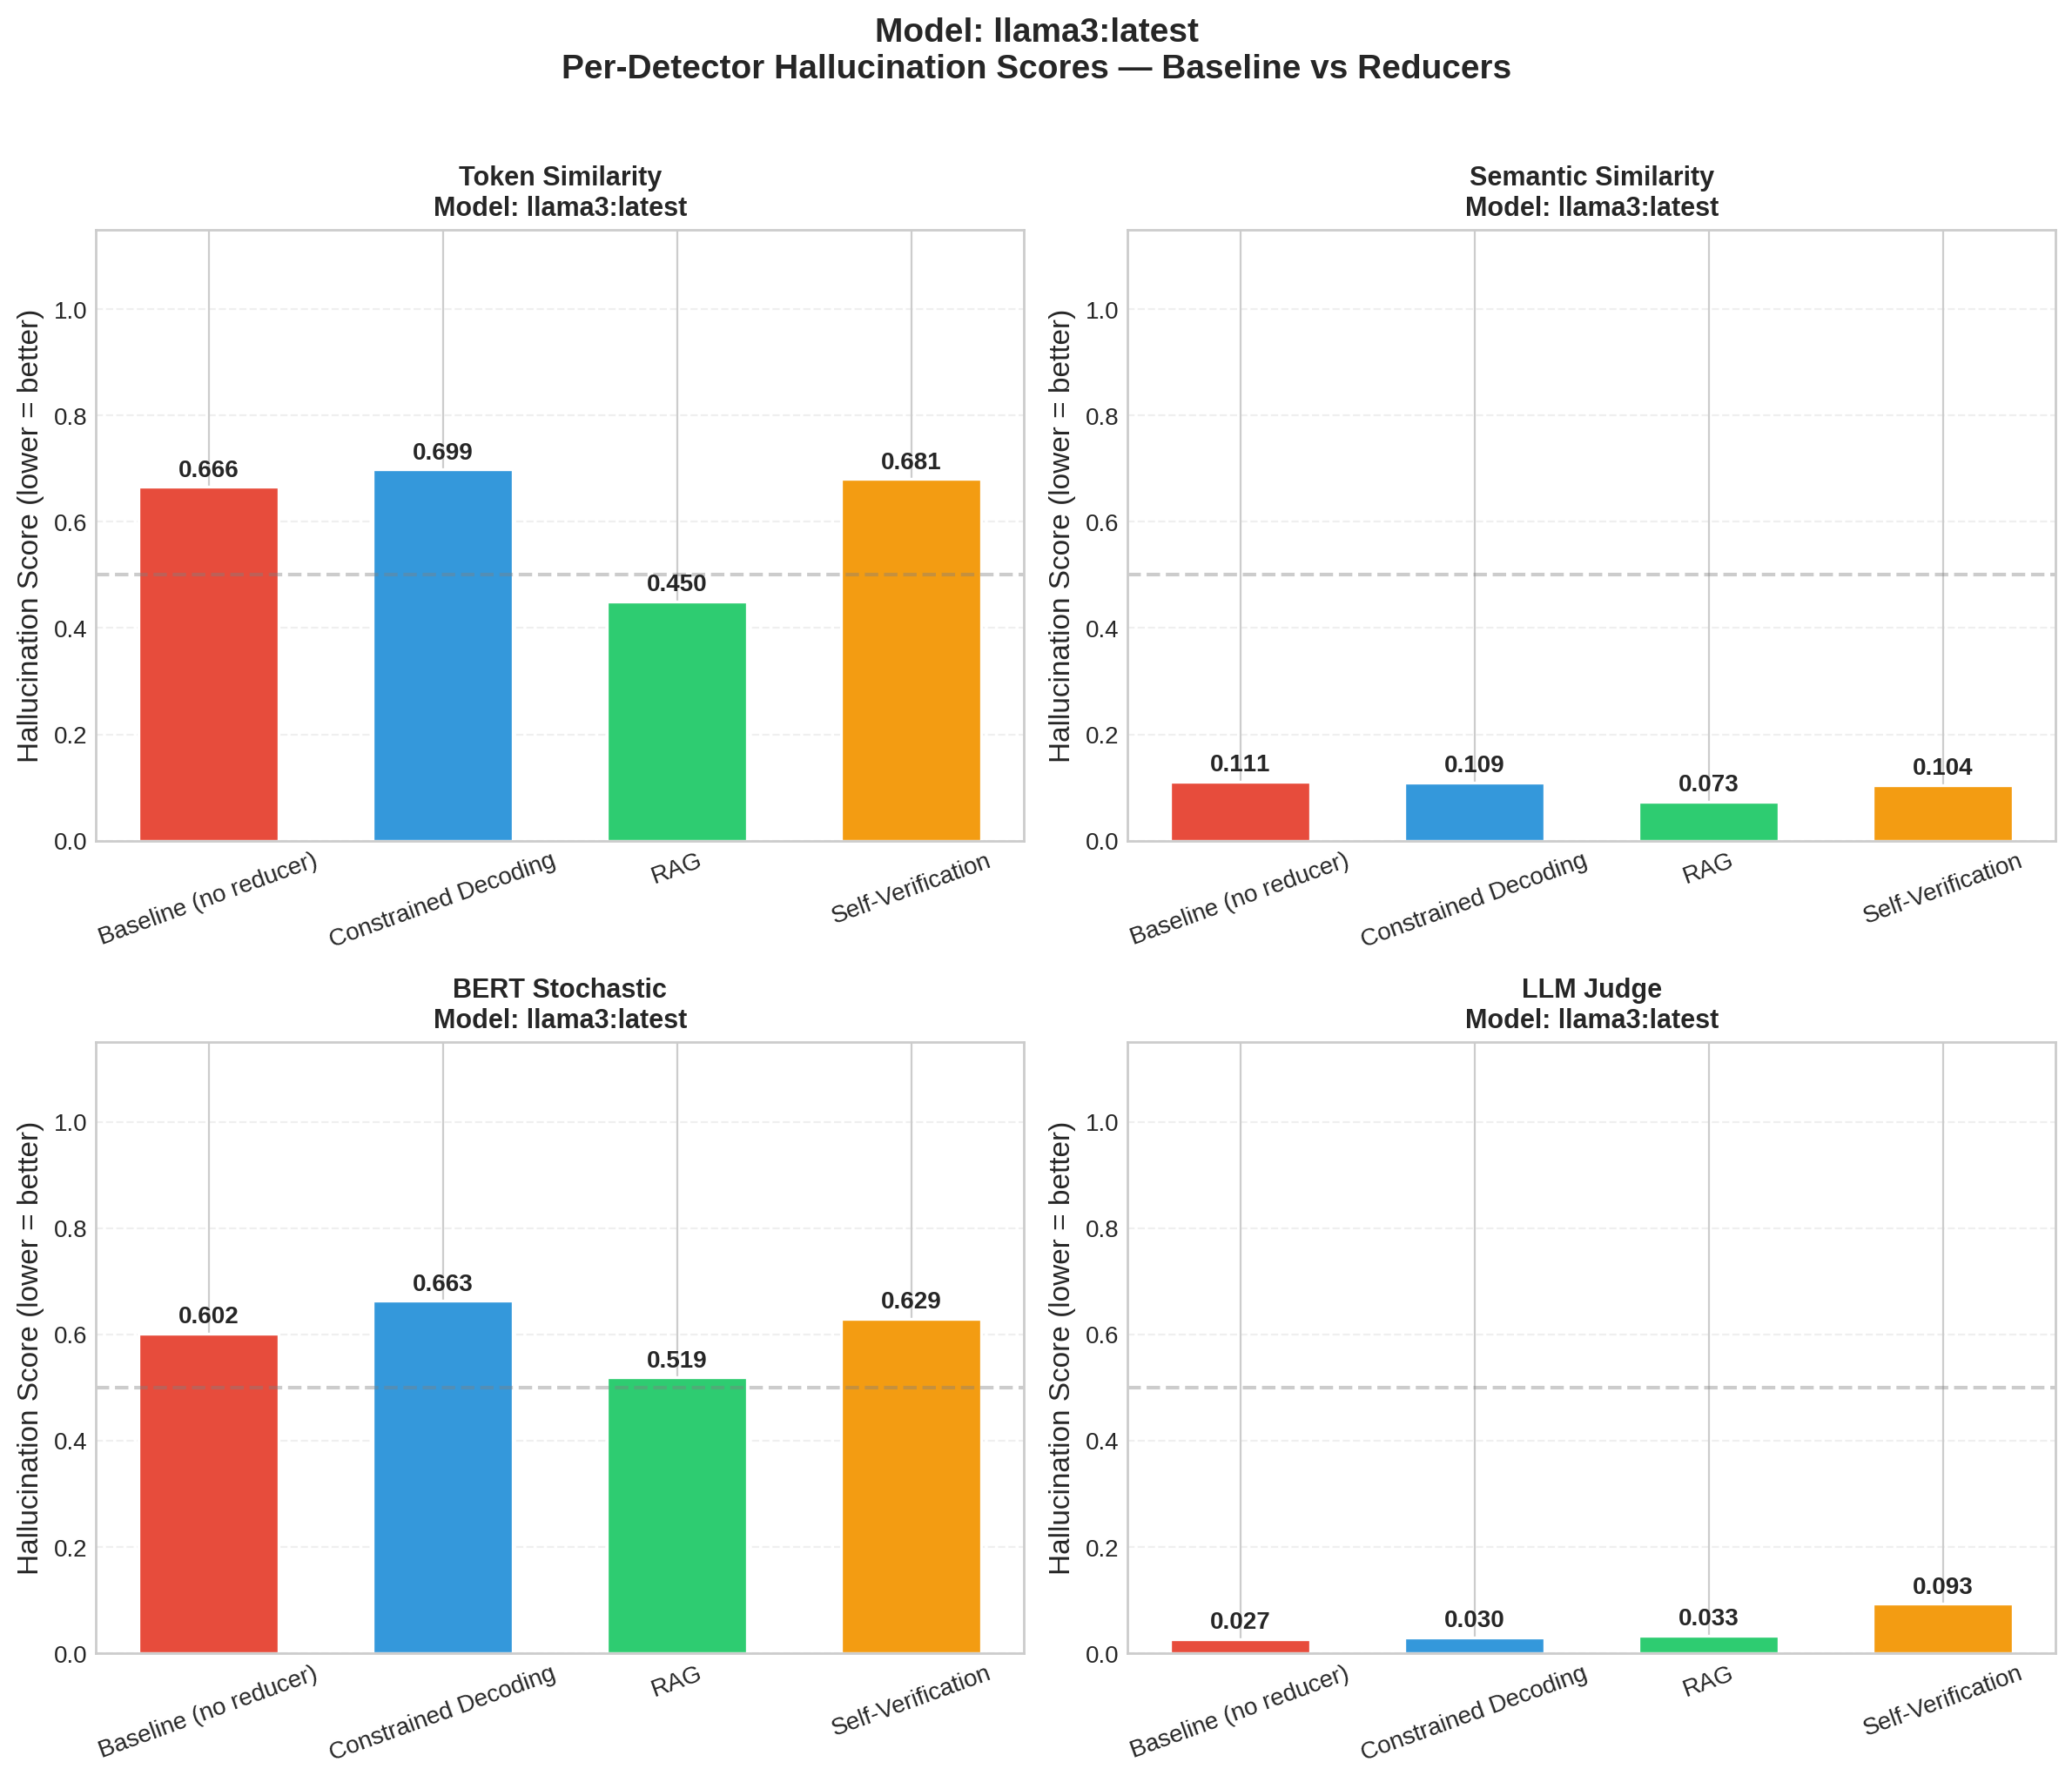
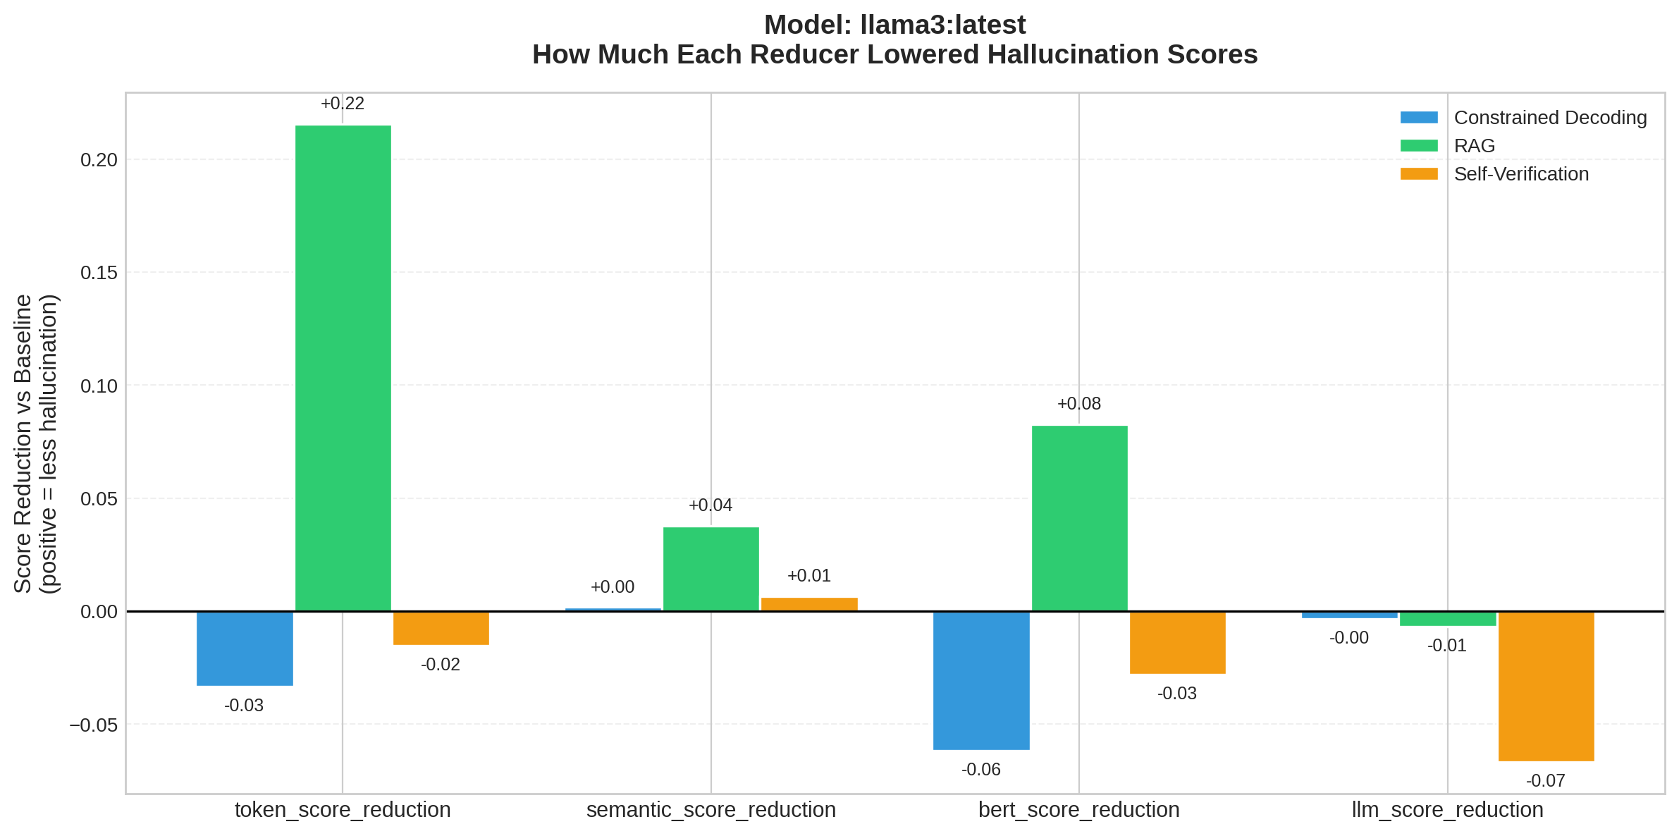
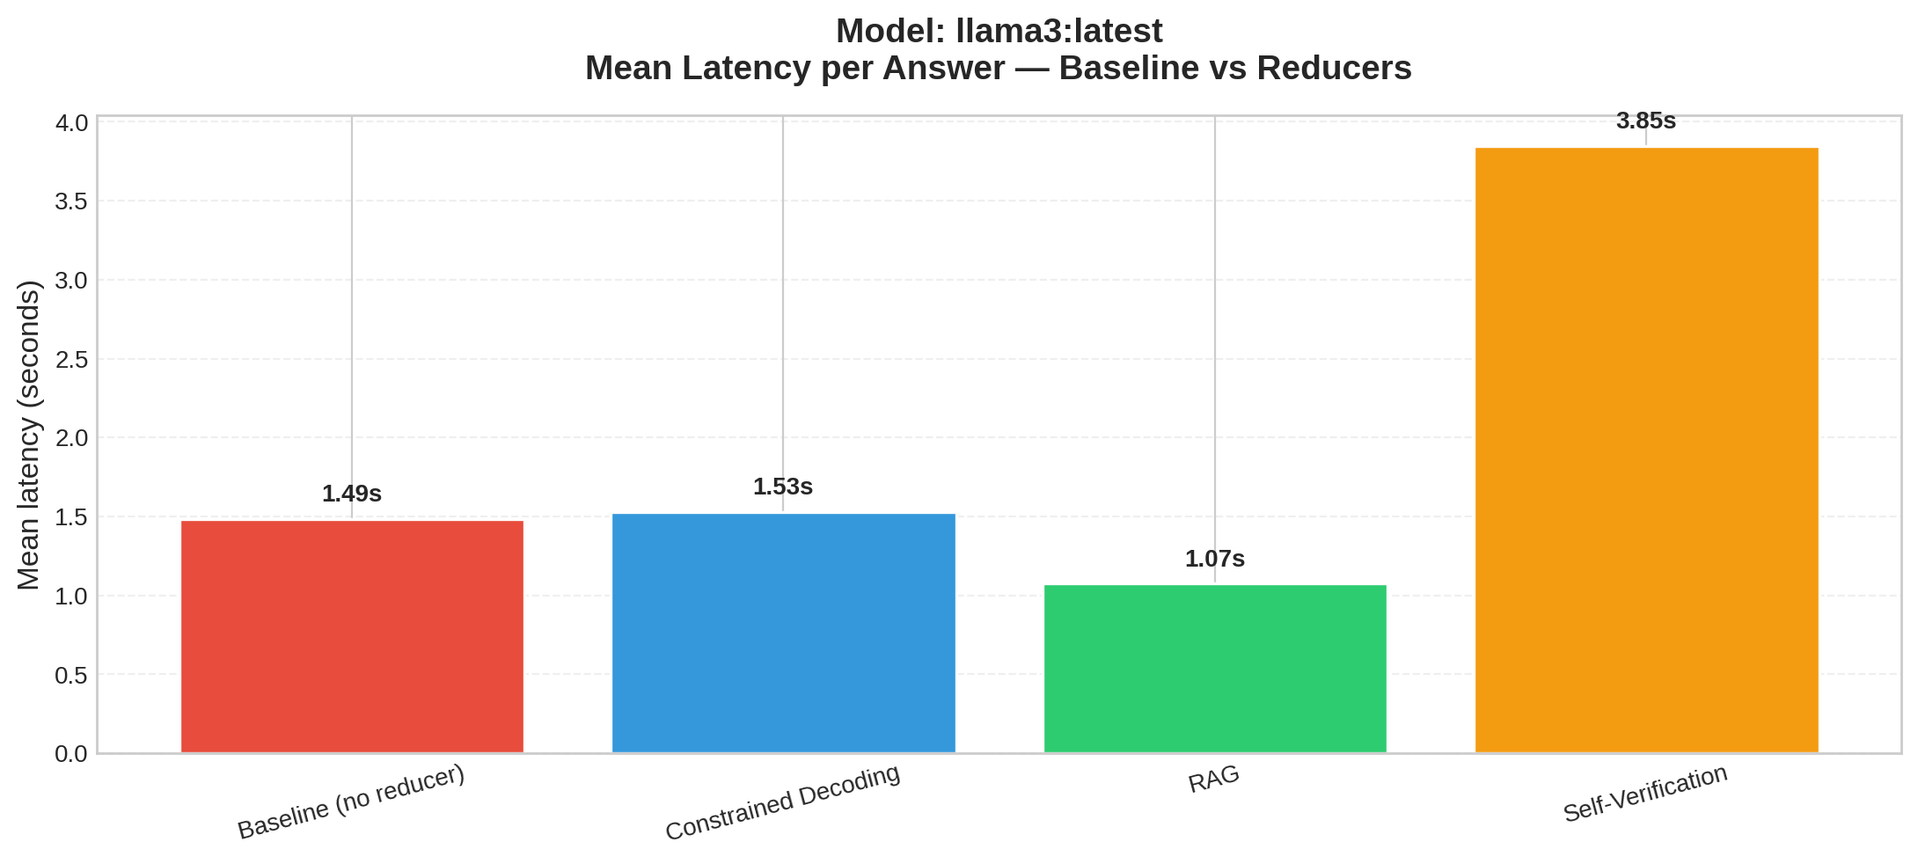

Summary Table (Mean Scores)
model | dataset | reducer | token_score | semantic_score | bert_score | llm_score | n_samples | mean_latency_s
llama3:latest | synthetic | baseline | 0.6656 | 0.1112 | 0.6015 | 0.0267 | 5 | 1.485
llama3:latest | synthetic | constrained_decoding | 0.6989 | 0.1094 | 0.6631 | 0.03 | 5 | 1.527
llama3:latest | synthetic | rag | 0.4502 | 0.0734 | 0.5189 | 0.0333 | 5 | 1.074
llama3:latest | synthetic | self_verification | 0.6808 | 0.1045 | 0.6294 | 0.0933 | 5 | 3.848

Reductions vs Baseline
model | reducer | token_score_reduction | semantic_score_reduction | bert_score_reduction | llm_score_reduction | token_score_win_rate | semantic_score_win_rate | bert_score_win_rate | llm_score_win_rate
llama3:latest | constrained_decoding | -0.0333 | 0.0018 | -0.0616 | -0.0033 | 0.6 | 0.4 | 0.6 | 0.4
llama3:latest | rag | 0.2154 | 0.0378 | 0.0826 | -0.0067 | 0.8 | 0.6 | 1.0 | 0.4
llama3:latest | self_verification | -0.0152 | 0.0067 | -0.028 | -0.0667 | 0.4 | 0.4 | 0.2 | 0.2

